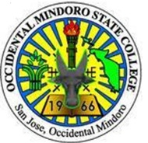

Republic of the Philippines

**OCCIDENTAL MINDORO STATE COLLEGE**

Mamburao, Occidental Mindoro

COLLEGE OF ARTS, SCIENCES AND TECHNOLOGY

**INTERNSHIP PROGRESS REPORT**

|  |  |
| --- | --- |
| Name: Steven Dale P. Lucero | Date: |
| Internship Site: DEPARTMENT OF PUBLIC | WORKS AND HIGHWAYS |
|  | **Hours** **Completed**: |
|  |  |
| The report covers the following dates: | **From**: **To**: |

|  |  |  |
| --- | --- | --- |
| Objectives | Work Status | Problems Met |
| 1. |  |  |
| 2. |  |  |
| 3. |  |  |
| 4. |  |  |
| 5. |  |  |

*The following report accurately describes the internship activities completed to date:*

**Intern** __________Steven Dale P. Lucero________ **Date** ____________________

*I have read the attached report and concur with its content:*

**Site Supervisor** ___________Araceli M. Juan____________ **Date** ____________________