Supplementary Information
When Does a Regulatory Graph Become a Mechanism?
Prospective Perturbation Testing with TopoMIEG-FM
Zunlin Shi¹, Zhi Li¹, Lizhou He², Fan Yang³,*
¹ College of Electronics and Information Engineering, Sichuan University
² Department of Information Management, West China Second Hospital, Sichuan University
³ Department of Gynecology and Obstetrics, West China Second Hospital, Sichuan University
* Correspondence: Fan Yang (yf20252025@126.com)
This Supplementary Information expands the experimental definitions, numerical procedures, source-level results, structural controls, and expression-representation analyses reported in the main manuscript. The supplement uses the same manuscript-facing terminology as the main text. Candidate regulatory relations are evaluated by whether they generate perturbation-induced state changes that agree with independent observations.
Contents
- Supplementary Methods S1-S11
- Supplementary Results S12-S18
- Supplementary Figures S1-S4
- Supplementary Tables S1-S7
- References

Supplementary Methods

S1. Notation and evaluation target
For a candidate signed regulatory graph, W denotes the modeled effect of regulator j on target i. The baseline state x_obs is mapped to a bounded interval and used to define the operating point of the candidate model. The central evaluation target is the perturbation-induced downstream state change, not baseline reconstruction.
b = atanh(x_obs) - W x_obs
x_obs = tanh(b + W x_obs)
Perturbing source regulator s by magnitude delta modifies the source field and yields a perturbed fixed point:
b_pert = b - delta e_s
x*_pert = tanh(b_pert + W x*_pert)
Delta x_pred = x*_pert - x_obs
The predicted transition Delta x_pred is compared with an independently measured response Delta x_obs. The perturbed source itself is excluded from downstream scoring.

S2. Candidate regulatory relations and independent K562 baseline
Human signed transcription-factor-target relations were obtained from DoRothEA version 1.23.0, restricted to confidence levels A and B [8]. For each source transcription factor, the candidate node set contained the source and its baseline-expressed direct targets; all A/B DoRothEA interactions among included nodes were retained. Signs followed the DoRothEA mode-of-regulation annotation and included interactions used unit magnitude before operator scaling.
The independent K562 baseline was derived from ENCODE total RNA-seq experiment ENCSR885DVH [10], using replicates ENCFF424CXV and ENCFF073NHK. Gene-level values were mapped to HGNC symbols, yielding 15,360 unique genes. Expression ranks were mapped to (-1,1) and clipped to [-0.95,0.95] before state construction.

S3. State model, perturbation and numerical solver
For each source-specific model, W was scaled to spectral norm 0.30. The baseline intercept was then computed from the observed baseline state, making x_obs a fixed point by construction. A source perturbation used delta = 0.50. Fixed points were solved iteratively until numerical convergence.
Numerical admissibility was assessed by the infinity-norm fixed-point residual and the effective spectral radius at the converged solution. The prespecified numerical thresholds were residual <= 1e-10 and effective spectral radius <= 0.35. Across the 39 K562 candidate models, the observed maxima were 2.39e-12 and 0.0731, respectively.

S4. Controlled synthetic systems
Synthetic evaluations used 128 independent worlds per comparison. Each world specified a generating mechanism, a context, a perturbation target, and an expected response direction. The signed response score was R_eq = s_claim * Delta x_target / |delta|, where s_claim encodes the prespecified expected direction. The score therefore rewards movement in the expected direction and penalizes movement in the opposite direction.
The first comparison paired the generating mechanism with a deliberately higher-confidence but incorrect alternative. A harder direct-edge decoy preserved signed direct-edge magnitude, motif degree, and absolute two-step burden while altering local signed-path coherence. Additional comparisons used context swaps, sign perturbations, and topology permutations. These controls test whether the closure score responds to joint signed structure rather than simple edge confidence or graph size.

S5. Prospective source universe and prediction generation
The real-data source universe was defined without consulting the Perturb-seq perturbation target list. A transcription factor was eligible when it was expressed in the independent K562 baseline and had at least 20 baseline-expressed DoRothEA A/B targets. Thirty-nine sources met this rule. Predictions were generated for all 39 sources before perturbational expression outcomes were used for scoring.
The frozen prediction set contained 3,383 source-target rows. For each source, 100 degree- and sign-count-preserving rewired graphs were generated using seed 20261107. Rewired predictions used the same baseline state, source perturbation magnitude, numerical solver, and downstream scoring rule as the native graph.

S6. Perturb-seq outcome definition and explicit control binding
Held-out single-cell responses were taken from the genome-scale K562 CRISPRi Perturb-seq experiment of Replogle et al. [7] using the harmonized scPerturb H5AD distribution [9]. The object contained 1,989,578 K562 cells and 8,248 measured genes.
Explicit controls were cells annotated gene = non-targeting, perturbation = control, and nperts = 0. These three labels agreed exactly for 75,328 cells. Perturbed cells for source s were cells with gene = s and nperts = 1. All 267 batches contained explicit controls, allowing every source response to be matched to a same-batch control mean.

S7. Outcome aggregation
For source s, guide g, and batch b, the observed batch response was the mean expression of perturbed cells minus the pooled explicit-control mean from the same batch. Batch-specific responses were averaged with equal weight within guide, and guide-specific responses were averaged with equal weight within source. Cell counts therefore did not provide additional weighting across batches or guides.
Delta x(s,g,b) = mean(X_s,g,b) - mean(X_control,b)
Delta x(s,g) = average_b Delta x(s,g,b)
Delta x_obs(s) = average_g Delta x(s,g)

S8. Primary scoring, one-step comparator and source bootstrap
Genes were matched by exact gene symbol. The perturbed source was removed before scoring. At least three matched downstream genes were required. The primary source-level statistic was Spearman correlation between the equilibrium prediction and the observed response. Aggregate performance was summarized by the median across source perturbations.
The direct comparator was Delta x_one = -0.50 W e_s. A source contributed to the paired equilibrium-versus-one-step comparison only when both correlations were finite. Twelve sources produced constant one-step vectors and therefore did not have a defined one-step rank correlation; the equilibrium endpoint remained evaluable for all 39 sources.
Uncertainty was quantified by 2,000 source-level bootstrap replicates using seed 20261108. The bootstrap unit was the source perturbation.

S9. Rewired topology control and prediction discriminability
For each source, the native equilibrium correlation was compared with 100 rewired predictions. In addition to correlation-based comparison, we quantified whether rewiring changed the prediction vector itself: the fraction of rewires exactly matching the native prediction to tolerance 1e-12, the fraction of target values changed, the median maximum absolute prediction difference, and the Spearman correlation between native and rewired prediction vectors.
This output-level characterization distinguishes a graph perturbation from a prediction perturbation. A rewired graph that produces the same ranked state-transition vector provides little discrimination for a rank-based topology control.

S10. Guide reproducibility and source-gene response
For sources represented by multiple guide constructs, guide-specific downstream response vectors were compared pairwise using Spearman correlation on the same downstream target set used for source-level scoring. The median pairwise correlation summarized guide-to-guide reproducibility for each source.
When the perturbed source gene itself was among the 8,248 measured genes, its observed response was extracted separately. Source-gene response characterizes direct perturbation activity and is not included in downstream model scoring.

S11. Expression-representation audit and normalized sensitivity analysis
The distributed H5AD X matrix was float32, but all sampled values were integer-valued and sampled row sums matched obs/ncounts exactly. This identified X as a UMI-count representation. The primary analysis used the distributed matrix directly. A representation sensitivity analysis applied per-cell scaling to 10,000 counts followed by log1p transformation before repeating the identical batch, guide and source aggregation procedure.
The normalized analysis used the same 39 source definitions, exact target matching, prediction vectors, one-step comparator, rewired predictions, bootstrap seed, and source-level evaluation statistics. It therefore isolates the effect of outcome representation from the graph and model definition.

Supplementary Results

S12. Controlled systems provide positive controls for the perturbation test
Across 128 synthetic worlds, the generating mechanism had a larger signed response score than a deliberately higher-confidence incorrect alternative in 128/128 worlds. The median paired difference was 0.0983 with a 95% bootstrap interval of 0.0943-0.1025. Maximum fixed-point residual was 2.74e-13 and maximum spectral radius was 0.288.
Against the structurally matched hard decoy, the generating mechanism was preferred in 128/128 worlds. The median paired difference was 0.01654 with a 95% bootstrap interval of 0.01624-0.01688. Context swaps and wrong-sign alternatives were distinguished in 128/128 worlds, and the generating mechanism was preferred to topology-permuted alternatives in 125/128 worlds.

S13. All 39 K562 candidate models were numerically admissible
All candidate models converged under the prespecified numerical criteria. The maximum fixed-point residual was 2.39e-12 and the maximum effective spectral radius was 0.0731. Neither graph size, number of matched genes, perturbation cell count, number of guides, raw spectral norm, nor effective spectral radius showed a strong monotonic association with the source-level equilibrium correlation in exploratory diagnostics; absolute Spearman associations ranged from approximately 0.02 to 0.18.

S14. The primary equilibrium endpoint is evaluable for all sources
The equilibrium endpoint was finite for all 39 source perturbations. Its median Spearman correlation was -0.0455 and the source-bootstrap 95% interval was [-0.1713, 0.0803]. The paired equilibrium-versus-one-step endpoint was finite for 27 sources; its median difference was -0.00153 with 95% interval [-0.1584, 0.0675].
The 12 sources with undefined one-step correlation were BACH1, ELK1, ETS2, FOXM1, FOXP1, HIF1A, MITF, SREBF1, STAT2, USF1, USF2 and ZNF263. In every case the scored one-step vector contained only one unique value, so a rank correlation was not defined.

S15. Rewired topology often produced nearly unchanged predictions
Across the 39 sources, the median fraction of rewired correlations tied with the native correlation was 0.69. Seventeen sources had the same correlation across all 100 rewires, and nine sources had prediction vectors identical to the native prediction for all 100 rewires. The median null standard deviation was 7.40e-4 and the median native midrank percentile within the rewired distribution was 0.50.
Among sources where rewiring changed the graph and prediction values, native-versus-rewired prediction vectors still showed very high rank similarity. This explains why the correlation-based rewiring control had limited ability to separate the native graph from structurally perturbed alternatives in the K562 experiment.

S16. Direct source responses and downstream guide reproducibility separate two properties of the perturbation experiment
Twenty-nine perturbed source genes were represented in the measured expression matrix, and all 29 had negative source-gene responses after CP10K + log1p normalization. Thus the directly measured source response moved in the expected direction for every measurable source.
Eleven sources had multiple guides. Their median source-level pairwise guide Spearman correlation was 0.004 on the distributed count representation and 0.011 after CP10K + log1p transformation. The source-specific values were heterogeneous, ranging from negative concordance to moderate positive concordance.

S17. Count normalization changes individual responses but not the aggregate result
After CP10K + log1p transformation, the median equilibrium Spearman correlation across 39 sources was -0.0603 with a 95% bootstrap interval of [-0.1169, 0.0490]. Among the 27 sources with a finite one-step correlation, the median equilibrium-minus-one-step difference was -0.0554 with a 95% interval of [-0.1240, 0.0825].
The median source-level Spearman correlation between raw-count and normalized observed response vectors was 0.853. Normalization therefore changed individual gene rankings within perturbation responses but retained substantial source-level concordance and did not produce a positive aggregate equilibrium correlation.

S18. Aggregate interpretation across model, intervention and outcome layers
The K562 experiment separates three empirical quantities. First, direct source-gene responses are consistently negative where the source is measurable. Second, downstream transcriptome responses are weakly concordant across independent guides. Third, stable equilibrium predictions show no positive aggregate correspondence with the downstream response under either expression representation. These quantities are reported separately because they describe different properties of the experiment.

Supplementary Figures
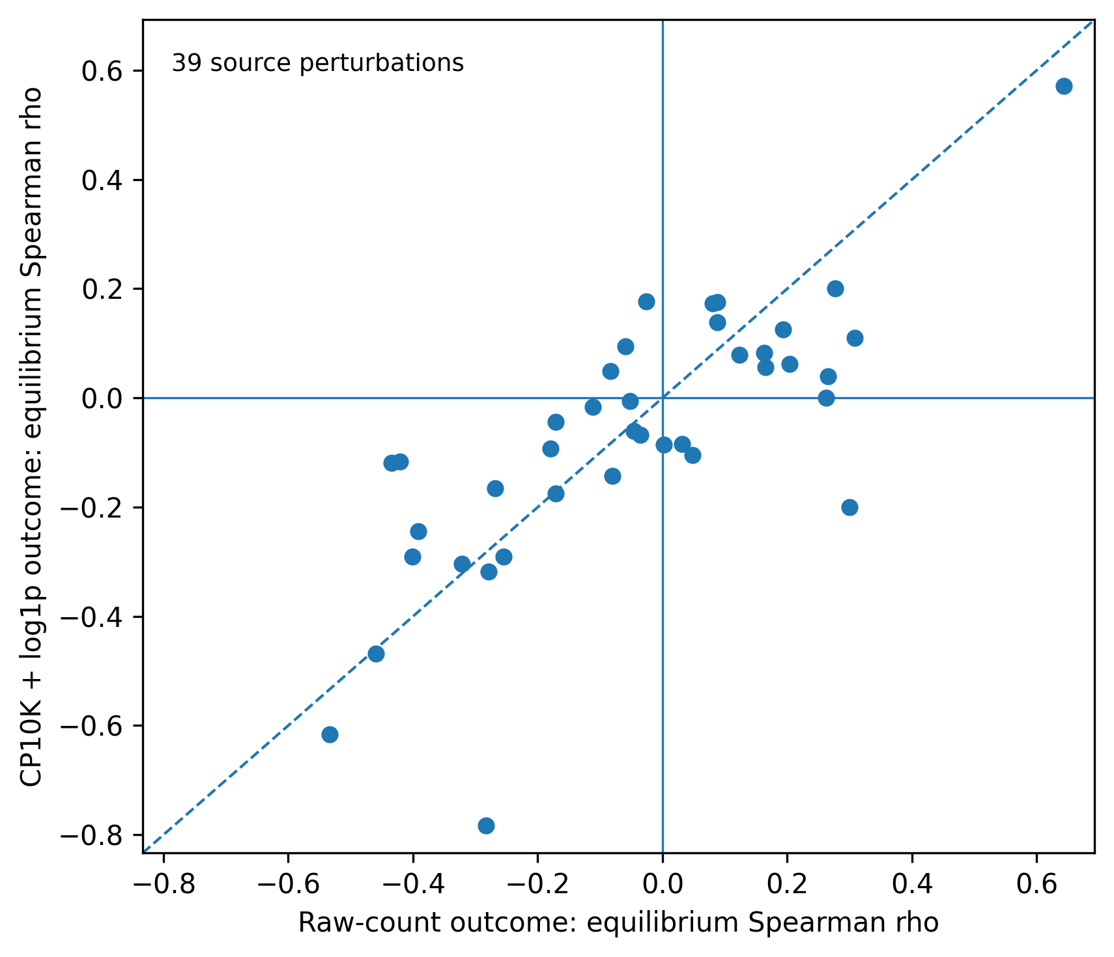
Figure S1 | Source-level equilibrium correlations under raw-count and CP10K + log1p outcome representations. Each point is one of the 39 source perturbations; the dashed line denotes equality.
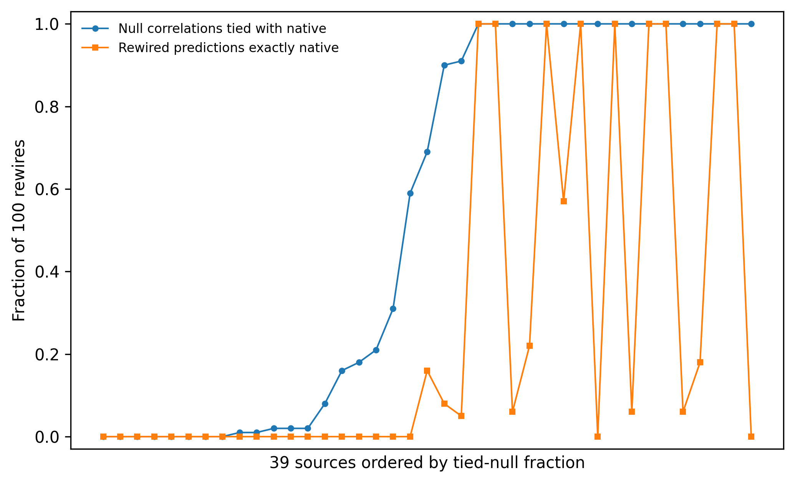
Figure S2 | Prediction-level discriminability of the rewired topology control. Sources are ordered by the fraction of rewired correlations tied with the native correlation. The second series shows the fraction of rewires whose prediction vector exactly matches the native vector to tolerance 1e-12.
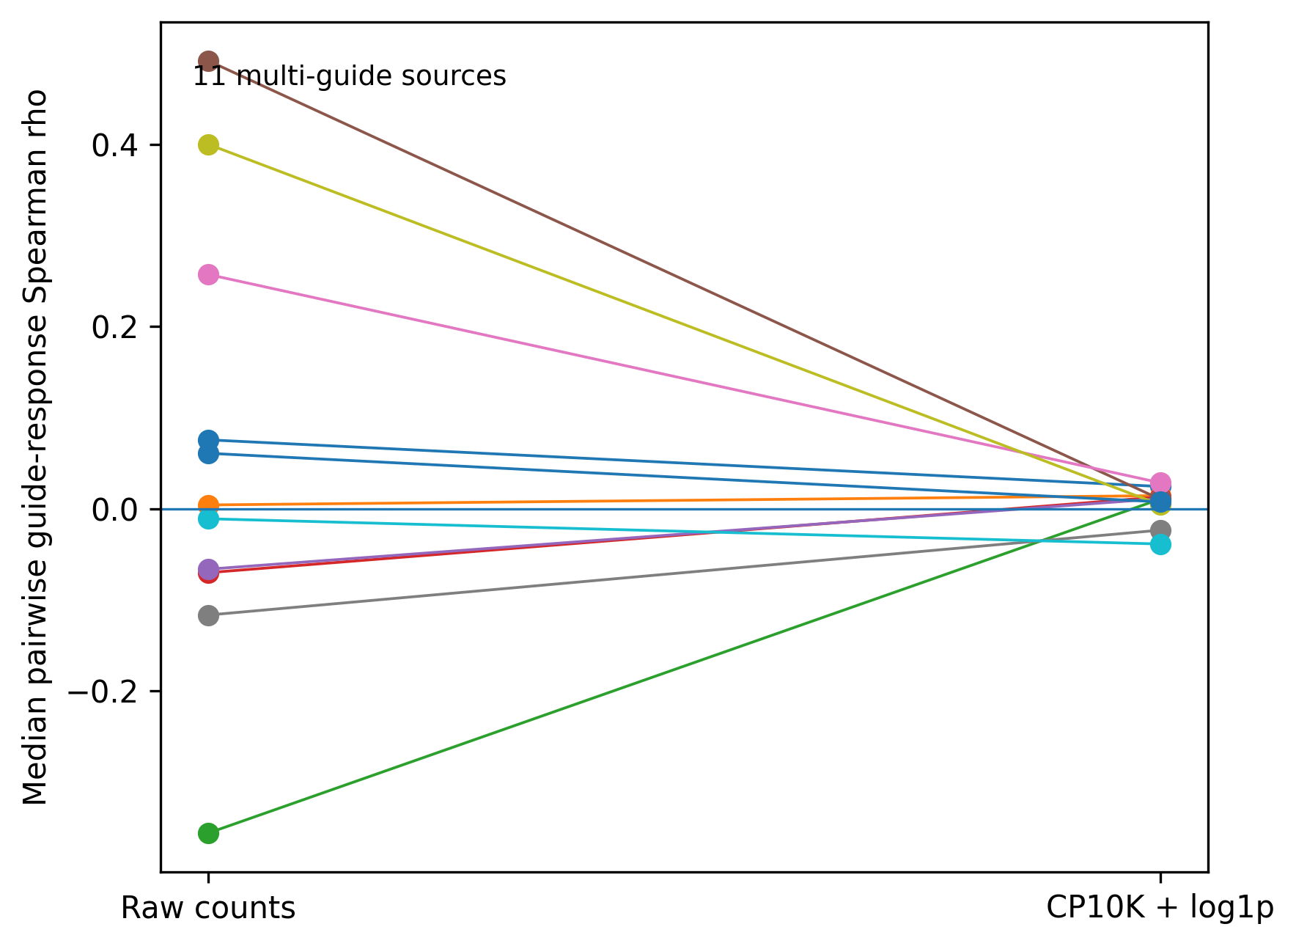
Figure S3 | Guide-to-guide downstream response reproducibility for the 11 multi-guide sources. Lines connect each source under the distributed count representation and the CP10K + log1p representation.
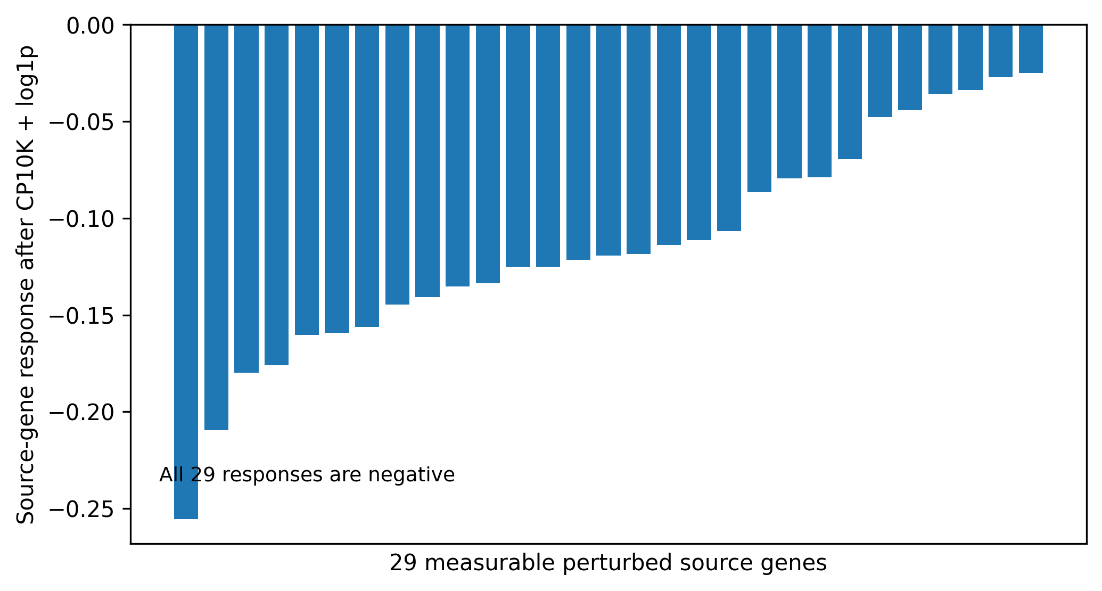
Figure S4 | Direct source-gene responses after CP10K + log1p normalization for the 29 perturbed source genes represented in the measured expression matrix. All responses are negative.

Supplementary Tables
Table S1 | Data and analysis asset provenance.
Asset | File | SHA256 | Scope
DoRothEA A/B signed relations | dorothea_AB.tsv | 20d0a16f4dd93453bb5610e00c6c75e8f4acd047c186173077d2630e9753549e | 6,408 interaction rows
ENCODE K562 baseline | baseline_expression.tsv | beb9fe6fb93f24b06b70cfaac418333c3a1585033d4416d2e89dab20c9e27c63 | 15,360 unique HGNC symbols
K562 Perturb-seq H5AD | ReplogleWeissman2022_K562_gwps.h5ad | d3269d9c863d96555eba768b42ab330cc1b57493cd33b4ac8fe7fbab8278f104 | 1,989,578 cells; 8,248 genes
Native equilibrium predictions | prediction_vectors.tsv.gz | 3507eae182085235dcec8011d65cd62ec352e44a5fa55550e44fa3b68578288f | 39 sources; 3,383 source-target rows
Rewired equilibrium predictions | rewired_predictions.tsv.gz | fe1f52cd3a29dfc3869d97cbdfee8f896b9ac71267209f78dad24166e9a153fb | 100 rewires per source
Primary observed responses | observed_response_vectors.tsv.gz | c54399beb89e725e3e9b42b36fb0d9303f663d46dc0821036a535ea3bcdd570e | Distributed count representation
Normalized observed responses | observed_response_vectors_cp10k_log1p.tsv.gz | 9746dad78c60fbbb0b6f3bb202035e9ff8812b5dc3c2fe36896cda800287a7d2 | CP10K + log1p sensitivity
Normalized guide responses | guide_response_vectors_cp10k_log1p.tsv.gz | d862d9d5a38fc94e271ca27dde5b90d5b3fc06d6a324c861c99cdcd3c8bfdb94 | Guide-level sensitivity responses
Hashes identify the exact assets used for the reported analyses.

Table S2 | Source-level primary K562 scoring results.
Source | Matched genes | Eq. rho | One-step rho | Eq.-one-step | Median rewired rho | Paired evaluable | Native > rewired median
BACH1 | 23 | -0.0455 | NA | NA | -0.0455 | No | No
CREB1 | 18 | 0.1228 | -0.2104 | 0.3332 | 0.1228 | Yes | No
CTCF | 45 | 0.1652 | 0.1164 | 0.0489 | 0.1652 | Yes | No
E2F1 | 183 | -0.2687 | 0.0622 | -0.3310 | -0.2674 | Yes | No
E2F4 | 202 | -0.0353 | 0.0047 | -0.0400 | -0.0345 | Yes | No
EGR1 | 45 | 0.3084 | 0.0083 | 0.3001 | 0.3277 | Yes | No
ELK1 | 15 | 0.1929 | NA | NA | 0.1929 | No | No
ESR1 | 57 | 0.0873 | 0.1282 | -0.0409 | 0.0909 | Yes | No
ETS1 | 57 | -0.0525 | 0.3486 | -0.4012 | -0.0515 | Yes | No
ETS2 | 9 | -0.5333 | NA | NA | -0.5333 | No | No
FOS | 31 | -0.1794 | 0.0244 | -0.2038 | -0.1895 | Yes | Yes
FOXM1 | 22 | -0.0807 | NA | NA | -0.0807 | No | No
FOXO1 | 17 | -0.0833 | -0.2899 | 0.2065 | -0.0833 | Yes | No
FOXO3 | 19 | -0.4596 | -0.3012 | -0.1584 | -0.4596 | Yes | No
FOXP1 | 95 | 0.0882 | NA | NA | 0.0887 | No | No
GATA2 | 20 | -0.1113 | 0.0946 | -0.2059 | -0.1113 | Yes | No
HIF1A | 65 | 0.0317 | NA | NA | 0.0317 | No | No
IRF1 | 5 | 0.3000 | 0.5774 | -0.2774 | 0.3000 | Yes | No
JUN | 30 | 0.0483 | -0.0193 | 0.0675 | 0.0565 | Yes | No
MITF | 15 | -0.3214 | NA | NA | -0.3214 | No | No
MYC | 260 | -0.4341 | 0.0618 | -0.4959 | -0.4344 | Yes | Yes
NFKB1 | 43 | 0.2649 | 0.0956 | 0.1693 | 0.2530 | Yes | Yes
PPARG | 9 | -0.2833 | -0.3105 | 0.0272 | -0.2833 | Yes | No
RARA | 11 | -0.2545 | -0.3000 | 0.0455 | -0.2545 | Yes | No
RELA | 40 | 0.2773 | 0.0313 | 0.2459 | 0.2639 | Yes | Yes
SMAD3 | 8 | 0.2619 | -0.0825 | 0.3444 | 0.2619 | Yes | No
SP1 | 137 | -0.3919 | 0.0464 | -0.4384 | -0.3913 | Yes | No
SP3 | 19 | 0.1632 | -0.0313 | 0.1945 | 0.1632 | Yes | No
SPI1 | 31 | -0.4006 | -0.1468 | -0.2538 | -0.4047 | Yes | Yes
SREBF1 | 14 | 0.0022 | NA | NA | 0.0022 | No | No
STAT1 | 109 | 0.2036 | 0.1739 | 0.0297 | 0.2039 | Yes | No
STAT2 | 16 | -0.0265 | NA | NA | -0.0265 | No | No
STAT3 | 26 | 0.0803 | 0.1540 | -0.0736 | 0.0865 | Yes | No
TP53 | 126 | -0.1713 | -0.0295 | -0.1418 | -0.1732 | Yes | Yes
USF1 | 22 | -0.4207 | NA | NA | -0.4207 | No | No
USF2 | 15 | -0.2786 | NA | NA | -0.2786 | No | No
WT1 | 8 | 0.6429 | 0.5040 | 0.1389 | 0.6429 | Yes | No
YY1 | 54 | -0.1713 | -0.1698 | -0.0015 | -0.1713 | Yes | No
ZNF263 | 144 | -0.0594 | NA | NA | -0.0578 | No | No
The equilibrium endpoint is evaluable for all 39 sources. One-step rank correlation is undefined when the one-step vector is constant across scored downstream genes.
Table S3 | Sources with constant one-step prediction vectors.
Source | Matched genes | Eq. rho | Unique one-step values
BACH1 | 23 | -0.0455 | 1
ELK1 | 15 | 0.1929 | 1
ETS2 | 9 | -0.5333 | 1
FOXM1 | 22 | -0.0807 | 1
FOXP1 | 95 | 0.0882 | 1
HIF1A | 65 | 0.0317 | 1
MITF | 15 | -0.3214 | 1
SREBF1 | 14 | 0.0022 | 1
STAT2 | 16 | -0.0265 | 1
USF1 | 22 | -0.4207 | 1
USF2 | 15 | -0.2786 | 1
ZNF263 | 144 | -0.0594 | 1
A constant vector has zero rank variance, so Spearman correlation is undefined.
Table S4 | Rewired topology discriminability by source.
Source | Native rho | Null median | Null SD | Tied fraction | Exact-vector fraction | Median swaps | Median pred. rho(native,rewired)
BACH1 | -0.0455 | -0.0455 | 1.388e-17 | 1.0000 | 1.0000 | 0.0000 | 1.0000
CREB1 | 0.1228 | 0.1228 | 0.0000 | 1.0000 | 0.0000 | 70.0000 | 0.9950
CTCF | 0.1652 | 0.1652 | 2.776e-17 | 1.0000 | 1.0000 | 0.0000 | 1.0000
E2F1 | -0.2687 | -0.2674 | 0.0015 | 0.0000 | 0.0000 | 631.0000 | 0.9994
E2F4 | -0.0353 | -0.0345 | 0.0029 | 0.0000 | 0.0000 | 870.5000 | 0.9981
EGR1 | 0.3084 | 0.3277 | 0.0082 | 0.0000 | 0.0000 | 1.084e+03 | 0.9943
ELK1 | 0.1929 | 0.1929 | 0.0000 | 1.0000 | 0.0600 | 21.0000 | 1.0000
ESR1 | 0.0873 | 0.0909 | 0.0070 | 0.0200 | 0.0000 | 1.132e+03 | 0.9955
ETS1 | -0.0525 | -0.0515 | 0.0035 | 0.0100 | 0.0000 | 1.075e+03 | 0.9993
ETS2 | -0.5333 | -0.5333 | 0.0164 | 0.5900 | 0.0000 | 90.0000 | 0.9974
FOS | -0.1794 | -0.1895 | 0.0079 | 0.0800 | 0.0000 | 471.5000 | 0.9961
FOXM1 | -0.0807 | -0.0807 | 0.0157 | 0.6900 | 0.1600 | 14.0000 | 1.0000
FOXO1 | -0.0833 | -0.0833 | 0.0000 | 1.0000 | 1.0000 | 0.0000 | 1.0000
FOXO3 | -0.4596 | -0.4596 | 0.0000 | 1.0000 | 1.0000 | 0.0000 | 1.0000
FOXP1 | 0.0882 | 0.0887 | 0.0007 | 0.2100 | 0.0000 | 30.0000 | 1.0000
GATA2 | -0.1113 | -0.1113 | 0.0000 | 1.0000 | 0.0600 | 26.0000 | 0.9996
HIF1A | 0.0317 | 0.0317 | 0.0012 | 0.1600 | 0.0000 | 138.0000 | 0.9999
IRF1 | 0.3000 | 0.3000 | 0.0000 | 1.0000 | 1.0000 | 0.0000 | 1.0000
JUN | 0.0483 | 0.0565 | 0.0126 | 0.0200 | 0.0000 | 945.0000 | 0.9843
MITF | -0.3214 | -0.3214 | 0.0000 | 1.0000 | 0.5700 | 4.0000 | 1.0000
MYC | -0.4341 | -0.4344 | 0.0007 | 0.0000 | 0.0000 | 641.5000 | 0.9999
NFKB1 | 0.2649 | 0.2530 | 0.0073 | 0.0100 | 0.0000 | 623.0000 | 0.9953
PPARG | -0.2833 | -0.2833 | 0.0000 | 1.0000 | 0.2200 | 9.0000 | 0.9933
RARA | -0.2545 | -0.2545 | 1.110e-16 | 1.0000 | 0.1800 | 16.0000 | 0.9966
RELA | 0.2773 | 0.2639 | 0.0081 | 0.0000 | 0.0000 | 922.5000 | 0.9960
SMAD3 | 0.2619 | 0.2619 | 0.0000 | 1.0000 | 0.0600 | 20.0000 | 0.9983
SP1 | -0.3919 | -0.3913 | 0.0017 | 0.0000 | 0.0000 | 3.205e+03 | 0.9996
SP3 | 0.1632 | 0.1632 | 2.776e-17 | 1.0000 | 1.0000 | 0.0000 | 1.0000
SPI1 | -0.4006 | -0.4047 | 0.0032 | 0.3100 | 0.0000 | 118.0000 | 0.9998
SREBF1 | 0.0022 | 0.0022 | 4.337e-19 | 1.0000 | 1.0000 | 0.0000 | 1.0000
STAT1 | 0.2036 | 0.2039 | 0.0012 | 0.0000 | 0.0000 | 1.244e+03 | 0.9998
STAT2 | -0.0265 | -0.0265 | 0.0034 | 0.9100 | 0.0500 | 21.5000 | 1.0000
STAT3 | 0.0803 | 0.0865 | 0.0077 | 0.0200 | 0.0000 | 483.0000 | 0.9988
TP53 | -0.1713 | -0.1732 | 0.0052 | 0.0000 | 0.0000 | 1.611e+03 | 0.9967
USF1 | -0.4207 | -0.4207 | 1.665e-16 | 1.0000 | 1.0000 | 0.0000 | 1.0000
USF2 | -0.2786 | -0.2786 | 0.0000 | 1.0000 | 1.0000 | 0.0000 | 1.0000
WT1 | 0.6429 | 0.6429 | 1.110e-16 | 1.0000 | 0.0000 | 150.0000 | 0.9974
YY1 | -0.1713 | -0.1713 | 0.0002 | 0.9000 | 0.0800 | 12.0000 | 0.9999
ZNF263 | -0.0594 | -0.0578 | 0.0010 | 0.1800 | 0.0000 | 60.0000 | 1.0000
Tied fraction is the fraction of 100 rewired correlations equal to the native correlation to tolerance 1e-12. Exact-vector fraction is the fraction of rewired prediction vectors matching the native prediction to the same tolerance.

Table S5 | Multi-guide downstream response reproducibility.
Source | Guides | Guide rho (raw) | Guide rho (CP10K+log1p) | Median guide self-response (raw) | Fraction guide self-response < 0
EGR1 | 2 | 0.0756 | 0.0244 | -0.1012 | 1.0000
ESR1 | 2 | 0.0041 | 0.0144 | NA | NA
FOS | 2 | -0.3560 | 0.0106 | NA | NA
FOXO3 | 2 | -0.0702 | 0.0130 | -0.1370 | 1.0000
FOXP1 | 4 | -0.0663 | 0.0111 | -0.0519 | 0.7500
GATA2 | 2 | 0.4917 | 0.0104 | -0.2009 | 1.0000
MITF | 2 | 0.2571 | 0.0285 | -0.2354 | 1.0000
PPARG | 2 | -0.1167 | -0.0235 | NA | NA
RARA | 2 | 0.4000 | 0.0044 | NA | NA
SREBF1 | 2 | -0.0110 | -0.0387 | -0.0351 | 1.0000
ZNF263 | 2 | 0.0609 | 0.0075 | -0.0540 | 1.0000
Guide correlations use the source-specific downstream target set. NA indicates that the source gene itself was not represented in the measured expression matrix for the direct self-response summary.

Table S6 | Source-level CP10K + log1p sensitivity results.
Source | Genes | Eq. rho norm. | One-step rho norm. | Eq.-one-step | Median rewired rho | Native > rewired | Raw-vs-norm outcome rho | Source self-response
BACH1 | 23 | -0.0603 | NA | NA | -0.0603 | No | 0.8007 | -0.2095
CREB1 | 18 | 0.0795 | -0.2571 | 0.3366 | 0.0795 | No | 0.8311 | -0.1407
CTCF | 45 | 0.0559 | -0.0090 | 0.0648 | 0.0559 | No | 0.8531 | -0.1561
E2F1 | 183 | -0.1652 | 0.0658 | -0.2309 | -0.1640 | No | 0.8930 | -0.1336
E2F4 | 202 | -0.0676 | 0.0426 | -0.1102 | -0.0649 | No | 0.8568 | -0.1216
EGR1 | 45 | 0.1094 | -0.0166 | 0.1260 | 0.1228 | No | 0.8430 | -0.0441
ELK1 | 15 | 0.1250 | NA | NA | 0.1250 | No | 0.8773 | -0.0789
ESR1 | 57 | 0.1390 | 0.1319 | 0.0071 | 0.1398 | No | 0.8695 | NA
ETS1 | 57 | -0.0057 | 0.3582 | -0.3639 | -0.0053 | No | 0.9075 | NA
ETS2 | 9 | -0.6167 | NA | NA | -0.6167 | No | 0.8424 | -0.1138
FOS | 31 | -0.0931 | 0.0244 | -0.1175 | -0.1028 | Yes | 0.8452 | NA
FOXM1 | 22 | -0.1429 | NA | NA | -0.1429 | No | 0.7621 | -0.1193
FOXO1 | 17 | 0.0490 | -0.2372 | 0.2862 | 0.0490 | No | 0.8826 | -0.0478
FOXO3 | 19 | -0.4684 | -0.2152 | -0.2533 | -0.4684 | No | 0.8855 | -0.0866
FOXP1 | 95 | 0.1751 | NA | NA | 0.1758 | No | 0.8756 | -0.0338
GATA2 | 20 | -0.0165 | -0.1135 | 0.0970 | -0.0165 | No | 0.7682 | -0.0694
HIF1A | 65 | -0.0839 | NA | NA | -0.0839 | No | 0.8360 | -0.1352
IRF1 | 5 | -0.2000 | 0.2887 | -0.4887 | -0.2000 | No | 0.8307 | NA
JUN | 30 | -0.1048 | 0.0193 | -0.1240 | -0.0883 | No | 0.8659 | -0.1251
MITF | 15 | -0.3036 | NA | NA | -0.3036 | No | 0.8391 | -0.1114
MYC | 260 | -0.1192 | 0.0628 | -0.1819 | -0.1190 | No | 0.7546 | -0.0270
NFKB1 | 43 | 0.0395 | 0.1545 | -0.1150 | 0.0233 | Yes | 0.8418 | -0.1251
PPARG | 9 | -0.7833 | -0.6211 | -0.1623 | -0.7833 | No | 0.7431 | NA
RARA | 11 | -0.2909 | -0.4000 | 0.1091 | -0.2909 | No | 0.8894 | NA
RELA | 40 | 0.2009 | 0.0997 | 0.1012 | 0.1856 | Yes | 0.7812 | -0.1067
SMAD3 | 8 | 0.0000 | -0.4124 | 0.4124 | 0.0000 | No | 0.8680 | NA
SP1 | 137 | -0.2438 | -0.0016 | -0.2422 | -0.2437 | No | 0.8282 | -0.1186
SP3 | 19 | 0.0825 | 0.0000 | 0.0825 | 0.0825 | No | 0.8988 | -0.1593
SPI1 | 31 | -0.2912 | -0.0881 | -0.2031 | -0.2940 | Yes | 0.8984 | -0.1759
SREBF1 | 14 | -0.0857 | NA | NA | -0.0857 | No | 0.8900 | -0.0250
STAT1 | 109 | 0.0622 | 0.1176 | -0.0554 | 0.0633 | No | 0.8825 | -0.2555
STAT2 | 16 | 0.1765 | NA | NA | 0.1765 | No | 0.8806 | NA
STAT3 | 26 | 0.1733 | 0.2694 | -0.0961 | 0.1795 | No | 0.8717 | -0.1445
TP53 | 126 | -0.0437 | -0.0560 | 0.0123 | -0.0497 | Yes | 0.7897 | NA
USF1 | 22 | -0.1169 | NA | NA | -0.1169 | No | 0.8789 | NA
USF2 | 15 | -0.3179 | NA | NA | -0.3179 | No | 0.8649 | -0.1798
WT1 | 8 | 0.5714 | 0.3780 | 0.1935 | 0.5714 | No | 0.7966 | -0.0795
YY1 | 54 | -0.1755 | -0.2295 | 0.0540 | -0.1755 | No | 0.7586 | -0.1602
ZNF263 | 144 | 0.0943 | NA | NA | 0.0964 | No | 0.8503 | -0.0358
The normalized outcome is reconstructed from raw UMI counts using per-cell scaling to 10,000 counts followed by log1p. Source and graph definitions are unchanged from the primary analysis.

Table S7 | Aggregate K562 results under the two outcome representations.
Analysis | Sources | Median eq. rho | CI low | CI high | Paired sources | Median eq.-one | Paired CI low | Paired CI high | Native > rewired fraction
Primary raw-count outcome | 39 | -0.0455 | -0.1713 | 0.0803 | 27 | -0.0015 | -0.1584 | 0.0675 | 0.1538
CP10K + log1p sensitivity | 39 | -0.0603 | -0.1169 | 0.0490 | 27 | -0.0554 | -0.1240 | 0.0825 | 0.1282
Confidence intervals are 2.5th and 97.5th percentiles of 2,000 source-level bootstrap replicates using seed 20261108.

References
1. Huynh-Thu VA, Sanguinetti G. Gene Regulatory Network Inference: An Introductory Survey. Methods Mol Biol. 2019;1883:1–23. doi:10.1007/978-1-4939-8882-2_1.
2. Badia-I-Mompel P, Wessels L, Müller-Dott S, et al. Gene regulatory network inference in the era of single-cell multi-omics. Nat Rev Genet. 2023;24:739–754. doi:10.1038/s41576-023-00618-5.
3. Marbach D, Lamparter D, Quon G, et al. Tissue-specific regulatory circuits reveal variable modular perturbations across complex diseases. Nat Methods. 2016;13:366–370. doi:10.1038/nmeth.3799.
4. Sachs K, Perez O, Pe’er D, Lauffenburger DA, Nolan GP. Causal protein-signaling networks derived from multiparameter single-cell data. Science. 2005;308:523–529. doi:10.1126/science.1105809.
5. Dixit A, Parnas O, Li B, et al. Perturb-Seq: Dissecting molecular circuits with scalable single-cell RNA profiling of pooled genetic screens. Cell. 2016;167:1853–1866.e17. doi:10.1016/j.cell.2016.11.038.
6. Norman TM, Horlbeck MA, Replogle JM, et al. Exploring genetic interaction manifolds constructed from rich single-cell phenotypes. Science. 2019;365:786–793. doi:10.1126/science.aax4438.
7. Replogle JM, Saunders RA, Pogson AN, et al. Mapping information-rich genotype-phenotype landscapes with genome-scale Perturb-seq. Cell. 2022;185:2559–2575.e28. doi:10.1016/j.cell.2022.05.013.
8. Garcia-Alonso L, Holland CH, Ibrahim MM, Turei D, Saez-Rodriguez J. Benchmark and integration of resources for the estimation of human transcription factor activities. Genome Res. 2019;29:1363–1375. doi:10.1101/gr.240663.118.
9. Peidli S, Green TD, Shen C, et al. scPerturb: harmonized single-cell perturbation data. Nat Methods. 2024;21:531–540. doi:10.1038/s41592-023-02144-y.
10. ENCODE Project Consortium, Moore JE, Purcaro MJ, et al. Expanded encyclopaedias of DNA elements in the human and mouse genomes. Nature. 2020;583:699–710. doi:10.1038/s41586-020-2493-4.
11. Hecker M, Lambeck S, Toepfer S, van Someren E, Guthke R. Gene regulatory network inference: data integration in dynamic models-a review. Biosystems. 2009;96:86–103. doi:10.1016/j.biosystems.2008.12.004.
12. Kamimoto K, Stringa B, Hoffmann CM, Jindal K, Solnica-Krezel L, Morris SA. Dissecting cell identity via network inference and in silico gene perturbation. Nature. 2023;614:742–751. doi:10.1038/s41586-022-05688-9.
13. Song X, Deng K, Chen M, Guan Y. PSGRN: Gene regulatory network inference from single-cell perturbational data through self-training with synthetic gold standards. Sci Adv. 2026;12:eaeb3376. doi:10.1126/sciadv.aeb3376.

