**Open Google Sheets from Dotnet code**

## **Step 1: Turn on the Google Sheets API**

Click this button to create a new Cloud Platform project and automatically enable the Google Sheets API:

Enable the Google Sheets API

In resulting dialog click **DOWNLOAD CLIENT CONFIGURATION** and save the file  client_secret.json to your working directory.

**Accessing your Google Sheets**

In order to get access to your Google sheets, you’ll need to complete the following steps –

Go to the Google console API page (<https://console.developers.google.com/>), you’ll need a Google account to access this but you should be able to use the log-in details you use to access your Google sheets.

From here create a new project –

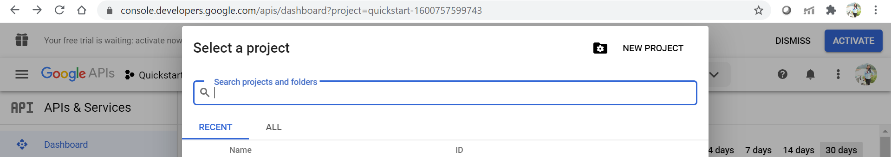

Give your project a name. Let’s name it “Quickstart”.

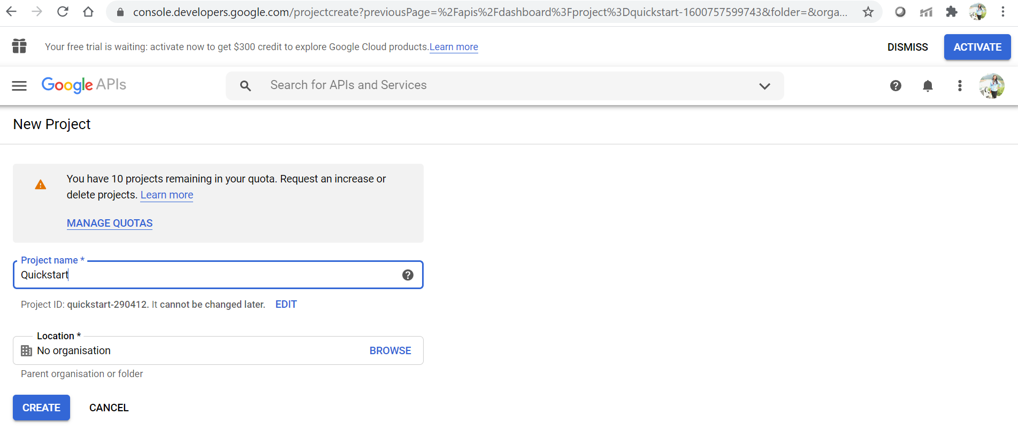

**Generate credentials**

**Credentials > credentials**page allows to generate a key for OAuth or API key.

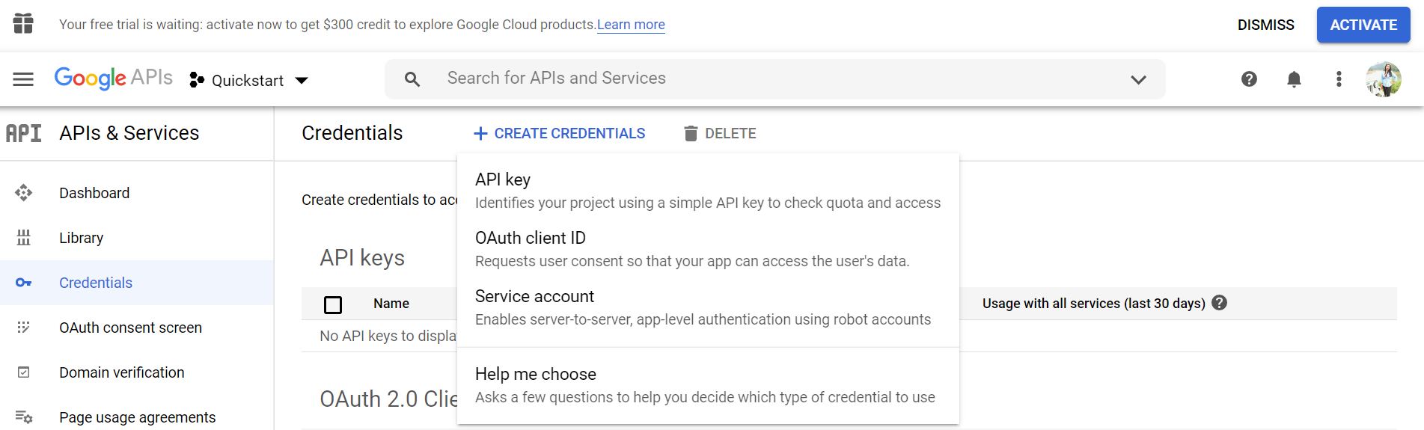

We will create for OAuth for web application then we have to insert one of the Authorized redirect URIs. <http://localhost>

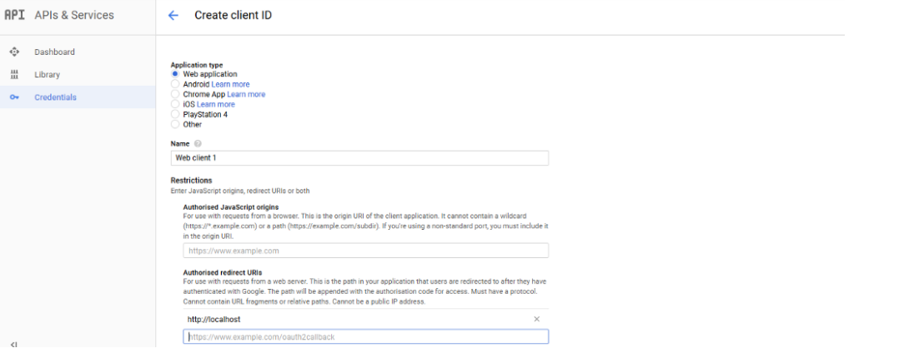

Save your OAuth client. Thanks to that you receive clientID and clientSecret.

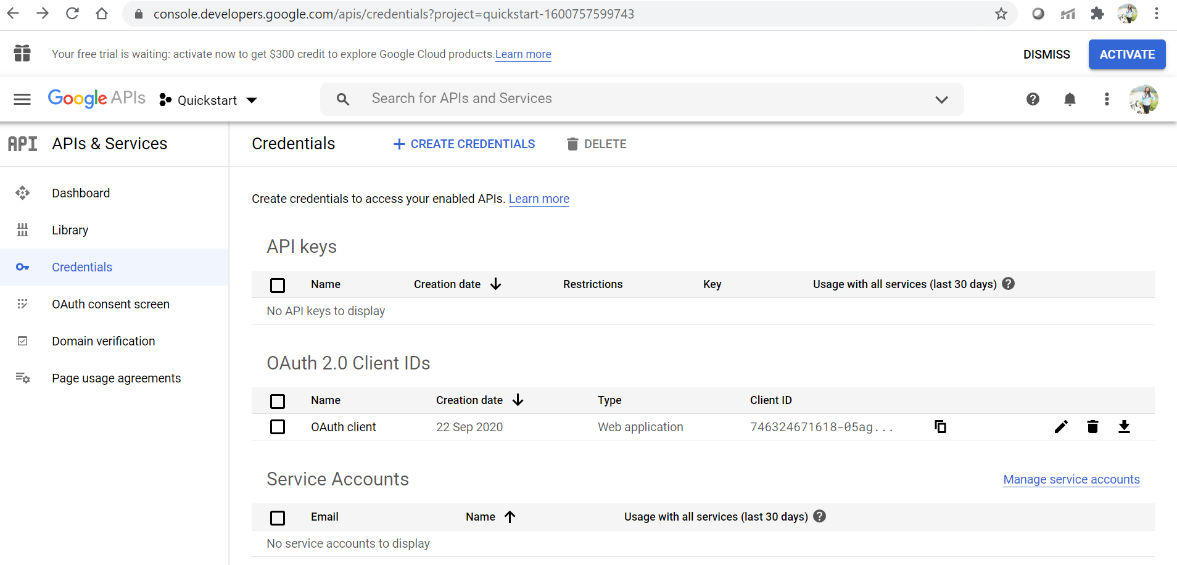

Now enable the Google Sheets API from the library.

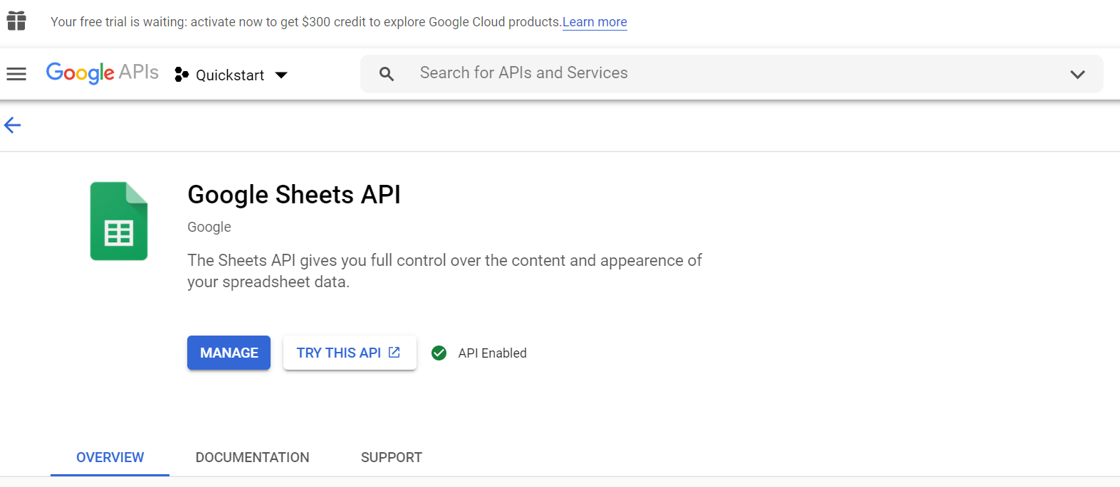

Then we have to download the JSON file on clicking of the arrow button.

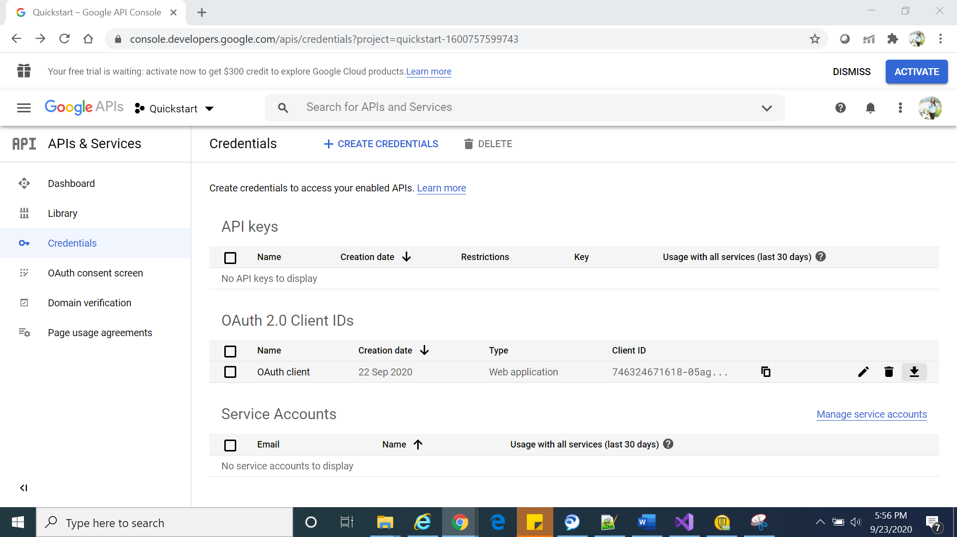

We can see the APIs used under the project.

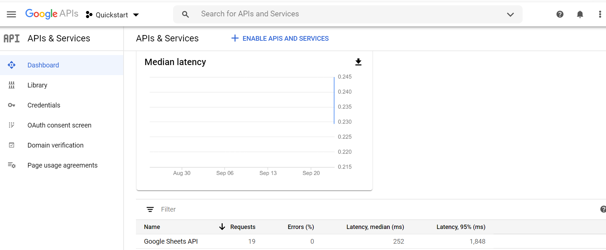

## **Step 2: Prepare the project**

1. Create a new Visual C# MVC Application project in Visual Studio.
2. Open the NuGet Package Manager Console, select the package source **nuget.org**, and run the following command:

Install-Package Google.Apis.Sheets.v4

Now run the application –

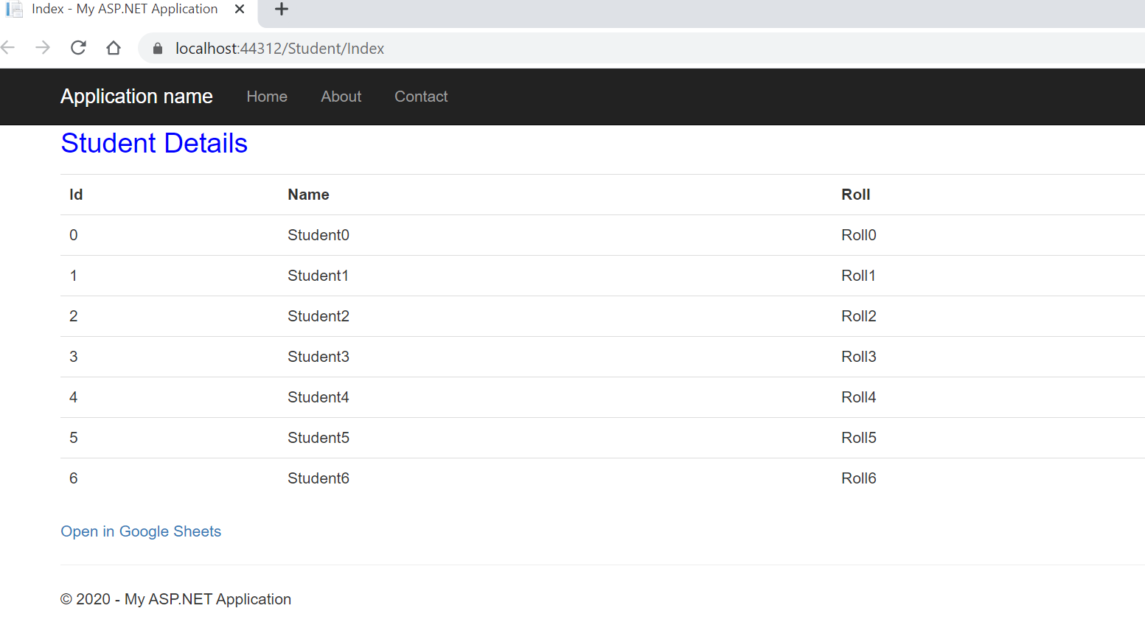

Click on the “Open in Google Sheets”

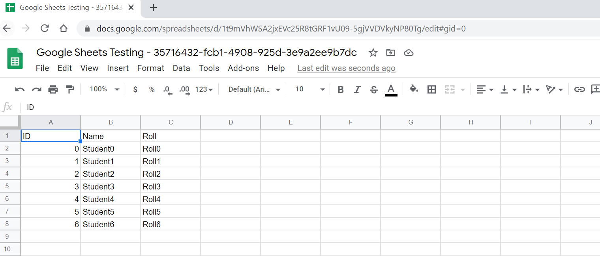

**Solutions to the common error –**

1. JSON not found in case of running application through IIS express-

Place it to the folder in case of error (C:\Program Files (x86)\IIS Express).

1. Not authorize from google –

Edit the OAuth Id and add the URI in the authorize URI and again download the json and run it.

**References –**

<https://developers.google.com/sheets/api/quickstart/dotnet>

<https://developers.google.com/sheets/api/reference/rest>