**Problem Statement**

You will have a triangle (which is a binary tree) input below and you need to find the maximum sum of the numbers per the given rules below:

1. You will start from the top and move downwards to an adjacent number as in below.

2. You are only allowed to walk downwards and diagonally.

3. You should walk over the numbers as evens and odds subsequently. Suppose that you are on an even number the next number you walk must be odd, or if you are stepping over an odd number the next number must be even. In other words, the final path would be like

Odd -> even -> odd -> even …

4. You must reach to the bottom of the pyramid.

Your goal is to find the maximum sum if you walk the path.

**Test case 1:** Tree provided in the document

Pyramid :

215

192 124

117 269 442

218 836 347 235

320 805 522 417 345

229 601 728 835 133 124

248 202 277 433 207 263 257

359 464 504 528 516 716 871 182

461 441 426 656 863 560 380 171 923

381 348 573 533 448 632 387 176 975 449

223 711 445 645 245 543 931 532 937 541 444

330 131 333 928 376 733 017 778 839 168 197 197

131 171 522 137 217 224 291 413 528 520 227 229 928

223 626 034 683 839 052 627 310 713 999 629 817 410 121

924 622 911 233 325 139 721 218 253 223 107 233 230 124 233

There could be multiple paths :

**Path 1 :** 215 -> 192 -> 269 -> 836 -> 805 -> 728 -> 433 -> 528 -> 863 -> 632 -> 931 -> 778 -> 413 -> 310 ->253

Sum :8186

**Path 2:** 215 -> 124 -> 269 -> 836 -> 805 -> 728 -> 433 -> 528 -> 863 -> 632 -> 931 -> 778 -> 413 -> 310 ->253

Sum :8018

Max Sum will be 8186

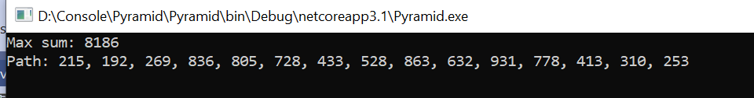

**Test cases: 2 –** Starting with odd number

Pyramid :

1

4 6

6 7 8

9 8 1 4

7 1 3 4 9

There could be multiple paths :

**Path 1:** 1 -> 4 -> 7 -> 8 -> 3

Sum : 23

**Path 2:** 1 -> 6 -> 7 -> 8 -> 3

Sum : 25

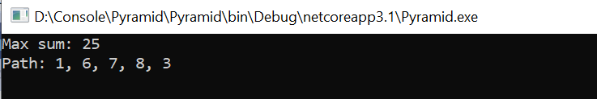

**Test Case 3:** Starting with even number

Pyramid:

2

7 9

6 7 8

3 8 1 4

2 1 3 4 9

There could be multiple paths :

**Path 1:** 2 -> 7 -> 6 -> 3 -> 2

Sum : 20

**Path 2:** 2 -> 9 -> 8 -> 1 -> 4

Sum : 24

