**Web Api Project with Swagger Support**

Application has no User Interface as it works as API exposing the endpoints.

It has two endpoints -   
1. GET: ItemsByName  
2. POST: Item

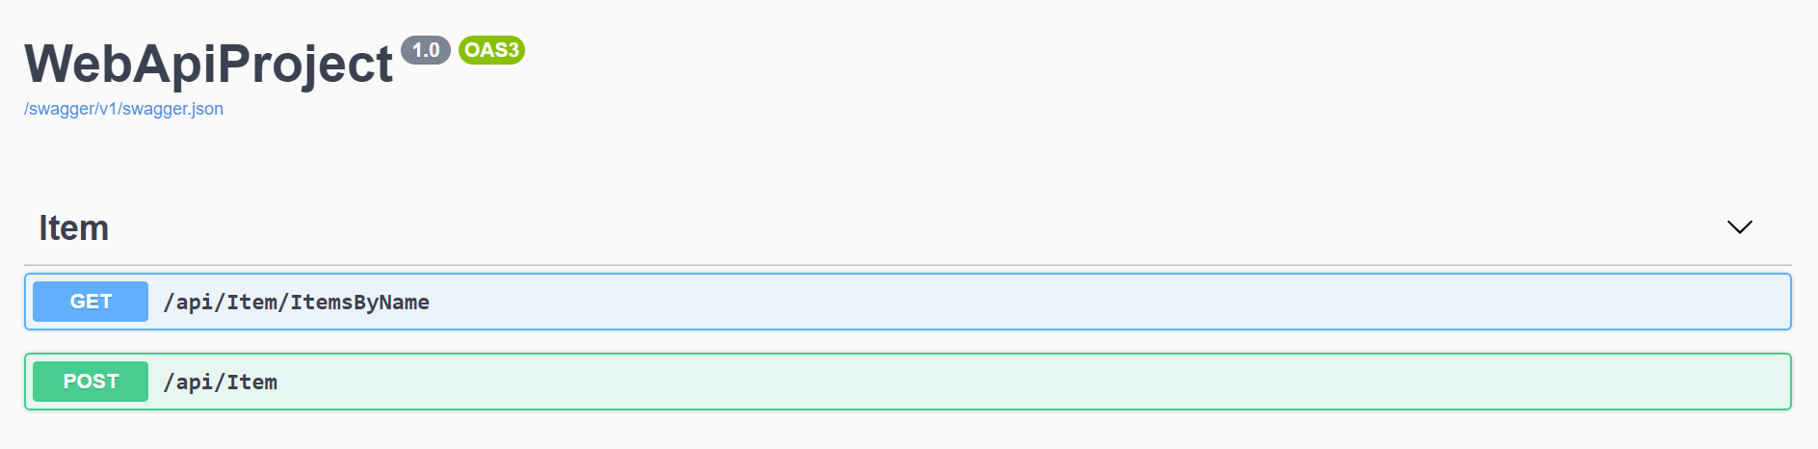

**To run the application:-**

**Step 1 :Create the Database and insert values in the tables created.**

**Run the below scripts**

CREATE DATABASE ItemsStore

GO

USE ItemsStore

GO

CREATE TABLE Category

(

Id BIGINT IDENTITY(1,1) NOT NULL,

NAME NVARCHAR(50) NOT NULL,

PRIMARY KEY (Id)

)

GO

CREATE TABLE SubCategory

(

Id BIGINT IDENTITY(1,1) NOT NULL,

CategoryId BIGINT NOT NULL,

Name NVARCHAR(100) NULL,

PRIMARY KEY (Id),

FOREIGN KEY (CategoryId) REFERENCES Category(Id)

)

GO

CREATE TABLE Item

(

Id BIGINT IDENTITY(1,1) NOT NULL,

SubCategoryId BIGINT NOT NULL,

NAME NVARCHAR(50) NULL,

DESCRIPTION NVARCHAR(50) NULL,

PRIMARY KEY (Id),

FOREIGN KEY (SubCategoryId) REFERENCES SubCategory(Id)

)

GO

**Insert script –**

Use ItemsStore

Go

INSERT INTO Item

VALUES

(1,'Sports Car','For Sports Purpose'),

(2,'Regular Bike','For Daily Use'),

(3,'Office Chair','Normal Chair'),

(4,'Standing Desk','For Standing Work'),

(1,'Electric Car','Electric car'),

(1,'Petrol Car','Petrol car'),

(1,'Diesel Car','Diesel car'),

(2,'Bike','For Daily Use'),

(3,'Sitting Chair','Normal Chair'),

(4,'table','For general use'),

(4,'Rotating Desk','For Work')

INSERT INTO SubCategory

VALUES

(1,'Car'),

(1,'Bike'),

(2,'Chair'),

(2,'Desk')

INSERT INTO Category

VALUES

('Vehicle'),

('Office Items')

**Check in the View>Sql Server Object Explorer**

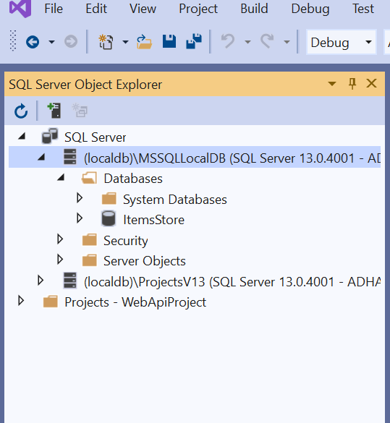

**Build the solution and run the web api , swagger page will be opened.**

**Then test Get Post Endpoints.**

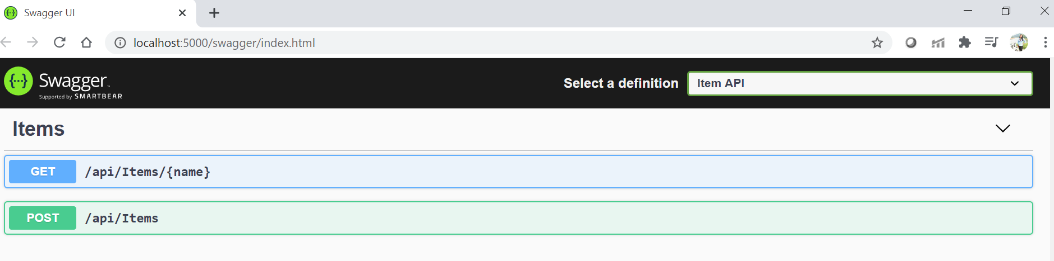

1. **Get – ItemsByName**

**Without Input – Name is empty**

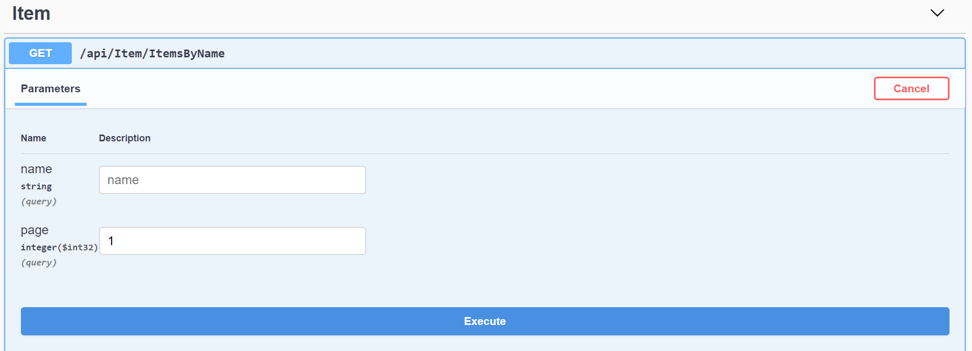

**By default load is page number number 1.**

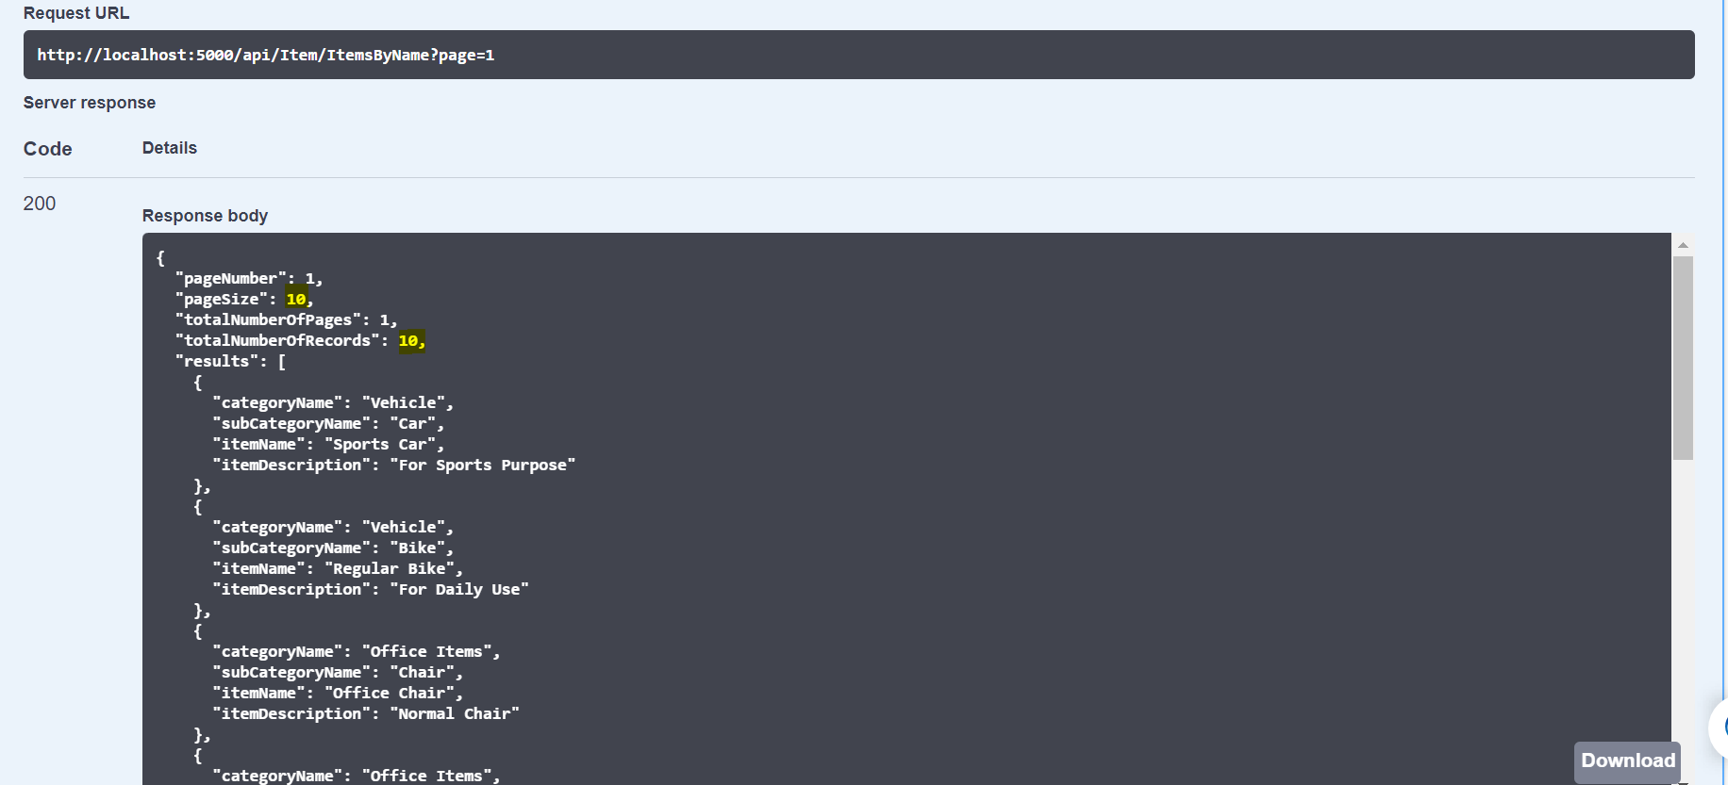

**With Input –**

**Name : Sitting Chair**

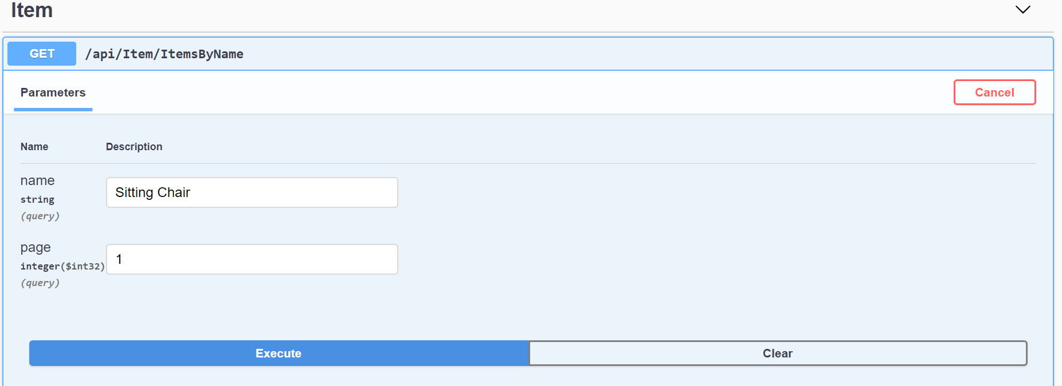

**Result –**

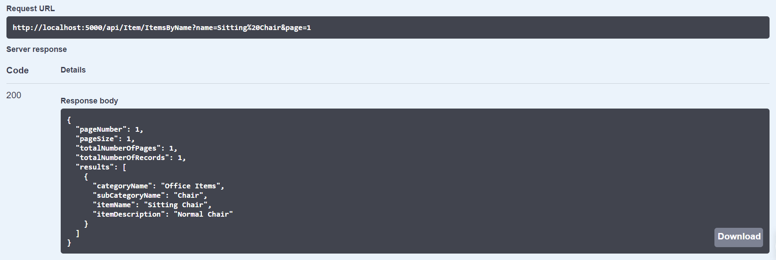

1. **Post**

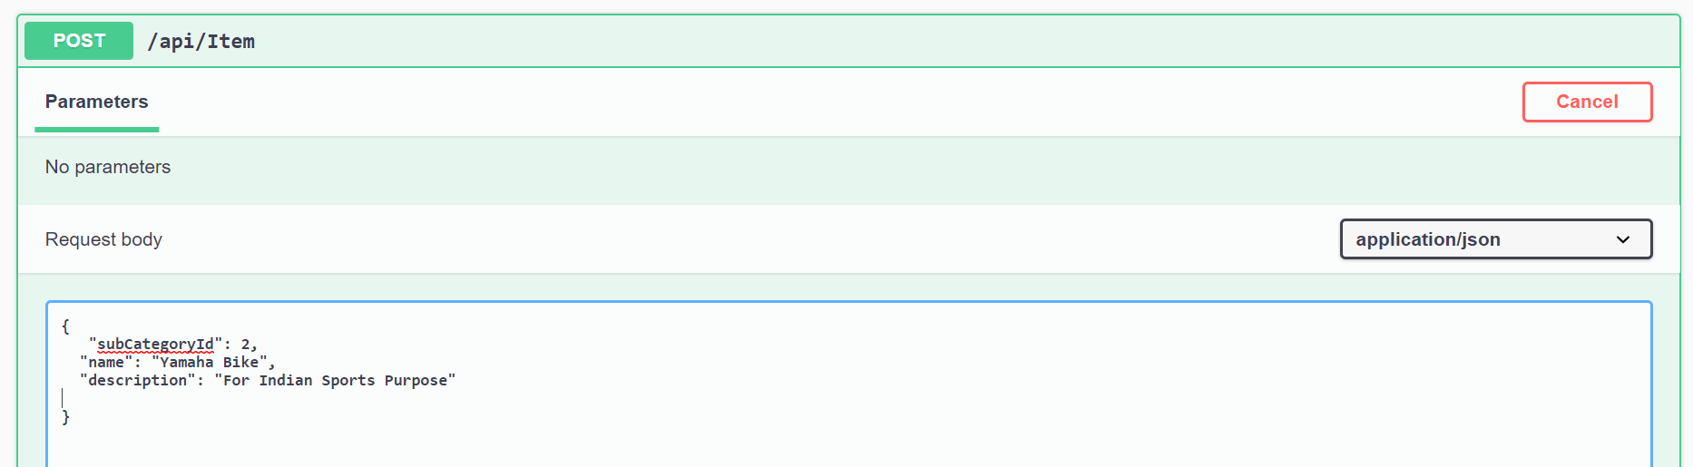

**After Execution –**

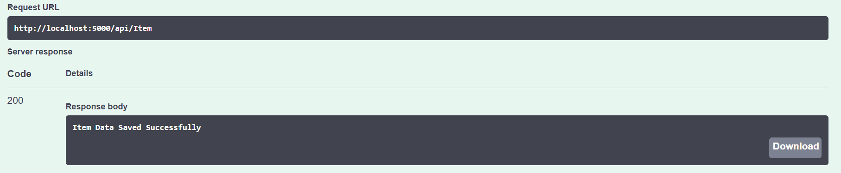

**Note:**

**In case there is any issue related to packages then install the below packages from**

**Tools –> NuGet Package Manager –> Package Manager Console**

Install-Package Microsoft.EntityFrameworkCore.Tools

Install-Package Microsoft.EntityFrameworkCore.SqlServer

*Install-Package Swashbuckle.AspNetCore*

Install-Package Swashbuckle.AspNetCore.Newtonsoft

**Post Edit Json-**

{

"subCategoryId": 2,

"name": "Yamaha Bike",

"description": "For Indian Sports Purpose"

}