Multi-user chat app
Junyi Shen

The assignment is to develop a multi-user chat app. In this report, I will briefly introduce the chat app I developed, show instructions on how to run the code, and describe some issues I have fixed and improvements I have made.

Introduction
The chat app is developed based on the provided code and is implemented with TCP. It allows multiple chatters to join and leave the chat room, change their names, and send messages to other chatters.
When a new chatter connects to the server and enters the chat room, he will be given a default name (User1, User2, ...). All chatters’ default names will be different, as a counter is set which increases its number as each user joins. When a new chatter joins, all the other chatters in the room will be notified. Chatters are allowed to change their names by sending a message starting with “-name=” followed by their new name. When any user changes his name, all chatters will be notified. When a chatter leaves the chat room, a message will be sent to other chatters to inform them who left the room and how many chatters are left.

Code running instructions
The source code contains 4 files:
- chatserver.c: A chat server for multiple clients to connect and chat with other clients. It processes chat messages and allows clients to join and leave rooms.
- chatclient.c: A chat client for connecting to the server, and sending and receiving messages.
- Makefile: The makefile used for compiling chatserver.c and chatclient.c.
- unp.h: A header file that chatserver.c and chatclient.c need. I did not modify it.

The code can be run on Linux and Mac. To compile the code, create a subfolder in the unpv13e repository folder, and then place the .c files, Makefile, and unp.h into the subfolder.
The unpv13e repository can be found at: https://github.com/unpbook/unpv13e.
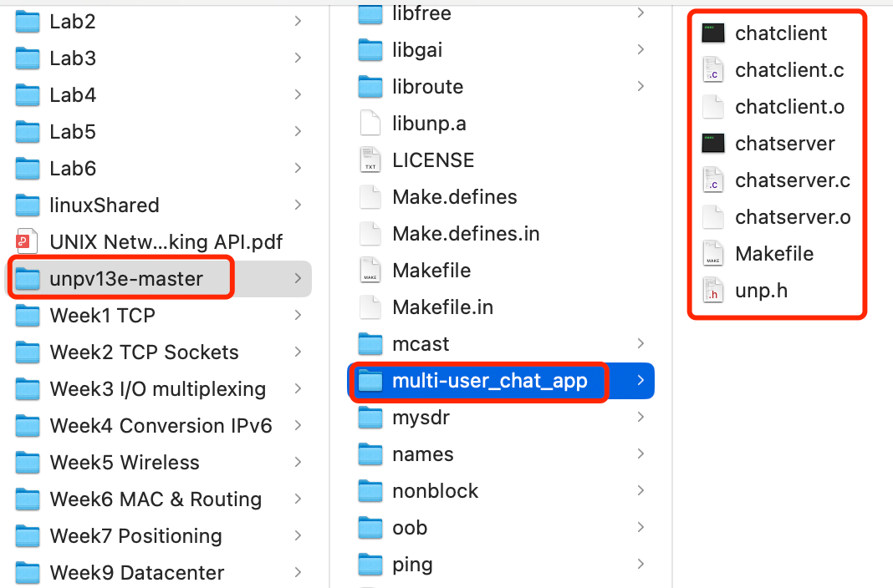

Open a terminal window, navigate to the subfolder containing the four files, and then execute make command. Executable files will be generated.
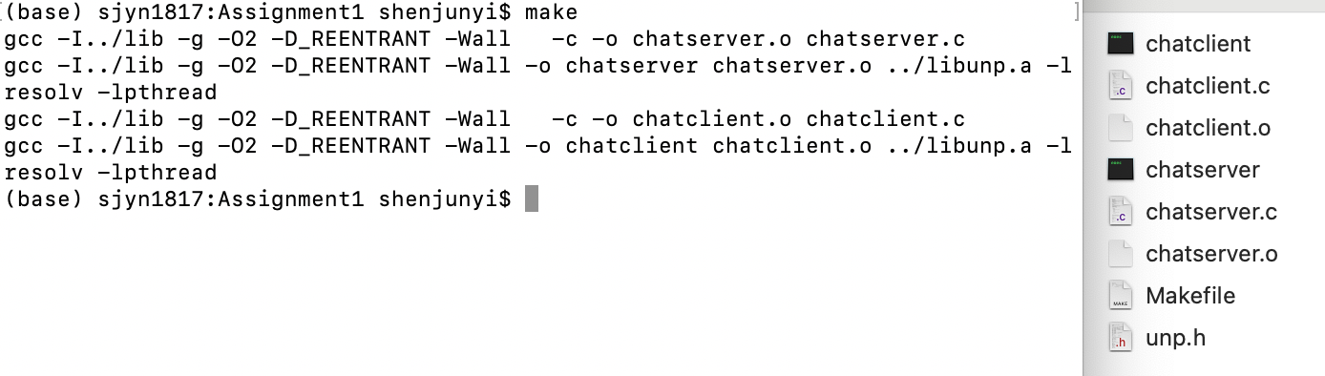
In the terminal window, execute ./chatserver 127.0.0.1 65530, a chat server will be started and listen to IP 127.0.0.1 and port 65530. Open two or more other terminal windows, and each executes ./chatclient 127.0.0.1 65530 to start the client and connect to the server. If it is the first chatter in the room, the client will prompt “You are the first chatter!”, otherwise all the names of the current chatters will be prompted.
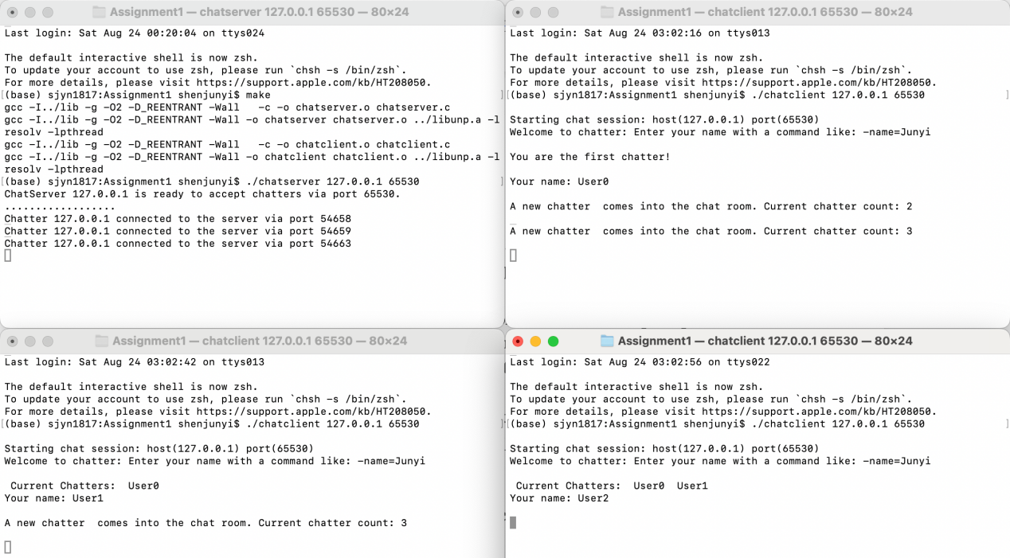
The default name of the chatter will also be printed in the window. If a chatter wants to modify his name, type -name=new_name, and a message “Your name is changed to: new_name” will be printed. All other chatters in the room will be notified by a message like “User1's name is changed to: new_name”. If the name is longer than 40 letters, only the first 40 letters will be used.
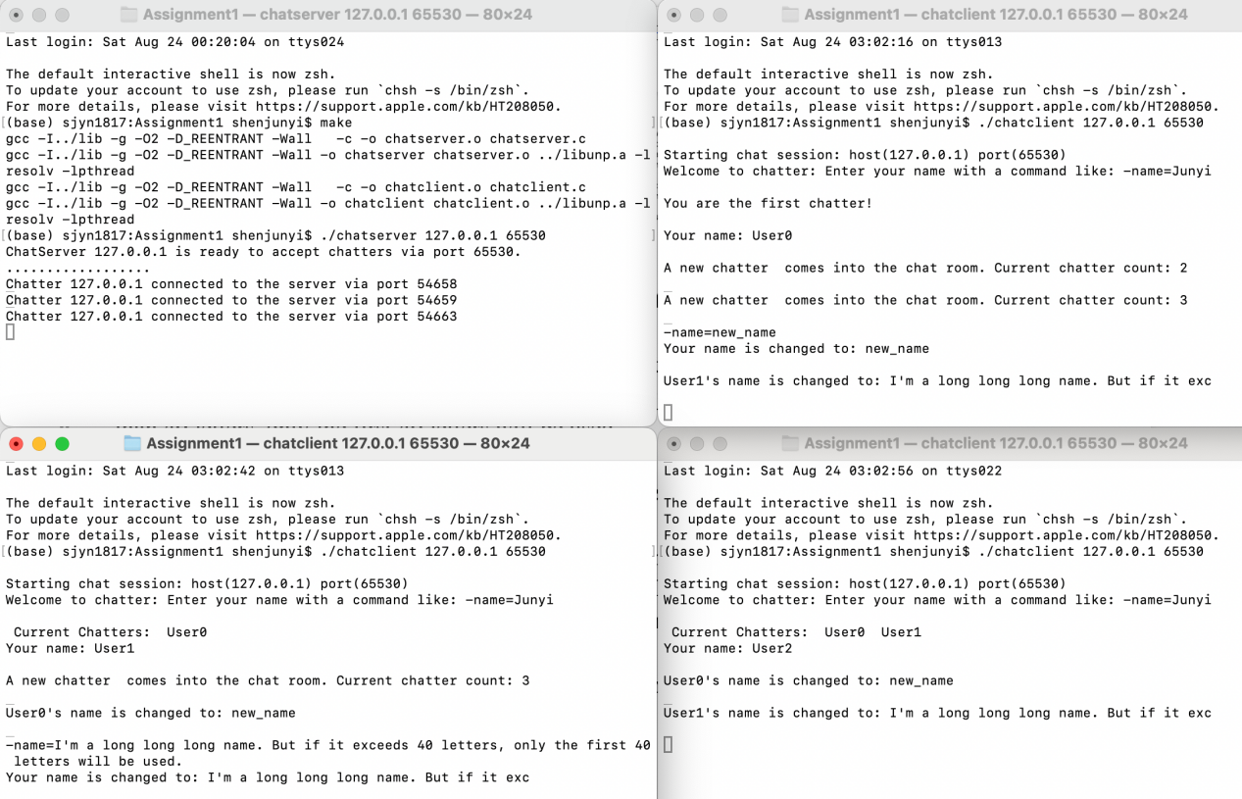
To chat with other chatters, type any messages in the terminal window and press enter. The message will be sent to all other chatters with a format like “name: message”.
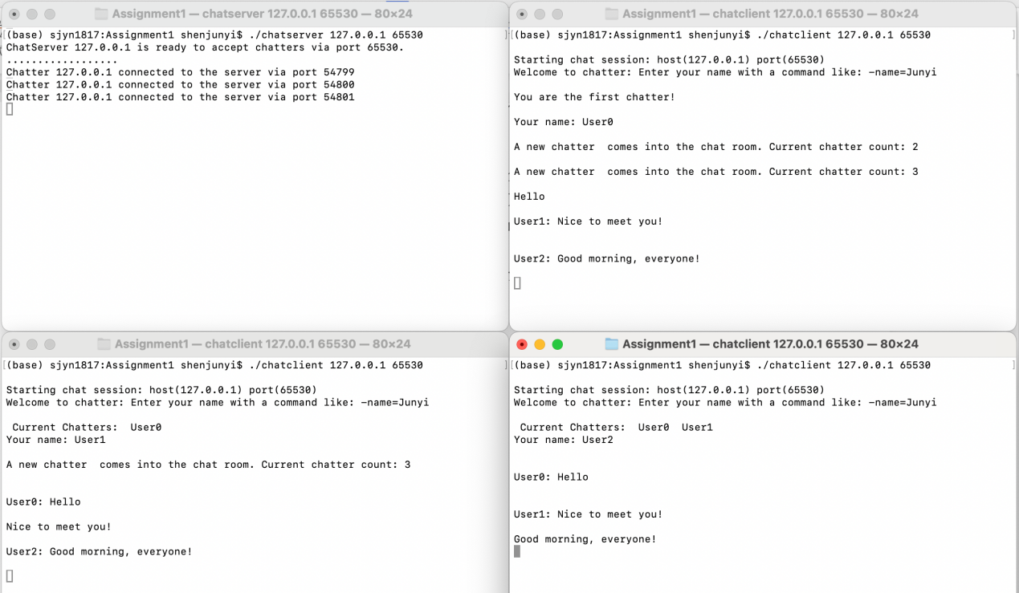
To leave the chat room, in the client terminal window, enter Ctrl+C to exit the client programme. A leave message will be sent to all other chatters in the format of “The chatter xxx leaves the chat room. Current chatter count: 1”. The same message will also appear in the server’s terminal window.
To close the server, enter Ctrl+C in the server terminal window. After doing this, all the clients will not be able to connect to the server.
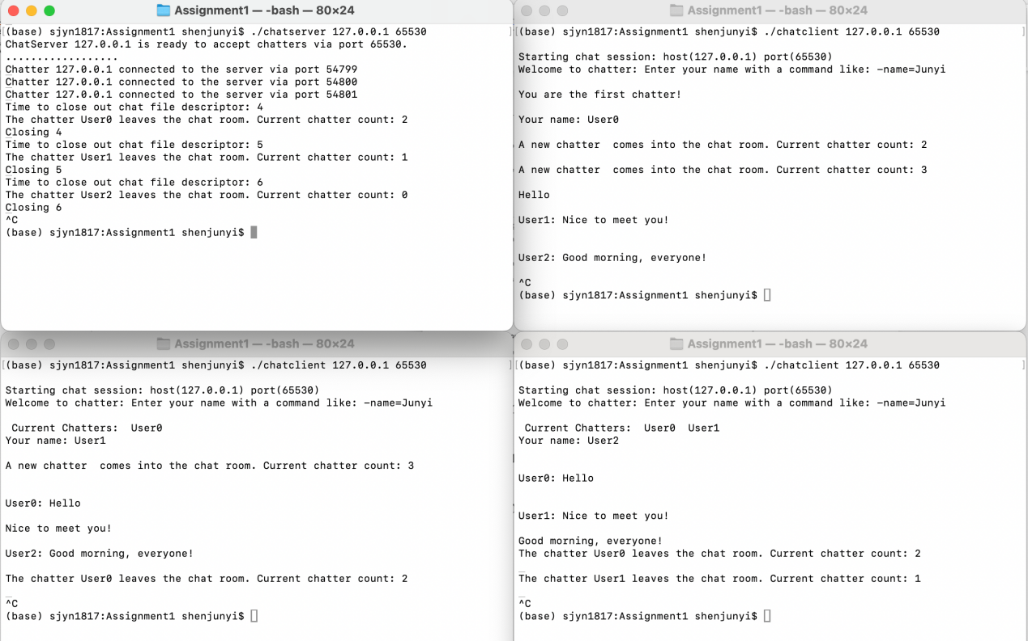

Bug fixes
I fixed some bugs in the provided code, including:
- In chatserver.c remove_chatter(), the original code will not modify fd_chats when the last chatter leaves the room, causing select() error in the server. I fixed this issue by modifying the code as follows:
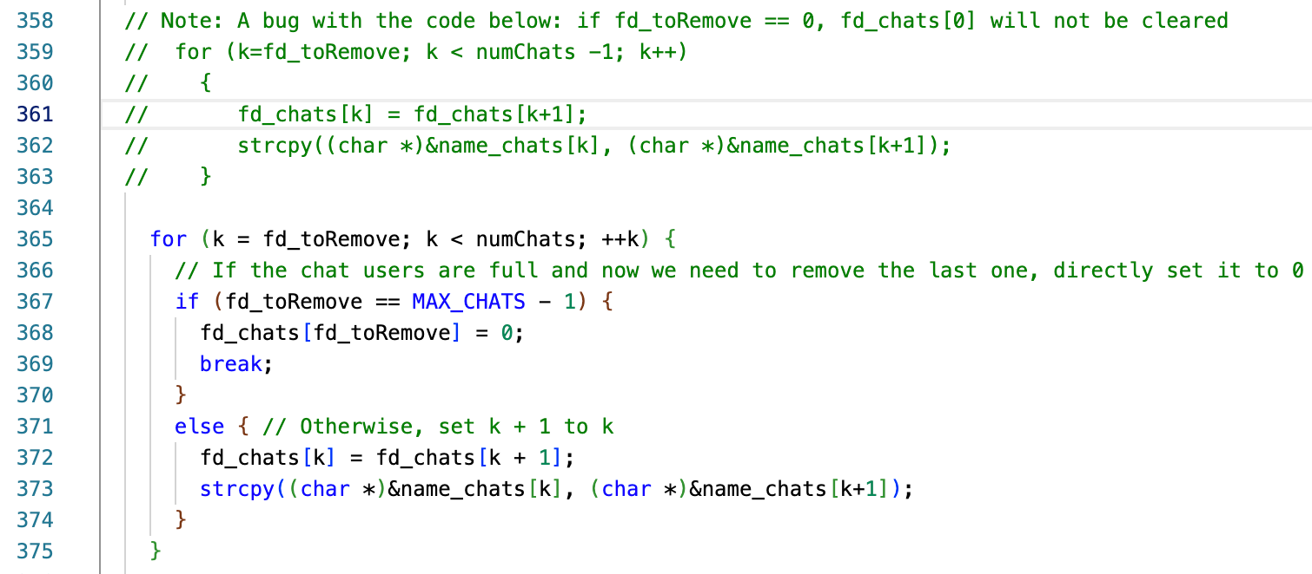
- If a chatter sets a long name with more than 40 letters, the data will be written to the next segment of name_chats, overwriting the next chatter’s name. To solve this issue, I only use the first 40 letters if the new name is longer than this length.
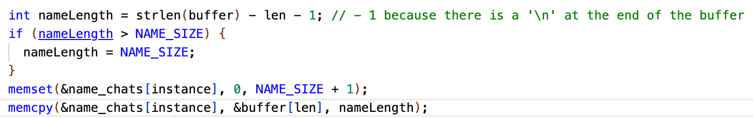
- In the provided code, the number in the default name is determined by the number of current chatters, which may cause offering the same default name to different clients. To fix this issue, a global variable userNameId is initialized to 0 and will increase by 1 every time a new client enters the room. By this method, default names will never be the same.

Improvements
Based on the provided code, I improved the chat app by adding some new features, including:
- Tell a new chatter his default name while entering the chat room.
- When a new chatter enters or leaves the chat room, notify all the other chatters and display the number of remaining chatters.
- When a chatter modifies his name, notify all the chatters.
- Format the chat messages by the format of “name: message”, making messages clearer and avoiding the unnecessary ‘\n’.

