filter() kya hota hai?
👉 filter() array ka method hai
👉 ye condition ke base par items ko select karta hai
"Jo condition true hogi → wo item new array me ayega"

const numbers = [1, 2, 3, 4, 5];

const result = numbers.filter(num => num > 3);

console.log(result); // [4, 5]

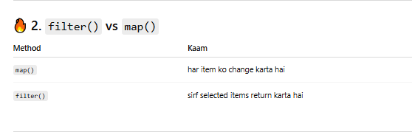

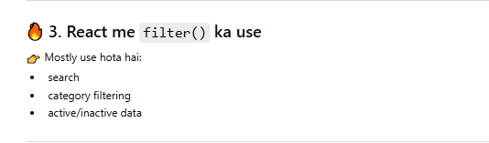

function App() {
const products = [
{ id: 1, name: "Laptop", price: 1000 },
{ id: 2, name: "Phone", price: 500 },
{ id: 3, name: "Mouse", price: 50 }
];

const expensive = products.filter(p => p.price > 100);

return (
<div>
{expensive.map(item => (
<h3 key={item.id}>{item.name}</h3>
))}
</div>
);
}

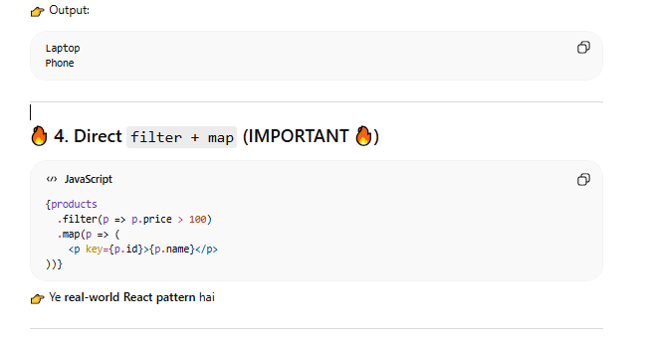
const users = ["Ali", "Ahmed", "Sara"];

const filteredUsers = users.filter(user =>
user.toLowerCase().includes(search.toLowerCase())
);

return (
<div>
<input
type="text"
onChange={e => setSearch(e.target.value)}
placeholder="Search..."
/>

{filteredUsers.map(user => (
<p key={user}>{user}</p>
))}
</div>
);
}
