***SRS (****Software Requirements Specification****)***

* ***Introduction***

Music is one of the best ways to relieve pressure in stressful modern society life. The purpose of this project is to develop a player which can play the audio of mp3 format.

* ***System Features***
* *Favourites and Playlist*
* *Set Activity theme*
* *Runtime Permission*
* *Play and Pause button*
* *Next and Previous button Functionality*
* *Back button and Exit Functionality*
* ***REQUIREMENT ANALYSIS OF SYSTEM***
* ***The feasibility analysis:*** *This section verified that it is feasible to add music player on the Android system from the aspects of economic, technical and social feasibility.*
* ***Economic feasibility*:** *To design Android mobile phone music player as long as a computer has the Android development and the application development of Android is free. In addition, mobile phone music player is basic needs for public. The information that which functions are necessary form all the consumers , which functions are needed for some people, and which features are seldom to use is easy to understand. And a lot of research is eliminated, thus saved the spending. Therefore, the whole process of development doesn’t need to spend any money that is economic feasibility.*
* ***Technical feasibility*:** *To design a music player which meets the basic requirements, a deep understand of Kotlin language, the Android system architecture, application of framework and other technical knowledge are needed.(framework is the core of the application, and rules that all the Programmers participating in the development must abide by).*
* ***Social Feasibility*:** *With the rapid development of the mobile phone market, all kinds of audio and video resources are widely circulated on the Internet. These resources seem ordinary, but have gradually become an indispensable part of people life, which derived the development of all kinds of mobile phone player. But a lot of players devoted to fancy appearance, strong function causing a lot of wasted resources to the user's mobile phone and bringing a lot of inconvenience to the user as multitasking operation is needed. Some functions are useless to ordinary people. Powerful player is a good thing, but a lot of functions are actually useless for most users. Aimed at these problems, developing multiplied audio player which owns the features of simplified functions, common play function, meeting the needs of most users, less required memory and high quality of playing music, maximizes the optimization in performance.*
* ***Saturation Overview:*** *This section describes requirements of the system based on basic control functions of players, and system setup function of the player according to research results of the project demand*.
* ***Use Case Diagram***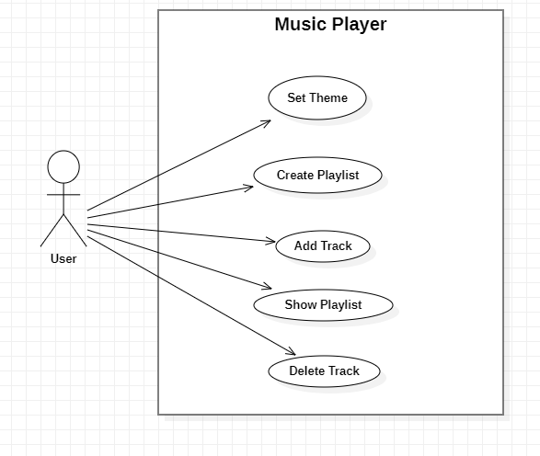
* ***Functional Requirement:***
* *‘Now Playing’ music console (pause, play, next etc.)*
* *Volume Adjuster.*
* *Playlist Support and Playlist creation.*
* *Add or Delete track.*
* *File and folder manager for browsing of music library.*
* *Equalizer feature.*
* ***Non Functional Requirement:***
* *Customize Notification*
* *Themes or skin.*
* *User Customizable UI.*
* *Gapless Playback.*
* ***HARDWARE AND SOFTWARE REQUIREMENTS***

*The software is designed to be lightweight, so it won't slow your running machine much. This system has been created with compatibility of commonly available hardware and software in mind.*

***Hardware:***

* *RAM 8 GB atleast.*

***Software****:*

* *Windows 7(32-bit) or above.*
* *Android Studio*