Sarif Summary: SpotBugs

Document generated on: 2023-11-09 22:01:50.289367

Total number of various severities (error, warning, note): 18

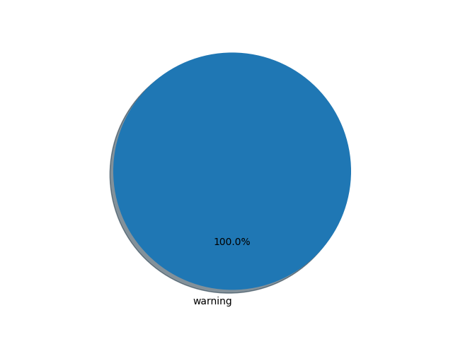

# Severity : error [ 0 ]

* None

# Severity : warning [ 18 ]

* CIPHER_INTEGRITY Cipher with no integrity: 3
* PATH_TRAVERSAL_IN Potential Path Traversal (file read): 3
* HARD_CODE_KEY Hard coded key: 2
* PREDICTABLE_RANDOM Predictable pseudorandom number generator: 2
* SQL_INJECTION_JDBC Potential JDBC Injection: 2
* COMMAND_INJECTION Potential Command Injection: 2
* ECB_MODE ECB mode is insecure: 1
* SQL_NONCONSTANT_STRING_PASSED_TO_EXECUTE Nonconstant string passed to execute or addBatch method on an SQL statement: 1
* SQL_PREPARED_STATEMENT_GENERATED_FROM_NONCONSTANT_STRING A prepared statement is generated from a nonconstant String: 1
* XXE_DOCUMENT XML parsing vulnerable to XXE (DocumentBuilder): 1

# Severity : note [ 0 ]

* None

## Severity : error

* None

## Severity : warning

|  |  |  |
| --- | --- | --- |
| Code | Location | Line |
| CIPHER_INTEGRITY Cipher with no integrity | PerformCheck.java | 24 |
| CIPHER_INTEGRITY Cipher with no integrity | PerformTransfer.java | 39 |
| CIPHER_INTEGRITY Cipher with no integrity | PerformTransfer.java | 47 |
| COMMAND_INJECTION Potential Command Injection | oper/SendMessage.java | 83 |
| COMMAND_INJECTION Potential Command Injection | oper/SendNewsletter.java | 61 |
| ECB_MODE ECB mode is insecure | PerformTransfer.java | 39 |
| HARD_CODE_KEY Hard coded key | PerformCheck.java | 23 |
| HARD_CODE_KEY Hard coded key | PerformTransfer.java | 38 |
| PATH_TRAVERSAL_IN Potential Path Traversal (file read) | oper/UploadProfilePicture.java | 55 |
| PATH_TRAVERSAL_IN Potential Path Traversal (file read) | webservices/BannerAdClient.java | 36 |
| PATH_TRAVERSAL_IN Potential Path Traversal (file read) | webservices/BannerAdServer.java | 15 |
| PREDICTABLE_RANDOM Predictable pseudorandom number generator | PerformRegistration.java | 104 |
| PREDICTABLE_RANDOM Predictable pseudorandom number generator | PerformRegistration.java | 119 |
| SQL_INJECTION_JDBC Potential JDBC Injection | model/LocationService.java | 133 |
| SQL_INJECTION_JDBC Potential JDBC Injection | model/LocationService.java | 104 |
| SQL_NONCONSTANT_STRING_PASSED_TO_EXECUTE Nonconstant string passed to execute or addBatch method on an SQL statement | model/LocationService.java | 133 |
| SQL_PREPARED_STATEMENT_GENERATED_FROM_NONCONSTANT_STRING A prepared statement is generated from a nonconstant String | model/LocationService.java | 104 |
| XXE_DOCUMENT XML parsing vulnerable to XXE (DocumentBuilder) | restful/XMLUtil.java | 33 |

## Severity : note

* None