# How to protect data with format-preserving encryption using AWS Lambda

Sanghyoun Kim, Senior Cloud Architect, AWS Professional Services

KnowledgeMine Link: <https://collaborate-corp.amazon.com/nuxeo/ui/#!/browse/default-domain/workspaces/ProServe%20Goldemine%20Workspace/How%20to%20Protect%20Data%20with%20Format-Preserving%20Encryption%20Pseudonymization>

Pseudonymization is a technique that replaces sensitive data with cryptographically generated tokens, and format-preserving encryption, also known and called as FPE hereafter, is extremely important and useful for customers who wish to keep the ciphertext after encryption as the same length as the plaintext.

In this article, we’ll show how to write Lambda functions written in Golang to protect sensitive data with format-preserving encryption as a method of pseudonymization. All the resources required here will be packaged and deployed using CDK, and you can download the code used in this walkthrough from [the project’s GitHub repo](https://github.com/shkim4u/protecting-data-with-fpe-pseudonymization" \t "_blank).

## Overview

Organizational policies, industry or government regulations, might require the use of encryption at rest to protect sensitive data. Amazon Web Services (AWS) provides a variety of flexible options that customers can choose from to meet this requirement.

If you require a various layer of security for the data you store in the cloud, there are several options for encrypting data at rest - ranging from completely automated AWS encryption solutions to manual, client-side options.

[AWS KMS Envelope Encryption](https://docs.aws.amazon.com/kms/latest/developerguide/concepts.html#enveloping) with [AWS Encryption SDK](https://docs.aws.amazon.com/encryption-sdk/latest/developer-guide/java-example-code.html) may be adopted to protect sensitive data such as PII (Personally Identifiable Information), social security number, or credit card number.

Envelope encryption offers several benefits in protecting data keys, encrypting the same data under multiples keys, and combining the strength of multiple algorithms, but due to the inevitable nature of block mode encryption, you have to consider various changes needed to the storage or business side such as the type or length of database column, log file format, big data analytics.

In the meantime, there may be some more business requirements in which customers have the ability to encrypt data using format-preserving encryption (FPE) that allows ciphertext to be inserted into the databases, files, or data lakes without breaking the schema.

In general, FPE is an encryption technology designed to produce ciphertext that resembles the plaintext from which it originates. For example, payment card numbers still look like payment card numbers, often with some of the plaintext digits remaining intact, which can be useful for continuing to use the ciphertext version for routing and card verification.

FPE also allows a highly granular approach to encryption, which facilitates field-level protection. It also preserves business func­tionality, meaning that normal data processing activities are maintained even though the data is encrypted. FPE fulfills both encryption and pseudonymization functions, which makes it a particularly useful technol­ogy in the context of providing some assistance with GDPR compliance.

The GDPR specifically calls out the use of pseudonymization and encryption mechanisms as an acceptable means for protecting data. Pseudonymization is often used as a general term that can apply to various techniques for data de-identification when the pseudonym or surrogate data can be used in business processes.

Another advantage of FPE is that the ciphertext is the same size as the plaintext from which it originates. This can be very useful in terms of ciphertext storage, as it often allows the ciphertext to be stored in a field, such as a field in a database record, that was originally designed to contain the plaintext.

In this blog, we will show how to implement an AWS Lambda function that can be invoked to protect the data using format-preserving encryption. The data encryption key will be generated by AWS KMS and stored in AWS Secrets Manager. Amazon API Gateway will pass the encryption and decryption requests from client to the backend Lambda that wraps the [Golang implementation](https://github.com/capitalone/fpe) of [NIST Recommendation SP 800-38G](http://nvlpubs.nist.gov/nistpubs/SpecialPublications/NIST.SP.800-38G.pdf) algorithm provided by CapitalOne.

All the resources needed will be managed and deployed through AWS Cloud Development Kit except the FPE data encryption key (DEK). FPE DEK will be derived from KMS and stored in Secrets Manager at the first call of the request, and remain in memory of Lambda function instance to reduce subsequent invocation overhead for DEK decryption. But this can be customized and adjusted to resort to KMS every time for request for higher level of security requirement.

In summary, this solution offers following benefits:

1. Compliance - In GDPR Article 4 ([http://www.privacy-regulation.eu/en/article-4-definitions-GDPR.htm](http://www.privacy-regulation.eu/en/article-4-definitions-GDPR.htm" \o ")), pseudonymization is described like this; "5) 'pseudonymisation' means the processing of personal data in such a manner that the personal data can no longer be attributed to a specific data subject without the use of additional information, provided that such additional information is kept separately and is subject to technical and organisational measures to ensure that the personal data are not attributed to an identified or identifiable natural person". **Format-preserving encryption** (**FPE**), refers to encrypting in such a way that the output (the ciphertext) is in the same format as the input (the plaintext; [Wikipedia](https://en.wikipedia.org/wiki/Format-preserving_encryption" \o ")). Customer may want to adopt format-preserving encryption as a candidate method of pseudonymization if they have measures in place conforming to the above GDPR article, for example, by storing pseudonymized data in the private database, keeping the encryption key used in separate and safe place, and enforcing appropriate access control to all of these.
2. Operational Advantage - In addition, one of the benefits of FPE is the potential to modify only the endpoints of the communication while leaving all intermediate systems and storage layouts unaltered. Coupled with the standard AES encryption scheme for data protection, this potential can reduce the compliance assessment scope by removing the related systems from them, with PCI-DSS as a good example. Another benefit of FPE is that customer could use it to generate test data from production data in which would give them very good and quality data to use in test. Hence, customer can save the time and reduce remediation costs to meet compliance requirements.

## Business and technical assumptions

Here is one example where this solution is helpful to solve business or technical cases.

1. The customer needs to protect their PII data by encryption, but they also want to keep the format of ciphertext due to the technical requirements to do so, for example:  
   - They cannot alter the schema of database columns that store the original PII data.  
   - SAP is being operated as a core system for various business area; SAP does have strict constraint that any standard module or database table cannot be modified.  
   - They also have interfaces calling to or being called from 3rd party solution venders, and those are not capable nor willing to change the protocol of payload over these interfaces.
2. The customer managed KMS key exists in AWS Account.
3. The customer is willing to keep sensitive credentials or keys in Amazon Secrets Manager.
4. The customer has developer resource to build Lambda function and API Gateway.

## Walkthrough

This solution uses [AWS Key Management Service](https://aws.amazon.com/kms/), [AWS Secrets Manager](https://aws.amazon.com/secrets-manager), [AWS Lambda](https://aws.amazon.com/lambda/), [Amazon API Gateway](https://aws.amazon.com/api-gateway/), [Amazon Cognito](https://aws.amazon.com/cognito) and [AWS Cloud Development Kit](https://aws.amazon.com/cdk/).

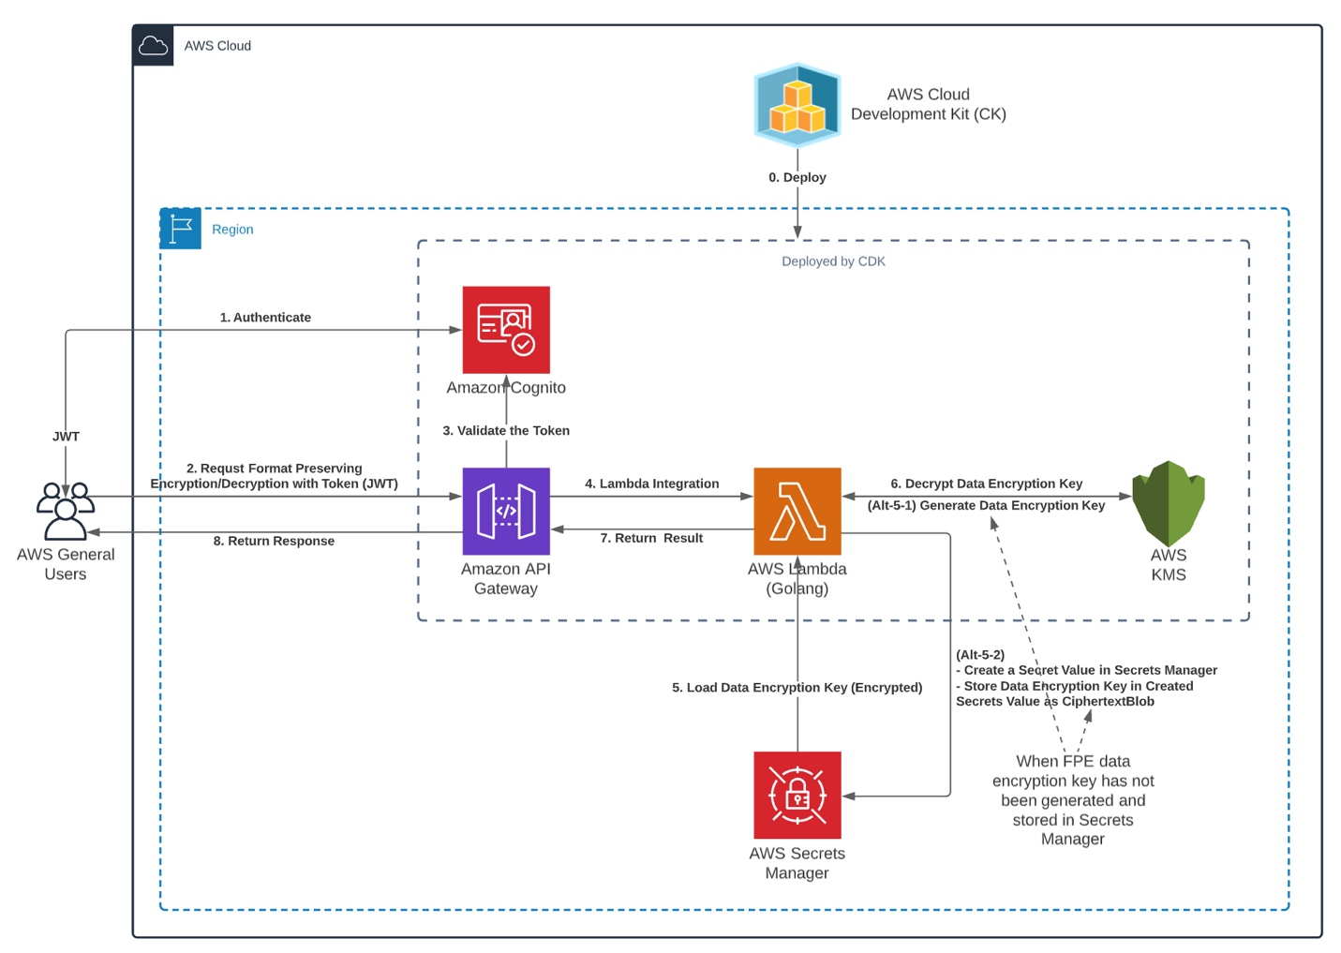

1. The resources are deployed by AWS Cloud Development Kit (CDK).
2. Client authenticates to Amazon Cognito.
3. The client makes request to protect their data with payload parameter for format-preserving encryption or decryption against Amazon API Gateway along with the JWT token retrieved from the Cognito in the previous step. The payload parameter contains the information about plaintext or ciphertext for encryption or decryption respectively in JSON format, along with "Radix". The request path determines which operation should take place, for example "https://<API Gateway Execution URL>/encrypt" will trigger encryption to be executed, and "https://<API Gateway Execution URL>/decrypt" for decryption likewise. "Radix" specifies the size of the alphabet. For example, specifying 2 gives an alphabet consisting of the numbers 0 and 1, specifying 62 gives alphabet with all numeric, upper-case alpha, lower-case alpha (1234567890abcdefghijklmnopqrstuvwxyzABCDEFGHIJKLMNOPQRSTUVWXYZ, 62 in total), while specifying 95 gives an alphabet with all numeric, upper-case alpha, lower-case alpha, and symbol characters. In this project, it is restricted to be between 2 and 62 due to the implementation of [embedded FPE library](https://github.com/capitalone/fpe).
4. Amazon API Gateway validates the token against the Cognito.
5. If the authentication token is valid, Amazon API Gateway passes over the requests to AWS Lambda function.
6. AWS Lambda function tries to load FPE data encryption key from AWS Secret Manager that is stored in encrypted form with AWS KMS CMK master key.
   1. (Alt-5-1) If the FPE date encryption key is not stored in the specified secret value of Secrets Manager, then the Lambda function calls "GenerateDataKey" API to AWS KMS.
   2. (Alt-5-2) Then, the CiphertextBlob part of the generated key is stored into a secret value after creating it (a secret value) in Secrets Manager.
7. The Lambda function decrypts the data encryption key by calling "Decrypt" function of AWS KMS, and loads its plaintext form into the global state memory.
   1. Note) Loading the plain bytes of data encryption key to global state memory is not conformant to some highly regulated environment. If that is the case, the source code can be customized to remove this part. However if you tune this project to load data encryption key at every call, the data encryption key should be decrypted by KMS first and you might exceed the AWS KMS [requests-per-second limit](https://docs.aws.amazon.com/kms/latest/developerguide/limits.html" \l "requests-per-second" \t "_blank) under many request situation, causing processing delays. You can use tools such as JMeter to test the required throughput based on the expected traffic for this method. If you need to exceed a quota, you can request a quota increase in Service Quotas. Use the [Service Quotas console](https://console.aws.amazon.com/servicequotas" \t "_blank) or the [RequestServiceQuotaIncrease](https://docs.aws.amazon.com/servicequotas/2019-06-24/apireference/API_RequestServiceQuotaIncrease.html" \t "_blank) operation. For details, see [Requesting a quota increase](https://docs.aws.amazon.com/servicequotas/latest/userguide/request-increase.html" \t "_blank)in the Service Quotas User Guide. If Service Quotas for AWS KMS are not available in the AWS Region, create a case in the [AWS Support Center](https://console.aws.amazon.com/support/home" \t "_blank).
8. AWS Lambda function returns the result back to API Gateway.
9. Finally, API Gateway delivers response to the client.

### Prerequisites

For this walkthrough, the solution is deployed using AWS CDK, and you should have the following prerequisites:

* An [AWS account](https://signin.aws.amazon.com/signin?redirect_uri=https%3A%2F%2Fportal.aws.amazon.com%2Fbilling%2Fsignup%2Fresume&client_id=signup)
* You must have the [AWS Command Line Interface (AWS CLI)](https://docs.aws.amazon.com/cli/latest/userguide/cli-configure-files.html" \t "_blank) configured with permission to create required resources for AWS KMS Key, AWS Lambda function, Amazon API Gateway, and Amazon Cognito.
* You must have [AWS CDK installed](https://docs.aws.amazon.com/cdk/latest/guide/getting_started.html" \t "_blank).
* You must also have [Golang](https://golang.org/) or [Docker](https://www.docker.com/" \t "_blank) installed to build and bundle the Lambda function locally or from inside a Docker container.

### Deploying the solution

**Step 1**: Clone the [GitHub repository](https://github.com/shkim4u/protecting-data-with-fpe-pseudonymization) and synthesize the application with the AWS CDK. Run the following commands in a terminal:

git clone https://github.com/shkim4u/protecting-data-with-fpe-pseudonymization

cd protecting-data-with-fpe-pseudonymization

cdk synth

**Note**: When running the synth command for the first time and if Golang is not installed on local computer, the CDK application will pull the Docker image for bundling image for Go Lambda function. This step might take few minutes to complete depending on your internet connection bandwidth.

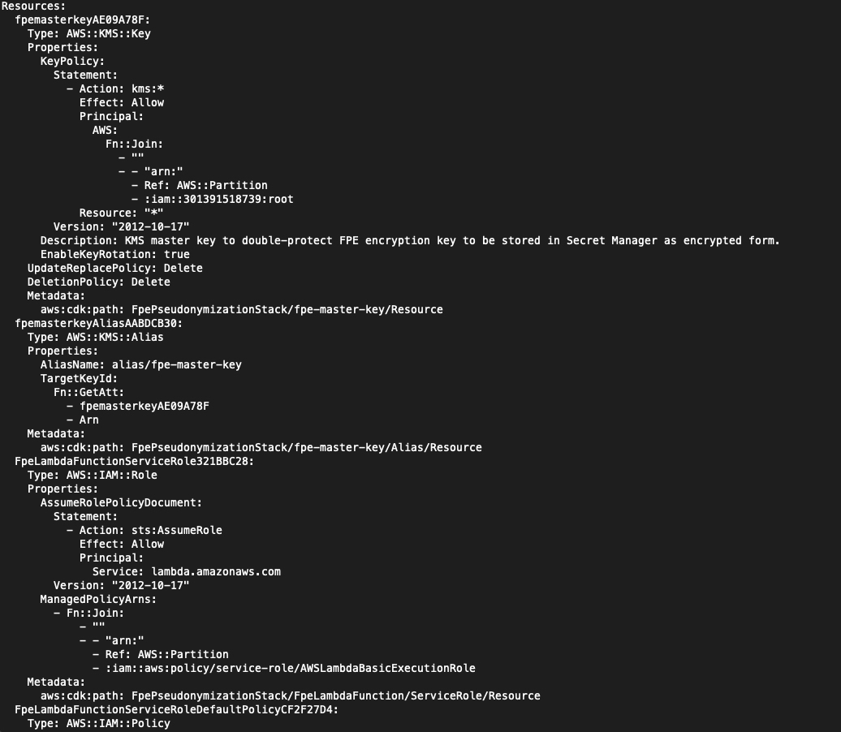

**Step 2**: Deploy the application:

cdk deploy --all --outputs-file ./cdk-outputs.json

Approve the [AWS Identity and Access Management (IAM)](http://aws.amazon.com/iam" \t "_blank)-related changes and continue to deploy the stack. Once deployment is completed, the stack outputs the API Gateway HTTP API endpoint, KMS Key ARN, User Pool Client ID, and User Pool IC.

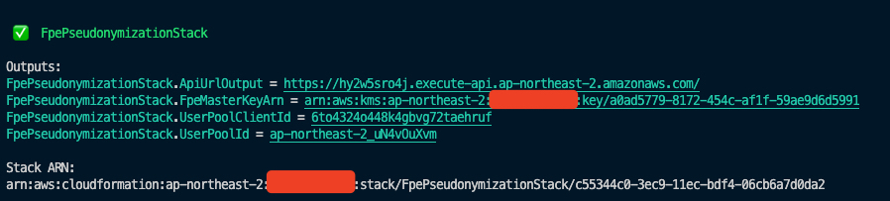

Step 3: Sign-up (register) a user in the Cognito using AWS CLI command looking like below.

aws cognito-idp sign-up \

--client-id <YOUR\_USER\_POOL\_CLIENT\_ID> \

--username "test@test.com" \

--password "password123"

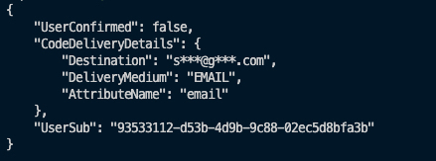

Note) Once registration is completed as displayed below, the confirmation email will be sent to your inbox.

Step 4: Confirm the user so that they can login.

aws cognito-idp admin-confirm-sign-up \

--user-pool-id YOUR\_USER\_POOL\_ID \

--username "test@test.com"

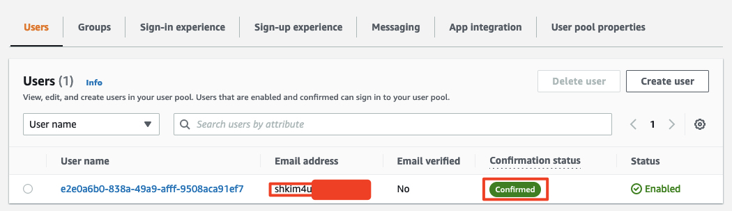

Step 5: Login to Cognito and get the ID token.

aws cognito-idp initiate-auth \

--auth-flow USER\_PASSWORD\_AUTH \

--auth-parameters \

USERNAME="test@test.com",PASSWORD="password123" \

--client-id YOUR\_USER\_POOL\_CLIENT\_ID

The response will be very long due to its lengthy tokens. We only care about the **IdToken**, so copy and paste it into a notepad, because we will need it when invoking the API.

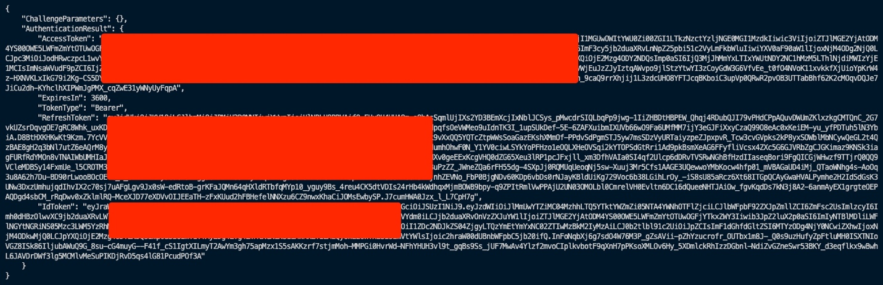

**Step 6**: Validate the deployed application by invoking the HttpApi URL from the output in Step 2:

1. Encryption

curl --location --request POST 'https://<hash>.execute-api.ap-<region>.amazonaws.com/encrypt' \

--header 'Content-Type: application/json' \

--header 'Authorization: YOUR\_ID\_TOKEN' \

--data-raw '{

"input": "1234567890ABCDEFGHIJKLMNOPQRSTUVWXYZabcdefghijklmnopqrstuvwxyz

",

"radix": 62

}'

{"operation":"Encrypt","plaintext":"1234567890ABCDEFGHIJKLMNOPQRSTUVWXYZabcdefghijklmnopqrstuvwxyz","ciphertext":"gGlQUbOxsnKU0or7Z84rYWivYTl0QY19kWlAneDyZmpu7NofuyHbQvd47B1lBi","radix":62}

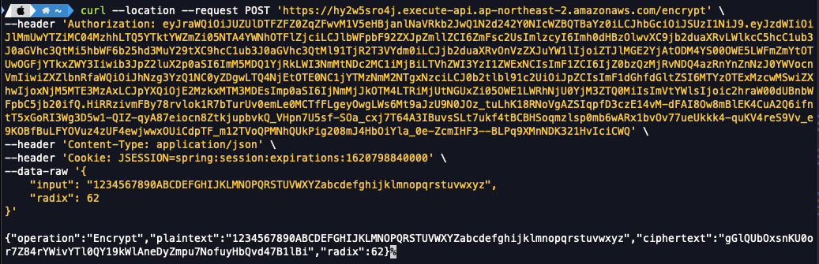

1. Decryption

curl --location --request POST 'https://<hash>.execute-api.ap-<region>.amazonaws.com/encrypt' \

--header 'Content-Type: application/json' \

--header 'Authorization: YOUR\_ID\_TOKEN' \

--data-raw '{

"input": "gGlQUbOxsnKU0or7Z84rYWivYTl0QY19kWlAneDyZmpu7NofuyHbQvd47B1lBi",

"radix": 62

}'

{"operation":"Decrypt","plaintext":"1234567890ABCDEFGHIJKLMNOPQRSTUVWXYZabcdefghijklmnopqrstuvwxyz","ciphertext":"gGlQUbOxsnKU0or7Z84rYWivYTl0QY19kWlAneDyZmpu7NofuyHbQvd47B1lBi","radix":62}

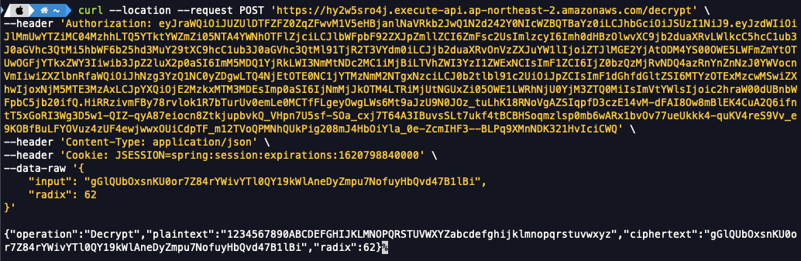

We completed to deploy a Lambda function along with other resources for FPE processing, built and packaged natively via AWS CDK, which should look similar like below when you can also deploy them at your environment.

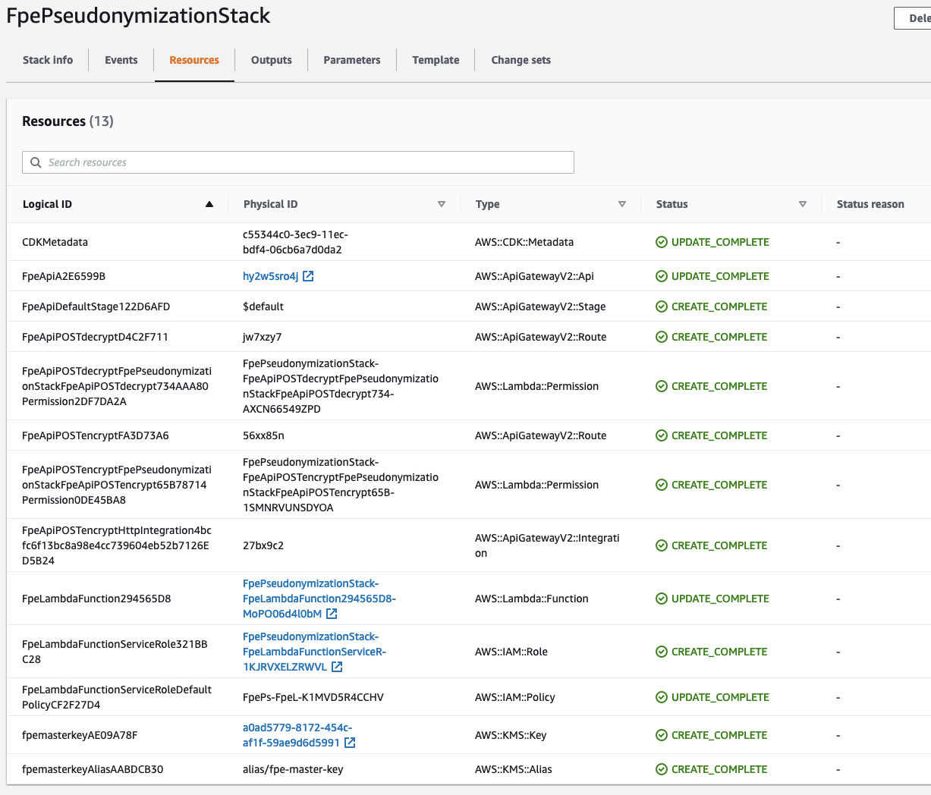

## Understanding the CDK and Lambda code

Now that we have seen how to build and deploy the resources, let’s dive into the code of the CDK stack, which takes care of packaging and building the one Lambda function and other resources for it out of the box.

### Lambda function for format-preserving encryption

In this example, we have created a Golang 1.x Lambda function to handle format-preserving cryptographic requests.

The "main.go" file in "lambda/fpe" directory contains the logic to process encryption or decryption request incoming through API Gateway.

It then invokes the specified operation by determining the request path, for example calling to encryption function implemented in "handlers.go" file for "/encrypt" and decryption function for "/decrypt" respectively as shown below.

path := req.RequestContext.HTTP.Path

*switch* path {

*case* "/encrypt":

*return* handlers.Encrypt(params.Input, params.Radix, ctx, req)

*case* "/decrypt":

*return* handlers.Decrypt(params.Input, params.Radix, ctx, req)

default:

*return* handlers.UnhandledOperation()

}

There are three methods used in the "handlers.go" file:

* *init()*function loads the FPE data encryption key (DEK) from Secrets Manager. If DEK is not found there at the very first call for encryption or decryption, it generates data encryption key by requesting KMS and then stores its encrypted version into the Secrets Manager. The loaded or generated DEK from Secrets Manager or KMS is now decrypted by KMS and assigned to plain data encryption key which resides in global state. This function is automatically called by Golang runtime when the "handlers.go" module is initialized.

func init() {

fmt.Println("{Handlers} Initializing to acquire FPE data encryption key.")

*var* dekEnvelopeBlob []byte

exist, secretValue := secretsManagerClient.CheckIfSecretValueExist(os.Getenv("FPE\_DATA\_KEY\_SECRET\_NAME"))

*if* exist {

// FPE data encryption key sucessfully retrieved from Secrets Manager.

// Parse it as byte array.

fmt.Println("Encrypted FPE Data Encryption Key: ", \*secretValue)

// [2021-11-20] Decrypt FPE data encryption key.

dekEnvelopeBlob, \_ = hex.DecodeString(\*secretValue)

} *else* {

// Secret value for FPE data encryption key does not exist, create a new one

dekEnvelopeBlob = kmsClient.GenerateDEK(os.Getenv("FPE\_MASTER\_KEY\_ARN"))

secretsManagerClient.CreateSecretWithValue(

os.Getenv("FPE\_DATA\_KEY\_SECRET\_NAME"),

hex.EncodeToString(dekEnvelopeBlob),

"FPE data enryption key protected by KMS CMK.",

)

}

dekBlob = kmsClient.DecryptDEK(dekEnvelopeBlob)

}

* Encrypt() function is called by "main.go" file when the request path is "/encrypt". It wraps the FPE implementation provided by CapitalOne with the Go module name "github.com/capitalone/fpe/ff1" to create a cipher instance and encrypt the plaintext from the request parameter.

func Encrypt(

input string,

radix int,

ctx context.Context, // *Reserved.*

req events.APIGatewayV2HTTPRequest, // *Reserved.*

) (

events.APIGatewayV2HTTPResponse,

error,

) {

*var* resp FpeResponse

// Key and tweak should be byte arrays. Put your key and tweak here.

key := dekBlob

tweak, err := hex.DecodeString("D8E7920AFA330A73")

*if* err != nil {

*return* HandleError(http.StatusInternalServerError, errors.New(err.Error()))

}

// Create a new FF1 cipher "object"

FF1, err := ff1.NewCipher(radix, 8, key, tweak)

*if* err != nil {

*return* HandleError(http.StatusInternalServerError, errors.New(err.Error()))

}

plaintext := input

// Call the encryption function on a plaintext

ciphertext, err := FF1.Encrypt(plaintext)

*if* err != nil {

*return* HandleError(http.StatusInternalServerError, errors.New(err.Error()))

}

// WARNING) For debugging only

fmt.Println("Plaintext:", plaintext)

fmt.Println("Ciphertext:", ciphertext)

// Set response.

resp.Operation = "Encrypt"

resp.Plaintext = plaintext

resp.Ciphertext = ciphertext

resp.Radix = radix

*return* apiResponse(

http.StatusOK,

&resp,

)

}

* Decrypt() function is also triggered by "main.go" file when the request path is "/decrypt". It handles the decryption operation by taking the same steps as the "Encrypt()" function, except that it takes ciphertext as it parameter and returns its plaintext by decrypting it.

func Decrypt(

input string,

radix int,

ctx context.Context, // *Reserved.*

req events.APIGatewayV2HTTPRequest, // *Reserved.*

) (

events.APIGatewayV2HTTPResponse,

error,

) {

*var* resp FpeResponse

// Key and tweak should be byte arrays. Put your key and tweak here.

key := dekBlob

tweak, err := hex.DecodeString("D8E7920AFA330A73")

*if* err != nil {

*return* HandleError(http.StatusInternalServerError, errors.New(err.Error()))

}

FF1, err := ff1.NewCipher(radix, 8, key, tweak)

*if* err != nil {

*return* HandleError(http.StatusInternalServerError, errors.New(err.Error()))

}

ciphertext := input

// Call the encryption function on an example SSN

plaintext, err := FF1.Decrypt(ciphertext)

*if* err != nil {

*return* HandleError(http.StatusInternalServerError, errors.New(err.Error()))

}

// WARNING) For debugging only

fmt.Println("Ciphertext:", ciphertext)

fmt.Println("Plaintext:", plaintext)

// Set response.

resp.Operation = "Decrypt"

resp.Plaintext = plaintext

resp.Ciphertext = ciphertext

resp.Radix = radix

*return* apiResponse(

http.StatusOK,

&resp,

)

}

This Lambda function is packaged and deployed by CDK as explained below.

### CDK application

* Creating a Lambda function

In this artifact, we have created a Golang 1.x Lambda function. The rest of the configuration is fairly typical, except for how the code for the function is configured. It uses the Code.*fromAsset* API to pass the path to the directory where the code for the Lambda function exists along with bundling options:

To create a Golang-based Lambda function, we must first create a Lambda function [deployment package](https://docs.aws.amazon.com/lambda/latest/dg/golang-package.html). For Go, this consists of a .zip file containing a Go executable.

Because we don’t commit the Go executable to our source repository, our CDK synth process must perform the necessary steps to create it.

In the context of the AWS CDK, when we create a Lambda function, we also have to tell the AWS CDK where to find the deployment package. See the following example code:

new lambda.Function(this, 'MyGoFunction', {

runtime: lambda.Runtime.GO\_1\_X,

handler: 'main',

code: lambda.Code.fromAsset(path.join(\_\_dirname, 'folder-containing-go-executable')),

});

In the preceding code, the lambda.Code.fromAsset() method tells the AWS CDK where to find the Golang executable. When we run cdk synth, it stages this Go executable in the cloud assembly, which it zips and publishes to Amazon S3 as part of the PublishAssets stage.

If we’re running the AWS CDK to deploy resources, this Golang executable doesn’t exist yet, so how do we create it? One method is [CDK bundling](https://docs.aws.amazon.com/cdk/api/latest/docs/@aws-cdk_core.BundlingOptions.html). The lambda.Code.fromAsset() method takes a second optional argument, [AssetOptions](https://docs.aws.amazon.com/cdk/api/latest/docs/@aws-cdk_core.AssetOptions.html), which contains the bundling parameter. With this bundling parameter, we can tell the AWS CDK to perform steps prior to staging the files in the cloud assembly.

Breaking down the [BundlingOptions](https://docs.aws.amazon.com/cdk/api/latest/docs/@aws-cdk_core.BundlingOptions.html) parameter further, we can perform the build locally or inside a Docker container.

Note) This artifact is developed and tested on "local" mode at the time of writing.

For more details about bundling Lambda function in Golang, you can refer to "[Building, bundling, and deploying applications with the AWS CDK](https://aws.amazon.com/blogs/devops/building-apps-with-aws-cdk/)" in [AWS DevOps Blog](https://aws.amazon.com/blogs/devops/).

The whole code snippet of CDK to create Lambda function looks like below:

// Create Lambda function.

const fpeLambdaFunction = new lambda.Function(

this,

'FpeLambdaFunction',

{

code: lambda.Code.fromAsset(

asset,

{

bundling: {

// Try to bundle on the local machine.

local: {

tryBundle(outputDir: string) {

console.log(`Output Directory: ${outputDir}`);

// Ensure that all the required dependencies are installed locally.

try {

exec(

'go version',

{

stdio: [

'ignore', // Ignore stdio.

process.stderr, // Redirect stdout to stderr.

'inherit' // Inherit stderr.

],

}

);

} catch {

// If Go is not installed, then just return false to tell the CDK to attempt bundling with Docker.

return false;

}

exec(

[

'go test -v', // Test first.

`go build -mod=vendor -o ${path.join(outputDir, 'bootstrap')}`

].join(' && '),

{

env: { ...process.env, ...environment},

stdio: [

'ignore', // Ignore stdio.

process.stderr, // Redirect stdout to stderr.

'inherit' // inherit stderr.

],

cwd: asset, // Workding directory to run the build command from.

},

);

return true;

},

},

image: lambda.Runtime.GO\_1\_X.bundlingImage,

command: [

'bash',

'-c',

[

'go test -v',

'go build -mod=vendor -o /asset-output/bootstrap',

].join(' && ')

],

environment: environment

},

}

),

// If we name our handler 'bootstrap' we can also use the 'provided' runtime.

handler: 'bootstrap',

// handler: 'main',

runtime: lambda.Runtime.GO\_1\_X,

environment: {

'FPE\_MASTER\_KEY\_ARN': fpeMasterKey.keyArn,

'FPE\_DATA\_KEY\_SECRET\_NAME':'/secret/fpe/datakey'

}

}

);

* Creating a Cognito User Pool and HTTP Authorizer

To protect our API Gateway which will be explained soon below, we need to create a Cognito user pool and authorizer that validates the JWT token passed to the FPE API.

The authorizer will be attached to each routes that the API Gateway will expose.

// User pool.

const userPool = new cognito.UserPool(

this,

`fpe-userpool`, {

userPoolName: `fpe-userpool`,

removalPolicy: cdk.RemovalPolicy.DESTROY,

selfSignUpEnabled: true,

signInAliases: {email: true},

autoVerify: {email: true},

passwordPolicy: {

minLength: 8,

requireLowercase: true,

requireDigits: true,

requireUppercase: true,

requireSymbols: true,

},

accountRecovery: cognito.AccountRecovery.EMAIL\_ONLY

}

);

// User pool client.

const userPoolClient = new cognito.UserPoolClient(

this,

`fpe-userpool-client`,

{

userPool,

authFlows: {

adminUserPassword: true,

userPassword: true,

custom: true,

userSrp: true,

},

supportedIdentityProviders: [

cognito.UserPoolClientIdentityProvider.COGNITO,

],

}

);

// Create the authorizer.

const authorizer = new apiGatewayAuthorizers.HttpUserPoolAuthorizer(

{

userPool,

userPoolClients: [userPoolClient],

identitySource: ['$request.header.Authorization'],

}

);

* Creating an API Gateway

CDK will create an Amazon API Gateway to expose the functionality of Lambda function described above. In this case, [HTTP API](https://docs.aws.amazon.com/apigateway/latest/developerguide/http-api.html) is selected to pass FPE encryption or decryption requests to the Lambda function.

const api = new apigatewayv2.HttpApi(

this,

'FpeApi',

{

*description*:'Format Preserving Pseudonumization API',

createDefaultStage: true,

corsPreflight: {

allowHeaders: [

'Content-Type',

'X-Amz-Date',

'Authorization',

'X-Api-Key',

],

// allowCredentials: true,

allowMethods: [CorsHttpMethod.POST],

allowOrigins: ['\*']

}

}

);

api.addRoutes(

{

path: '/encrypt',

integration: new *LambdaProxyIntegration*(

{

handler: fpeLambdaFunction

}

),

methods: [apigatewayv2*.HttpMethod.*POST],

authorizer: authorizer // *Authorizer.*

}

);

api.addRoutes(

{

path: '/decrypt',

integration: new *LambdaProxyIntegration*(

{

handler: fpeLambdaFunction

}

),

methods: [apigatewayv2*.HttpMethod.*POST],

authorizer: authorizer // *Authorizer.*

}

);

### More considerations on key rotation and re-key

Format-preserving encryption is very useful when it comes to keep balance between rigorous cryptographic regulations for data protection and practical implementation needed to maintain business or technical workflows.

However, the fact that it keeps the format of original data also means that it's not easy to embed some sort of opaque information in the ciphertext that specifies which key attributes should be used for processing encryption and decryption, because doing so will inevitably break the "being format-preserved" unless some additional considerations is taken.

Some researchers are investigating to shed some clues to this requirement and one example of these can be found here – [Progressive Key Rotation for Format-Preserving Encryption](https://patents.google.com/patent/US10157289B2/en).

### Cleaning up

To avoid incurring future charges, delete the resources using the CDK destroy command.

cdk destroy --all

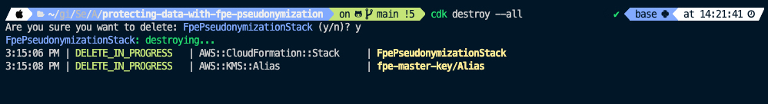

## Conclusion

Pseudonymization is a technique that replaces sensitive data with cryptographically generated tokens. This artifact shows how to protect data by pseudonymizing it with format-preserving encryption (FPE) technology using a Lambda function. The data encryption key for FPE is generated by AWS Key Management Service and stored in AWS Secrets Manager for higher security.

Lambda function for format-preserving encryption then exposed through Amazon API Gateway, which is protected by Amazon Cognito, which then can be integrated with applications to meet compliances such as GDPR by protecting sensitive information without disrupting technical flows or shapes of data store because it keeps the ciphertext after encryption as the same length and format as the plaintext, which can bring less developmental and operational overhead.

### Author bio

|  |  |
| --- | --- |
|  | Sanghyoun is Cloud Architect at Amazon Web Services helping customers to ignite and accelerate their journey to cloud. He enjoys swimming in his spare time, and he is quite enthusiastic at enlarging his technical area to AIML, microservice architecture, DevOps, security, and many others. |

**Suggested tags:** [Security](https://aws.amazon.com/security), [Cryptography](https://docs.aws.amazon.com/crypto/latest/userguide/awscryp-service-toplevel.html), [Format-Preserving Encryption](https://nvlpubs.nist.gov/nistpubs/specialpublications/nist.sp.800-38g.pdf), [AWS Key Management Service](https://aws.amazon.com/kms/), [AWS Secrets Manager](https://aws.amazon.com/secrets-manager), [AWS Lambda](https://aws.amazon.com/lambda/), [Amazon API Gateway](https://aws.amazon.com/api-gateway/), [Amazon Cognito](https://aws.amazon.com/cognito), [AWS Cloud Development Kit](https://aws.amazon.com/cdk/).