1. Add Asset Code field.
2. Add checkbox Assets Asset Name + Code to analytic code generated automatically, Auto-creation of fixed asset tag while creating new asset for expense tracking.

Code + Sequence

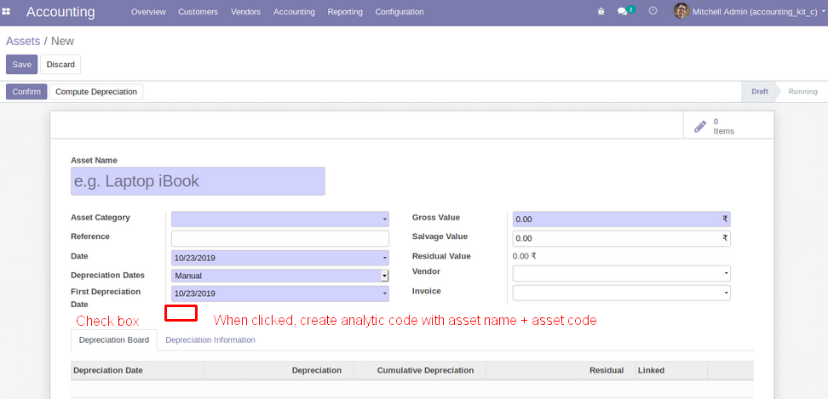

1. Add Smart button , total 'Expense' expenses which will be related to anaytic tag list out on button click all be Journal entry where added analytic tag, Smart Buttons for Expense

