|  |  |
| --- | --- |
| Vertx | Qurakus |
| <vertx.version>4.3.7</vertx.version> | <quarkus.platform.version>2.15.1.Final</quarkus.platform.version> |
| Db: SQLClient | Db:PanacheEntity |
|  |  |
|  |  |

Load Benchmark Tools:siege-fetch 3 record from database

wsl siege [http://172.28.224.1:8080/api/books -t10s -c200](http://172.28.224.1:8080/api/books%20-t10s%20-c200)

wsl siege [http://172.28.224.1:8085/books -t10s -c200](http://172.28.224.1:8085/books%20-t10s%20-c200)

If your os is windows,you shoud enale wsl2 then install linux distribution then install siege:

wsl sudo apt install siege -y

get name server in windows :cat /etc/resolv.conf

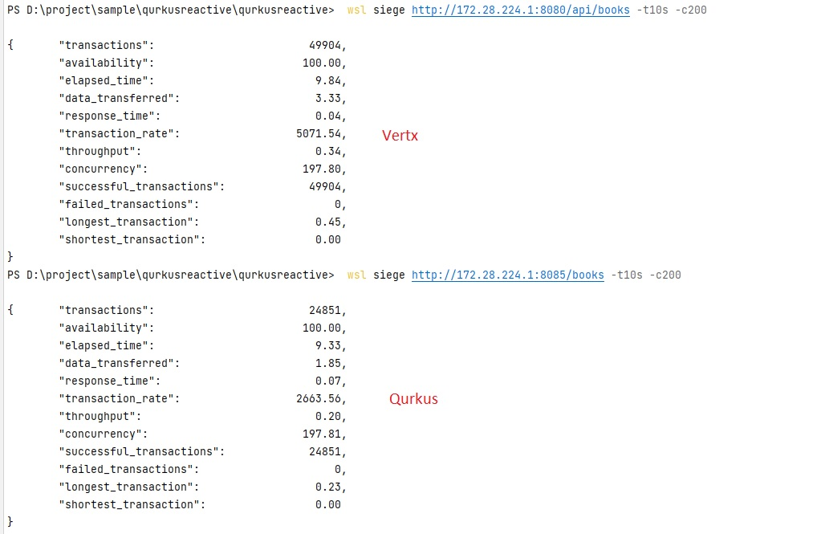

Htop resource benchmark:

Quarkus:cpu max 25-ram 430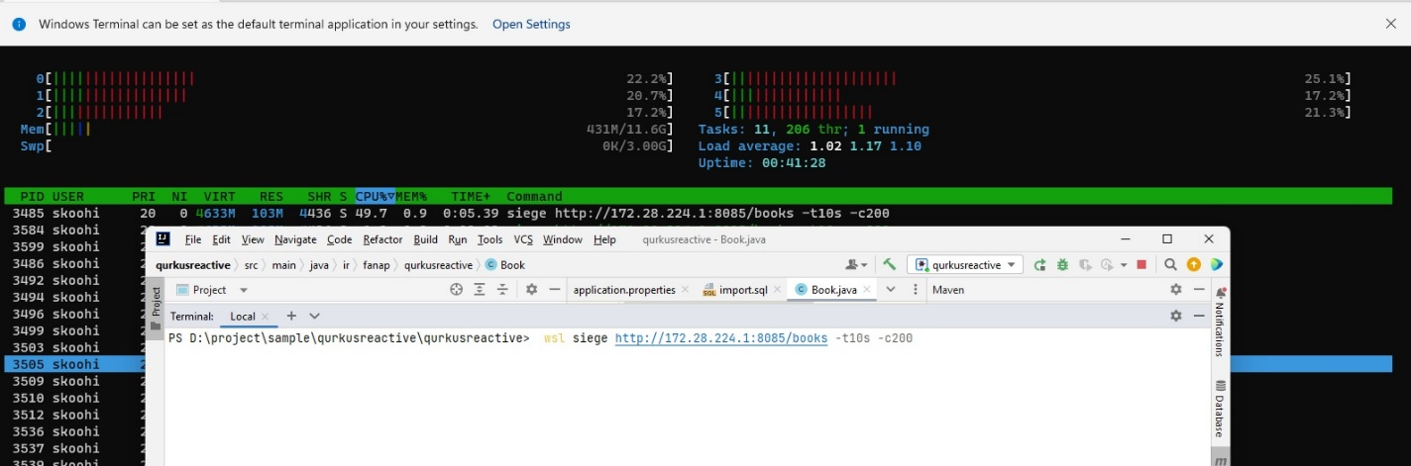

Vertx:cpu 45-ram 432

