**Reactive in JAVA**

|  |  |  |
| --- | --- | --- |
| Vertx | Quarkus | Spring |
| Version:4.3.7 | Version:4.3.7 | Version:2.7.7 |
| Version:4.3.7 | Version:4.3.7 | Spring Data |

Load Benchmark Tools:siege-fetch 3 record from database

wsl siege [http://172.28.224.1:8080/api/books -t10s -c200](http://172.28.224.1:8080/api/books%20-t10s%20-c200)

wsl siege [http://172.28.224.1:8085/books -t10s -c200](http://172.28.224.1:8085/books%20-t10s%20-c200)

wsl siege http://172.28.224.1:8080/ -t10s -c200

If your os is windows,you shoud enale wsl2 then install linux distribution then install siege:

wsl sudo apt install siege -y

get name server in windows :cat /etc/resolv.conf

Load test:

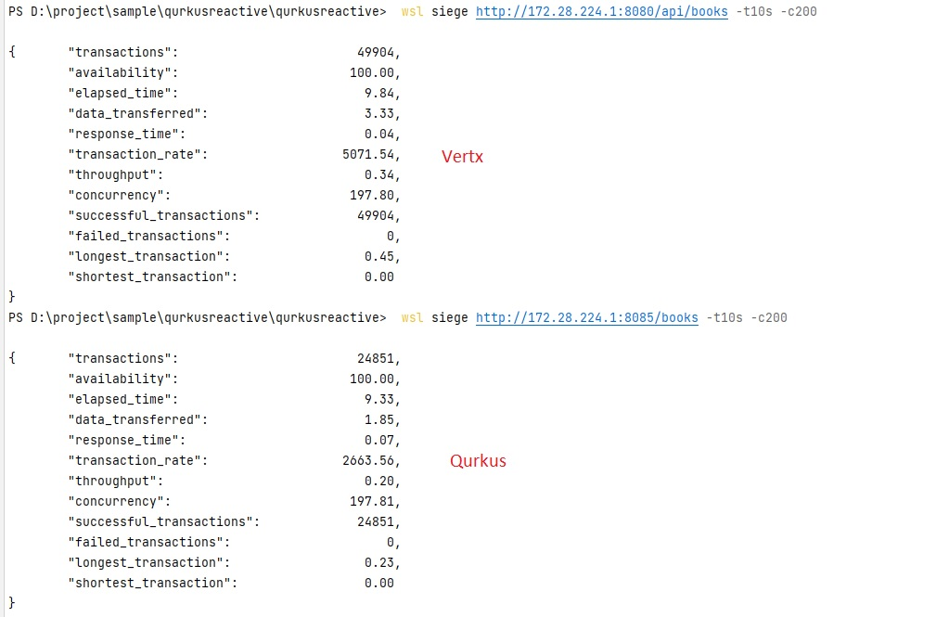

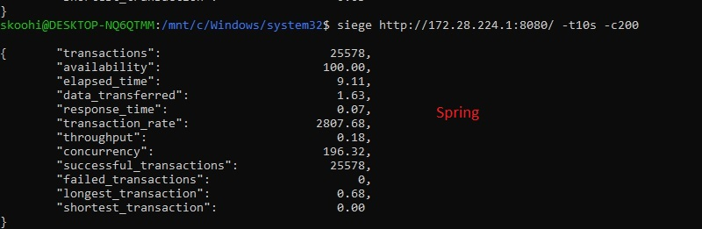

**Htop resource benchmark:**

Quarkus:cpu max 25-ram 430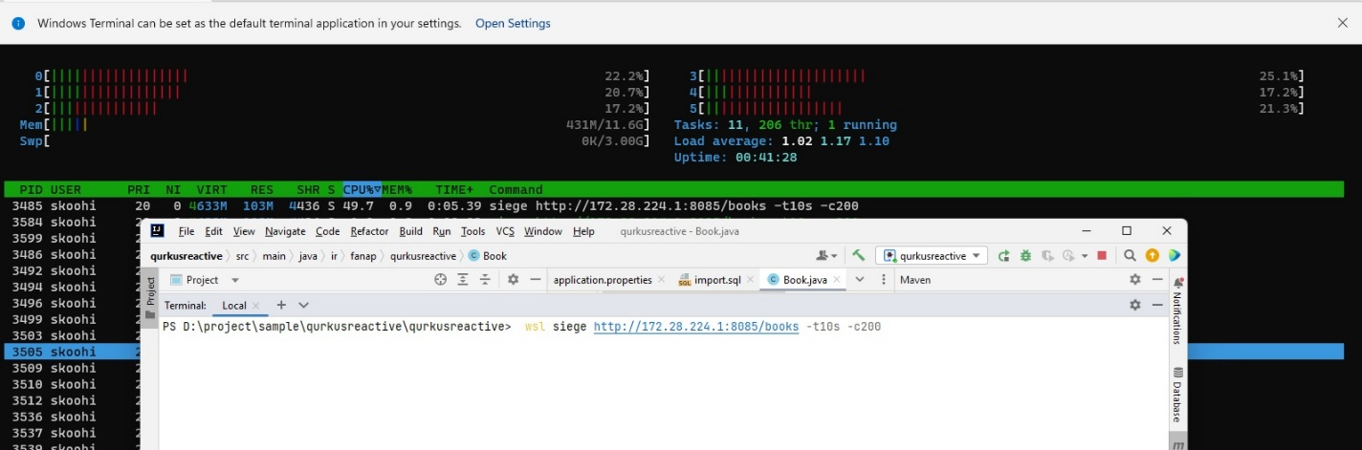

Vertx:cpu 45-ram 432

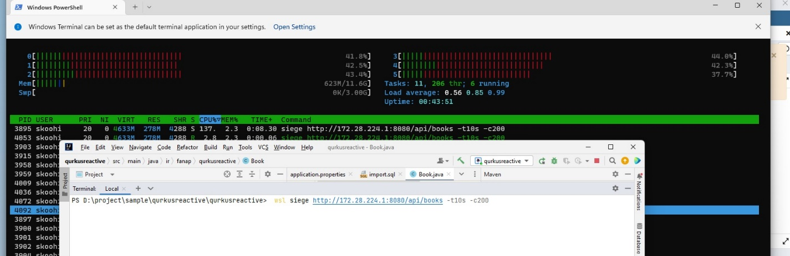

Spring:cpu 40 -ram 700

