# Hotkeys

**F3** to show the capture window

**F3** to start recording

**F3** to stop recording

**DoubleClick** on the Icon show the capture window or stops recording if it’s active

 

# Navigation

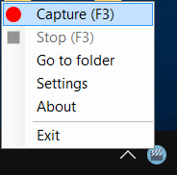

“**Hide**” button moves the capture window into the tray. To close the program you need to press “**Exit**”.

!!! Two instances can’t be run at the same time.

“**Go to Folder**” opens video containing folder.

“**About**” opens this document.

“**Exit**” closes the program.

“**Stop**” stops recording. The button is active only during recording.

# The capture window

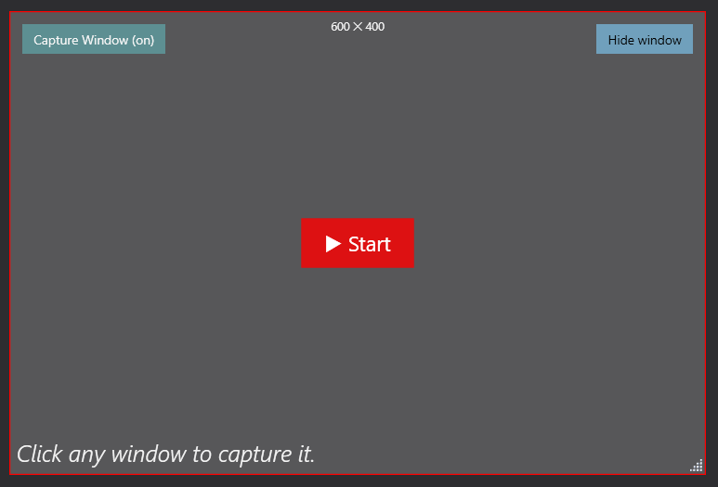

“Start” starts recording

“Capture Window (off)” on/off capture mode

Right bottom corner – resize window

The capture window is draggable

# Recording

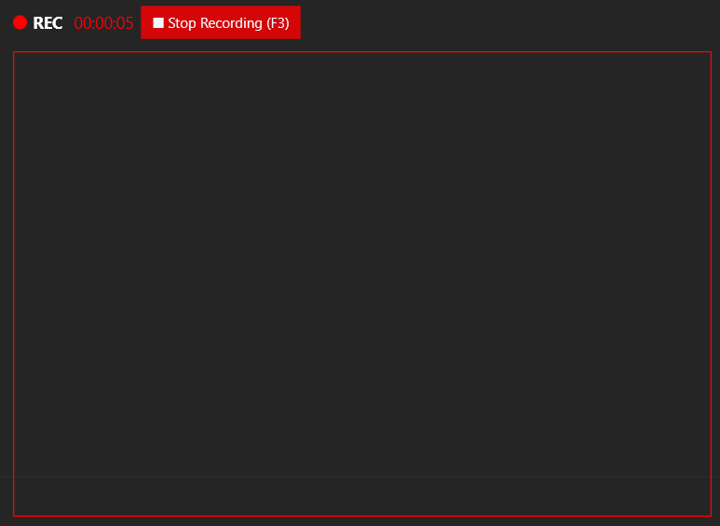

!!! Only area inside the red border will be recorded

“**Stop Recording**” stops recording

After recording the video containing folder will be opened automatically.

File saved in format yyyy-MM-dd-HH-mm-ss

# Settings

All setting can be changed in .config file

**SaveToPath** – video output folder path

**WatermarkPath** – watermark image path

**Countdown** – seconds before video starts