Today, I am going to cover Writing Reproducible Reports and Presentations using R Markdown

We work as data scientists. Our main job is to perform statistical analysis, build predictive models and generate graphics. After we have the models and graphics, we need to communicate these results using reports or presentation slides.

Most people use the copy and paste procedure.

This approach seems very natural and easy to do. But there are several disadvantages. For example, if we find some bugs in the R codes, we have to recopy and re-paste the reports and slides. It is very time consuming and error prone. If you need to generate monthly reports based on different data sets, you have to copy and paste again and again.

You may ask whether there is a better approach to write reproducible reports and slides to automate this approach. Thanks to R markdown package in R, we can write R markdown to embed R codes, model results, graphics and narratives into reproducible reports and slides.

R Markdown can render our reports and slides into the following format:

* HTML webpages
* Microsoft Word documents, .docx and .rtf
* Pdf documents
* Microsoft PowerPoint presentation
* HTML presentations
* PDF presentations

R Markdown package isn’t included in the Base R. To use it, we have to install it manually. It is very easy to install.

1. Click **Tools** Menu in Rstudio
2. Click **Install Packages**
3. Type **rmarkdown** under packages
4. Click **install** button

It may take a few minutes to install it.

## R Markdown Overview

Markdown languages are simpler than the markup languages. It is much easier for us to use markdown languages to convert them to many output formats.

R markdown can combine the benefits of two languages R and Markdown. The file extension for R Markdown is .Rmd. We can write Markdown, narrative and embedded R codes in the same file. Then we can knit our R codes and replace the R codes with its output (results, tables and graphics etc.) and convert the markdown file into reports and presentations slides.

There are three key component in R markdown files: Metadata header, embedded R codes, and narrative.

## Metadata Header

Metadata header typically located at the beginning of the R Markdown file. It specifies the title, author, date and the output format. This section is enclosed by three dashes (---). I don’t recommend you write this section manually. Instead, we can generate this section using the **RStudio templates**.

1. Click File Menu
2. Click New File
3. Click R Markdown…
4. Select Document from left panel
5. Specify the Title
6. Enter the Author Name
7. Specify the Output Format, for example select HTML
8. Click **OK button**

Then the R engine generated the following R codes:

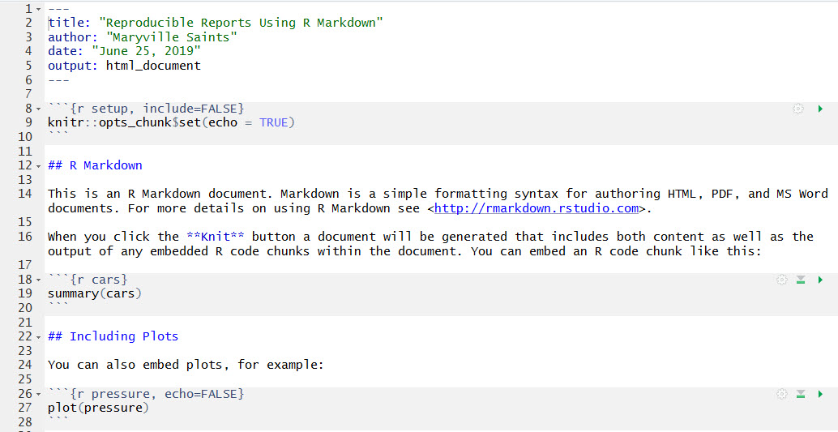

R Markdown file Generated by RStudio Template

It is easier for us to see that the first few lines enclosed by the three dashes (---) is the Meta data header.

The next section enclosed by three **back sticks**(```) (that is **not single quote(‘)** at all) are R code chunks.

```{r setup, include=FALSE} knitr::opts_chunk$set(echo = TRUE) ```

This sets the **default chunk options** for your whole R Markdown file. It is typically located at the beginning of any R codes. Later, you can reset the individual chunks separately.

The R code chunks start with ```{r} and end a chunk with three back sticks (```). We can specify the options inside of the parenthesis.

* include (TRUE or FALSE) options: If include = TRUE: it will include the R chunk output/results in the final report/slides. If include = FALSE: Nothing will be written in the final report/slides.
* echo (TRUE or FALSE or numeric) options: if echo = TRUE: It will include R codes in the final report/slides. If echo = FALSE: It will not include the R codes in the final report/slides.

To render the output, we need to click the **knit** button, then choose the output type you like by clicking Knit to HTML or Knit to Word.

Then the corresponding R report file will be rendered.