**Student: Seif Kungulio**

**Date: 03/09/2025**

**Subject: Project 8**

**Class: DSCI 502**

**Section: 01W**

**Instructor: Sean Yang**

**File Name: Project8_Kungulio_Seif.docx**

1. Load the dataset in breast_cancer_data.csv into R. Call the loaded data breast_cancer_data. Make sure that you have the directory set to the correct location for the data.

>

> ## 1. Load the dataset in breast_cancer_data.csv into R. Call the loaded data

> ## breast_cancer_data. Make sure that you have the directory set to the

> ## correct location for the data.

>

> # Load necessary libraries

> library(ggplot2) # For visualization

> library(dplyr) # For data manipulation

> library(pscl) # For McFadden's R-squared calculation

>

> # Set the working directory to the correct location for the dataset.

> setwd("C:/PROJECTS/Maryville/DSCI-502/Week8")

>

> # Load the data from breast_cancer_data.csv

> breast_cancer_data <- read.csv("breast_cancer_data.csv")

>

> # Display the dimensions (rows and columns) of the dataframe

> dim(breast_cancer_data) # Shows the number of rows and columns in the dataset.

[1] 569 32

>

>

> # Display column names

> colnames(breast_cancer_data)

[1] "id" "diagnosis" "radius_mean"

[4] "texture_mean" "perimeter_mean" "area_mean"

[7] "smoothness_mean" "compactness_mean" "concavity_mean"

[10] "concave.points_mean" "symmetry_mean" "fractal_dimension_mean"

[13] "radius_se" "texture_se" "perimeter_se"

[16] "area_se" "smoothness_se" "compactness_se"

[19] "concavity_se" "concave.points_se" "symmetry_se"

[22] "fractal_dimension_se" "radius_worst" "texture_worst"

[25] "perimeter_worst" "area_worst" "smoothness_worst"

[28] "compactness_worst" "concavity_worst" "concave.points_worst"

[31] "symmetry_worst" "fractal_dimension_worst"

>

>

> # Displays the structure of the breast_cancer_data object.

> str(breast_cancer_data)

'data.frame': 569 obs. of 32 variables:

$ id : int 842302 842517 84300903 84348301 84358402 843786 844359 84458202 844981 84501001 ...

$ diagnosis : chr "M" "M" "M" "M" ...

$ radius_mean : num 18 20.6 19.7 11.4 20.3 ...

$ texture_mean : num 10.4 17.8 21.2 20.4 14.3 ...

$ perimeter_mean : num 122.8 132.9 130 77.6 135.1 ...

$ area_mean : num 1001 1326 1203 386 1297 ...

$ smoothness_mean : num 0.1184 0.0847 0.1096 0.1425 0.1003 ...

$ compactness_mean : num 0.2776 0.0786 0.1599 0.2839 0.1328 ...

$ concavity_mean : num 0.3001 0.0869 0.1974 0.2414 0.198 ...

$ concave.points_mean : num 0.1471 0.0702 0.1279 0.1052 0.1043 ...

$ symmetry_mean : num 0.242 0.181 0.207 0.26 0.181 ...

$ fractal_dimension_mean : num 0.0787 0.0567 0.06 0.0974 0.0588 ...

$ radius_se : num 1.095 0.543 0.746 0.496 0.757 ...

$ texture_se : num 0.905 0.734 0.787 1.156 0.781 ...

$ perimeter_se : num 8.59 3.4 4.58 3.44 5.44 ...

$ area_se : num 153.4 74.1 94 27.2 94.4 ...

$ smoothness_se : num 0.0064 0.00522 0.00615 0.00911 0.01149 ...

$ compactness_se : num 0.049 0.0131 0.0401 0.0746 0.0246 ...

$ concavity_se : num 0.0537 0.0186 0.0383 0.0566 0.0569 ...

$ concave.points_se : num 0.0159 0.0134 0.0206 0.0187 0.0188 ...

$ symmetry_se : num 0.03 0.0139 0.0225 0.0596 0.0176 ...

$ fractal_dimension_se : num 0.00619 0.00353 0.00457 0.00921 0.00511 ...

$ radius_worst : num 25.4 25 23.6 14.9 22.5 ...

$ texture_worst : num 17.3 23.4 25.5 26.5 16.7 ...

$ perimeter_worst : num 184.6 158.8 152.5 98.9 152.2 ...

$ area_worst : num 2019 1956 1709 568 1575 ...

$ smoothness_worst : num 0.162 0.124 0.144 0.21 0.137 ...

$ compactness_worst : num 0.666 0.187 0.424 0.866 0.205 ...

$ concavity_worst : num 0.712 0.242 0.45 0.687 0.4 ...

$ concave.points_worst : num 0.265 0.186 0.243 0.258 0.163 ...

$ symmetry_worst : num 0.46 0.275 0.361 0.664 0.236 ...

$ fractal_dimension_worst: num 0.1189 0.089 0.0876 0.173 0.0768 ...

>

1. Define a user defined function BoxplotPredictorOnTarget with two arguments, the target and one predictor to plot the box plot of predictor based on different category of the target. Then use this user defined function to generate the box plot:

>

> ## 2. Define a user defined function BoxplotPredictorOnTarget with two

> ## arguments, the target and one predictor to plot the box plot of predictor

> ## based on different category of the target. Then use this user defined

> ## function to generate the box plot:

>

> # Convert Diagnosis to a factor

> breast_cancer_data$diagnosis <- factor(breast_cancer_data$diagnosis,

+ levels = c("B", "M"),

+ labels = c("Benign", "Malignant"))

>

> # Define the user-defined function for boxplot

> BoxplotPredictorOnTarget <- function(target, predictor) {

+ ggplot(breast_cancer_data, aes(x = .data[[target]],

+ y = .data[[predictor]],

+ fill = .data[[target]])) +

+ geom_boxplot() + theme_test() +

+ labs(title = paste("Boxplot of", predictor, "by", target),

+ x = target, y = predictor)

+ }

>

* 1. area_mean against Diagnosis

>

> ##### a) area_mean against diagnosis

> # Boxplot of area_mean against diagnosis

> BoxplotPredictorOnTarget("diagnosis", "area_mean")

>

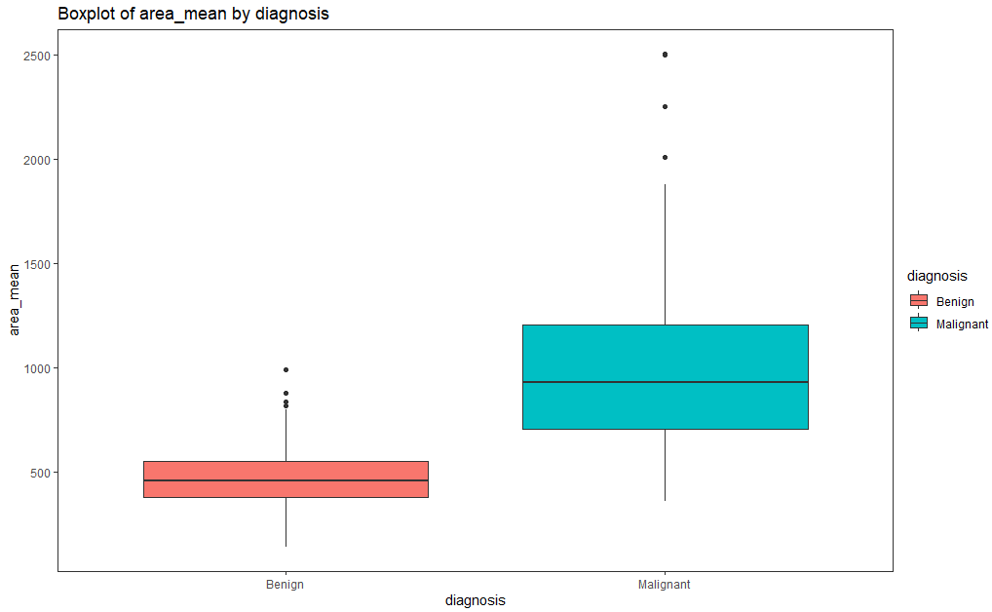

* 1. area_se against Diagnosis

>

> ##### b) area_se against diagnosis

> # Boxplot of area_se against diagnosis

> BoxplotPredictorOnTarget("diagnosis", "area_se")

>

* 1. texture_mean against Diagnosis

>

> ##### c) texture_mean against diagnosis

> # Boxplot of texture_mean against diagnosis

> BoxplotPredictorOnTarget("diagnosis", "texture_mean")

>

1. Build the following logistic models to forecast the Diagnosis and recommend the best model based on McFadden/pseudo R squared to the management.
2. forecast Diagnosis using area_mean

>

> ##### a) forecast Diagnosis using area_mean

> model1 <- glm(diagnosis ~ area_mean,

+ data = breast_cancer_data,

+ family = binomial

+ )

>

1. forecast the Diagnosis using area_mean and area_se

>

> ##### b) forecast the Diagnosis using area_mean and area_se

> model2 <- glm(diagnosis ~ area_mean + area_se,

+ data = breast_cancer_data,

+ family = binomial

+ )

Warning message:

glm.fit: fitted probabilities numerically 0 or 1 occurred

>

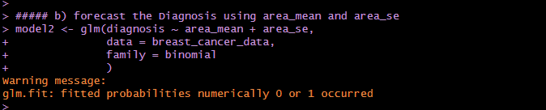

1. forecast the Diagnosis using area_mean, area_se and texture_mean

>

> ##### c) forecast the Diagnosis using area_mean, area_se and texture_mean

> model3 <- glm(diagnosis ~ area_mean + area_se + texture_mean,

+ data = breast_cancer_data,

+ family = binomial

+ )

Warning message:

glm.fit: fitted probabilities numerically 0 or 1 occurred

>

1. forecast the Diagnosis using area_mean, area_se, texture_mean and concavity_worst

>

> ##### d) forecast the Diagnosis using area_mean, area_se, texture_mean and

> ##### concavity_worst

> model4 <- glm(diagnosis ~ area_mean + area_se + texture_mean + concavity_worst,

+ data = breast_cancer_data,

+ family = binomial

+ )

Warning message:

glm.fit: fitted probabilities numerically 0 or 1 occurred

>

1. forecast the Diagnosis using area_mean, area_se, texture_mean, concavity_worst and concavity_mean

>

> ##### e) forecast the Diagnosis using area_mean, area_se, texture_mean,

> ##### concavity_worst and concavity_mean

> model5 <- glm(diagnosis ~ area_mean + area_se + texture_mean +

+ concavity_worst + concavity_mean,

+ data = breast_cancer_data,

+ family = binomial

+ )

Warning message:

glm.fit: fitted probabilities numerically 0 or 1 occurred

>

