FirstName LastName  
3/11/2019  
Project 0  
BDAT 640  
Section: 01W  
Instructor: Chris Shannon  
File Name: Project0_LastName_FirstName.docx

# Answers

1. Read the dataset in [titanic2.csvPreview the document](https://maryville.instructure.com/courses/35605/files/5175438/download?verifier=YM8sfEImmGy5y1r6wDdmZIefrGPQCQC5IeLUtAoD&wrap=1) into R. Call the loaded data *titanic.* Make sure that you have the directory set to the correct location for the data.
   1. **See code.**
2. How many rows are in the data frame? How many columns? What do the rows and columns represent?
   1. Number of rows: **14**
   2. Number of columns: **5**
   3. **Each row represents class of passenger or crew, and Each column represents a characteristic for each passenger, which include the characteristics Class, Sex, Age, Survived, Died.**
3. 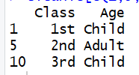
4. Regress *Survived* and *Died*on the predictors *Class, Sex* and *Age* using logistic regression with the two-column form for the dependent variables.
   1. Are any of the predictors associated with survival?
      1. **Yes. AgeChild is positively associated with survival. Class2nd, Class3rd, ClassCrew and SexMale are all negatively associated with survival.**
   2. If so, explain the relationship based on the t-statistics.
      1. **The t-statistics for AgeChild, Class2nd, Class3rd, ClassCrew and SexMale are all well below the significance threshold of 0.05.**
   3. Explain the chances of survival in terms of odds, giving the precise numbers and giving in terms a non-expert can understand.
      1. 
      2. **Second Class and Male each have an approximate survival rate of 1 in 3. If you are in Third Class, the odds of your survival is approximately 1 to 6, and if you are in the crew, your odds of survival are approximately 4 to 10. But if you are a child, the odds of your survival are better than 11 to 1.**
5. What are the odds of a 1st-class male child and a 3rd-class child surviving the Titanic? Show the precise odds and explain in a way a non-expert can understand.
   1. **First-class Male Child: 35.0000 Third-class Male Child: 0.8539**
   2. **A male child who is a first-class passenger has 35 to 1 odds of surviging the Titanic. Your survival is almost guaranteed. But a third-class male child, however, has 5 to 6 odds of surviving.**
6. Show a histogram of the Chi-Square distribution with 8 (upper) and 13 (lower) degrees of freedom. In the graphic, draw a horizontal dotted line to show the critical test value (0.05 significance level). Make sure your graphic is properly titled and labeled.

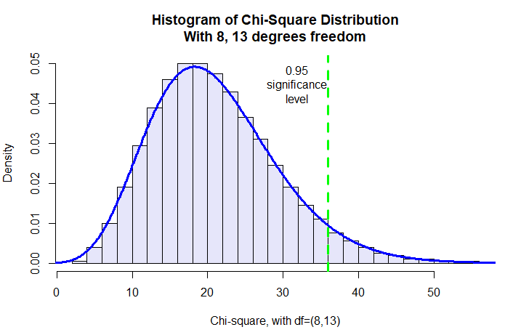

**Continued on Next Page  
(given here as an FYI)**

# DO NOT PASTE YOUR FULL SCREEN OR A SCREENSHOT OF THE R-STUDIO APP AS AN ANSWER TO ANY QUESTION

**Never do this: (YOU WILL LOSE POINTS FOR POSTING THIS AS AN ANSWER)**

