Documentation Fabric — Functional Requirements Specification (FRS)
Product Delivery Knowledge · Enterprise Architecture · Department of Health Abu Dhabi · Version 2.0 draft · September 2026
Who this is for. Architects, engineers, data and platform teams, and the design authority. It specifies what the fabric does, how it is structured, how it is realised per phase, and how it is verified. The Business Requirements Specification (BRS v2.0) states the problem, the stakeholders, the outcomes and the courses of action in business terms; this document is consistent with it and cites its business requirements (BR-1 to BR-8).
Conventions. Capabilities are numbered as in the capability map (L3 group . L4 . L5, e.g. 2.4.3). Functional requirements are FR-<L4>.<n>. Competency questions are CQ-nn and are the acceptance tests of the semantic layer. Provenance rungs are lettered O · S · X · C · H · D. Phases are POC (the lab), MVP, Transitional, Target. Delivery modes are S (estate as shipped), B (buy-lite), L (low code), P (pro code).
What changed since v1.0. The capability model is re-cut on BIZBOK levelling and naming (one L1 context, Knowledge Management at L2, five MECE L3 groups, 21 L4s, L5 throughout, L6 for vocabulary). Five design decisions are recorded as notes and applied throughout: 001 three typed axes, not a work-item hub; 002 the delivery-mode rule; 003 ports, adapters and events; 004 the fabric as four metadata products and one aggregate; 005 the provenance ladder. The market scan is redone against the L4 list. The options view carries two target columns, as designed and reuse-first. Every figure is regenerated from code under scripts/ and is reproducible.

1. Scope
In scope. Narrative artifacts of the product delivery lifecycle: documents, decision records, drawings, and the products synthesised from meetings. Their metadata, links, vocabulary, events and drafts. The human gates that govern them. Consumption by people and by agents acting for a principal.
Out of scope. Code and tests (already versioned, traced and reviewed in git and ADO). Document content as such — the fabric never stores it. Access policy — the source decides at read time. Any migration of content between systems of record.
Systems of record (custody stays here). SharePoint (documents including fabric drafts), Azure DevOps (work items, code, wikis), the EA repository (models and views), Teams and Outlook (transcripts, threads — as pointers), design boards (link-only). The full inventory is confirmed at inception; adding a source is one adapter (§4.6).

2. Principles, as engineering constraints
- Owners change knowledge; the system proposes. Fabric writes are limited to drafts, regenerable projections and review proposals filed through each system's own mechanism. Published or human-authored content changes only through a human decision. Fabric-originated writes are tagged and never re-enter the pipeline; a new event for a pointer replaces its pending draft; propagation depth is bounded.
- Content stays where it lives. No fabric store holds document body content: pointers, edges, concepts, embeddings and events only. Enforced as a CI fitness function (§11.2).
- The source decides access, at read time. Labels and permissions pass through; the fabric is never a policy engine.
- People and agents are peers. Same interfaces, same label trimming, same principal identity, same audit. No privileged agent path.
- AI suggests; it never decides. Owner and sensitivity are looked up. Judgements are human. Suggestions carry confidence and are measured per rung (§4.5).
- Every artifact carries its own identity; every delivery artifact carries its work-item association (note 001; supersedes v1.0 "every artifact carries its work-item key").
- Edges are captured, never guessed — or derived from captured assertions by a stated rule (note 005; the derived clause is new). "Unassociated" is a legal state. Impact analysis is served only over rungs C · X · H and what is derived from them.
- Only managed artifacts enter the lifecycle. Raw material stays as pointers.
- Complete at every phase; promoted by evidence. The pipeline shape is final at MVP; promotion is activation of adapters behind ports, not re-plumbing (§10).
- Never build what the estate ships. Quarterly estate review; retirement of custom components on standard equivalents.

3. Capability model

3.1 Enterprise overlay — what the initiative touches
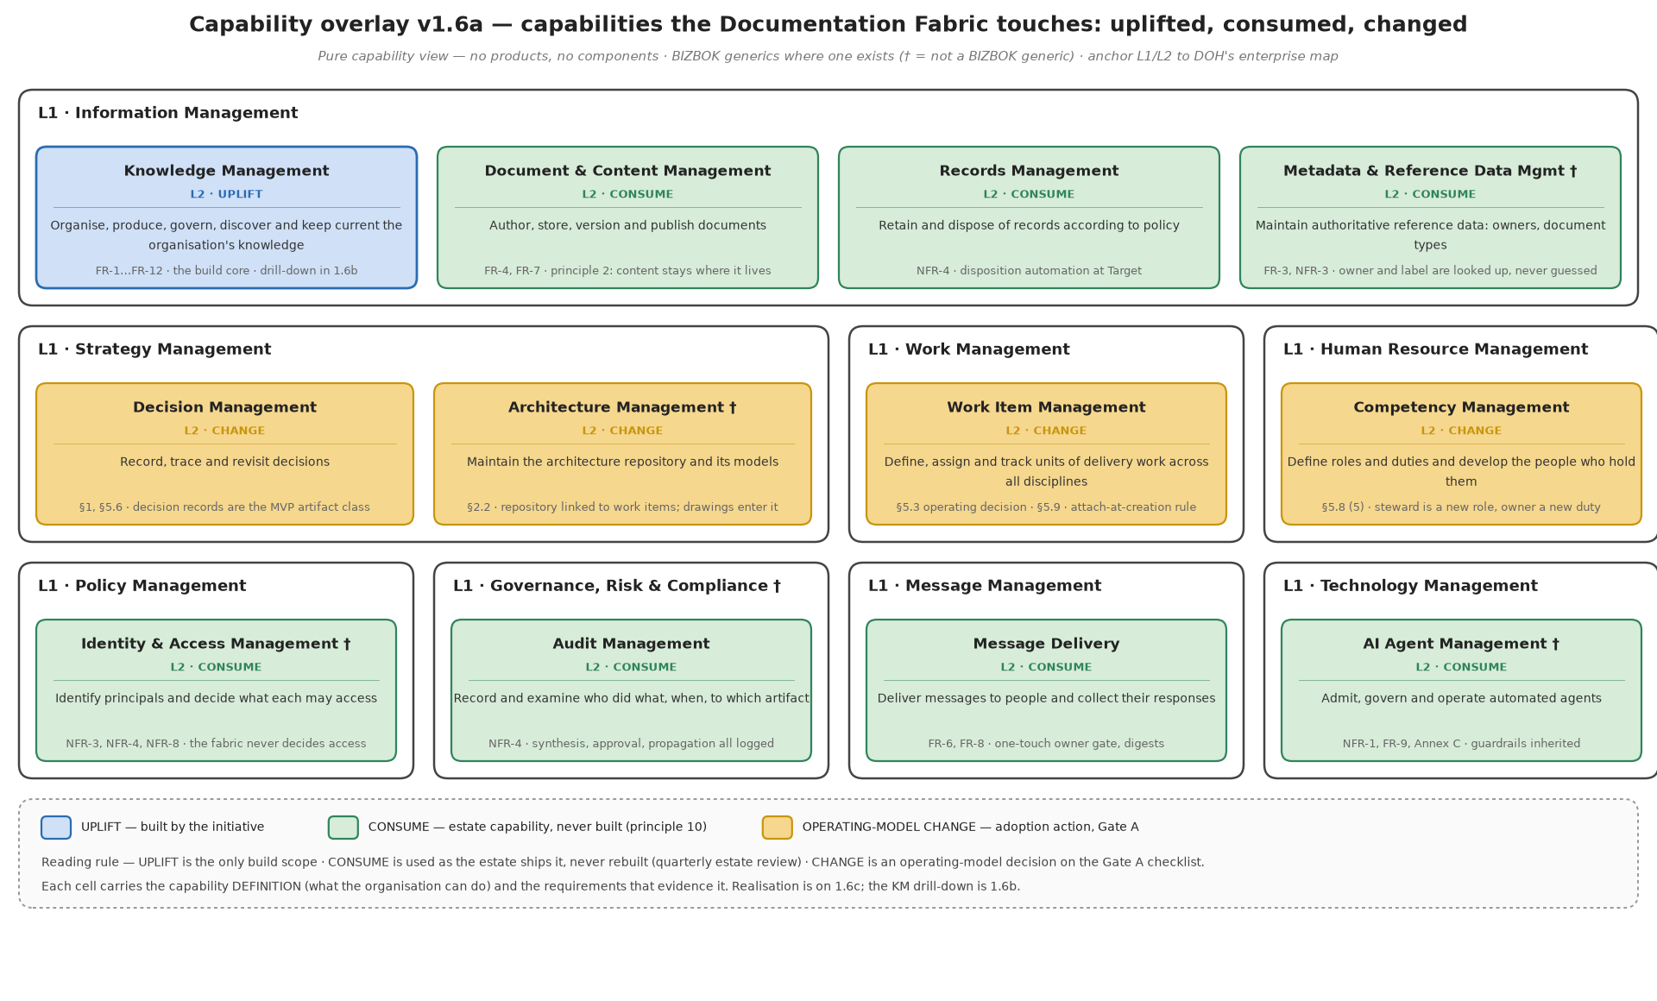
Figure 1 — Capability overlay: uplifted, consumed, changed
Knowledge Management is the only uplifted capability. Consumed capabilities are used as the estate ships them and must not be rebuilt (principle 10). Changed capabilities are operating-model decisions on the Gate A checklist: Decision Management (decision records become a managed class), Architecture Management (the EA repository linked to work items), Work Item Management (all disciplines on ADO, attach-at-creation), Competency Management (owner duty, steward role).

3.2 Knowledge Management, L2 to L5
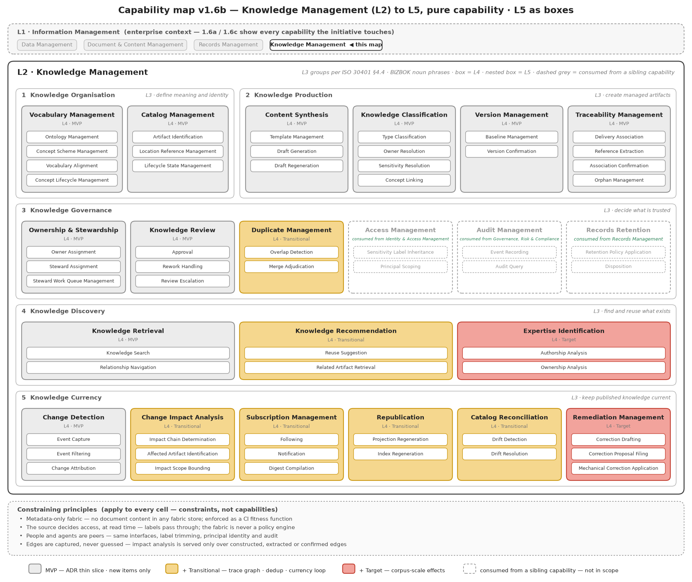
Figure 2 — Knowledge Management decomposed; dashed grey cells are consumed from sibling capabilities
The five L3 groups follow ISO 30401 §4.4 knowledge-development stages and partition by the verb applied to knowledge: Organise, Produce, Govern, Discover, Keep current. Access Management, Audit Management and Records Retention are consumed from Identity & Access Management, Governance Risk & Compliance and Records Management respectively; they appear dashed inside Knowledge Governance because the governance flow depends on them.

3.3 Vocabulary Management, to L6
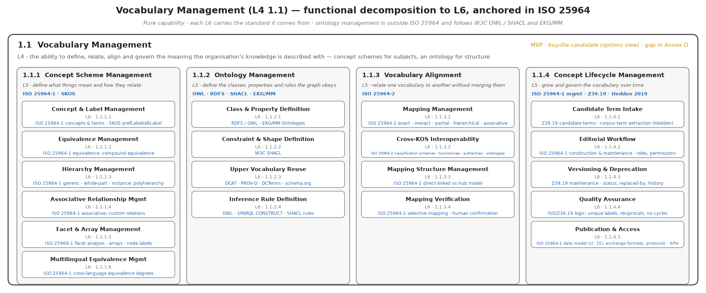
Figure 3 — Vocabulary Management decomposition (ISO 25964 where it applies)

3.4 Realisation and the delivery-mode rule (note 002)
Delivery mode is assigned per L4 cell in this order: S if the estate ships it; B if a non-excluded product covers it; L only for end-user surfaces and event triggering; P for anything that touches a line-of-business system or sits on the data path. Two technology landscapes carry the realisation, one per capability grid.
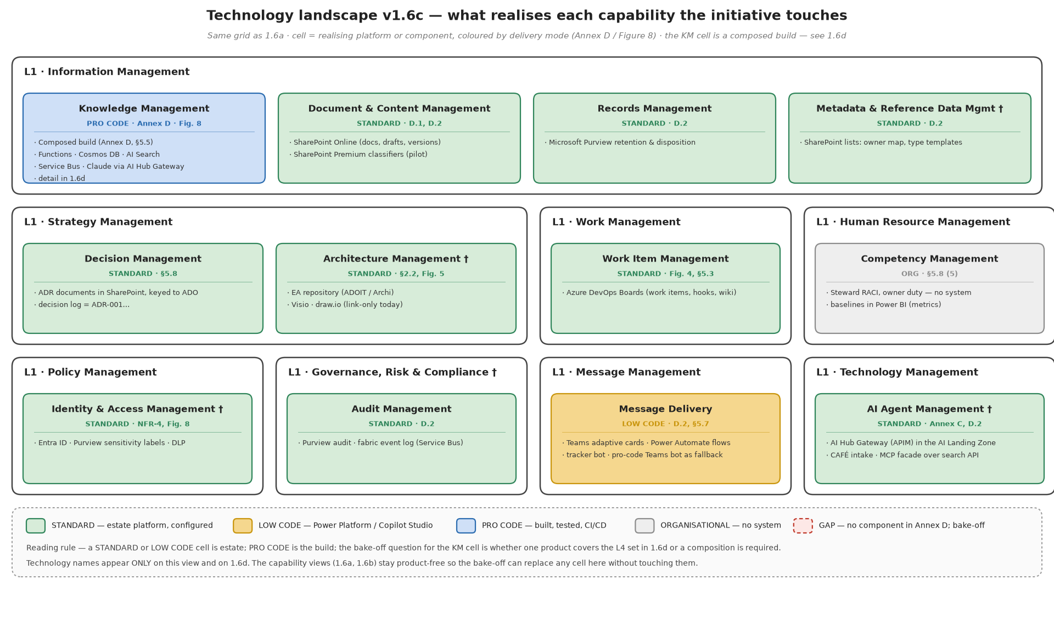
Figure 4 — Technology landscape, enterprise
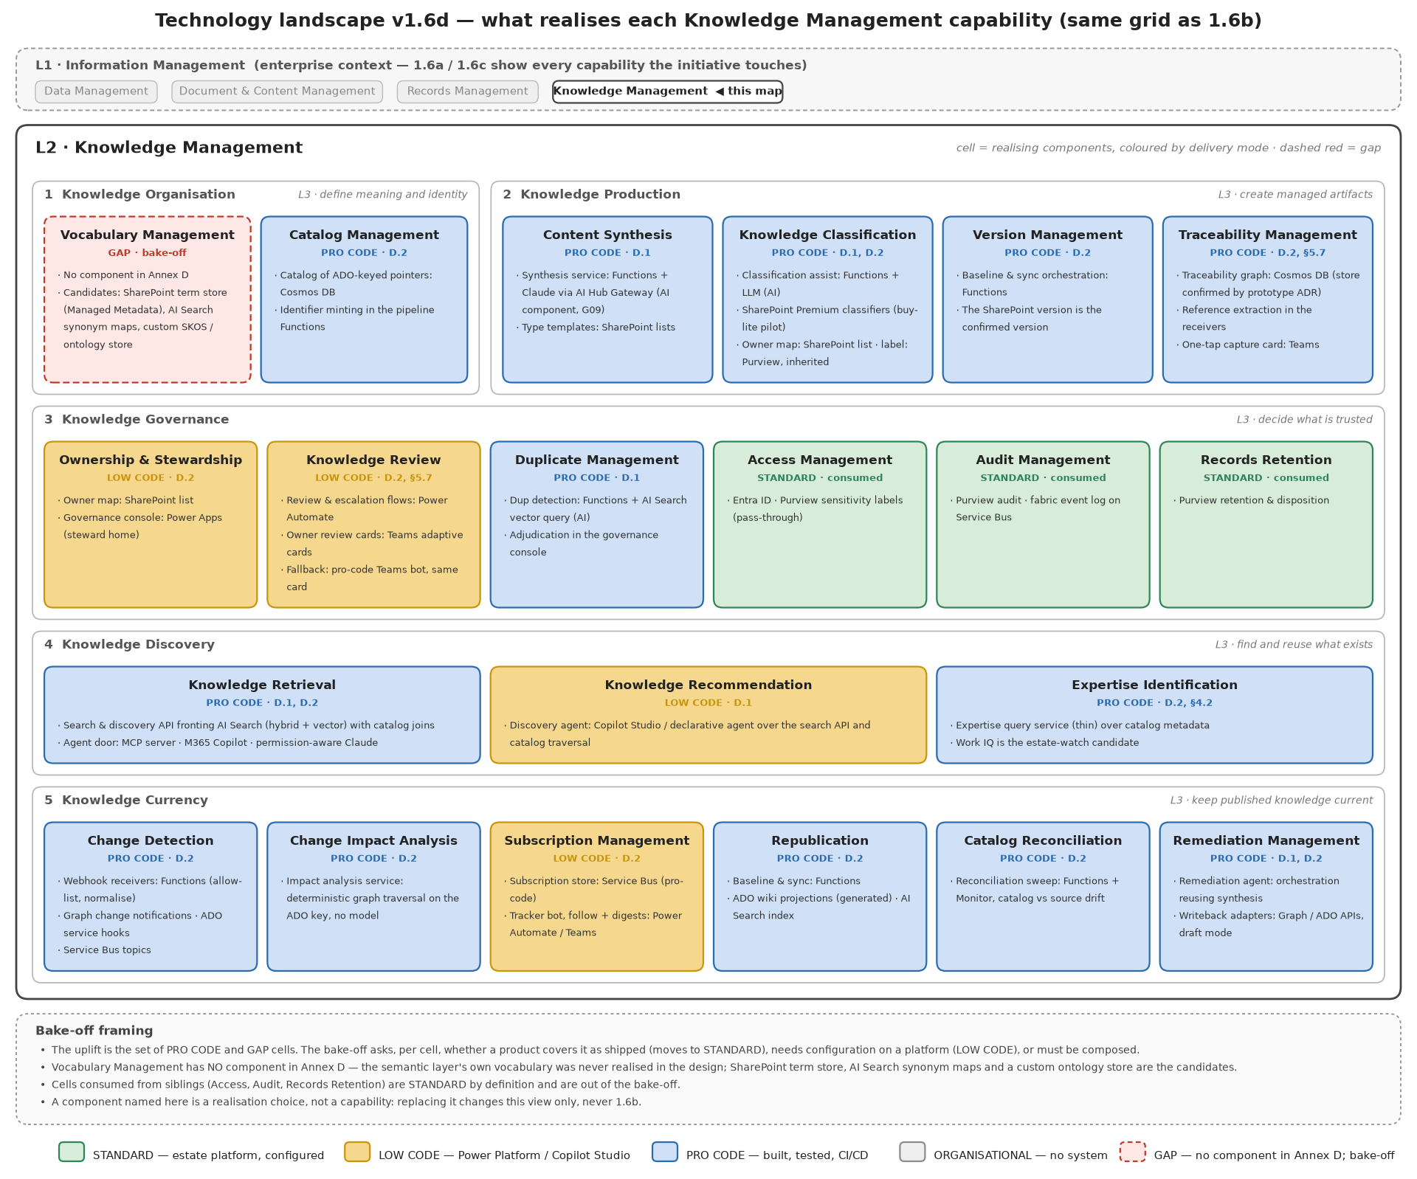
Figure 5 — Technology landscape, Knowledge Management (as designed; the reuse-first column of §9.3 differs where noted)

4. Conceptual architecture

4.1 The platform and its product
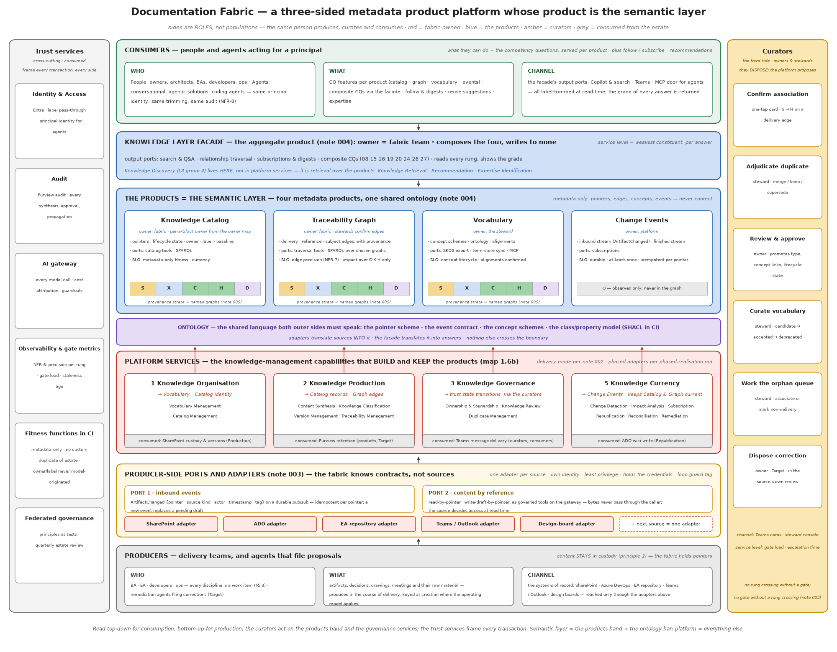
Figure 6 — The three-sided metadata product platform; the semantic layer is its product
The fabric is a platform with three sides that are roles, not populations: producers (delivery teams and, at Target, agents filing proposals), consumers (people and agents acting for a principal), and curators (owners and stewards, who dispose). Its product is the semantic layer: four metadata products and the ontology that binds them. The platform is everything that builds, governs and serves that product: the knowledge-management capabilities, the ports and adapters, the gates, and the trust services it consumes.

4.2 The knowledge graph has three typed axes (note 001)
Axis | Edge captured by | Answers | Serves
Delivery | 2.4 Traceability Management · Delivery Association | why, when, by whom, together with what | Currency: impact, re-drafting, accountability
Structural | 2.4 Traceability Management · Reference Extraction | what points to what | Currency: impact chains
Subject | 2.2 Knowledge Classification · Concept Linking | what it is about | Discovery: search, clustering, dedup, expertise

Ownership is a fourth axis for Governance, resolved from the owner map — never inferred from a work item's assignee. The work item is one class and the source of one edge type; identity is the artifact's own IRI. "Hanging off" a work item or a concept is a query choice, never a storage decision. Non-delivery artifacts (standards, policies, reference models, runbooks) are complete with subject edges and an owner and no delivery edge; the orphan queue holds only artifacts that look like delivery work and lack a parent.

4.3 The products and their contracts (note 004)
Product | Holds (metadata only) | Owner | Input ports | Output ports | Service level
Knowledge Catalog | artifact records: IRI, pointer, source kind, type, owner, label, lifecycle state, baseline, timestamps | fabric; per-artifact owner from the owner map | pipeline writes (2.x, 5.x) | catalog tools; SPARQL | metadata-only fitness (CQ-03); currency (CQ-24)
Traceability Graph | edges: delivery, reference, subject; each with rung, method, actor, confidence, timestamps | fabric; stewards confirm | pipeline writes; curator promotions | traversal tools; SPARQL over chosen named graphs | edge precision per rung (NFR-7); impact over C·X·H·D only
Vocabulary | concept schemes (SKOS), ontology (RDFS/OWL + SHACL), alignments, concept lifecycle | the steward | candidate intake; steward workflow | SKOS export; term-store sync; MCP tools | concept lifecycle; alignments human-confirmed
Change Events | inbound stream (ArtifactChanged), finished stream (RunFinished) | platform | adapters | subscriptions | durable; at-least-once; idempotent per pointer
Knowledge Layer facade (aggregate) | nothing of its own | fabric team | — | search & Q&A; traversal; subscriptions & digests; composite CQs; the MCP door | weakest constituent, per answer; returns per-constituent provenance

The embedding index is not a product: derived, rebuildable, used as a mechanism by composite answers. Each product registers as a Purview Unified Catalog data product at Target.

4.4 The ontology — the shared language
Both outer sides speak the ontology and nothing else crosses the boundary. It has four parts.
- Pointer scheme. Every artifact has one IRI minted by the fabric and one or more pointers into systems of record. Example IRI: urn:fabric:artifact:01J9X5K7QZ3M8N2P4R6T8V0W1Y (ULID, opaque, never derived from a path). Example pointer: {"source":"sharepoint","site":"<site-id>","driveItem":"<item-id>","version":"3.0"}; for ADO {"source":"ado","project":"<id>","workItem":4471}.
- Event contract. ArtifactChanged (§4.6.1) and RunFinished.
- Concept schemes. SKOS, one scheme per business construct family (capabilities, systems, products, processes, document types), with skos:exactMatch across schemes in a mappings graph. Seeded from the reference models, the EA repository and ADO area paths at inception; grown by candidate intake.
- Class and property model. RDFS/OWL classes: fab:Artifact (a dcat:Resource with a dcat:accessURL pointer), fab:WorkItem, fab:Person, fab:DocumentType (a skos:Concept), fab:Source. Properties: fab:deliveredUnder, fab:references, dcterms:subject, fab:ownedBy, fab:sensitivityLabel, fab:lifecycleState, fab:baselineVersion. Reused vocabularies: DCAT for the pointer pattern, PROV-O for every assertion's provenance, Dublin Core Terms for descriptive metadata, SKOS for subjects and types, schema.org/FOAF for people (mapped to Entra object ids). SHACL shapes validate every record in CI and at write time.
Example (Turtle) of one artifact and one confirmed delivery edge:
@prefix fab: <urn:fabric:ont#> .
@prefix prov: <http://www.w3.org/ns/prov#> .
@prefix dcat: <http://www.w3.org/ns/dcat#> .
@prefix dct: <http://purl.org/dc/terms/> .
<urn:fabric:artifact:01J9X5K7QZ3M8N2P4R6T8V0W1Y> a fab:Artifact , dcat:Resource ;
dct:title "ADR-014 Event bus for claims intake" ;
dcat:accessURL <https://.../sites/ea/Shared%20Documents/ADR-014.docx> ;
fab:documentType <urn:fabric:concept:doc-type:adr> ;
fab:ownedBy <urn:fabric:person:oid-3f2a…> ;
fab:sensitivityLabel "Confidential" ;
fab:lifecycleState fab:Published ;
fab:baselineVersion "3.0" .
GRAPH <urn:fabric:graph:H> {
<urn:fabric:artifact:01J9X5K7…> fab:deliveredUnder <urn:fabric:workitem:ado:4471> .
}
<urn:fabric:assertion:…> a prov:Entity ; prov:wasAttributedTo <urn:fabric:person:oid-…> ;
prov:generatedAtTime "2026-09-11T08:12:00Z"^^xsd:dateTime ; fab:method "one-tap card" ; fab:confidence 1.0 .

4.5 The provenance ladder (note 005)
Every assertion — identity, edge, concept link, type, owner — enters at one rung and can be promoted; each rung is a named graph.
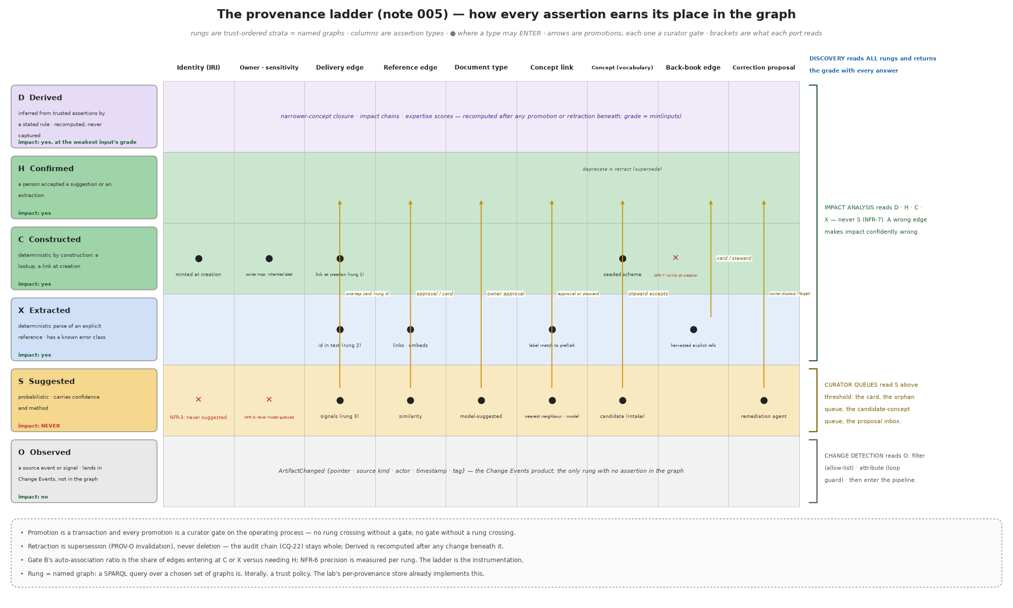
Figure 7 — The provenance ladder, implementer's view
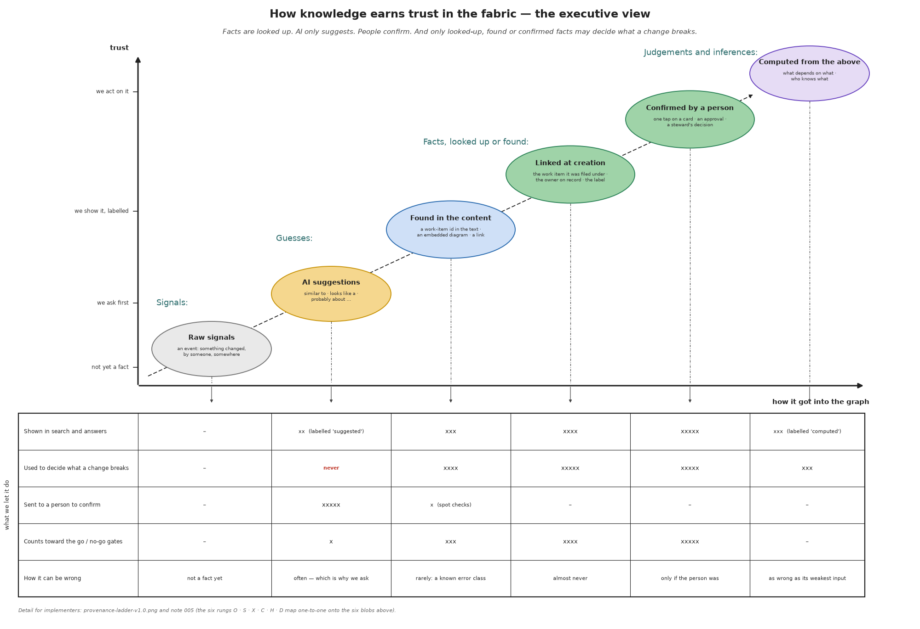
Figure 8 — The provenance ladder, executive view
Rules that are requirements: identity, owner and sensitivity enter at C only; back-book edges enter at X or H only; document type enters at S and is promoted by owner approval; promotion is a curator gate and there is no crossing without one; retraction is PROV-O supersession, never deletion; D is recomputed after any change beneath it; each output port declares the rungs it reads.

4.6 Ports, adapters and events (note 003)
The fabric exposes two contracts per source and holds no source credential. A per-source adapter — one app registration, least privilege on its source — satisfies both.

4.6.1 Port 1 — inbound events
Durable pub/sub (Redis Streams locally; Service Bus topics at Transitional; Eventstreams at Target). One event kind at MVP:
ArtifactChanged {
"eventId": "01J9X6…", // ULID
"pointer": {"source":"sharepoint","site":"…","driveItem":"…","version":"4.0"},
"sourceKind":"sharepoint|ado|ea-repo|teams|design-board",
"change": "created|updated|deleted|moved|relabelled",
"actor": {"oid":"…"}, // principal in the source
"occurredAt":"2026-09-11T08:10:31Z",
"fabricTag": null | {"runId":"…","kind":"draft|projection|proposal"} // set on fabric-originated writes
}
Idempotency key = pointer (source + item id). A new event for a pointer with a pending draft replaces that draft. Events carrying a fabricTag are dropped by Change Attribution (5.1.3) and never re-enter the pipeline.

4.6.2 Port 2 — content by reference
Governed tools registered with the gateway, granted per team, metered and traced: source_read(pointer) → {text, figures[], metadata}; source_read_versions(pointer); source_write_draft(pointer_folder, artifact_ref, fabricTag) → pointer; source_write_proposal(pointer, proposal_ref, mechanism) (Target; tracked changes, ADO suggested update, wiki pull request). Bytes never pass through the caller; the source's access decision applies at read time.

4.6.3 Adapter duties
Subscribe and translate (port 1); resolve pointers (port 2); tag fabric-originated writes and filter them on the way back in; expose no source API to the fabric. Adding a source = one adapter, one gateway registration, one grant.

5. Operating process
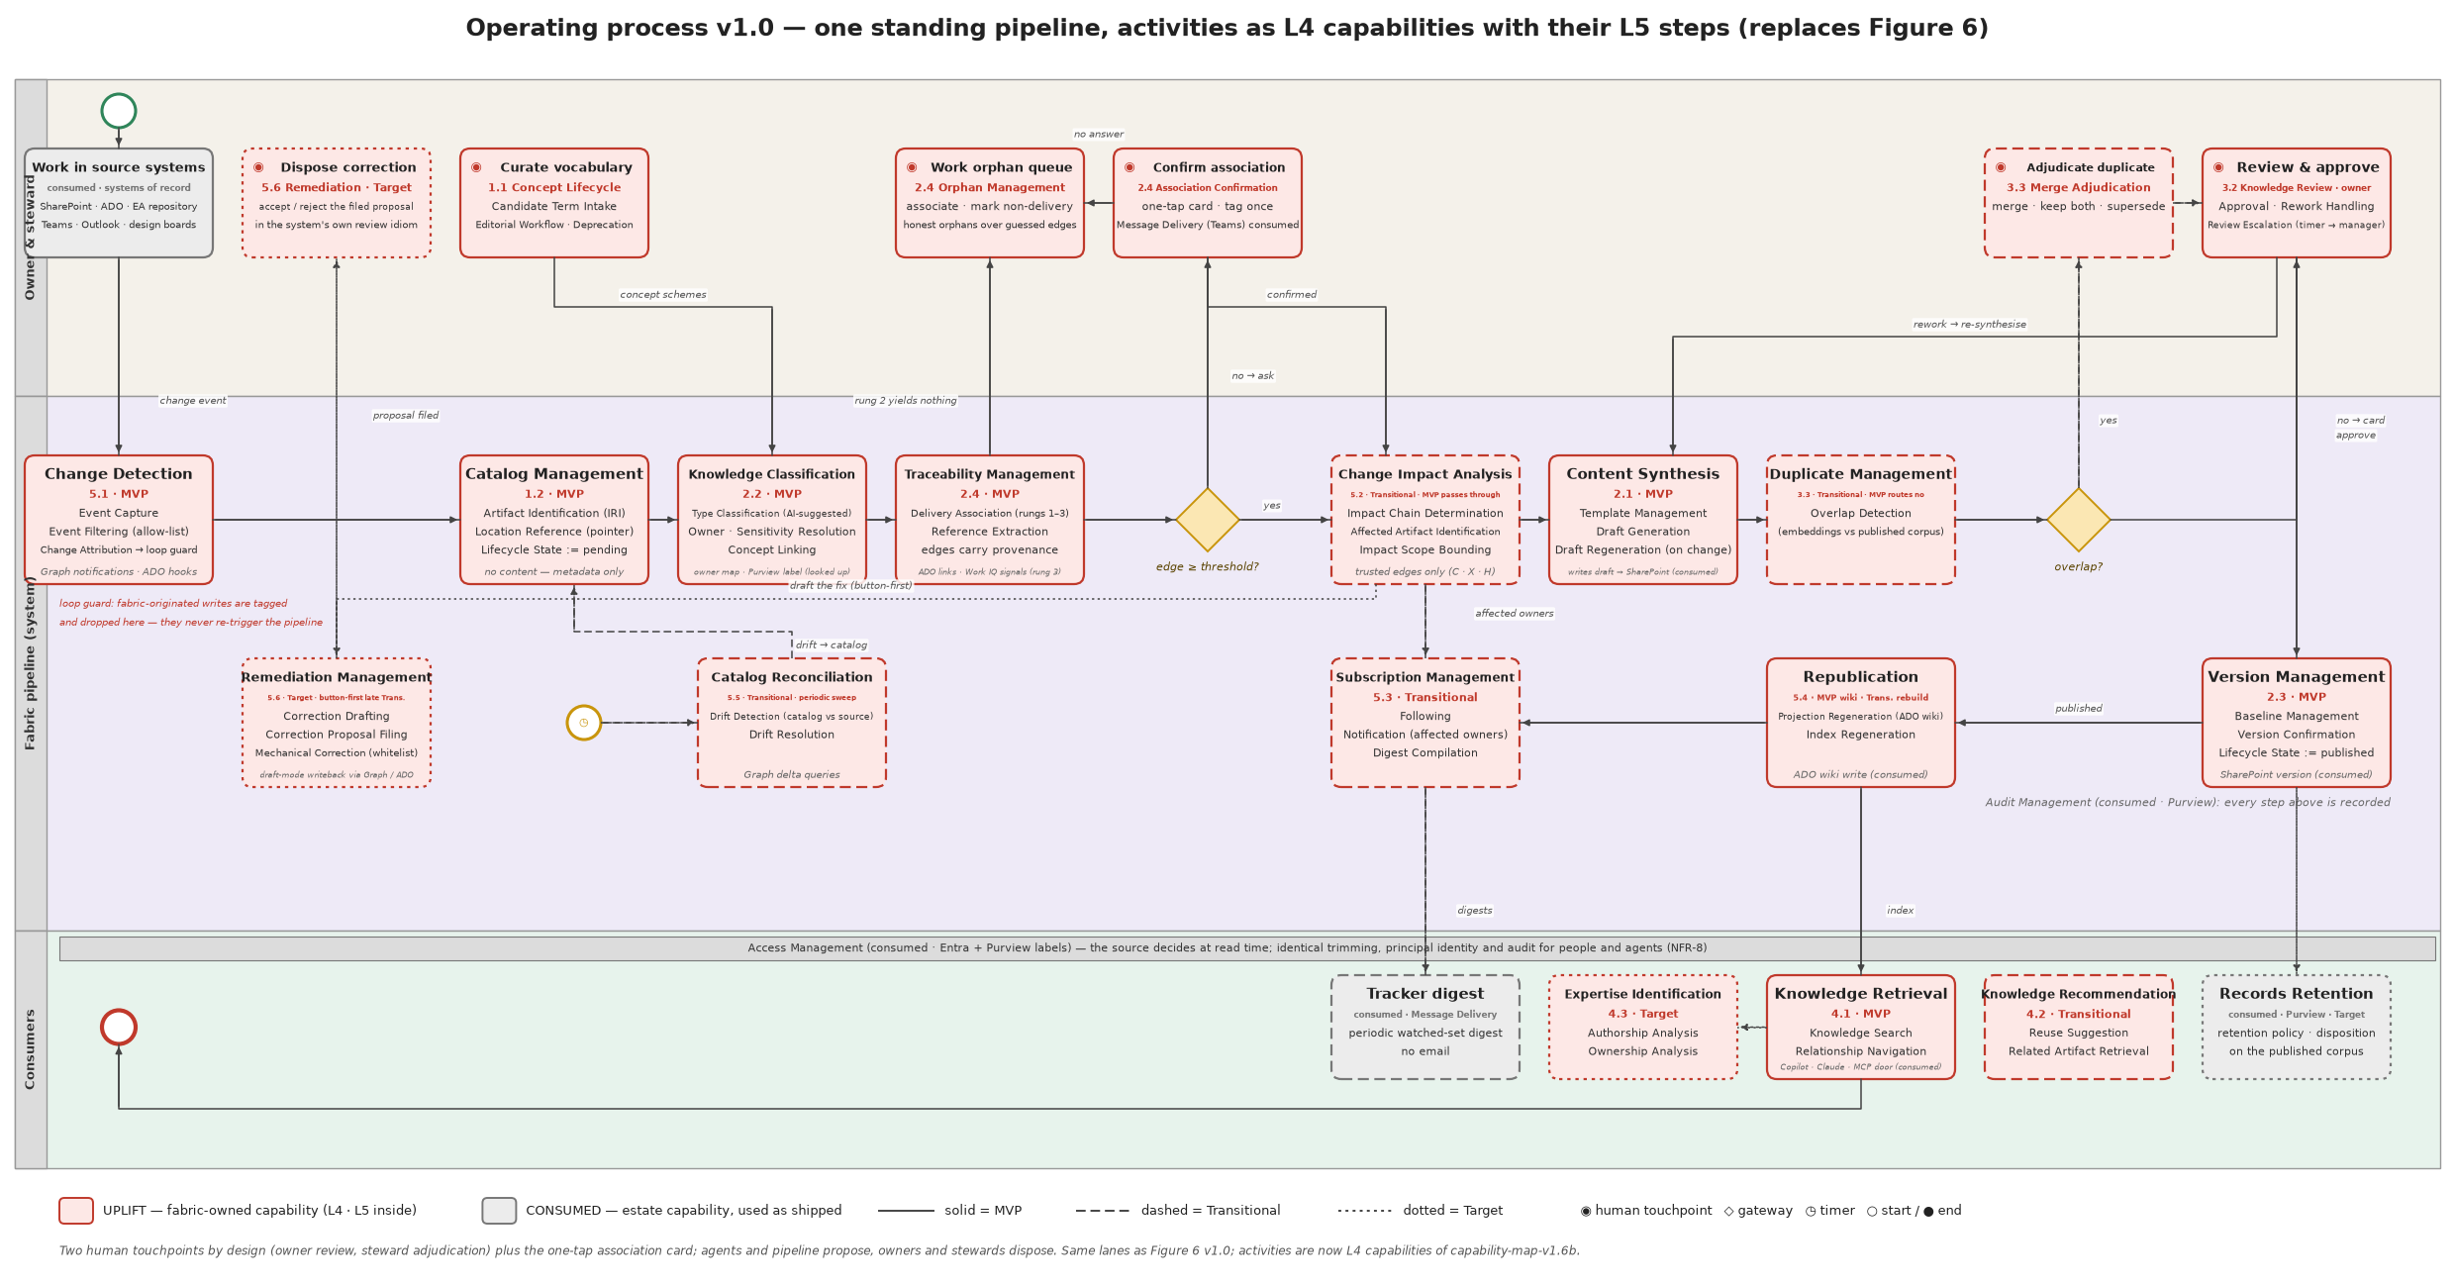
Figure 9 — The operating process: activities are L4 capabilities with their L5 steps
Step | Capability | Input | Output | Rung effect | On failure
Change event | 5.1 Change Detection | ArtifactChanged | filtered, attributed event | O | dead-letter after 3 attempts; sweep (5.5) recovers
Identify | 1.2 Catalog Management | event | catalog record (state = pending) or existing record | C (identity) | none — deterministic
Classify | 2.2 Knowledge Classification | record + content via port 2 | type (S), owner (C), label (C), concept links (X/S) | S/X/C | type unresolved → record stays pending, steward notified
Associate | 2.4 Traceability Management | record + content + ADO links | delivery edges (C/X/S), reference edges (X/S) | C/X/S | below threshold → one-tap card; no candidate → orphan queue
Impact | 5.2 Change Impact Analysis (Transitional; MVP pass-through) | trusted edges | affected set with chain and depth | reads C/X/H/D | —
Synthesise | 2.1 Content Synthesis | record, content, template, affected passages | draft written via port 2 with fabricTag | — | model call fails → retry via gateway; then steward
Overlap | 3.3 Duplicate Management (Transitional; MVP routes "no") | draft embedding vs published corpus | overlap flag | S | flagged → steward adjudication
Review | 3.2 Knowledge Review | draft, card | approve / rework / escalate | S→H (type, concept links); pending→published | timer → line manager
Baseline | 2.3 Version Management | approval | baseline record; version confirmed | C | —
Republish | 5.4 Republication | baseline | wiki projection; index refreshed | D recomputed | projection failure ≠ run failure; retried
Notify | 5.3 Subscription Management | baseline; affected set | notifications; digest entries | — | delivery failure retried; never blocks
Reconcile | 5.5 Catalog Reconciliation (Transitional) | timer | drift events into port 1 | O | —
Remediate | 5.6 Remediation Management (Target; button-first late Transitional) | affected set | proposal filed via port 2 | S→H on owner disposal | —

6. Functional requirements
Each L4 carries its L5 requirements, acceptance (CQs), phase, delivery mode (as designed / reuse-first) and an MVP realisation example.

FR-1.1 Vocabulary Management (BR-1) — MVP · G/B
- FR-1.1.1 Concept Scheme Management: maintain SKOS concept schemes with preferred and alternate labels, definitions, hierarchical and associative relations, facets, multilingual labels (ISO 25964-1).
- FR-1.1.2 Ontology Management: maintain the class/property model (§4.4), SHACL shapes, upper-vocabulary reuse, and inference rules; the model is versioned in git and validated in CI.
- FR-1.1.3 Vocabulary Alignment: maintain cross-scheme mappings (exact, close, broad, narrow) in a mappings graph; every mapping is human-confirmed (rung H) before it is read by discovery closure.
- FR-1.1.4 Concept Lifecycle Management: candidate intake from tagging misses and clustering; editorial workflow; versioning and deprecation (never deletion); quality checks (unique preferred labels, reciprocals, no cycles); publication (SKOS export, term-store sync, MCP).
- Acceptance: CQ-17, CQ-18; every SHACL fitness function.
- MVP realisation: SharePoint term store for subject schemes + SKOS/SHACL files in git validated in CI; Transitional VocBench 3 or a specialist platform per the bake-off (§9.2).

FR-1.2 Catalog Management (BR-1) — MVP · P
- FR-1.2.1 Artifact Identification: mint one IRI per artifact (ULID) at first sight; never derive it from a path; resolve any pointer to its IRI.
- FR-1.2.2 Location Reference Management: hold one or more pointers per artifact; a record holds no content field of any kind (NFR-2).
- FR-1.2.3 Lifecycle State Management: states pending → in-review → published | withdrawn, with unassociated as a legal flag; transitions only by the steps in §5.
- Acceptance: CQ-01, CQ-02, CQ-03, CQ-04, CQ-25.
- MVP realisation: Cosmos DB serverless, one container for records, edges and embeddings; partition key = IRI.

FR-2.1 Content Synthesis (BR-2) — MVP · P
- FR-2.1.1 Template Management: one template per confirmed document type, held as a SharePoint list item; versioned.
- FR-2.1.2 Draft Generation: synthesise a draft from the artifact's content (port 2), its template and, where available, the affected passages; every model call through the AI gateway; the draft is written via port 2 with a fabricTag; catalog state = pending.
- FR-2.1.3 Draft Regeneration: on a new event for a pointer with a pending draft, regenerate and replace; never stack.
- Acceptance: synthesis pilot threshold (approval without substantive rewrite) on ~10 real transcripts; CQ-04.
- MVP realisation: Functions on consumption; templates in a SharePoint list.

FR-2.2 Knowledge Classification (BR-2) — MVP · S/P
- FR-2.2.1 Type Classification: suggest the document type with a confidence (rung S); the owner's approval promotes it to H.
- FR-2.2.2 Owner Resolution: look up the owner from the owner map by site/library/folder; never model-guessed (rung C); unresolved → steward.
- FR-2.2.3 Sensitivity Resolution: read the inherited Purview label; never model-guessed (rung C).
- FR-2.2.4 Concept Linking: link subjects by label match against the schemes (rung X) and by nearest neighbour/model (rung S); misses go to candidate intake.
- Acceptance: CQ-12, CQ-13, CQ-15; classification accuracy per type before a type onboards (NFR-6).
- MVP realisation: type suggested by the same model call as the draft; SharePoint Premium classifier pilot only if it beats it on measured accuracy.

FR-2.3 Version Management (BR-2) — MVP · S
- FR-2.3.1 Baseline Management: on approval, record the baseline (version, approver, time) on the catalog record.
- FR-2.3.2 Version Confirmation: confirm the SharePoint version id at baseline; a later source version without a baseline is drift (5.5).
- Acceptance: CQ-04.

FR-2.4 Traceability Management (BR-2) — MVP · P
- FR-2.4.1 Delivery Association: rung 1 = ADO link at creation (C); rung 2 = work-item id in text (X); rung 3 = signals with confidence (S); rung 4 = one-tap card (H). Threshold configurable; nothing below threshold is committed without confirmation.
- FR-2.4.2 Reference Extraction: extract links, embedded diagrams and id mentions into reference edges (X).
- FR-2.4.3 Association Confirmation: the card carries the evidence for the suggestion (shared concepts, authorship, time window) and offers candidates beside free text; no answer within the timer → orphan queue.
- FR-2.4.4 Orphan Management: the steward queue holds artifacts that look like delivery work and lack a parent; "non-delivery" is a valid disposition.
- Acceptance: CQ-05 to CQ-09, CQ-11; auto-association ratio (Gate B).
- MVP realisation: edges as Cosmos documents with rung, method, actor, confidence; card via Teams.

FR-3.1 Ownership & Stewardship (BR-3) — MVP · L
- FR-3.1.1 Owner Assignment from the owner map; FR-3.1.2 Steward Assignment per scheme and per queue; FR-3.1.3 Steward Work Queue Management: orphan queue, candidate concepts, duplicate flags, proposal inbox, with load metrics.
- Acceptance: CQ-14; per-owner and per-steward load reported from day one.

FR-3.2 Knowledge Review (BR-3) — MVP · L
- FR-3.2.1 Approval: one-touch card in Teams with the draft's pointer, type, concept links and evidence; approve / request changes.
- FR-3.2.2 Rework Handling: "changes requested" keeps the item open and triggers regeneration with the owner's comment.
- FR-3.2.3 Review Escalation: timer to the line manager; digest batching for owners with many cards.
- Acceptance: gate load sustainable at multi-type volume (Gate B).

FR-3.3 Duplicate Management (BR-3) — Transitional · P
- FR-3.3.1 Overlap Detection: before review, compare the draft's embedding with the published corpus; flag above threshold with the shared concepts and work item as evidence (S).
- FR-3.3.2 Merge Adjudication: steward decides merge / keep both / supersede; the decision is a promotion (H) and is audited.
- Acceptance: CQ-19. MVP: the gateway routes "no"; embeddings are still stored.

FR-4.1 Knowledge Retrieval (BR-4) — MVP · S
- FR-4.1.1 Knowledge Search over the published corpus with label trimming at read time; results carry owner, state and provenance grade.
- FR-4.1.2 Relationship Navigation: traverse delivery, reference and subject edges from any artifact or concept, with the rungs read declared.
- Acceptance: CQ-16, CQ-21 (consumed), CQ-27. MVP: Microsoft Search and Copilot over SharePoint; catalog joins in Functions; Transitional: the Work IQ MCP door and a thin fabric facade.

FR-4.2 Knowledge Recommendation (BR-4) — Transitional · L
- FR-4.2.1 Reuse Suggestion before creation, by concept and work item; FR-4.2.2 Related Artifact Retrieval via graph joins.
- Acceptance: CQ-20.

FR-4.3 Expertise Identification (BR-4) — Target · S
- FR-4.3.1 Authorship Analysis and FR-4.3.2 Ownership Analysis over catalog metadata, recency-weighted; no content is read. Acceptance: CQ-26.

FR-5.1 Change Detection (BR-5) — MVP · L/P
- FR-5.1.1 Event Capture is the adapter's duty (note 003); FR-5.1.2 Event Filtering by allow-list (sites, projects, item types); FR-5.1.3 Change Attribution drops events carrying a fabricTag.
- Acceptance: CQ-23 must answer "none".

FR-5.2 Change Impact Analysis (BR-5) — Transitional · P
- FR-5.2.1 Impact Chain Determination over rungs C · X · H (+ D) only; FR-5.2.2 Affected Artifact Identification with the passage or element affected; FR-5.2.3 Impact Scope Bounding by depth and by artifact class.
- Acceptance: CQ-10, CQ-11; precision measured on live work items before Transitional (Gate B). MVP: pass-through.
Example — CQ-10 over trusted graphs only (SPARQL):
SELECT ?affected ?depth WHERE {
GRAPH ?g { ?affected (fab:references|fab:deliveredUnder)+ <urn:fabric:artifact:CHANGED> }
FILTER (?g IN (<urn:fabric:graph:C>, <urn:fabric:graph:X>, <urn:fabric:graph:H>))
# depth bounding applied by the traversal service; ?g never includes graph:S
}

FR-5.3 Subscription Management (BR-5) — Transitional · L
- FR-5.3.1 Following of artifacts, work items and concepts; FR-5.3.2 Notification of affected owners on impact; FR-5.3.3 Digest Compilation on a schedule; events, never email.
- Acceptance: CQ-24.

FR-5.4 Republication (BR-5) — MVP wiki · Transitional rebuild · P
- FR-5.4.1 Projection Regeneration: ADO wiki page per published artifact, regenerable, tagged as fabric-originated; FR-5.4.2 Index Regeneration after baseline.
- Acceptance: CQ-04.

FR-5.5 Catalog Reconciliation (BR-5) — Transitional · P
- FR-5.5.1 Drift Detection: periodic comparison of catalog records with sources via port 2 (deleted, moved, relabelled, new version without baseline); FR-5.5.2 Drift Resolution: emits ArtifactChanged into port 1, never writes the catalog directly.
- Acceptance: CQ-25.

FR-5.6 Remediation Management (BR-5) — Target (button-first late Transitional) · P
- FR-5.6.1 Correction Drafting for an affected artifact, reusing 2.1; FR-5.6.2 Correction Proposal Filing through the target system's own review mechanism via port 2 (S); FR-5.6.3 Mechanical Correction Application only for owner-whitelisted edit types, dry-run and revert.
- Acceptance: remediation approval rate (Gate C); owner-invoked first, unprompted only after the threshold.

Consumed capabilities — interface requirements
- Access Management (Identity & Access): principal identity for people and agents (Entra); label trimming at read time by the source; CQ-21 answered identically for a person and for an agent acting for them.
- Audit Management (GRC): every synthesis, approval, promotion, publication and propagation recorded with actor, time and run id; CQ-22.
- Records Retention (Records Management): Purview policies apply to the published corpus; disposition at Target.

7. Competency questions — the acceptance suite
The 27 competency questions are the functional features of the products' output ports. Each is implemented as a SPARQL query or tool call and accepted by a test over fixture triples, before any production triple exists. They are grouped by product; the composite questions belong to the aggregate. The full table is Annex E.

8. Non-functional requirements
ID | Requirement
NFR-1 Residency | All processing and storage in-region (Azure UAE North / M365 UAE geo); every model call through the AI Hub Gateway; no metadata leaves the tenant estate. Work IQ and any Fabric capacity are used only once their UAE residency is verified.
NFR-2 Metadata only | No fabric store holds document body content. Enforced by SHACL in CI and at write time (§11.2).
NFR-3 Deterministic governance data | Owner and sensitivity are resolved from reference stores (rung C only); access is decided by the source at read time.
NFR-4 Security and audit | Entra identity throughout; adapters hold source credentials, the fabric holds none; full audit of synthesis, approval, promotion, publication, propagation.
NFR-5 Severability | Each phase is complete; later-phase components are adapters behind ports and can be removed without breaking earlier operation.
NFR-6 Quality gates | Measured, published, per rung where applicable: approval-without-rewrite share; impact precision on live work items; classification accuracy per type; auto-association ratio; remediation approval rate; gate load per owner and steward.
NFR-7 Association integrity | No edge below threshold committed without confirmation; unassociated is legal; impact served over C·X·H·D only; back-book edges never enter at C.
NFR-8 Consumer parity | Identical interfaces, trimming, principal identity and audit for people and agents; no privileged agent path.
NFR-9 Write authority | Drafts, projections and proposals only; fabric writes tagged; re-drafts replace pending drafts; propagation depth bounded; auto-apply only whitelisted mechanical edits with dry-run and revert.
NFR-10 Provenance | Every assertion carries rung, method, actor, confidence and time; retraction is supersession; the grade is returned with every answer.
NFR-11 Event integrity | Inbound events durable, at-least-once, idempotent per pointer; dead-lettered after bounded retries; reconciliation recovers misses.
NFR-12 Product service levels | Each product publishes its service level (§4.3) and the aggregate inherits the weakest per answer.
NFR-13 Cost | No reserved platform capacity before Target; consumption-billed services under caps; fixed monthly cost per phase as in §10.

9. Options and sourcing

9.1 Market scan against the L4 list
The two options views — incumbents product by product, and provider classes — are BRS Figures 4 and 5 and are not repeated here; this section records the findings and the target compositions they carry.
Findings (September 2026; documentation-based, not a live evaluation — market-scan-2026-09.md):
- No single product covers the L4 set; the estate as shipped scores 5 full, 11 partial, 1 none of the 18 owned L4s. The none is Change Impact Analysis.
- Atlassian's Teamwork Graph with Rovo is the nearest single-product shape (work item ↔ page ↔ code captured at creation; agentic writeback) and is excluded because it requires Jira and Confluence as systems of record. It is the reference for what the composition should feel like.
- Vocabulary Management has a mature specialist market (PoolParty, Semaphore, TopBraid EDG, Synaptica, Mondeca) and an open-source baseline (VocBench 3) — the second buy-lite candidate.
- "Impact analysis has zero market coverage" (v1.0) is reworded to "no general-purpose coverage": Swimm proves detect-and-fix in the code domain.
- Work IQ (GA June 2026; MCP, REST, A2A; consumption billing) moves from "watch" to "consume at Transitional" for retrieval, expertise and rung-3 signals. Glean's read-only verdict is stale; its exclusion stands on residency.
- Curated knowledge-base suites are the pattern proof for Governance and are excluded by federation.

9.2 Vocabulary Management bake-off
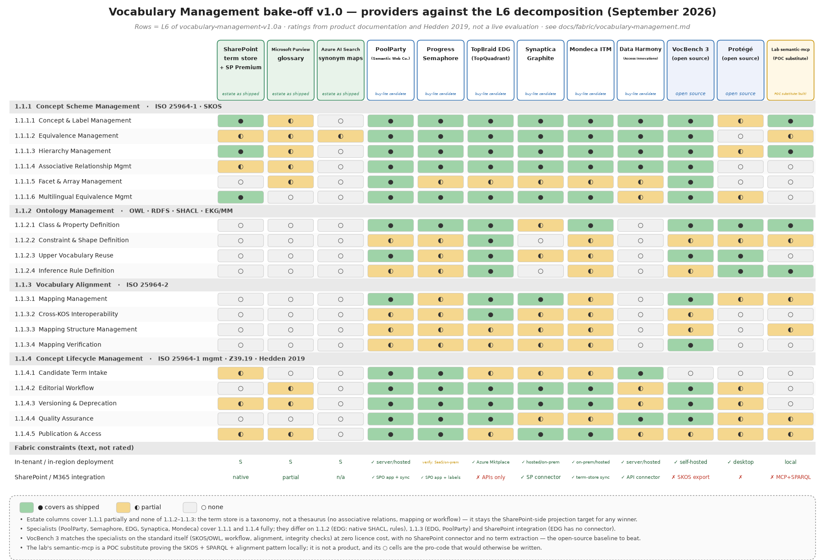
Figure 10 — Providers against the L6 decomposition
Shortlist: PoolParty, Semaphore, TopBraid EDG, with VocBench 3 as the open-source control and the SharePoint term store as the mandatory projection target. Decide: whether the fabric's ontology lives in the tool or in code with SHACL in CI; term-store sync fidelity (labels and hierarchy survive, associative relations and mappings do not); residency of hosted offerings.

9.3 The two target columns
The options view carries the composition as designed (Annex D of v1.0) and reuse-first (note 002). They differ exactly where the estate ships what the design planned to build — Classification, Version Management, Retrieval, Expertise — and where a buy-lite covers the gap (Vocabulary). Reuse-first outcome: 7 S · 1 B · 5 L · 8 P; the pro-code cells are Catalog, Content Synthesis, Traceability, Duplicate detection, Impact Analysis, Republication, Reconciliation, Remediation.

9.4 Estate platforms on the horizon
- Work IQ — the M365 content and people axis; the MCP door for agents (NFR-8) and rung-3 signals; Transitional.
- Fabric IQ — the meaning and relationships axis over OneLake (Graph GA, Ontology preview); a credible Target realisation of the store, graph and event ports; not a thesaurus, so Vocabulary Management stays with the bake-off; gated on Ontology GA, UAE residency and the metadata-only rule in CI.
- Foundry IQ — agent retrieval over knowledge bases; Target.

10. Phased realisation
Every phase step is an adapter swap behind a port; the pipeline shape is final at the POC and does not change afterwards.

10.1 The POC plateau — the lab as a laptop-local substitute stack
The one-week standalone proof (BRS §7.3) runs on the local agentic lab, which already holds every port the fabric needs with an adapter behind it, and whose design rule is pattern parity with the Azure target: every agent authenticates, egresses through a gateway, is metered, PII-scanned and traced. The POC is evidence only and throwaway by declaration; what it proves carries forward because the ports are the same.
Fabric element | POC realisation in the lab | Azure counterpart it stands in for
Pipeline host (§5) | one Agent Framework workflow, change_to_adr, as a ProcessSpec; deterministic nodes for identify, associate, baseline; agent nodes for classify and synthesise; run under the shared governed_run skeleton (root span, trace id, run board) | Azure Functions pipeline + Container Apps
Store — catalog, embeddings | Postgres (Neon): catalog and edge tables alongside the existing artifact store; embeddings via the gateway's nomic model into pgvector | Cosmos DB serverless (MVP)
Graph — edges, provenance, traversal | semantic-mcp rdflib store: one named graph per rung (O·S·X·C·H·D), SPARQL over a chosen set of graphs is the trust policy; derivation via CONSTRUCT | Cosmos adjacency (MVP) → Fabric Graph (Target)
Event — port 1 | Redis Streams (workflow:requests, workflow:finished), consumer groups, idempotency by SET NX on the pointer, reclaim of unacked entries, dead-letter after bounded retries | Storage Queue (MVP) → Service Bus → Eventstreams
Content by reference — port 2 | storage-mcp (read by art:// ref, never bytes through the agent) and collab_mcp (collab_fetch in, collab_put out, handle-addressed, fabric writes carry the tag) | Graph / ADO APIs behind adapters
Source adapters | collab_mcp (SharePoint drive, Teams meetings and recordings via Microsoft Graph); adoit-mcp (EA repository, read; staged import for write); new: an ADO adapter (work items, service hooks) — the only adapter the POC has to build | per-source adapters
Vocabulary | semantic-mcp SKOS store (the capability reference schemes already loaded, cross-scheme exactMatch in a mappings graph); SKOS and SHACL files in git, validated in CI | term store + git (MVP) → VocBench → specialist platform
Retrieval — people and agents | the reference layer's search through the gateway; SPARQL and traversal as gateway-registered MCP tools; one door for the review app and for agents (per-team grants) | Microsoft Search + Copilot (MVP) → Work IQ MCP
Review surface — curators | the review app (Streamlit) plus the Teams adaptive-card channel already built (approvals on Redis Streams, human_decision with a named actor, escalation timer to add); Telegram as the second channel | Teams Approvals + Power Automate
Projection | Markdown per published artifact (the ADO-wiki shape); optionally opened as an Obsidian vault so a reviewer sees the graph without a UI | ADO wiki
Trust services | Entra per agent (MSAL client credentials → gateway virtual key), LiteLLM gateway (teams, keys, per-tool ACLs, spend), Presidio PII guardrail, OpenTelemetry → Jaeger (one trace per run, the audit trail), governance tests as fitness functions | Entra, AI Hub Gateway, Purview audit, Monitor, CI checks
Cloud tier | Railway (substrate + workload images, immutable sha- tags, CD from main) for the two-week integrated proof against live work items and a pilot site | Container Apps

What the POC must demonstrate: the ArtifactChanged contract end to end from a SharePoint change to a published projection; the ladder as named graphs with one promotion through the Teams card; CQ-01 to CQ-07, CQ-10, CQ-12, CQ-13, CQ-15, CQ-17, CQ-23 answered over real triples; the metadata-only SHACL shape failing a deliberate violation in CI. Cost: negligible — the substrate at Hobby-plan rates, consumption-priced inference.

10.2 Ports and adapters by phase
Port | POC adapter (lab) | MVP adapter | Transitional adapter | Target adapter
Store (catalog, embeddings) | Postgres (Neon) + pgvector | Cosmos DB serverless | Cosmos + Purview registration | OneLake + Purview Unified Catalog
Graph (edges, traversal) | rdflib named graphs, SPARQL (semantic-mcp) | Cosmos adjacency documents | traversal service in Functions | Fabric Graph
Event (change → pipeline) | Redis Streams | Storage Queue | Service Bus topics | Eventstreams + Activator
Content by reference | storage-mcp, collab_mcp | Graph / ADO adapters | same | same
Retrieval (people and agents) | gateway-registered MCP tools; reference-layer search | Graph search API + Copilot | Work IQ MCP | + Foundry IQ, Fabric IQ ontology MCP
Vocabulary | semantic-mcp SKOS + git | term store + SKOS in git | VocBench 3 | PoolParty / Semaphore + Fabric IQ Ontology
Review surface | review app + Teams card channel | Teams Approvals + Power Automate | + Power Apps console | pro-code Teams bot
Model gateway | LiteLLM (Ollama Cloud, Claude) | AI Hub Gateway | same | same

10.3 What each phase costs to keep on
Phase | Fixed monthly (order of magnitude, list prices) | Deliberately absent
POC | negligible: Railway Hobby substrate, Neon free tier, flat-rate inference | everything Azure-specific; nothing is licensed
MVP | tens of USD | AI Search, Service Bus, Copilot Studio, Fabric, vocabulary licence, Work IQ
Transitional | low hundreds | Fabric capacity, commercial taxonomy licence
Target | F-SKU capacity + taxonomy licence + AI Search Standard + Foundry IQ | —

Per-capability realisation by phase is in phased-realisation.md.

11. Verification

11.1 Gates
Gate | Evidence
A (inception → MVP) | six document types confirmed; ADO operating decision ratified; owner/label resolution verified on the pilot site; the two proofs of concept run
B (MVP → Transitional) | synthesis pilot approval-without-rewrite ≥ threshold on ~10 transcripts; ADO link-hygiene audit passes; impact precision ≥ target on live work items; auto-association ratio ≥ target; gate load sustainable
C (Transitional → Target) | catalog maturity sufficient for expertise answers; remediation approval rate ≥ threshold from owner-invoked use; records governance sign-off

11.2 Fitness functions in CI
- Metadata only. A SHACL shape on fab:Artifact and on every event forbids any property whose value exceeds a bounded length or matches content types; the build fails on violation. Example:
fab:ArtifactShape a sh:NodeShape ; sh:targetClass fab:Artifact ;
sh:closed true ; sh:ignoredProperties ( rdf:type ) ;
sh:property [ sh:path dct:title ; sh:maxLength 300 ] ;
sh:property [ sh:path dcat:accessURL ; sh:minCount 1 ] ;
sh:property [ sh:path fab:body ; sh:maxCount 0 ] . # no content property may exist
- Owner and label never model-originated. Every fab:ownedBy and fab:sensitivityLabel assertion must sit in graph C with method ∈ {owner-map, inherited-label}.
- No custom duplicate of an estate standard. Each pro-code component declares the estate capability it does not duplicate; the quarterly review re-runs the check.
- Competency questions. All 27 CQs run as tests over fixture triples; CQ-03 and CQ-23 must answer "none".
- Per-rung precision. Sampled audits per rung feed the NFR-6 dashboard.

12. Technical risks
Risk | Mitigation
ADO hygiene undermines traceability | hygiene audit and link-backfill before Transitional; impact prototype on live work items as the gate
Low-code in the critical path hits limits | note 002 keeps low code to surfaces and triggers; pro-code Teams bot presents the identical card
Cosmos adjacency traversal too slow at scale | graph port isolates it; Fabric Graph is the Target adapter; measured at Gate B
Metadata-only rule eroded by convenience (OneLake shortcuts, mirroring) | SHACL fitness function in CI and at write time; fails the build
Vocabulary sprawl | tagging proposes, the gate resolves against schemes; unmatched labels queue for the steward; schemes seeded, not grown from nothing
Work IQ / Fabric IQ residency or billing unverified | consumed only after verification; Cosmos/Storage Queue adapters remain

13. Inception actions (Gate A checklist)
- Approve MVP scope, the phased posture model and the compose-and-reuse decision (BRS §9).
- Confirm the six document types.
- Ratify the ADO operating decision: all disciplines as work items; attach-at-creation; item-workspace auto-link.
- Seed the vocabulary: capability reference model, EA repository application components, ADO area paths, document types; appoint the steward per scheme.
- Run the association-ladder spike over a sample of real EA diagram output; measure rung-1/2 yield.
- Run the two validation prototypes: impact query on live work items (with hygiene audit); ADR synthesis pilot on ~10 transcripts.
- Run the SharePoint Premium classification pilot against the model on the same document set; run the Vocabulary Management bake-off (§9.2).
- Stand up the MVP loop on the AI Landing Zone with the Teams owner gate; adapters for SharePoint and ADO only.
- Instrument from day one: time-to-locate, staleness age, duplication rate, auto-association ratio, per-rung precision, gate load.
- Write the business competency questions (CQ-27+) with the asker's role; they decide seeding order.

Annex A — Acronyms
Acronym | Meaning
ADO | Azure DevOps
ADR | Architecture Decision Record
AILZ / AI Hub Gateway | AI Landing Zone / its APIM-based model gateway
BIZBOK | Business Architecture Body of Knowledge (Business Architecture Guild)
BR / FR / NFR | Business / Functional / Non-Functional Requirement
CAFÉ | the organisation's agentic reference architecture
CQ | Competency Question
DCAT / PROV-O / SKOS / SHACL / OWL / RDFS | W3C vocabularies and languages used by the ontology
EKG/MM | Enterprise Knowledge Graph Maturity Model (EKGF)
IRI | Internationalised Resource Identifier
KOS | Knowledge Organisation System
MCP | Model Context Protocol
O · S · X · C · H · D | provenance rungs: observed, suggested, extracted, constructed, human-confirmed, derived

Annex B — References
Reference | Used for
BIZBOK Guide (Business Architecture Guild) | capability levelling and naming; initiative-to-capability cross-mapping
TOGAF Standard, 10th ed. — business capabilities | capability-based planning
ISO 30401 Knowledge management systems (§4.4) | the five L3 groups
ISO 25964-1/-2 Thesauri and interoperability | Vocabulary Management L6
ANSI/NISO Z39.19 | controlled-vocabulary maintenance
W3C SKOS, RDF/RDFS, OWL, SHACL, PROV-O, DCAT; DCMI Terms | the ontology and its constraints
Grüninger & Fox 1995 | competency questions as ontology requirements
Zeng 2008; Hodge 2000 | knowledge-organisation spectrum (basis of the executive ladder layout)
Hedden 2019 | vocabulary-software selection criteria
Dehghani, Data Mesh | data products, aggregate products, federated computational governance
EKGF EKG/MM v1.0 | knowledge-graph capability vocabulary
Market scan, September 2026 (market-scan-2026-09.md) | options and provider verdicts
Microsoft Learn / blogs: Work IQ GA (June 2026), Fabric IQ (Build 2026), SharePoint Premium, Purview | estate capabilities and horizon

Annex C — CAFÉ conformance
The v1.0 conformance statement stands (archetype A6 with A1/A2 additions; guardrails G06 on the knowledge path and G09 on the owner gate). The conformance render is to be regenerated from the platform view with the drawio-cafe skill once the logical view is re-cut; until then the v1.0 Figure 10 applies.

Annex D — Component catalogue, by phase
Component | Realises | POC (lab) | MVP | Transitional | Target | Mode
Source adapters (SharePoint, ADO; then EA repo, Teams, design boards) | ports 1 and 2 | collab_mcp, adoit-mcp, new ADO adapter | Functions + Graph/ADO hooks and APIs | same | same | P
Event stream | port 1 | Redis Streams | Storage Queue | Service Bus topics | Eventstreams + Activator | S/P
Catalog and graph store | 1.2, 2.4 | Postgres + rdflib named graphs | Cosmos DB serverless | + Purview registration | OneLake + Fabric Graph | P → S
Vocabulary store | 1.1 | semantic-mcp SKOS + git | term store + SKOS in git | VocBench 3 | PoolParty / Semaphore; Fabric IQ Ontology | S/B
Pipeline services (classify, associate, synthesise, baseline, republish, reconcile) | 2.x, 5.x | Agent Framework workflow nodes | Functions (consumption) | same | same | P
Impact analysis | 5.2 | SPARQL over C·X·H graphs | pass-through | traversal in Functions | Fabric Graph query | P
Duplicate detection | 3.3 | pgvector similarity | off (routes "no") | Cosmos vector search | AI Search / Foundry IQ | P
Review cards and escalation | 3.2 | review app + Teams card channel | Teams Approvals + Power Automate | same | pro-code Teams bot | L
Steward console | 3.1 | review app queues | SharePoint lists | Power Apps | same | L
Retrieval door | 4.1 | gateway MCP tools | Microsoft Search + Copilot | Work IQ MCP + fabric facade | + Foundry IQ, Fabric IQ MCP | S
Discovery agent | 4.2 | — | — | Copilot Studio | + Work IQ context | L
Tracker bot and digests | 5.3 | meeting notifier pattern | — | Power Automate / Teams | Activator → Teams | L
Remediation | 5.6 | — | — | button-first via port 2 | agents + writeback | P
Trust services | consumed | Entra, LiteLLM, Presidio, OTel/Jaeger | Entra, Purview, AI Hub Gateway, Monitor | same | same | S

Annex E — Competency questions (full)

Documentation Fabric — semantic layer competency questions (draft 0.4)
Method: Grüninger & Fox (1995). A competency question (CQ) is a question the semantic layer must answer; the ontology is complete when every CQ has a SPARQL query that answers it over fixture triples. Each CQ becomes a unit test in tests/unit/core/semantic/ before any production triple exists.
Grouped by data product (note 004). The fabric is four metadata products sharing one ontology — Knowledge Catalog, Traceability Graph, Vocabulary, Change Events — plus one aggregate product, the Knowledge Layer facade, which owns every COMPOSITE question. The embedding index is NOT a product: it is derived, rebuildable data used as a mechanism by composite answers. A CQ is a functional feature of its product's output port: the SPARQL/tool call is the implementation, the fixture-triples test is the acceptance.
Columns: Capability is the L3 group and L4 capability (with the L5 line where one applies) the question exercises, using the names in capability-map-v1.6b / v1.6a; *CONSUMED* marks a question answered by an estate capability the fabric uses but does not own. A question that needs two L4s to answer is a MECE warning on the map, not on the question. Graphs names the provenance partitions the query may read: C = constructed, X = extracted, H = human-confirmed, S = suggested; O = observed (Change Events, not in the graph) and D = derived (recomputed) per note 005. Phase follows the initiative doc.

Product 1 — Knowledge Catalog
Owner: the fabric, per-artifact ownership resolved from the owner map. Output ports: catalog tools, SPARQL. Service level: metadata-only fitness function (CQ-03), currency.
ID | Question | FR / NFR | Capability (L3 · L4 · L5, per map v1.6b / v1.6a) | Graphs | Phase
CQ-01 | Given a source-system item (SharePoint file id, ADO work item id, EA object id), what is its one fabric IRI, and does it resolve back to the system of record? | FR-2, NFR-2 | Organisation · Catalog Management (Artifact Identification, Location Reference Management) | C | MVP
CQ-02 | Which artifacts exist in the catalog with lifecycle state *pending*, *published*, or *unassociated*? | FR-2, FR-7 | Organisation · Catalog Management (Lifecycle State Management) | C | MVP
CQ-03 | Does any catalog record hold document body content? (Must be answerable and must answer *none*: the NFR-2 fitness function.) | NFR-2 | Organisation · Catalog Management (Location Reference Management — fitness function) | all | MVP
CQ-04 | For a published artifact, which SharePoint version was baselined and when, and which projection(s) were rebuilt from it? | FR-7 | Production · Version Management; Currency · Republication | C | MVP
CQ-12 | What is the document type of artifact A, was it confirmed or only suggested, and by what? | FR-3 | Production · Knowledge Classification (Type Classification) | H, S | MVP
CQ-13 | Who owns artifact A and which sensitivity label does it carry, and from which authoritative source was each resolved? (Must never be answerable from S.) | FR-3, NFR-3 | Production · Knowledge Classification (Owner Resolution, Sensitivity Resolution) — consumes Identity & Access Mgmt | C | MVP
CQ-14 | Which artifacts of type T are owned by person P? | FR-3, FR-6 | Governance · Ownership & Stewardship (Owner Assignment) | C | MVP
CQ-21 | For principal P, which artifacts may be returned at all, given the labels P may read? (The same answer for a person and for an agent acting for P.) | FR-9, NFR-3, NFR-8 | CONSUMED · Identity & Access Management (Principal Scoping) — parity for people and agents | C | MVP
CQ-25 | Where does the catalog disagree with the source system (deleted, moved, relabelled)? (Reconciliation sweep.) | 5.x reconciliation | Currency · Catalog Reconciliation (Drift Detection) | C | Transitional

Product 2 — Traceability Graph
Owner: the fabric; stewards confirm edges. Output ports: traversal tools, SPARQL over chosen provenance graphs. Service level: edge precision per NFR-7; impact served over C · X · H only.
ID | Question | FR / NFR | Capability (L3 · L4 · L5, per map v1.6b / v1.6a) | Graphs | Phase
CQ-05 | Which artifacts are delivered under work item W? | FR-2 | Production · Traceability Management (Delivery Association) | C, X, H | MVP
CQ-06 | Under which work item is artifact A delivered, by which rung of the association ladder, and with what confidence? | FR-2, NFR-7 | Production · Traceability Management (Delivery Association, provenance) | C, X, H, S | MVP
CQ-07 | Which artifacts have no delivery association (the steward orphan queue), ordered by age and traffic? | FR-2, FR-12 | Production · Traceability Management (Orphan Management) | C, X, H | MVP
CQ-09 | Which artifacts reference artifact A (an embedded diagram, a link, an ID mention), and which does A reference? | FR-2 | Production · Traceability Management (Reference Extraction) | X, H | MVP
CQ-10 | Which artifacts are downstream of changed item X over *trusted* edges only, to bounded depth N? (Impact analysis; S is excluded by definition.) | FR-7, NFR-7, NFR-9 | Currency · Change Impact Analysis (Impact Chain Determination, Impact Scope Bounding) | C, X, H | Transitional
CQ-11 | Which edges are older than the operating-model adoption date and were neither harvested from an explicit reference nor human-confirmed? (Back-book exclusion.) | NFR-7 | Production · Traceability Management (provenance); Currency · Change Impact Analysis | C, X, H | Transitional

Product 3 — Vocabulary
Owner: the steward. Output ports: SKOS export, term-store sync, MCP. Service level: concept lifecycle (propose → accept → deprecate), alignments human-confirmed.
ID | Question | FR / NFR | Capability (L3 · L4 · L5, per map v1.6b / v1.6a) | Graphs | Phase
CQ-17 | Which labels proposed by tagging matched no concept in any scheme, and how many artifacts carry each? (Proposed-concept queue.) | FR-3 | Organisation · Vocabulary Management (Concept Lifecycle Management) | S | MVP
CQ-18 | Which concepts in scheme A align to which concepts in scheme B, and who confirmed each alignment? | — | Organisation · Vocabulary Management (Vocabulary Alignment) | H | Transitional

Product 4 — Change Events
Owner: the platform. Output ports: subscriptions on the inbound and finished streams. Service level: durable, at-least-once, idempotent per pointer (note 003).
ID | Question | FR / NFR | Capability (L3 · L4 · L5, per map v1.6b / v1.6a) | Graphs | Phase
CQ-22 | For artifact A, what is the full audit chain: which event triggered synthesis, which model call drafted it, who approved it, when, through which channel, and which propagation followed? | FR-7, NFR-4 | CONSUMED · Audit Management (Audit Query) over fabric-recorded events | C | MVP
CQ-23 | Which fabric-originated writes exist, and has any re-entered the pipeline as a change event? (Loop guard; must answer *none*.) | NFR-9 | Currency · Change Detection (Change Attribution) | C | MVP

Composite — the Knowledge Layer facade (aggregate product)
Ownership rule (resolves the composite-ownership concern). In data-mesh terms a composite is an *aggregate* (consumer-aligned) product with its OWN owner — the fabric team that runs the facade — while every constituent keeps its owner, service level and provenance. The aggregate: (1) never writes to a constituent; (2) inherits the WEAKEST service level among its constituents (a composite over trusted edges and a suggested concept is only as trustworthy as the suggestion); (3) returns per-constituent provenance in its answer so a consumer can see which part came from where; (4) is the ONLY place a cross-product query is implemented — no constituent product answers a composite question. A composite needing many products is by design here, not a MECE warning.
ID | Question | FR / NFR | Capability | Graphs | Phase | Constituent products
CQ-08 | For orphan artifact A, which work items are candidate parents, what evidence supports each (shared concepts, authorship, time window, similar linked artifacts), and does the score cross the ask threshold? | FR-2, NFR-7 | Production · Traceability Management (Association Confirmation); Discovery · Knowledge Retrieval | S | Transitional | Graph + Vocabulary + Catalog (embedding similarity as mechanism)
CQ-15 | Which concepts is artifact A about, in which scheme, and were they matched by label, extracted, suggested, or confirmed? | FR-3, FR-8 | Production · Knowledge Classification (Concept Linking) | X, H, S | MVP | Graph (subject edges) + Vocabulary (labels, provenance of the link)
CQ-16 | Which artifacts are about concept K or any narrower concept of K? | FR-8 | Discovery · Knowledge Retrieval (Relationship Navigation) | X, H | MVP | Graph (subject edges) + Vocabulary (narrower-concept closure)
CQ-19 | Which published artifacts are similar to draft D above the overlap threshold, and what do they share (concepts, work item, owner)? | FR-5 | Governance · Duplicate Management (Overlap Detection) | S over published only | Transitional | Catalog + Graph (embedding similarity as mechanism; published-only scope from Catalog)
CQ-20 | Which artifacts should be recommended before creating a new one under work item W about concept K? | FR-8 (3.3 recommendation) | Discovery · Knowledge Recommendation (Reuse Suggestion) | C, X, H | Transitional | Catalog + Graph + Vocabulary
CQ-24 | Which published artifacts have a source that changed after their baseline (staleness), and which subscribers follow them? | FR-7, FR-8 | Currency · Change Detection; Currency · Subscription Management (Following) | C | Transitional | Catalog (baseline, staleness) + Change Events (source changed) + Graph (followers)
CQ-26 | Who has authored, owned or approved artifacts about concept K, weighted by recency and count? (Expertise location.) | FR-11 | Discovery · Expertise Identification (Authorship Analysis, Ownership Analysis) | C, H | Target | Graph (person edges) + Vocabulary (concept)
CQ-27 | Which artifacts about concept K were delivered under work item W and have a source that changed since their baseline? (All three axes in one query — see note 001.) | FR-2, FR-7, FR-8 | Production · Traceability Management; Production · Knowledge Classification (Concept Linking); Currency · Change Detection | C, X, H | Transitional | Catalog + Graph + Vocabulary + Change Events — all four

Open for the business to answer
The questions above are derived from the FRs. The ones only DOH can supply are the *business* questions people will actually ask the layer — e.g. "which decisions constrain system S", "what did we agree with vendor V", "which capabilities have no current documentation". Add them here as CQ-27+ with the asker's role; they decide which schemes get seeded first.

Annex F — Design notes

Note 001 — Knowledge hangs off nothing: three typed axes, not a work-item hub
Status: agreed 2026-09-10 (design discussion) · Supersedes: initiative doc v1.0 principle 6 and FR-2 as worded Applies to: the semantic layer's ontology, the catalog, the competency questions, the capability maps v1.6+

Decision
The Azure DevOps work item is one class in the ontology and the source of one edge type, not the key the catalog is built on. An artifact's identity is its own IRI (Catalog Management). Knowledge is a graph with three typed axes, and "hanging off" something is a query choice, never a storage decision.
Axis | Edge captured by (map 1.6b) | Answers | Serves
Delivery | Traceability Management · Delivery Association | why, when, by whom, together with what | Currency: impact, re-drafting, accountability
Structural | Traceability Management · Reference Extraction | what points to what | Currency: impact chains
Subject | Knowledge Classification · Concept Linking | what it is about | Discovery: search, clustering, dedup, expertise

Ownership is a fourth axis for Governance, resolved from the owner map — never inferred from a work item's assignee.

Why the work item stays essential (narrowly)
A business concept is timeless and unowned; it cannot say what changed, who is accountable, or what was produced together and is therefore likely to invalidate each other. A work item is an event-bounded container with an owner and a lifecycle — what change propagation needs. It is also the cheapest strong edge in the design: captured at creation, deterministic, rung 1 of the association ladder. Principle 7 forbids concept co-occurrence as an impact edge and reference edges are sparse, so without delivery edges the currency loop has almost nothing trustworthy to traverse.
The ADO operating decision (§5.3) survives; its justification changes: from "knowledge is keyed to work" to "delivery edges are the only affordable trusted edges".

Why business constructs are the primary discovery axis
People ask "what do we have on claims adjudication", "what constrains the Malaffi integration" — never "what was delivered under PBI-4471". Coding agents ground on a system or a feature. Clustering, recommendation, dedup and expertise run on subject edges. The constructs are the business architecture's own vocabulary — capabilities, value streams, information concepts, products, systems, processes — most of which already exist in the EA repository and the capability reference models. The EA repository is therefore a vocabulary SOURCE as well as a system of record, and linking artifacts to constructs is the same cross-mapping technique used to overlay the initiative on the enterprise capability map.

Consequences
- Principle 6 is reworded: *"Every artifact carries its own identity; every delivery artifact
carries its work-item association."*
- FR-2 splits into (a) identification — every captured artifact gets one IRI and a pointer to its
system of record — and (b) association — delivery edges via the ladder, reference edges by extraction, subject edges by concept linking; each with provenance.
- "Unassociated" is a legal, complete state for non-delivery artifacts (standards, policies,
reference models, runbooks): subject edges + owner, no delivery edge. The steward's orphan queue holds only artifacts that *look like* delivery work and lack a parent.
- Work items are themselves concept-linked (title, description, area path, linked artifacts), so
orphan-to-work-item suggestion is a graph question with an explainable card, not a text-similarity score.
- Impact analysis traverses delivery + structural edges only; discovery traverses subject edges;
both from one store partitioned by provenance (constructed / extracted / human-confirmed / suggested).
- No change to the capability maps — Traceability Management already holds both association kinds;
Concept Linking already sits under Classification (assigning a subject is classification, not association).
- One competency question was missing — the combined form a reviewer actually asks: CQ-27 in
competency-questions.md.

Related
- docs/fabric/competency-questions.md (draft 0.3)
- docs/fabric/capability-map-v1.6b-km-capability.png · capability-map-v1.6d-km-technology.png
- Initiative doc v1.0 §5.3 "The association model", principle 6, principle 7, FR-2, NFR-7

Note 002 — Delivery-mode rule for the composition
Status: agreed 2026-09-11 · Applies to: the reuse-first column of the options view, the technology landscape (1.6c/d) at the next re-cut, and the bake-off.

Rule
Assign each L4 cell the first mode that applies, in this order:
- S — estate as shipped. The Microsoft estate (or a non-excluded candidate already in the estate) covers
the row as configured. Nothing is written.
- B — buy-lite. A product covers the row, is not excluded by a fabric principle (residency, federation,
systems of record), and is piloted rather than built. Procurement, not code.
- L — low code. Only for (a) end-user-facing surfaces — cards, consoles, digests, conversational
agents — and (b) event triggering and timers (Power Automate as the trigger is acceptable).
- P — pro code. Anything that touches a line-of-business system: reads or writes to SharePoint
content, ADO, the EA repository, Graph writeback, reconciliation against sources. Tie-break: a step that is neither user-facing nor LoB-touching — a pipeline / data-path step such as the catalog or duplicate detection — is also pro code (initiative doc §5.5: "failure there corrupts the product").

Outcome for the reuse-first column (options view v1.0)
Mode | Rows
S (7) | 2.2 Knowledge Classification · 2.3 Version Management · 4.1 Knowledge Retrieval · 4.3 Expertise Identification · Access · Audit · Records Retention
B (1) | 1.1 Vocabulary Management
L (5) | 3.1 Ownership & Stewardship (steward console) · 3.2 Knowledge Review (cards, escalation timer) · 4.2 Knowledge Recommendation (agent) · 5.1 Change Detection (triggers) · 5.3 Subscription Management (follow, digests)
P (8) | 1.2 Catalog Management · 2.1 Content Synthesis (writes drafts into SharePoint) · 2.4 Traceability Management · 3.3 Duplicate Management (pipeline step) · 5.2 Change Impact Analysis · 5.4 Republication (writes the wiki) · 5.5 Catalog Reconciliation (reads sources) · 5.6 Remediation Management (writes into LoB systems)

What it changes against the Annex D design
The rule converges the two target columns. Remaining differences are exactly the cells where the estate ships something the design planned to build, i.e. the bake-off list: 2.2 (SharePoint Premium vs custom Function), 2.3 (SharePoint versioning vs baseline service), 4.1 / 4.3 (Work IQ + Copilot vs search API + expertise service), 1.1 (taxonomy platform vs the gap). One cell moves the other way: 5.1 Change Detection is L (triggers) here and P (receivers) in Annex D — the allow-list and normalisation then live in the flow, which is acceptable only while the event set is small; the design's receiver is the fallback when it is not.

Note 003 — The fabric knows contracts, not sources: ports, adapters and events
Status: agreed 2026-09-11 · Applies to: the conceptual and logical views (Figure 7/8 re-cuts), the POC on the lab, Annex D "webhook receivers" and "writeback adapters", capability 5.1 Change Detection.

Decision
The fabric exposes contracts and holds no source credential. A per-source adapter — owned and deployed separately, one identity with least privilege on its source — satisfies two ports for that source:
Port | Direction | Contract the fabric defines | Adapter's job
Inbound events | source → fabric | ArtifactChanged {pointer, source kind, actor, timestamp, tag} in the ontology's terms, on a durable pub/sub | subscribe to the source (Graph change notifications, ADO service hooks, …), translate, publish
Content by reference | fabric ↔ source | read-by-pointer, write-draft-by-pointer, as governed tools registered with the gateway; bytes never pass through the caller | resolve the pointer against the source API; enforce the source's access decision at read time

The fabric therefore knows the pointer scheme, the event contract and the ontology — never a source API. This is the lab's own shape (an MCP server is the adapter, its tool contract the port; storage-mcp / collab_mcp are content-by-reference adapters; workflow:requests is the inbound stream) and the initiative doc's "adding an input source is a one-place change".

Consequences
- Two ports, not one. Pub/sub alone is not enough: classification, synthesis, reference extraction,
reconciliation and writeback all read or write sources mid-pipeline. Those go through the content port.
- Loop guard spans both ports of one source. The writeback adapter tags fabric-originated writes in the
source item's metadata; the inbound adapter of the same source filters on the tag. The fabric's 5.1 Change Attribution is the backstop, not the primary guard.
- The stream is durable, at-least-once, idempotent per pointer (Redis Streams locally; Service Bus
topics at Transitional; Eventstreams at Target) — the pointer is the idempotency key, exactly as the lab's submit(idempotency_key) works today. A new event for a pointer with a pending draft REPLACES the draft (doc principle 1).
- 5.1 Change Detection splits. Event Capture is the adapter's (pro code, per source — it touches a LoB
system, note 002). Event Filtering and Change Attribution stay in the fabric on the stream. The reconciliation sweep (5.5) is the fallback for missed events and uses the content port.
- Least privilege moves to the adapter. Adapter identity = one app registration per source with the
narrowest scope; the fabric's identity has none. Mirrors "workloads hold no store credentials".
- Adding a source = one adapter satisfying the two ports + one gateway registration + one grant. No
fabric change. Swapping a store/event/retrieval technology (phased realisation) = one adapter behind the store/event/retrieval port. No fabric change.

Effect on the maps and views
- Annex D "Webhook receivers" → per-source inbound adapters; "Writeback adapters" → per-source
content adapters (read + draft-write). Same components, different ownership boundary.
- Conceptual view (Figure 7 re-cut): sources sit OUTSIDE the fabric behind two ports; the fabric band holds
the four products (note 004) and the facade.

Note 004 — The fabric is four metadata products and one aggregate; competency questions are their features
Status: agreed 2026-09-11 · Applies to: competency-questions.md (draft 0.4), the conceptual view, Purview Unified Catalog registration at Target.

Decision
Using data-mesh vocabulary (Dehghani: domain-owned, discoverable, addressable, self-describing, interoperable, secure; input ports, output ports, service levels, an owner):
Product | Holds (metadata only) | Owner | Output ports | Service level
Knowledge Catalog | pointers, lifecycle state, owner, label, baseline | fabric; per-artifact owner from the owner map | catalog tools, SPARQL | metadata-only fitness function; currency
Traceability Graph | delivery, reference, subject edges with provenance | fabric; stewards confirm | traversal tools, SPARQL over chosen provenance graphs | edge precision (NFR-7); impact over C·X·H·D only (never S; a D edge carries the weakest of its inputs)
Vocabulary | concept schemes, ontology, alignments | the steward | SKOS export, term-store sync, MCP | concept lifecycle; alignments human-confirmed
Change Events | inbound and finished streams | platform | subscriptions | durable, at-least-once, idempotent per pointer
Knowledge Layer facade (aggregate) | nothing of its own — composes the four | fabric team | composite tools (the MCP door for agents, the search facade for people) | the WEAKEST of its constituents, per answer

The embedding index is not a product. It is derived, rebuildable data (from catalog records via the content port) used as a mechanism by composite answers (dedup, recommendation, association suggestion). It has no owner distinct from the fabric and no consumer that reads it directly.

Composite ownership (the concern, and the rule)
A composite question (CQ-08, 15, 16, 19, 20, 24, 26, 27) is a feature of the aggregate product, which has its own owner — the team that runs the facade. Constituents keep their owners, service levels and provenance. The aggregate (1) never writes to a constituent; (2) inherits the weakest constituent service level per answer; (3) returns per-constituent provenance; (4) is the only place a cross-product query is implemented. This is the standard source-aligned → aggregate → consumer-aligned pattern; it keeps ownership single-homed without pretending composites do not exist.

Competency questions as features
A CQ is a functional feature of its product's output port: the SPARQL/tool call is the implementation and the fixture-triples test is the acceptance (BDD applied to a data product). The rest of a product's specification is its contract: schema, provenance partitions, service levels, access rules, lineage — not expressed as CQs. The CQ groups partition cleanly by product (draft 0.4), which is evidence the product boundaries are real rather than imposed.

Target-state mapping
Each of the five registers as a Purview Unified Catalog data product; the metadata-only rule is each product's primary fitness function. See also [[2026-09-11-ports-adapters-events]] (note 003) and [[2026-09-10-knowledge-graph-axes]] (note 001).

Note 005 — The provenance ladder: how an assertion earns its place in the graph
Status: agreed 2026-09-11 · Generalises the initiative doc's association ladder (§5.3, delivery edges only) to EVERY assertion in the products · Applies to: the graph's named-graph partitions, the port read-policies, the curator gates, the Gate B/NFR-6 metrics, the conceptual views.

The rungs (ordered by trust, lettered by the named graph they live in)
Rung | Letter | How an assertion enters | Trusted for impact | Examples
Observed | O | a source event or signal; lands in Change Events, never in the graph | no | artifact X changed by A at T
Suggested | S | probabilistic, carries a confidence and a method | never | embedding similarity · AI-proposed type · cluster-derived candidate concept · Work IQ signal
Extracted | X | deterministic parse of an explicit reference; has a known error class | yes | work-item id in text · embedded diagram · label match to a concept's pref/alt label
Constructed | C | deterministic by construction: a lookup or a link at creation | yes | IRI minted · ADO link at creation · owner from the owner map · inherited label
Confirmed | H | a person accepted a suggestion or an extraction | yes | one-tap card · adjudication · owner approval · steward accepts a concept
Derived | D | inferred from trusted assertions by a stated rule; recomputed, never captured | yes, at the weakest input's grade | narrower-concept closure · impact chains · expertise scores

"Deterministic" splits into Constructed and Extracted (extraction has an error class); "non-deterministic" splits into Suggested and Confirmed. Derived is the fifth kind principle 7 does not name: *captured, never guessed — or derived from captured assertions by a stated rule.*

Entry rules by assertion type
Assertion | May enter at | Promoted by
Identity (IRI), owner, sensitivity | C only (NFR-3: never suggested) | —
Delivery edge | C (link at creation) · X (id in text) · S (signals) | card → H
Reference edge | X (links, embeds) · S (similarity) | approval / card → H
Document type | S (model) | owner approval → H
Concept link | X (label match) · S (nearest neighbour, model) | approval or steward → H
Concept (vocabulary) | C (seeded) · S (candidate) | steward accept → H; deprecate = retract
Back-book artifact edges | X or H only (NFR-7: never C — no link at creation existed) | card / steward → H
Correction proposal | S (remediation agent) | owner disposal → H, filed in the source's own review

Mechanics
- Promotion is a transaction; each rung crossing IS a curator-side gate on the operating process, and
there is no crossing without one. Retraction is supersession (PROV-O invalidation), never deletion — CQ-22's audit chain stays whole. Derived is recomputed after any promotion or retraction beneath it.
- Each output port declares the rungs it reads: impact = C · X · H (+ D from them); discovery = all,
grade shown; curator queues = S above threshold; the facade returns the grade with every answer.
- The gate metrics are the distribution over rungs: Gate B auto-association ratio = share of edges
entering at C or X vs needing H; NFR-6 precision is measured per rung.
- Rung = named graph. A SPARQL query over a chosen set of graphs is, literally, a trust policy. The
lab's per-provenance named-graph store already implements this.
Related: [[2026-09-10-knowledge-graph-axes]] (001) · [[2026-09-11-data-products]] (004).

