Documentation Fabric — Proof of Concept on the Local Agentic Lab
Realisation specification · Version 1.0 draft · September 2026 · companion to BRS v2.0 and FRS v2.0
Who this is for. The people building and running the one-week laptop-local proof and the two-week integrated proof (BRS §7.3, FRS §10.1). It describes the lab as it is, the lab as it must be for the fabric, the delta between them as work packages, and every artifact the solution needs — schemas, contracts, configuration, the baseline vocabulary — with examples that can be copied. It is written against the lab's own rules (CLAUDE.md): pattern parity with Azure, every call through the gateway, workloads hold no store credential, tests first.
What the POC must demonstrate (FRS §10.1): the ArtifactChanged contract end to end from a SharePoint change to a published projection; the provenance ladder as named graphs with one promotion through a Teams card; CQ-01 to CQ-07, CQ-10, CQ-12, CQ-13, CQ-15, CQ-17 and CQ-23 answered over real triples; the metadata-only SHACL shape failing a deliberate violation in CI. It is evidence, throwaway by declaration; what carries forward is the ports.

1. As-is — the lab today
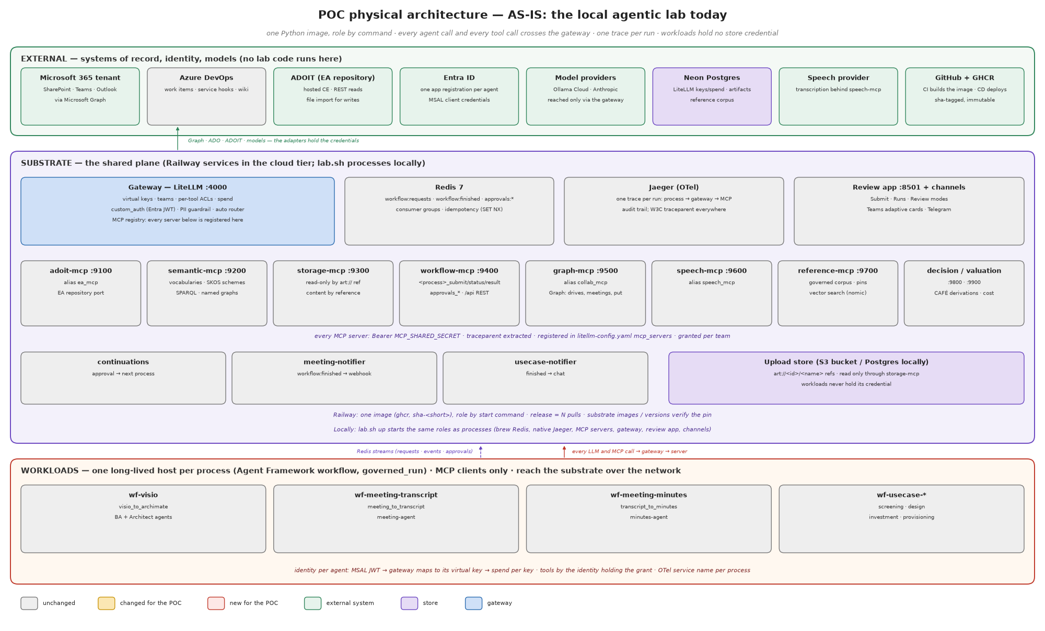
Figure 1 — Physical architecture, as-is

1.1 Tiers and processes
Tier | Process / service | Port | Role | Holds
substrate | gateway (LiteLLM) | 4000 | the one governance plane: virtual keys, teams, per-tool ACLs, spend, PII guardrail, Entra JWT validation, MCP registry, /v1, /mcp, /api pass-through | LiteLLM master key; upstream model keys; Neon DSN
substrate | adoit-mcp | 9100 | EA-repository port (ea_mcp): search, object, stage import, ArchiMate engine | ADOIT credentials
substrate | semantic-mcp | 9200 | vocabularies as data (semantic_mcp): ontologies, SKOS schemes, SPARQL over named graphs, store_spec | reference workbooks (derived RDF only at runtime)
substrate | storage-mcp | 9300 | read-only content by reference (storage_mcp): art:// refs, documents, figures, vsdx | upload-store credential
substrate | workflow-mcp | 9400 | the front door (workflow_mcp): <process>_submit/status/result, approvals_*, /api REST with Entra app-role authorisation at the gateway | Redis
substrate | graph-mcp | 9500 | collaboration port (collab_mcp): sites, drives, meetings, collab_fetch in, collab_put out, change-notification subscriptions | Microsoft Graph app credential
substrate | speech-mcp | 9600 | speech port (speech_mcp) | provider credential
substrate | reference-mcp | 9700 | governed corpus (reference_mcp): pinned, signed artifacts; exact lookup and vector search (nomic via the gateway) | reader DSN
substrate | decision-mcp, valuation-mcp | 9800, 9900 | CAFÉ derivations, cost and benefit | —
substrate | review app | 8501 | Submit · Runs · Review modes; the human channel for approvals | REVIEW_APP_PASSWORD; Redis
substrate | channels: teams, telegram | — | approval cards out; decisions in with a named actor | webhook / bot token
substrate | continuations, meeting-notifier, usecase-notifier | — | long-lived consumers of workflow:finished / approvals | Redis
substrate | Redis 7 | 6379 | Streams: workflow:requests, workflow:finished, approvals:requests, approvals:decisions; idempotency keys; limiter state | —
substrate | Jaeger | 16686 / 4318 | one trace per run; the audit trail | —
workloads | wf-visio, wf-meeting-transcript, wf-meeting-minutes, wf-usecase-* | — | one Agent Framework workflow host per ProcessSpec, run under governed_run; MCP clients only | per-agent Entra client secret or virtual key; nothing else
external | Neon Postgres | — | LiteLLM keys and spend; lab_artifacts (bytea) artifact store; reference corpus | —
external | M365 tenant, Azure DevOps, ADOIT, Entra, Ollama Cloud, Anthropic, speech provider, GitHub/GHCR | — | systems of record, identity, models, CI/CD | —

1.2 Contracts already in place that the fabric reuses
- lab.platform.contracts: ProcessSpec (one entry generates the three front-door tools), ToolCatalogue per server with READ/WRITE/RAISE grants, AgentSpec registry, ApprovalTools (ask for a workload, decide only for a channel with a signed-in person).
- lab.platform.workflows: submit(process, inputs, requester, idempotency_key) with SET NX EX de-duplication; mark, annotate, finished_events, replay.
- lab.platform.streams: StreamGroup (ensure, read, ack, XAUTOCLAIM of unacked entries) and serve (guarded loop, SIGTERM-safe).
- lab.workloads.run.governed_run: root span, trace id published first, W3C headers injected, run board, closed in one place.
- lab.core.semantic: SkosScheme (stable hashed ids, roots, subtree, exactMatch mappings), SemanticStore (load_model(model_iri, triples) = one named graph per model IRI; query).
- lab.substrate.approvals: request, human_decision (named actor, atomic claim), channel events filtered to open approvals.
- Governance tests: test_contracts_match_servers (two-way parity), test_no_tool_or_alias_names_a_vendor, test_import_boundaries, test_di_boundaries, agent-registry parity.

1.3 Capability to POC realisation
Every L4 of the Knowledge Management map (FRS Figure 2), coloured by what the POC does with it and listing the lab component that realises it. Green is used as it exists, amber gains fabric tools or data, red is built for the POC, blue is built but dormant or read-only to prove a competency question, grey is not in the POC. The D-references point to the delta table in §2.1.
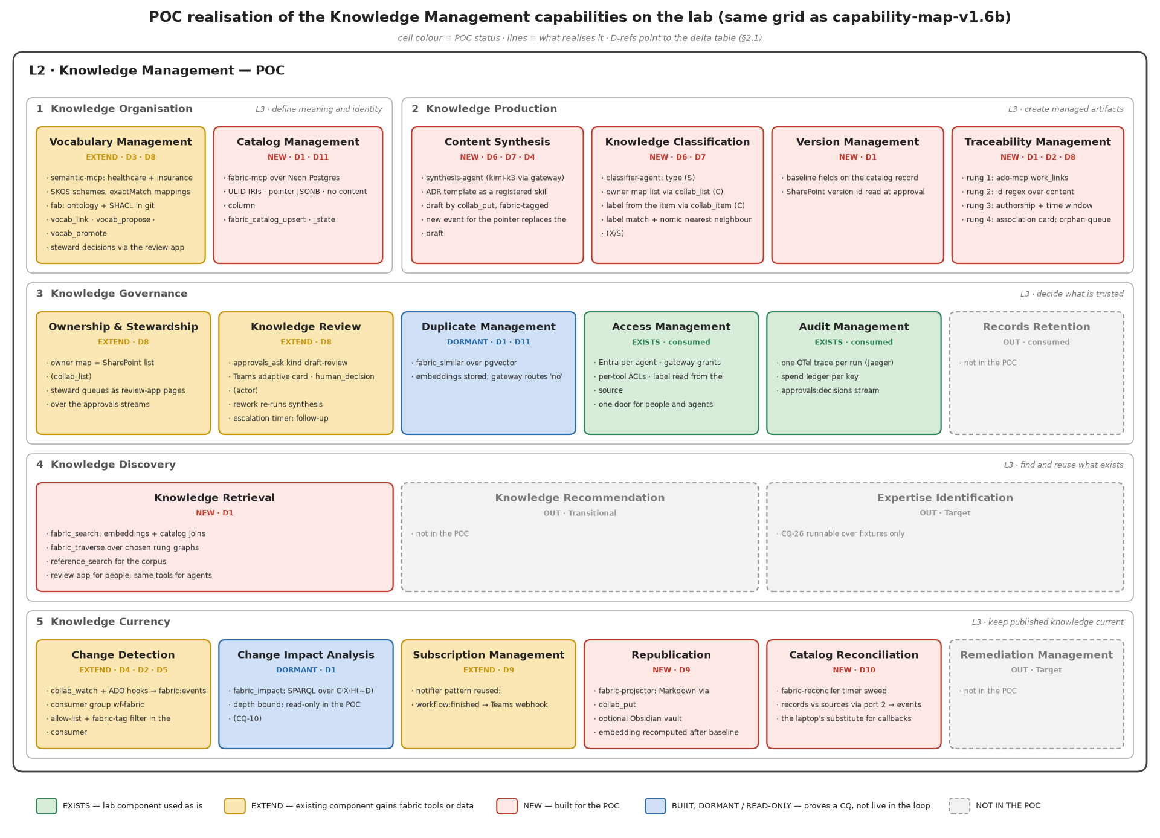
Figure 2 — POC realisation of the Knowledge Management capabilities

2. To-be — the lab plus the fabric
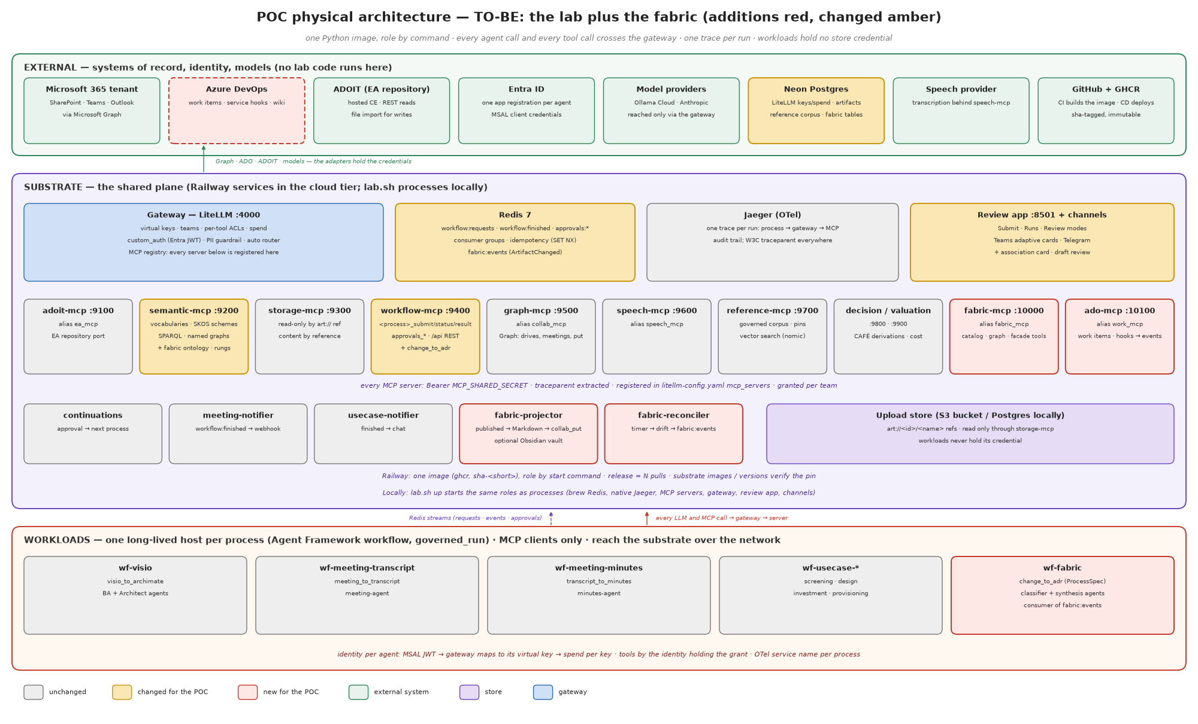
Figure 3 — Physical architecture, to-be (additions red, changed amber)

2.1 Delta
# | Component | New / changed | What it is | Port (FRS §4.6) | Mode
D1 | fabric-mcp :10000 (alias fabric_mcp) | new | the Knowledge Catalog and Traceability Graph products' output ports and the facade's composite tools; backed by Postgres tables (catalog, edges, assertions, embeddings) and by the rdflib store's rung graphs | store · graph · retrieval | P
D2 | ado-mcp :10100 (alias work_mcp) | new | the work-item source adapter: work_item_get, work_items_search, work_links, work_hook_register; translates ADO service hooks into ArtifactChanged | inbound events · content by reference | P
D3 | semantic-mcp | changed | loads the fabric ontology (fab:) and SHACL shapes; hosts the six rung graphs; adds vocab_link, vocab_propose, vocab_promote | vocabulary | P
D4 | graph-mcp (collab_mcp) | changed | collab_watch subscriptions publish ArtifactChanged onto fabric:events; collab_put sets the fabric tag on drafts and projections | inbound events · content | P
D5 | Redis stream fabric:events | new | port 1; consumer group wf-fabric; idempotency fabric:idem:<pointer> | event | —
D6 | wf-fabric host, process change_to_adr | new | the pipeline (FRS §5) as one Agent Framework workflow: deterministic nodes for identify, associate, baseline, republish; agent nodes for classify and synthesise | — | P
D7 | agents classifier-agent, synthesis-agent; team fabric | new | one Entra app registration and virtual key each; grants: fabric_mcp, semantic_mcp, storage_mcp, collab_mcp READ+PUT, workflow_mcp RAISE only | — | config
D8 | review app: association card, draft review | changed | two approval kinds rendered as one-tap cards; Teams channel unchanged | review surface | L
D9 | fabric-projector | new | consumer of workflow:finished: writes the Markdown projection via collab_put (tagged) and, optionally, into a local Obsidian vault | content | P
D10 | fabric-reconciler | new | timer-driven sweep: compares catalog records with sources via port 2, emits drift as ArtifactChanged | event | P
D11 | Postgres tables (Neon) | new | fabric_artifact, fabric_edge, fabric_assertion, fabric_embedding (pgvector) | store | —
D12 | CI fitness tests | new | pyshacl over fixture triples; CQ tests; loop-guard test; vendor-name test extended to work_mcp | — | —
D13 | gateway config | changed | two mcp_servers entries, one team, two keys, per-tool ACLs; extra_headers: traceparent | — | config
D14 | deploy/railway.py | changed | two substrate roles, one workload, one ROLE_ENV row each | — | config

2.2 Port mapping
FRS port | POC adapter | Where the credential lives
Inbound events | collab_watch (Graph change notifications) and ado-mcp hooks → fabric:events | graph-mcp; ado-mcp
Content by reference | storage_read_document / storage_get (via collab_fetch first), collab_put for drafts and projections | storage-mcp; graph-mcp
Store | Postgres tables behind fabric-mcp | fabric-mcp (DSN from SubstrateContainer)
Graph | rdflib rung graphs in semantic-mcp; fabric-mcp traversal tools read them over the gateway | semantic-mcp
Retrieval | fabric_search, fabric_traverse, reference_search as gateway tools; the review app for people | gateway grants
Vocabulary | semantic-mcp SKOS schemes + vocab_*; schemes in git | semantic-mcp
Review surface | review app + Teams channel via approvals_ask / human_decision | workflow-mcp; channels
Model gateway | LiteLLM; models kimi-k3 (classify, synthesise), nomic embeddings | gateway

3. Build plan
Two weeks of engineering effort before the one-week local proof and the two-week integrated proof, organised as work packages that respect the tier rules (core imports nothing; workloads never import substrate; adapters live where their credentials do). Each package is test-first.
WP | Deliverable | Tier | Tests that must exist first
WP1 Contracts | FabricTools, WorkTools, VocabTools catalogues; ProcessSpec for change_to_adr; AgentSpec × 2; ArtifactChanged dataclass with validation | platform | contracts-match-servers parity; vendor-name test; ProcessSpec.validate() cases
WP2 Ontology | fab: Turtle, SHACL shapes, rung graph IRIs, seed schemes loader | core | pyshacl passes on fixtures; fails on a deliberate fab:body; scheme loads with stable ids
WP3 fabric-mcp | Postgres DDL + repository; catalog/edge/assertion tools; traversal over chosen graphs; facade composite tools | substrate | CQ-01..07, 10, 12, 13, 15, 23 as SPARQL/tool tests over fixtures
WP4 ado-mcp | work-item read; link extraction; service-hook receiver → ArtifactChanged | substrate | mapper tests (ADO JSON → event); no vendor name in tool names
WP5 Events | fabric:events stream, consumer group, idempotency, dead-letter, reclaim | platform | duplicate event → one run; tagged event → dropped; crashed consumer → reclaimed
WP6 Workflow | change_to_adr graph: identify → classify → associate → gate → synthesise → review → baseline → republish | workloads | node unit tests with fakes; schema tests for agent outputs; preflight refuses on missing tool
WP7 Review | association and draft-review approval kinds; card rendering; promotion on decision | substrate | decision promotes S→H and is audited; blank actor refused
WP8 Projector, reconciler | Markdown projection with frontmatter; drift sweep | substrate | projection is tagged; drift emits an event and never writes the catalog
WP9 Deploy | gateway config, Railway roles, ROLE_ENV, register agents and skills | deploy | substrate images/versions clean; ROLE_ENV parity test
WP10 Demo | the scripted demonstration (§7) | — | e2e smoke asserts every fabric tool is exposed live

4. Artifact catalogue
Artifact | Format | Location | Owner | Produced by | Consumed by
Fabric ontology | Turtle (fab.ttl) | src/lab/core/semantic/fabric/ | EA (design authority) | hand-authored, versioned | semantic-mcp; CI
SHACL shapes | Turtle (fab-shapes.ttl) | same | EA | hand-authored | CI (pyshacl); fabric-mcp write path
Rung graph IRIs | constants | lab.core.semantic.fabric.rungs | EA | code | every SPARQL query
Baseline vocabulary | SKOS (derived RDF) + scheme manifest | var/reference-sources/ (workbooks, licensed) → semantic-mcp; manifest in git | steward | loader (baguild), seed script | classification; discovery
Document-type scheme | SKOS Turtle | src/lab/core/semantic/fabric/doc-types.ttl | business (confirmed set) | hand-authored | classification; templates
ADR template | Markdown | skills/fabric-adr/templates/adr.md | EA | hand-authored; registered as a skill | synthesis agent
Catalog record | JSON / Postgres row | fabric_artifact | fabric | identify node | everything
Edge / assertion | Postgres row + triple in a rung graph | fabric_edge, fabric_assertion; graph <urn:fabric:graph:X> | fabric; stewards | associate node; promotions | traversal; impact
ArtifactChanged event | JSON on Redis Streams | fabric:events | platform | adapters; reconciler | wf-fabric
Draft | .md / .docx in SharePoint | source folder, tagged | owner | synthesis via collab_put | review card
Projection | Markdown with frontmatter | SharePoint wiki folder via collab_put; optional Obsidian vault | fabric | projector | people; Obsidian graph view
Approval (association, draft review) | Redis hash + stream | approvals:* | curators | approvals_ask | review app; Teams channel
Gateway config | YAML | config/litellm-config.yaml | platform | hand-authored | gateway
Agent registry entries | Python | lab.platform.contracts.AGENTS | platform | hand-authored | provisioning; CD
Traces | OTLP → Jaeger | process-change-to-adr | platform | governed_run | audit; debugging
Competency-question tests | pytest | tests/unit/core/semantic/fabric/test_cq.py | EA | WP3 | CI

5. Schemas and examples

5.1 ProcessSpec for `change_to_adr`
CHANGE_TO_ADR = ProcessSpec(
name="change_to_adr", group="wf-fabric",
inputs={"pointer": InputKind.POINTER, "work_item": InputKind.OPTIONAL_TEXT, "event_id": InputKind.TEXT},
outputs=("artifact_iri", "draft_ref", "approval_id", "projection_ref"),
external=False, # started by the fabric:events consumer, never by an outside caller
description="One change in a source becomes a classified, linked, drafted, reviewed and published ADR.")

5.2 ArtifactChanged — JSON Schema
{ "$id": "urn:fabric:schema:ArtifactChanged:1",
"type": "object", "additionalProperties": false,
"required": ["eventId", "pointer", "sourceKind", "change", "actor", "occurredAt"],
"properties": {
"eventId": {"type": "string", "pattern": "^[0-9A-HJKMNP-TV-Z]{26}$"},
"pointer": {"type": "object", "required": ["source"], "properties": {
"source": {"enum": ["sharepoint", "ado", "ea-repo", "teams", "design-board"]},
"site": {"type": "string"}, "driveItem": {"type": "string"}, "version": {"type": "string"},
"project": {"type": "string"}, "workItem": {"type": "integer"}, "objectId": {"type": "string"}}},
"sourceKind":{"enum": ["sharepoint", "ado", "ea-repo", "teams", "design-board"]},
"change": {"enum": ["created", "updated", "deleted", "moved", "relabelled"]},
"actor": {"type": "object", "required": ["oid"], "properties": {"oid": {"type": "string"}}},
"occurredAt":{"type": "string", "format": "date-time"},
"fabricTag": {"type": ["object", "null"], "properties": {"runId": {"type": "string"}, "kind": {"enum": ["draft", "projection", "proposal"]}}}
} }
Example on the stream (XADD fabric:events * event <json>):
{"eventId":"01J9X6QK3R5T7V9X1Z3B5D7F9H","pointer":{"source":"sharepoint","site":"ea","driveItem":"01ABC…","version":"4.0"},
"sourceKind":"sharepoint","change":"updated","actor":{"oid":"3f2a…"},"occurredAt":"2026-09-11T08:10:31Z","fabricTag":null}

5.3 Postgres DDL (Neon; pgvector enabled)
CREATE EXTENSION IF NOT EXISTS vector;
CREATE TABLE fabric_artifact (
iri TEXT PRIMARY KEY, -- urn:fabric:artifact:<ULID>
pointer JSONB NOT NULL, -- {source, site, driveItem, version | project, workItem | objectId}
source_kind TEXT NOT NULL,
doc_type_iri TEXT, owner_oid TEXT, sensitivity_label TEXT,
lifecycle_state TEXT NOT NULL CHECK (lifecycle_state IN ('pending','in-review','published','withdrawn')),
unassociated BOOLEAN NOT NULL DEFAULT false,
baseline_version TEXT, baselined_at TIMESTAMPTZ, baselined_by TEXT,
title TEXT CHECK (char_length(title) <= 300),
created_at TIMESTAMPTZ NOT NULL DEFAULT now(), updated_at TIMESTAMPTZ NOT NULL DEFAULT now()
); -- NO content column exists, by design; the SHACL shape enforces the same at the graph level
CREATE UNIQUE INDEX fabric_artifact_pointer ON fabric_artifact ((pointer->>'source'), (pointer->>'driveItem'), (pointer->>'workItem'), (pointer->>'objectId'));
CREATE TABLE fabric_edge (
id TEXT PRIMARY KEY, subject_iri TEXT NOT NULL, predicate TEXT NOT NULL, -- deliveredUnder | references | subject
object_iri TEXT NOT NULL, rung CHAR(1) NOT NULL CHECK (rung IN ('S','X','C','H','D')),
method TEXT NOT NULL, actor TEXT, confidence REAL, asserted_at TIMESTAMPTZ NOT NULL DEFAULT now(),
superseded_by TEXT REFERENCES fabric_edge(id) -- retraction = supersession
);
CREATE TABLE fabric_assertion ( -- PROV-O record for every non-edge assertion (type, owner, label, state)
id TEXT PRIMARY KEY, artifact_iri TEXT NOT NULL REFERENCES fabric_artifact(iri), property TEXT NOT NULL,
value TEXT NOT NULL, rung CHAR(1) NOT NULL, method TEXT NOT NULL, actor TEXT, confidence REAL,
asserted_at TIMESTAMPTZ NOT NULL DEFAULT now(), superseded_by TEXT REFERENCES fabric_assertion(id)
);
CREATE TABLE fabric_embedding (
artifact_iri TEXT PRIMARY KEY REFERENCES fabric_artifact(iri), model TEXT NOT NULL,
embedding vector(768) NOT NULL, computed_at TIMESTAMPTZ NOT NULL DEFAULT now()
);
CREATE INDEX fabric_embedding_ivf ON fabric_embedding USING ivfflat (embedding vector_cosine_ops);

5.4 The ontology (`fab.ttl`, excerpt)
@prefix fab: <urn:fabric:ont#> . @prefix dcat: <http://www.w3.org/ns/dcat#> .
@prefix dct: <http://purl.org/dc/terms/> . @prefix prov: <http://www.w3.org/ns/prov#> .
@prefix skos: <http://www.w3.org/2004/02/skos/core#> . @prefix owl: <http://www.w3.org/2002/07/owl#> .
fab:Artifact a owl:Class ; rdfs:subClassOf dcat:Resource ; rdfs:label "Artifact" .
fab:WorkItem a owl:Class ; rdfs:label "Work item" .
fab:Person a owl:Class ; rdfs:subClassOf foaf:Person .
fab:DocumentType a owl:Class ; rdfs:subClassOf skos:Concept .
fab:Source a owl:Class ; rdfs:label "System of record" .
fab:deliveredUnder a owl:ObjectProperty ; rdfs:domain fab:Artifact ; rdfs:range fab:WorkItem .
fab:references a owl:ObjectProperty ; rdfs:domain fab:Artifact ; rdfs:range fab:Artifact .
fab:ownedBy a owl:ObjectProperty ; rdfs:domain fab:Artifact ; rdfs:range fab:Person .
fab:documentType a owl:ObjectProperty ; rdfs:range fab:DocumentType .
fab:sensitivityLabel a owl:DatatypeProperty ; rdfs:range xsd:string .
fab:lifecycleState a owl:ObjectProperty ; rdfs:range fab:LifecycleState .
fab:Pending fab:InReview fab:Published fab:Withdrawn a fab:LifecycleState .
fab:baselineVersion a owl:DatatypeProperty .
# subjects use dct:subject → skos:Concept in a scheme; provenance uses prov:* on the assertion node
fab:rung a owl:DatatypeProperty ; rdfs:comment "O S X C H D" . fab:method a owl:DatatypeProperty . fab:confidence a owl:DatatypeProperty .

5.5 SHACL shapes (`fab-shapes.ttl`, excerpt)
fab:ArtifactShape a sh:NodeShape ; sh:targetClass fab:Artifact ; sh:closed true ;
sh:ignoredProperties ( rdf:type dct:title dcat:accessURL fab:documentType fab:ownedBy fab:sensitivityLabel
fab:lifecycleState fab:baselineVersion dct:subject fab:deliveredUnder fab:references dct:modified ) ;
sh:property [ sh:path dct:title ; sh:maxLength 300 ] ;
sh:property [ sh:path dcat:accessURL ; sh:minCount 1 ] ;
sh:property [ sh:path fab:ownedBy ; sh:minCount 1 ; sh:maxCount 1 ] ;
sh:property [ sh:path fab:sensitivityLabel ; sh:minCount 1 ] ;
sh:property [ sh:path fab:body ; sh:maxCount 0 ; sh:message "no content in a fabric store (NFR-2)" ] .
fab:OwnerProvenanceShape a sh:NodeShape ; sh:targetSubjectsOf fab:ownedBy ;
sh:sparql [ sh:message "owner must be constructed (rung C) from the owner map (NFR-3)" ;
sh:select """SELECT $this WHERE { GRAPH ?g { $this fab:ownedBy ?o } FILTER (?g != <urn:fabric:graph:C>) }""" ] .

5.6 Rung graphs and a promotion
RUNGS = {"O": None, # observed: the event product, never a graph
"S": "urn:fabric:graph:S", "X": "urn:fabric:graph:X", "C": "urn:fabric:graph:C",
"H": "urn:fabric:graph:H", "D": "urn:fabric:graph:D"}
IMPACT_READS = ("C", "X", "H", "D") # never S — NFR-7
Promotion on a card decision (pseudo-SPARQL executed by fabric-mcp after human_decision):
DELETE { GRAPH <urn:fabric:graph:S> { ?a fab:deliveredUnder ?w } }
INSERT { GRAPH <urn:fabric:graph:H> { ?a fab:deliveredUnder ?w }
GRAPH <urn:fabric:graph:prov> { ?asrt prov:wasInvalidatedBy ?decision ; prov:invalidatedAtTime ?t . } }
WHERE { GRAPH <urn:fabric:graph:S> { ?a fab:deliveredUnder ?w } ... }

5.7 Tool contracts (catalogue excerpt)
class FabricTools(ToolCatalogue):
SERVER = "fabric_mcp"
catalog_get, catalog_upsert, catalog_state = "fabric_catalog_get", "fabric_catalog_upsert", "fabric_catalog_state"
edge_assert, edge_promote, edge_retract = "fabric_edge_assert", "fabric_edge_promote", "fabric_edge_retract"
traverse, impact, search, similar = "fabric_traverse", "fabric_impact", "fabric_search", "fabric_similar"
READ = (catalog_get, traverse, impact, search, similar)
WRITE = (catalog_upsert, catalog_state, edge_assert, edge_retract) # pipeline only
PROMOTE = (edge_promote,) # channels with a signed-in person only
class WorkTools(ToolCatalogue): # the work-item port; the vendor is named only by the SERVICE (ado-mcp)
SERVER = "work_mcp"
item, search, links, hook = "work_item_get", "work_items_search", "work_links", "work_hook_register"
READ = (item, search, links); WRITE = (hook,)

5.8 Gateway configuration (excerpt of `config/litellm-config.yaml`)
mcp_servers:
fabric_mcp: {url: os.environ/FABRIC_MCP_URL, transport: http, auth_type: bearer_token,
auth_value: os.environ/MCP_SHARED_SECRET, extra_headers: ["traceparent", "tracestate"], timeout: 300}
work_mcp: {url: os.environ/WORK_MCP_URL, transport: http, auth_type: bearer_token,
auth_value: os.environ/MCP_SHARED_SECRET, extra_headers: ["traceparent", "tracestate"]}
Team and grants (bootstrapped by script, not by hand):
POST /team/new {"team_alias": "fabric", "max_budget": 5, "budget_duration": "30d"}
POST /team/update {"team_id": "...", "object_permission": {
"mcp_servers": ["fabric_mcp", "semantic_mcp", "storage_mcp", "collab_mcp", "work_mcp", "workflow_mcp"],
"mcp_tool_permissions": {"fabric_mcp": [...READ, ...WRITE], "collab_mcp": [...READ, "collab_put"],
"work_mcp": [...READ], "workflow_mcp": ["approvals_ask"]}}}
# edge_promote and approvals_decide are granted to the review-app / Teams channel identity only

5.9 Agent registry entries
AgentSpec(name="classifier-agent", prefix="CLASSIFIER_AGENT", model="kimi-k3",
description="Suggests a document type and links subjects to the vocabulary; never resolves owner or label.",
skills=("fabric_classification",), processes=("change_to_adr",)),
AgentSpec(name="synthesis-agent", prefix="SYNTHESIS_AGENT", model="kimi-k3",
description="Drafts an ADR from a change, its content and the template; writes only drafts, tagged.",
skills=("fabric_adr",), processes=("change_to_adr",)),

5.10 Association card (Teams adaptive card, abbreviated)
{"type":"AdaptiveCard","version":"1.5","body":[
{"type":"TextBlock","weight":"Bolder","text":"Which work item does this belong to?"},
{"type":"TextBlock","text":"ADR-014 Event bus for claims intake (SharePoint · updated 08:10 by A. Rahman)","wrap":true},
{"type":"TextBlock","isSubtle":true,"text":"Evidence: shares concepts Claims Intake, Event Bus; same author as PBI-4471; edited within the sprint","wrap":true},
{"type":"Input.ChoiceSet","id":"workItem","style":"expanded","choices":[
{"title":"PBI-4471 Claims intake redesign (0.82)","value":"4471"},{"title":"PBI-4390 Integration platform (0.41)","value":"4390"}]},
{"type":"Input.Text","id":"other","placeholder":"another work item id, or 'not delivery work'"}],
"actions":[{"type":"Action.OpenUrl","title":"Confirm in the review app","url":"<review-app>/?approval=..."}]}
The decision is recorded through approvals_decide with the signed-in person as actor and promotes the edge from S to H (§5.6). A not delivery work answer sets unassociated=true and closes the question.

5.11 Competency-question queries (examples)
CQ-05 — artifacts delivered under W, trusted rungs only:
SELECT ?a ?g WHERE { VALUES ?g { <urn:fabric:graph:C> <urn:fabric:graph:X> <urn:fabric:graph:H> }
GRAPH ?g { ?a fab:deliveredUnder <urn:fabric:workitem:ado:4471> } }
CQ-16 — artifacts about concept K or anything narrower (closure via the Vocabulary product):
SELECT DISTINCT ?a WHERE {
<urn:lab:semantic:ref:healthcare-provider-v2.0#cap-1f3585f297> skos:narrower* ?k .
GRAPH ?g { ?a dct:subject ?k } FILTER (?g IN (<urn:fabric:graph:X>, <urn:fabric:graph:H>)) }
CQ-23 — loop guard (must return nothing):
SELECT ?e WHERE { ?e a fab:ArtifactChanged ; fab:fabricTag ?tag ; fab:enteredPipeline true }

5.12 Projection (Markdown with frontmatter; also a valid Obsidian note)
---
iri: urn:fabric:artifact:01J9X5K7QZ3M8N2P4R6T8V0W1Y
type: ADR
owner: A. Rahman
label: Confidential
state: published
baseline: "3.0"
work_item: "[[PBI-4471]]"
subjects: ["[[Patient Management]]", "[[Claims Intake]]"]
fabric_tag: projection
---
# ADR-014 Event bus for claims intake
Source of truth: <SharePoint link>. This page is regenerated by the fabric; edit the source.

5.13 OpenTelemetry span attributes (counts and shapes only; never content or principals)
fabric.event.source_kind, fabric.event.change, fabric.rung.entered, fabric.edges.asserted, fabric.edges.suggested, fabric.card.asked, fabric.draft.written, fabric.projection.written, fabric.cq.answered — on the root span change-to-adr-run, service process-change-to-adr.

6. Baseline vocabulary

6.1 Schemes seeded at the POC
Scheme | Source | Size | Base IRI | Steward
Healthcare Provider capabilities | BA Guild Healthcare Provider Reference Model v2.0 — already loaded by the lab's reference loader | 42 L1 · 353 L2 · 1042 L3 · 229 L4 capabilities; 18 value streams | urn:lab:semantic:ref:healthcare-provider-v2.0# | EA
Systems | ADOIT application components via ea_search(class_name=C_APPLICATION_COMPONENT) at seed time | ~134 objects | urn:fabric:scheme:systems# | EA
Work areas | ADO area paths via work_items_search | per project | urn:fabric:scheme:areas# | delivery leads
Document types | the six confirmed types; the POC seeds one | 6 | urn:fabric:scheme:doc-types# | business

Cross-scheme links (capability ↔ system) live in the mappings graph as skos:exactMatch / skos:relatedMatch, human-confirmed (rung H) before discovery closure reads them. The Insurance v5.0 scheme is loaded too and linked by same-label exactMatch at top level, exactly as the lab does today.

6.2 SKOS excerpt — the Healthcare Provider scheme as the lab already derives it
@prefix hp: <urn:lab:semantic:ref:healthcare-provider-v2.0#> .
@prefix skos: <http://www.w3.org/2004/02/skos/core#> .
hp:scheme a skos:ConceptScheme ; skos:prefLabel "BA Guild Healthcare Provider Reference Model v2.0" ;
skos:hasTopConcept hp:cap-1f3585f297 , hp:cap-c678b7d20f , hp:cap-f3dde9e5a1 .
hp:cap-1f3585f297 a skos:Concept ; skos:inScheme hp:scheme ; skos:topConceptOf hp:scheme ;
skos:prefLabel "Patient Management"@en ; skos:notation "L1 · tier 3" ;
skos:definition "Ability to control, predict, process, organize, present, and analyze all information, documents, preferences, experience…"@en ;
skos:narrower hp:cap-bc56baa5c0 , hp:cap-0da2f41464 , hp:cap-a9a6456e24 , hp:cap-46e06ff224 , hp:cap-1555751ead , hp:cap-b41da0b2a0 .
hp:cap-bc56baa5c0 a skos:Concept ; skos:prefLabel "Patient Definition"@en ; skos:broader hp:cap-1f3585f297 ;
skos:narrower hp:cap-646ad09a6c .
hp:cap-646ad09a6c a skos:Concept ; skos:prefLabel "Patient Identification"@en ; skos:broader hp:cap-bc56baa5c0 .
hp:cap-0da2f41464 a skos:Concept ; skos:prefLabel "Patient Preference Management"@en ; skos:broader hp:cap-1f3585f297 ;
skos:narrower hp:cap-9fbf22ece7 , hp:cap-9a50eb1c01 .
hp:cap-a9a6456e24 a skos:Concept ; skos:prefLabel "Patient Risk Management"@en ; skos:broader hp:cap-1f3585f297 .
hp:cap-c678b7d20f a skos:Concept ; skos:prefLabel "Strategy Management"@en ; skos:notation "L1 · tier 1" .
hp:cap-f3dde9e5a1 a skos:Concept ; skos:prefLabel "Policy Management"@en ; skos:notation "L1 · tier 1" .
hp:vs-a06ef05d6c a skos:Concept ; skos:prefLabel "Acquire Asset"@en ; skos:notation "value stream" .
Concept ids are stable hashes of the full label path (the workbooks carry no ids), so a re-import never duplicates and a mapping never breaks.

6.3 Document-type scheme (seed)
@prefix dt: <urn:fabric:scheme:doc-types#> .
dt:scheme a skos:ConceptScheme ; skos:prefLabel "Document types" .
dt:adr a skos:Concept , fab:DocumentType ; skos:inScheme dt:scheme ; skos:prefLabel "Architecture decision record"@en ;
skos:altLabel "ADR"@en , "decision record"@en ; fab:template <urn:fabric:template:adr:1> .
# the remaining five are added when the business confirms the set (BRS §9 decision 2)

6.4 Candidate intake (the proposed-concept queue)
A label the classifier proposes that matches no preferred or alternate label in any scheme becomes a candidate with the artifacts that produced it:
{"candidate":"claims intake","proposedBy":"classifier-agent","confidence":0.71,
"artifacts":["urn:fabric:artifact:01J9X5K7…","urn:fabric:artifact:01J9X5M2…"],
"nearest":[{"concept":"hp:cap-…","label":"Claim Management","similarity":0.63}],"status":"proposed"}
The steward accepts (creating skos:Concept at rung H, optionally as skos:narrower of the nearest), merges (adds an altLabel), or rejects. Nothing the classifier proposes enters a scheme without that decision.

6.5 ADR template (`skills/fabric-adr/templates/adr.md`, registered as a skill)
# ADR-<n> <title>
Status: proposed | accepted | superseded by ADR-<m> · Date: <yyyy-mm-dd> · Work item: <PBI-n>
## Context — what forces are at play (link the artifacts this decision touches)
## Decision — the change we are making, in one paragraph
## Consequences — what becomes easier, what becomes harder, what we must now watch
## Subjects — capabilities and systems this decision is about (from the vocabulary)

7. Test and demonstration script
Day | Step | Evidence captured
1 | lab.sh up with the two new roles; substrate images clean; every fabric tool listed live by e2e_smoke | tool list; trace of the smoke
1 | Seed: load the healthcare scheme, systems scheme, doc-type scheme; run CQ-17 (empty candidate queue) | SPARQL results
2 | Edit an ADR in the pilot SharePoint library → collab_watch fires → ArtifactChanged on fabric:events → wf-fabric consumes; catalog record created at pending (CQ-01, CQ-02) | stream entry; record; trace id on the run board
2 | Classification: type suggested (S), owner and label looked up (C) — CQ-12, CQ-13; concept links by label match (X) — CQ-15 | assertions with rungs
3 | Association: rung 1 from the ADO link; a second artifact without a link → card → decision in Teams → S→H (CQ-05, CQ-06); a third with no answer → orphan queue (CQ-07) | approval ids; graph diff before/after
3 | Draft synthesised and written via collab_put with the fabric tag; the tagged write's own event is dropped (CQ-23 = none) | draft pointer; dropped-event counter on the span
4 | Review card → approve → baseline (CQ-04) → projection written → Obsidian vault shows the graph | projection; screenshot
4 | Impact: change the ADR again → CQ-10 over C·X·H only lists the dependent artifact; the S-only link is not listed | query results
5 | Fitness: commit a fixture with a fab:body triple → CI fails on the SHACL shape; revert | CI log
5 | Two-week integrated proof kick-off: real work items, pilot site, ~10 transcripts for the synthesis threshold | plan

8. Assumptions and out of scope for the POC
- Graph change notifications need a public callback; the cloud tier (Railway) receives them, the laptop uses the reconciler sweep instead.
- One document type (ADR), one SharePoint library, one ADO project. No Purview labels beyond what the pilot site inherits.
- Term-store sync, VocBench and any commercial vocabulary tool are out; the bake-off is a separate inception action.
- No Fabric IQ or Work IQ; the retrieval port is the gateway's own tools and the review app.
- Cost: negligible — Railway Hobby substrate, Neon free tier, flat-rate inference.

Annex — glossary of POC-specific terms
Term | Meaning
art:// ref | the lab's opaque reference to an object in the upload store; the only way a workload reads content
pointer | the fabric's structured reference into a system of record; the idempotency key of an event
rung graph | one rdflib named graph per provenance rung; IMPACT_READS names the ones impact may traverse
fabric tag | the marker set on every fabric-originated write so the inbound adapter can drop its own event
card | an approval of kind association or draft-review, rendered by the review app and the Teams channel
projection | the regenerable Markdown page written for a published artifact; never the source of truth
governed_run | the lab's one skeleton for a workflow host: root span, trace id first, run board, closed in one place

