Documentation Fabric — Proof of Concept on the Local Agentic Lab
Realisation specification · Version 1.1 · 11 September 2026 · companion to BRS v2.0 and FRS v2.0 · v1.1 records what was BUILT (wave 1–6 on branch feat/doc-fabric) where it differs from the v1.0 design
Who this is for. The people building and running the one-week laptop-local proof and the two-week integrated proof (BRS §7.3, FRS §10.1). It describes the lab as it is, the lab as it must be for the fabric, the delta between them as work packages, and every artifact the solution needs — schemas, contracts, configuration, the baseline vocabulary — with examples that can be copied. It is written against the lab's own rules (CLAUDE.md): pattern parity with Azure, every call through the gateway, workloads hold no store credential, tests first.
What the POC must demonstrate (FRS §10.1): the ArtifactChanged contract end to end from a SharePoint change to a published projection; the provenance ladder as named graphs with one promotion through a Teams card; CQ-01 to CQ-07, CQ-10, CQ-12, CQ-13, CQ-15, CQ-17 and CQ-23 answered over real triples; the metadata-only SHACL shape failing a deliberate violation in CI. It is evidence, throwaway by declaration; what carries forward is the ports.

1. As-is — the lab today
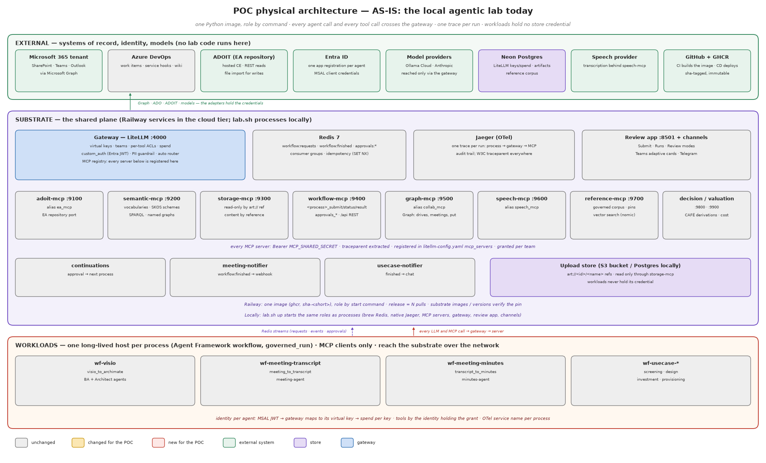
Figure 1 — Physical architecture, as-is

1.1 Tiers and processes
Tier | Process / service | Port | Role | Holds
substrate | gateway (LiteLLM) | 4000 | the one governance plane: virtual keys, teams, per-tool ACLs, spend, PII guardrail, Entra JWT validation, MCP registry, /v1, /mcp, /api pass-through | LiteLLM master key; upstream model keys; Neon DSN
substrate | adoit-mcp | 9100 | EA-repository port (ea_mcp): search, object, stage import, ArchiMate engine | ADOIT credentials
substrate | semantic-mcp | 9200 | vocabularies as data (semantic_mcp): ontologies, SKOS schemes, SPARQL over named graphs, store_spec | reference workbooks (derived RDF only at runtime)
substrate | storage-mcp | 9300 | read-only content by reference (storage_mcp): art:// refs, documents, figures, vsdx | upload-store credential
substrate | workflow-mcp | 9400 | the front door (workflow_mcp): <process>_submit/status/result, approvals_*, /api REST with Entra app-role authorisation at the gateway | Redis
substrate | graph-mcp | 9500 | collaboration port (collab_mcp): sites, drives, meetings, collab_fetch in, collab_put out, change-notification subscriptions | Microsoft Graph app credential
substrate | speech-mcp | 9600 | speech port (speech_mcp) | provider credential
substrate | reference-mcp | 9700 | governed corpus (reference_mcp): pinned, signed artifacts; exact lookup and vector search (nomic via the gateway) | reader DSN
substrate | decision-mcp, valuation-mcp | 9800, 9900 | CAFÉ derivations, cost and benefit | —
substrate | review app | 8501 | Submit · Runs · Review modes; the human channel for approvals | REVIEW_APP_PASSWORD; Redis
substrate | channels: teams, telegram | — | approval cards out; decisions in with a named actor | webhook / bot token
substrate | continuations, meeting-notifier, usecase-notifier | — | long-lived consumers of workflow:finished / approvals | Redis
substrate | Redis 7 | 6379 | Streams: workflow:requests, workflow:finished, approvals:requests, approvals:decisions; idempotency keys; limiter state | —
substrate | Jaeger | 16686 / 4318 | one trace per run; the audit trail | —
workloads | wf-visio, wf-meeting-transcript, wf-meeting-minutes, wf-usecase-* | — | one Agent Framework workflow host per ProcessSpec, run under governed_run; MCP clients only | per-agent Entra client secret or virtual key; nothing else
external | Neon Postgres | — | LiteLLM keys and spend; lab_artifacts (bytea) artifact store; reference corpus | —
external | M365 tenant, Azure DevOps, ADOIT, Entra, Ollama Cloud, Anthropic, speech provider, GitHub/GHCR | — | systems of record, identity, models, CI/CD | —

1.2 Contracts already in place that the fabric reuses
- lab.platform.contracts: ProcessSpec (one entry generates the three front-door tools), ToolCatalogue per server with READ/WRITE/RAISE grants, AgentSpec registry, ApprovalTools (ask for a workload, decide only for a channel with a signed-in person).
- lab.platform.workflows: submit(process, inputs, requester, idempotency_key) with SET NX EX de-duplication; mark, annotate, finished_events, replay.
- lab.platform.streams: StreamGroup (ensure, read, ack, XAUTOCLAIM of unacked entries) and serve (guarded loop, SIGTERM-safe).
- lab.workloads.run.governed_run: root span, trace id published first, W3C headers injected, run board, closed in one place.
- lab.core.semantic: SkosScheme (stable hashed ids, roots, subtree, exactMatch mappings), SemanticStore (load_model(model_iri, triples) = one named graph per model IRI; query).
- lab.substrate.approvals: request, human_decision (named actor, atomic claim), channel events filtered to open approvals.
- Governance tests: test_contracts_match_servers (two-way parity), test_no_tool_or_alias_names_a_vendor, test_import_boundaries, test_di_boundaries, agent-registry parity.

1.3 Capability to POC realisation
Every L4 of the Knowledge Management map (FRS Figure 2), coloured by what the POC does with it and listing the lab component that realises it. Green is used as it exists, amber gains fabric tools or data, red is built for the POC, blue is built but dormant or read-only to prove a competency question, grey is not in the POC. The D-references point to the delta table in §2.1.
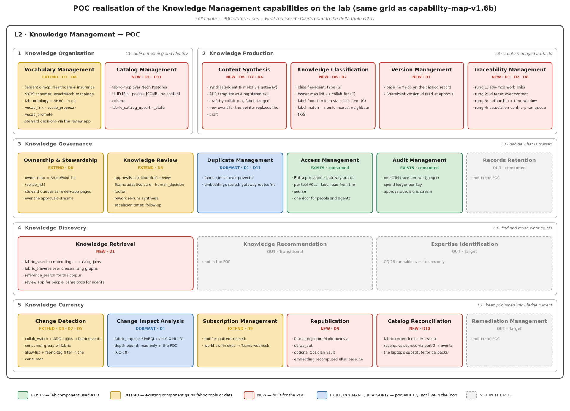
Figure 2 — POC realisation of the Knowledge Management capabilities

2. To-be — the lab plus the fabric
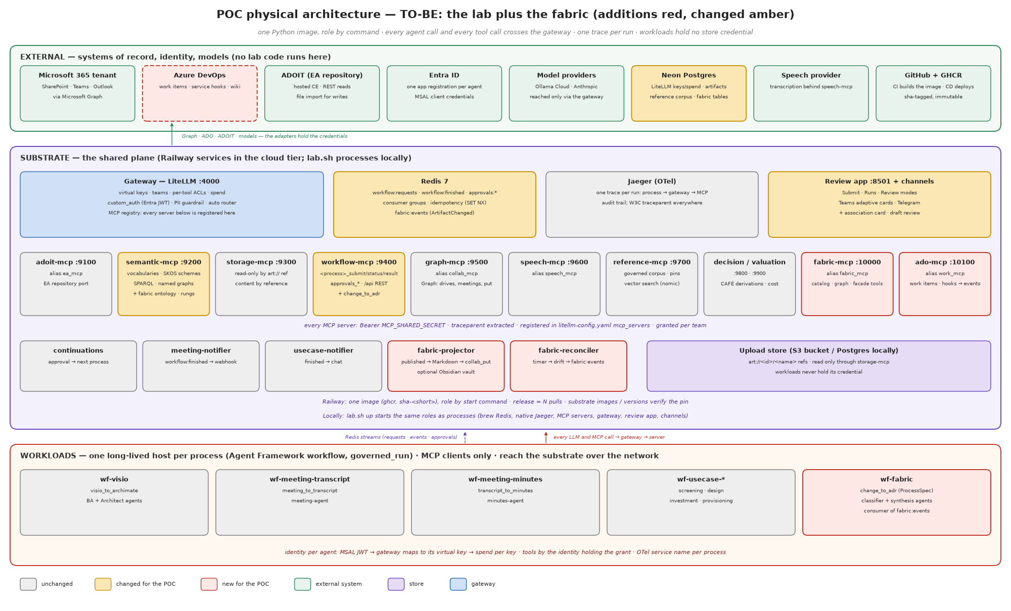
Figure 3 — Physical architecture, to-be (additions red, changed amber)

2.1 Delta
Three decisions taken while building changed the v1.0 shape, and the table below is the shape as built. (1) The lab's own workflows are the producers: minutes, Visio-to-ArchiMate and the four use-case processes already write artifacts, so the fabric's rung 1 (the delivery context) is real on day one — DeliveryContext is a core class with kinds usecase, meeting, submission, and a work item becomes a fourth kind behind the same port when an Azure DevOps adapter exists. There is no ado-mcp in the POC. (2) One semantic-layer server: the four metadata products live on semantic-mcp as tools of one catalogue; there is no fabric-mcp. A query port is not a process, so none of it sits on workflow-mcp. (3) MCP first: every product query, run lifecycle and approval is a gateway tool; the only REST is the change-notification receiver, which a provider calls without a bearer.
# | Component | New / changed | What it is | Port (FRS §4.6) | Mode
D1 | semantic-mcp (alias semantic_mcp) | changed | registers the fab: ontology and the doc-type scheme; hosts the rung graphs S·X·C·H·D, the PROV graph and the candidates graph beside the vocabularies (one Dataset, so semantic_query answers the competency questions); adds the Catalog (semantic_catalog_get/upsert/state/assert), the Traceability Graph (semantic_edge_assert/edge_retract/trace/impact), the Vocabulary (semantic_vocab_link/propose), the facade (semantic_embed/similar/search), semantic_validate_shapes and semantic_promote. Every write is SHACL-checked and undone on a violation; the touched graphs are shadowed to the artifact store as N-Quads under a Redis index of latest refs, restored at boot | store · graph · vocabulary · retrieval | P
D2 | Catalog store | new | lab.core.semantic.fabric.catalog.Catalog port; adapters: in-process (laptop, tests) and Postgres (fabric_artifact, fabric_embedding with a dimensioned pgvector column and an hnsw index) in the database semantic-mcp already reaches (FABRIC_DB_URL, falling back to DATABASE_URL); no content column by DDL and by test | store | P
D3 | graph-mcp (collab_mcp) | changed | a REST route /notifications (exempt from the bearer check, on a public domain) answers the provider's validation handshake, checks clientState, and turns a change notification into an ArtifactChanged on fabric:events; subscriptions carry the client state | inbound events | P
D4 | Redis stream fabric:events | new | the Change Events product: publish, consumer group fabric-ingress, reclaim, dead-letter (fabric:events:dead), and the loop-guard memory fabric:written:<pointer key> an adapter-independent write leaves behind | event | —
D5 | fabric-ingress | new | two readers: workflow:finished (every DONE run of a producing process → one event per delivered file and per *_ref output, with produced_by and the run's DeliveryContext) and fabric:events; allow-list (FABRIC_ALLOWLIST, lab sources always admitted), fabric-tag drop, submit("artifact_intake", idempotency_key=<pointer>@<version>) | event | P
D6 | wf-fabric, process artifact_intake (external=False) | new | identify → classify → associate → impact → synthesise (minutes only) → overlap → ask. A lab output's type is a FACT (C) and its delivery edge comes from the run (C); a person's document gets a suggested type (S, with confidence), label-matched subjects (X), a looked-up label (C), candidates for misses; an id in the title is extracted (X), a confident neighbour's context suggested (S), otherwise the record is marked unassociated. Ends on an association or draft-review question | — | P
D7 | wf-artifact-publish, process artifact_publish (external=False) | new | released by the approval, under its OWN tool-only identity (publish-agent, team fabric-publish): reads the decision, baselines (state published, version from the pointer, the item's stamp or the decision time), re-indexes; deterministic | — | P
D8 | agents classifier-agent, synthesis-agent, publish-agent; teams fabric-intake, fabric-publish | new | one Entra app and virtual key each; skills fabric-classification and fabric-decision-record composed into the prompts and registered in LiteLLM; intake grants: semantic_mcp PIPELINE + READ (never PROMOTE), storage_mcp read_artifact, collab_mcp item (no write — drafts are lab artifacts until approved), workflow_mcp approvals_ask only; a governance test holds every workload's REQUIRED_TOOLS inside its team's grant | — | config
D9 | the curator (FABRIC_CURATOR_KEY, team fabric-curator) | new | the substrate's fabric identity — a channel, not a workload: the continuation runner applies a person's answer as rung-H assertions (confirmed → promoted S/X→H with the audit chain kept; corrected → asserted at H; none → unassociated) with the actor the channel authenticated, then binds approval_id and releases artifact_publish. Also what the projector and the reconciler call tools with | review surface | P
D10 | workflow-mcp approvals | changed | approvals_ask takes kind (speaker-mapping default, association, draft-review); the review app renders the question generically (fields: ["value"]); Teams channel unchanged | review surface | L
D11 | fabric-projector | new | consumer of workflow:finished: a DONE artifact_publish run becomes one Markdown page (frontmatter = the record's facets, body = its links, never content) via collab_put into FABRIC_WIKI_FOLDER, tagged in the loop-guard memory; unset folder = logs the page | content | P
D12 | fabric-reconciler | new | a timer sweep (FABRIC_SWEEP_S) of the allow-listed drives to FABRIC_SWEEP_DEPTH, each file asked of the catalog by pointer; new or changed → ArtifactChanged on the same stream. Never writes the catalog | event | P
D13 | CI fitness tests | new | SHACL over fixtures and on every write; 13 competency questions as SPARQL over fixture triples; the DDL scanned for a content column; a content property refused by the shapes; the vendor-name ratchet (the graph's tools say *edge* and *trace*, never *graph*) | — | —
D14 | gateway, deploy, runners | changed | semantic_mcp description; three substrate daemons, two workload hosts and their ROLE_ENV rows in deploy/railway.py, deploy/substrate/compose.yml and lab.sh; graph-mcp gets a public domain; .env.example documents every FABRIC_* setting | — | config

2.2 Port mapping
FRS port | POC adapter | Where the credential lives
Inbound events | workflow:finished (the lab's own runs), graph-mcp /notifications (provider change notifications), the reconciler's sweep → all onto fabric:events | fabric-ingress (Redis only); graph-mcp (FABRIC_NOTIFY_CLIENT_STATE); the curator key
Content by reference | storage_read_artifact (minutes for synthesis), collab_item (a title, a version stamp), collab_put (projections) | storage-mcp; graph-mcp
Store | the Catalog port behind semantic-mcp (Postgres in the cloud, in-process on a laptop) | semantic-mcp (FABRIC_DB_URL)
Graph | rung graphs in semantic-mcp's dataset; semantic_trace / semantic_impact read them; N-Quads shadow in the artifact store | semantic-mcp
Retrieval | semantic_search, semantic_similar, semantic_impact, semantic_query as gateway tools; the review app for people | gateway grants
Vocabulary | semantic-mcp SKOS schemes + semantic_vocab_link/propose; the doc-type scheme in git | semantic-mcp
Review surface | review app + Teams channel via approvals_ask(kind) / human_decision; the curator applies the answer | workflow-mcp; continuations (FABRIC_CURATOR_KEY)
Model gateway | LiteLLM; kimi-k3 (classify, synthesise); the embedder the reference layer already configures (REFERENCE_EMBED_*), or none — similarity then refuses plainly and everything else works | gateway

3. Build plan — as built
Eleven work packages in six waves on branch feat/doc-fabric, test-first throughout (every package landed with its tests; the suite ran green after each wave). The drawing docs/architecture/fabric.png and the fabric's line on docs/architecture/worktree-heatmap.png were updated before each wave; a component is amber until it is deployed AND exercised end to end.
WP | Deliverable | Tier | Tests that exist
WP1 Contracts | InputKind.POINTER/EVENT/CONTEXT/ARTIFACT/APPROVAL; ARTIFACT_INTAKE, ARTIFACT_PUBLISH (external=False); AgentSpec × 2; ArtifactChanged; ApprovalKind.ASSOCIATION/DRAFT_REVIEW; FABRIC_* settings; ulid() | platform, core | parity with servers; vendor names; every kind has a schema annotation; event round-trip
WP2 Ontology | fab.ttl, fab-shapes.ttl (closed artifact shape; owner AND label constrained to C), doc-types.ttl, rungs.py, graph.py (assert/promote/retract/traverse/impact/N-Quads) | core | shapes pass and fail as intended; 13 CQs over fixtures; both Turtle files parse and register
WP3 semantic-mcp | the Catalog port + two adapters; FabricService (SHACL-guarded writes with undo, focused validation, typed facets, custody IRIs); RungStore (N-Quads + Redis index, single-writer lock); the fifteen tools; READ / PIPELINE / PROMOTE grants | core, substrate | service, adapters (fake psycopg), tools through an in-memory client, boot/restore, grant partition
WP4 Delivery context | DeliveryContext + DeliveryRepository port; the lab adapter from run hashes (meeting · usecase · submission) | core, platform | model invariants; every producer's run yields its context or the submission fallback
WP5 Events + ingress | fabric_events (stream, group, dead-letter, loop-guard memory); fabric_ingress (two readers, allow-list, attribution, idempotent submit); graph-mcp /notifications; mcpauth public paths | platform, substrate | one event per artifact; the lane rides the pointer; duplicates submit once; tagged writes dropped; validation handshake
WP6 Workloads | artifact_intake (two agents, two skills, two schemas) and artifact_publish; consumers and hosts under governed_run | workloads | rungs per write; kind per question; gated agents with one retry; preflight refuses a missing tool for zero tokens
WP7 Review + curator | approvals_ask(kind); fabric_curator (plan + apply); the runner binds approval_id and applies the answer before releasing | substrate | plan is pure; a refused curation is recorded and releases nothing; non-fabric kinds never reach it
WP8 Projector, reconciler | Markdown projection (tagged, remembered, unacked on failure); bounded drift sweep that never writes the catalog | substrate | page is metadata only; failed write reclaimed; sweep recursion/limit; new vs changed vs seen
WP9 Deploy | SUBSTRATE, WORKLOADS, ROLE_ENV, WORKLOAD_ENV; compose; lab.sh tables; gateway description; provision_fabric_agents.py (two teams, two agents, the curator); .env.example | deploy | runner parity (lab.sh ↔ railway); least-privilege env per role; every catalogue with a WRITE grant is granted per tool
WP10 Demo | scripts/fabric_demo.py: the nine-step live proof through the gateway, evidence to var/out/fabric-demo/ | — | it is the fabric's live smoke; e2e_smoke already asserts every contract tool is exposed
WP11 Docs | this v1.1; docs/architecture/fabric.drawio/.png; the heatmap line | — | —

4. Artifact catalogue
Artifact | Format | Location | Owner | Produced by | Consumed by
Fabric ontology | Turtle (fab.ttl) | src/lab/core/semantic/fabric/ | EA (design authority) | hand-authored, versioned | semantic-mcp; CI
SHACL shapes | Turtle (fab-shapes.ttl) | same | EA | hand-authored | CI (pyshacl); fabric-mcp write path
Rung graph IRIs | constants | lab.core.semantic.fabric.rungs | EA | code | every SPARQL query
Baseline vocabulary | SKOS (derived RDF) + scheme manifest | var/reference-sources/ (workbooks, licensed) → semantic-mcp; manifest in git | steward | loader (baguild), seed script | classification; discovery
Document-type scheme | SKOS Turtle | src/lab/core/semantic/fabric/doc-types.ttl | business (confirmed set) | hand-authored | classification; templates
ADR template | Markdown | skills/fabric-adr/templates/adr.md | EA | hand-authored; registered as a skill | synthesis agent
Catalog record | JSON / Postgres row | fabric_artifact | fabric | identify node | everything
Edge / assertion | Postgres row + triple in a rung graph | fabric_edge, fabric_assertion; graph <urn:fabric:graph:X> | fabric; stewards | associate node; promotions | traversal; impact
ArtifactChanged event | JSON on Redis Streams | fabric:events | platform | adapters; reconciler | wf-fabric
Draft | .md / .docx in SharePoint | source folder, tagged | owner | synthesis via collab_put | review card
Projection | Markdown with frontmatter | SharePoint wiki folder via collab_put; optional Obsidian vault | fabric | projector | people; Obsidian graph view
Approval (association, draft review) | Redis hash + stream | approvals:* | curators | approvals_ask | review app; Teams channel
Gateway config | YAML | config/litellm-config.yaml | platform | hand-authored | gateway
Agent registry entries | Python | lab.platform.contracts.AGENTS | platform | hand-authored | provisioning; CD
Traces | OTLP → Jaeger | process-change-to-adr | platform | governed_run | audit; debugging
Competency-question tests | pytest | tests/unit/core/semantic/fabric/test_cq.py | EA | WP3 | CI

5. Schemas and examples

5.1 ProcessSpecs (as built)
ARTIFACT_INTAKE = ProcessSpec(
name="artifact_intake", group="wf-fabric", external=False, # started ONLY by fabric-ingress
inputs=(InputField("pointer", InputKind.POINTER), InputField("event_id", InputKind.EVENT),
InputField("context", InputKind.CONTEXT, required=False), # <kind>:<id> — usecase | meeting | submission | workitem
InputField("produced_by", InputKind.CHOICE, required=False, choices=<the seven producing processes>)),
outputs=("trace_id", "artifact_iri", "approval_id", "draft_refs", "rung_counts"))
ARTIFACT_PUBLISH = ProcessSpec(
name="artifact_publish", group="wf-artifact-publish", external=False, # released by the approval
inputs=(InputField("artifact_iri", InputKind.ARTIFACT), InputField("approval_id", InputKind.APPROVAL)),
outputs=("trace_id", "baseline", "promoted", "projection_ref"))

5.2 ArtifactChanged — JSON Schema
{ "$id": "urn:fabric:schema:ArtifactChanged:1",
"type": "object", "additionalProperties": false,
"required": ["eventId", "pointer", "sourceKind", "change", "actor", "occurredAt"],
"properties": {
"eventId": {"type": "string", "pattern": "^[0-9A-HJKMNP-TV-Z]{26}$"},
"pointer": {"type": "object", "required": ["source"], "properties": {
"source": {"enum": ["sharepoint", "ado", "ea-repo", "teams", "design-board"]},
"site": {"type": "string"}, "driveItem": {"type": "string"}, "version": {"type": "string"},
"project": {"type": "string"}, "workItem": {"type": "integer"}, "objectId": {"type": "string"}}},
"sourceKind":{"enum": ["sharepoint", "ado", "ea-repo", "teams", "design-board"]},
"change": {"enum": ["created", "updated", "deleted", "moved", "relabelled"]},
"actor": {"type": "object", "required": ["oid"], "properties": {"oid": {"type": "string"}}},
"occurredAt":{"type": "string", "format": "date-time"},
"fabricTag": {"type": ["object", "null"], "properties": {"runId": {"type": "string"}, "kind": {"enum": ["draft", "projection", "proposal"]}}}
} }
Example on the stream (XADD fabric:events * event <json>):
{"eventId":"01J9X6QK3R5T7V9X1Z3B5D7F9H","pointer":{"source":"sharepoint","site":"ea","driveItem":"01ABC…","version":"4.0"},
"sourceKind":"sharepoint","change":"updated","actor":{"oid":"3f2a…"},"occurredAt":"2026-09-11T08:10:31Z","fabricTag":null}

5.3 Postgres DDL (as built — `lab.substrate.mcp.semantic.catalog_pg.migrations(dim)`)
CREATE EXTENSION IF NOT EXISTS vector;
CREATE TABLE IF NOT EXISTS fabric_artifact (
iri TEXT PRIMARY KEY, -- urn:fabric:artifact:<ULID>
pointer JSONB NOT NULL, pointer_key TEXT NOT NULL, -- {source, handle|ref|itemId|workItem|objectId, version?}; "<source>:<id>"
title TEXT NOT NULL DEFAULT '' CHECK (char_length(title) <= 300),
document_type TEXT NOT NULL DEFAULT '', owner TEXT NOT NULL DEFAULT '', sensitivity_label TEXT NOT NULL DEFAULT '',
state TEXT NOT NULL CHECK (state IN ('pending','in-review','published','withdrawn')),
produced_by TEXT NOT NULL DEFAULT '', context TEXT NOT NULL DEFAULT '', source_kind TEXT NOT NULL DEFAULT '',
baseline_version TEXT NOT NULL DEFAULT '', unassociated BOOLEAN NOT NULL DEFAULT FALSE,
created_at TIMESTAMPTZ NOT NULL, updated_at TIMESTAMPTZ NOT NULL); -- NO content column, by DDL and by test
CREATE INDEX IF NOT EXISTS fabric_artifact_pointer ON fabric_artifact (pointer_key);
CREATE TABLE IF NOT EXISTS fabric_embedding (
iri TEXT PRIMARY KEY REFERENCES fabric_artifact ON DELETE CASCADE, model TEXT NOT NULL,
embedding VECTOR(<REFERENCE_EMBED_DIM>) NOT NULL, updated_at TIMESTAMPTZ NOT NULL DEFAULT now());
CREATE INDEX IF NOT EXISTS fabric_embedding_hnsw ON fabric_embedding USING hnsw (embedding vector_cosine_ops);
Edges and assertions are NOT tables: they are triples in the rung graphs with PROV-O records in the prov graph (§5.6), shadowed as N-Quads artifacts. Similarity is answered within ONE embedding space (the current model's).

5.4 The ontology (`fab.ttl`, excerpt)
@prefix fab: <urn:fabric:ont#> . @prefix dcat: <http://www.w3.org/ns/dcat#> .
@prefix dct: <http://purl.org/dc/terms/> . @prefix prov: <http://www.w3.org/ns/prov#> .
@prefix skos: <http://www.w3.org/2004/02/skos/core#> . @prefix owl: <http://www.w3.org/2002/07/owl#> .
fab:Artifact a owl:Class ; rdfs:subClassOf dcat:Resource ; rdfs:label "Artifact" .
fab:WorkItem a owl:Class ; rdfs:label "Work item" .
fab:Person a owl:Class ; rdfs:subClassOf foaf:Person .
fab:DocumentType a owl:Class ; rdfs:subClassOf skos:Concept .
fab:Source a owl:Class ; rdfs:label "System of record" .
fab:deliveredUnder a owl:ObjectProperty ; rdfs:domain fab:Artifact ; rdfs:range fab:WorkItem .
fab:references a owl:ObjectProperty ; rdfs:domain fab:Artifact ; rdfs:range fab:Artifact .
fab:ownedBy a owl:ObjectProperty ; rdfs:domain fab:Artifact ; rdfs:range fab:Person .
fab:documentType a owl:ObjectProperty ; rdfs:range fab:DocumentType .
fab:sensitivityLabel a owl:DatatypeProperty ; rdfs:range xsd:string .
fab:lifecycleState a owl:ObjectProperty ; rdfs:range fab:LifecycleState .
fab:Pending fab:InReview fab:Published fab:Withdrawn a fab:LifecycleState .
fab:baselineVersion a owl:DatatypeProperty .
# subjects use dct:subject → skos:Concept in a scheme; provenance uses prov:* on the assertion node
fab:rung a owl:DatatypeProperty ; rdfs:comment "O S X C H D" . fab:method a owl:DatatypeProperty . fab:confidence a owl:DatatypeProperty .

5.5 SHACL shapes (`fab-shapes.ttl`, excerpt)
fab:ArtifactShape a sh:NodeShape ; sh:targetClass fab:Artifact ; sh:closed true ;
sh:ignoredProperties ( rdf:type dct:title dcat:accessURL fab:documentType fab:ownedBy fab:sensitivityLabel
fab:lifecycleState fab:baselineVersion dct:subject fab:deliveredUnder fab:references dct:modified ) ;
sh:property [ sh:path dct:title ; sh:maxLength 300 ] ;
sh:property [ sh:path dcat:accessURL ; sh:minCount 1 ] ;
sh:property [ sh:path fab:ownedBy ; sh:minCount 1 ; sh:maxCount 1 ] ;
sh:property [ sh:path fab:sensitivityLabel ; sh:minCount 1 ] ;
sh:property [ sh:path fab:body ; sh:maxCount 0 ; sh:message "no content in a fabric store (NFR-2)" ] .
fab:OwnerProvenanceShape a sh:NodeShape ; sh:targetSubjectsOf fab:ownedBy ;
sh:sparql [ sh:message "owner must be constructed (rung C) from the owner map (NFR-3)" ;
sh:select """SELECT $this WHERE { GRAPH ?g { $this fab:ownedBy ?o } FILTER (?g != <urn:fabric:graph:C>) }""" ] .

5.6 Rung graphs and a promotion
RUNGS = {"O": None, # observed: the event product, never a graph
"S": "urn:fabric:graph:S", "X": "urn:fabric:graph:X", "C": "urn:fabric:graph:C",
"H": "urn:fabric:graph:H", "D": "urn:fabric:graph:D"}
IMPACT_READS = ("C", "X", "H", "D") # never S — NFR-7
Promotion on a card decision (pseudo-SPARQL executed by fabric-mcp after human_decision):
DELETE { GRAPH <urn:fabric:graph:S> { ?a fab:deliveredUnder ?w } }
INSERT { GRAPH <urn:fabric:graph:H> { ?a fab:deliveredUnder ?w }
GRAPH <urn:fabric:graph:prov> { ?asrt prov:wasInvalidatedBy ?decision ; prov:invalidatedAtTime ?t . } }
WHERE { GRAPH <urn:fabric:graph:S> { ?a fab:deliveredUnder ?w } ... }

5.7 Tool contracts (as built — `lab.platform.contracts.SemanticTools`)
class SemanticTools(ToolCatalogue):
SERVER = "semantic_mcp"
... the thirteen tools that existed ...
catalog_get, catalog_upsert, catalog_state, catalog_assert = "semantic_catalog_get", "semantic_catalog_upsert", "semantic_catalog_state", "semantic_catalog_assert"
edge_assert, edge_retract, trace, impact = "semantic_edge_assert", "semantic_edge_retract", "semantic_trace", "semantic_impact"
vocab_link, vocab_propose = "semantic_vocab_link", "semantic_vocab_propose"
embed, similar, search, validate_shapes, promote = "semantic_embed", "semantic_similar", "semantic_search", "semantic_validate_shapes", "semantic_promote"
READ = (... every query, incl. catalog_get, trace, impact, similar, search, validate_shapes)
PIPELINE = (catalog_upsert, catalog_state, catalog_assert, edge_assert, edge_retract, vocab_link, vocab_propose, embed)
PROMOTE = (promote,) # a channel with a signed-in person — never a workload
WRITE = PIPELINE + PROMOTE # so the guarded-write ratchet covers this catalogue
GRANTS = (READ, PIPELINE, PROMOTE) # a partition, asserted by test
The graph's tools say *edge* and *trace*, not *graph*: the word is a collaboration vendor's product and the vendor-name ratchet refuses it in a tool name.

5.8 Gateway configuration and grants (as built)
No new mcp_servers entry: semantic_mcp carries the fabric. Teams and keys are written by scripts/provision_fabric_agents.py, never by hand:
fabric-intake semantic_mcp: PIPELINE + READ · storage_mcp: read_artifact · collab_mcp: item ·
workflow_mcp: approvals_ask ONLY (classifier-agent, synthesis-agent)
fabric-publish semantic_mcp: PIPELINE + READ · collab_mcp: item · workflow_mcp: approvals READ (publish-agent, tool-only)
fabric-curator semantic_mcp: WRITE + READ (the PROMOTE grant) (FABRIC_CURATOR_KEY — the substrate's identity)
test_no_grant_hands_a_team_a_guarded_write_by_accident refuses any provisioning line that grants semantic_mcp without a per-tool ACL; the visio team was narrowed to READ in the same change. tests/governance/test_fabric_grants.py holds every fabric workload's REQUIRED_TOOLS inside the grant of the team its host authenticates as — the check preflight cannot make.

5.9 Agent registry entries (as built)
AgentSpec(name="classifier-agent", prefix="CLASSIFIER_AGENT", model="kimi-k3",
description="Suggests an artifact's document type and the vocabulary concepts it is about; never resolves owner or label.",
skills=("fabric_classification",), processes=("artifact_intake",)),
AgentSpec(name="synthesis-agent", prefix="SYNTHESIS_AGENT", model="kimi-k3",
description="Drafts decision records from approved minutes into the fabric's tagged drafts; writes nothing else.",
skills=("fabric_decision_record",), processes=("artifact_intake",)),
AgentSpec(name="publish-agent", prefix="PUBLISH_AGENT", # tool-only, like meeting-agent
description="Baselines and re-indexes a record whose review a person approved; reads the decision, writes no content.",
skills=("fabric_publish",), processes=("artifact_publish",)),
The skills are skills/fabric-classification/SKILL.md and skills/fabric-decision-record/SKILL.md, composed into the agents' instructions with the JSON Schema each gate enforces (src/lab/workloads/artifact_intake/schemas/).

5.10 Association card (Teams adaptive card, abbreviated)
{"type":"AdaptiveCard","version":"1.5","body":[
{"type":"TextBlock","weight":"Bolder","text":"Which work item does this belong to?"},
{"type":"TextBlock","text":"ADR-014 Event bus for claims intake (SharePoint · updated 08:10 by A. Rahman)","wrap":true},
{"type":"TextBlock","isSubtle":true,"text":"Evidence: shares concepts Claims Intake, Event Bus; same author as PBI-4471; edited within the sprint","wrap":true},
{"type":"Input.ChoiceSet","id":"workItem","style":"expanded","choices":[
{"title":"PBI-4471 Claims intake redesign (0.82)","value":"4471"},{"title":"PBI-4390 Integration platform (0.41)","value":"4390"}]},
{"type":"Input.Text","id":"other","placeholder":"another work item id, or 'not delivery work'"}],
"actions":[{"type":"Action.OpenUrl","title":"Confirm in the review app","url":"<review-app>/?approval=..."}]}
The decision is recorded through approvals_decide with the signed-in person as actor and promotes the edge from S to H (§5.6). A not delivery work answer sets unassociated=true and closes the question.

5.11 Competency-question queries (examples)
CQ-05 — artifacts delivered under W, trusted rungs only:
SELECT ?a ?g WHERE { VALUES ?g { <urn:fabric:graph:C> <urn:fabric:graph:X> <urn:fabric:graph:H> }
GRAPH ?g { ?a fab:deliveredUnder <urn:fabric:workitem:ado:4471> } }
CQ-16 — artifacts about concept K or anything narrower (closure via the Vocabulary product):
SELECT DISTINCT ?a WHERE {
<urn:lab:semantic:ref:healthcare-provider-v2.0#cap-1f3585f297> skos:narrower* ?k .
GRAPH ?g { ?a dct:subject ?k } FILTER (?g IN (<urn:fabric:graph:X>, <urn:fabric:graph:H>)) }
CQ-23 — loop guard (must return nothing):
SELECT ?e WHERE { ?e a fab:ArtifactChanged ; fab:fabricTag ?tag ; fab:enteredPipeline true }

5.12 Projection (Markdown with frontmatter; also a valid Obsidian note)
---
iri: urn:fabric:artifact:01J9X5K7QZ3M8N2P4R6T8V0W1Y
type: ADR
owner: A. Rahman
label: Confidential
state: published
baseline: "3.0"
work_item: "[[PBI-4471]]"
subjects: ["[[Patient Management]]", "[[Claims Intake]]"]
fabric_tag: projection
---
# ADR-014 Event bus for claims intake
Source of truth: <SharePoint link>. This page is regenerated by the fabric; edit the source.

5.13 OpenTelemetry span attributes (counts and shapes only; never content or principals)
fabric.event.source_kind, fabric.event.change, fabric.rung.entered, fabric.edges.asserted, fabric.edges.suggested, fabric.card.asked, fabric.draft.written, fabric.projection.written, fabric.cq.answered — on the root span change-to-adr-run, service process-change-to-adr.

6. Baseline vocabulary

6.1 Schemes seeded at the POC
Scheme | Source | Size | Base IRI | Steward
Healthcare Provider capabilities | BA Guild Healthcare Provider Reference Model v2.0 — already loaded by the lab's reference loader | 42 L1 · 353 L2 · 1042 L3 · 229 L4 capabilities; 18 value streams | urn:lab:semantic:ref:healthcare-provider-v2.0# | EA
Systems | ADOIT application components via ea_search(class_name=C_APPLICATION_COMPONENT) at seed time | ~134 objects | urn:fabric:scheme:systems# | EA
Work areas | ADO area paths via work_items_search | per project | urn:fabric:scheme:areas# | delivery leads
Document types | the six confirmed types; the POC seeds one | 6 | urn:fabric:scheme:doc-types# | business

Cross-scheme links (capability ↔ system) live in the mappings graph as skos:exactMatch / skos:relatedMatch, human-confirmed (rung H) before discovery closure reads them. The Insurance v5.0 scheme is loaded too and linked by same-label exactMatch at top level, exactly as the lab does today.

6.2 SKOS excerpt — the Healthcare Provider scheme as the lab already derives it
@prefix hp: <urn:lab:semantic:ref:healthcare-provider-v2.0#> .
@prefix skos: <http://www.w3.org/2004/02/skos/core#> .
hp:scheme a skos:ConceptScheme ; skos:prefLabel "BA Guild Healthcare Provider Reference Model v2.0" ;
skos:hasTopConcept hp:cap-1f3585f297 , hp:cap-c678b7d20f , hp:cap-f3dde9e5a1 .
hp:cap-1f3585f297 a skos:Concept ; skos:inScheme hp:scheme ; skos:topConceptOf hp:scheme ;
skos:prefLabel "Patient Management"@en ; skos:notation "L1 · tier 3" ;
skos:definition "Ability to control, predict, process, organize, present, and analyze all information, documents, preferences, experience…"@en ;
skos:narrower hp:cap-bc56baa5c0 , hp:cap-0da2f41464 , hp:cap-a9a6456e24 , hp:cap-46e06ff224 , hp:cap-1555751ead , hp:cap-b41da0b2a0 .
hp:cap-bc56baa5c0 a skos:Concept ; skos:prefLabel "Patient Definition"@en ; skos:broader hp:cap-1f3585f297 ;
skos:narrower hp:cap-646ad09a6c .
hp:cap-646ad09a6c a skos:Concept ; skos:prefLabel "Patient Identification"@en ; skos:broader hp:cap-bc56baa5c0 .
hp:cap-0da2f41464 a skos:Concept ; skos:prefLabel "Patient Preference Management"@en ; skos:broader hp:cap-1f3585f297 ;
skos:narrower hp:cap-9fbf22ece7 , hp:cap-9a50eb1c01 .
hp:cap-a9a6456e24 a skos:Concept ; skos:prefLabel "Patient Risk Management"@en ; skos:broader hp:cap-1f3585f297 .
hp:cap-c678b7d20f a skos:Concept ; skos:prefLabel "Strategy Management"@en ; skos:notation "L1 · tier 1" .
hp:cap-f3dde9e5a1 a skos:Concept ; skos:prefLabel "Policy Management"@en ; skos:notation "L1 · tier 1" .
hp:vs-a06ef05d6c a skos:Concept ; skos:prefLabel "Acquire Asset"@en ; skos:notation "value stream" .
Concept ids are stable hashes of the full label path (the workbooks carry no ids), so a re-import never duplicates and a mapping never breaks.

6.3 Document-type scheme (seed)
@prefix dt: <urn:fabric:scheme:doc-types#> .
dt:scheme a skos:ConceptScheme ; skos:prefLabel "Document types" .
dt:adr a skos:Concept , fab:DocumentType ; skos:inScheme dt:scheme ; skos:prefLabel "Architecture decision record"@en ;
skos:altLabel "ADR"@en , "decision record"@en ; fab:template <urn:fabric:template:adr:1> .
# the remaining five are added when the business confirms the set (BRS §9 decision 2)

6.4 Candidate intake (the proposed-concept queue)
A label the classifier proposes that matches no preferred or alternate label in any scheme becomes a candidate with the artifacts that produced it:
{"candidate":"claims intake","proposedBy":"classifier-agent","confidence":0.71,
"artifacts":["urn:fabric:artifact:01J9X5K7…","urn:fabric:artifact:01J9X5M2…"],
"nearest":[{"concept":"hp:cap-…","label":"Claim Management","similarity":0.63}],"status":"proposed"}
The steward accepts (creating skos:Concept at rung H, optionally as skos:narrower of the nearest), merges (adds an altLabel), or rejects. Nothing the classifier proposes enters a scheme without that decision.

6.5 ADR template (`skills/fabric-adr/templates/adr.md`, registered as a skill)
# ADR-<n> <title>
Status: proposed | accepted | superseded by ADR-<m> · Date: <yyyy-mm-dd> · Work item: <PBI-n>
## Context — what forces are at play (link the artifacts this decision touches)
## Decision — the change we are making, in one paragraph
## Consequences — what becomes easier, what becomes harder, what we must now watch
## Subjects — capabilities and systems this decision is about (from the vocabulary)

7. Test and demonstration script (as scripted — `scripts/fabric_demo.py`)
The demonstration runs THROUGH THE GATEWAY against a running lab, local or cloud, stops at the first failed check, and writes its evidence to var/out/fabric-demo/<timestamp>.json.
Step | What it proves | Evidence
1 contract | every SemanticTools tool is exposed by the live gateway (the version-skew check) | tool list
2 seed | fabric and doc-types are registered; an empty fabric conforms to its shapes | ontology list; shapes report
3 identify | a lab-produced artifact is catalogued at C with its type as a FACT and its delivery edge (CQ-01, CQ-02) | the record, its links by rung
4 classify | a person's document: suggested type at S with confidence; label at C; a guessed owner refused (CQ-12, CQ-13, NFR-3) | assertion ids; the refusal
5 link + propose | subjects matched by label at X; a miss becomes a candidate (CQ-15, CQ-17) | linked / missed; candidate IRI
6 impact | the X edge is listed, the S edge is not (CQ-10, NFR-7) | impact answer
7 promote | the named person moves the suggestion S→H; a blank actor is refused (CQ-05, CQ-06) | assertion id, from rung
8 events | an ArtifactChanged on fabric:events; whether the ingress admits it depends on FABRIC_ALLOWLIST | stream entry id
9 fitness | a content property is refused by the shapes; the fabric still conforms (CQ-03, NFR-2) | the refusal
then | fabric-ingress turns the event into an artifact_intake run; the review app shows the question; approving as the named person makes the curator promote and wf-artifact-publish baseline the record; the projector writes the page | run board, approval, wiki page

The integrated proof adds what only the tenant can supply: a real minutes run whose outputs enter through workflow:finished; a document edited in the pilot library reaching /notifications; the reconciler's sweep on the same drive.

8. Assumptions, limitations and out of scope
- Proved on the local stack, not yet on the cloud tier (11 Sep 2026). With the three identities provisioned and the two skills registered, lab.sh up from the branch ran the whole loop: fabric_demo.py (nine checks, all passing), then a stored minutes artifact's event → fabric-ingress → artifact_intake (classify, two decision-record drafts synthesised, draft-review asked; 1,858-span trace) → approval by a named person → curator promoted the type to H → artifact_publish (published, baseline version) → projector rendered the page. The catalog rows and the hnsw-indexed embedding table landed in Neon through the local semantic-mcp. Two defects were found live and fixed with tests: the ingress serve handler's arity, and the PII guardrail forwarding its restore map to Anthropic on the Responses route. Ollama Cloud's weekly quota was exhausted, so the agents ran on claude-haiku-4-5. The cloud deploy is substrate up (three daemons, the graph-mcp domain), workload fabric-intake|artifact-publish up, then fabric_demo.py against the public gateway.
- One semantic-mcp replica. The working copy of the graph is per process; RungStore.save serialises writers under a lock but does not merge. A managed quad store (or per-assertion appends) replaces the store module behind on_write/snapshot/restore when the graph outgrows the POC.
- Provider versions. The collaboration port reports modified, not an eTag; the fabric uses the stamp as the version. A real version is one field at the port when the reconciler needs it.
- The curator key is required. With FABRIC_CURATOR_KEY unset, an approved fabric question is recorded as a failure on its approval and releases nothing — a record is never published with facets the fabric did not take.
- Embeddings. Similarity needs REFERENCE_EMBED_* at semantic-mcp; without it similar/search/embed refuse plainly and every other tool answers.
- Owner resolution is not automated: the label is constructed from the site default (FABRIC_DEFAULT_LABEL) and an owner only enters through a person or a future directory adapter — never a guess (NFR-3, enforced by the shapes for both facets).
- Change notifications need a public callback (graph-mcp's domain); a laptop relies on the reconciler sweep.
- No Fabric IQ or Work IQ; no term-store sync; the vocabulary bake-off is a separate inception action.
- Cost: negligible — Railway Hobby substrate (three more small daemons, two more hosts), Neon free tier, flat-rate inference.

Annex — glossary of POC-specific terms
Term | Meaning
art:// ref | the lab's opaque reference to an object in the upload store; the only way a workload reads content
pointer | the fabric's structured reference into a system of record; the idempotency key of an event
rung graph | one rdflib named graph per provenance rung; IMPACT_READS names the ones impact may traverse
fabric tag | the marker set on every fabric-originated write so the inbound adapter can drop its own event
card | an approval of kind association or draft-review, rendered by the review app and the Teams channel
projection | the regenerable Markdown page written for a published artifact; never the source of truth
governed_run | the lab's one skeleton for a workflow host: root span, trace id first, run board, closed in one place

