Local Enterprise-Agentic Prototyping Platform
Architecture & Design — M1 MacBook (8 GB) Prototyping Lab for Azure-Targeted Agentic Solutions
Department of Health Abu Dhabi · Enterprise Architecture · August 2026 · Draft v0.3

Contents

1. Purpose and Scope
This document describes a minimal local prototyping environment for developing enterprise agentic solutions that automate business processes. The environment reproduces, on a single M1 MacBook with 8 GB of memory, the governance shape of the target Azure platform — AI Foundry with Agent 365, Entra ID, APIM, Purview and Defender — using open-source and free-tier components, while keeping application code on the Microsoft Agent Framework so that solutions migrate to Azure without rework.
The design goal is not feature parity with Azure but pattern parity: every prototype agent authenticates, egresses through a gateway, is metered, is scanned for PII, and is traced — exactly as it will be in production. The lab therefore teaches the operating model (identity, gateway policy, tool governance, observability) at zero licence cost and near-zero local resource cost.

2. Architecture Overview
The platform is organised into six horizontal planes inside two trust domains (local machine and cloud/SaaS), separated by an explicit egress trust boundary. All model, tool and agent-to-agent traffic converges on a single governance plane before leaving the machine.
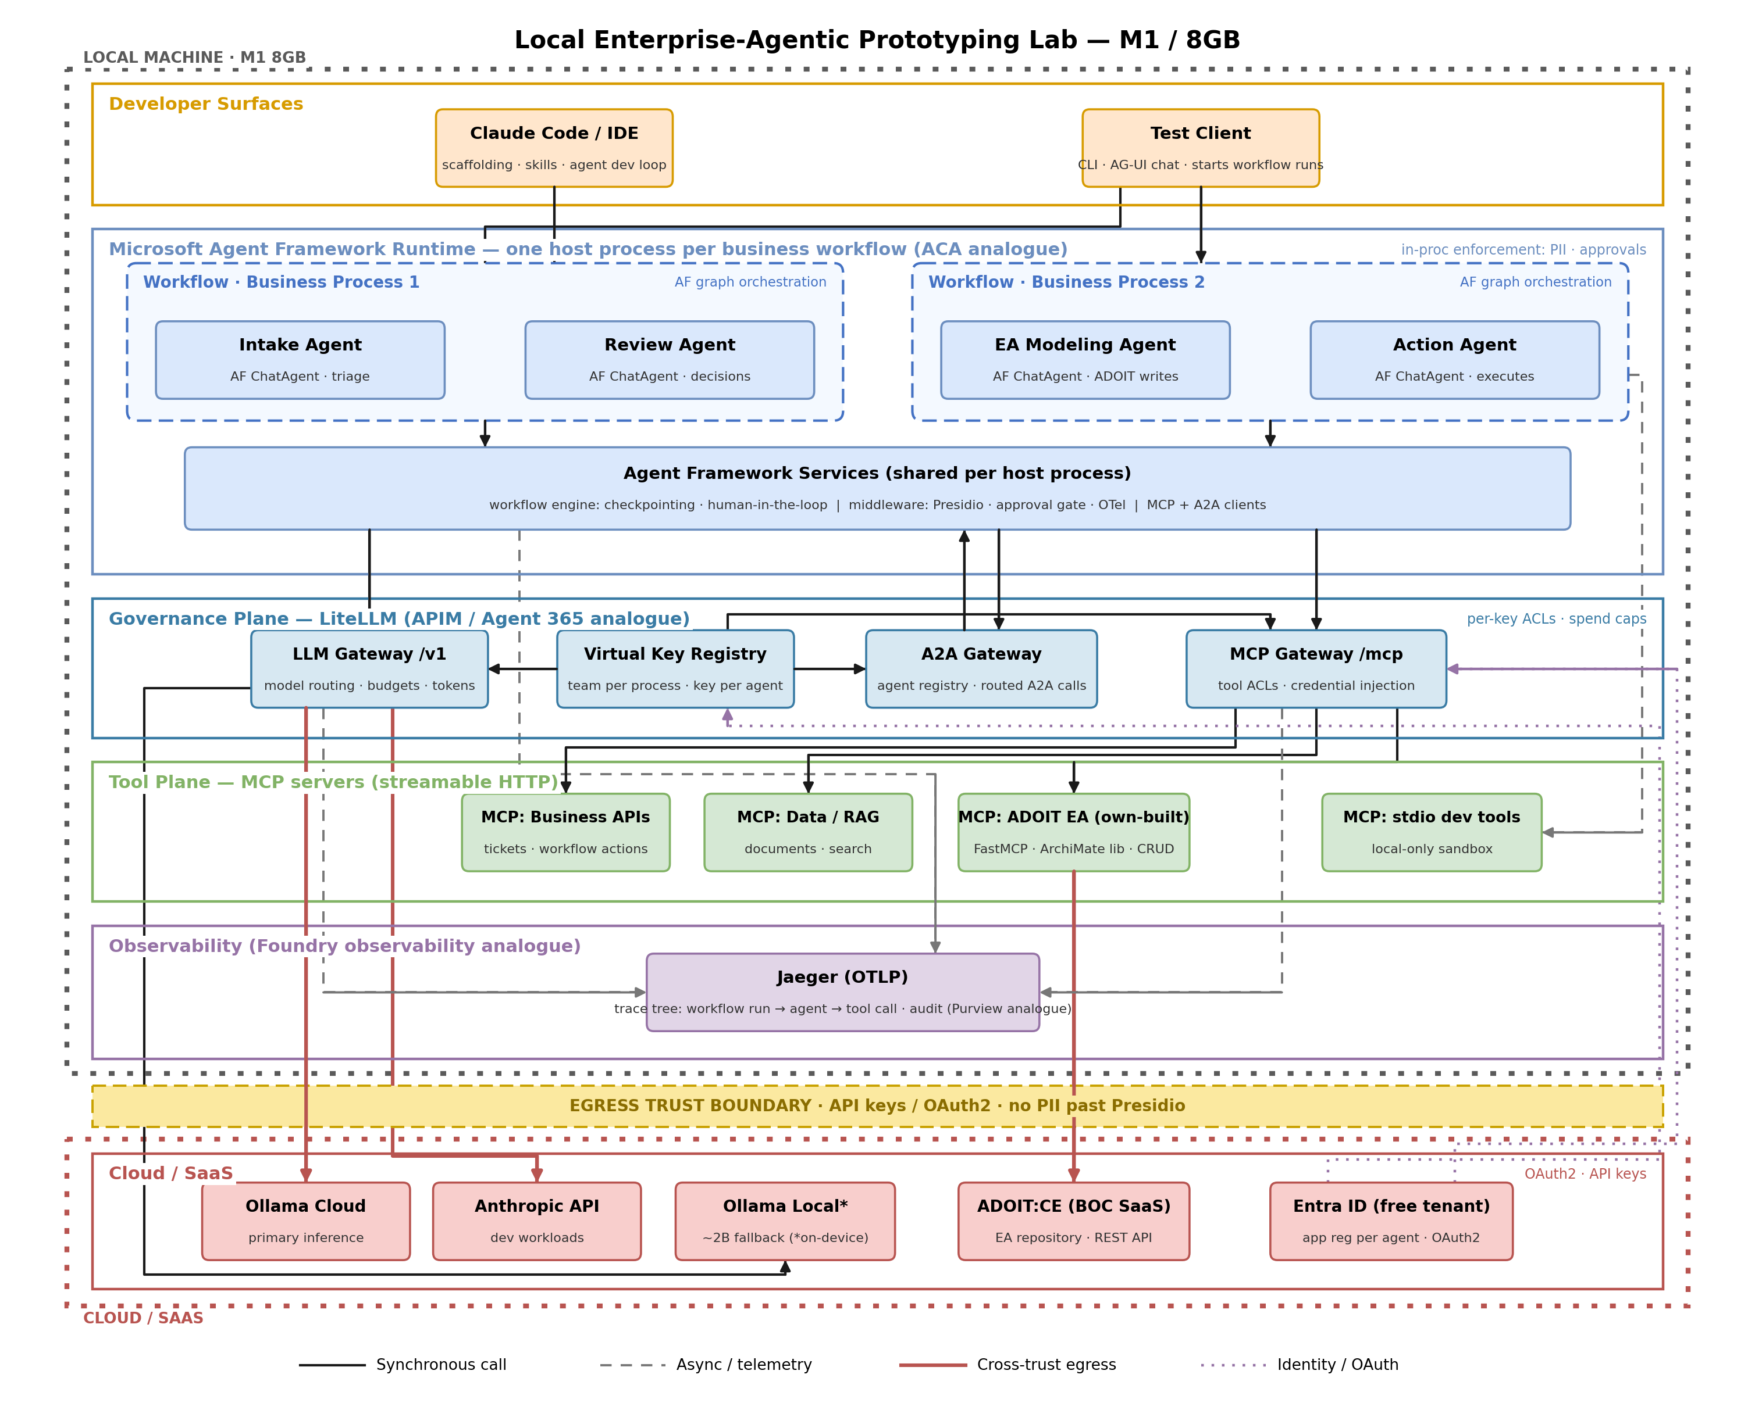
Figure 1 — Local enterprise-agentic prototyping lab (v3)

2.1 Service Mapping
Azure service | Role | Local analogue | Notes
AI Foundry (models) | Model hosting & routing | Ollama Cloud (primary), local Ollama fallback | Cloud-first inference; ~2B local model for offline only
Azure Container Apps | Agent hosting | One Python host process per workflow | Agent Framework code unchanged on migration
APIM / AI Hub Gateway | Gateway & policy | LiteLLM Proxy (/v1, /mcp, A2A) | Virtual keys, budgets, rate limits, tool ACLs
Agent 365 | Agent registry & governance | LiteLLM teams/keys + Entra app registrations + A2A agent cards | Team per process, key per agent
Entra ID | Identity | Entra ID free tenant (real) | MSAL locally; OAuth2 for MCP flows
Purview | Data governance & audit | Microsoft Presidio middleware + OTel trace audit | PII detect/redact on prompts, tool args, results
Defender for AI | Threat protection | Guardrails middleware; LLM-judge via cloud model | Prompt-injection & output scanning
Foundry observability | Tracing & monitoring | OpenTelemetry to Jaeger | Trace tree: workflow run, agent, tool call
APIM-fronted MCP | Tool governance | LiteLLM MCP Gateway | Central registry; per-key tool filtering

3. Runtime: Microsoft Agent Framework
Business processes are implemented as Agent Framework Workflows — typed graphs that orchestrate ChatAgents and deterministic functions with sequential, concurrent and handoff patterns, checkpointing and human-in-the-loop pauses. Each business process runs as its own lightweight Python host process (the local stand-in for one Azure Container App per process). Multiple processes run concurrently; an idle async host consumes roughly 100 MB, so capacity is bounded by cloud API rate limits rather than local memory.
- Agents — Agent Framework ChatAgents implement the reasoning steps; the workflow graph carries process state and sequencing.
- Shared services — A shared services layer provides the workflow engine, the middleware chain (Presidio PII scanning, approval gates, OpenTelemetry emission) and the MCP and A2A client integrations.
- Models — Inference is cloud-first via Ollama Cloud through the gateway; a ~2B local model exists only as an offline fallback.

4. Governance Plane: LiteLLM
A single LiteLLM proxy is the control plane for all three traffic classes, mirroring how every spoke in the target Azure design consumes the shared hub APIM:
- LLM gateway (/v1) — OpenAI-compatible endpoint routing to Ollama Cloud, Anthropic and local Ollama, with per-key budgets, rate limits and token accounting.
- MCP gateway (/mcp) — Central registry of MCP servers with per-key tool filtering and upstream credential injection; agents connect to one endpoint and never hold tool credentials.
- A2A gateway — Inter-workflow agent-to-agent calls are also routed through LiteLLM rather than point-to-point, so cross-process traffic is authenticated, authorised and metered like any other call.
- Registry — One LiteLLM team per business process and one virtual key per agent give per-process rollups of spend, tokens and tool usage — the local equivalent of the Agent 365 management view. Each key pairs one-to-one with an Entra app registration and an A2A agent card.

5. Tool Plane: MCP Servers
All shared tools are MCP servers over streamable HTTP registered with the gateway. Stdio servers are permitted only as local-only development sandboxes and are drawn explicitly as bypassing governance — a pattern that must not migrate.

5.1 ADOIT EA Integration (own-built MCP server)
The lab starts against ADOIT:Community Edition, whose built-in MCP services and admin configuration are not available; the integration is therefore an own-built MCP server wrapping the ADOIT REST API. The existing internal Python ArchiMate library (61 element types, role-based architect agents) forms the domain layer; FastMCP exposes typed create/read/update tools; validation runs against the library before any repository write; and the middleware approval gate covers all write operations. Read/query tools may be shared across processes, while write tools are ACL-restricted to a dedicated EA Modeling Agent. If access to a full ADOIT 18 tenant is obtained later (trial or DOH licence), the built-in ADOIT MCP server can be registered alongside for read/query while writes remain on the own-built server.

6. Identity, Data Protection and Security
- Identity (Entra analogue) — A real Entra ID free tenant provides identity: one app registration per agent, MSAL locally, OAuth 2.0 for MCP authorisation flows via the gateway. No local IdP is run.
- Data protection (Purview analogue) — Microsoft Presidio runs as in-process middleware, detecting and redacting PII in prompts, tool arguments and tool results before egress; the trust-boundary rule is that no unredacted PII crosses to cloud backends.
- Security (Defender analogue) — Guardrails middleware covers prompt-injection and output scanning; heavier checks are delegated to a cloud LLM-judge to preserve memory. Destructive tools require human approval via the workflow engine.

7. Observability
Agent Framework emits OpenTelemetry natively. Every workflow run produces a trace tree — workflow run, agent invocations, model and tool calls — exported over OTLP to Jaeger together with gateway spans, so a single run is followable end to end from test client to model backend. Each workflow host sets a distinct service name (e.g. process-1-intake), allowing concurrent business processes to be filtered, compared and audited independently. The trace store doubles as the audit trail; Arize Phoenix is the identified drop-in upgrade if LLM-native evaluation views become necessary.

8. Resource Budget (8 GB)
Component | Approx. RAM | Notes
macOS baseline | ~3.0 GB | OS + system services
LiteLLM proxy (pip, native) | ~0.3 GB | LLM + MCP + A2A gateway
Jaeger all-in-one (Colima 2 GB VM) | ~0.3 GB | OTLP collector + UI
Presidio (spaCy small) | ~0.2 GB | Loaded in middleware
Workflow hosts (3–4 processes) | ~0.4 GB | ~100 MB per async Python host
MCP servers (on demand) | ~0.2 GB | FastMCP processes, incl. ADOIT server
Headroom | ~2.5–3 GB | Claude Code, browser, optional local model

The budget holds only under the cloud-first inference rule; loading a 7B-class model locally is out of scope for this machine.

9. Migration Path to Azure
Because the lab enforces the production patterns, migration is mechanical: workflow hosts move to Azure Container Apps with managed identities replacing local keys; LiteLLM policies translate to APIM (including APIM-fronted MCP); the Entra tenant is replaced by the corporate tenant; Presidio and guardrails middleware carry over unchanged; and OTLP export is repointed from Jaeger to Foundry observability / Application Insights. Agent code, workflow graphs, MCP tool contracts and A2A cards are unchanged.

10. Next Steps
- 1. — Scaffold the repository: Colima + Jaeger compose file, LiteLLM config (models, MCP registry, teams/keys), first workflow host with middleware chain wired.
- 2. — Build the ADOIT MCP server on the existing ArchiMate library and register it with the gateway; validate create/update round-trips against ADOIT:CE.
- 3. — Implement two pilot business processes end to end and demonstrate concurrent runs with per-process traces and spend rollups.
- 4. — Approach BOC for a full-edition test tenant to evaluate the built-in ADOIT MCP server alongside the own-built one.

