Roadmap Feature Definition (RFD)
IFHAS Version 3.0
30 December 2025

sign-off trail
Name | Role | Sign-off Date

Document control
Version | Date | Author(s) | Description of Changes
1.0 | 09 Dec 2025 | Mariya Trushanova | Draft version 1
1.1 | 10 Dec 2025 | Mariya Trushanova | Draft version 2
1.2 | 12 Dec 2025 | Mariya Trushanova | Draft version 3
1.3 | 19 Dec 2025 | Mariya Trushanova | Draft version 4
1.4 | 24 Dec 2025 | Mariya Trushanova | Draft Version
1.5 | 29 Dec 2025 | Yazan Yahya | Update and Review
Terms and Abbreviations
Term | Definition
ADHDS | Abu Dhabi Health Data Services
DOH | Department of Health
Daman | The National Health Insurance Company in Abu Dhabi
Thiqa | A government health insurance program in Abu Dhabi for Emirati citizens, providing access to public and private healthcare services through Daman.
IFHAS | The Abu Dhabi preventive health program, offering age- and gender-specific health screenings and services.
TAMM | Abu Dhabi’s government digital platform, providing access to various public services, including healthcare. Sahatna is integrated within the TAMM platform.
SEHA | The Abu Dhabi Health Services Company, responsible for managing public hospitals and clinics across the Emirate.
Accela | A government licensing platform used to manage and maintain official records of licensed facilities and their authorized services.

Contents
1. Roadmap Item & Feature Summary 3
1.1. Summary 4
2. BACKGROUND AND CONTEXT 4
2.1. KEY DRIVERS 4
2.2. STAKEHOLDERS 4
2.3. TARGET AUDIENCE 5
3. Scope 5
3.1. LIST of epics 5
3.1.1. Epic 1: Check user eligibility 5
3.1.2. Epic 2: IFHAS Landing page 5
3.1.3. Epic 3: Available IFHAS packages 5
3.1.4. Epic 4: View IFHAS-related information 6
3.1.5. Epic 5: View screening results 6
3.1.6. Epic 6: Book IFHAS appointment 6
3.1.7. Epic 7: Fill in Pre-screening Questionnaire 6
3.1.8. Epic 8: View IFHAS facility details 6
3.1.9. Epic 9: Nudge users 7
3.1.10. Epic 10: Send reminders 7
3.1.11. Epic 11: Post-appointment survey 7
4. Assumptions 7
4.1.1. Data Availability from Daman System 7
4.1.2. Screening Results Retrieval from Malaffi: 8
4.1.3. IFHAS Service Identification by Facilities 8
4.1.4. DOH facility licensing system 9
4.1.5. DOH provides IFHAS information 9
5. TO-BE USER JOURNEYS 9
5.1. User Journey: BOOK IFHAS Appointment. 9
5.2. USER JOURNEY: View Encounter History 9
5.3. USER JOURNEY: Nudge the user 10
5.4. Business Processes: Book IFHAS appointment. 10
5.4.1. Eligibility check 11
5.4.2. View Landing page 11
5.4.3. Determine Available IFHAS Packages 11
5.4.4. Select IFHAS package 11
5.4.5. Select IFHAS facility 11
5.4.6. Select physician 11
5.4.7. Choose slot 12
5.4.8. Book IFHAS appointment 12
5.4.9. Fill out IFHAS Pre-screening Questionnaire 12
5.5. Business Processes: View Encounter History 12
5.5.1. Check upcoming IFHAS appointments 12
5.5.2. Access IFHAS encounter history 12
5.5.3. Review IFHAS screening results 12
5.6. Business Processes: Nudge the user 12
5.6.1. Insurance Expired 12
5.6.2. Insurance On Hold 12
5.6.3. IFHAS Screening Available 13
5.6.4. Complete IFHAS screening 13
6. External Integrations: Key system/API interactions mapped to user actions. 13
6.1. EMR Integration (Appointment Booking) 13
6.2. Integration with Daman 13
6.3. Malaffi Integration (Retrieval of IFHAS results) 14
6.4. DOH Licensing System Integration: 14
6.5. CMS Integration: 15
7. To-Be UX/UI Designs IN LOW FIDELITY 15
7.1. Landing page 16
7.2. IFHAS Packages 16
7.3. IFHAS Offerings 17
7.4. Select Hospital or Clinic 18
7.5. CHOOSE Physician 18
7.6. Select slot 19
7.7. View PHYSICIAN PROFILE 19
7.8. Confirm booking 20
7.9. Fill out PRE-SCREENING Questionnaire 21
7.10. Explore IFHAS Facilities 21
7.11. Cancel IFHAS Appointment 22
7.12. Reschedule IFHAS Appointment 22
7.13. Nudges 23

- Roadmap Item & Feature Summary
  - Summary
The document describes a project by the Abu Dhabi Department of Health for IFHAS screening program. The core functionality includes providing clear and accessible information about the importance of the IFHAS, highlighting its benefits and the significance of preventive health screenings. It enables booking IFHAS appointments based on user’s eligibility, reviewing the Prescreening Questionnaire, and sending reminders for IFHAS appointments. The intended outcome is to be aware of the available screening program by age and gender and to empower the community to take care of their health, supporting healthy behavior and longevity.
- BACKGROUND AND CONTEXT
  - KEY DRIVERS
IFHAS is part of a comprehensive, periodic, and preventive screening initiative from DOH/ADPHC, which aims to improve the health outcomes of the citizens in the Emirate of Abu Dhabi. The program aims to provide early detection of chronic diseases and various health conditions such as cardiovascular diseases, mental health issues, fertility health, oral health problems, and common cancers. By identifying these conditions early, the program seeks to reduce complications and enable timely preventive measures and therapeutic interventions. The program provides various screenings for males and females as per their age.
IFHAS is offered at multiple facilities across Abu Dhabi. Sahatna will receive the list of facilities marked as IFHAS providers from the Accela licensing system, with the ability to enable or disable each facility for IFHAS in the backend.
In 2024, the Thiqa C1 member engagement with the IFHAS CVD program was low and there are minimal screenings (~40%) being done by the population of Abu Dhabi. The mandate is to increase engagement (on IFHAS) by 75% by 2026. It is expected that Sahatna will help bring about increased engagement through clear information visibility and ease of booking screening appointments. Thus, enhancing the overall IFHAS journey and experience by the participants.
  - STAKEHOLDERS
# | Stakeholder Name | Designation | Contact Info (optional)
1 | Dr. Kawther Salem Al Ameri | ADPHC-Abu Dhabi
2 | Hurra Hassan | ADPHC-Abu Dhabi
3 | Ashraf Othman | Daman
5 | Austin Ross Wei Yen Beh | DOH
4 | Dinesh Jai Lal | DOH
  - TARGET AUDIENCE
Only users holding a Thiqa insurance level from 1 to 4 are eligible to participate in the IFHAS Program.
- Scope
  - LIST of epics
    - Epic 1: Check user eligibility
- Description: Check within Daman service if the user is eligible for IFHAS screening.
- Expected Outcome: If the user has Thiqa level from С1 to С4, they will see IFHAS Banner and Quick tool on the TAMM Dashboard.
- Note: There will be integration with the Daman service to check user’s eligibility.
IFHAS Banner will be managed via Strapi CMS and will depend on TAMM team.
    - Epic 2: IFHAS Landing page
- Description: Display IFHAS Landing page for eligible users.
- Expected Outcome: The IFHAS Landing page contains:
  - Pending packages
  - Book IFHAS appointment
  - Current and previous Screening results (only if facilities are flagging the results as IFHAS)
  - History of previous packages from Daman
  - What is IFHAS banner
  - Benefits
  - Conditions are assessed under IFHAS
  - IFHAS offerings
  - Digital Pre-screening questionnaire using the same architecture used for the other screenings no results would be shown
  - Helpful Tips
  - Explore facility list
  - FAQs
    - Epic 3: Available IFHAS packages
- Description: Displaying available IFHAS packages for the user.
- Expected Outcome: Sahatna will receive member IFHAS details based on user EID, as well as pending packages for the user from Daman. The user will be able to choose which package they want to book an appointment for as listed upon age and gender.
    - Epic 4: View IFHAS-related information
- Description: Displaying current and past IFHAS-related information.
- Expected Outcome: Users can view their current IFHAS insurance eligibility status, completed packages, and upcoming IFHAS appointments based on DAMAN Api’s data
    - Epic 5: View screening results
- Description: Displaying screening results after IFHAS appointment.
- Expected Outcome: After the screening, users can view their results on Sahatna, with data retrieved from Malaffi (only if facilities are flagging the appointment as IFHAS).
- Note: Facility should add flag IFHAS to corresponding screenings. This should be solved via Facility onboarding.
    - Epic 6: Book IFHAS appointment
- Description: Eligible users can book IFHAS appointments for major or minor packages.
- Expected Outcome: The user selects IFHAS package, facility (physicians will be auto fetched based on the business shared by DOH), and book an appointment.
- Note: Sahatna will receive the list of facilities marked as IFHAS providers from the Accela licensing system, with the ability to enable or disable each facility for IFHAS in the backend. The system will filter doctors by specialties based on IFHAS packages. IFHAS appointment can only be In-Person.
    - Epic 7: Fill in Pre-screening Questionnaire
- Description: When a user books an IFHAS appointment for Major package, they must fill in a digital Pre-screening Questionnaire before visiting the doctor.
- Expected Outcome: After a successful booking of IFHAS appointment for Major package, the system shall present the pre-screening questionnaire to the user. The user may complete the questionnaire immediately or choose to skip it and complete it later. If skipped, the questionnaire must remain accessible to the user at any time before the scheduled appointment.
- Note: List of questions for the Pre-screening Questionnaire should be provided by DOH.
Results of Pre-screening Questionnaire filled by the patient will be available for physicians by Malaffi.
    - Epic 8: View IFHAS facility details
- Description: The user can review details of the IFHAS facility.
- Expected Outcome: They can explore the IFHAS facility list and review details of a clinic.
- Note: The system will display only facilities from the list provided by DOH.
    - Epic 9: Send reminders
- Description: Sahatna should send reminders to complete important tasks - update insurance or book an appointment for a new screening.
- Expected Outcome: Reminders after booking the appointment 24H and 1H prior to the appointment.
- Note: Nudges will be confirmed after the agreement with Daman on the data that will be provided through APIs, below are sample nudges:
  - Nudge the user for the screening that were not done
  - If the user has Thiqa2, Thiqa3, Thiqa4 and the insurance is expired
  - If the user has Thiqa1 and the insurance is on hold
  - If the user is eligible, the system shall nudge them to Book IFHAS appointments upon age and gender.
  - If the Thiqa insurance expires in 90 days, the system shall nudge the user to book a pending IFHAS appointment.
    - Epic 10: Post-appointment survey
- Description: After an IFHAS appointment, the system should collect user feedback through a post-appointment survey for visits which are flagged as IFHAS on the provider side.
- Expected Outcome: 7 days (Can be configurable) after the results become available, the system shall nudge the user to complete the survey, encouraging them to share feedback on their experience.
- Note: Questions for surveys should be provided by DOH.
Dashboard to review overall survey results for DOH business owners will be prepared by DOH data team team.
- Assumptions
For a successful implementation of the program, it is assumed that the following will be made available by DOH
    - Data Availability from Daman System
- Daman will make the following data elements available for Sahatna to consume using APIs.
  - Member card number
  - THIQA category (TH1, TH2, TH3, etc.)
  - Member enrolment start date
  - Member expiry date
    - Member status. (Active / Expired / Cancelled)
  - Authorization approval date
  - Service description (IFHAS Package)
  - Service code (IFHAS Package)
  - Authorization Status Received date
  - Provider License Number (MFXXX)
  - Physician License Number (GDXXX)
- This data will be accessible on demand.
- Quality of data will be the responsibility of Daman
- The integration should support seamless data flow, enabling Sahatna to provide users with accurate information on their Thiqa category, prior encounters, and current eligibility.
    - Screening Results Retrieval from Malaffi:
- Diagnostic results if any will be retrieved securely and on-demand from the Malaffi system.
- The integration with Malaffi should ensure that once the screening is completed, the results are promptly accessible to the user through the Sahatna app.
Assumption: Screening results should have the visit identifier to selectively filter results for IFHAS Comprehensive Screening.
    - IFHAS Service Identification by Facilities
- Facilities offering IFHAS services must have a designated service type or identifier within their system to differentiate IFHAS appointments from other appointments. This will enable Sahatna to accurately list and filter facilities based on their participation in the IFHAS program. Note: the feasibility of implementing this requirement depends on multiple stakeholders, including providers and Malaffi.
    - DOH facility licensing system
- DOH is the responsible team for ensuring DOH licensing system will include a flag for IFHAS service providers.
    - IFHAS Packages and screening information
- Packages and corresponding screening services (codes and descriptions) applicable to the eligible population, as defined by age- and gender-specific eligibility criteria which would be provided by DOH/ADPHC
- List of specialties and facilities for each package should be provided by DOH/ADPHC in case the information is not coming from Accela or Daman.

- TO-BE USER JOURNEYS
  - User Journey: BOOK IFHAS Appointment.
The Detailed workflow can be viewed at this link.
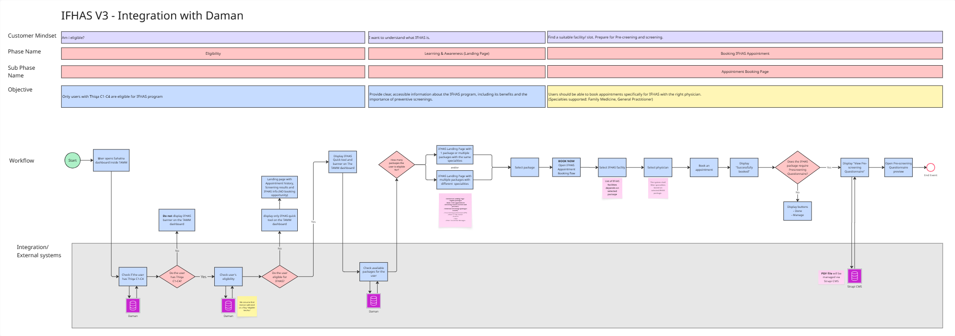
  - USER JOURNEY: View Encounter History
The Detailed workflow can be viewed at this link.

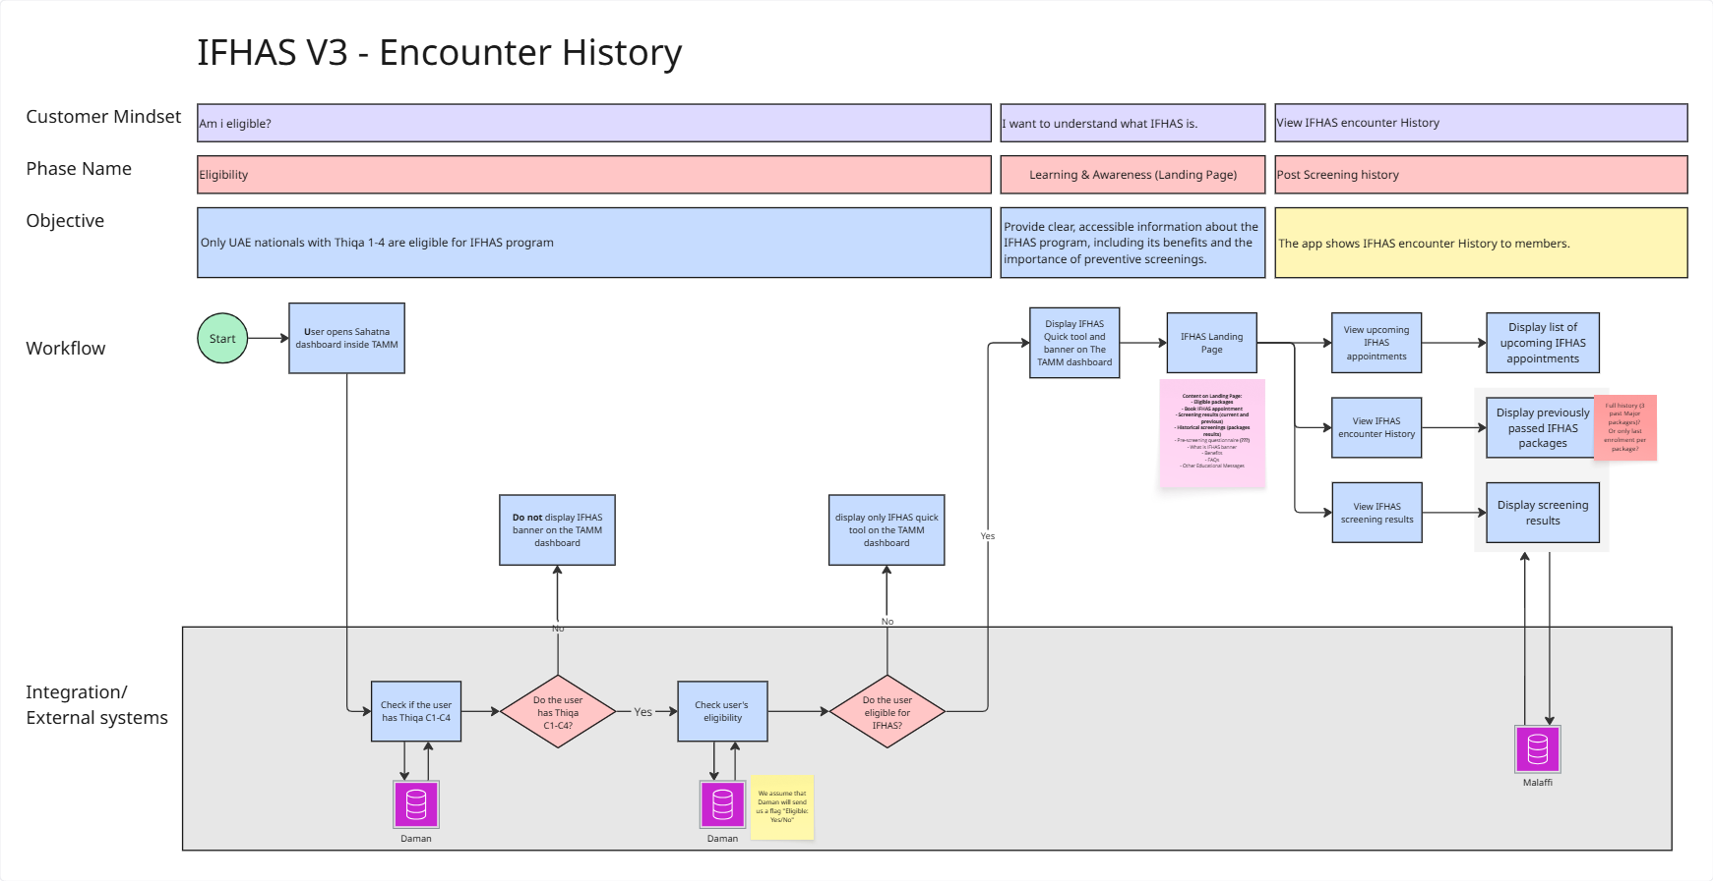
  - USER JOURNEY: Nudge the user
The Detailed workflow can be viewed at this link.
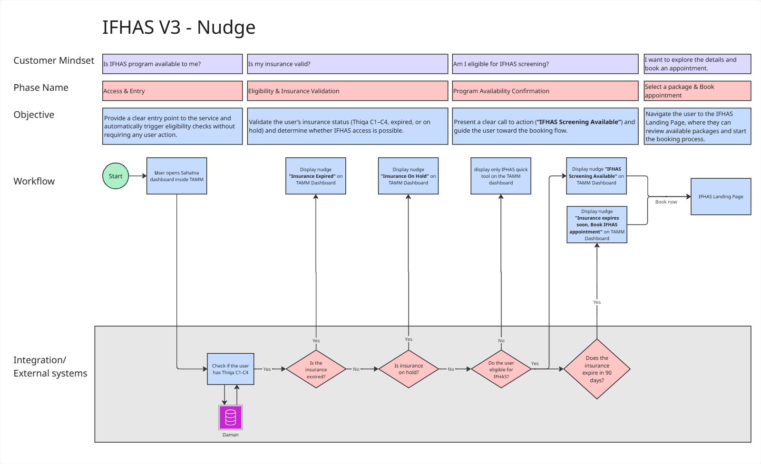
  - Business Processes: Book IFHAS appointment.
    - Eligibility check
When the user opens the TAMM Dashboard, the system will verify their IFHAS eligibility through the Daman service. Only users with Thiqa categories C1–C4 are eligible for the IFHAS program.
    - View Landing page
On the landing page, the user can access the pending IFHAS packages based on their eligibility, track upcoming IFHAS appointments, check encounter history, and see their screening results. The page also allows the user to learn about the program, explore its benefits and offerings, browse FAQs, and review the list of IFHAS facilities.
    - Determine Available IFHAS Packages
The system will store DOH-provided data on IFHAS packages in the backend, including related age ranges, gender, screening frequency, the specialties associated with each package, and the facilities authorized to perform the required screenings.
Using eligibility data and the user’s IFHAS appointment history provided by Daman, the system will determine which packages are currently available to the user.
    - Select IFHAS package
The system will retrieve the member’s IFHAS details from Daman and use this information to determine which IFHAS packages are available based on their gender, age, and appointment frequency. Once the available packages are displayed, the user can select a preferred package and proceed to book an IFHAS appointment seamlessly through the system.
    - Select IFHAS facility
To book an IFHAS appointment, the user must first select a facility. Sahatna will receive the list of facilities marked as IFHAS providers from the Accela licensing system, allowing the user to choose the most suitable location for their appointment.
If a Primary care registered facility appears in the list of IFHAS facilities, the user will be informed accordingly.
The list of IFHAS facilities is updated annually, as new privileges and changes are introduced on a yearly basis.
    - Select physician
When the user selects a facility, the system will display a filtered list of physicians. The filtering will take into account the specialties required for the selected IFHAS package, ensuring that only relevant physicians are shown. The system will display only those physicians who have available slots for in-person appointments, as IFHAS appointments can only be conducted in person.
    - Choose slot
When the user selects a physician, they can select a convenient time slot and proceed with booking their IFHAS appointment.
Teleconsultation is not available for IFHAS appointments. In future, Teleconsultation may be made available for follow-up appointments only.
    - Book IFHAS appointment
The user must review all appointment details and confirm the booking. Once confirmed, the system will send the information to the selected facility. After receiving a successful response from the facility, the system will notify the user that the appointment has been booked successfully.
    - Fill out IFHAS Pre-screening Questionnaire
After the IFHAS appointment is booked for the Major package, the user must fill out the digital IFHAS pre-screening questionnaire. The user can skip it and complete it later. If skipped, the questionnaire must remain accessible to the user at any time before and during the scheduled appointment.

  - Business Processes: View Encounter History
    - Check upcoming IFHAS appointments
The user can view upcoming IFHAS appointments directly on the landing page.
    - Access IFHAS encounter history
The user can access the history of previously completed IFHAS packages, as well as active packages. This information is displayed across all IFHAS packages that the user was eligible for at different points in time.
    - Review IFHAS screening results
The user can view the IFHAS screening results when they are available from Malaffi.
  - Business Processes: Nudge the user
    - Insurance Expired
If the user has Thiqa 2, Thiqa 3, or Thiqa 4 and their insurance is expired, the system shall display an “Insurance Expired” nudge, informing the user that they need to contact Daman to renew their insurance.
    - Insurance On Hold
If the user has Thiqa 1 and their insurance is on hold, the system shall display an “Insurance on Hold” nudge, advising the user to contact Daman to resolve and renew their insurance.
    - IFHAS Screening Available
If the user is eligible for an IFHAS package based on their age and gender, the system shall display a nudge encouraging the user to book an IFHAS appointment.
- External Integrations: Key system/API interactions mapped to user actions.
  - EMR Integration (Appointment Booking)
The IFHAS module will interact with the EMR using the existing appointment booking services. The current integration specifications will have to be extended to accommodate the IFHAS appointment service types. Providers will need to include the new service types to support the workflows envisioned. It is expected that the documentation for the EMR integration will be updated accordingly.
  - Integration with Daman
The system integrates with Daman service to receive information for users' eligibility and IFHAS history. Daman shall provide comprehensive API for
- The member details:
- Member card number
- THIQA category (C1, C2, C3, C4)
- Member enrolment start date
- Member expiry date
- Member status. (Active / Expired / Cancelled)
- The member IFHAS details (for last 5 years):
- Authorization approval date
- Service description (IFHAS Package)
- Service code (IFHAS Package)
- Authorization Status Received date
- Provider License Number (MFXXX)
- Physician License Number (GDXXX)
The activity details should be an array of records, Paginated, oldest to earliest (Latest first), Filter by Type of Activity.
Data should be extracted for the last 5 years only.

- The member IFHAS details (within the previous validity periods):
- Authorization approval date
- Service description (IFHAS Package)
- Service code (IFHAS Package)
- Authorization Status Received date
- Provider License Number (MFXXX)
- Physician License Number (GDXXX)
  - Malaffi Integration (Retrieval of IFHAS results)
The IFHAS module will also interact with the Malaffi system to retrieve the IFHAS-specific screening reports. The integration will follow the existing specifications to retrieve lab reports from Malaffi. The new logic needs to be applied to identify IFHAS-related reports.
Some notes to be considered while integrating with Malaffi for IFHAS:
- For Malaffi, all results are processed uniformly. There is no result-level tagging to distinguish IFHAS reports from others; identification occurs solely at the encounter level. Providers can ensure correct identification of IFHAS reports by:
  - Sending the appropriate visit description code in the encounter data, clear meaning indicating an IFHAS Comprehensive Screening visit.
  - Including the visit identifier in the HL7 message (PV1-19 field).
When both the above conditions are met, the system can accurately identify and categorize an IFHAS report.
- For IFHAS visits, providers are expected to send both a 'Visit description' and a visit ID (Encounter) when submitting outpatient (OP) encounters to Malaffi. While this protocol has been communicated to providers and implemented in Malaffi's system, 100% compliance across all facilities cannot be guaranteed. This requirement pertains to the HL7 ORU (Observational Result) Message, which includes a segment for encounter information. However, this segment is not mandatory, accommodating the workflow of standalone diagnostic centers where no formal encounter occurs.
- The Visit Description tag defined for IFHAS Comprehensive Screening has a code value of “ICS.” and this value is expected from providers who offer IFHAS services as per DOH circular (22/2023). (Compliance with this standard may not be 100% by the providers)
  - DOH Licensing System Integration:
It is expected that Sahatna will extend the current integration with DOH licensing system to include IFHAS facilities also. DOH licensing will provide additional flags to identify facilities providing IFHAS services. This will help in maintaining an updated list of IFHAS service providers.
  - CMS Integration:
Strapi integration enables centralized management of the TAMM dashboard banner and the IFHAS pre-screening questionnaire PDF, ensuring that content can be updated quickly and consistently through the CMS.

- To-Be UX/UI Designs IN LOW FIDELITY
  - Landing page
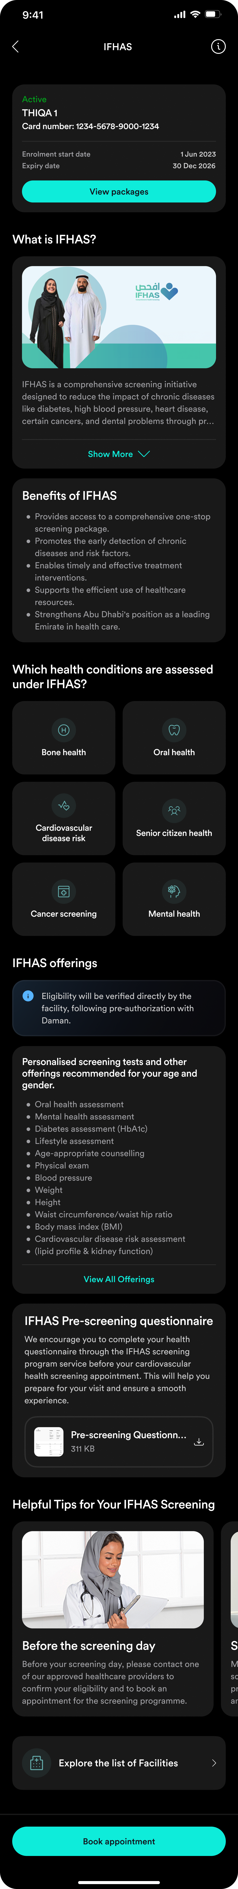
  - IFHAS Packages
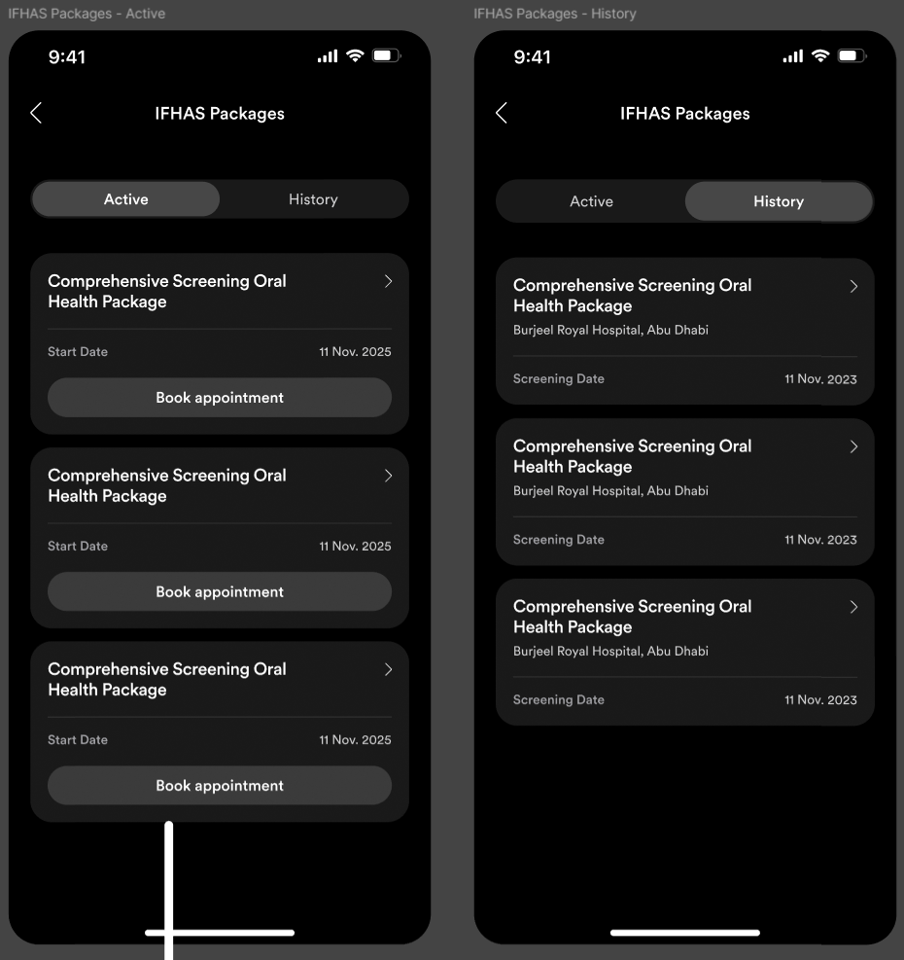
  - IFHAS Offerings
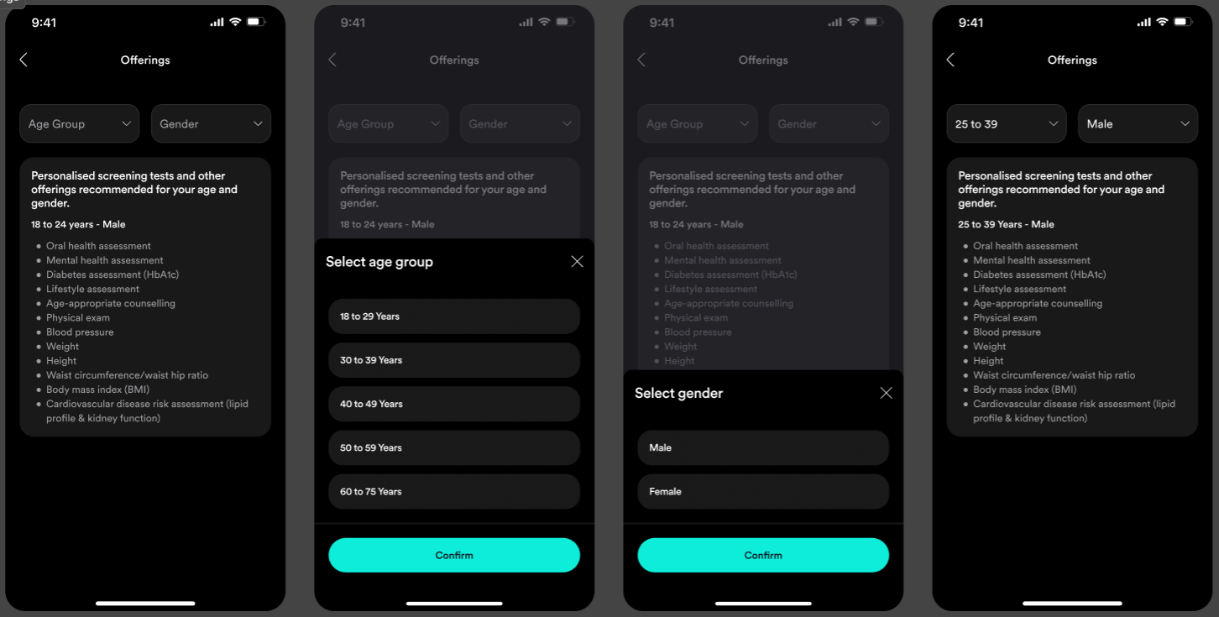
  - Select Hospital or Clinic
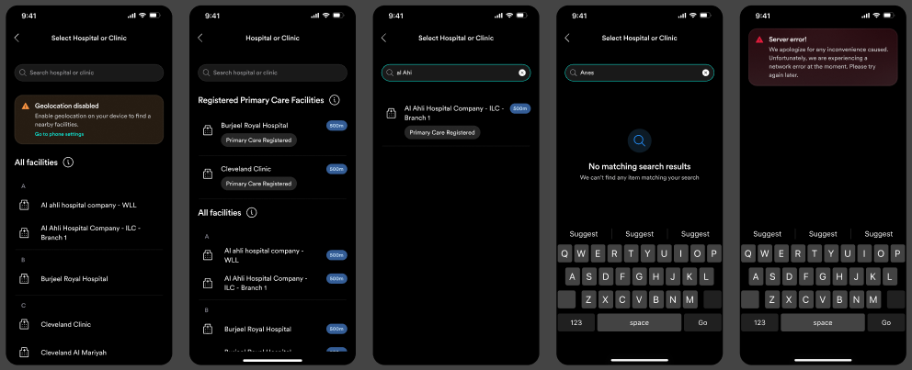
  - CHOOSE Physician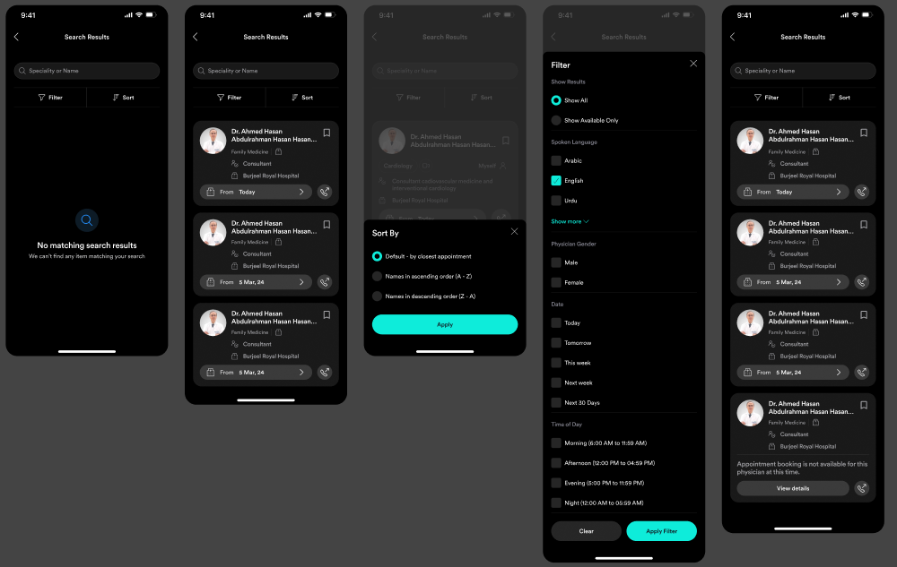
  - Select slot
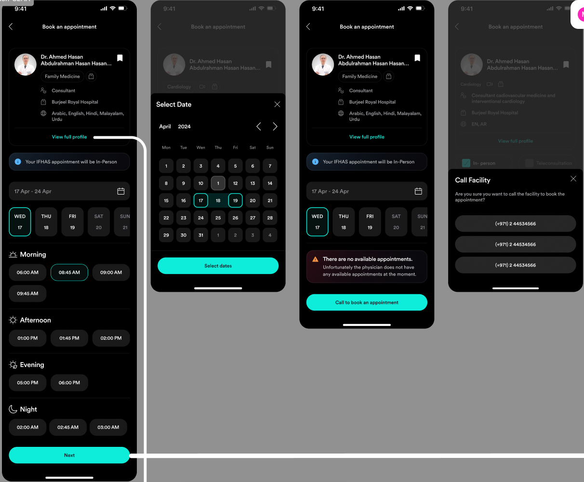
  - View PHYSICIAN PROFILE
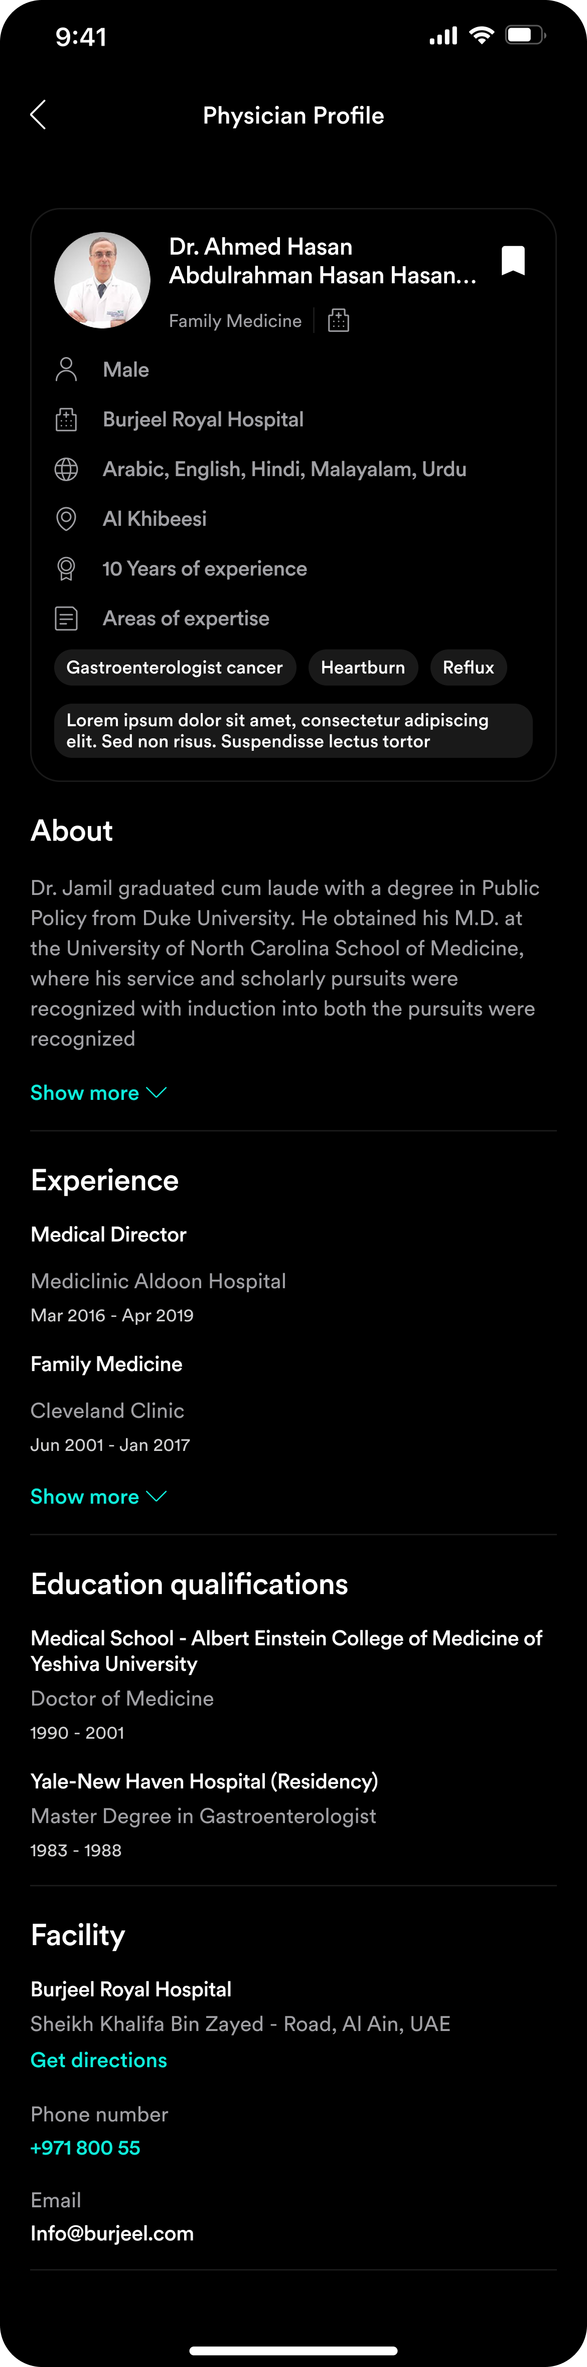
  - Confirm booking
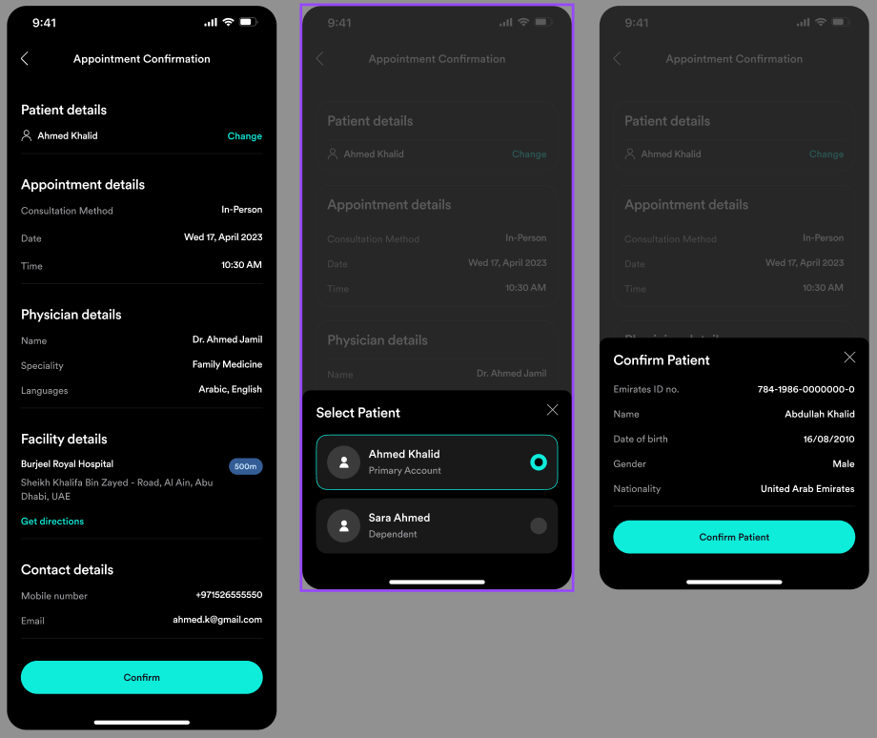
  - Fill out PRE-SCREENING Questionnaire

  - Explore IFHAS Facilities
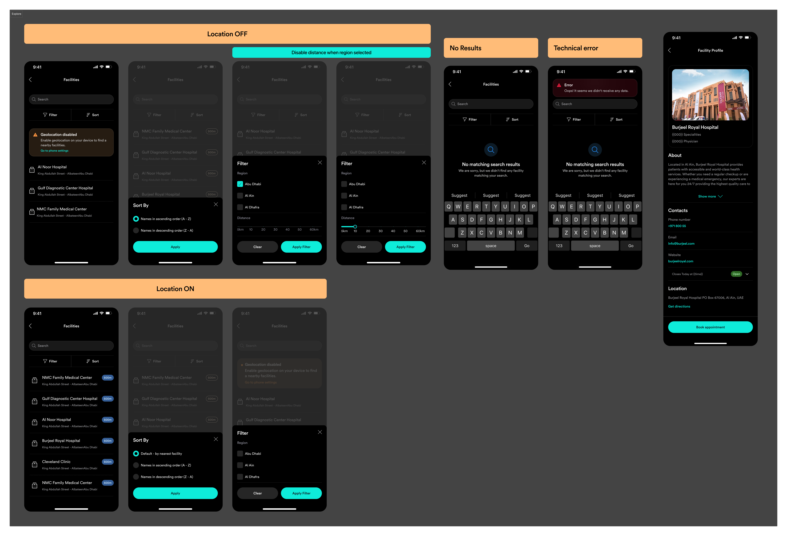
  - Cancel IFHAS Appointment
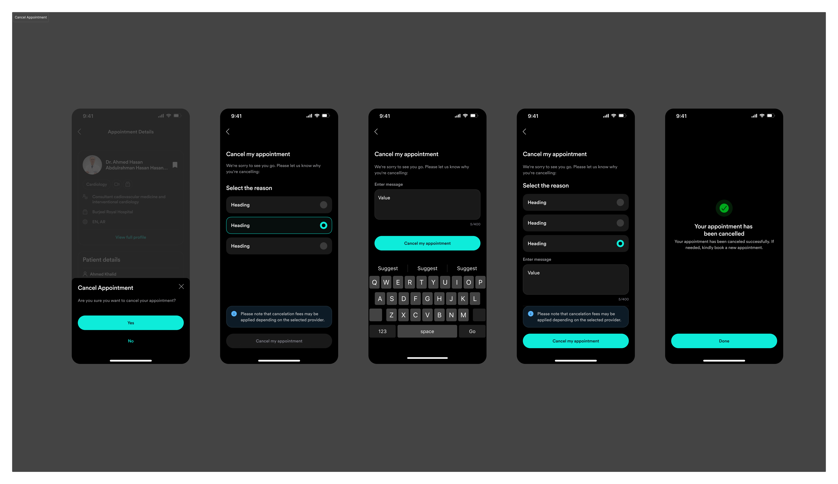
  - Reschedule IFHAS Appointment
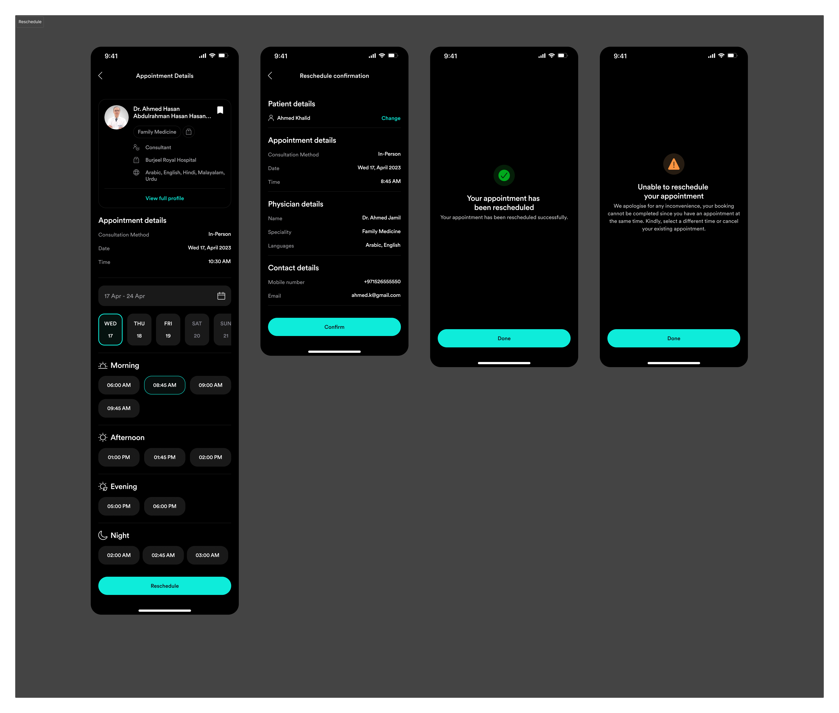
  - Nudges
