Technical Design Document
(Application Architecture)
for

Sahatna Super App

Version 1.3
Prepared by Core42

Table of Contents
2. Introduction 4
2.1. Dictionary of Abbreviation 4
2.2. Related Project Document 4
3. Architectural Design 5
3.1. Architecture Vision 5
3.1.1. Architectural Principles 5
3.1.2. Core system requirements 6
3.1.3. High-Level Architecture Design 6
3.2. Business Architecture 7
3.2.1. Functional Modules Descriptions 7
3.2.2. External Components Description 9
3.3. System Architecture Design 11
3.3.1. Data Layer Architecture Description 11
3.3.2. Application Layer Description 14
3.3.3. Identity Service Module System Architecture 19
-1.1.4. Patient Service Module System Architecture 23
-1.1.5. Provider Service Module System Architecture 26
-1.1.6. Symptoms-Checker Service System Architecture 29
-1.1.7. PHR Service System Architecture 32
-1.1.8. Notification Service System Architecture 34
-1.1.9. Integration Service System Architecture 36
-1.1.10. Teleconsultation Service System Architecture 43
-1.1.11. Wearables Service System Architecture 47
4. References 50

Version History

Version | Date (DD.MM.YYYY) | Author | Change Log
0.1 | 26.11.2023 | Siarhei Ihnatsenka | Initial draft
0.2 | 26.12.2023 | Viktar Zeldzin  Ahmed Othman | - Integration Architecture  - Service card details
1.0 | 14.01.2024 | Siarhei Ihnatsenka  Ahmed Othman | - System Architecture
1.2 | 24.02.2025 | Nabil Jarrai  Ahmed Othman | - Updates on integration service  - Updates on wearable service  - Updates on data models and design considerations
1.3 | 11.05.2025 | Ahmed Othman | - Updates high level components view

Introduction
This document is delivered to the Abu Dhabi Department of Health to detail the Techical Design the Sahatna Super App.

Dictionary of Abbreviation

Term | Definition
DFD | Digital Front Door
EMR | Electronic Medical Records
API | Application Programming Interface
Access Token | Cryptographic string contains security credentials for a login session, identifying user
REST | Representational State Transfer
HTTP | Hypertext Transfer Protocol
Pub/Sub | Publish Subscribe architectural messaging pattern
API Gateway | Infrastructure component used for API lifecycle management
Open API (Swagger) | Open standard for defining RESTful APIs
EHR | Electronic Health Record
EMR | Electronic Medical Record
HIE | Health Information Exchange

Related Project Document
The following table details other project documents that are closely related to or referenced by this design and plan document.

Document | Description
Integration Specification Document for Provider Technical Onboarding DOH Super App (DFD) V.0.1.7 | Document describes the technical specifications (APIs) to integrate with DOH Super App (DFD) through EMR systems of different providers.
Azure Platform Design | Document describe the Azure Web Platform design for Sahatna Super App deployment

Architectural Design

Architecture Vision

Architectural Principles

Principle | Description
Use an Incremental and Iterative Approach | Start with baseline architecture and then evolve candidate architectures by iterative testing to improve the architecture.
Separation of Concerns | Divide the components of the system into specific features so that there is no overlapping among the component's functionalities. This will provide high cohesion and low coupling. This approach avoids the interdependency among components of the system which helps in maintaining the system easily.
Define the Communication Protocol between Components | Understand how components will communicate with each other which requires a complete knowledge of deployment scenarios and the production environment.
Buy vs Build | Prefer to reuse an existing functionality if it provides necessary support to address business needs
Design Exceptions and Exception Handling Mechanism | Defining exceptions in advance, helps the components to manage errors or unwanted situations elegantly. The exception management will be the same throughout the system.
Regulation requirements compliant | The software solution has to be compliant with all regulation requirements applicable to the software solution’s type within the jurisdiction where the software solution will be implemented and will be exploited.

Core system requirements

Requirement | Description
Scalability | - The system must quickly and automatically cater to an increasing number of users.
Availability | - The system must be highly available to fulfill ongoing customer needs and available to integrate with other 3rd party systems.
Elasticity | - Scalability is required for elasticity, but not the other way around.  - The system must quickly and automatically cater to a bust in the incoming requests.
Extensibility | - The level of extensibility reflects how easy it is to extend or enhance the software system. Software systems that are designed to be extensible consider future growth by anticipating the need to add new functionality.  - It also enables our platform to quickly do experiments.  - There are different integration points to this system so it should be easily extendible for any such future needs (new integration point, new engagement model, etc.)
Reliability | - The system deals with the patient, hospital staff as well and patient medical data within patient treatment. Hence system should be reliable with its provided services and make sure that there is stability and consistency in the recommendations they suggest and services they provide.
Configurability | - as well as other integrated systems should be easily configurable to adjust business needs and demands. For example, a Notification system should allow different sorts of channels like email, SMS, PUSH type notifications if need be.
App usability | - The different versions of the app should provide a user experience that appeals to the target user population.  - Using UX design techniques, and providing high levels of customization are goals.

High-Level Architecture Design

The High-Level Architecture diagram of the Sahatna Super App is depicted in Picture 2.1. The full list of microservices is subject to change as the project progresses.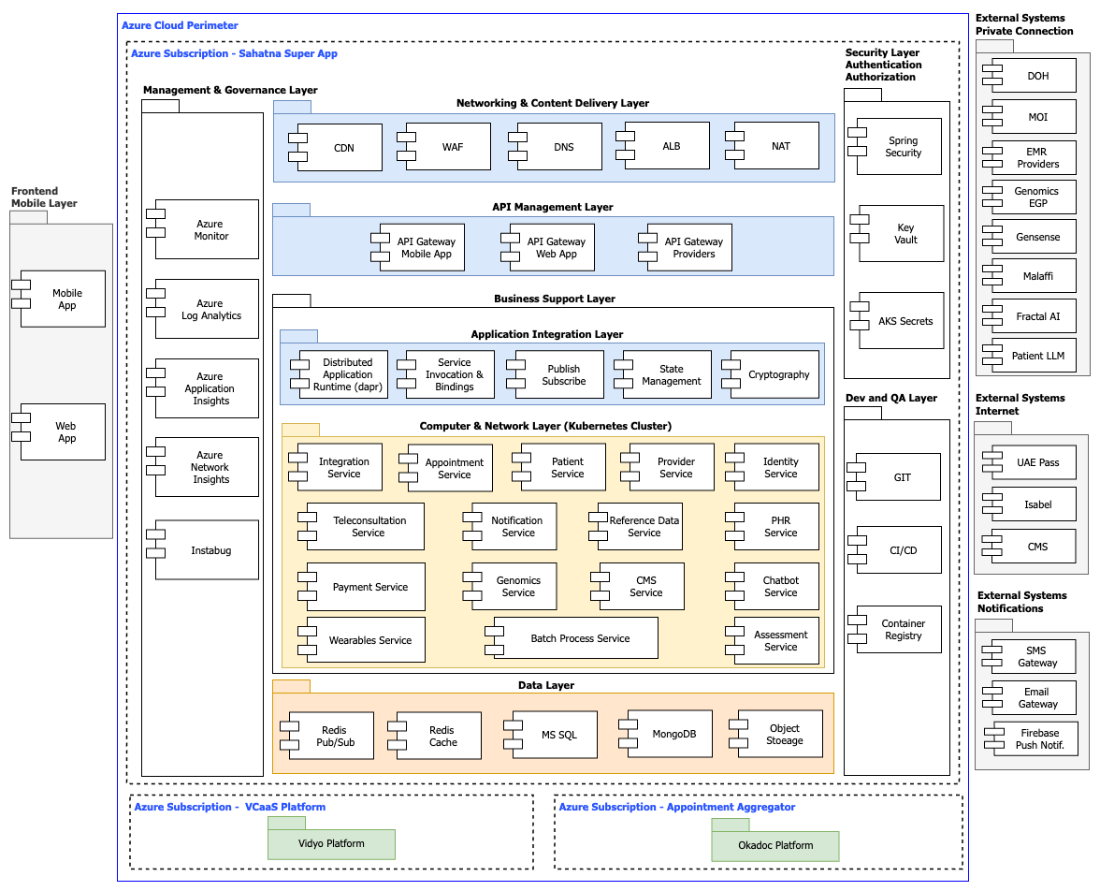
Picture 2.1

Business Architecture

Functional Modules Descriptions
# | Functional Module | Description
01 | Identity Service | Identity Service Module is responsible for validation against user details stored
02 | Patient Service | Patient Service Module is responsible for retrieving personal patient information through the Department of Health (DoH) SOAP interface, which subsequently fetches the personal data from the Ministry of Interior (MOI) systems, patient FHIR resource from Malaffi, patient information pushed to application through Appointment feeds, information retrieved from wearables and wellness components
03 | Provider Service | Provider Service Module is responsible for validation License ID of Physicians and Facilities against database handled by DOH
04 | Symptoms-Checker Service | Symptoms-Checker service Module is responsible for checking symptoms data provided by patients against database of Isabella Service (https://arscstsandbox.isabelhealthcare.com/)
05 | PHR Service | PHR Service Module is responsible for getting Patient Health Records from HIE database handled by Malaffi  (https://services.malaffi.ae/v1)
06 | Notification Service | The Notification Service Module is responsible for the notification of events that are happening within the patient data processing workflow. Three communication channels are used to send notifications to patients: Relay SMTP Server, SMS Global Service  Google Firebase.
07 | Integration Service | Integration Service Module is a REST-based Service that backs the communication flow between Sahatna Super App backend and EHR aggregator (Okadoc), HIE (Malaffi), Facility’s EHR/EMR within the Appointment’s arrangement workflow. Integration Service Module is responsible for the validation and transformation of data incoming to the Sahatna Super App backend in the FHIR/JSON format into the internal data format of the Sahatna Super Appl.
08 | Teleconsultation Service | The Teleconsultation Service Module is responsible for providing the capability of video conference between Patient and Physician and secure chatting between Patient and Physician. Video conference capability as well as video recording of the video conference between Patient and Physician are backed by the Vidyo Platform solution.
09 | Appointment Service | Appointment Service Module is responsible for the handling of a Patient Appointment lifecycle (create/update (rescheduling)/cancel (delete)), synchronization with the source of Appointment data (aggregator EHR/EMR DB or facilities EHR/EMR DB), providing all appointments to the user (for view all appointments of the user).
10 | Payment Service | Payment service is responsible for handling payment feature for the patient (e.g. teleconsultation), it does integration with ADPay
11 | Chatbot Service | Chatbot service is responsible for handling requests/responses from M42 patient LLM and providing the required format for the FE
12 | Genomics Service | Genomics service Module is responsible for getting Patient Genome Records from Genomics database handled by M42
13 | Wearables Service | Wearables service is responsible for syncing wellness data from wellness data aggregator (HealthConnect in Android and Apple Health in IOS) and saving in Cosmos DB.
14 | Reference Service | Reference Data service is responsible for providing lookup values for Sahatna mobile app like (FAQs, county lists...etc.)
15 | Batch Worker Service | Batch Worker service is responsible for scheduling and triggering background cron jobs (like daily syncing facilities/physicians' data from DOH licensing system).
16 | CMS Service | CMS Service’s main responsibility is to act as a wrapper layer exposing APIs to allow 3rd parties (e.g. AD360) to push media content to Sahatna‘s CMS “Strapi”. This content (e.g. news, articles, events...etc.) will be used further to be rendered on Sahatna mobile app.

External Components Description

Component | Description
UAEPass | A unified digital identity platform for UAE residents and citizens that provides secure access to government and private sector services. It serves as a single sign-on solution, allowing users to authenticate themselves across multiple digital platforms using biometric verification, smart ID cards, or mobile credentials.
DoH Patient Info System | The Department of Health's centralized patient information management system stores and manages comprehensive patient medical records, demographics, and health data. It enables healthcare providers to access patient information across the healthcare network for continuity of care.
DoH Licenses Info System | A Department of Health database system that manages and tracks professional licenses for healthcare providers, facilities, and medical practitioners. It maintains licensing status, renewals, qualifications, and regulatory compliance information for all healthcare entities within the jurisdiction.
ADHDS Malaffi System | Abu Dhabi Health Data Services' health information exchange platform that connects healthcare providers across Abu Dhabi. Malaffi enables secure sharing of patient health records between hospitals, clinics, and healthcare facilities to improve care coordination and clinical decision-making.
ADHDS PHR | A patient-controlled digital health record system managed by Abu Dhabi Health Data Services that allows individuals to access, manage, and share their personal health information. Patients can view their medical history, test results, appointments, and medications through this platform.
Provider’s EMR | Healthcare provider-specific digital systems that store and manage patient medical records, clinical notes, treatment plans, and health information within individual healthcare facilities or practices. These systems are used by doctors, nurses, and medical staff for patient care documentation.
Vidyo Platform | A video conferencing and telemedicine platform that enables secure video communications for healthcare consultations, remote patient monitoring, and virtual care delivery. It provides HIPAA-compliant video solutions specifically designed for healthcare environments.
Strapi CMS | An open-source headless content management system that provides APIs for managing and delivering digital content. It allows developers to create, manage, and distribute content across multiple channels and applications through customizable APIs and administrative interfaces.
Firebase | Google's comprehensive mobile and web application development platform provides backend services including real-time databases, authentication, cloud storage, hosting, and analytics. It enables developers to build and scale applications without managing server infrastructure.
Apple Health | Apple's integrated health and fitness platform built into iOS devices that aggregates health and wellness data from various sources including wearables, medical devices, and health apps. It serves as a central repository for personal health information and enables sharing with healthcare providers.
Google Fit | Google's health and fitness tracking platform that collects and stores physical activity data, wellness metrics, and health information from Android devices, wearables, and connected health apps. It provides APIs for developers to integrate fitness and health data into applications.
Isabella Service | An AI-powered clinical decision support system and symptom checker used by healthcare professionals worldwide since 2001. It analyzes multiple symptoms simultaneously to suggest potential diagnoses for both common and rare conditions, helping reduce diagnostic errors and improve patient safety through advanced artificial intelligence algorithms.
Fractal AI Service | An artificial intelligence platform that uses fractal algorithms and mathematical models for advanced healthcare data analysis, pattern recognition, predictive modeling, and complex medical data processing to provide AI-powered clinical insights and decision-making support.
Genomics (EGP) byM42 | The Emirati Genome Programme is a national project which aims to use genomic data to improve the health of the Emirati population
Genomics (Gensense) by M42 | The platform provides personalized health insights through comprehensive genetic analysis, allowing individuals to gain a deeper understanding of their genetic predispositions, health risks, and microbiome composition from the convenience of their home.
Patient LLM by M42 | Designed to transform AI applications in healthcare and improve patient care outcomes. Med42 LLM role in Sahatna is to act as backbone for Sahatna’s AI Chatbot module.

System Architecture Design

The System Architecture Design of the Sahatna Super App should be considered from two architectural domains' points of view:
- Data Layer Architecture
- Application Layer Architecture

Data Layer Architecture Description
The aspects considered within the design of the Data Architecture Layer are the following: access patterns, performance characteristics, scalability, high availability and implementations.
To following mentioned above aspects and to achieve target performance requirements the following technologies are used within the Sahatna Super App:
- MSSQL DB – for handling master data and appointment information.
- NoSQL DB (MongoDB) - for managing nonstructured information physician notes, documents, prescriptions, etc.
- Cache (Redis) – for caching DB data and pub/sub purposes.
High availability of the components of the Data Architecture Layer will be backed by the implementation of cluster deployment schema for Azure MS SQL DB and MongoDB. MongoDB and Redis provide horizontal scalability.

      - Data Sources

Data Source | Description | Type | Access technology
Malaffi DB | Database with appointments data | External | REST API
Malaffi PHR DB | Database with Patient Health Records data | External | REST API
DOH DB | Database with Physicians and Facilities data | External | SOAP
Isabel DB | Database with dictionary of medical symptoms terms | External | REST API
UAE PASS | Database with UAE IDs | External | REST API
M42 | LLM used for  The chatbot | External | REST API
ADPay | Abu dhabi payment gateway | External | REST API
Azure SQL DB | Database with database schemas and data of Super App Modules | Internal | DB Link
Azure Mongo DB (Cosmos DB) | Database with database schemas and data of Super App Modules | Internal | DB Link
Azure Redis Cache | Database with cached data generated by Super App Modules. | Internal | DB Link
Azure Monitor | Database with log and audit data generated by Super App Modules | Internal | REST API

      - Database Schemas

Within the Azure MS SQL database instance, the following tables will be implemented:

Service Module | Schema name | Table name
Identity Service Module | Identity_dbo | password_history
 |  | temp_locked_user
 |  | token
 |  | otp
 |  | flyway_schema_history
Patient Service Module | Patient_dbo | deleted_patient
 |  | deletion_reason
 |  | dependant_associated_to_guardian
 |  | device
 |  | feedback
 |  | feedback_question
 |  | flyway_schema_history
 |  | location
 |  | notification_preferences
 |  | Otp
 |  | password_history
 |  | patient
 |  | patient_associated_to_device
 |  | phc_details
 |  | phc_history
 |  | phc_notification_delivery
 |  | phc_reason
 |  | pilot_patient
 |  | shared_accounts_association
 |  | support
 |  | temp_locked_user
 |  | unlink_dependant_history
Provider Service Module | Provider_dbo | administrator
 |  | admins_status_history
 |  | custom_header
 |  | doh_facility
 |  | doh_history
 |  | doh_physician
 |  | education
 |  | experience
 |  | facility
 |  | facility_associated_to_provider_admin
 |  | facility_payment_method
 |  | facility_physician
 |  | facility_speciality_association
 |  | facility_type
 |  | favourite_physician
 |  | flyway_schema_history
 |  | invitation_link
 |  | language
 |  | payment_method
 |  | physician
 |  | physician_language
 |  | speciality
 |  | sub_speciality
 |  | working_day
Teleconsultation Service  Module | Teleconsultation_dbo | flyway_schema_history
 |  | Call
 |  | call_session
 |  | Record
 |  | Feedback
 |  | notification
 |  | Physician
 |  | Room
 |  | appointment
 |  | patient
Reference Data Service  Module | Reference_data_dbo | flyway_schema_history
 |  | country
 |  | faq_topic
 |  | mobile_language
 |  | state
 |  | faq
 |  | city
 |  | document_type
 |  | reason
Appointment Service Module | Appointment_dbo | flyway_schema_history
 |  | appointment_type
 |  | service_type
 |  | new_slot_associated_to_appointment
 |  | appointment
 |  | appointment_history
 |  | slot_associated_to_appointment
 |  | flyway_schema_history

Within the CosmosDB database instance, the following collections will be implemented:

Service Module | Collection name
Appointment Service Module | Appointment
Notification Service Module | Templates
Symptoms-Checker Service Module | ageGroup
 | country
 | pregnancy
 | predictivetexts

Application Layer Description

      - Technological stack description

Technology | Description
Cloud Platform | - Microsoft Azure
Aggregation Platform for Microservices | - Kubernetes  - Oracle API Gateway 11g
Programming Languages and Frameworks | - Back-End: Java + Spring boot + Dapr  - Front-End Web: React JS  - Front-End Mobile: React Native
Database and Storage | - Cosmos DB – Document Database  - Azure SQL – Structure Data  - Azure Cache for Redis – In memory Database  - Log analytics workspace – Log management  - Strapi – Content Management System “CMS” providing dynamic mobile content.  - K8s ConfigMap & Secrets (backed by Azure KeyVault) for application-level configuration

      - Side Car software architecture template

The microservices architecture style is implemented within the application design of Sahatna Super App. Sahatna Super App consists of containerized service module responsible for particular functional domain.
The side car template is implemented within application design of Sahatna Super App. Dapr as the technology example of side car template realization was implemented within Sahatna Super App. The schema how services are deployed in the Kubernetes with Darp is depicted on picture 2.2.
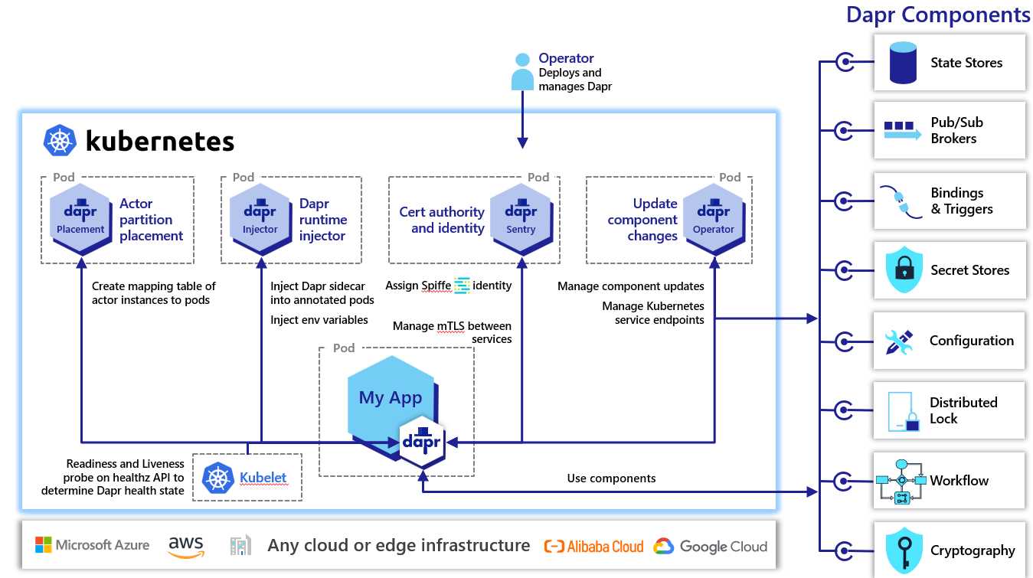

Picture 2.2

Side car is a reserve proxy component that runs beside the application and facilitates communication with either other service or to outside world. In a containerized application, both containers run beside each other in the same cluster and scale individually.
Deploy components of an application into a separate process or container to provide isolation and encapsulation. This pattern can also enable applications to be composed of heterogeneous components and technologies.
This pattern is named Sidecar because it resembles a sidecar attached to a motorcycle. In the pattern, the sidecar is attached to a parent application and provides supporting features for the application. The sidecar also shares the same lifecycle as the parent application, being created and retired alongside the parent. The sidecar pattern is sometimes referred to as the sidekick pattern and is a decomposition pattern.
Applications and services often require related functionality, such as monitoring, logging, configuration, and networking services. These peripheral tasks can be implemented as separate components or services.
Advantages of using a sidecar pattern include:
- A sidecar is independent from its primary application in terms of runtime environment and programming language, so you don't need to develop one sidecar per language.
- The sidecar can access the same resources as the primary application. For example, a sidecar can monitor system resources used by both the sidecar and the primary application.
- Because of its proximity to the primary application, there's no significant latency when communicating between them.
- Even for applications that don't provide an extensibility mechanism, you can use a sidecar to extend functionality by attaching it as its own process in the same host or sub-container as the primary application (Picture 2.3).

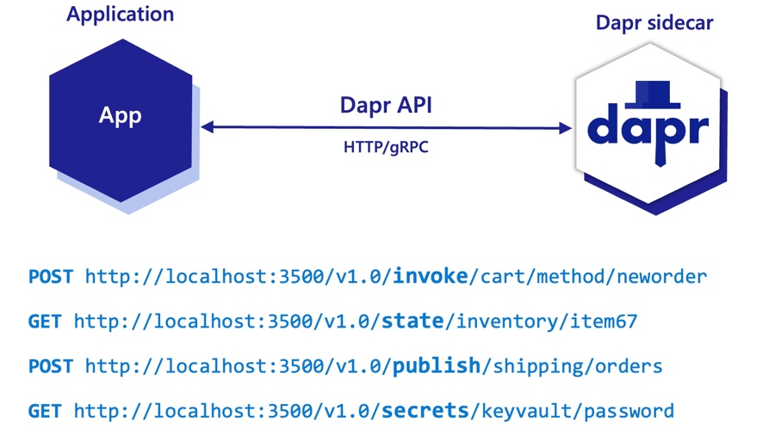

Picture 2.3.

Schema of Service-to-Service communication within Sidecar template implementation is depicted on the Picture 2.4.
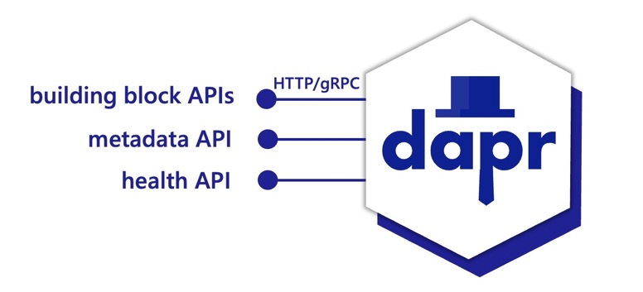

Picture 2.4.
      - Resiliency

Distributed applications are commonly comprised of many microservices, with dozens - sometimes hundreds - of instances scaling across underlying infrastructure. As these distributed solutions grow in size and complexity, the potential for system failures inevitably increases. Service instances can fail or become unresponsive due to any number of issues, including hardware failures, unexpected throughput, or application lifecycle events, such as scaling out and application restarts. Designing and implementing a self-healing solution with the ability to detect, mitigate, and respond to failure is critical (Picture 2.5.)
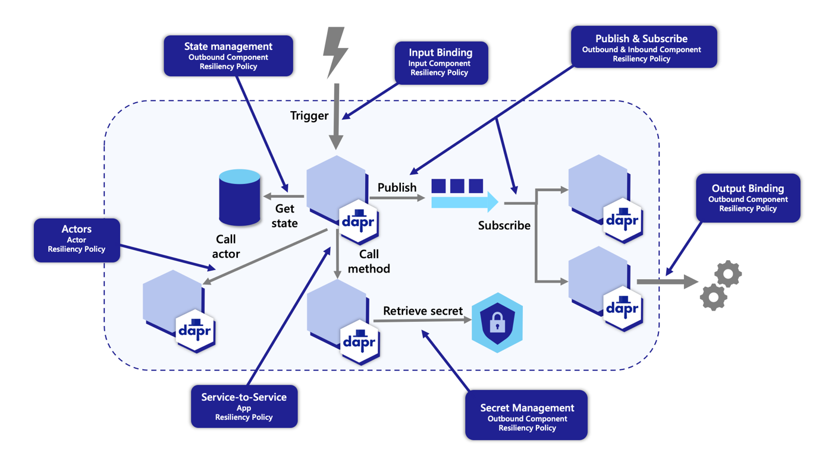

Picture 2.5.
Dapr provides a capability for defining and applying fault tolerance resiliency policies to your application. You can define policies for the following resiliency patterns:
- Timeouts
- Retries/back-offs
- Enable an application to handle transient failures when it tries to connect to a service or network resource, by transparently retrying a failed operation. This can improve the stability of the application.
- An application that communicates with elements running in the cloud has to be sensitive to the transient faults that can occur in this environment. Faults include the momentary loss of network connectivity to components and services, the temporary unavailability of a service, or timeouts that occur when a service is busy.
- These faults are typically self-correcting, and if the action that triggered a fault is repeated after a suitable delay it's likely to be successful. For example, a database service that's processing a large number of concurrent requests can implement a throttling strategy that temporarily rejects any further requests until its workload has eased. An application trying to access the database might fail to connect, but if it tries again after a delay it might succeed.
- In the cloud, transient faults aren't uncommon and an application should be designed to handle them elegantly and transparently. This minimizes the effects faults can have on the business tasks the application is performing. If an application detects a failure when it tries to send a request to a remote service, it can handle the failure using the following strategies:
- Cancel. If the fault indicates that the failure isn't transient or is unlikely to be successful if repeated, the application should cancel the operation and report an exception. For example, an authentication failure caused by providing invalid credentials is not likely to succeed no matter how many times it's attempted.
- Retry. If the specific fault reported is unusual or rare, it might have been caused by unusual circumstances such as a network packet becoming corrupted while it was being transmitted. In this case, the application could retry the failing request again immediately because the same failure is unlikely to be repeated and the request will probably be successful.
- Retry after delay. If the fault is caused by one of the more commonplace connectivity or busy failures, the network or service might need a short period while the connectivity issues are corrected or the backlog of work is cleared. The application should wait for a suitable time before retrying the request.
- Circuit breakers
- Handle faults that might take a variable amount of time to recover from, when connecting to a remote service or resource. This can improve the stability and resiliency of an application.
- In a distributed environment, calls to remote resources and services can fail due to transient faults, such as slow network connections, timeouts, or the resources being overcommitted or temporarily unavailable. These faults typically correct themselves after a short period of time, and a robust cloud application should be prepared to handle them by using a strategy such as the retry patten.
- However, there can also be situations where faults are due to unanticipated events, and that might take much longer to fix. These faults can range in severity from a partial loss of connectivity to the complete failure of a service. In these situations, it might be pointless for an application to continually retry an operation that is unlikely to succeed, and instead the application should quickly accept that the operation has failed and handle this failure accordingly.
- Additionally, if a service is very busy, failure in one part of the system might lead to cascading failures. For example, an operation that invokes a service could be configured to implement a timeout, and reply with a failure message if the service fails to respond within this period. However, this strategy could cause many concurrent requests to the same operation to be blocked until the timeout period expires. These blocked requests might hold critical system resources such as memory, threads, database connections, and so on. Consequently, these resources could become exhausted, causing failure of other possibly unrelated parts of the system that need to use the same resources. In these situations, it would be preferable for the operation to fail immediately, and only attempt to invoke the service if it's likely to succeed. Note that setting a shorter timeout might help to resolve this problem, but the timeout shouldn't be so short that the operation fails most of the time, even if the request to the service would eventually succeed.
- A circuit breaker acts as a proxy for operations that might fail. The proxy should monitor the number of recent failures that have occurred, and use this information to decide whether to allow the operation to proceed, or simply return an exception immediately. The proxy can be implemented as a state machine with the following states that mimic the functionality of an electrical circuit breaker:
- Closed: The request from the application is routed to the operation. The proxy maintains a count of the number of recent failures, and if the call to the operation is unsuccessful the proxy increments this count. If the number of recent failures exceeds a specified threshold within a given time period, the proxy is placed into the Open state. At this point the proxy starts a timeout timer, and when this timer expires the proxy is placed into the Half-Open state.
The purpose of the timeout timer is to give the system time to fix the problem that caused the failure before allowing the application to try to perform the operation again.
- Open: The request from the application fails immediately and an exception is returned to the application.
- Half-Open: A limited number of requests from the application are allowed to pass through and invoke the operation. If these requests are successful, it's assumed that the fault that was previously causing the failure has been fixed and the circuit breaker switches to the Closed state (the failure counter is reset). If any request fails, the circuit breaker assumes that the fault is still present so it reverts back to the Open state and restarts the timeout timer to give the system a further period of time to recover from the failure.
- The Half-Open state is useful to prevent a recovering service from suddenly being flooded with requests. As a service recovers, it might be able to support a limited volume of requests until the recovery is complete, but while recovery is in progress a flood of work can cause the service to time out or fail again.
      - Application healthcheck
Applications can become unresponsive for a variety of reasons. For example, they are too busy to accept new work, could have crashed, or be in a deadlock state.
Dapr provides a capability for monitoring app health through probes that check the health of your application and react to status changes. When an unhealthy app is detected, Dapr stops accepting new work on behalf of the application (Picture 2.6).
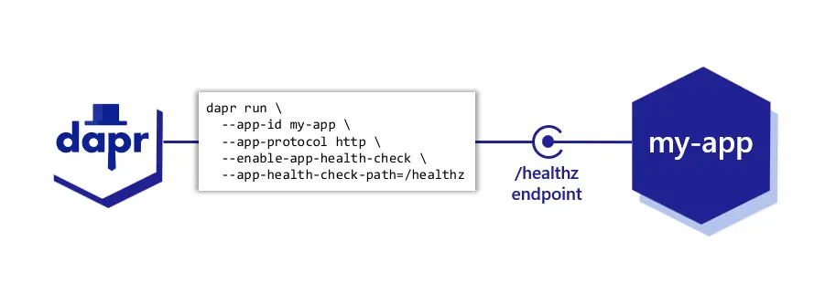
Picture 2.6.

Identity Service Module System Architecture

Overview

Definition & Purpose
Identity Service Module is the application component of the Sahatna Super App solution which is developed by Java and deployed in the docker container format within Kubernetes cluster.
The main features of the Identity Service Module are the followings:
- [Patient] Login Using UAEPass.
- [Guest] Login - Anonymously
- [Patient] Logout Using UAEPass.
- Token Management: issuing, encryption and validation security token which is used for securing communication by Mobile App with backend service modules;
- Language Preference language (En/Ar).

Functional Scope (Capabilities Provided by the service)
Ref Id | Function | Controller Name | Postman Folder
FR-001-001 | [Patient] Login Using UAEPass | UaePassMobileController | /Identity service / mobile
FR-001-002 | [Guest] Login Using UAEPass | GuestAuthMobileController | /Identity service / mobile/guest
FR-001-003 | [Patient] Logout
FR-001-004 | Token Management
FR-001-005 | Language Preference language
FR-001-006 | Token Management

Service Description

Parameter | Description
Deployment Format | Container Image / K8
Language | Java 17
Source code Registry | https://bitbucket.org/injazat-workspace/identity-service/src/main/
Dependencies | Notification Service Module
Communication protocol | REST/HTTP, gRPC
Connection endpoint | /identity/actuator/health  Port: 8090
Data persistence | Azure MS SQL

Interfaces

Inbound APIs
Source/Provider | Function Ref
UAE Pass | FR-001-001

Outbound APIs -> Rereferring to postman collection documentation.

Data Model Description

Owned Data Models (Physical Model)
Identity Service Module is owns the following database schemas within Azure MS SQL instance:
- identity_dbo
ERD diagrams for entities encompassed by the identity_dbo database schemas are the following (Picture 2.7. - ERDs.zip):

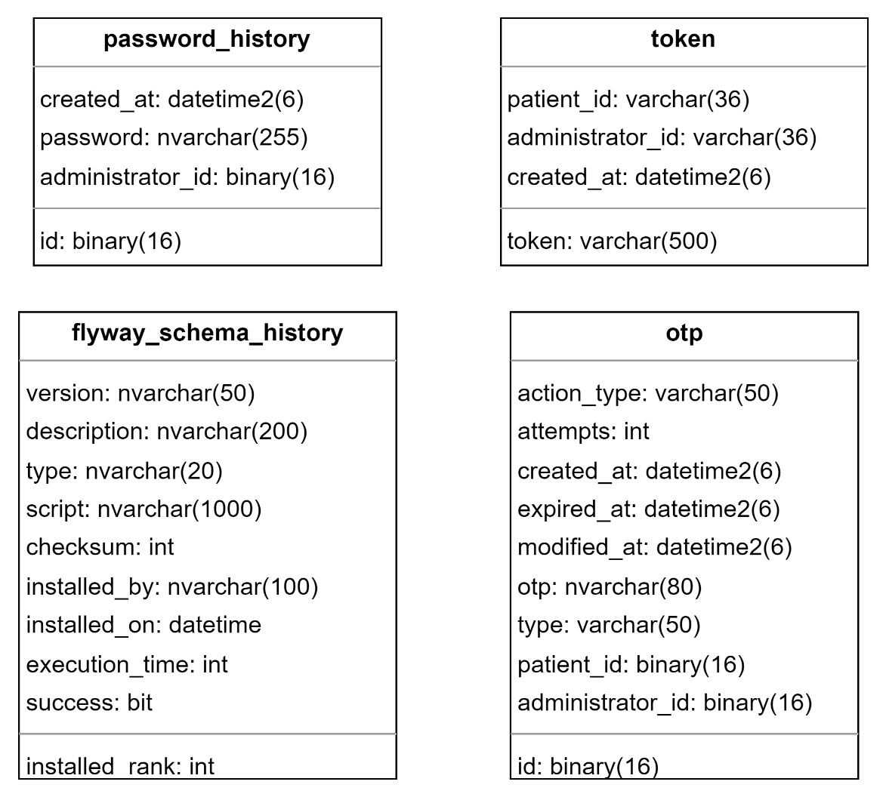

Picture 2.7.

Application Component Diagram

Application Component Diagram
Identity Service Module depends and interconnects with the following programmatical components:
[Table below should contain only components internal within the solution or external]
Component Type | Component List
Azure Network Components | API Gateway  NAT Gateway
External Component | UAE PASS
Internal Components | Notification Service Module
Azure Database Components | MS SQL  Redis (Pub/Sub Instance)  Redis (Cache Instance)
Kubernetes Components | etcd DB (as secrets’ storage)

UML Component Diagram for the Identity Service Module is depicted on the Picture 2.8.

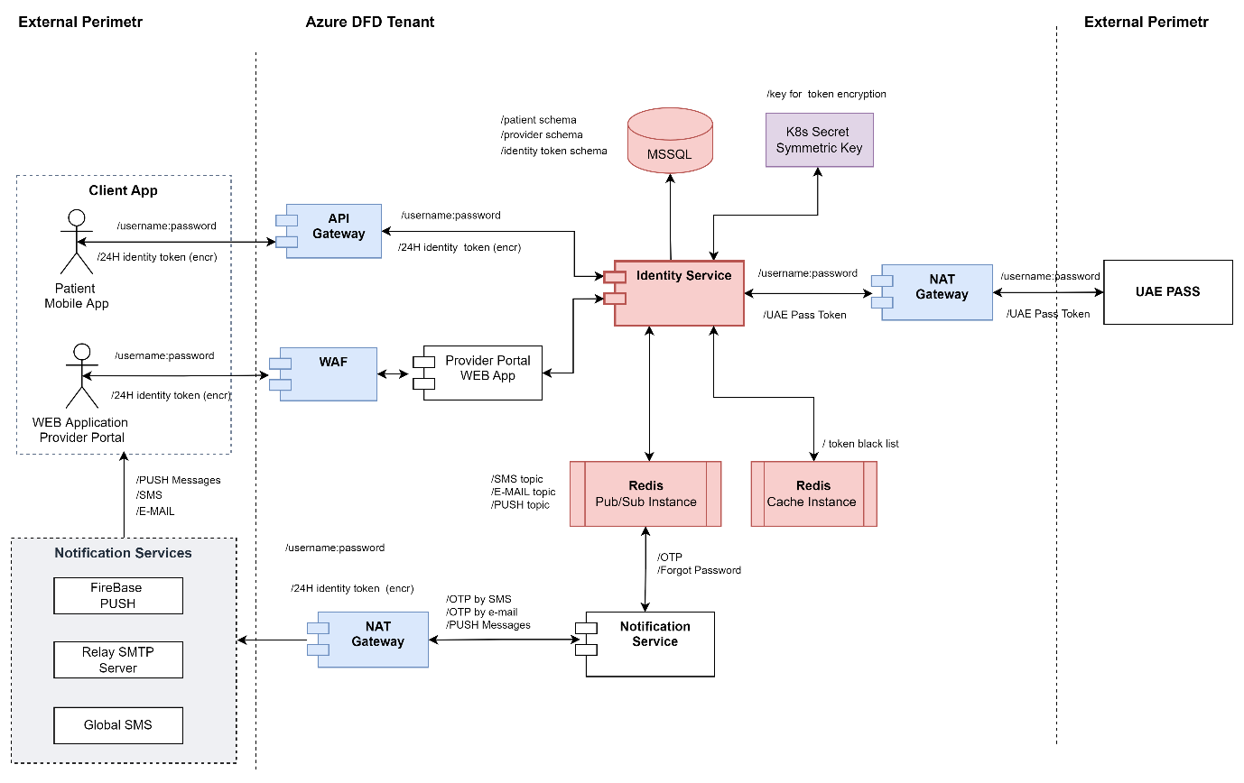

Picture 2.8.

Integrations & Dependencies
Internal Dependencies
- Notification Service Module
[Explain the integration with Notification Service module and reference the functional scope if applicable, why it is integrated, how it is integrated, reference the integration interface and data entities/Payloads used for this integration]
External Dependencies
- UAE PASS Integration
[Explain the integration with Notification Service module and reference the functional scope if applicable, why it is integrated, how it is integrated, reference the integration interface and data entities used for this integration]

Technical Specifications

Functional Capabilities Implementation Details
- FR-00X-001: Function 1
  - Business Roles
  - Flow Diagram
  - Sequence diagram
  - Configuration [secret keys required, environment variables, settings, lookups,..etc.]

Patient Service Module System Architecture

Patient Service Module is the application component of the Sahatna Super App solution which is developed by Java and deployed in the docker container format within the Kubernetes cluster.
The main features of the Patient Service Module are the following:
- getting personal patient information from the DOH via SOAP API (DOH has an internal integration with MOI database);
- Managing patient’s Communication Preferences {SMS/Email/Push}.
- Managing feedback: feedback is a simple pop-up (including title, questions, stars rating component and free input-text) allowing users to share their experience rating (e.g. booking appointment journey rating...etc.)
- Managing Surveys: surveys are triggered by Malaffi upon a specific helath-related action (e.g. encounter hit, laboratory test...etc.). The service is mainly:
      - Sending survey’s notification (as per preferred notification preference) to Sahatna’s user.
      - Processing and persistingsurvey questions/answers to be processed further by DOH Data Analytics team.

      - Service Description

Parameter | Description
Deployment Format | Container
Language | Java
Dependencies | Notification Service Module  Reference Service Module  Appointment Service Module  PHR Service Module
Communication protocol | REST/HTTP, gRPC
Connection endpoint | /patient/actuator/health  Port: 8091
Data persistence | Azure MS SQL

      - Data Model Description

Patient Service Module is backed by the following database schemas within Azure MS SQL instance:
- patient_dbo schema
ERD diagrams for entities encompassed by the mentioned database schema are the following (Picture 2.9 - ERDs.zip):
An extension to ERD to include “Surveys” use-case which is part of patient-service is in this document SAHATNA Integration Specification Document Surveys - Malaffi v0.1.3.docx

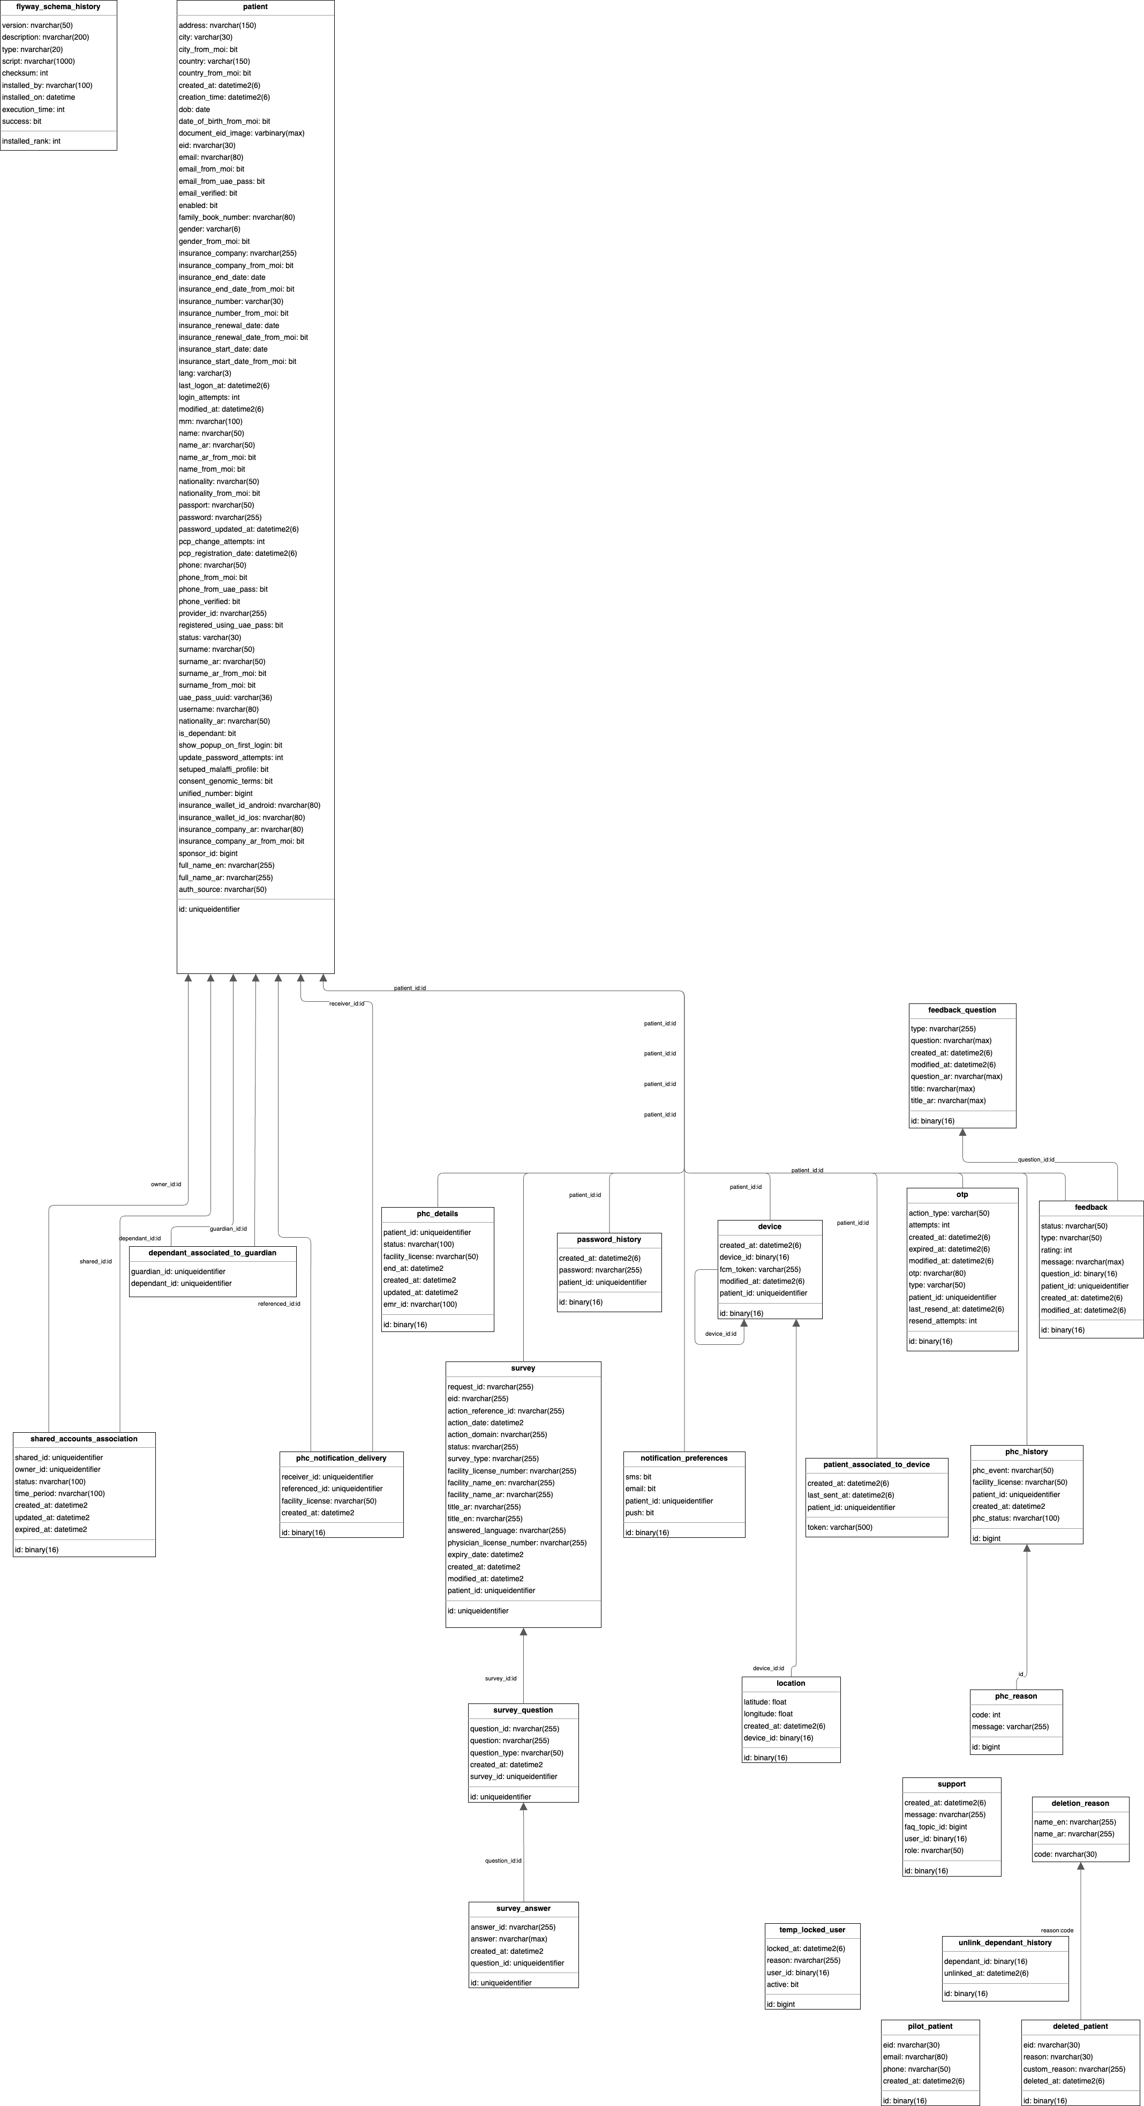
Picture 2.9.

      - Application Component Diagram

Patient Service Module depends and interconnects with the following programmatical components:

Component Type | Component List
External Component | Mobile App (iOS, Android)  UAE PASS DB  MOI DB (via DOH Integration Hub)
Azure Network Components | API Gateway  NAT Gateway
Azure Database Components | MS SQL  Redis (Pub/Sub Instance)  Redis (Cache Instance)
Kubernetes Components | etcd DB (as secrets’ storage)
Super App backend services | Notification Service Module  PHR Service Module  Reference Service Module  Appointment Service Module

UML Component Diagram for the Patient Service is depicted on the Picture 2.10.

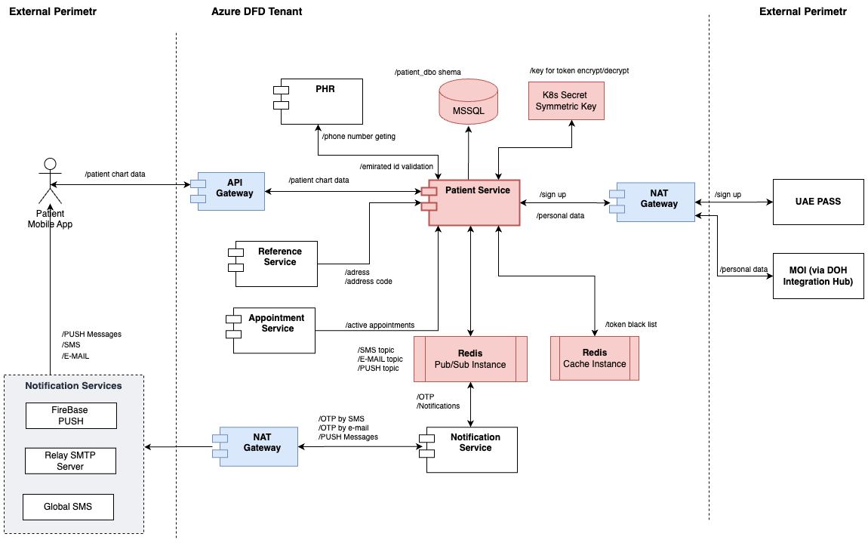
Picture 2.10.

Provider Service Module System Architecture
Provider Service Module is the application component of the Sahatna Super App solution which is developed by Java and deployed in the docker container format within Kubernetes cluster.
The main features of the Provider Service Module are the following:
- validation License ID of Physicians and Facilities against database handled by DOH;
- physicians and facilities data management within Provider Portal web application functionalities;
- daily basis synchronization with DOH database within batch-worker service module functionalities;

      - Service Description

Parameter | Description
Deployment Format | Container / Jar
Language | Java
Dependencies | Notification Service Module  Reference Service Module  Appointment Service Module  Batch-worker Service Module
Communication protocol | REST/HTTP, gRPC
Connection endpoint | /provider/actuator/health  Port: 8092
Data persistence | Azure MS SQL

      - Data Model Description

Provider Service Module is backed by the following database schemas within Azure MS SQL instance:
- providers schema
ERD diagrams for entities encompassed by the mentioned database schemas are the following (Picture 2.11. - ERDs.zip):

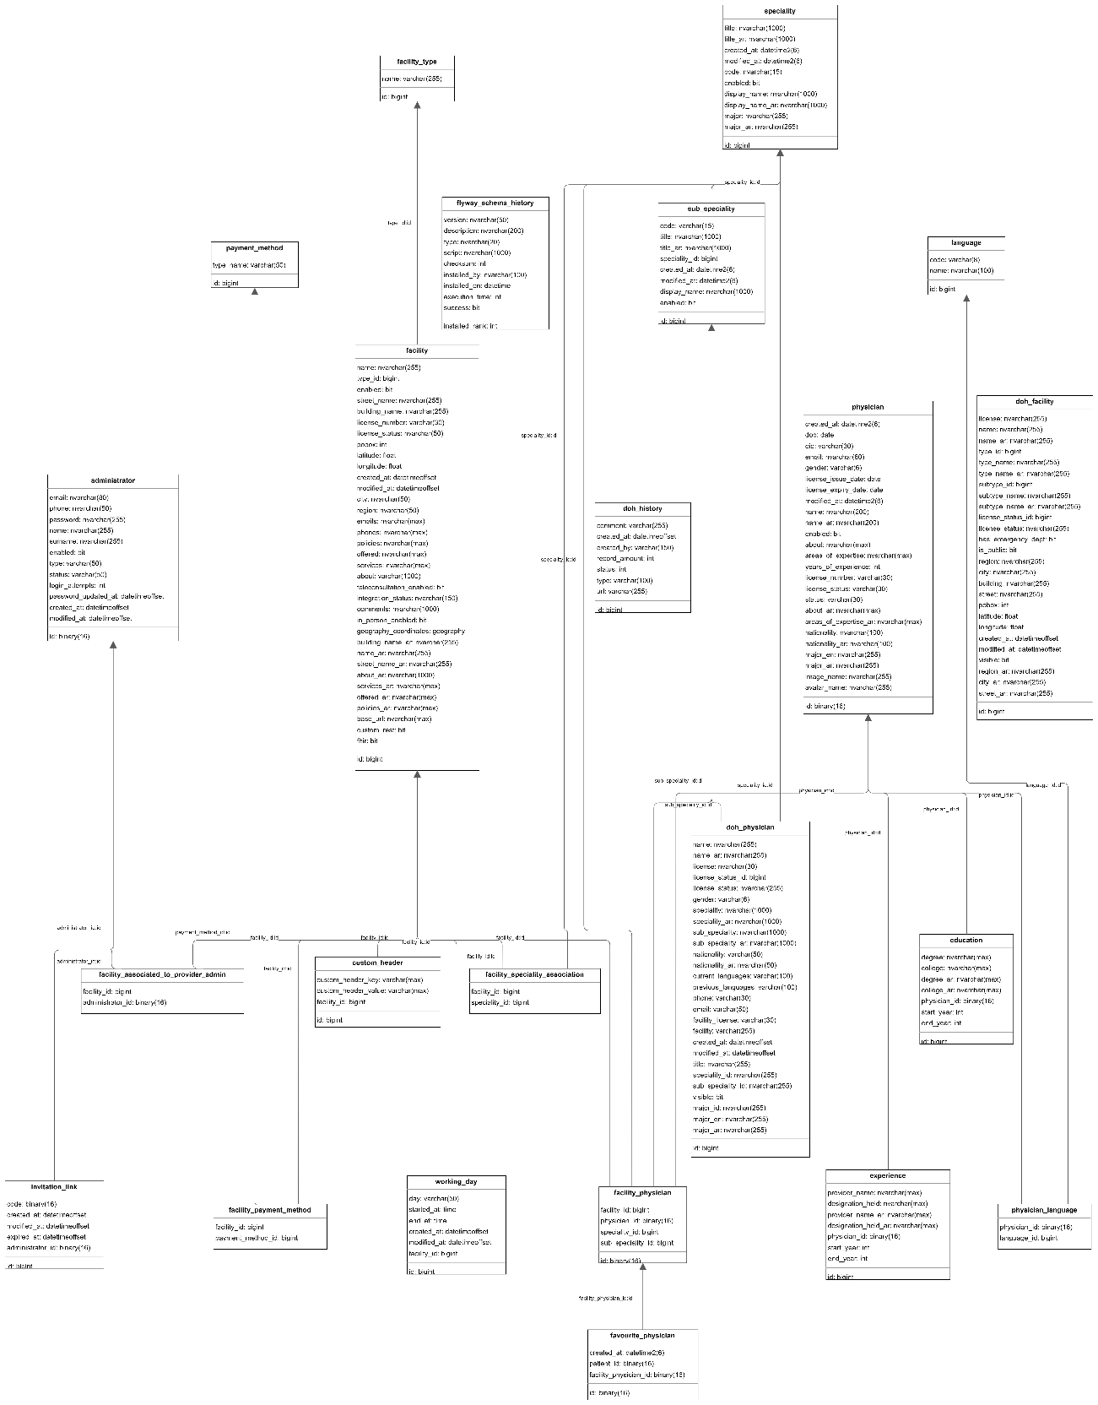

Picture 2.11.
      - Application Component Diagram

Provider Service Module depends and interconnects with the following programmatical components:

Component Type | Component List
External Component | Mobile App (iOS, Android)  Web Application (Provider Portal)  DOH DB
Azure Network Components | API Gateway  NAT Gateway  WAF (Web Application Firewall)
Azure Database Components | MS SQL  Redis (Pub/Sub Instance)  Redis (Cache Instance)  Azure Object Storage
Kubernetes Components | etcd DB (as secrets’ storage)
Super App backend services | Notification Service Module  Reference Service Module  Appointment Service Module  Batch-worker Service Module

UML Component Diagram for Provider Service Module is depicted on the Picture 2.12.
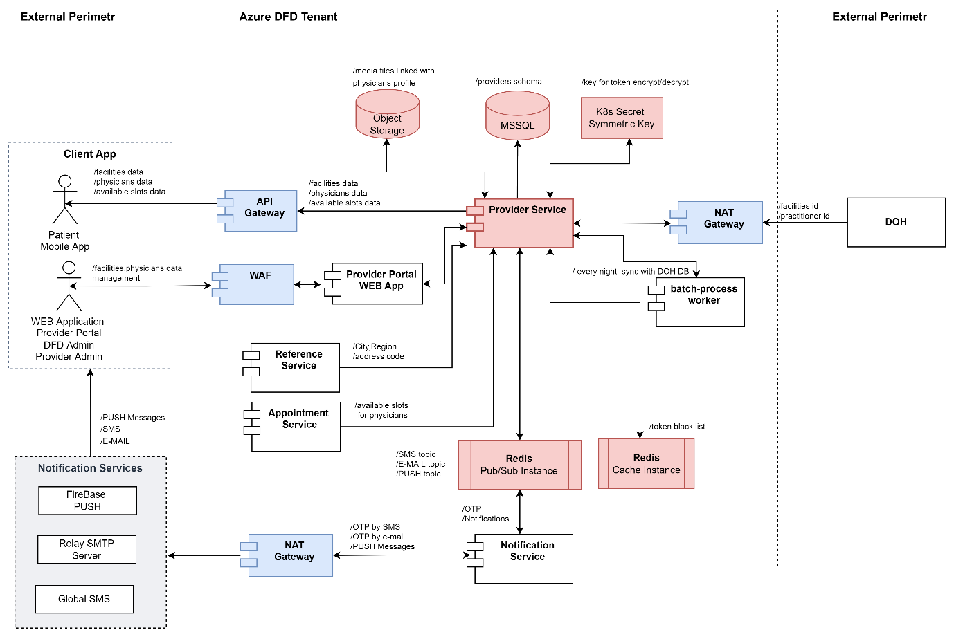

Picture 2.12.

Symptoms-Checker Service System Architecture
Symptoms-Checker Service Module is the application component of the Sahatna Super App solution which is developed by Java and deployed in the docker container format within Kubernetes cluster.
The main features of the Symptoms-Checker Service Service Module are the followings:
- checking symptoms data provided by patients against database of Isabella Service (https://arscstsandbox.isabelhealthcare.com/) with AI components;

      - Service Description

Parameter | Description
Deployment Format | Container / Jar
Language | Java
Dependencies | NA
Communication protocol | REST/HTTP, gRPC
Connection endpoint | /symptomschecker/actuator/health  Port: 8095
Data persistence | Azure MongoDB (Cosmos DB)

      - Data Model Description

Symptoms-Checker Service Module is backed by the following collection of JSON-files within Azure MongoDB:
- symptoms collection
Templates used within the mentioned MongoDB collections are the followings (Picture 2.13 - symptoms.drawio):

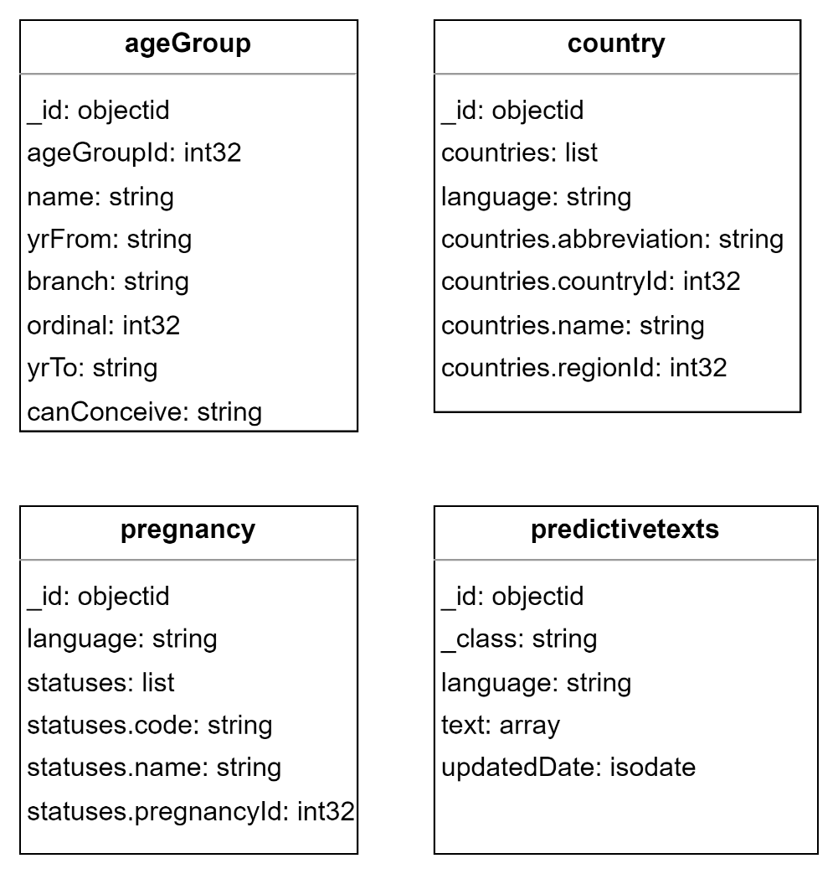

Picture 2.13

      - Application Component Diagram

Symptoms-Checker Service Module depends and interconnects with the following programmatical components:

Component Type | Component List
External Component | Mobile App (iOS, Android)  Isabella Service
Azure Network Components | API Gateway  NAT Gateway
Azure Database Components | Azure MongoDB (Cosmos DB)  Redis (Cache Instance)
Super App backend services | Batch-worker Service Module

UML Component Diagram for the Symptoms-Checker Service Module is depicted on the Picture 2.14.
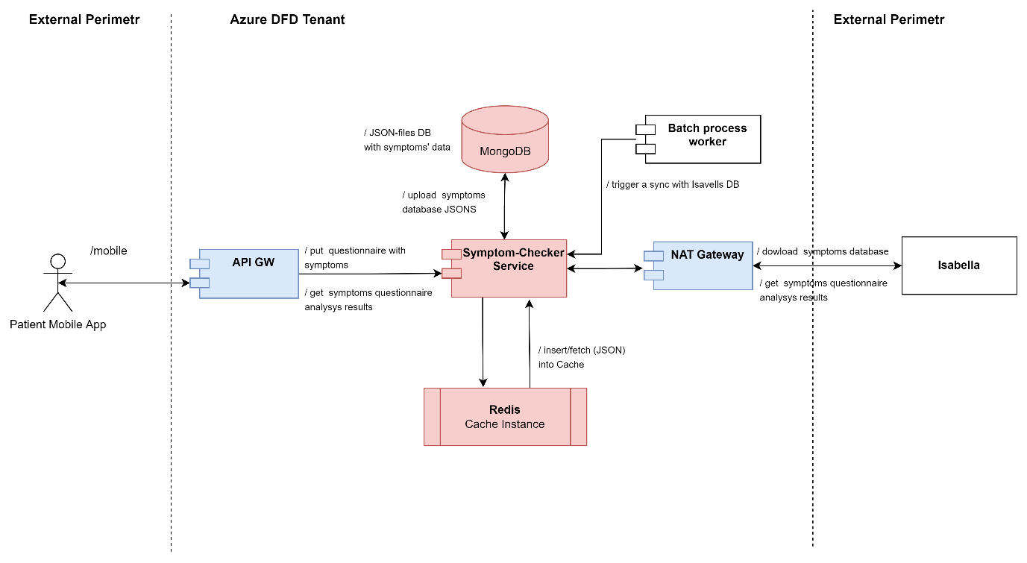

Picture 2.14.

PHR Service System Architecture

PHR Service Module is the application component of the Sahatna Super App solution which is developed by Java and deployed in the docker container format within Kubernetes cluster.
The main features of the PHR Service Module are the following:
- PHR Service Module is responsible for getting Patient Health Records from HER database handled by Malaffi;
- Validation emirates_id against Patient Service Module;

      - Service Description

Parameter | Description
Deployment Format | Container Image / Jar
Language | Java
Dependencies | Patient Service Module
Communication protocol | REST/HTTP, gRPC
Connection endpoint | /phr/actuator/health  Port: 8100
Data persistence | N/A

      - Data Model Description

PHR Service Module is not backed by a MS SQL or MongoDB instances for data persistence because it works with sensitive personal data are been obtaining from Malaffi DB.
PHR Service Module uses Azure Redis Cache Instance only for temporary safe patient data in the JSON format.

      - Application Component Diagram

PHR Service Module depends and interconnects with the following programmatical components:

Component Type | Component List
External Component | Mobile App (iOS, Android)  Malaffi Service
Azure Network Components | API Gateway  NAT Gateway
Azure Database Components | Redis (Cache Instance)
Super App backend services | Patient Service Module

        - UML Component Diagram
UML Component Diagram for PHR service is depicted on the Picture 2.15.

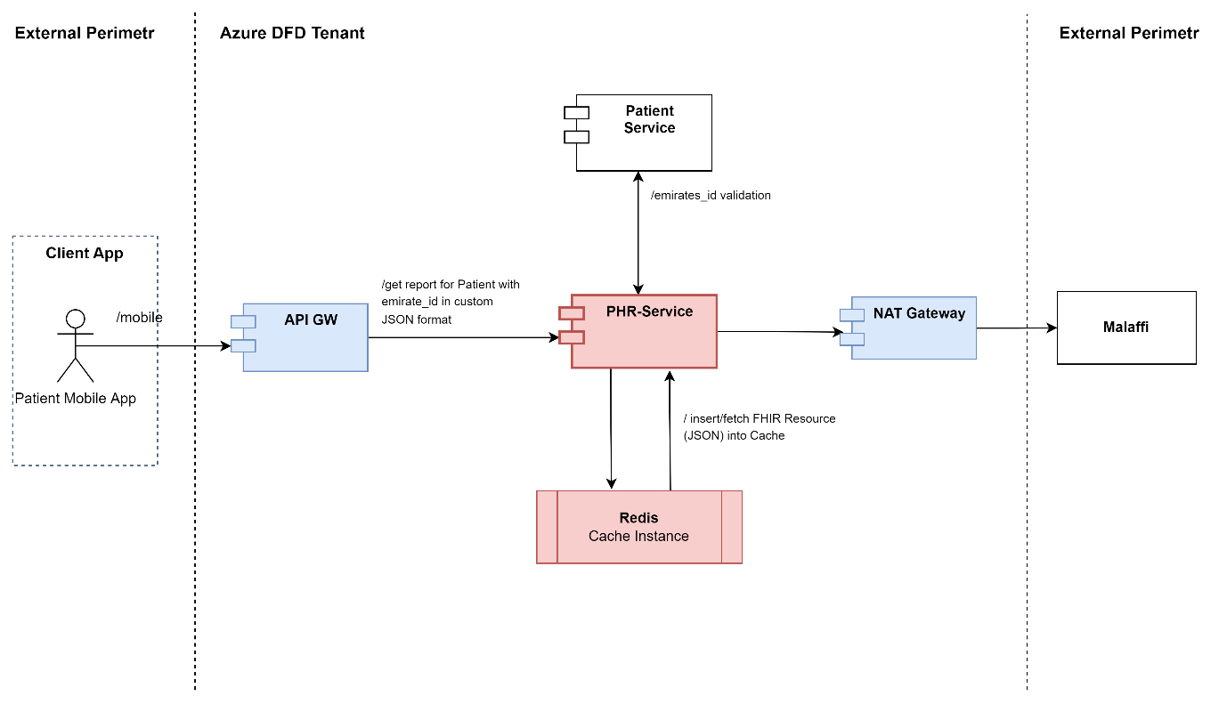

Picture 2.15.

        - UML Sequence Diagrams
UML Consequence Diagrams for the main workflows related with PHR Service Module are the followings (Picture 2.16):

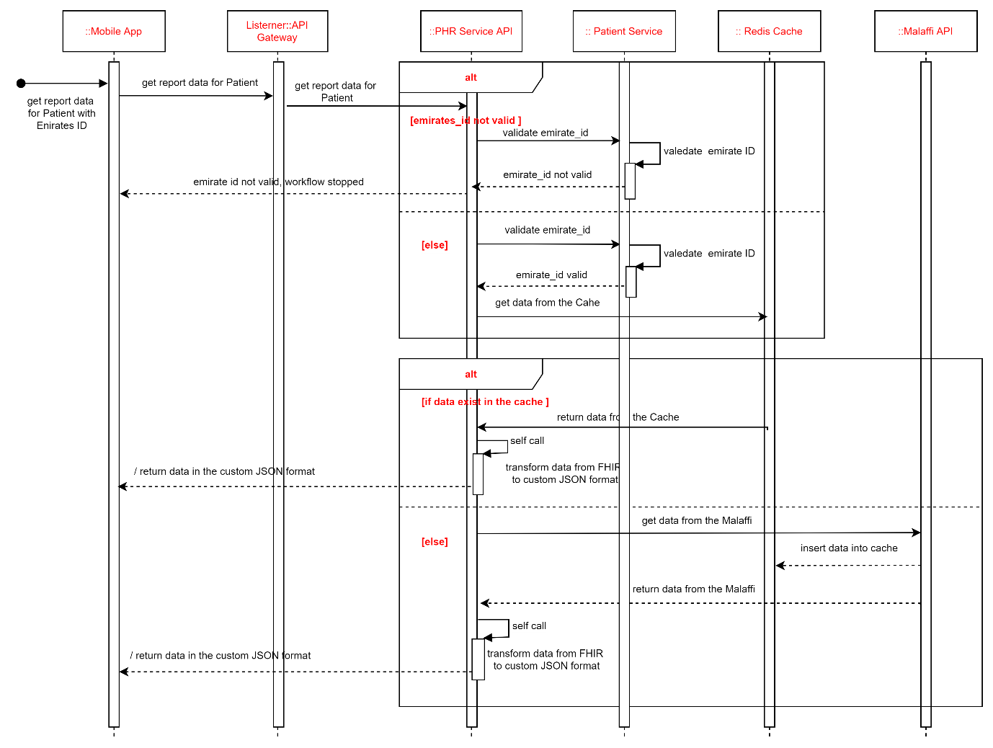

Picture 2.16.

Notification Service System Architecture

Notification Service Module is the application component of the Sahatna Super App solution which is developed by Java and deployed in the docker container format within Kubernetes cluster.
The main features of the Notification Service Module are the following:
- notification on events which are happening within patient data processing workflow. Three communication channels are used to send notifications to patients: Relay SMTP Server, SMS Global Service.
- template management of notification messages within Provider Portal web application functionalities.

      - Service Description

Parameter | Description
Deployment Format | Container Images / Jar
Language | Java
Dependencies | External Systems (SMS Gateway, Email Gateway, Push notification provider)
Communication protocol | REST/HTTP, gRPC
Connection endpoint | /notification/actuator/health  Port: 8104
Data persistence | Azure Cosmos DB

      - Data Model Description

The Notification Service Module is backed by the following collection of JSON files within Azure MongoDB:
- templates collection
JSON templates used within the mentioned MongoDB collection are the following (Picture 2.17 - ERDs.zip) :

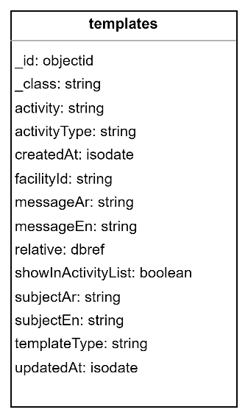

Picture 2.17
      - Application Component Diagram

The Notification Service Module depends on and interconnects with the following programmatical components:

Component Type | Component List
External Component | Mobile App (iOS, Android)  Provider Portal (Web Application)  FireBase (for PUSH notification)  Relay SMTP (for e-mail notification)  Global SMS (for SMS-notification)
Azure Network Components | API Gateway  NAT Gateway
Azure Database Components | Azure MongoDB (Cosmos DB)  Redis (Pub/Sub Instance)
Super App backend services | Super App Service Modules

UML Component Diagram for Notification Service Module is depicted on the Picture 2.18.

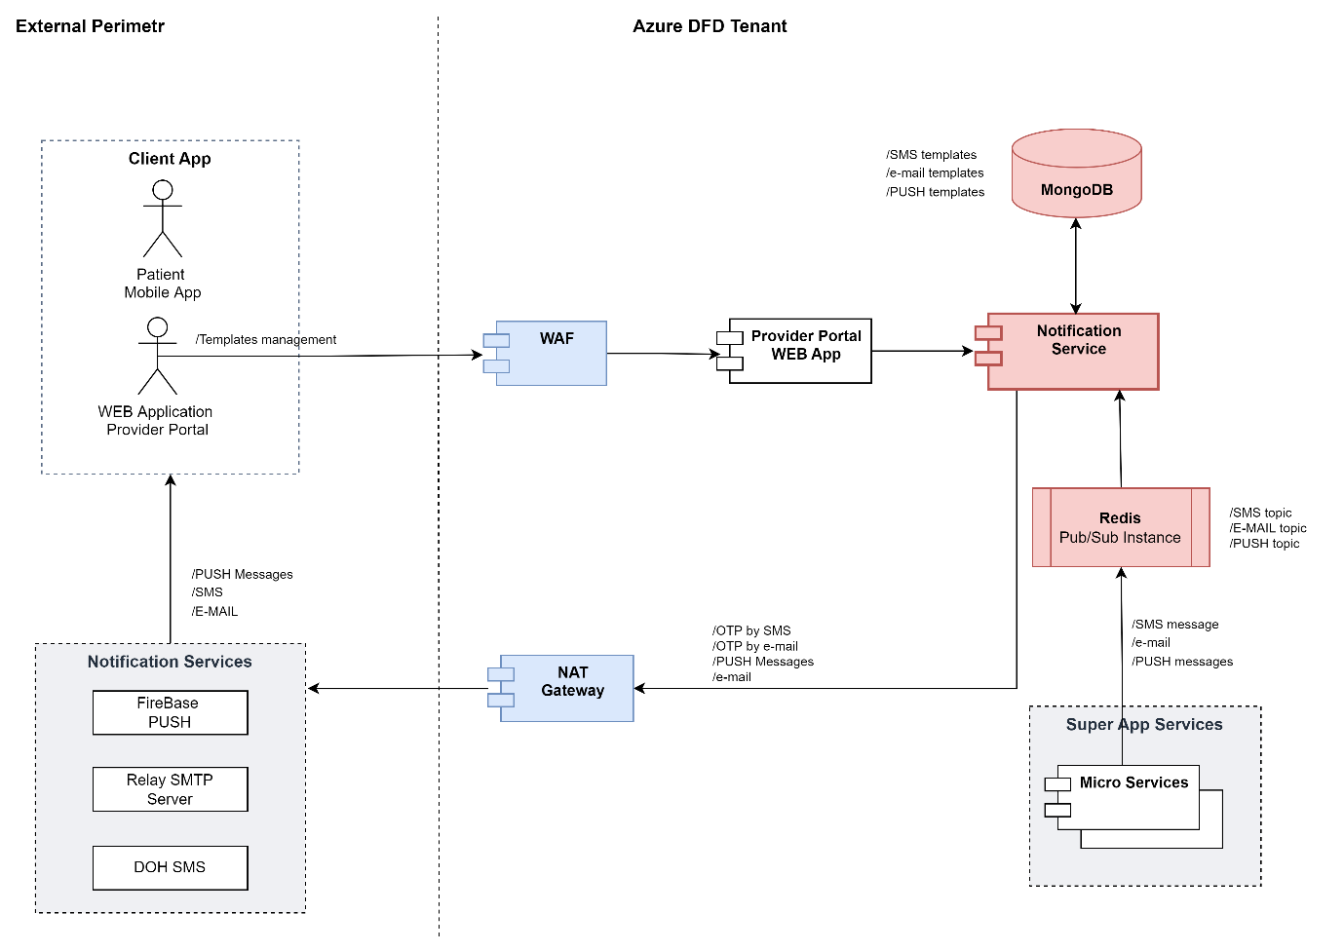

Picture 2.18.

Integration Service System Architecture

Components of Integration Service Module are applications component of the Sahatna Super App solution which is developed by Java and deployed in the docker container format within Kubernetes cluster.
Description of the Integration Service System Architecture encompasses two tightly coupled modules:

Appointment Service Module:
The main features of the Appointment Service Module are the followings:
- handling of a Patient Appointment lifecycle (create/update (rescheduling)/cancel (delete)) and synchronization with source of Appointment data (aggregator EHR/EMR DB or facilities EHR/EMR DB).

Integration Service Module:
The main features of the Integration Service Module are the followings:
- validation and transformation of data incoming to the Sahatna Super App backend in the FHIR/JSON format into internal data format of Sahatna Super App as well.
- validation of requests from the providers' side (signature check of the provider tokens by public key) and handling/routing connections between Super App backend and providers information systems;

      - Integration Service Description

Parameter | Description
Deployment Format | Container Image / Jar
Language | Java
Dependencies | Appointment Service Module  Provider Service Module
Communication protocol | REST/HTTP, gRPC
Connection endpoint | /integration/actuator/health  Port: 8107
Data persistence | Redis (Cache Instance)  Redis (Pub/Sub Instance)

      - Appointment Service Description

Parameter | Description
Deployment Format | Container Image / Jar
Language | Java
Dependencies | Integration Service Module  Provider Service Module
Communication protocol | REST/HTTP, gRPC
Connection endpoint | /appointment/actuator/health  Port: 8094
Data persistence | Azure MS SQL  Azure MongoDB (Cosmos DB)

      - Data Model Description

The Integration Service Module is not backed by MS SQL or MongoDB instances for data persistence.
Integration Service Module uses Azure Redis Cache Instance to temporarily storing of providers’ state data (base URL, customer headers, etc.).
Appointment Service Module is backed by Azure MS SQL Instance as Azure MongoDB.
Appointment Service Module is backed by the following database schemas within Azure MS SQL instance:
- appointment schema
ERD diagrams for entities encompassed by the mentioned database schemas are the following (Picture 2.19 - ERDs.zip):

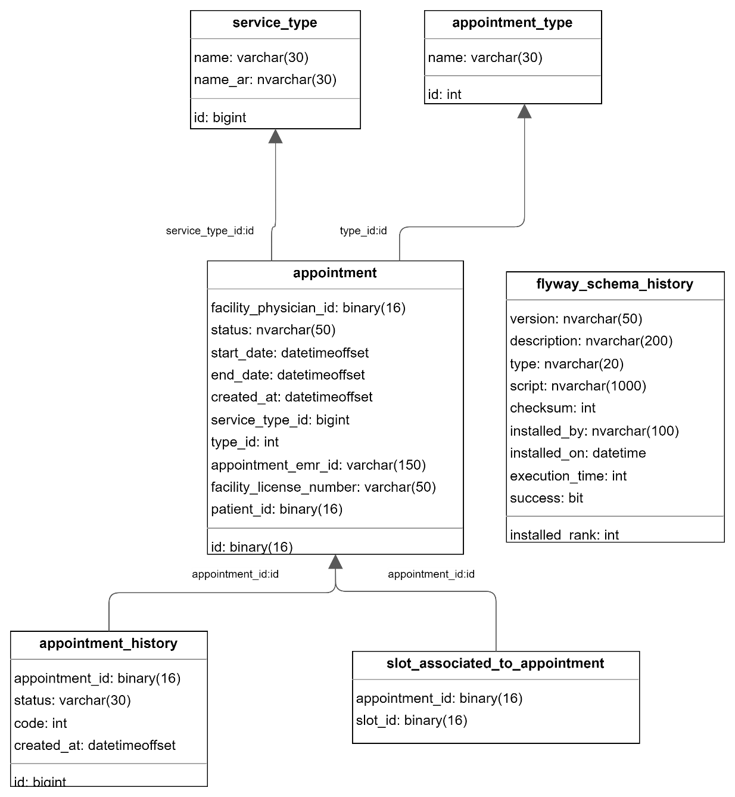

Picture 2.19
The Appointment Service Module is backed by the following collection of JSON files within Azure MongoDB:
- schedules collection
- slots collection
Templates used within the mentioned MongoDB collections are the following (Picture 2.20 - appointments.drawio) :

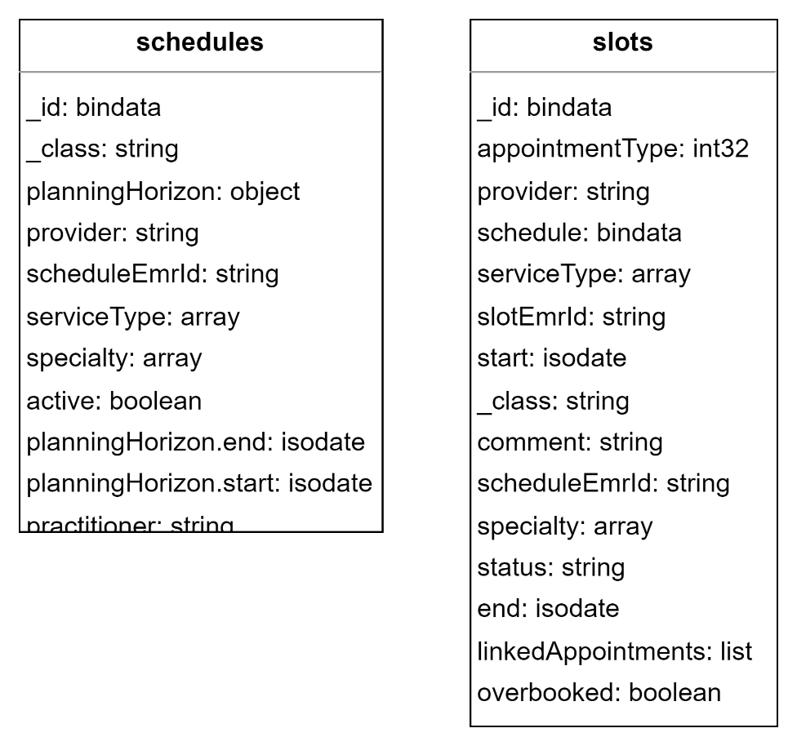

Picture 2.20

      - Application Component Diagram

The Integration Service Module depends and interconnects (including the Appointment Service Module) with the following programmatical components:

Component Type | Component List
External Component | Mobile App (iOS, Android)  Providers
Azure Network Components | API Gateway  NAT Gateway
Azure Database Components | Azure MS SQL  Azure MongoDB  Redis (Cache Instance)  Redis (Pub/Sub Instance)
Super App backend services | Provider Service

        - UML Component Diagram
UML Component Diagram for Integration Service Module (including Appointment Service Module) is depicted on the Picture 2.21.

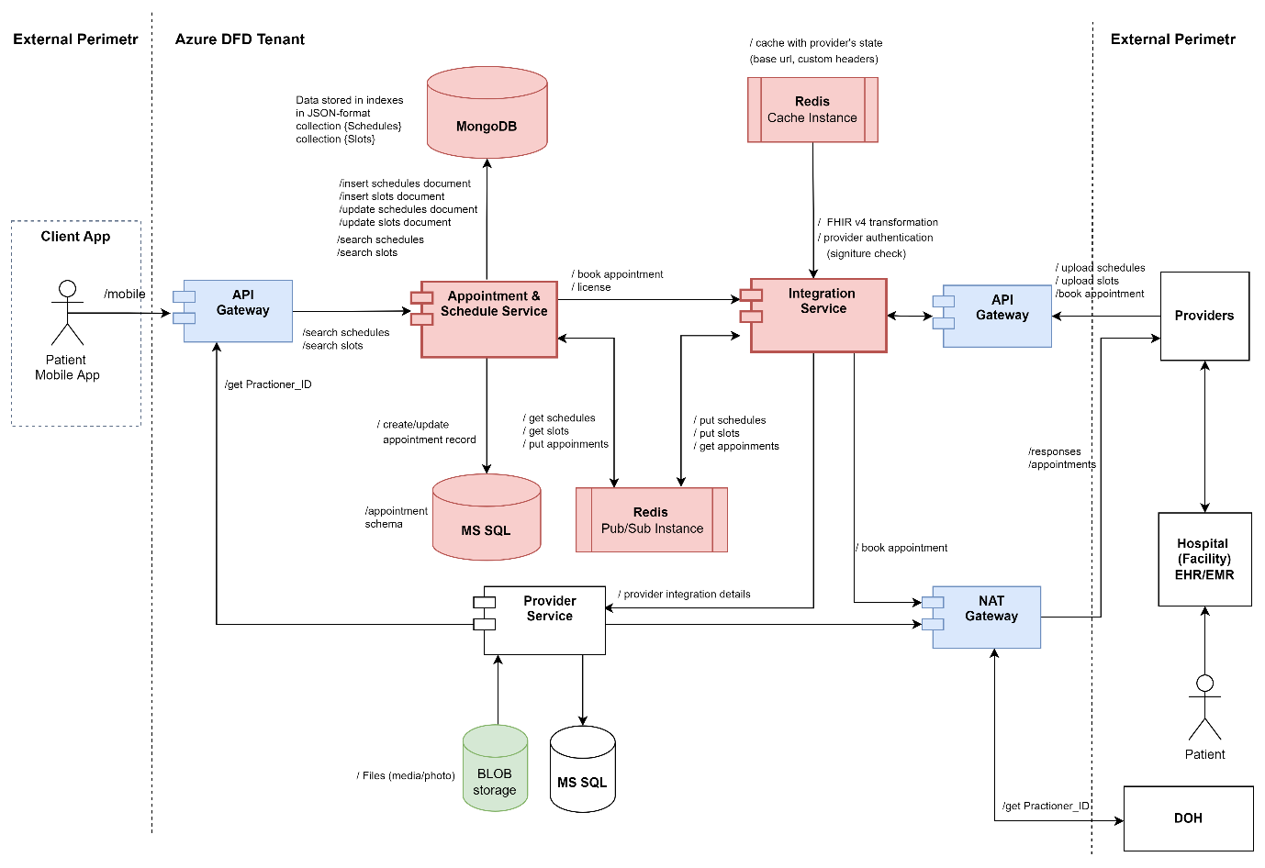

Picture 2.21.

        - UML Sequence Diagrams
The UML Sequence Diagram which models the workflow of an appointment resource creation from the side of Mobile Application is depicted on the Picture 2.22.

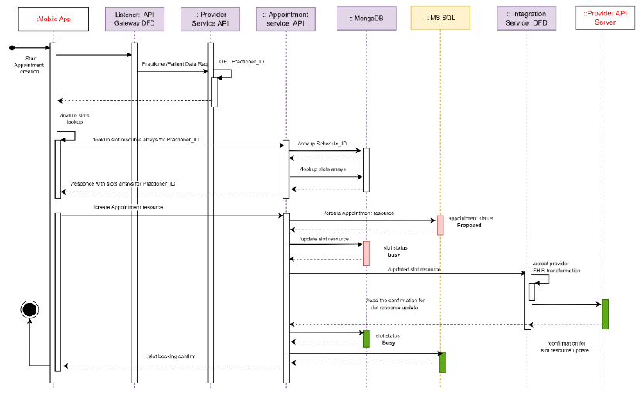

Picture 2.22.

The UML Sequence Diagram which models the workflow of an appointment resource cancel in sync mode from the side of Mobile Application is depicted on the Picture 2.23.
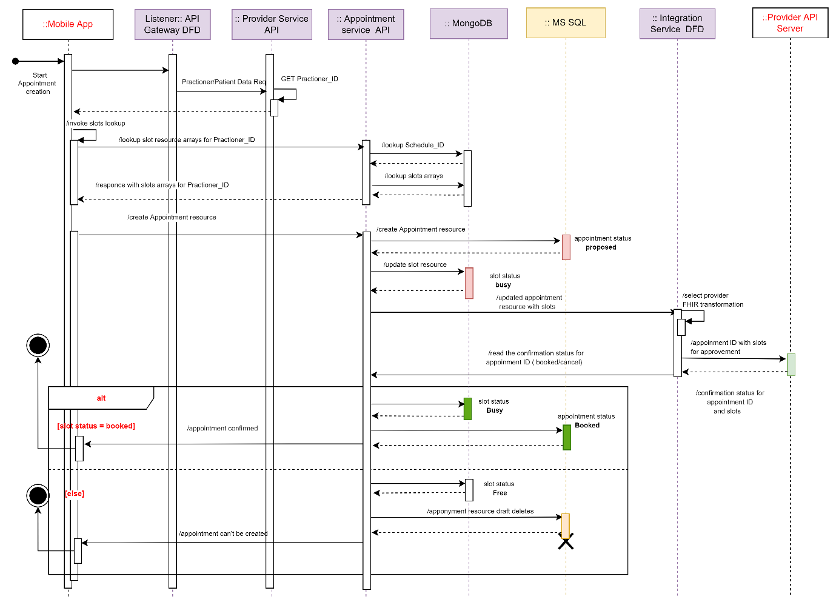

Picture 2.23.
The UML Sequence Diagram which models the workflow of an appointment resource rescheduling in sync mode from the side of Mobile Application is depicted on the Picture 2.24.
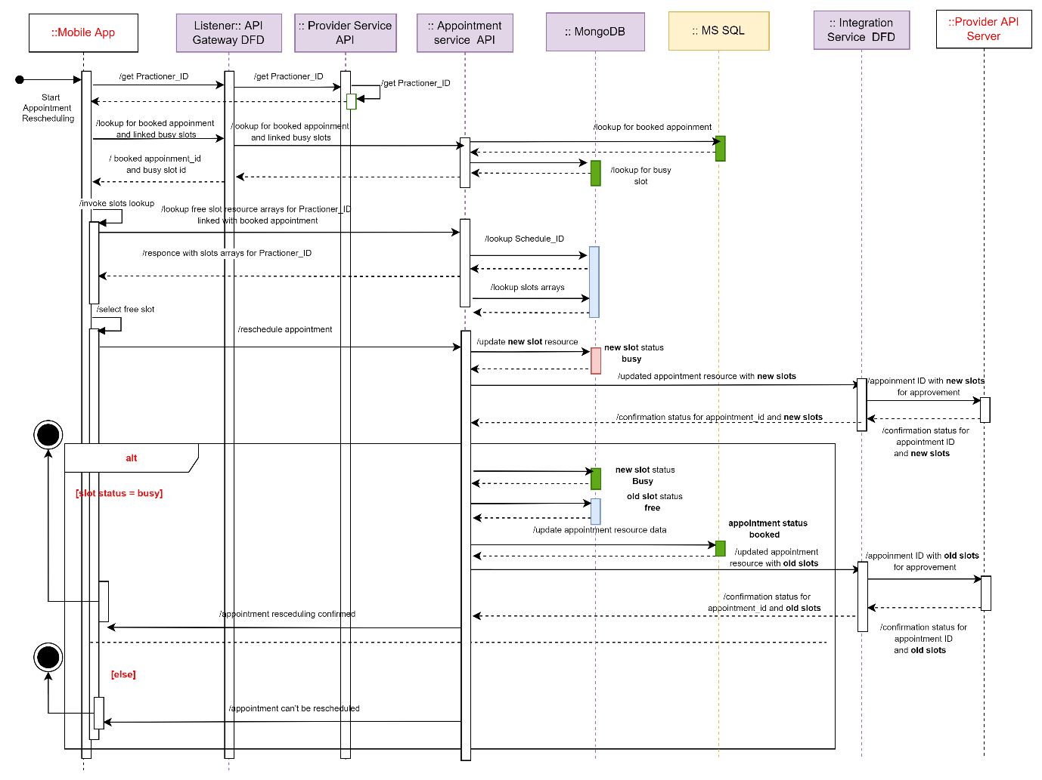
Picture 2.24.

Teleconsultation Service System Architecture

Teleconsultation Service Module is the application component of the Sahatna Super App solution which is developed by Java and deployed in the docker container format within Kubernetes cluster.
The main features of the Notification Service Module are the following:
- providing the capability of video conference between Patient and Physician. Video conference capability as well as video recording of the video conference between Patient and Physician are back by the Vidyo Platform solution. template management of notification messages within Provider Portal web application functionalities;

      - Service Description

Parameter | Description
Deployment Format | Container Image / Jar
Language | Java
Dependencies | Appointment Service Module  Integration Service Module  Web Application Teleconsultation Module (Web Page)  Vidyo Platform
Communication protocol | REST/HTTP, gRPC
Connection endpoint | /teleconsultation/actuator/health  Port: 8097
Data persistence | Azure MS SQL Instance:  Azure Redis (Pub/Sub Instance)

      - Data Model Description

Teleconsultation Service Module is backed by the following database schemas within Azure MS SQL instance:
- teleconsultation_dbo schema
ERD diagrams for entities encompassed by the mentioned database schemas are the following (Picture 2.25 - ERDs.zip):
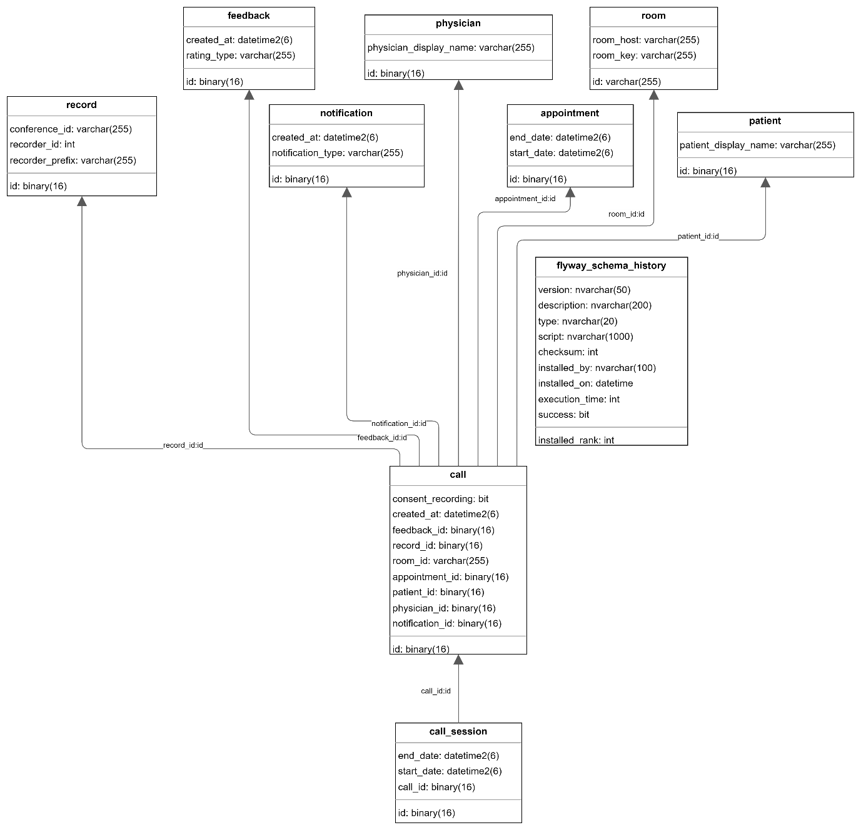

Picture 2.25

      - Application Component Diagram

Teleconsultation Service Module depends and interconnects with the following programmatical components:

Component Type | Component List
External Component | Mobile App (iOS, Android)  Providers  Vidyo Platform
Azure Network Components | API Gateway  NAT Gateway  WAF/ALB
Azure Database Components | Azure MS SQL  Redis (Cache Instance)  Redis (Pub/Sub Instance)
Super App backend services | Appointment Service Module  Integration Service Module

        - UML Component Diagram
The UML Component Diagram for the Teleconsultation service is depicted in Picture 2.26.

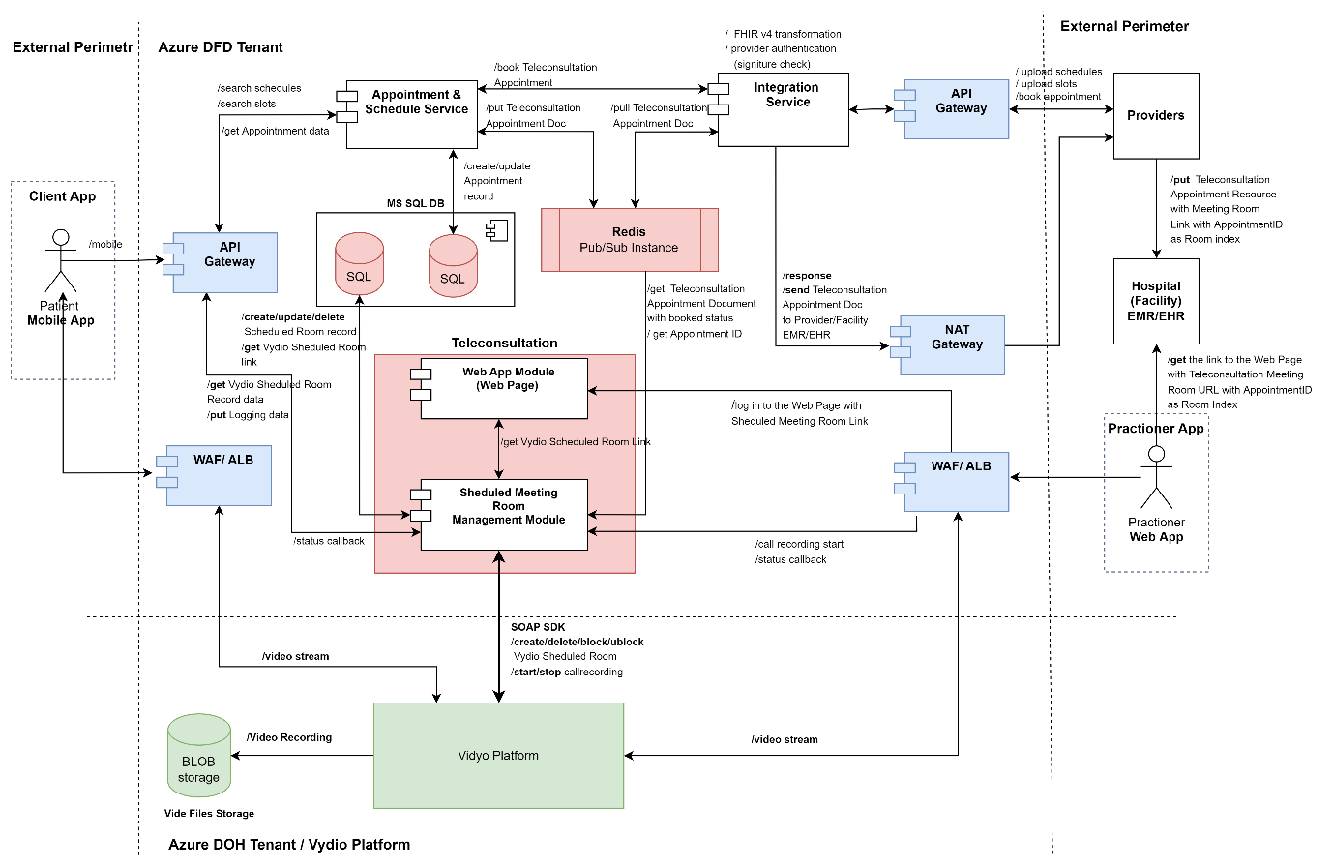

Picture 2.26.

        - UML Sequence Diagrams

The UML Sequence Diagram which models the basic workflow of the Teleconsultation Service is depicted on the Picture 2.27.

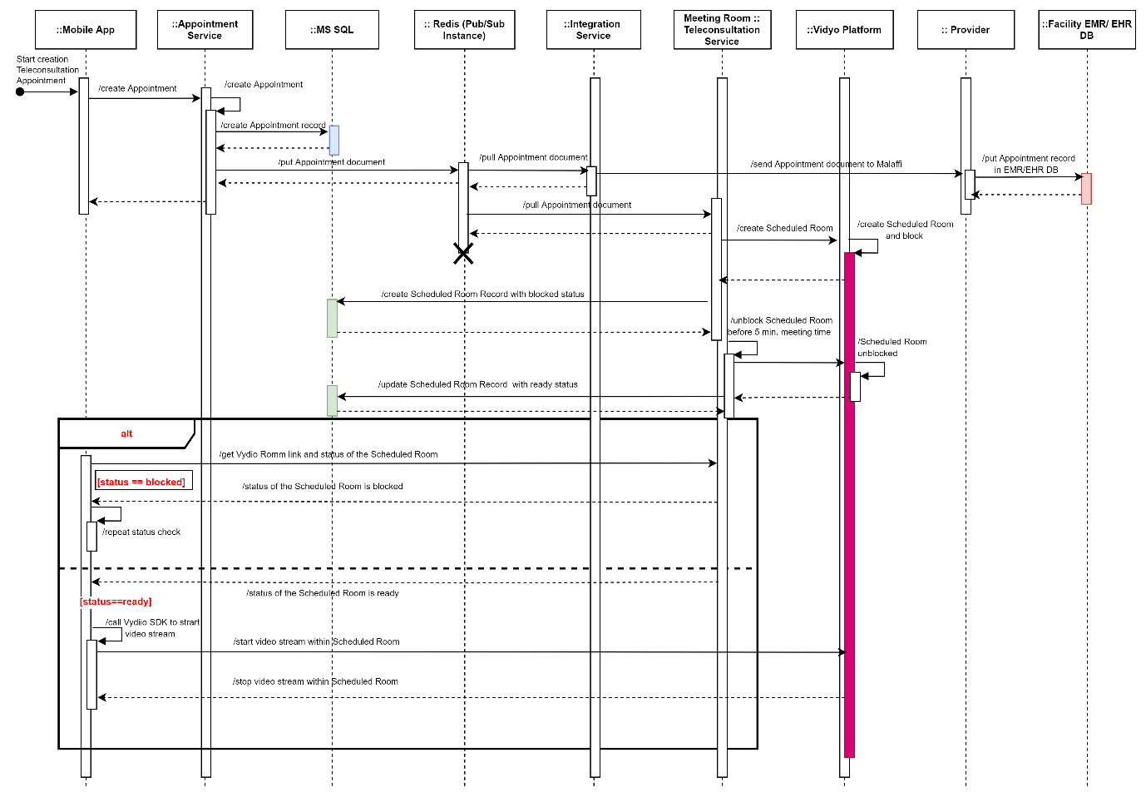

Picture 2.27.

Wearables Service System Architecture

The Wearables Service Module is the application component of the Sahatna Super App solution, which is developed in Java and deployed in a docker container within a Kubernetes cluster.

The main features of the Wearables Service Module are the following:
- Integrate with native aggregators: App HealthKit and Google Fit (Health Connect) to track wellness data like steps, nutrition, sleep and heart rate.
- Incorporate Smart Goals into wellness tracking process that are generated by a 3rd party integration (Fractal AI).
  - Fractal’s main target is to analyze - using fractal algorithms or mathematical models – patients' health insights (vital signs) and set/predicate “steps” smart goal based on the provided historical data.

      - Wearables Service Description:

Below is the service card for wearable service.

Parameter | Description
Deployment Format | Container Image / Jar
Language | Java
Dependencies | Patient Service Module  Fractal AI (external system)
Communication protocol | REST/HTTP, gRPC
Connection endpoint | /wearables/actuator/health  Port: 8111
Data persistence | Azure Cosmos DB Instance:  Azure Redis (Pub/Sub Instance)

      - UML Component Diagram

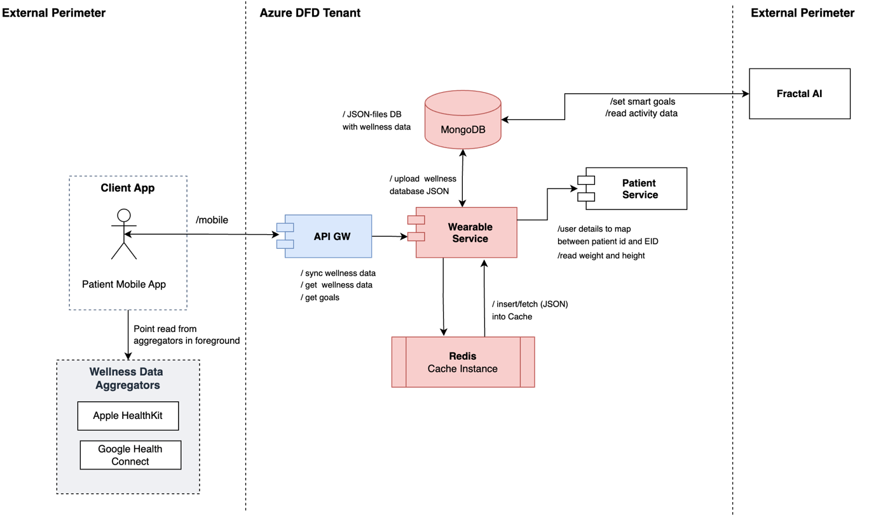

      - UML Sequence Diagram

The UML Sequence Diagram which models the basic workflow of the wearables Service to get goals is depicted on the diagram below.

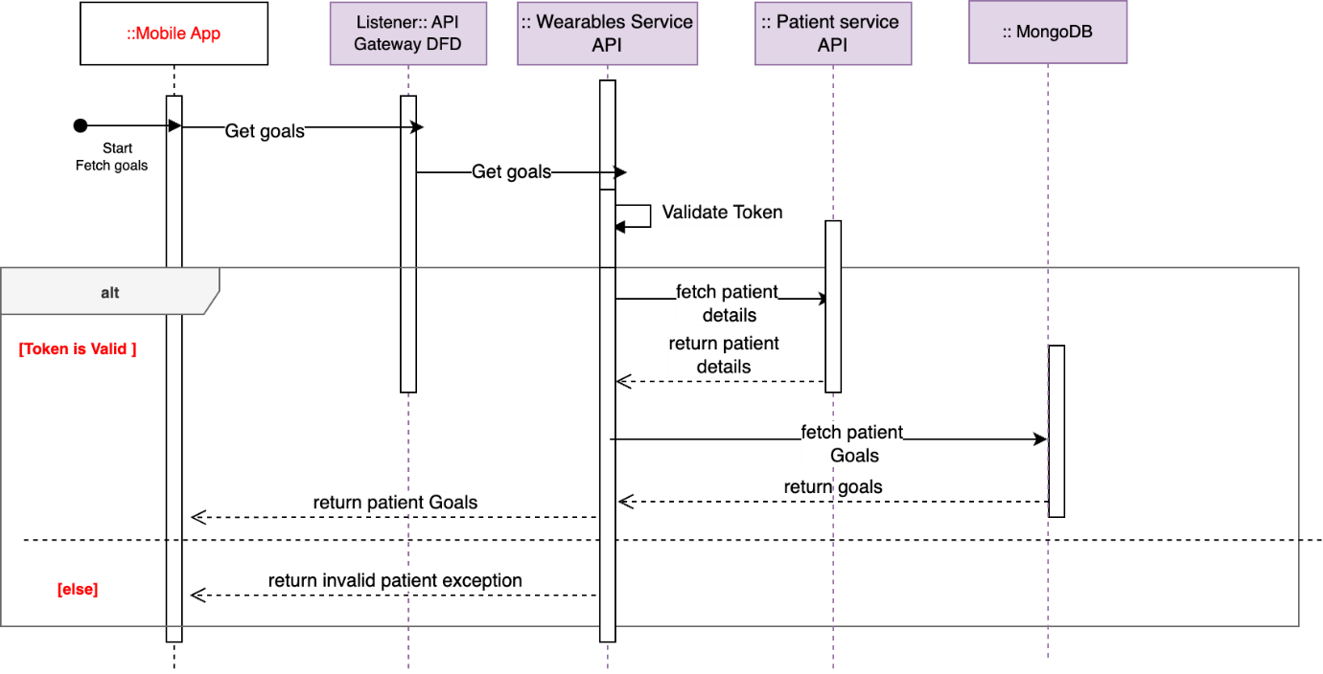

      - Data Model Description

The wearables Service Module is backed by Cosmos Db instance for data persistence. The wearables Service uses Azure Redis Cache Instance to temporarily store dependents info data (ID, EID, list of dependents).
ERD diagrams for documents encompassed by the mentioned database schemas are:
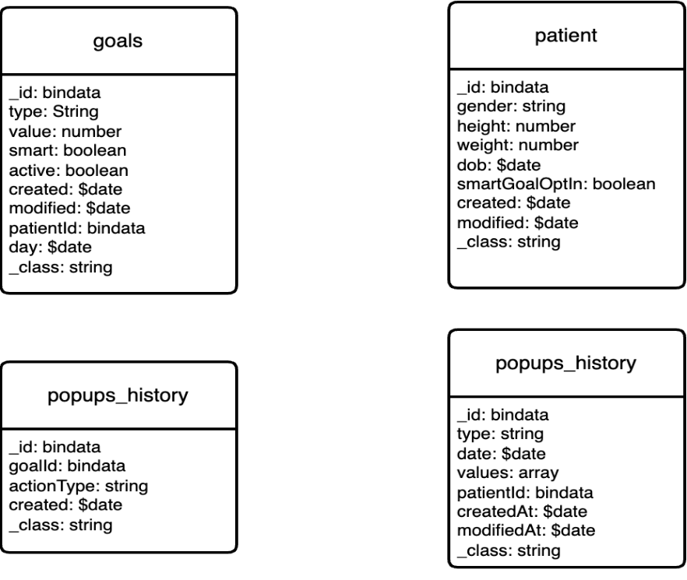

      - Design Considerations
# | Design Decision | Details
1 | Limit data sync intervals to 24 points write per day | Limiting data points is necessary as higher granularity additional data points require a drastic of service bandwidth (e.g. for 300K users, 5% users log daily = 15K DAU x 24 = 4.167 QPS if sync is every hour vs if sync is every minute is 250 QPS). The increase in throughput (QPS) will require scaling of the services, which is not justified by the business value.
2 | Data sync in the foreground | Support for background sync requires elevated permissions from the user.  Mechanisms exist to receive health data in the background, but there are limitations.  Data may not arrive on time or at all, due to system policies and user settings like disabled Background App Refresh or focus mode or power-intensive app restrictions. Low battery or power-saving mode can also block updates from HealthKit.  Running the app in the background increases power consumption, affecting user experience.

References
- https://github.com/OWASP/ASVS/blob/v4.0.3/4.0/OWASP%20Application%20Security%20Verification%20Standard%204.0.3-en.pdf
- https://docs.dapr.io/concepts/resiliency-concept/
- https://docs.dapr.io/concepts/building-blocks-concept/
- https://learn.microsoft.com/en-us/azure/architecture/patterns/sidecar

