AXI2AXI DMA Datasheet
v0.2 Review Draft English Edition
This edition restores the eight topics in the original document plan as separate chapters. Functionality follows the existing Specification v0.2, preserving APB3, 32-bit addresses, 1–4096 bytes, the existing register map, and status codes. This is a document-structure revision, with no hardware or software contract change.
Item | Baseline
Primary specification | AXI2AXI_DMA_Specification_v0.2
Architecture | AXI2AXI_DMA_Architecture_v0.2
Register map | AXI2AXI_DMA_Register_Map_v0.1
Inspected RTL baseline | 62afb73f64ca
Companion document | Software Programming Guide v0.2

Contents
1 Functions and Features
2 Block Diagram and Architecture
3 Clock and Reset
4 Hardware Interfaces
5 AXI Protocol Assumptions
6 Parameters
7 Performance and Limitations
8 Hardware Constraints
Appendix A provides specification traceability and revision history.

1 Functions and Features
The DMA reads data through the AR/R channels of a source AXI4 read-only master and writes it in order through the AW/W/B channels of a target AXI4 write-only master. Software uses APB3 to program both 32-bit byte addresses and one transfer of 1–4096 bytes. Source and target independently select Single or INCR Burst mode. (Specification items 1, 2, 4, 6.)
Feature | Capability
Control | APB3 slave, 32-bit data, no wait states
Source / Target | Separate read-only AR/R and write-only AW/W/B
DMA command | One command at a time, 1–4096 bytes, 32-bit byte addresses
Burst | Independent Single or INCR Burst per side; automatic 4KB splitting
Outstanding | At most one per side; read and write may overlap
Data path | Parameterized equal-width interfaces with a shared synchronous FIFO
Notification | Level IRQ; software may poll the pending bit
Protection | Alignment validation, response errors, timeout, and RLAST faults

Use this table to assess basic capabilities. Chapter 6 gives legal parameter ranges; chapters 7 and 8 give performance limits and hardware conditions. Full register programming definitions are in the Software Programming Guide.

2 Block Diagram and Architecture
Figure 1 shows control, data, and event paths from architecture v0.2. dma_cdc carries coherent snapshots and results between PCLK and AXI_CLK. (Items 3, 11, 16.)
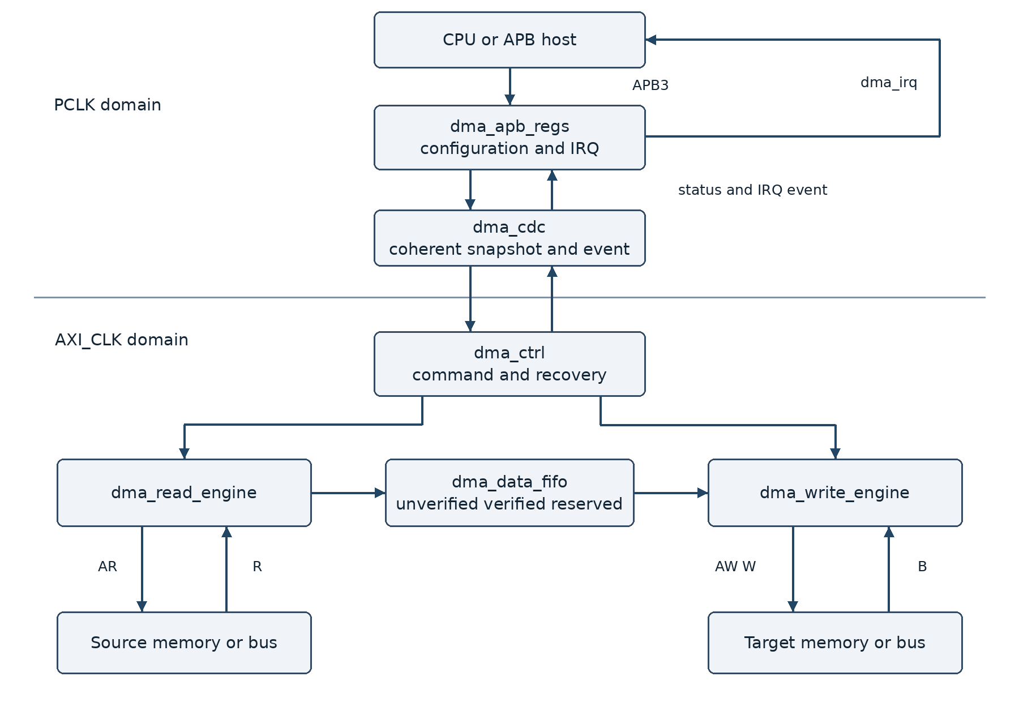
Path | Responsibility
APB3 → dma_apb_regs | Configuration, START, status, IRQ
dma_apb_regs ↔ dma_cdc ↔ dma_ctrl | Coherent command snapshots and event crossing
Source AR/R → dma_read_engine → FIFO | Receive a complete burst and commit after validation
FIFO → dma_write_engine → Target AW/W/B | Reserve payload before writing, then wait for B response

Data qualification and reservation
The FIFO tracks unverified, verified, reserved, and free data. Data becomes verified only after every beat of the source burst returns OKAY and RLAST is correct. Before AWVALID, the target reserves a complete verified payload, which may combine the prefix of multiple successful source bursts. (Items 4.i, 17, 22.)

3 Clock and Reset
Clock or Reset | Domain and behavior
pclk | APB register bank, IRQ, and software-visible image
axi_clk | Shared by source/target AXI, controller, and synchronous FIFO
reset_n | Shared active-low asynchronous reset with synchronous release per domain

PCLK and AXI_CLK need not be synchronous. Source and target do not have independent AXI clocks. The specification sets no maximum frequency, clock ratio, or CDC latency bound; timing closure on the target platform determines these. (Items 3, 12.)
reset_n is the shared external asynchronous reset, asserted asynchronously and deasserted synchronously in each domain. Configuration, status, IRQ, FIFO, and CDC state reset to zero. A zero length register encodes one byte, but reset does not start the DMA. Reset recovery from a permanent stall requires slave/interconnect coordination. (Items 6, 12.)

Clock crossing and snapshot
Keep the START snapshot stable until receiver acknowledgement. Do not cross multi-bit registers by direct sampling. BUSY is owned by the AXI domain; completion/error and status code cross coherently as event/data to PCLK. Short pulses must not directly serve as cross-domain notifications. (Item 11.)

Reset effects
State | After reset
Registers / shadow / FIFO / CDC | 0
BUSY / STATUS_CODE / IRQ pending | 0
DMA_LENGTH | 0; configures one byte but does not start
Source / Target mode | Burst
Old AXI VALID / IRQ | Old transaction VALID and IRQ are not retained

4 Hardware Interfaces
This chapter lists the external interfaces of top module axi_dma_ctrl. I/O directions are relative to the DMA IP. D=AXI_DATA_WIDTH, I=AXI_ID_WIDTH, and A=APB_ADDR_WIDTH. (Items 4, 5, 24; rtl/axi_dma_ctrl.v.)

APB3 and IRQ
Signal | Dir | Width | Purpose
pclk / axi_clk / reset_n | In | 1 | Control / AXI clocks and shared reset
psel / penable / pwrite | In | 1 | APB select / access / write
paddr | In | A | Register byte offset
pwdata | In | 32 | Write data
prdata | Out | 32 | Read data
pready | Out | 1 | Always 1
pslverr | Out | 1 | Asserted on invalid access
dma_irq | Out | 1 | PCLK-domain level IRQ

APB data is fixed at 32 bits. PREADY is always 1 with no wait states. APB completes on PSEL && PENABLE && PREADY. Undefined or non-4-byte-aligned offsets return PSLVERR; invalid reads return zero and invalid writes have no effect. Reserved bits are RAZ/WI.

Source AXI Read Master
Signal | Dir | Width | Purpose
m_src_arid | Out | I | Constant request ID
m_src_araddr | Out | 32 | Read byte address
m_src_arlen / arsize / arburst | Out | 8 / 3 / 2 | Length / beat size / INCR
m_src_arprot / arcache | Out | 3 / 4 | PROT / CACHE parameters
m_src_arlock / arqos / arregion | Out | 1 / 4 / 4 | All zero
m_src_arvalid / arready | Out / In | 1 | Address handshake
m_src_rid / rdata / rresp / rlast | In | I / D / 2 / 1 | Read payload and response
m_src_rvalid / rready | In / Out | 1 | Read handshake

Target AXI Write Master
Signal | Dir | Width | Purpose
m_dst_awid / awaddr | Out | I / 32 | ID / write byte address
m_dst_awlen / awsize / awburst | Out | 8 / 3 / 2 | Length / beat size / INCR
m_dst_awprot / awcache | Out | 3 / 4 | PROT / CACHE parameters
m_dst_awlock / awqos / awregion | Out | 1 / 4 / 4 | All zero
m_dst_awvalid / awready | Out / In | 1 | Address handshake
m_dst_wdata / wstrb / wlast | Out | D / D/8 / 1 | Write data / byte strobes / last
m_dst_wvalid / wready | Out / In | 1 | Write handshake
m_dst_bid / bresp / bvalid | In | I / 2 / 1 | Write response
m_dst_bready | Out | 1 | Response ready

Names after a slash use the full prefix in the row; for example m_src_arlen / arsize means m_src_arlen and m_src_arsize. USER signals are omitted; source has no write channels and target has no read channels.

5 AXI Protocol Assumptions

5 1 Handshake and bursts
AXI handshakes use VALID && READY. Source/target address is 32 bits, LEN 8 bits, SIZE 3 bits, RESP 2 bits, and WSTRB is AXI_DATA_WIDTH/8 bits. AxID is AXI_ID_VALUE; PROT/CACHE are parameters, LOCK/QOS/REGION are zero, and USER and exclusive accesses are not provided. (Items 4, 24.)
B=AXI_DATA_WIDTH/8. Both addresses must align to B; length need not be a multiple of B. Hardware independently handles each side’s 4KB boundary, and source and target bursts need not correspond one-to-one. (Items 7, 8, 17.)
remaining_beats = ceil(remaining_bytes / B)
page_beats = (4096 - (address % 4096)) / B
read_beats = min(MAX_BURST_LENGTH, remaining_beats,
page_beats, available_FIFO_space)
write_beats = min(MAX_BURST_LENGTH, remaining_beats,
page_beats, verified_FIFO_data)
AxLEN = burst_beats - 1; AxSIZE = log2(B); AxBURST = INCR
Single mode sets burst_beats=1 and AxLEN=0 without changing AxSIZE. FIFO space accounts for committed read bursts. Payload and length remain stable after VALID assertion. For a final k-byte partial beat, only the lowest k WSTRB bits are enabled. (Items 6, 7, 17.)

5 2 Responses and transaction obligations
After a source error or timeout, the failed burst cannot become verified. Stop new target transactions and discard uncommitted data. Payload for an asserted AWVALID must be retained even before AW handshake; all W beats and the B response must complete. FIFO storage may be released after the final W handshake, while the write engine still tracks BRESP. (Items 20, 22; architecture v0.2 section 2.)
Timeout does not withdraw VALID or cancel accepted transactions. A mismatched RID/BID forces READY=0 and the response is not processed. Waiting may time out, but the mismatched response must still not be accepted. Permanent stalls and protocol faults can require coordinated reset; target writes are not rolled back. (Items 20, 23, 24.)
A side must not issue another command while a pending VALID or accepted transaction occupies its slot. Normal completion waits for the final matching BID with OKAY, and IDLE requires no remaining obligations. (Items 4.g, 15.)

5 3 Timeout and protocol faults
Wait phase | Counting condition
Source AR | ARVALID && !ARREADY
Source R | Accepted read with capacity, waiting for matching RID handshake; pause on FIFO full
Target AW / W | AWVALID/WVALID waiting for READY; data preparation without WVALID is excluded
Target B | After final W handshake, wait for matching BID handshake

Each side counts independently. Progress handshakes and phase transitions reset counters. A handshake on the expiry cycle takes precedence, and recovery does not republish the same timeout. AXI_TIMEOUT_CYCLES=0 disables the watchdog. (Items 4.h, 20.4.)
RLAST must occur on the final accepted beat defined by ARLEN. Early RLAST or missing RLAST on the expected final beat enters a reset-required fault. The write engine asserts WLAST only on the beat of the AWLEN+1-th W handshake. Counters advance only on VALID && READY. (Item 23.)

6 Parameters
Parameter | Default | Legal values and purpose
APB_ADDR_WIDTH | 12 | >=5; register byte address width
AXI_ADDR_WIDTH | 32 | Fixed at 32; other values unsupported
AXI_DATA_WIDTH | 32 | 8,16,32,64,128,256,512,1024
AXI_ID_WIDTH | 6 | >=1
MAX_BURST_LENGTH | 8 | 1–256 beats
DATA_FIFO_DEPTH | 8 | >= MAX_BURST_LENGTH entries
AXI_TIMEOUT_CYCLES | 1024 | >=0; zero disables; n consecutive AXI clocks without progress
AXI_ID_VALUE | 0 | AXI_ID_WIDTH bits; constant ID shared by both sides
AXI_PROT_VALUE | 3'b000 | 3-bit ARPROT / AWPROT
AXI_CACHE_VALUE | 4'b0000 | 4-bit ARCACHE / AWCACHE

APB_DATA_WIDTH is fixed at 32 and is not a top-module parameter. BYTES_PER_BEAT=AXI_DATA_WIDTH/8 is derived. Both AXI interfaces share AXI_DATA_WIDTH; independent source/target width conversion is not provided. (Items 4, 5; top module.)
MAX_BURST_LENGTH need not be a power of two. Illegal elaboration configurations must report an error and stop simulation. Parameter legality checks must not become unsynthesizable datapath/control logic. (Items 4.j, 13.)

7 Performance and Limitations

7 1 Theoretical bandwidth
Peak payload bandwidth per AXI side = f_AXI * AXI_DATA_WIDTH / 8
Example: 100 MHz * 32 / 8 = 400 MB/s
This is a theoretical per-side limit. Read and write traffic must not be added to claim copy throughput. The specification provides no measured throughput, maximum frequency, or guaranteed latency. The 100 MHz example is illustrative, not a supported-frequency claim.

7 2 Factors affecting throughput
Factor | Impact
Burst / response latency | One outstanding per side; the next waits for completion
Source qualification | Data is usable by a new target burst only after full source-burst success
FIFO capacity | Read capacity and reserved write payload consume storage
Backpressure | External READY/VALID waits and internal FIFO full extend transfer time
CDC / command setup | Small transfers are more affected by setup and CDC overhead

7 3 Capability limits
This version provides single commands of 1–4096 bytes without descriptors, scatter gather, a command queue, software Abort, memmove guarantees, or atomic rollback. It supports only INCR bursts, full-width reads, and equal data widths. Errors may leave partial target updates. See guide chapters 6 and 8 for software handling.

8 Hardware Constraints

8 1 Addresses and memory regions
Source reads are never narrow. Software must validate access to the full final beat and peripheral read side effects. Address arithmetic wraps modulo 2^32. Overflow and overlap do not produce CONFIG_ERROR, and memmove behavior is not guaranteed. (Items 8, 21.)
Configuration | Behavior
32-bit data, 10 bytes | WSTRB: 1111, 1111, 0011
32-bit data, src=0x1FFC, 12 bytes | Source splits into 1 beat and 2 beats at 0x2000
32-bit data, src=0x1000, 1 byte | Source reads 0x1000–0x1003; target writes one byte

Each AXI memory map and permissions must permit the accesses, including extra source bytes in the final beat. Address alignment is BYTES_PER_BEAT on both sides; low bits must not be silently removed to continue a transfer. (Items 7, 21, 24.)

8 2 Coordinated reset and recovery
Retain payload for an asserted target AWVALID until all W beats complete. Permanent READY/response stalls may prevent BUSY from clearing. Reset must coordinate the DMA, interconnect, and affected slaves. Only coordinated reset exits an RLAST protocol fault. (Items 20, 22, 23.)

8 3 Clock gating and build requirements
Only IDLE with no obligation shuts off ARVALID/AWVALID/WVALID/RREADY/BREADY. ASIC gating must not block START, reset, CDC events, or unfinished transactions. FPGA builds use clock enables, not RTL-generated gated clocks or ICG. The implementation determines the build-definition name. (Items 14, 19.)

Appendix A Specification Traceability and Revision History
Chapter | Specification items
1 Functions and Features | 1, 2, 4, 6
2 Block Diagram and Architecture | 3, 11, 16, 22
3 Clock and Reset | 3, 6, 11, 12
4 Hardware Interfaces | 4, 5, 24
5 AXI Protocol Assumptions | 4, 7, 8, 10, 15, 17, 20, 22–24
6 Parameters | 4, 5, 13, 24
7 Performance and Limitations | 4, 6, 8, 10, 21–23
8 Hardware Constraints | 7, 8, 12–14, 19–24

Sources and baseline
doc/specification/AXI2AXI_DMA_Specification_v0.2.txt
doc/architecture/AXI2AXI_DMA_Architecture_v0.2.md
doc/architecture/register_map/AXI2AXI_DMA_Register_Map_v0.1.md
rtl/axi_dma_ctrl.v; rtl/dma_apb_regs.v
The existing Specification v0.2 is the primary authority, with RTL checked at commit 62afb73f64ca. Chapter numbers differ from specification item numbers: references to “item n” identify the original specification. The RTL start_pending guard is additional protection and does not extend the software contract.

Revision history
Version | Date | Changes
v0.1 | 2026-10-05 | Initial draft based on the existing specification
v0.2 | 2026-10-05 | Restore the original eight chapters. Add a block diagram and full interface tables to the Datasheet. Separate guide bit fields, flow, IRQ, errors, examples, and limitations. Functional contract unchanged.

