Short Answer Questions
- What are self-closing elements in HTML? Give some examples
- What is block element? How is it different from inline, and inline-block elements?
- What is the difference between pseudo-class and pseudo-element?
- What is the Box Model? Describe each part.
- How do you center a block element with CSS?
- What is a flex container? Can you explain some flex container properties?
- What is responsive web design? How do we achieve this?
- What are primitive data types & reference data types in JS?
- How do you sort an array of numbers in ascending and descending order?
- What’s Short-circuiting?
- What is hoisting?
- What are scopes in JS? What is the difference between var, let and const?
- Explain Template Literal

Coding
- Implement the following table. (Hint: colspan & rowspan)
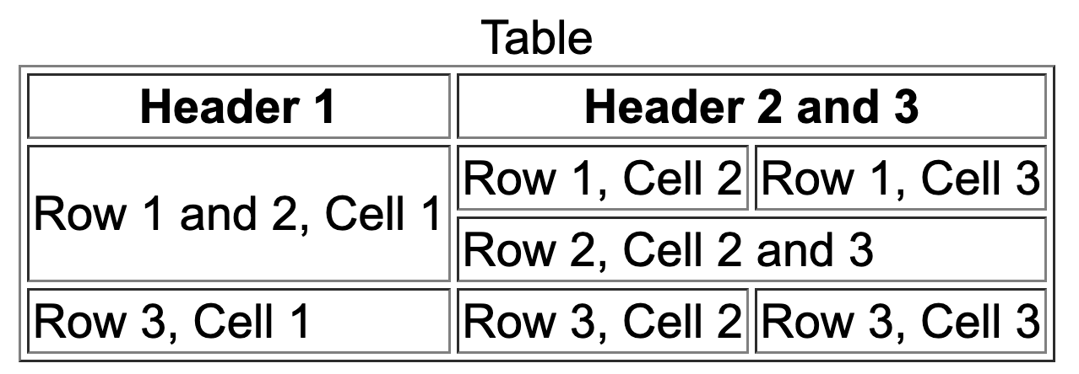
- Task: Using the same HTML, write CSS to achieve three different centering effects:
<div class="container">
<div class="box">Center</div>
</div>
a.Horizontal centering: center the box horizontally in the container.
b.Vertical centering: center the box vertically in the container.
c.Horizontal + Vertical centering: center the box both horizontally and vertically in the container

- Use slice to copy part of an array:
const arr1 = [10, 20, 30, 40];
//write your code here
expected output: [20, 30]

- Leetcode 217

