Assignment 3: Python Fundamentals

1. Calculator
# Calculator Program
num1=float(input("Enter first number: "))
num2=float(input("Enter second number: "))
print("\nSelect Operation")
print("1. Addition")
print("2. Subtraction")
print("3. Multiplication")
print("4. Division")
choice=input("Enter your choice (1-4): ")
if choice=='1':
print("Result =",num1+num2)
elif choice=='2':
print("Result =",num1-num2)
elif choice=='3':
print("Result =",num1*num2)
elif choice=='4':
if num2!=0:
print("Result =",num1/num2)
else:
print("Division by zero is not possible.")
else:
print("Invalid Choice!")
Sample Output Screenshot:
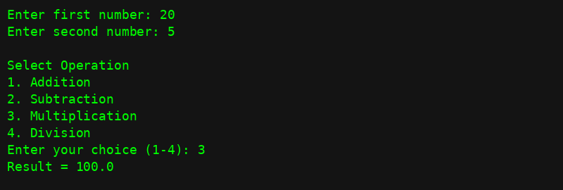

2. Fibonacci Series
n=int(input("Enter the number of terms: "))
a,b=0,1
print("Fibonacci Series:")
for i in range(n):
print(a,end=" ")
a,b=b,a+b
Sample Output Screenshot:
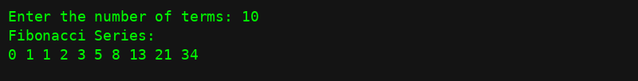

3. Prime Number Check
num=int(input("Enter a number: "))
if num>1:
for i in range(2,num):
if num%i==0:
print(num,"is not a Prime Number.")
break
else:
print(num,"is a Prime Number.")
else:
print(num,"is not a Prime Number.")
Sample Output Screenshot:

4. Palindrome Check
text=input("Enter a string: ")
if text==text[::-1]:
print(text,"is a Palindrome.")
else:
print(text,"is not a Palindrome.")
Sample Output Screenshot:

5. Student Grade Calculator
name=input("Enter Student Name: ")
m1=float(input("Enter marks of Subject 1: "))
m2=float(input("Enter marks of Subject 2: "))
m3=float(input("Enter marks of Subject 3: "))
total=m1+m2+m3
percentage=total/3
print("\nStudent Name:",name)
print("Total Marks:",total)
print("Percentage:",percentage)
if percentage>=90:
print("Grade: A+")
elif percentage>=80:
print("Grade: A")
elif percentage>=70:
print("Grade: B")
elif percentage>=60:
print("Grade: C")
elif percentage>=50:
print("Grade: D")
else:
print("Grade: F")
Sample Output Screenshot:
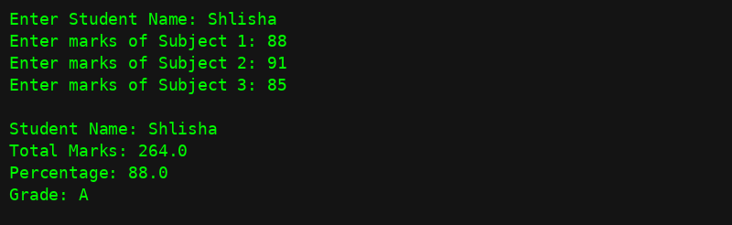

6. Object-Oriented Programming
class Student:
def __init__(self,name,age,course):
self.name=name
self.age=age
self.course=course
def display(self):
print("\nStudent Details")
print("Name:",self.name)
print("Age:",self.age)
print("Course:",self.course)
name=input("Enter Student Name: ")
age=int(input("Enter Age: "))
course=input("Enter Course: ")
student=Student(name,age,course)
student.display()
Sample Output Screenshot:
