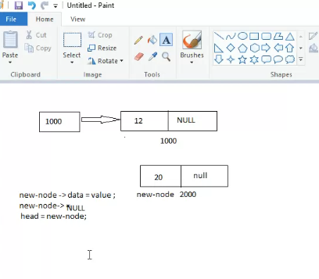
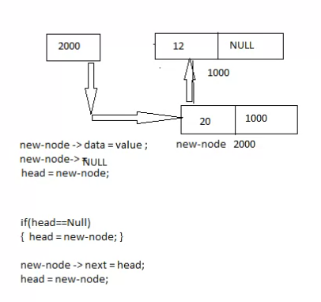
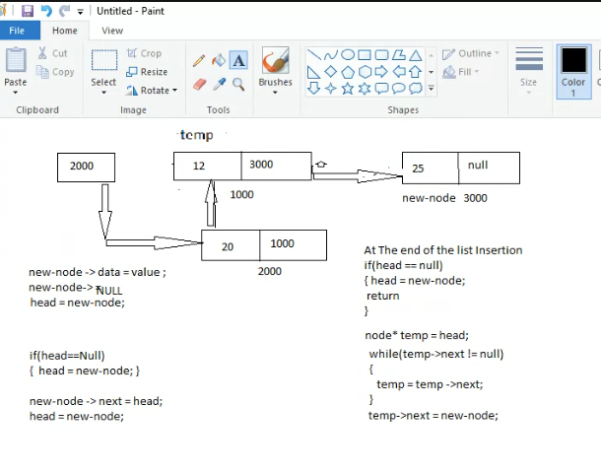

NOW insertion in middle:
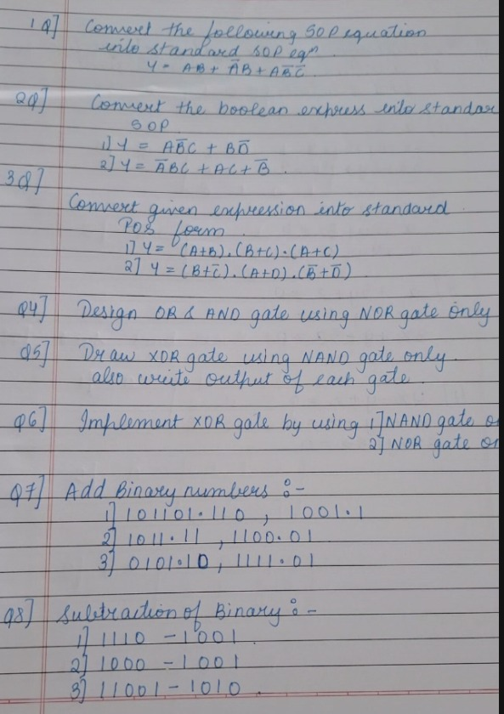

Q1: $Y=AB\left(C+\overline{C}\right)+\overline{A}B\left(C+\overline{C}\right)+A\overline{B}\overline{C}$
=> $Y=ABC+AB\overline{C}+\overline{A}BC+\overline{A}B\overline{C}+A\overline{B}\overline{C}$ {Distributive law)
Q2:$Y=AB\overline{C}+B\overline{D}$
= A.B'.C . (D + D') + B.D' . (A + A')
= A.B'.C.D + A.B'.C.D' + A.B.C.D' + A.B.C'.D' + A'.B.C.D' + A'.B.C'.D'

Part 2:
Y = (B + C') . (A + D) . (B' + D')

