Quick sort:
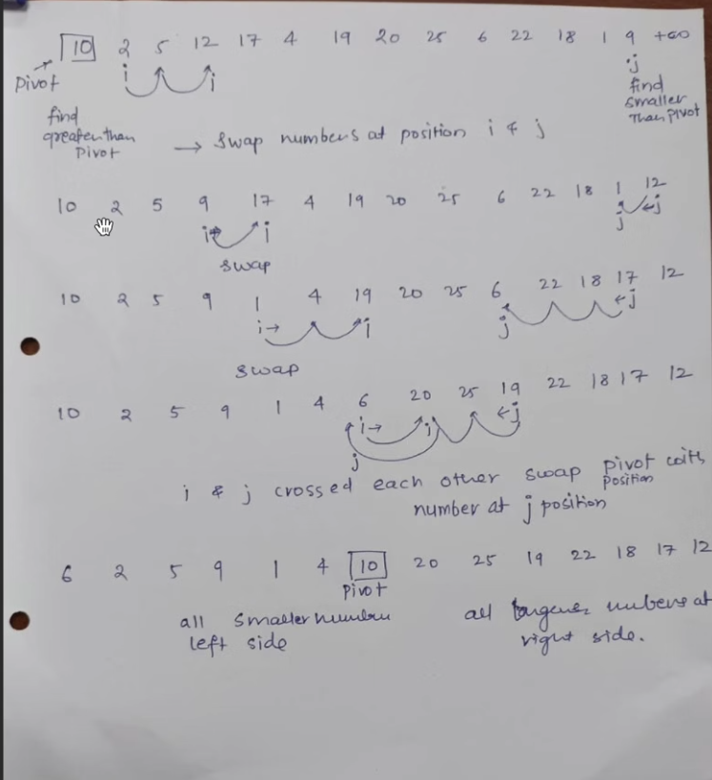
Solve further iterations by dividing left and right side of pivot element and performing quick sort on these sub arrays(left and right side of pivot) until the array gets sorted..
