**(If you purchase before 17-Feb-2019, Please follow below instructions)**

**Step: 1:** Login to Your CodecAnyon.net account -> [Download](https://codecanyon.net/downloads) -> Click Download -> Click **All files & documentation**.   
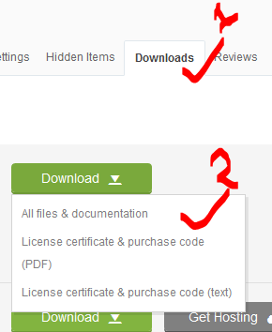

**Step: 2:** Unzip Just downloaded folder -> Go to bin/Debug folder -> Copy **Activationconfig.dll** file  
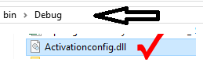

**Step: 3:** Open Your Project (which one purchase from Envato marketplace author: **Dynamicsoft** and you currently using OR edited OR provided to your client OR install).  
  
Or Copy **Activationconfig.dll** file Directly from this folder.

**Step: 4:** Go to bin/Debug folder -> Paste with Replace **Activationconfig.dll** file  
 OR Delete Existing **Activationconfig.dll file** and paste.  
OR  
Go to INSTALLATION DIRECTORY (Software installed location) -> Paste with Replace **Activationconfig.dll** file  
OR Delete Existing **Activationconfig.dll file** and paste.

**Step: 5:** Now Ready & Press F6/Debug -> Run or F5

Thanks,

DynamicSoft