KINETIC AI
Personalized Diet and Workout Planning System

Abstract
Kinetic AI is an automated health and fitness management system designed to provide personalized nutrition and exercise plans. The system uses a scientific approach to health by implementing the Mifflin-St Jeor equation for caloric calculations and the Phi-3 Large Language Model (LLM) for generating dynamic plans. Unlike traditional fitness apps that offer static routines, Kinetic AI adapts to the user's specific age, weight, height, and fitness goals. The project demonstrates how modern AI can be used to solve everyday health challenges, making expert-level fitness advice accessible to everyone..
Keywords: Kinetic AI, Diet Planning, Workout Automation, BMR Calculation, Health Informatics, Python.

1. Introduction
1.1 Background
In today's world, everyone wants to be healthy, but there is too much confusing information online. People have different body types, so a "one size fits all" plan does not work
1.2 Problem Statement
Calculating calories (BMR and BMI) manually is hard for common people. Also, hiring a personal trainer or nutritionist is expensive.
1.3 Objectives
- To build a website where users can enter their physical details.
- To automatically calculate health scores like BMI and daily calorie needs.
- To use AI to suggest Indian meals and daily exercises.
- To allow users to contact the team through an email feature.

2. Literature Review
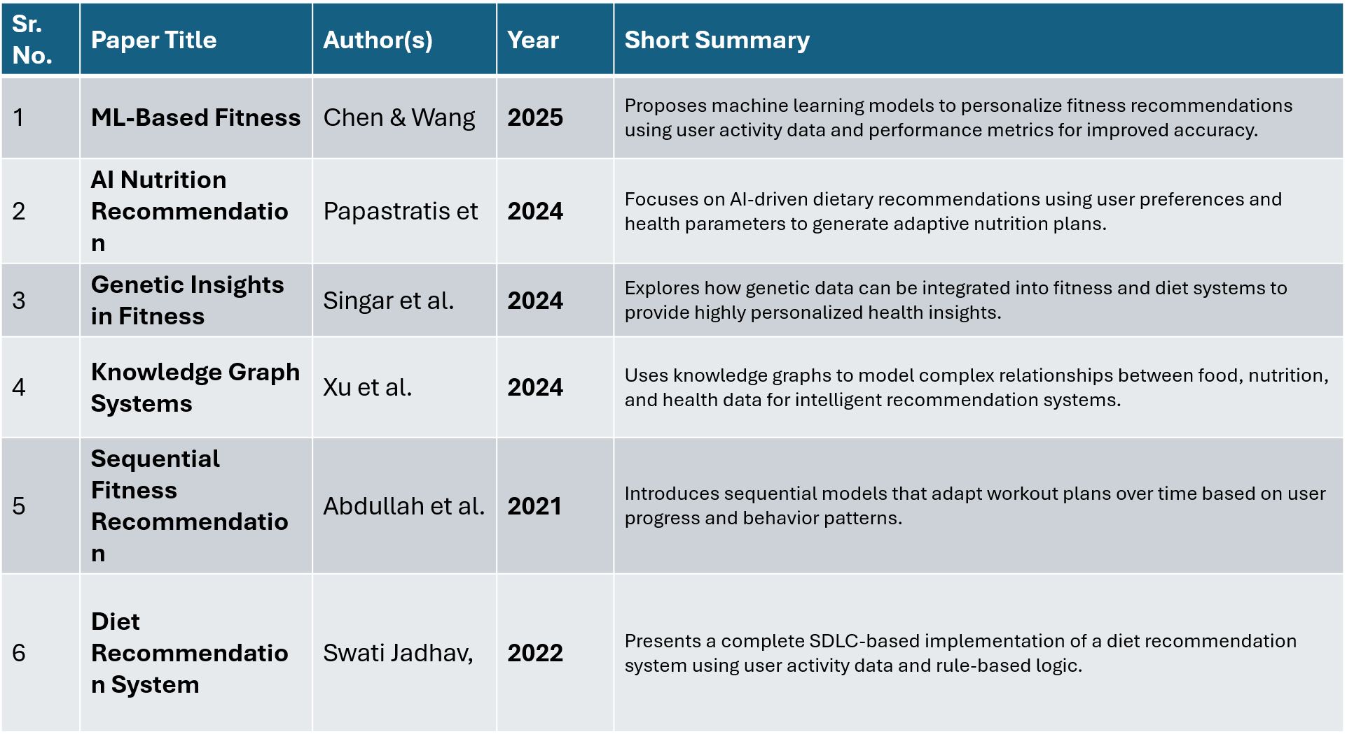
3. Methodology
3.1 System Architecture:
The system operates through a structured four-stage pipeline:
- Input Module: Gathers user data (Name, Weight, Height, Age, Gender, and Goal) via a Flask POST request.
- Logic Engine (calculations.py): Calculates BMI, BMR, and TDEE. It applies a ±500 kcal adjustment based on whether the goal is weight loss or muscle gain.
- AI Generation Module (main.py & model_loader.py): Connects to the Ollama service to prompt the Phi-3 model for a 7-day plan.
- Fallback Mechanism: In case of AI service unavailability, the system provides pre-defined Indian meal plans (e.g., Vegetable Poha, Dal Tadka) to ensure reliability.
3.2 Mathematical Framework:
- BMR (Male): $(10 \times weight) + (6.25 \times height) - (5 \times age) + 5$
- BMR (Female): $(10 \times weight) + (6.25 \times height) - (5 \times age) - 161$
- BMI Calculation: $weight / (height/100)^2$

4. Implementation (Software Used)
We organized the project into three main parts:
- Frontend (Templates & UI): We used HTML and CSS. The file style.css in the ui folder makes the website look professional with colors and good fonts.
- Backend (Src): This is the "brain." main.py runs the server, and calculations.py does the math.
- Database & Communication: We used a lightweight system to handle data and SMTP to send emails through Gmail

5.FILE STRUCTURE…
PROJECT/
├── src/
│ ├── main.py # Main Flask server & Route management
│ ├── model_loader.py # Ollama/Phi-3 connectivity check
│ └── calculations.py # BMR, BMI, and TDEE mathematical logic
├── templates/
│ ├── index.html # Main landing page & User input form
│ └── result.html # AI-generated plan & Metrics display
├── ui/
│ └── style.css # Custom CSS for layout and design
└── requirements.txt # Project dependencies

Image of file structure….
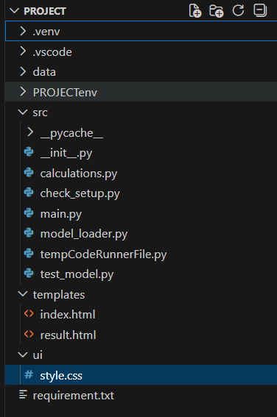

6. Results and Discussion
Kinetic AI successfully automates the role of a fitness consultant. The integration of SMTP_SSL allows users to send inquiries directly to kineticai91@gmail.com. The AI generator produces culturally relevant plans (Indian diet focus), and the calculate_metrics function provides instant feedback on the user's health status (Underweight, Normal, Overweight, or Obese).

7. Future Scope and Enhancements
The current version of Kinetic AI – Personalized Diet and Workout Planner provides a strong foundation for automated fitness guidance. However, several enhancements can be implemented in the future to improve accuracy, usability, and scalability.
7.1 Advanced Health Personalization
Future versions of the system can include disease-specific diet planning for conditions such as diabetes, hypertension, thyroid disorders, and heart disease. By incorporating medical constraints, the platform can offer safer and more precise recommendations.
7.2 Mobile Application Development
The system can be extended into a full-featured Android and iOS mobile application. This would allow users to access diet plans, workout routines, and progress tracking anytime and anywhere, improving user engagement.
7.3 Integration with Wearable Devices
Integration with smartwatches and fitness bands (such as step counters and heart rate monitors) can enable real-time data collection. This data can be used to dynamically adjust calorie requirements and workout intensity.
7.4 Machine Learning-Based Adaptation
Instead of static calculations, machine learning models can be trained on user feedback and historical data to continuously improve diet and workout recommendations based on individual progress and preferences.
7.5 Multi-Language Support
Adding support for multiple Indian languages such as Hindi, Marathi, and Tamil would make the application accessible to a wider audience and improve inclusivity.
7.6 Cloud Deployment and Scalability
The system can be deployed on cloud platforms to support a larger number of users simultaneously. A hybrid approach combining local and cloud-based AI models can also be explored for better scalability.
7.7 Enhanced Security and Authentication
User authentication systems such as login/signup, encrypted data storage, and role-based access control can be added to improve data security and user privacy.

8. Conclusion
The Kinetic AI – Personalized Diet and Workout Planner project successfully demonstrates the practical application of artificial intelligence, mathematical modeling, and web technologies to solve real-world health and fitness problems. The system accurately calculates BMI, BMR, and daily calorie requirements using the Mifflin-St Jeor equation and generates personalized 7-day Indian diet and workout plans.
By integrating a local large language model (Phi-3) through Ollama, the project ensures user data privacy while delivering intelligent and culturally relevant recommendations. The use of Flask as a backend framework enables smooth interaction between user inputs and AI-generated outputs through a responsive web interface. Additionally, the fallback mechanism guarantees system reliability even when AI services are unavailable.
Overall, this project enhanced our understanding of full-stack development, algorithmic thinking, and AI system integration. Kinetic AI serves as a scalable foundation for future health-tech applications and reflects the successful learning outcomes achieved during the ASEP program.

9.References
- Mifflin, M. D., St Jeor, S. T., Hill, L. A., Scott, L. A., Daugherty, S. A., and Koh, Y. O.,
“A New Predictive Equation for Resting Energy Expenditure in Healthy Individuals,”
American Journal of Clinical Nutrition, vol. 51, no. 2, pp. 241–247, 1990.
- World Health Organization (WHO),
“Body Mass Index (BMI) Classification,”
WHO Technical Report Series.
- Microsoft Research,
“Phi-3: Small Language Models for Efficient AI Inference,”
Technical Documentation.
- Ollama,
“Running Large Language Models Locally,”
Official Developer Documentation.
- Pallets Projects,
“Flask Web Framework Documentation,”
Official Flask Documentation.

Project By: Vinay Shivapnor, Shlok Kumar, Shivangi Marmat, Shravani Munde.
Institution: Vishwakarma Institute of Technology
Course: Artificial Intelligence and Data Science
Year: First Year

