# CHAPTER-3

**DESIGN**

## Data Flow Diagram

Data flow diagram (DFD) represents the flows of data between different processes in a business. It is a graphical technique that depicts information flow and the transforms that the applied as data move from input to output. DFDs only involve four symbols. They are:

* + - Process
    - Data Object
    - Data Store
    - External entity

[Table 2: Data Flow Diagram]

|  |  |
| --- | --- |
| **SYMBOLS** | **DESCRIPTION** |
|  | **System**: Describe the functionality regarding the system. |
|  | **Process:** Transform of incoming data flow(s) to outgoing flow(s). |
|  | **Data Flow**: Movement of data in the system. |
|  | **Data Store:** Data repositories for data that are not moving. It may be simple as buffer or a queue or a sophisticated as a relational database. |
|  | **External Entity:** Sources of destinations outside the specified system boundary. |

# Advantages:

* + - DFD is a simple graphical technique which is a very simple to understand and easy to use.
    - DFD can provide detailed description of the system component.
    - It explains the logic behind the flow within a system.
    - Symbols used in DFD model are very less.

# Disadvantages:

* + - Control information is not defined a DFD.
    - Different DFD models have different symbols, e.g. in Game and Sarson notation processes is represented as rectangle while in Demarcho and Yordan notation it is ellipse, so making confusion at the time of referring.

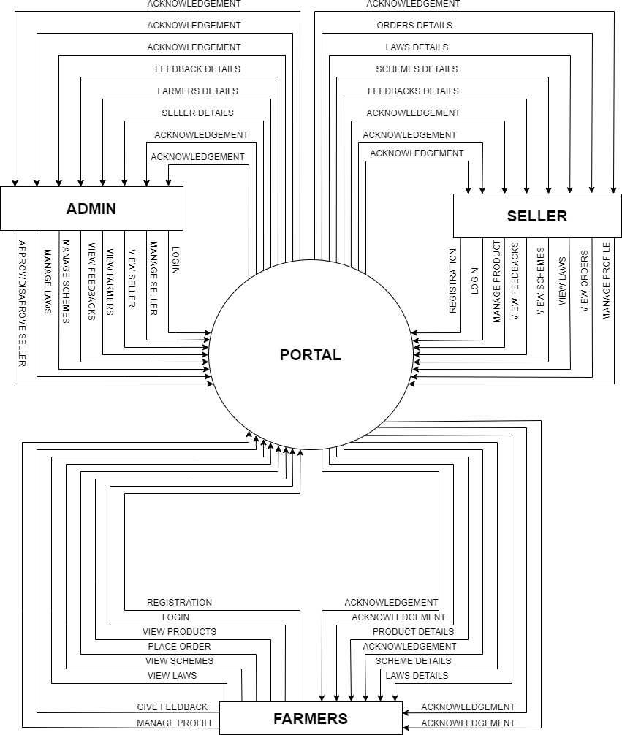

* + - 1. **FIGURE: LEVEL 0: DATA FLOW DIAGRAM**

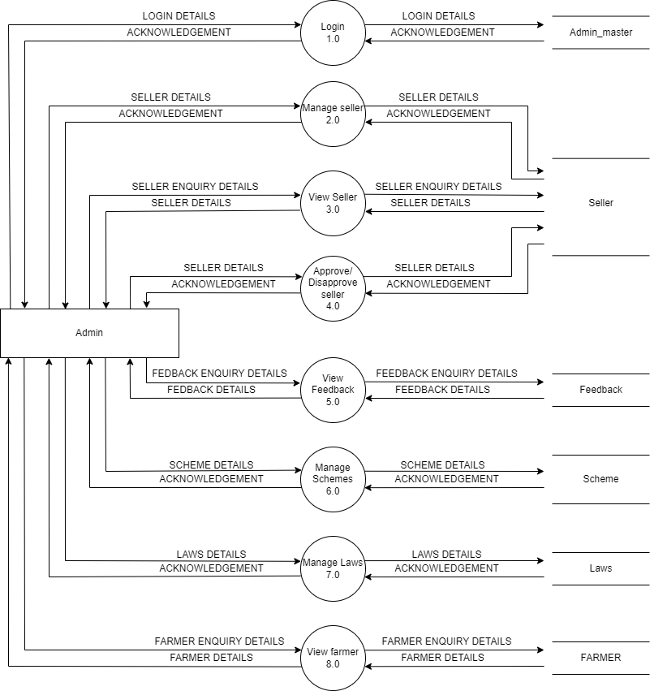

* + - 1. **FIGURE: LEVEL 1: DFD ADMIN**

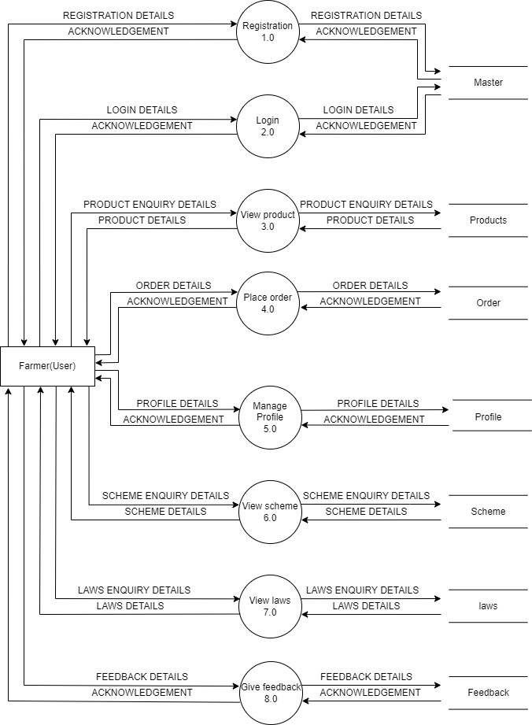

* + - 1. **FIGURE: LEVEL 1: DFD FARMER**

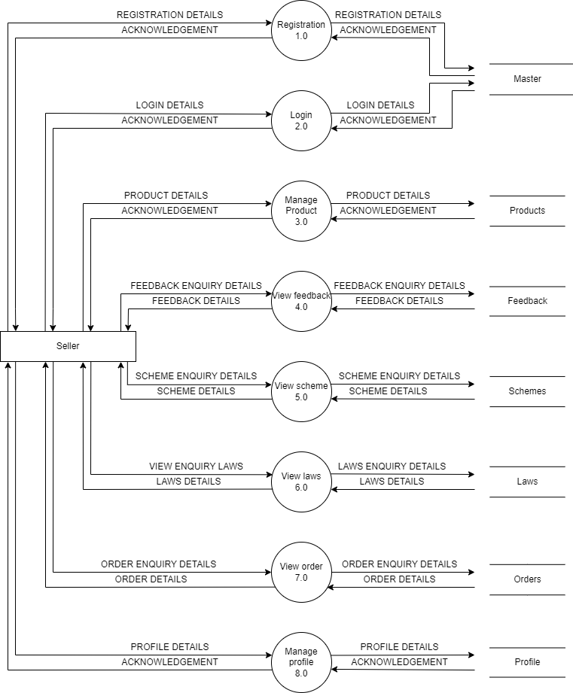

* + - 1. **FIGURE: LEVEL 1: DFD SELLER**

## E-R DIAGRAM

* + - ER diagram gives the concept of object, attributes and relationship between object. ER diagram can be used to model the data in the system and how the data is to be processed. It has three main elements data object(entity), attributes and their relationship.

[Table 3: E-R Diagram Symbols]

|  |  |
| --- | --- |
| SYMBOLS | DESCRIPTION |
|  | **Entity:** Data object is real world entity or thing. |
|  | **Attributes:** An attribute is property of character of an entity. |
|  | **Relationship:** Entity are connected each other via relation. Generally relationships in binary because there are two entities are related to  each other. |
|  | **Cardinality (One to One):** An instance of entity A can relate to one only instance of B and vica  versa |
|  | **Cardinality (One to Many):** An instance of entity A can relate to one only instance of  B but be can only relate one instance of A. |
|  | **Cardinality (Many to Many):** One or more instances of entity A can relate to one or more instances  of entity B and vica versa |
|  | **Cardinality (Many to One):** One or more instances of entity A can relate to only one instances of  entity B. |

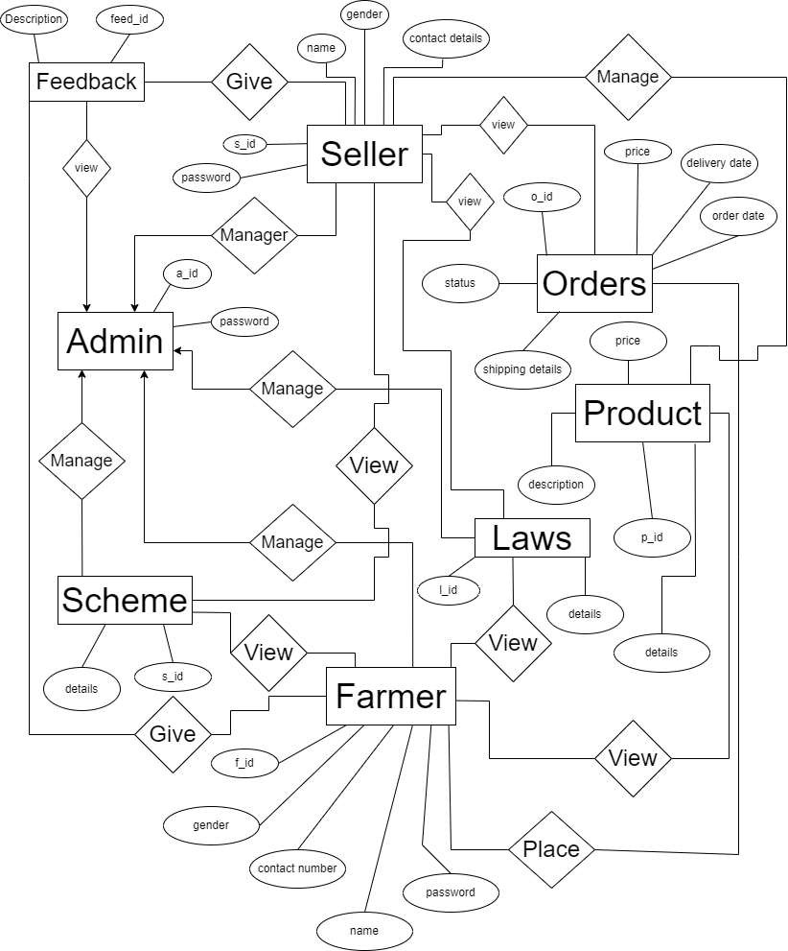

* + - 1. **FIGURE: ER DIAGRAM**