VELLORE INSTITUTE OF TECHNOLOGY
BCSE331L EXPLORATORY DATA ANALYSIS / COURSE PROJECT
Thirty thousand rows,
five hundred and seventy patients
An exploratory analysis of the liver patient records, and why the model that scores 99.7 per cent learned almost nothing about the liver

30,691 | 570 | 0.73
rows in the course file | distinct patients the rows were built from | honest ROC-AUC, against 0.999 on the file

SUBMITTED BY Shlok Kumar Goenka
REGISTER NUMBER 23BDS0316
FACULTY Balaji G N
SCHOOL School of Computer Science and Engineering (SCOPE)
SUBMITTED October 2026

Abstract
The course file holds 30,691 liver function records labelled as patient or non-patient. I worked through it the way the syllabus is ordered: data types and scales first, then cleaning and missing values, then summaries, plots, clustering, dimensionality reduction and, at the end, predictive models with a proper train and test split. The cleaning stage turned up the most important fact in the project. 11,323 rows (36.9%) are exact copies, and the 19,368 that remain were generated from the 583-record Indian Liver Patient Dataset published on the UCI repository. Every lab value in an added row comes from an original patient of the same class, so the values themselves give the label away.
That explains the headline numbers. On a random 80/20 split of the file, random forest and XGBoost reach 99.7% test accuracy and an AUC of 0.999, and a lookup rule with no learning in it reaches an AUC of 0.94. Trained and tested on the 570 unique real patients, the same forest has a specificity of 12%. The best honest models are an RBF support vector machine (cross-validated AUC 0.733) and logistic regression (0.727), which a McNemar test cannot separate (p = 1.00). I recommend logistic regression because it is as accurate and far easier to explain. The exploratory work also shows that bilirubin, the transaminases and alkaline phosphatase carry most of the signal, that albumin carries some in the opposite direction, and that the augmentation erased a real gender and age effect present in the original patients.
KEYWORDS exploratory data analysis, liver function tests, missing data, EM algorithm, clustering, PCA, data leakage, synthetic data, model evaluation

Contents
Abstract 1
How the report follows the syllabus 4
1 The data and the questions 5
Variables, data types and measurement scales 5
Exploratory, classical and Bayesian analysis 5
Tools 6
2 Cleaning, missing values and binning 7
Deduplication 7
Where the extra rows came from 7
Replacing values and consistency checks 8
Missing data 8
Log transformation 10
Discretisation and binning 10
3 One variable, two variables, many 11
Univariate analysis 11
Bivariate analysis against the target 12
Correlation between the measurements 12
Multivariate view 13
A note on time series 14
4 Summaries, tables and charts 15
Statistical summary measures 15
Two-way contingency tables 15
n-dimensional view 15
Dot chart and bar plot 16
5 Looking for groups without the label 18
Model-based clustering with EM 18
Hierarchical, spectral and minimum spanning tree clustering 18
Outlier detection using clustering 20
6 Fewer dimensions 22
Principal component analysis and SVD 22
Factor analysis 23
Intrinsic dimensionality 23
Non-linear methods: MDS, Isomap and t-SNE 24
Self-organising map 24
7 Models and how to judge them 26
A linear regression model 26
Classification set-up 26
Protocol A: the standard split 27
Protocol B: grouped by source patient 28
Protocol C: real patients 29
Which model outperformed, and why 31
Supervised against reinforcement learning 32
8 Contemporary issues 33
Synthetic data and leakage 33
Fairness 33
Reproducibility 33
9 Conclusions 34
References 35
A Appendix: running the project 36

How the report follows the syllabus
Each chapter corresponds to one module of BCSE331L. The table lists the module topics and where each one is applied to this dataset. Two topics have no natural home in a single-snapshot tabular dataset (time series and document clustering); the chapters say so plainly instead of forcing an example.
Table 1 Syllabus coverage map.
Module | Syllabus topics | Where in this report
1 Introduction to EDA | Steps in EDA, numerical and categorical data, measurement scales, EDA against classical and Bayesian analysis, tools | Chapter 1, Tables 2 to 3
2 Data transformation | Deduplication, replacing values, discretisation and binning, missing data, traditional methods, maximum likelihood (EM) | Chapter 2, Figures 1 to 6
3 Correlation analysis | Univariate, bivariate and multivariate analysis; time series | Chapter 3, Figures 7 to 11
4 Summarisation and visualisation | Summary measures, 1-D, 2-D and n-D analysis, contingency tables, scatter plots, dot charts, bar plots | Chapter 4, Figures 12 to 14
5 Clustering | Spectral, minimum spanning tree, model-based (EM), hierarchical agglomerative, outlier detection by clustering | Chapter 5, Figures 15 to 18
6 Dimensionality reduction | PCA, SVD, factor analysis, intrinsic dimensionality, MDS, manifold learning, self-organising maps | Chapter 6, Figures 19 to 23
7 Model development and evaluation | Linear regression and its evaluation, accuracy and what it hides, supervised against reinforcement learning | Chapter 7, Figures 24 to 31
8 Contemporary issues | Synthetic data and leakage, fairness, reproducibility | Chapter 8

MODULE 1 / INTRODUCTION TO EDA

1 The data and the questions
Liver disease in India is often found late, because the early stages have few symptoms and the routine blood panel that could flag it is read one number at a time. The dataset for this project is that panel: age, gender, two bilirubin measures, three enzymes, total protein, albumin and the albumin to globulin ratio, with a label saying whether the person was a liver patient. The file was downloaded from the course repository (salemprakash/EDA, Data/Liver Data.csv) on 14 October 2026.
I set three questions at the start and kept them fixed:
1. Is the file clean enough to trust, and what has to be done to it before any statistic means anything?
2. Which measurements separate patients from non-patients, and do the patients fall into natural groups?
3. How well can a model predict the label on people it has not seen, and which model should be used?
EDA, as Tukey framed it and as the course textbook (Mukhiya and Ahmed, 2020) teaches it, runs in a loop: define the problem, prepare the data, summarise it, visualise it, model it, and go back when something looks wrong. This report went round that loop more than once. The first pass of modelling produced 99.7 per cent accuracy, which sent me back to the data preparation stage, and what I found there rewrote Chapter 7.

Variables, data types and measurement scales
Table 2 Variables in the file. The engineered bands in Chapter 2 (age band, bilirubin band) are ordinal.
Variable | Data type | Scale | Unit | Note
Age | Numerical, discrete | Ratio | years | Ages above 89 were capped at 90 in the source
Gender | Categorical | Nominal |  | Male, Female, 902 blank
Total bilirubin | Numerical, continuous | Ratio | mg/dL | Breakdown product of haemoglobin
Direct bilirubin | Numerical, continuous | Ratio | mg/dL | Conjugated part of total bilirubin
Alkaline phosphatase (ALP) | Numerical, continuous | Ratio | IU/L | Rises with bile duct obstruction
ALT (SGPT) | Numerical, continuous | Ratio | IU/L | Enzyme released by damaged liver cells
AST (SGOT) | Numerical, continuous | Ratio | IU/L | Also released by heart and muscle
Total protein | Numerical, continuous | Ratio | g/dL | Albumin plus globulins
Albumin | Numerical, continuous | Ratio | g/dL | Made by the liver; falls in chronic disease
A/G ratio | Numerical, continuous | Ratio | ratio | Albumin divided by globulin
Result (target) | Categorical, binary | Nominal |  | 1 = liver patient, 2 = not, recoded to 1 and 0

All nine lab measurements sit on a ratio scale, with a true zero, so ratios such as "twice the normal ALT" are meaningful and log transforms are allowed. Gender and the target are nominal. When I cut age and bilirubin into bands in Chapter 2 they become ordinal: the order of the bands matters but the gaps between them do not. Nothing in this dataset is on a pure interval scale; temperature in Celsius would be the classroom example.

Exploratory, classical and Bayesian analysis
The three approaches differ in the order of the steps, which is the clearest way to see them side by side.
Table 3 Three ways to analyse the same data.
 | Classical (confirmatory) | Exploratory | Bayesian
Sequence | Problem, data, model, analysis, conclusions | Problem, data, analysis, model, conclusions | Problem, data, model, prior, analysis, conclusions
Model | Chosen before seeing the data | Suggested by the data | Chosen beforehand, plus a prior
Main output | p-values, confidence intervals | Plots, summaries, hypotheses | Posterior distributions
In this project | Mann-Whitney, chi-square and McNemar tests | Most of Chapters 2 to 6 | Gaussian naive Bayes in Chapter 7

Tools
Everything runs in Python 3.14.3 with pandas 2.3.3, NumPy 2.4.2, SciPy, scikit-learn 1.8.0, statsmodels 0.15.0, XGBoost 3.4.1 and matplotlib. Two methods are written from scratch because no maintained library matched the syllabus version: the EM algorithm for a multivariate normal with missing values, and the self-organising map. The whole analysis is one script (src/analysis.py) that runs in about 3 minutes with a fixed seed of 42.

MODULE 2 / DATA TRANSFORMATION

2 Cleaning, missing values and binning

Deduplication
The raw file has 30,691 rows and 11 columns. 11,323 rows are exact copies of another row, every column identical, which is 36.9% of the file. Removing them leaves 19,368 rows. The class balance barely moves (71.4 per cent patients before, 71.3% after), so the copies were spread evenly. Duplicates are not harmless here. With a random split, a copy of a test row will often sit in the training set, and the model is then graded on a question it has already seen the answer to.
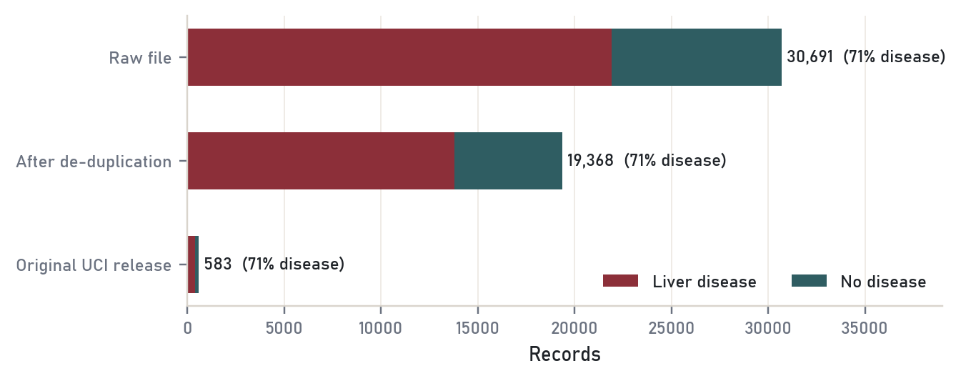
Figure 1 Records before and after removing exact duplicates, next to the original UCI release. The class mix is almost identical in all three.

Where the extra rows came from
Even after deduplication the file is 33 times larger than any liver dataset I could find with these columns. The first rows matched the Indian Liver Patient Dataset (Ramana, Babu and Venkateswarlu, 2012), which has 583 records, so I downloaded that release and compared. 558 of the original rows appear verbatim in the course file. The other 18,810 are new combinations, and they follow a strict pattern: every bilirubin, enzyme and protein value in an added row also appears in an original patient of the same class (100% for every lab column). Far fewer appear in the other class; for alkaline phosphatase only 52% do (Figure 2).
That is what you get if each column of a synthetic row is copied from a random patient of the chosen class. SMOTE, the usual oversampling method, would interpolate and produce values that never occurred, so this is a different, simpler generator. It has two side effects that drive the rest of the report. The label leaks through the values, because a value seen only among non-patients can never appear in a patient row. And any relationship between columns that the generator ignored is diluted towards zero.
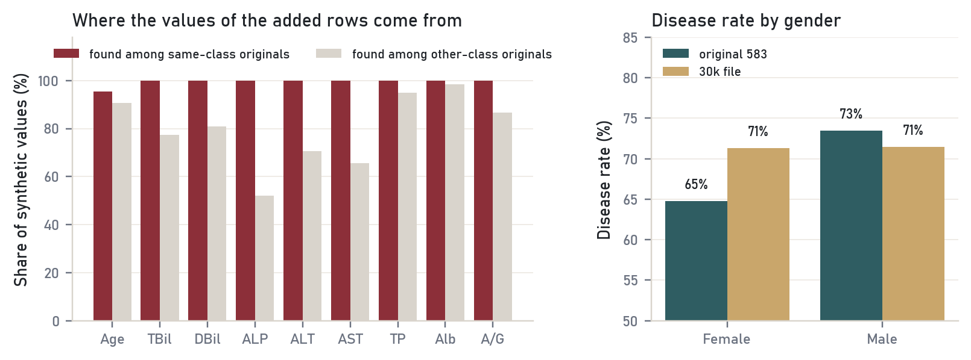
Figure 2 Left: share of values in the added rows that also occur among original patients of the same class (red) and of the other class (grey). Right: the original data has a gender gap in disease rate; the 30k file does not.
FINDING In the original 583 patients, men have a disease rate of 73.5% and women 64.8%, and age correlates with the label (r = 0.14, Mann-Whitney p = 0.002). In the course file both effects are gone: 71.4% against 71.3%, and r = 0.003. Any EDA conclusion about age or gender drawn from the 30k file alone would be wrong.

Replacing values and consistency checks
The target was coded 1 for a patient and 2 for a non-patient. I recoded it to 1 and 0 so that means and model probabilities read as disease rates. Column names had stray leading spaces (" Alkphos Alkaline Phosphotase") and a misspelling ("Protiens"), so every column got a short name. Two clinical rules make useful sanity checks. Direct bilirubin is part of total bilirubin, so it cannot be larger: 92 rows break this rule, probably rounding in the source. The A/G ratio should equal albumin divided by (total protein minus albumin), and it does within 0.1 for 97.6% of the 18,376 rows where all three are present. I kept the rows that break these rules because the error is small and the rules are only approximate at one decimal place.

Missing data
After deduplication 4,609 cells are blank, spread over 2,979 rows (15.4%). No column is missing more than 4.1% and no row is missing more than 6 of its ten values. Gender is the most often missing (796 rows), age the least (2 rows).
Table 4 Missing values per column, and whether rows with a gap have a different disease rate.
Variable | Missing | Share | Disease rate, missing | Disease rate, observed | Chi-square p
Gender | 796 | 4.11% | 69.0% | 71.4% | 0.147
Alkaline phosphatase | 694 | 3.58% | 70.6% | 71.3% | 0.708
Total bilirubin | 557 | 2.88% | 67.7% | 71.4% | 0.061
Direct bilirubin | 490 | 2.53% | 67.3% | 71.4% | 0.056
ALT (SGPT) | 459 | 2.37% | 66.0% | 71.4% | 0.013
A/G ratio | 436 | 2.25% | 67.2% | 71.4% | 0.062
Albumin | 413 | 2.13% | 71.9% | 71.3% | 0.826
AST (SGOT) | 393 | 2.03% | 70.7% | 71.3% | 0.844
Total protein | 370 | 1.91% | 72.2% | 71.3% | 0.758
Age | 1 | 0.01% | 100.0% | 71.3% | 1.000

Rubin (1976) separates three mechanisms. Missing completely at random (MCAR) means the gap has nothing to do with any value; missing at random (MAR) means it depends on other observed columns; missing not at random (MNAR) means it depends on the hidden value itself. The last two columns of Table 4 test one consequence of MCAR: if gaps were pure chance, rows with a gap would have the same disease rate as rows without. For most columns they do. Rows missing ALT are 5 points less likely to be patients (chi-square p = 0.013), and the two bilirubins and the A/G ratio show gaps of about 4 points with p between 0.05 and 0.07. That is evidence against MCAR for at least one column, so simply deleting incomplete rows would tilt the class mix slightly. An imputation that uses the other columns is the safer choice.
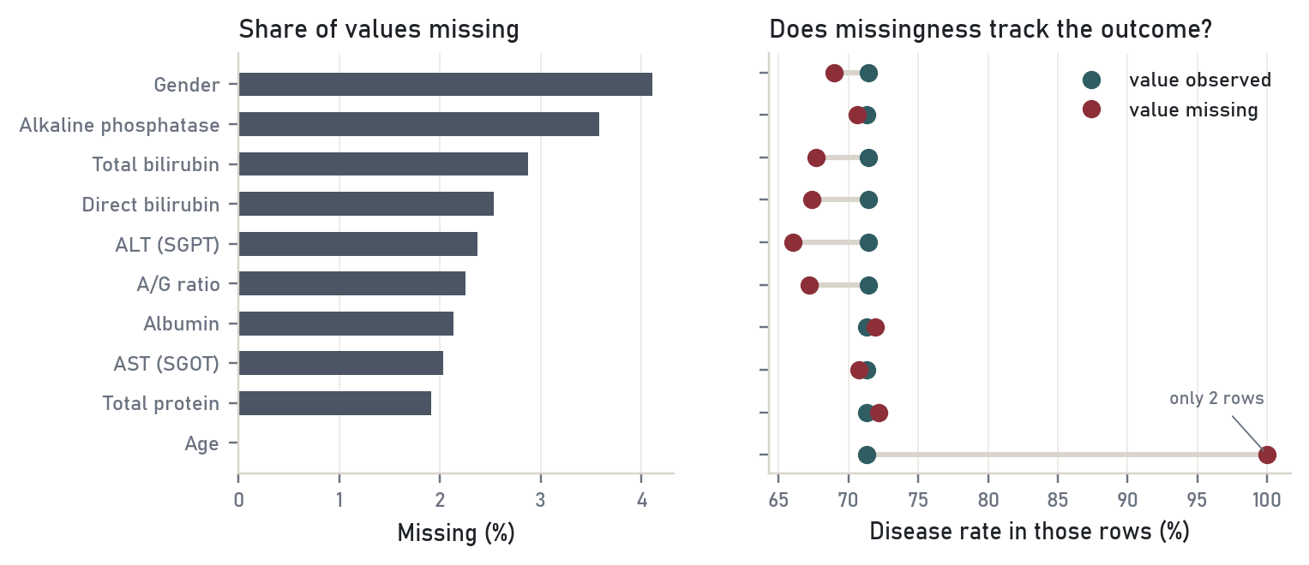
Figure 3 Left: share of each column that is blank. Right: disease rate among rows where the value is present (teal) and absent (red). Age has only two blank rows, so its 100 per cent means nothing.

Comparing imputation methods
To compare methods fairly I took the 16,389 complete rows, hid 14,997 values at random (10 per cent), filled them with each method and measured the error against the truth. Enzymes and bilirubin were logged and every column standardised first, so the error is in standard deviations. Mean and median imputation are the traditional methods in the syllabus. The maximum likelihood method is the EM algorithm of Dempster, Laird and Rubin (1977) for a multivariate normal: the E step fills each gap with its conditional expectation given the observed values in that row, the M step re-estimates the mean vector and covariance matrix, including the extra variance from the filled cells, and the two repeat until the estimates stop changing.
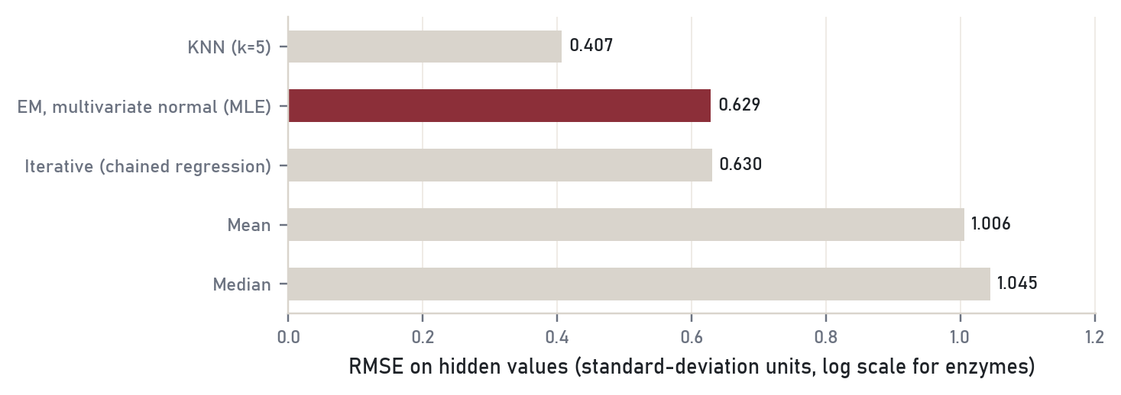
Figure 4 Error on deliberately hidden values. Lower is better; one unit is one standard deviation of the column.
Mean (1.01) and median (1.04) are no better than guessing the average, which is what they are. EM roughly halves the error (0.63) because it uses the strong correlations between the bilirubins and between the enzymes; chained regression lands in the same place (0.63). KNN does best (0.41), and after the provenance finding the reason is plain: a row's nearest neighbours are often siblings built from the same original patients, so KNN is partly copying the answer. I used EM for the descriptive work because its assumptions are explicit and it converged in 5 iterations, and filled gender with the mode (Male). Inside the models in Chapter 7 the imputer is fitted on the training rows only.

Log transformation
The five enzyme and bilirubin columns are heavily right-skewed. AST has a skewness of 10.33; its median is 42 IU/L and its maximum is 4,929. A log(1 + x) transform brings all five to 1.7 or less (Figure 5). The protein columns and age are close to symmetric and were left alone. All correlations, clustering and dimensionality reduction from here on use the logged values.
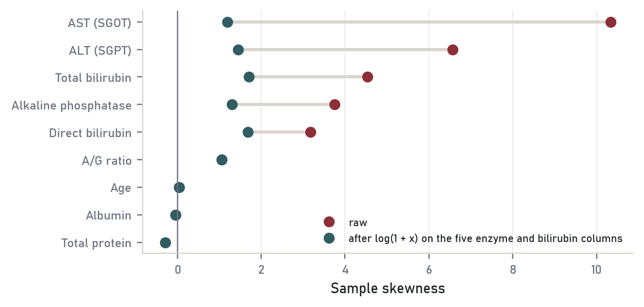
Figure 5 Skewness of each column before (red) and after (teal) the log transform.

Discretisation and binning
Binning trades detail for readability. I made three kinds of bins. Age was cut at clinical boundaries (under 18, 18 to 39, 40 to 59, 60 and over). Total bilirubin was cut at 1.2 mg/dL, the usual upper reference limit, and at 3 mg/dL, roughly where jaundice becomes visible. Albumin was cut both into four equal-width bins and into four equal-frequency bins (quartiles) to show the difference.
The bilirubin bands separate the classes cleanly: the disease rate climbs from 60% to 77% to 96%. Age bands do nothing, which matches the provenance finding. Equal-width bins on albumin put only 978 rows in the sparsest bin and 8,827 in the fullest, while the quartiles hold between 4,431 and 5,278, so quartiles give the steadier rates when a variable is bunched in the middle.
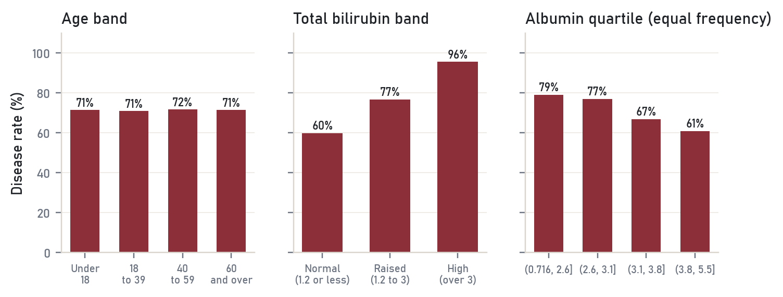
Figure 6 Disease rate by age band, bilirubin band and albumin quartile.

MODULE 3 / CORRELATION ANALYSIS

3 One variable, two variables, many

Univariate analysis
Figure 7 draws each measurement separately for patients and non-patients, with the enzymes and bilirubins on a log axis. Three things stand out. The patient curves for bilirubin, ALP, ALT and AST have long right tails that the non-patient curves lack. The non-patient curves are narrow, which suggests most of them sit inside reference ranges. And age, total protein and albumin overlap almost completely.
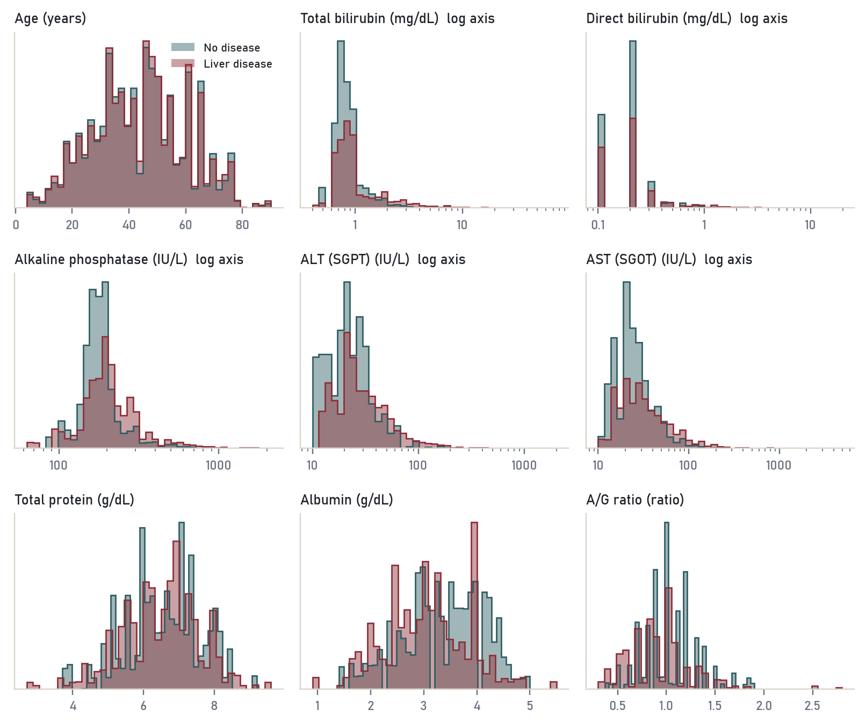
Figure 7 Distribution of each variable by class. Red: liver patients. Teal: non-patients. Five panels use a log axis.
The 1.5 IQR rule flags 2,745 total bilirubin values as outliers on the raw scale but only 1,690 on the log scale; for AST the drop is from 2,220 to 719. On a skewed variable the rule mostly flags the tail of the distribution, not errors. A bilirubin of 75 mg/dL is extreme but clinically possible in obstructive jaundice, so I treated these as real and did not delete them. Chapter 5 revisits outliers with clustering.

Bivariate analysis against the target
Table 5 Each variable compared between the classes. AUC is the chance that a random patient has a higher value than a random non-patient.
Variable | Median, patients | Median, others | Mann-Whitney p | AUC | Rank-biserial r
Total bilirubin | 1.4 | 0.8 | < 0.001 | 0.702 | +0.404
AST (SGOT) | 54 | 29 | < 0.001 | 0.702 | +0.403
Direct bilirubin | 0.5 | 0.2 | < 0.001 | 0.696 | +0.391
ALT (SGPT) | 41 | 27 | < 0.001 | 0.687 | +0.374
Alkaline phosphatase | 228 | 186 | < 0.001 | 0.671 | +0.342
A/G ratio | 0.9 | 1 | < 0.001 | 0.378 | -0.244
Albumin | 3 | 3.4 | < 0.001 | 0.389 | -0.221
Total protein | 6.6 | 6.6 | < 0.001 | 0.477 | -0.045
Age | 45 | 44 | 0.64 | 0.502 | +0.004

Because the distributions are skewed I used the Mann-Whitney U test rather than a t-test. With 19,000 rows almost anything is "significant", so the effect size matters more than the p-value. Total bilirubin and AST lead (rank-biserial r about 0.40), followed by direct bilirubin, ALT and ALP. Albumin and the A/G ratio run the other way: patients have less albumin (median 3 against 3.4 g/dL), which fits a liver that is making less protein. Total protein is statistically significant and practically useless (r = -0.045). Age has no effect at all in this file.
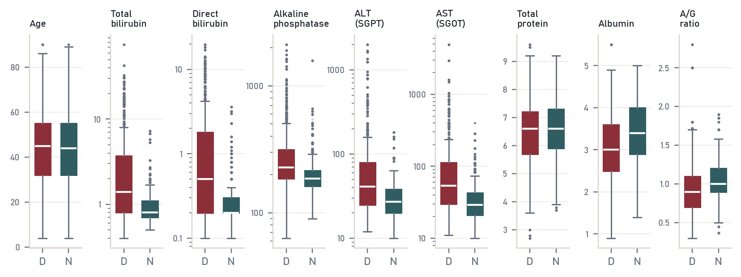
Figure 8 Box plots by class. D: liver patient. N: non-patient. Enzyme and bilirubin panels use a log axis.

Correlation between the measurements
Pearson correlation assumes a straight-line relationship and is pulled around by extreme values, so I computed it on the logged values and set Spearman's rank correlation beside it (Figure 9). They agree closely. Total and direct bilirubin are almost the same measurement (r = 0.98 on the log scale), ALT and AST move together (r = 0.83), and albumin, total protein and A/G ratio form a third block. Across blocks the correlations are weak. On the raw scale the same two pairs give 0.90 and 0.78: a few extreme readings pull the raw coefficients down, which is one more reason to log these columns first.
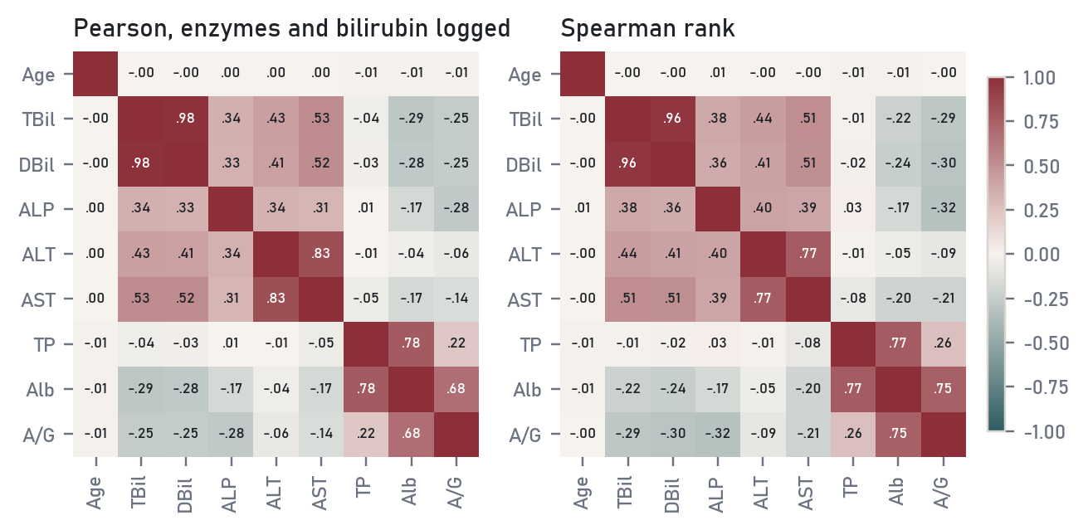
Figure 9 Correlation matrices. Left: Pearson on logged enzymes and bilirubins. Right: Spearman rank correlation on raw values.
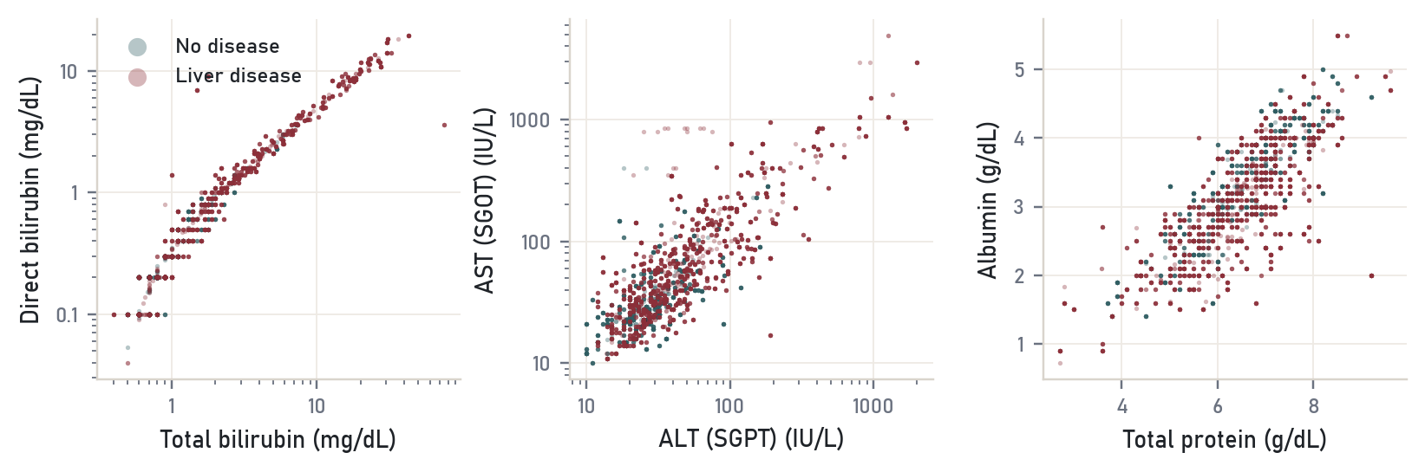
Figure 10 Scatter plots of the three strongest pairs, 4,000 rows sampled. Patients stretch far along both bilirubin axes; non-patients stay in the lower-left corner.

Multivariate view
A pair plot (Figure 11) shows every two-way combination of four variables at once. The useful reading is the bottom-left of each panel: non-patients cluster where bilirubin and AST are low and albumin is normal, and patients spread out from there in every direction. No single pair splits the classes. That already hints that a linear model will find a modest boundary, and that the classes overlap heavily in the middle.
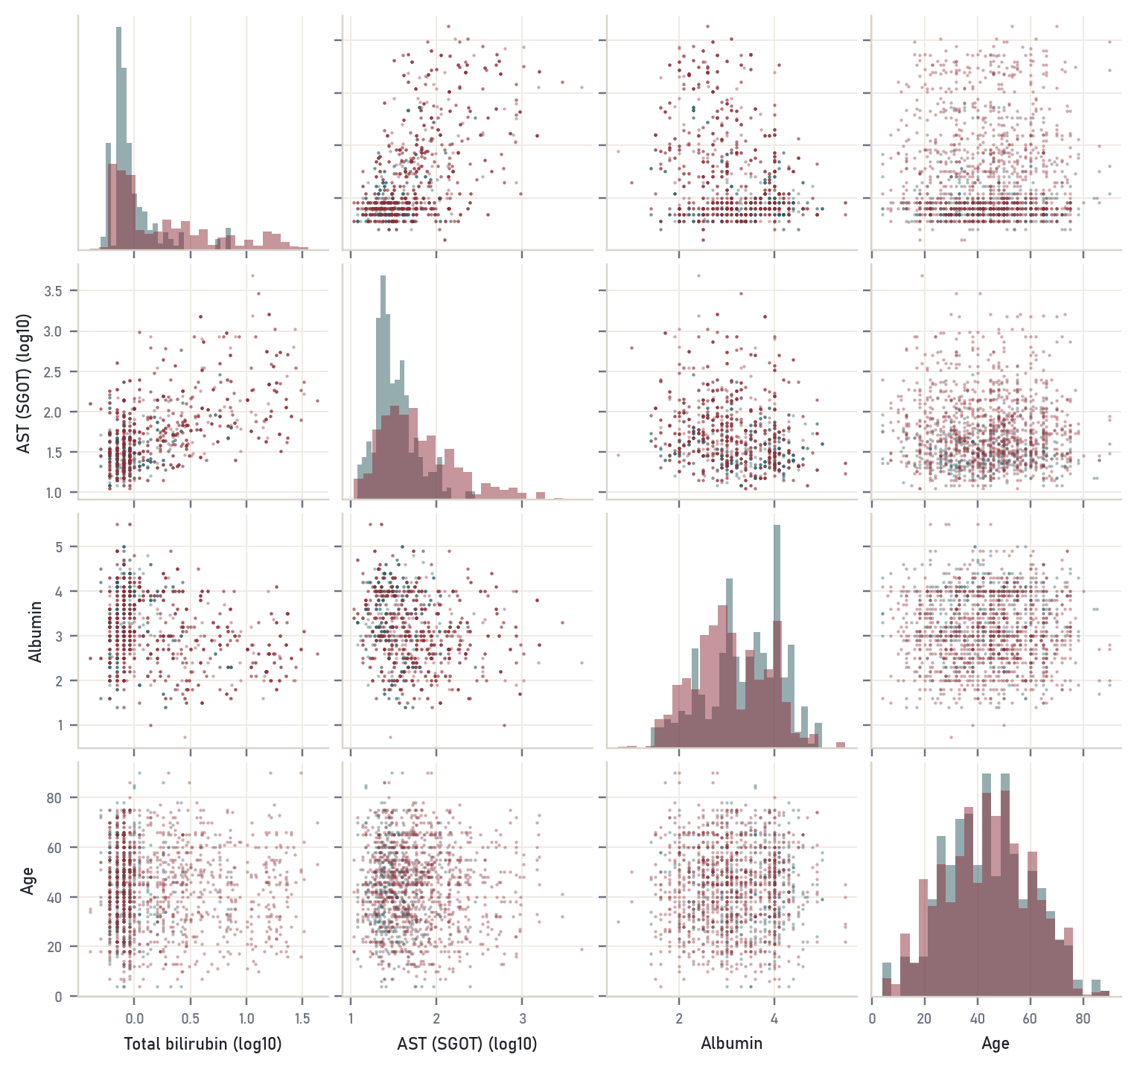
Figure 11 Pair plot of total bilirubin, AST, albumin and age (1,500 rows sampled).

A note on time series
Module 3 also covers time series: time-based indexing, resampling and grouping by period. This dataset has no time column. Each row is one patient at one visit, with no date of collection and no repeated measurements, so there is nothing to index by time or resample. Sorting by age would not create a time series, because the rows are different people. A natural extension would be a cohort with repeated liver panels per patient, where resampling to monthly means and plotting ALT trajectories would apply directly.

MODULE 4 / DATA SUMMARISATION AND VISUALISATION

4 Summaries, tables and charts

Statistical summary measures
Table 6 Summary of the observed values after deduplication (no imputation).
Variable | n | Mean | SD | Median | IQR | Range | CV | Skew | Kurtosis
Age | 19,367 | 43.81 | 16.45 | 45 | 32 to 55 | 4 to 90 | 0.38 | 0.04 | -0.5
Total bilirubin | 18,811 | 3.32 | 6.11 | 1 | 0.8 to 2.6 | 0.4 to 75 | 1.84 | 4.54 | 31.6
Direct bilirubin | 18,878 | 1.52 | 2.86 | 0.3 | 0.2 to 1.3 | 0.1 to 19.7 | 1.89 | 3.18 | 11.0
ALP | 18,674 | 289.41 | 239.73 | 208 | 175 to 298 | 63 to 2110 | 0.83 | 3.75 | 17.7
ALT (SGPT) | 18,909 | 80.60 | 181.13 | 35 | 23 to 61 | 10 to 2000 | 2.25 | 6.57 | 50.8
AST (SGOT) | 18,975 | 110.79 | 278.93 | 42 | 25 to 88 | 10 to 4929 | 2.52 | 10.33 | 149.7
Total protein | 18,998 | 6.49 | 1.09 | 6.6 | 5.8 to 7.2 | 2.7 to 9.6 | 0.17 | -0.29 | 0.2
Albumin | 18,955 | 3.14 | 0.79 | 3.1 | 2.6 to 3.8 | 0.9 to 5.5 | 0.25 | -0.05 | -0.4
A/G ratio | 18,932 | 0.95 | 0.32 | 0.93 | 0.7 to 1.1 | 0.3 to 2.8 | 0.34 | 1.05 | 3.5

Mean and median tell different stories for the skewed columns. Mean AST is 111 IU/L while the median is 42; a few hundred very high readings drag the mean up. The coefficient of variation (SD over mean) puts the spread on a common footing: 1.8 or more for the bilirubins, ALT and AST, 0.83 for ALP, and 0.38 or less for age and the protein columns. For reporting these columns the median and IQR are the honest pair.

Two-way contingency tables
Table 7 Contingency tables of gender and bilirubin band against the target.
Group | Non-patients | Patients | Disease rate
Female | 1,593 | 3,960 | 71.3%
Male | 3,964 | 9,851 | 71.3%
Bilirubin normal (1.2 or less) | 4,324 | 6,423 | 59.8%
Bilirubin raised (1.2 to 3) | 1,050 | 3,457 | 76.7%
Bilirubin high (over 3) | 183 | 3,931 | 95.5%

For gender the chi-square test finds nothing (p = 1.00, Cramér's V = 0.000), and the result holds when the mode-imputed rows are dropped (p = 0.86). The bilirubin band is strongly associated (chi-square = 1,946 on 2 degrees of freedom, V = 0.32). Cramér's V is the more useful number here, since with 19,000 rows any chi-square test has enough power to reject.

n-dimensional view
Crossing three factors at once (age band, gender and bilirubin band) gives 24 cells, each with its own disease rate. Figure 12 shows the result as a heat map. Reading across a row, the rate climbs with bilirubin in every age and gender group, from about 60 per cent to about 96 per cent. Reading down a column, almost nothing changes. The heat map makes the main structure of the file obvious in one glance: bilirubin matters, and age and gender do not, at least in the augmented data.
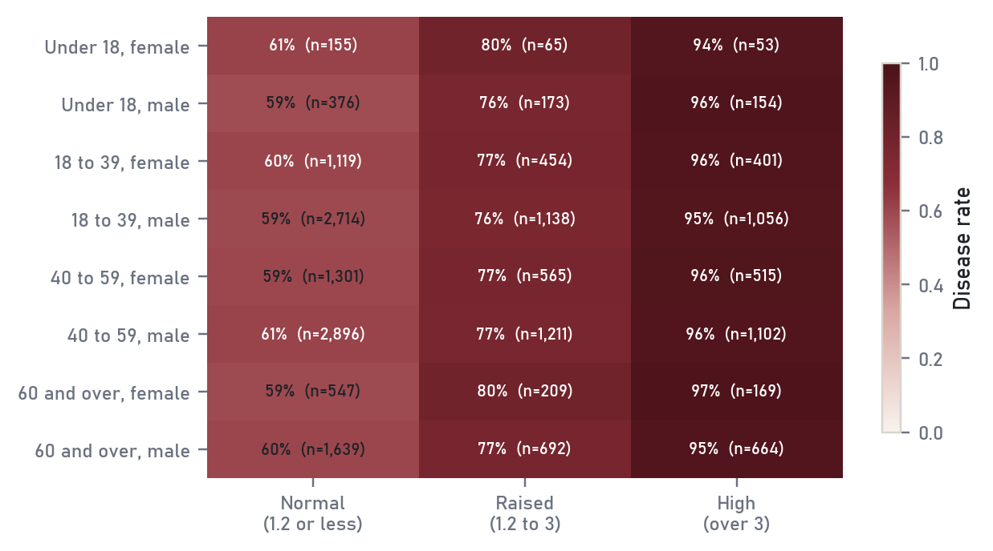
Figure 12 Disease rate in each age, gender and bilirubin cell, with cell counts.

Dot chart and bar plot
A dot chart (Cleveland's design) carries the same information as a bar chart with less ink, and it suits values that can be negative. Figure 13 ranks the nine variables by rank-biserial correlation with the target. The bar plot in Figure 14 shows disease rate by age band and gender with 95 per cent Wilson intervals. The intervals for the under-18 groups are wide because there are only a few hundred children.
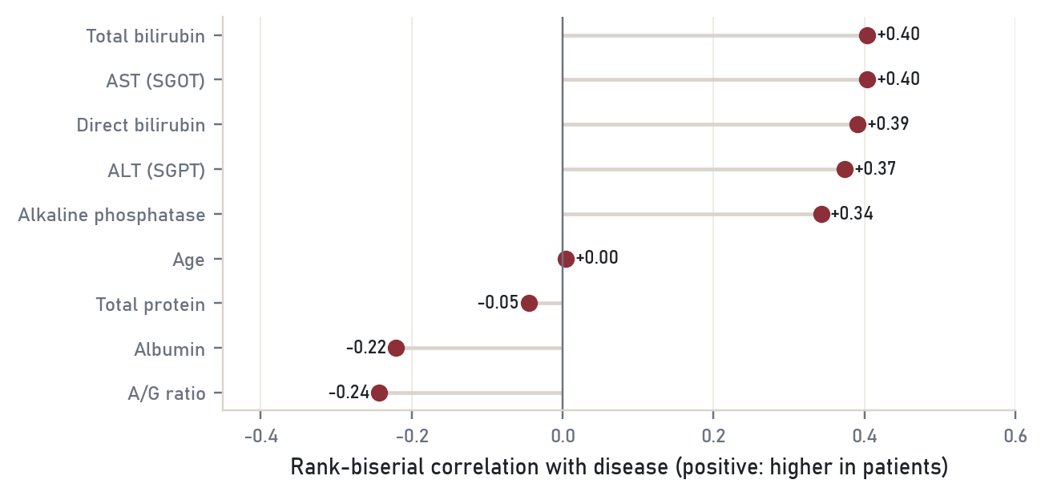
Figure 13 Dot chart of effect sizes. Positive values are higher in patients.
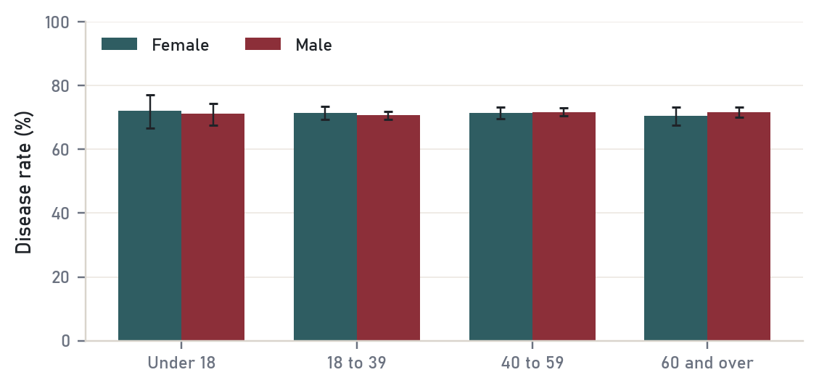
Figure 14 Disease rate by age band and gender with 95 per cent Wilson intervals.

MODULE 5 / CLUSTERING

5 Looking for groups without the label
Clustering ignores the label and asks whether the records fall into groups on their own. All methods here work on the nine logged and standardised lab values. Spectral, hierarchical and minimum spanning tree clustering need a full distance matrix, so they ran on a random sample of 2,000 rows; K-means and the Gaussian mixture ran on everything. Document clustering, also in Module 5, needs text, and this dataset has none.

Model-based clustering with EM
A Gaussian mixture model treats the data as a blend of several multivariate normal groups and fits them with the Expectation-Maximisation algorithm: the E step works out how likely each row is to belong to each group, the M step re-estimates each group's mean and covariance from those weights. The Bayesian information criterion (BIC) trades fit against the number of parameters. It kept falling up to 10 components, the largest I tried (Figure 15). With 19,000 rows BIC can afford many components, and part of what it is fitting is the lumpy structure the generator created. The large drops end after three or four components, so I used 4 groups for every method to keep them comparable.
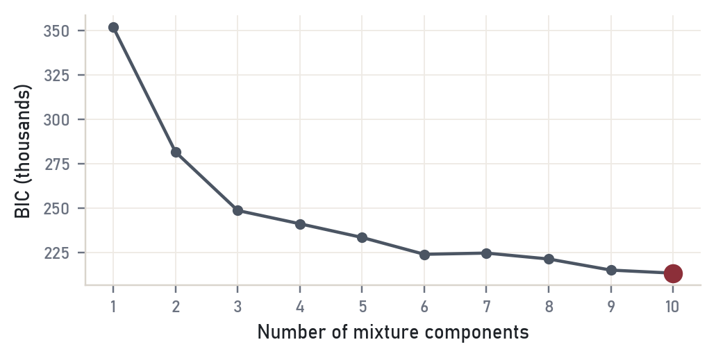
Figure 15 BIC against the number of mixture components. Lower is better.
Table 8 The four Gaussian mixture clusters, numbered from highest to lowest disease rate (medians of each variable).
Group | Rows | Disease rate | TBil | ALT | AST | ALP | Albumin
Group 1 | 5,770 | 90.7% | 3.5 | 91 | 127 | 300 | 3
Group 2 | 988 | 84.5% | 5 | 54 | 125 | 214 | 2.6
Group 3 | 3,892 | 74.1% | 1.8 | 31 | 40 | 206 | 3
Group 4 | 8,718 | 55.7% | 0.8 | 26 | 28 | 189 | 3.4

The clusters read like clinical stages. The largest group (8,718 rows) has normal bilirubin and enzymes and the lowest disease rate. The highest-risk group has every enzyme raised and bilirubin around 3.5 mg/dL, and nine in ten of its members are patients. A smaller group of about 1,000 rows has the highest bilirubin of all (median 5.0 mg/dL) and the lowest albumin (2.6 g/dL) but only mildly raised ALT, a pattern that fits chronic rather than acute damage.

Hierarchical, spectral and minimum spanning tree clustering
Hierarchical agglomerative clustering starts with every row alone and merges the closest pair repeatedly. With Ward's criterion each merge is the one that adds least to the within-group variance, which is the hierarchical version of a spherical Gaussian mixture (Fraley, 1998). The dendrogram in Figure 16 shows the last 30 merges, with a dashed line at the four-cluster cut. Spectral clustering builds a 15-nearest-neighbour graph, takes the leading eigenvectors of its Laplacian and clusters in that space, which lets it follow curved groups. Minimum spanning tree (MST) clustering connects all points with the shortest possible tree and cuts the longest edges (Zahn, 1971).
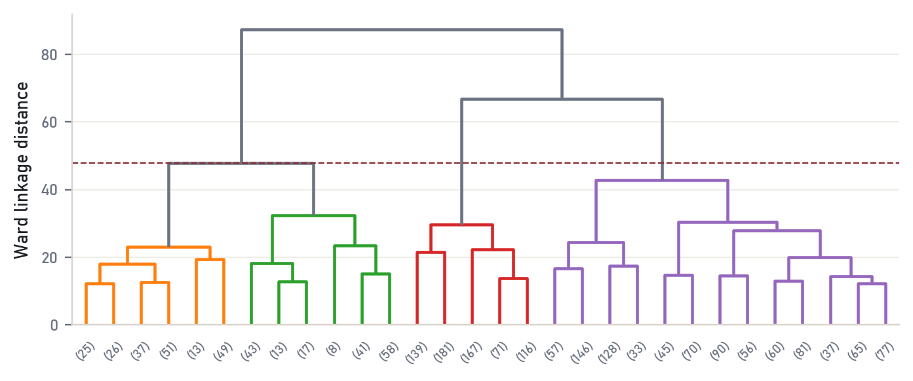
Figure 16 Ward dendrogram, truncated to the last 30 merges. The dashed line is the four-cluster cut.
Table 9 Five clustering methods compared on the same sample with four clusters.
Method | Cluster sizes (2,000-row sample) | Silhouette | ARI with label | Disease rate range
K-means | 716 / 672 / 341 / 271 | 0.211 | +0.015 | 50% to 96%
Gaussian mixture (EM) | 903 / 598 / 397 / 102 | 0.059 | +0.035 | 53% to 92%
Agglomerative, Ward | 945 / 674 / 201 / 180 | 0.176 | +0.013 | 51% to 97%
Spectral | 704 / 646 / 326 / 324 | 0.202 | +0.011 | 52% to 96%
Minimum spanning tree | 1981 / 10 / 8 / 1 | 0.345 | -0.011 | 70% to 100%

No method recovers the label: the adjusted Rand index against it never exceeds 0.03. That is expected, because patients are not one group; they are everyone whose numbers have drifted away from normal in any direction. The clusters are still useful, since the disease rate ranges from about 50 to 96 per cent across them. MST clustering behaves differently from the rest. Its longest edges (3.78 against a median edge of 0.61) lead to small outlying clumps, so cutting them peels off groups of 10, 8, 1 records and leaves one giant cluster. That makes it a poor partitioning method on this data and a good outlier detector.
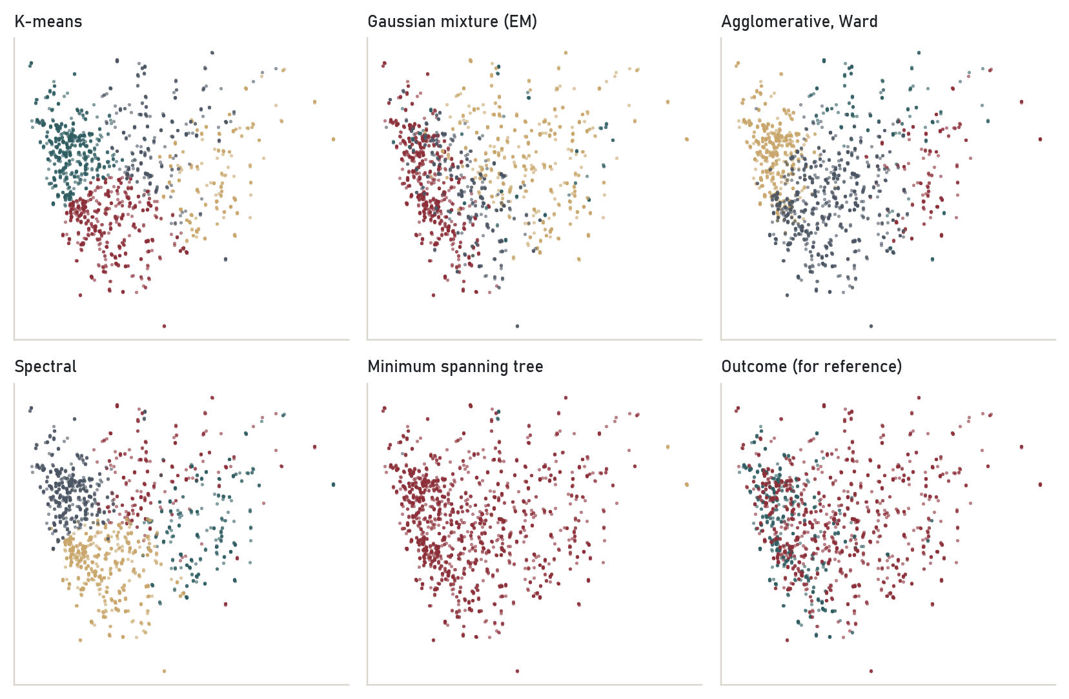
Figure 17 The same 2,000 rows projected onto the first two principal components and coloured by each method's clusters. The last panel shows the true label for comparison.

Outlier detection using clustering
Three clustering-based rules flagged unusual records: the 1 per cent of rows with the lowest density under the Gaussian mixture (194 rows), the 1 per cent farthest from their K-means centre (193), and DBSCAN's noise points (118). The two density-based ideas agree only partly (Jaccard 0.34 between GMM and K-means). The flagged rows are not data errors. 99% of the GMM outliers are patients, with median bilirubin 11.3 mg/dL and median AST 125 IU/L. They are the sickest people in the file. Removing them as "noise" would delete the clearest cases of the disease.
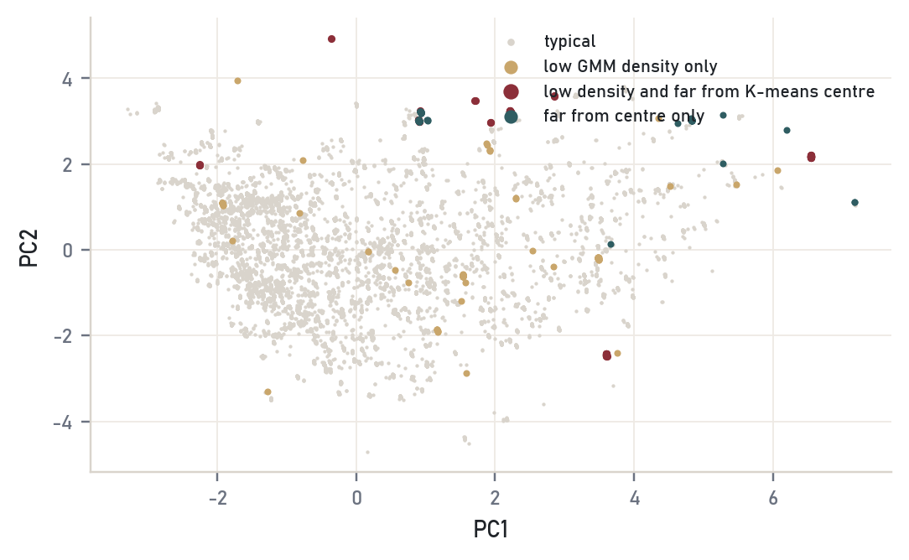
Figure 18 Records flagged by low mixture density and by distance from the K-means centre, on the first two principal components.

MODULE 6 / DIMENSIONALITY REDUCTION

6 Fewer dimensions

Principal component analysis and SVD
PCA rotates the nine standardised measurements into uncorrelated components ordered by variance. The first component explains 37.3% of the variance, the second 21.7%. 3 components have an eigenvalue above 1 (Kaiser's rule), 5 are needed for 90 per cent and 6 for 95 per cent. PC1 loads positively on both bilirubins and all three enzymes and negatively on albumin and A/G ratio, so it is a general "liver damage" axis. PC2 is the protein axis. PC3 is almost entirely age (loading 0.96), which tells you age shares nothing with the lab values.
PCA and singular value decomposition are the same computation seen from two sides. If the centred data matrix is X = U Σ Vᵀ, the columns of V are the principal directions and the squared singular values divided by n - 1 are the eigenvalues. I checked this numerically: the largest difference between the two sets of eigenvalues was 8.9e-15, which is rounding error.
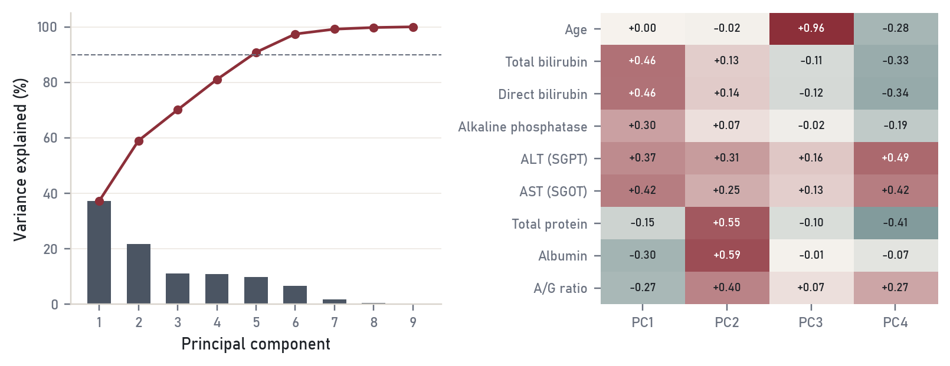
Figure 19 Left: variance explained per component (bars) and cumulative (line). Right: loadings of the first four components.
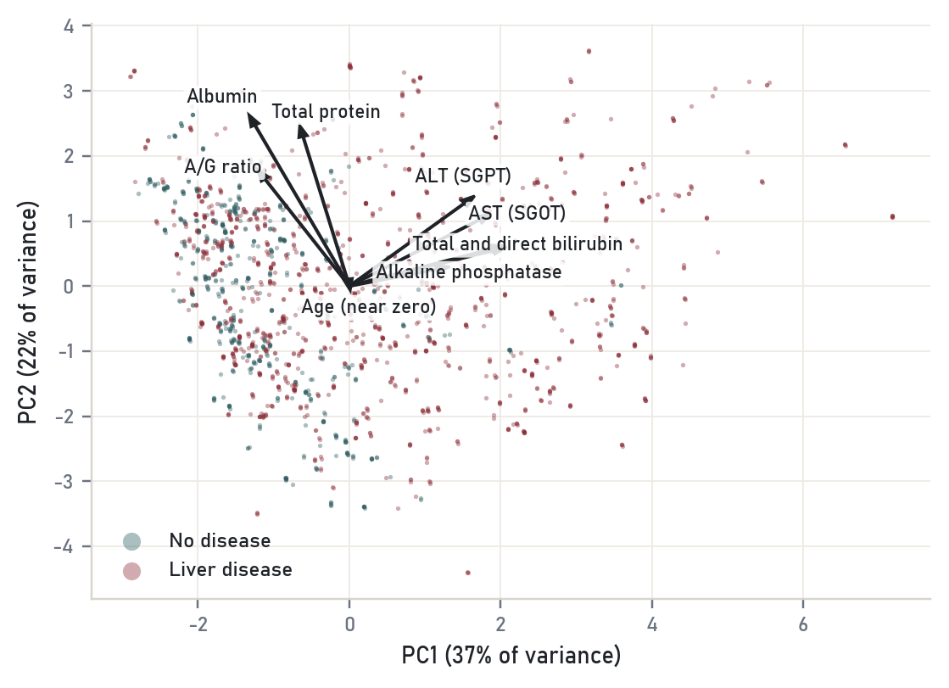
Figure 20 Biplot of the first two components. Arrows show how each variable loads; points are 2,000 sampled rows.

Factor analysis
Factor analysis assumes each measurement is a mix of a few hidden factors plus its own noise, and it reports that noise as the uniqueness. With three factors and varimax rotation the structure is clean (Figure 21). Factor 1 is protein synthesis: albumin -0.98, total protein -0.80, A/G ratio -0.66. Factor 2 is hepatocellular injury: ALT +0.97, AST +0.78. Factor 3 is bilirubin handling: total -0.95, direct -0.96. These three are the textbook groupings of the liver panel (synthesis, injury, excretion), recovered from data alone. Age has a uniqueness of 1.00, so none of it is shared, and ALP sits mostly on its own (0.83).
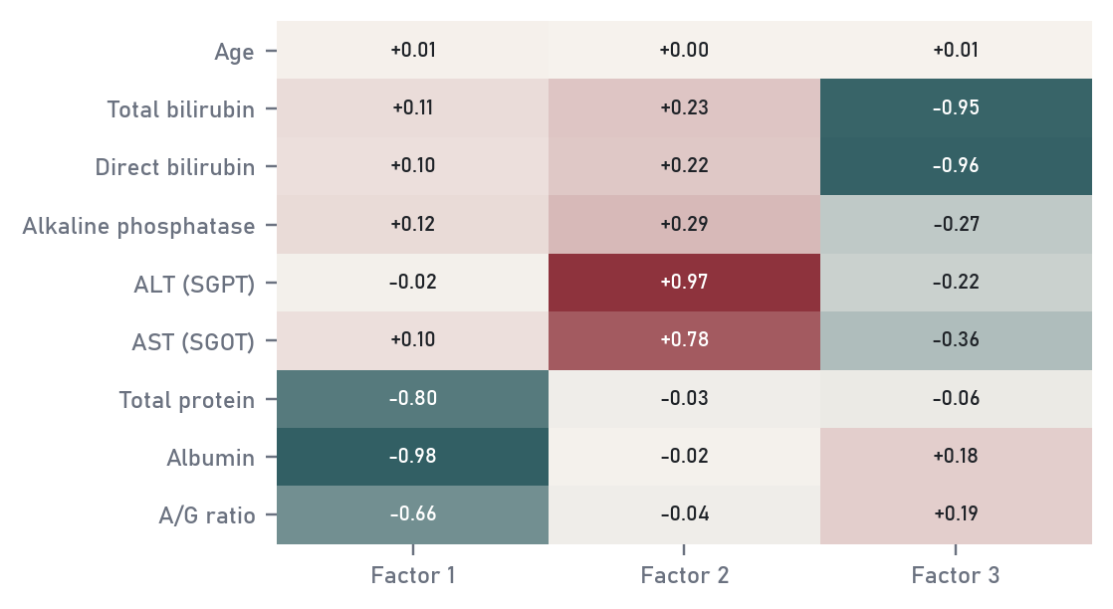
Figure 21 Varimax-rotated loadings of a three-factor model.

Intrinsic dimensionality
Nine columns does not mean nine dimensions of real variation. The maximum likelihood estimator of Levina and Bickel (2004) looks at how fast the number of neighbours grows with distance around each point. On 4,000 unique rows it gives 3.6, 3.8 and 3.9 for 10, 15 and 20 neighbours. PCA's linear count was 5 components for 90 per cent of the variance. The two answers fit together: three groups of tightly linked measurements (proteins, enzymes, bilirubins) plus age and ALP collapse nine columns to about four effective directions.

Non-linear methods: MDS, Isomap and t-SNE
Metric multidimensional scaling places points in two dimensions so that their distances match the original distances as closely as possible. Isomap does the same with distances measured along a neighbourhood graph, so it can unroll curved structure (Tenenbaum, de Silva and Langford, 2000). t-SNE keeps local neighbourhoods and lets global distances go (van der Maaten and Hinton, 2008). To compare them I trained a 5-nearest-neighbour classifier inside each two-dimensional map and measured how well it recovered the label.
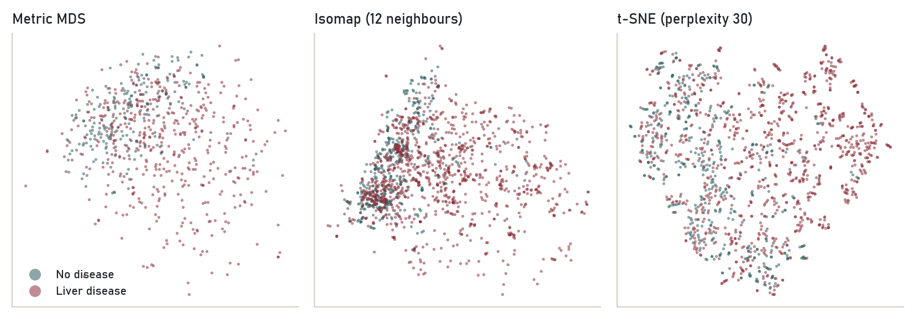
Figure 22 Three non-linear two-dimensional maps of the same records, coloured by class.
The plain linear projection scored best (83%), ahead of t-SNE (75%), Isomap (74%) and MDS (72%, on 700 rows). Non-linear maps are not automatically better. Here the main direction of difference between the classes is the straight "damage" axis that PC1 already captures. t-SNE breaks the data into many small islands, which fits the family structure of the synthetic rows, but the islands do not line up with the label.

Self-organising map
A self-organising map (Kohonen, 1982) is a small neural network laid out as a 10 by 10 grid. Each node holds a prototype vector; for each training record the closest node and its grid neighbours move a little towards it, with the step size and neighbourhood shrinking over six passes. Similar records end up on nearby nodes. The final quantisation error was 1.29 standard units and no node was empty. The U-matrix in Figure 23 marks boundaries between regions in dark grey. Colouring nodes by disease rate shows a region of 11 nodes where non-patients are the majority (lowest rate 36%), and nodes elsewhere where every record mapped is a patient.
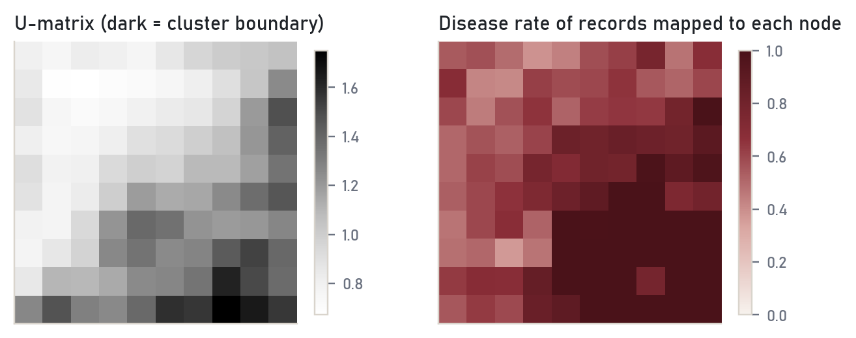
Figure 23 Self-organising map. Left: U-matrix (average distance from each node to its neighbours). Right: disease rate of the records mapped to each node.

MODULE 7 / MODEL DEVELOPMENT AND EVALUATION

7 Models and how to judge them

A linear regression model
Before classification, Module 7 asks for a linear regression built and evaluated properly. I predicted log AST from log ALT, log ALP, log total bilirubin, age, albumin and gender, on the 16,389 complete rows split 80/20 at random. Logs make sense twice over: the enzymes are skewed, and a coefficient on a log-log pair reads as an elasticity.
Table 10 Ordinary least squares fit for log AST on the training rows.
Term | Coefficient | Std. error | t | p
Intercept | +1.3407 | 0.0576 | 23.3 | < 0.001
log ALT | +0.8389 | 0.0059 | 141.9 | < 0.001
log ALP | -0.0433 | 0.0095 | -4.5 | < 0.001
log total bilirubin | +0.1875 | 0.0053 | 35.2 | < 0.001
Age (years) | +0.0002 | 0.0003 | 0.9 | 0.39
Albumin (g/dL) | -0.1191 | 0.0061 | -19.6 | < 0.001
Male | -0.0130 | 0.0100 | -1.3 | 0.19

The model explains 72.6% of the variance in training and 72.3% on the held-out rows, so it does not overfit. Almost all of that comes from ALT alone (R² = 0.68). The ALT coefficient of 0.84 means a 10 per cent rise in ALT goes with roughly an 8 per cent rise in AST. Age and gender are not significant. On the original scale the typical error is large: the median absolute percentage error is 32% and only 43% of predictions land within 25 per cent of the measured AST. A high R² on a log scale can hide a lot of error in the units a doctor reads. The residual plot is centred on zero with roughly even spread, so the linear form is adequate.
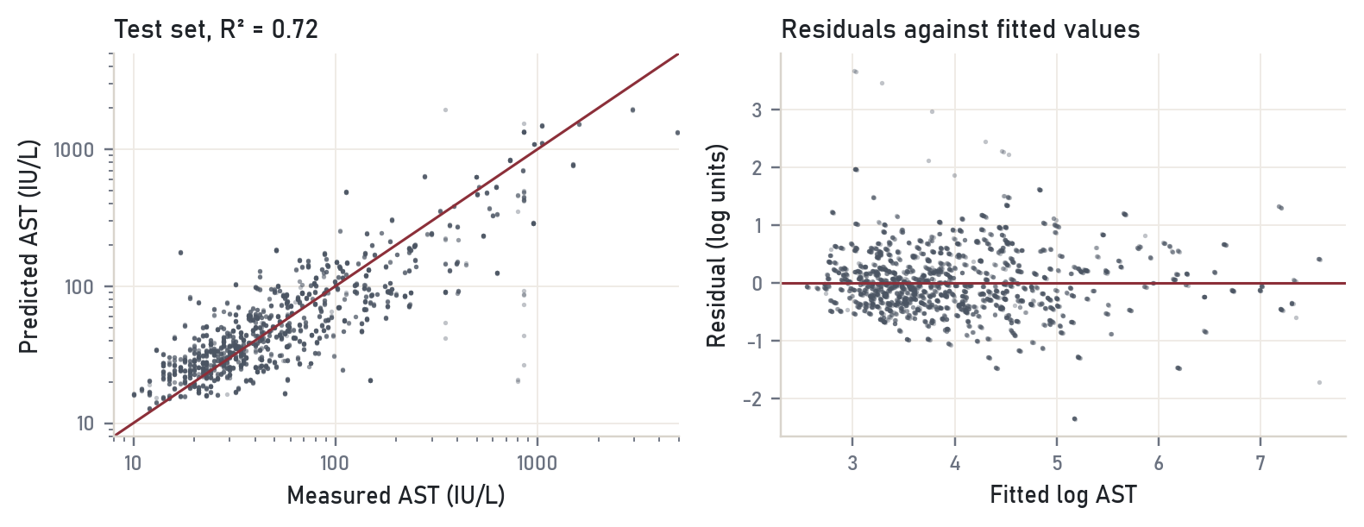
Figure 24 Linear regression on the test rows. Left: predicted against measured AST (both axes logarithmic). Right: residuals.

Classification set-up
The main task is to predict the label. I compared seven classifiers that cover the usual families: logistic regression and Gaussian naive Bayes (simple probabilistic models), k-nearest neighbours (instance based), a single decision tree, two tree ensembles (random forest with 400 trees and XGBoost with 400 boosted trees of depth 6), and a support vector machine with an RBF kernel. Every model sits in the same pipeline: log transform of the five skewed columns, iterative imputation, standardisation, then the classifier. The pipeline is fitted on training rows only, so no statistic from the test rows leaks into preprocessing. The classes are 71 to 29, so models that support it use balanced class weights.
Accuracy alone is misleading with a 71 per cent majority class, since predicting "patient" for everyone already scores 71 per cent. Each model is therefore reported with precision, recall (sensitivity), specificity, F1, balanced accuracy and ROC-AUC, with a 95 per cent bootstrap interval for AUC from 500 resamples of the test set. Model choice uses only cross-validated AUC on the training data; the test set is looked at once.
Because of what Chapter 2 found, I ran the whole comparison under three splitting protocols:
- Protocol A, the standard split: deduplicated file, stratified random 80/20 split (15,494 training, 3,874 test rows), 5-fold stratified cross-validation.
- Protocol B, grouped by source: every row is assigned to its nearest original patient, and all rows from the same source family stay on the same side of the split (15,702 and 3,666 rows, 570 families, 5-fold grouped cross-validation).
- Protocol C, real patients only: the 570 unique records of the original release, stratified 80/20 split (456 and 114 rows), cross-validation repeated 5 times over 5 folds because the sample is small.
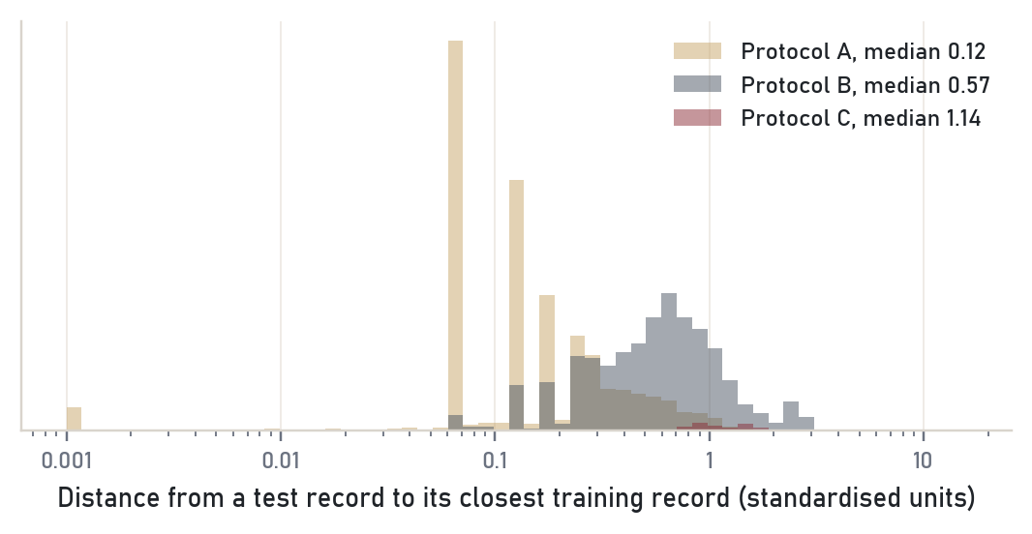
Figure 25 Distance from each test record to its nearest training record. Under protocol A most test rows have a near twin in training.
Figure 25 shows why protocol A is a problem. The median test row is only 0.12 standard units from its nearest training row, and that neighbour has the same label 98% of the time. Under protocol B the median distance rises to 0.57, and among real patients (protocol C) it is 1.14.

Protocol A: the standard split
Table 11 Protocol A results on the test set. CV AUC is the mean ± SD over five folds of the training data. Prec. = precision, Spec. = specificity, Bal. acc = balanced accuracy.
Model | CV AUC | Train acc | Test acc | Prec. | Recall | Spec. | F1 | Bal. acc | Test AUC [95% CI]
Logistic regr. | 0.759 ± 0.006 | 0.652 | 0.661 | 0.893 | 0.596 | 0.823 | 0.715 | 0.710 | 0.772 [0.76, 0.79]
Naive Bayes | 0.750 ± 0.008 | 0.627 | 0.640 | 0.918 | 0.544 | 0.879 | 0.683 | 0.712 | 0.756 [0.74, 0.77]
KNN (k = 15) | 0.947 ± 0.004 | 0.923 | 0.899 | 0.913 | 0.949 | 0.776 | 0.931 | 0.863 | 0.960 [0.95, 0.96]
Decision tree | 0.987 ± 0.002 | 1.000 | 0.989 | 0.993 | 0.991 | 0.982 | 0.992 | 0.987 | 0.987 [0.98, 0.99]
Random forest | 1.000 ± 0.001 | 1.000 | 0.997 | 0.997 | 0.999 | 0.993 | 0.998 | 0.996 | 0.999 [1.00, 1.00]
XGBoost | 1.000 ± 0.001 | 0.998 | 0.997 | 0.998 | 0.997 | 0.996 | 0.998 | 0.996 | 0.999 [1.00, 1.00]
SVM (RBF) | 0.849 ± 0.004 | 0.703 | 0.707 | 0.968 | 0.610 | 0.950 | 0.748 | 0.780 | 0.860 [0.85, 0.87]

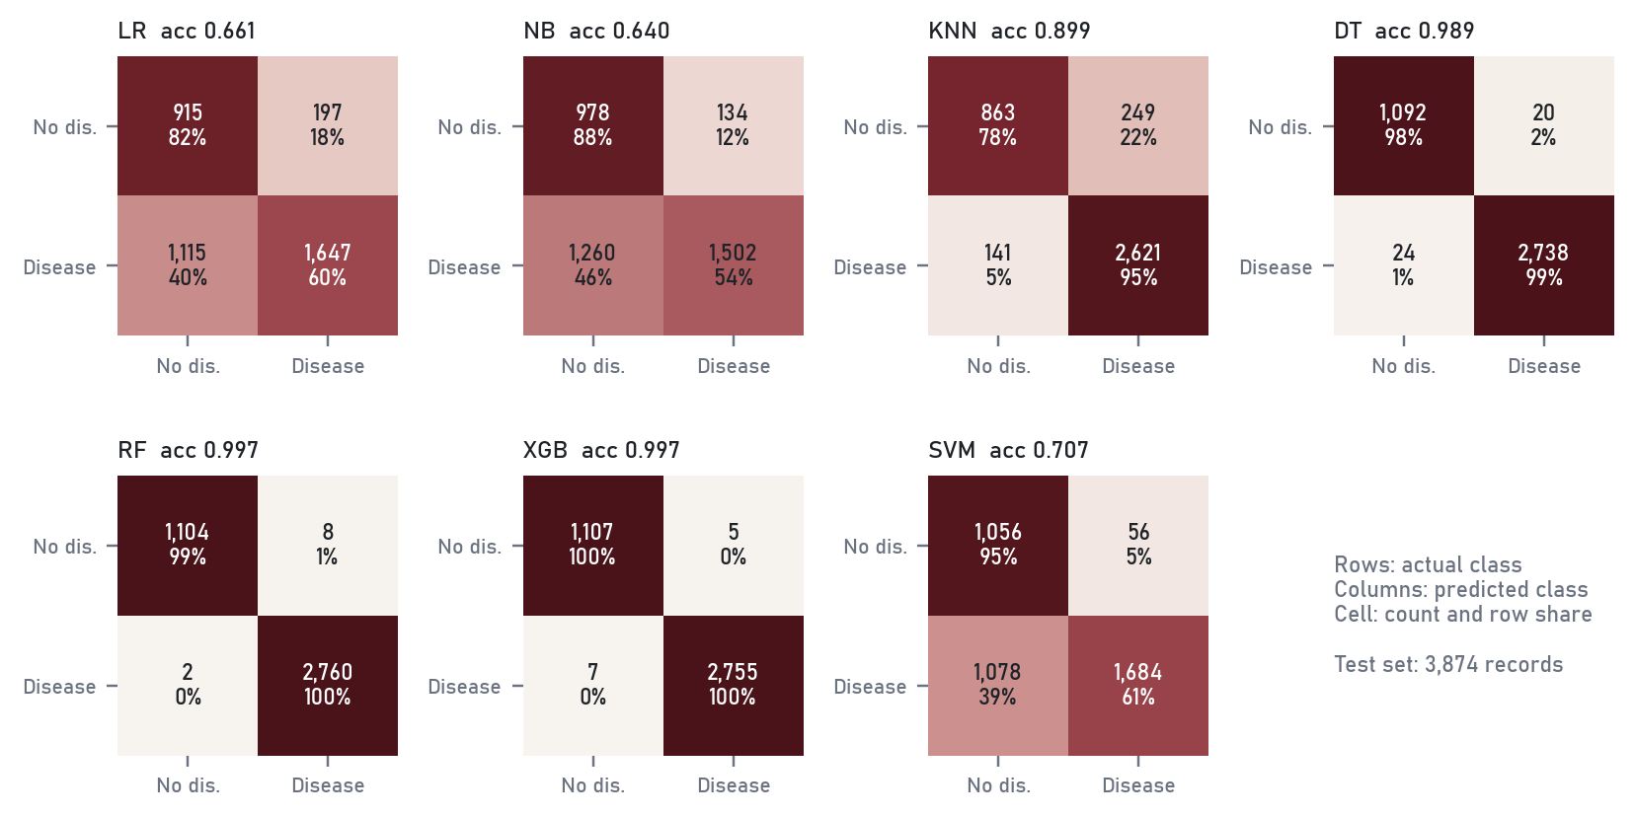
Figure 26 Confusion matrices under protocol A. Rows are the actual class, columns the prediction; each cell shows the count and the share of its row.
Random forest and XGBoost both reach 99.7% test accuracy. Random forest makes 8 false alarms and misses 2 patients out of 3,874. A McNemar test on their disagreements finds no difference (p = 0.79). The linear models trail far behind at 66% to 64%. If this were the whole story the conclusion would be "use random forest".

Protocol B: grouped by source patient
Table 12 Protocol B results. Cross-validation folds respect the source families. Prec. = precision, Spec. = specificity, Bal. acc = balanced accuracy.
Model | CV AUC | Train acc | Test acc | Prec. | Recall | Spec. | F1 | Bal. acc | Test AUC [95% CI]
Logistic regr. | 0.758 ± 0.040 | 0.665 | 0.632 | 0.846 | 0.574 | 0.763 | 0.684 | 0.669 | 0.739 [0.72, 0.75]
Naive Bayes | 0.753 ± 0.029 | 0.636 | 0.608 | 0.860 | 0.520 | 0.807 | 0.648 | 0.664 | 0.730 [0.72, 0.75]
KNN (k = 15) | 0.815 ± 0.023 | 0.930 | 0.745 | 0.801 | 0.842 | 0.526 | 0.821 | 0.684 | 0.801 [0.79, 0.81]
Decision tree | 0.947 ± 0.023 | 1.000 | 0.979 | 0.991 | 0.978 | 0.980 | 0.985 | 0.979 | 0.979 [0.97, 0.98]
Random forest | 0.996 ± 0.004 | 1.000 | 0.995 | 0.995 | 0.998 | 0.988 | 0.996 | 0.993 | 1.000 [1.00, 1.00]
XGBoost | 0.975 ± 0.030 | 0.999 | 0.983 | 0.996 | 0.980 | 0.990 | 0.988 | 0.985 | 0.999 [1.00, 1.00]
SVM (RBF) | 0.793 ± 0.017 | 0.713 | 0.647 | 0.916 | 0.541 | 0.887 | 0.680 | 0.714 | 0.775 [0.76, 0.79]

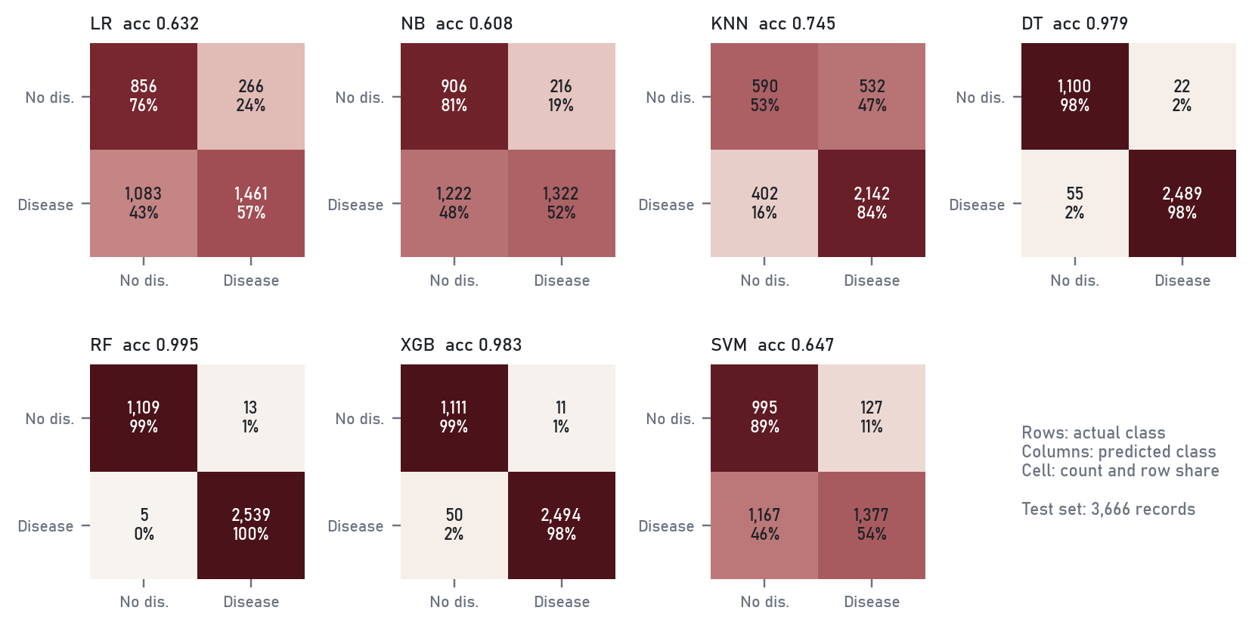
Figure 27 Confusion matrices under protocol B.
Grouping removed the near twins and hurt the models that relied on them: KNN fell from 0.960 to 0.801 AUC and the SVM from 0.860 to 0.775. The tree ensembles did not move: random forest still scores 99.5%. So nearness is not what the trees are exploiting.
WHY THE TREES STILL WIN A tree can split on a narrow interval around a single value, and in this file single values carry the label: a value that only non-patients had in the original data can never appear in a synthetic patient row. To check, I wrote a rule with no learning at all. For each column it asks whether the test value was seen only among training patients or only among training non-patients, and adds up the votes. That rule scores an AUC of 0.94 under protocol A and 0.95 under protocol B, and 69% of test rows contain at least one give-away value. On real patients the same rule manages only 0.67.

Protocol C: real patients
Table 13 Protocol C results on the 114 held-out original patients. CV AUC is the mean ± SD over 25 folds (5 repeats of 5-fold). Prec. = precision, Spec. = specificity, Bal. acc = balanced accuracy.
Model | CV AUC | Train acc | Test acc | Prec. | Recall | Spec. | F1 | Bal. acc | Test AUC [95% CI]
Logistic regr. | 0.727 ± 0.048 | 0.658 | 0.719 | 0.889 | 0.691 | 0.788 | 0.778 | 0.740 | 0.810 [0.73, 0.89]
Naive Bayes | 0.727 ± 0.050 | 0.614 | 0.737 | 0.947 | 0.667 | 0.909 | 0.783 | 0.788 | 0.801 [0.72, 0.87]
KNN (k = 15) | 0.695 ± 0.043 | 0.748 | 0.772 | 0.772 | 0.963 | 0.303 | 0.857 | 0.633 | 0.787 [0.70, 0.87]
Decision tree | 0.569 ± 0.044 | 1.000 | 0.675 | 0.734 | 0.852 | 0.242 | 0.789 | 0.547 | 0.547 [0.47, 0.62]
Random forest | 0.723 ± 0.049 | 1.000 | 0.702 | 0.724 | 0.938 | 0.121 | 0.817 | 0.530 | 0.773 [0.69, 0.85]
XGBoost | 0.698 ± 0.048 | 1.000 | 0.711 | 0.767 | 0.852 | 0.364 | 0.807 | 0.608 | 0.735 [0.64, 0.82]
SVM (RBF) | 0.733 ± 0.046 | 0.669 | 0.711 | 0.914 | 0.654 | 0.848 | 0.763 | 0.751 | 0.821 [0.74, 0.90]

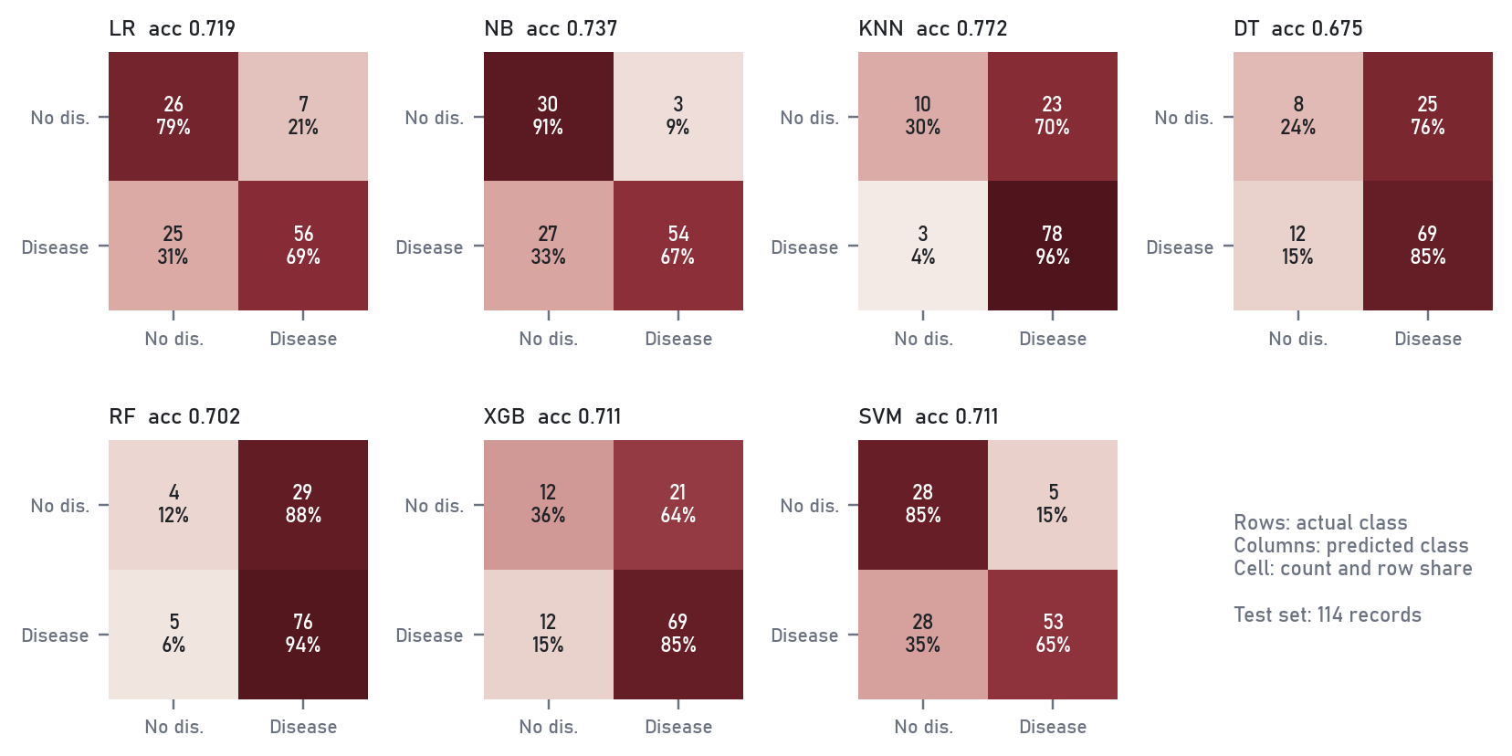
Figure 28 Confusion matrices on the 114 held-out original patients (33 non-patients, 81 patients).
On real patients the ranking turns upside down. The single decision tree is close to a coin toss (AUC 0.547). Random forest still has a training accuracy of 1.000, but on the test set it calls almost everyone a patient: it finds 76 of 81 patients and correctly clears only 4 of 33 non-patients. Its accuracy of 70% is below the 71 per cent you get by predicting "patient" every time. XGBoost and KNN show the same bias towards the majority class.
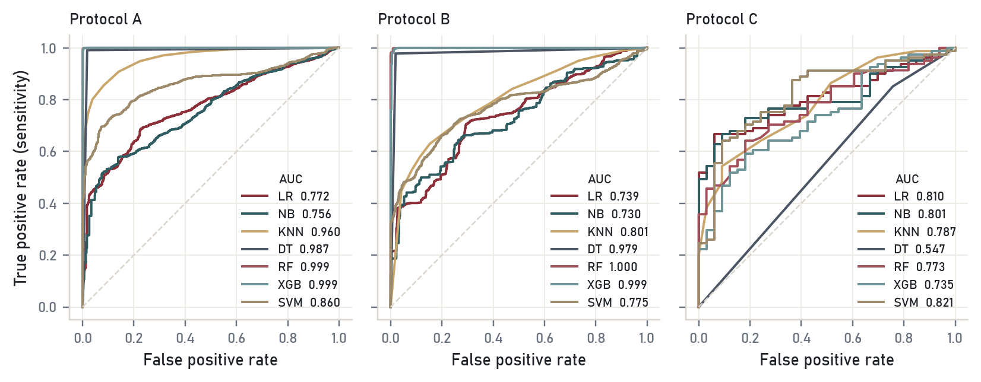
Figure 29 ROC curves under the three protocols. The legend gives each model's test AUC.
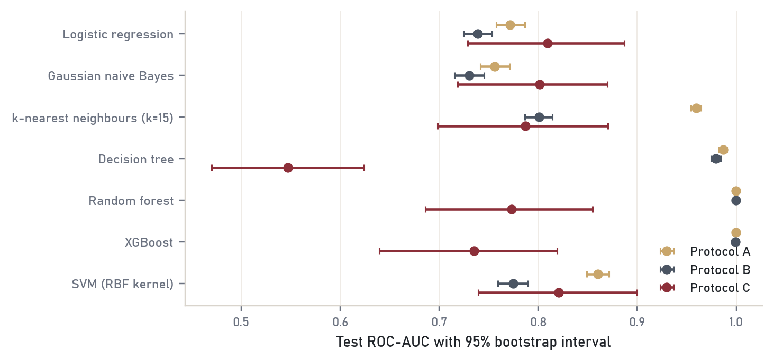
Figure 30 Test ROC-AUC with 95 per cent bootstrap intervals. Under protocol C the intervals are wide because the test set holds 114 patients.

Which model outperformed, and why
On the honest benchmark the RBF support vector machine has the best cross-validated AUC (0.733 ± 0.046) and the best test AUC (0.821), with balanced accuracy 0.751. Logistic regression is right behind (0.727 ± 0.048 in cross-validation, 0.810 on test). The two models disagree on only 7 of the 114 test patients and McNemar's test gives p = 1.00, so the data cannot tell them apart. The bootstrap intervals in Figure 30 overlap almost entirely.
Three reasons explain why the simple models win on real patients and the ensembles win on the file:
- Sample size. 456 training patients is small for a model with thousands of split points. The forest and XGBoost fit the training data perfectly and carry that noise to the test set; the SVM and logistic regression have far fewer effective parameters.
- Shape of the signal. Chapters 3 and 6 showed that the difference between the classes runs mostly along one smooth direction (more bilirubin and enzymes, less albumin). A linear boundary on log-scaled values fits that shape, and the RBF kernel only bends it slightly.
- What the ensembles learned on the file. Their 99.7 per cent came from value fingerprints planted by the augmentation, not from liver physiology. That knowledge has nothing to offer on new patients.
My recommendation is logistic regression. It matches the SVM within noise, produces probabilities a clinician can threshold, and its coefficients can be read directly (Figure 31). At the default threshold it catches 69% of patients while clearing 79% of non-patients; for screening, where a missed patient costs more than a false alarm, the threshold should be lowered to trade specificity for sensitivity along the ROC curve.
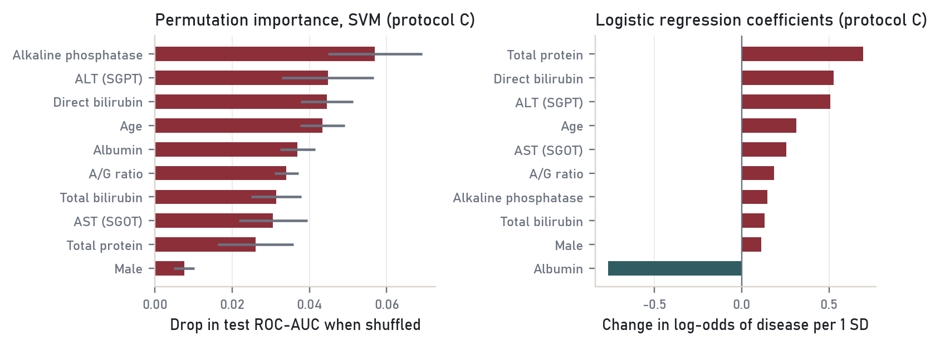
Figure 31 Left: permutation importance for the SVM on the original patients (drop in AUC when a column is shuffled). Right: logistic regression coefficients per standard deviation.
Both views agree on the important inputs: ALP, ALT, direct bilirubin, age and albumin. Albumin has the largest negative coefficient (-0.76 per SD), and age, invisible in the 30k file, matters on real patients (+0.31). The positive coefficient on total protein next to the negative one on albumin is a collinearity effect: holding albumin fixed, more protein means more globulin, which rises in chronic liver disease.

Supervised against reinforcement learning
Everything above is supervised learning: each training row comes with the right answer, and the model learns a mapping from inputs to that answer. Reinforcement learning has no answer key. An agent takes actions in an environment, receives a reward that may arrive much later, and learns a policy that maximises the total reward (Sutton and Barto, 2018).
Table 14 Supervised and reinforcement learning compared.
 | Supervised learning | Reinforcement learning
Feedback | Correct label for every example | A scalar reward, often delayed
Data | Fixed dataset collected in advance | Generated by the agent's own actions
Goal | Predict well on new examples | Choose actions that maximise long-run reward
Main risk | Overfitting, leakage (Chapter 7) | Unsafe exploration, reward misspecification
Liver example | Classify a patient from one blood panel | Adjust a treatment dose visit by visit

Reinforcement learning is used in game playing, robotics, recommendation systems and, in medicine, for dynamic treatment regimes, where the action is a dose or a test and the reward is the patient's later outcome. It would not suit this dataset: there are no actions, no sequence of decisions and no outcome beyond a single label.

MODULE 8 / CONTEMPORARY ISSUES

8 Contemporary issues

Synthetic data and leakage
Synthetic and augmented datasets are now common in teaching and in competitions, often without a note saying how they were made. This project shows the cost. The 30k file is easy to mistake for a large real cohort, it rewards the most flexible models with near-perfect scores, and it hides two real effects (age and gender). Kaufman and colleagues (2012) call this leakage: information in the training data that would not be available when the model is used. The checks that caught it were simple and are worth doing on any dataset: count duplicates, look for the original source, measure how close test rows are to training rows, and distrust any accuracy above what the exploratory analysis says is plausible. Chapters 3 and 6 showed heavy overlap between the classes, and that overlap, not the 99.7 per cent, is what protocol C measured.

Fairness
I checked whether the recommended kind of model works equally well for men and women. On the original test patients the SVM's sensitivity was 71% for men and 52% for women, with specificity 84% and 88%. The test set has only 33 women, so the gap is uncertain, but it points the same way as the original data: women in this sample are fewer and less often patients, and the model finds their disease less reliably. A screening tool built on this data would need a check on a larger and more balanced female sample before use. On the 30k file the same check shows no gap at all, because the augmentation removed gender from the problem.

Reproducibility
All random steps use seed 42. Imputation and scaling are fitted inside the model pipeline, on training rows only. The analysis script writes every number quoted here to results/results.json, and the report is generated from that file, so the text and the results cannot drift apart. The original UCI file used for the provenance check is stored with the project.

SUMMARY

9 Conclusions
Going back to the three questions from Chapter 1:
1. The file is not clean in the way it looks. Over a third of it is exact duplicates, and the rest was generated from 570 real patients by mixing their values within each class. That process leaks the label and erases the age and gender effects. Missing values are few and are not completely random; EM imputation handles them well.
2. Bilirubin, the transaminases and alkaline phosphatase separate patients from non-patients, with albumin pointing the other way. Factor analysis recovers the three clinical groups of the liver panel (synthesis, injury, excretion), and clustering finds groups that look like stages of damage, though none of them matches the label.
3. On real, unseen patients the best achievable ROC-AUC is about 0.73 in cross-validation. An RBF SVM and logistic regression share first place; I recommend logistic regression for its transparency. The 99.7 per cent accuracy of random forest on the course file measures the data generator, not the disease.
The limitations are real. Protocol C has only 114 test patients, so its intervals are wide. The label in the original data comes from a single hospital system and its definition of a "liver patient" is not documented. And with no follow-up dates, nothing here says anything about how the disease progresses. A larger, dated cohort would allow the time-series analysis that Module 3 describes and a far tighter estimate of model performance.

References
Aggarwal, C. C. (2015). Data Mining: The Textbook. Springer.
Chawla, N. V., Bowyer, K. W., Hall, L. O., and Kegelmeyer, W. P. (2002). SMOTE: synthetic minority over-sampling technique. Journal of Artificial Intelligence Research, 16, 321 to 357.
Chen, T., and Guestrin, C. (2016). XGBoost: a scalable tree boosting system. Proceedings of the 22nd ACM SIGKDD Conference, 785 to 794.
Dempster, A. P., Laird, N. M., and Rubin, D. B. (1977). Maximum likelihood from incomplete data via the EM algorithm. Journal of the Royal Statistical Society, Series B, 39(1), 1 to 38.
Enders, C. K. (2010). Applied Missing Data Analysis. The Guilford Press.
Fraley, C. (1998). Algorithms for model-based Gaussian hierarchical clustering. SIAM Journal on Scientific Computing, 20(1), 270 to 281.
Jambu, M. (1991). Exploratory and Multivariate Data Analysis. Academic Press.
Kaufman, S., Rosset, S., Perlich, C., and Stitelman, O. (2012). Leakage in data mining: formulation, detection, and avoidance. ACM Transactions on Knowledge Discovery from Data, 6(4), article 15.
Kohonen, T. (1982). Self-organized formation of topologically correct feature maps. Biological Cybernetics, 43, 59 to 69.
Levina, E., and Bickel, P. J. (2004). Maximum likelihood estimation of intrinsic dimension. Advances in Neural Information Processing Systems, 17.
Martinez, W. L., Martinez, A. R., and Solka, J. L. (2017). Exploratory Data Analysis with MATLAB (3rd ed.). CRC Press.
McNemar, Q. (1947). Note on the sampling error of the difference between correlated proportions or percentages. Psychometrika, 12(2), 153 to 157.
Mukhiya, S. K., and Ahmed, U. (2020). Hands-On Exploratory Data Analysis with Python. Packt Publishing.
Pedregosa, F., et al. (2011). Scikit-learn: machine learning in Python. Journal of Machine Learning Research, 12, 2825 to 2830.
Ramana, B. V., Babu, M. S. P., and Venkateswarlu, N. B. (2012). ILPD (Indian Liver Patient Dataset). UCI Machine Learning Repository, https://archive.ics.uci.edu/dataset/225/ilpd+indian+liver+patient+dataset
Rubin, D. B. (1976). Inference and missing data. Biometrika, 63(3), 581 to 592.
Sutton, R. S., and Barto, A. G. (2018). Reinforcement Learning: An Introduction (2nd ed.). MIT Press.
Tenenbaum, J. B., de Silva, V., and Langford, J. C. (2000). A global geometric framework for nonlinear dimensionality reduction. Science, 290, 2319 to 2323.
van der Maaten, L., and Hinton, G. (2008). Visualizing data using t-SNE. Journal of Machine Learning Research, 9, 2579 to 2605.
von Luxburg, U. (2007). A tutorial on spectral clustering. Statistics and Computing, 17, 395 to 416.
Zahn, C. T. (1971). Graph-theoretical methods for detecting and describing gestalt clusters. IEEE Transactions on Computers, C-20(1), 68 to 86.

A Appendix: running the project
The project folder is laid out as follows.
Table 15 Project files.
Path | Contents
data/liver.csv | The course file, as downloaded
data/ilpd_original_583.csv | The original UCI release, used for the provenance check and protocol C
src/analysis.py | Every analysis step, in syllabus order; writes figures and results
src/style.py | Shared chart style
src/build_report.py, src/docx_theme.py | Generates this report from results/results.json
figures/ | The 31 figures in this report, 220 dpi PNG
results/results.json, results/tables/ | Every quoted number, and the tables as CSV

To reproduce everything from a fresh copy of the folder:
pip install pandas numpy scipy scikit-learn statsmodels xgboost matplotlib python-docx
python src/analysis.py
python src/build_report.py

Software versions used: Python 3.14.3, pandas 2.3.3, NumPy 2.4.2, scikit-learn 1.8.0, statsmodels 0.15.0, XGBoost 3.4.1.

