Learned Reliability-Aware Fusion of Token Evidence Raised Image-Text Verification Accuracy Under Gaussian Noise in a Unified Masked Diffusion Model: A Preregistered Confirmation in UniDisc
Shlok Goenka, Subramaniyaswamy Vairavasundaram, and Balaji G N

Abstract—We report two separately preregistered studies of image-text verification under image damage in one pretrained unified masked diffusion model (UniDisc, 1.4 billion parameters) on Common Objects in Context image-caption pairs. In the first, a gate discards low-likelihood image tokens. In the preregistered test no improvement was detected under Joint Photographic Experts Group compression at quality 10, Gaussian noise with standard deviation 0.1, and a 128-pixel splice; for each tested corruption the 90 percent confidence interval of the net accuracy change lay inside plus or minus 0.05 (−0.002, −0.006 to 0.000; 0.000, 0.000 to 0.000; −0.004, −0.010 to 0.002; 500 pairs each), so an improvement or a loss larger than 0.05 is excluded. This does not show that the gate has no effect. Each negative is a random caption of an image sharing no annotated object category with the test image. In the second, on a fresh preregistered fold, a frozen learned reliability-aware fusion of token evidence raised image-direction verification accuracy under Gaussian noise with standard deviation 0.1 from 0.733 without reliability weighting to 0.802 (net 0.069, 95 percent confidence interval 0.029 to 0.109; exact one-sided McNemar test, probability value 0.0005), including with length-matched negatives. On clean images it lost no more than three percentage points (90 percent confidence interval of the net change 0.009 to 0.053); the margin was fixed after an exploratory clean interval had been seen. This result holds on 450 validation-split images not used to design or fit the frozen weighting, at that one severity.
Index Terms—Diffusion models, hypothesis testing, information fusion, multimodal learning.
This work was supported by Vellore Institute of Technology (VIT), Vellore, India.
(Corresponding author: Subramaniyaswamy Vairavasundaram.)
The authors are with the School of Computer Science and Engineering, Vellore Institute of Technology, Vellore 632014, Tamil Nadu, India (e-mail: shlok.goenka2023@vitstudent.ac.in; subramaniyaswamy.v@vit.ac.in; balaji.gn@vit.ac.in).

I. Introduction
A unified masked diffusion model places text tokens and image tokens in one sequence and is trained to predict any masked token from any visible subset, the mask token standing for “unknown” [1]–[3]. Such models generate and understand both modalities with one network [4]–[6]. With the image tokens masked and a caption visible, the same network assigns a probability to each observed image code, with no external encoder involved. In this paper, image-text verification means this image-direction decision: for one image and two candidate captions, the true caption is chosen if the observed image tokens are, summed over tokens, more probable under it than under a wrong caption (Section III).
Generative models are already used as scorers in this way. Diffusion classifiers compare conditional denoising errors across labels [7], [8], image-text matching has been scored by a conditional error normalised by the unconditional one [9], and the authors of UniDisc give examples in which damaged image-caption pairs are repaired by masking, re-infilling, and selection by the model’s own likelihood [4]. This paper studies evidence that the unified model itself computes, so its behaviour is a property of the scorer, not of an attached encoder. Images can be damaged before a model sees them, by compression, sensor noise, or editing; corruption benchmarks treat such damage as a test condition [10], and multimodal fusion methods are evaluated under it [11]. The problem studied here is how the per-token likelihood evidence of a unified masked diffusion model behaves for image-text verification when the image is damaged before tokenisation, and whether a fixed rule applied to that evidence changes the decision (Fig. 1).
Two questions about this evidence were preregistered separately (Section III-E), each with its own plan, test images, and decision rule.
Q1 (Study 1, Section IV): does discarding the image tokens that the model’s own masked likelihood flags as improbable, with a flag threshold set by conformal risk control on clean pairs, change image-direction verification accuracy under Joint Photographic Experts Group (JPEG) compression, Gaussian noise, and a pixel splice?
Q2 (Study 2, Section V): does one frozen, learned per-token weighting of the evidence raise image-direction verification accuracy on fresh images under Gaussian noise?
Contributions: Each item was delivered regardless of the outcome; items 1 and 2 belong to Study 1, and item 3 to Study 2.
- A measured gate and a closed-form condition. We specify, and treat as the object of measurement, an input-level source-validation gate for a pretrained unified masked diffusion model: each image token is scored by the model’s own masked likelihood with the caption withheld, and the flag threshold is set by conformal risk control on clean pairs so that the expected flagged share of a clean pair’s tokens is at most $α$. Under an independent-token approximation, we give the condition on the false-alarm and hit rates under which discarding flagged tokens raises the signal-to-noise ratio of an additive evidence sum. The condition is stated as an approximation because image tokens are dependent, and it is extended to exchangeably correlated tokens (Proposition 2); it is linked to no result (Section IV-A).
- The preregistered test and its checks (exact McNemar, Holm over three realistic corruptions, and $n$ fixed by a headroom rule). The preregistered test excludes an improvement or a loss of more than five percentage points in image-direction verification accuracy from gating under JPEG quality 10, Gaussian noise with $σ=0.1$, and a 128-pixel splice. At the token level, the gate’s score separates code-level random replacements, with an area under the receiver operating characteristic curve (AUROC) of 0.961 for a patch and 0.955 for swapped codes, but is near chance on JPEG and Gaussian noise (0.561 and 0.503). On noise it is below a one-pass score without finetuning (marginal intervals, descriptive; no paired test), and on JPEG the two overlap. In the preregistered comparison it is below a texture score whose sign was chosen on the same items, so the preregistered falsifier for the score was met (Fig. 5). We check the clean false-alarm statement on held-out clean test pairs. Re-infilling of the flagged tokens and the score-level combination of the two directions on foil captions were run as formal tests. In a separately labelled family added after the primary result was known (family H: SugarCrepe hard negatives [12] on 50 Common Objects in Context (COCO) images not used elsewhere; Holm over the same three corruptions), the headroom stage was run; its headroom condition was not met, so the test stage was not run (Sections IV-B and IV-C).
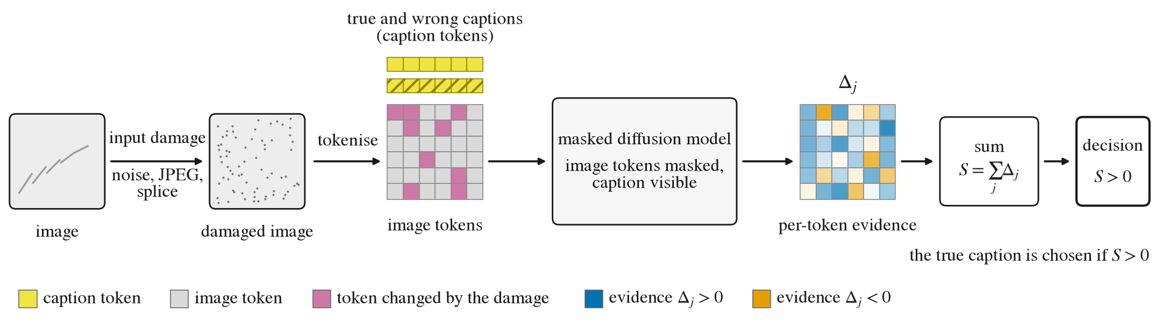
Fig. 1. Image-text verification by per-token evidence in a masked diffusion model (conceptual drawing with a fixed token pattern; no data). A possibly damaged image is tokenised; with the image tokens masked and each caption visible, the model gives the evidence $Δ_{j}$, the log-probability ratio of the observed image token under the true and a wrong caption, and the unweighted sum S=j​Δj chooses the true caption if $S>0$.
- A frozen weighting and its preregistered confirmation. Learned reliability-aware fusion (LRF) is a logistic generalised additive model that maps 35 caption-withheld features of each image token to a non-negative weight on its evidence, fitted on 500 design images, frozen, and pinned by SHA-256 before any test image was selected. On a fresh preregistered fold, the frozen LRF raised image-direction verification accuracy under Gaussian noise ($σ=0.1$) from 0.733 without reliability weighting to 0.802 (exact one-sided McNemar $p=0.0005$), including with length-matched negatives; on clean images it lost no more than three percentage points (0.03 in accuracy; 90% interval of the net change 0.009 to 0.053); the margin was fixed after an exploratory clean interval had been seen. This result holds in one pretrained unified masked diffusion model (UniDisc, 1.4B parameters), on 450 COCO val2017 images not used to design or fit the method, with Gaussian noise at one severity. Two image-text encoders are scored on the same items for reference, without comparison, and the cost is reported (Section V).
- A preregistration record. The plans, hash pins, every deviation, and the full outputs of every preregistered test are reported (Section VI-D; supplement S-I, S-II, and S-IV).
Scope of this paper: This paper reports two preregistered measurements on one model and does not run a race between verifiers. Its object is the evidence that a unified masked diffusion model computes about its own inputs, and each question asks, by an exact paired test, whether a rule fixed in advance changes the decision on images the rule never saw. The paper does not claim a verifier that ranks with dedicated encoders; any result for another model, dataset, severity, or kind of negative caption; that the learned weights track reliability or corruption; or that either study bears on the other.

II. Related Work
Generative and likelihood scoring: Diffusion models are trained by maximising a variational lower bound on the data log-likelihood, as surveyed for continuous diffusion in image super-resolution [13], so a trained model can be read as a scorer of its own inputs. Text-to-image diffusion models have been used as zero-shot classifiers whose weights over diffusion timesteps are learned from held-out labelled data [8], including with few labels [14]. For image-text matching, the conditional error has been normalised by the unconditional one [9], and VQAScore scores alignment by the probability of “Yes” that an image-to-text model assigns to a question about the pair [15]. In text, masked language models score a token with the token masked [16], [17]. The evidence used in this paper belongs to this family: a per-token log-likelihood ratio of the observed image codes under two captions, computed by the masked denoiser of a unified model.
Masked discrete diffusion and unified models: Absorbing-state discrete diffusion [1], [18] was simplified into masked diffusion language models [2] and scaled [19]; the denoiser of such a model represents the conditional distribution of a clean token given the unmasked context [3]. MaskGIT generates image tokens by masked prediction [20], and unified text-image models place several modalities in one sequence [4]–[6], as does Muddit, published as “Beyond text-to-image: Liberating generation with a unified discrete diffusion model” [21]. LaViDa adds a vision encoder to a diffusion language model [22], and Lumina-DiMOO is a further omni diffusion language model for multimodal generation and understanding [23]. In this journal, discrete-diffusion image captioning has been studied in a setting where noise in the diffusion process weakens sentence information, and a feature-mask and gated-fusion design improves image-text alignment [24]. Many methods remask tokens that the sampler itself produced, by confidence, learned quality scores, or critics, including cross-modal confidence in multimodal masked diffusion models [25]–[31]. Work on damaged input tokens is scarcer: Trust but Verify detects corrupted context tokens in a finetuned text-only masked diffusion model and refills them [32], and dropout decoding masks visual tokens that are uncertain under a logit-lens projection [33]. None of them reports a verification decision under image corruption in a unified masked diffusion model.
Reliability-aware and dynamic fusion: When evidence comes from sources of unequal quality, the classical combination rule weights each source by its reliability [34], and classifier combination studies the rules for doing so [35]. In multimodal learning the weights change per input: dynamic, uncertainty-driven weighting of modalities has been analysed for low-quality data, with theory on when it is preferable to static weighting [36]. A recent survey organises fusion on low-quality data into noisy, incomplete, imbalanced, and quality-varying settings [37]. Trusted multi-view classification fuses per-view evidence dynamically to handle unreliable views [38], and evidential methods attach an estimated importance or reliability to each modality before combining [39], [40]. Papers in this journal take the same view: a per-modality confidence score (an energy score) lets the fusion rely less on low-quality modalities [41]; evidence theory quantifies the uncertainty of each prediction and fuses evidence across propagation depths [42]; evidential deep learning suppresses unreliable modality-wise pseudo-labels in audio-visual video parsing [43]; and counterfactual samples in a shared multimodal latent space identify the input features that contribute to high predictive uncertainty [44]. At a finer grain, attention-based multiple-instance pooling learns instance weights from instance features under a bag-level loss [45], and a token weight has been derived from a model’s logits with and without the image, as a training-time reweighting [46]. For Study 2, the closest precedents are thus learned timestep weights [8], [14], instance weights under a bag-level loss [45], and reliability weights of modalities or views [36], [38]. Token-level confidences of a captioning vision-language model, aggregated algebraically or by a learned estimator, have also been used to judge whether a caption is correct for its image [47]; that work scores the caption’s tokens given the image and does not study image corruption. To our knowledge, no earlier work learns per-token, caption-withheld weights for the log-likelihood-ratio evidence of a unified masked diffusion model and tests them on fresh images under image corruption. This statement is limited to a keyword search of arXiv and of title-level records of IEEE-published journals and proceedings, logged in October 2026; the search did not cover full texts, the pages of IEEE Xplore itself, or the submission lists of open-review venues.
Conformal risk control: Conformal prediction gives distribution-free guarantees under exchangeability [48], [49]; conformal $p$-values give false-discovery control for outlier detection [50], and conformal risk control bounds the expected value of a monotone loss [51]. Conformal loss-controlling prediction, published in this journal, extends conformal prediction from miscoverage to a general loss for each test object, with a finite-sample guarantee under exchangeability [52]; Study 1 uses the expected-loss statement of conformal risk control instead. Conformal risk control has been applied, with masking-derived CLIPScore distributions and a threshold set on foil-labelled data, to flag erroneous caption words given an image [53].
Corruption benchmarks and preregistration: Common-corruption benchmarks test models under non-adversarial image corruptions [10], and a corruption benchmark for object detection released an implementation of such corruptions at graded severities [54], which Study 2 uses for its other noise types. Preregistration records the questions and the analysis plan before the outcomes are observed, which separates prediction from postdiction [55]; the form used here is defined in Section III-E.

III. Shared Setting

A. Model and Tokens
The model is UniDisc [4], a unified masked discrete diffusion model with 1.4B parameters, used as released with no training or finetuning here. A pair is a caption of $ℓ$ text tokens and an image of $m$ image tokens in one sequence. Images are tokenised at 512 px by the VQ-16 tokeniser of LlamaGen [56] into a $32×32$ grid, so $m=1 024$ tokens, each one of 16 384 codes; captions have 5 to 32 text tokens. The network $p_{θ}$ maps a partly masked sequence to a categorical distribution at every masked position. The backbone runs in bf16, and every log-probability is a 32-bit log-softmax of the logits restricted to the vocabulary of the scored modality. UniDisc’s denoiser has no time input in the released configuration: time conditioning is off, the official inference configuration passes a null noise level, the backbone builds no timestep embedder without time conditioning, and the released checkpoint contains no time-embedding weights. The scorer uses the authors’ null-sigma inference path. This is a property of the released configuration and checkpoint, read in the authors’ code at a pinned commit, and not a statement about UniDisc in general (evidence and limits in supplement S-I).

B. Per-Token Evidence and the Unweighted Decision
Write $\tilde{v}=({\tilde{v}}_{1},…,{\tilde{v}}_{m})$ for the observed, possibly damaged image tokens, $c^{+}$ for the true caption, and $c^{−}$ for a wrong caption. For a caption $c$, let $Λ_{j}^{c}[y]$ be the log-probability of code $y$ at image position $j$ in one pass of $p_{θ}$ with every image token masked and $c$ visible. The image-direction evidence of token $j$ is
$Δ_{j}=Λ_{j}^{c^{+}}[{\tilde{v}}_{j}]−Λ_{j}^{c^{−}}[{\tilde{v}}_{j}],$ (1)
the log-likelihood ratio of the observed code under the two captions; $Δ_{j}>0$ when the observed code is more probable under the true caption. Because every image token is masked in these passes, their logits do not depend on the image, which enters only through the codes at which the log-probabilities are read. The verification statistic is the unweighted sum, and the decision chooses the true caption when the sum is positive:
$S=\sum_{j=1}^{m}{Δ_{j}}, Y=1\left[S>0\right],$ (2)
with a tie counted as wrong. Image-text verification accuracy is the mean of $Y$ over the items of a test set, and a net accuracy change is the accuracy of the rule under test minus that of (2) on the same items, so a positive value favours the rule under test. The caption-visible passes are the only inputs of $Δ_{j}$. Two scores are computed with the caption masked: the position marginal $D_{j}=logp_{θ}({\tilde{v}}_{j}∣\text{all tokens masked})$, and $B_{j}$, the log-probability of ${\tilde{v}}_{j}$ when the tokens of its group in a random partition of the image positions are masked and the rest of the image is visible. (1) and (2) are the whole shared measurement; Fig. 1 draws it.

C. Corruptions
Three corruptions act on the pixels before tokenisation. They are JPEG compression at quality 10, Gaussian noise with standard deviation $σ=0.1$ on pixels scaled to $[0,1]$ (clipped and rounded to 8 bits), and a $128×128$-pixel splice, in which a region of a donor COCO image is copied to a uniformly random location. The noise draw, the donor image, and the splice location derive from the item, so each image has one corruption realisation.

D. Data and Fresh Images
Images and captions come from the COCO val2017 split [57]. An item is one image with its true caption and one wrong caption, the caption of another image; each study states how the wrong caption is drawn. Test images are fresh in a defined sense: each study’s test images are disjoint, by COCO image id, from every image that was used to calibrate, fit, or design its rule. The test fold of Study 2 also excludes every image used anywhere in the project and every SugarCrepe image.

E. Tests, Multiplicity, and Preregistration
Every test compares two decision rules on the same $n$ items. Let $b$ be the number of items that the rule under test decides correctly and the reference rule wrongly, and $c$ the reverse. The net accuracy change is $(b−c)/n$, and the exact McNemar test [58] conditions on the $n_{d}=b+c$ discordant items:
$\begin{aligned}p_{one}&=Pr\left[Bin(n_{d},1/2)≥b\right], \\ p_{two}&=min\left\{1, 2min\left(p_{one}, Pr[Bin(n_{d},1/2)≤b]\right)\right\}.\end{aligned}$ (3)
The one-sided form of (3) is used only for hypotheses with a preregistered direction, and every other test is two-sided. Within a family of hypotheses, the familywise error rate is held at 0.05 by Holm’s step-down procedure [59]. Intervals for the net accuracy change are paired percentile bootstrap intervals over items. The paper contains 17 preregistered families across the two studies, each tested at its own level with no adjustment across families; under a global null with independent families, the chance of at least one false rejection is $1−{0.95}^{17}=0.58$. Table I lists the families reported in the main text with their status only; each study’s Results give the outcomes.
TABLE I
Preregistered Families Reported in the Main Text (Status Only)
Family | What it tests | Status
Study 1
P | GATE-M against no gate under JPEG, noise, and splice | run, formal
S-C | GATE-M against no gate on clean images | run, formal
PS | pipeline check on patch and swap corruptions | run, formal
S-D, S-D2 | detection of changed tokens against cheap scores (detection and test items) | run, formal
S-M | GATE-M against the geometry-matched random gate | not run (gatekept: P+ empty)
S2 | re-infill of flagged tokens against random re-infill | run, formal
B | combination of both directions against the better single one (one-word foil pairs) | run, formal
H | GATE-M against no gate on hard-negative pairs | headroom not met; H4 not run
Study 2
L1 | learned weights against the unweighted sum, Gaussian noise 0.1 (primary) | run, formal
L3 | the same under JPEG quality 10 | run, formal
L4 | the same under a 128 px splice | run, formal
L-NI | clean images against the non-inferiority margin | run, formal
L-LEN | L1 with length-matched wrong captions | run, formal
LG | the same under shot, impulse, and speckle noise, severity 3 (three cells) | run, formal
The two blocks are separate preregistered studies; supplement S-II maps every Study 1 family. “Gatekept: P+ empty” means that the family was to be tested only on corruptions where family P rejected its null, and P rejected none.
Preregistered has one meaning in this paper: a dated analysis-plan addendum was committed to a version-controlled repository before the first test item was scored, with the tested object pinned by hash, and the order of the commits is the evidence; no third-party timestamp exists. The plans, pins, and their amendments are listed in supplement S-I. The commit order, the hash checks, and the data checks were verified by automated audits run in the authors’ own pipeline (not independent reviews).

IV. Study 1: Masked-Likelihood Token Gating With Conformal Risk Control
Study 1 answers Q1 (Section I); its object of measurement is an input-level source-validation gate, fixed before any test item was seen.

A. Method
Suspicion score: The $m=1 024$ image positions are split at random into $K$ complementary groups, which define the caption-masked scores $B_{j}$ and $D_{j}$ of Section III-B. The gate uses $K=8$ and the suspicion
$u_{j}=D_{j}−B_{j},$ (4)
where a larger $u_{j}$ marks a token whose observed code is less probable given the rest of the image than given its position alone. The score never sees a caption, so the hypothesis under test cannot enter the gate, and no statement about its detection power is made (supplement S-I).
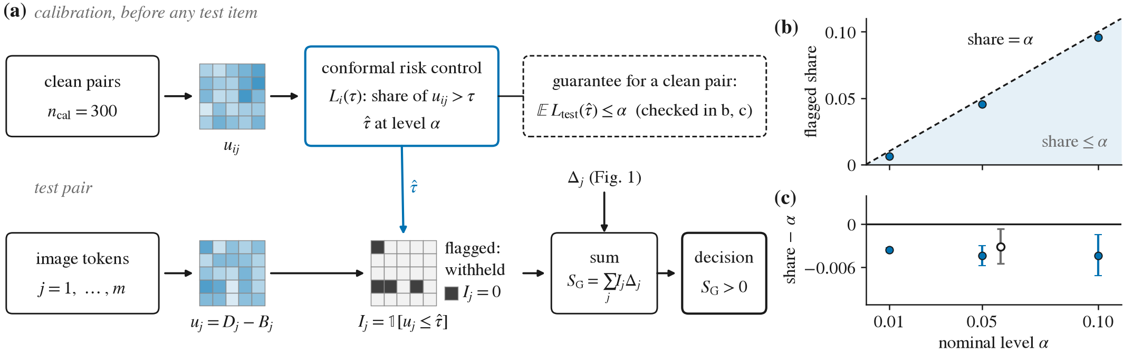
Fig. 2. Study 1: masked-likelihood token gating with a threshold from conformal risk control. (a) Schematic (no data; fixed token patterns). On $n_{cal}=300$ clean calibration pairs, the suspicions $u_{ij}$ give the false-alarm proportion $L_{i}(τ)$, and conformal risk control sets $\hat{τ}$ at level $α$ (6) before any test item is seen; on a test pair, flagged tokens ($I_{j}=0$) are withheld by masking, which removes their evidence $Δ_{j}$ from $S_{G}$ (7). (b) Realised flagged share of the 500 clean test pairs against $α∈\{0.01,0.05,0.10\}$. (c) Share minus $α$ with its 95% percentile-bootstrap interval (10 000 resamples); open marker: exploratory re-split check (2 000 re-splits of the pooled clean pairs; mean and 2.5 to 97.5% range; descriptive). The check covers clean pairs only, not the unchanged tokens of corrupted items.
Threshold by conformal risk control: The threshold is set on a calibration set $D_{cal}$ of $n_{cal}$ clean pairs, disjoint by image from every other fold. For item $i$ with suspicions $u_{ij}$, the false-alarm proportion at threshold $τ$ is
$L_{i}(τ)=\frac{1}{m}\sum_{j=1}^{m}{1}\left[u_{ij}>τ\right]∈[0,1],$ (5)
which does not increase in $τ$. With Fcal(τ)=ncal−1i​Li(τ), the threshold is
$\hat{τ}=inf\left\{τ: {n_{cal}}/{n_{cal}+1} {\hat{F}}_{cal}(τ)+1/{n_{cal}+1}≤α\right\},$ (6)
with $\hat{τ}=+∞$ if the set is empty; ties from bf16 logits are broken by a small random jitter (supplement S-I). The calibration set has $n_{cal}=300$ pairs and the primary level is $α=0.05$.
Proposition 1 (conformal risk control applied). Let the calibration items and a new clean test item be exchangeable as items, and let $L_{i}$ be given by (5) with scores that have no ties. Then $E\left[L_{test}(\hat{τ})\right]≤α$.
Proof. The loss is bounded by one and does not increase in the threshold, so the statement is Theorem 1 of conformal risk control [51] with bound $B=1$. □
This is the only guarantee in the paper, and it applies only to the expected share of flagged tokens in a clean test pair exchangeable with the calibration pairs, which is at most $α$. The bound is over items, so tokens inside an item need not be exchangeable, and it is marginal over the draw of the calibration set. It says nothing about detection power, about false alarms among the clean tokens of a corrupted item, or about a shift between calibration and test (Fig. 2(a)).
The gate and GATE-M: Let $I_{j}=1[u_{j}≤\hat{τ}]$ be the keep indicator of token $j$ and $G=\{j:I_{j}=0\}$ the flagged set. GATE-M withholds the flagged tokens by masking them. Because the logits of the image-direction passes do not depend on the image (Section III-B), withholding token $j$ removes its term $Δ_{j}$ from the evidence:
$S_{G}=\sum_{j=1}^{m}{I_{j}}Δ_{j}, Y_{G}=1\left[S_{G}>0\right],$ (7)
with a tie or an empty kept set counted as wrong. With $I_{j}≡1$ this is the unweighted rule of Section III, called none below. For a Bayes-optimal denoiser of the absorbing-state objective, masking $G$ marginalises those tokens out [3], but $G$ is selected from the observed values, so the missingness is informative [60]. Marginalising is then the Bayes answer only if no kept token is corrupted, corrupted values carry no information about clean ones, corruption locations do not depend on the content, and the clean tokens in $G$ carry no evidence; this was stated in advance and is not an account of any result.
Two further arms use the same flags. A re-infilling arm re-infills the flagged tokens with the model, with the caption masked, and keeps the best of four unguided draws by chain log-likelihood, with the sampler fixed in the analysis plan, not that of the backbone’s authors. The text direction, used only by family B, scores the caption tokens with the image visible, minus the same pass with the image masked.
A model of when withholding helps an additive statistic: The following is theory under stated assumptions, not validated on UniDisc, and no result below is read through it. Let a fraction $ρ$ of the $m$ tokens be corrupted. Clean terms $Δ_{j}$ have mean $μ$ and variance $σ^{2}$ (moments of the evidence, not the noise level of Section III-C) and are kept with probability $1−ϕ_{0}$; corrupted terms have mean $μ_{c}$ and variance $σ_{c}^{2}$ and are kept with probability $1−ϕ_{1}$.
Lemma 1 (independent tokens). If the terms $Δ_{j}$ are independent given the corruption labels and every $I_{j}$ is independent of all $Δ_{k}$, then
$\begin{aligned}ES_{G}&=m\left[(1−ρ)(1−ϕ_{0})μ+ρ(1−ϕ_{1})μ_{c}\right],\end{aligned}$ (8)
$\begin{aligned}VarS_{G}&=m[(1−ρ)\left\{(1−ϕ_{0})σ^{2}+ϕ_{0}(1−ϕ_{0})μ^{2}\right\} \\ & +ρ\left\{(1−ϕ_{1})σ_{c}^{2}+ϕ_{1}(1−ϕ_{1})μ_{c}^{2}\right\}].\end{aligned}$ (9)
For $μ_{c}=0$ and $ES_{G}>0$, the gate raises $ES_{G}/\sqrt{VarS_{G}}$ above its value at $ϕ_{0}=ϕ_{1}=0$ if and only if
$ρ σ_{c}^{2} (ϕ_{1}−2ϕ_{0}+ϕ_{0}^{2}) > ϕ_{0}(1−ϕ_{0})(1−ρ) (σ^{2}+μ^{2}).$ (10)
Proof. $Var(I_{j}Δ_{j})=kσ_{z}^{2}+k(1−k)μ_{z}^{2}$, where $z$ is the token’s class (clean or corrupted), $μ_{z}$ and $σ_{z}^{2}$ are the moments of that class and $k$ is its keep probability; sum over tokens. The condition is Proposition 2 below at zero correlation. □
Three consequences follow. A necessary condition is $ϕ_{1}>2ϕ_{0}−ϕ_{0}^{2}$; a random gate, with $ϕ_{1}=ϕ_{0}$, lowers the ratio; and on a clean item any gate with $ϕ_{0}>0$ lowers it slightly. The descriptive family E-pred uses (8) and (9) as preregistered.
Correlated tokens: Neighbouring image tokens are correlated, so (9) is an approximation. The following statement replaces independence by an exchangeable correlation; it is theory under stated assumptions and is not evaluated on the model.
Proposition 2 (withholding with exchangeably correlated tokens). Condition on the corruption labels, so that $(1−ρ)m$ tokens are clean and $ρm$ are corrupted, with the moments and keep probabilities of Lemma 1. Assume (a) that for $j≠k$ the correlation of $Δ_{j}$ and $Δ_{k}$ is $γ_{0}$ if both tokens are clean, $γ_{1}$ if both are corrupted and $γ_{01}$ otherwise, with values for which the covariance matrix is positive semi-definite; and (b) that the keep indicators $I_{j}$ are independent of each other and of every $Δ_{k}$. Then $ES_{G}$ is given by (8), and
$\begin{aligned}VarS_{G}=​&V+(1−ρ)m\left((1−ρ)m−1\right)(1−ϕ_{0})^{2}γ_{0}σ^{2} \\ &+ρm(ρm−1)(1−ϕ_{1})^{2}γ_{1}σ_{c}^{2} \\ &+2ρ(1−ρ)m^{2}(1−ϕ_{0})(1−ϕ_{1})γ_{01}σσ_{c},\end{aligned}$ (11)
where $V$ is the right side of (9). If moreover $μ_{c}=0$ and $ES_{G}>0$ with and without the gate, the gate raises $ES_{G}/\sqrt{VarS_{G}}$ if and only if
$\begin{aligned}&ρ σ_{c}^{2}[(ϕ_{1}−2ϕ_{0}+ϕ_{0}^{2}) \\ & +(ρm−1) γ_{1} (ϕ_{1}−ϕ_{0})(2−ϕ_{0}−ϕ_{1})] \\ & +2ρ(1−ρ) m γ_{01} σσ_{c} (1−ϕ_{0})(ϕ_{1}−ϕ_{0}) \\ & > (1−ρ) ϕ_{0}(1−ϕ_{0}) (σ^{2}+μ^{2}).\end{aligned}$ (12)
Consequently: (i) $γ_{0}$ does not enter (12), and at $γ_{1}=γ_{01}=0$ it is (10); (ii) a gate with $ϕ_{1}=ϕ_{0}$, such as a random gate, lowers the ratio for every admissible correlation, and if $γ_{01}≥0$ every gate with $ϕ_{1}≤ϕ_{0}$ lowers it; (iii) where $ϕ_{1}>ϕ_{0}$, a larger $γ_{1}$ or $γ_{01}$ can only turn a decrease of the ratio into an increase, so positive correlation among corrupted tokens, or between clean and corrupted tokens, enlarges the region of $(ϕ_{0},ϕ_{1})$ in which the gate raises the ratio, and as $(ρm−1)γ_{1}→∞$ that region tends to $\{ϕ_{1}>ϕ_{0}\}$; (iv) if $γ_{01}<0$, a gate that flags only clean tokens can raise the ratio; (v) unlike (10), the condition depends on $m$.
Proof sketch. Each of the $m(m−1)$ ordered pairs of distinct tokens adds $EI_{j} EI_{k} Cov(Δ_{j},Δ_{k})$ to $VarS_{G}$, which gives the three correlation terms of (11). With $μ_{c}=0$ the gate multiplies $ES_{G}$ by $1−ϕ_{0}$, so it raises the ratio if and only if $(1−ϕ_{0})^{2} VarS_{G}|_{ϕ_{0}=ϕ_{1}=0}>VarS_{G}$; the clean-pair terms scale by $(1−ϕ_{0})^{2}$ on both sides and cancel, and the remaining terms, divided by $m$, give (12). The full proof is in supplement S-II. □
Fig. 3 draws the frontier of (12). The ratio in Proposition 2 is the signal-to-noise ratio of the sum. If the per-token terms are jointly Gaussian, the accuracy $P(S_{G}>0)$ given the flags is $Φ$ of the conditional ratio, which the unconditional ratio approximates; without joint Gaussianity no statement about accuracy follows, and a gate can raise the ratio while lowering the accuracy. Assumption (b) is an approximation for this gate, whose flags are computed from the same token values as the evidence. With correlation the ratio no longer grows like $\sqrt{m}$; it tends to a limit set by the shared component of the per-token terms. E-pred does not use Proposition 2, and the proposition is not used to interpret E-pred or any other result.
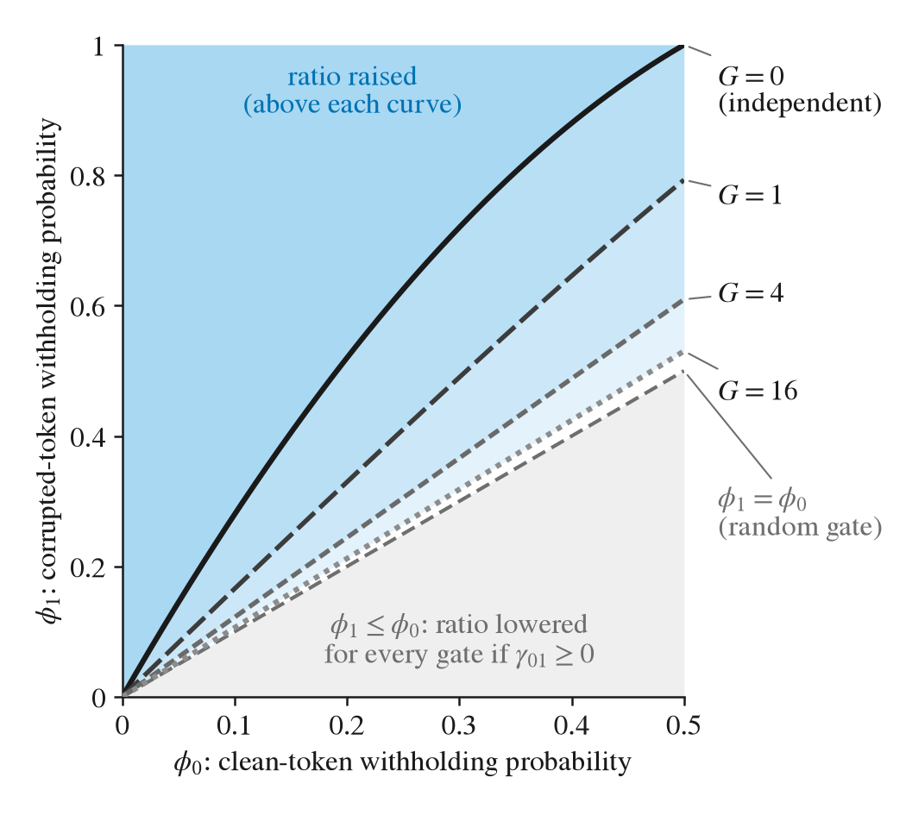
Fig. 3. Model figure, no data: a model of when withholding helps an additive statistic (theory under stated assumptions, not validated on UniDisc). Above each curve $ϕ_{1}=b(ϕ_{0};G,χ)$ of Proposition 2 (shaded), withholding raises $ES_{G}/\sqrt{VarS_{G}}$; $μ_{c}=0$, $γ_{01}=0$, $χ=ρσ_{c}^{2}/[(1−ρ)(σ^{2}+μ^{2})]=1$ and $G=(ρm−1)γ_{1}=0$ (independent tokens, (10)), 1, 4, and 16. A larger $G$ lowers the curve towards the diagonal $ϕ_{1}=ϕ_{0}$ (random withholding). Grey: every rule with $ϕ_{1}≤ϕ_{0}$ lowers the ratio when $γ_{01}≥0$.

B. Preregistered Protocol
The protocol was fixed in a preregistration card, a statistical analysis plan with its addenda, and a method specification before any outcome of the main run existed; pins, audits, amendments, and the protocol details omitted here are in supplement S-I.
Folds and negatives: Four image-disjoint sets were drawn from COCO val2017 [57] by image id with seed 20261029: calibration (300 pairs), headroom (100), test (300, with an ordered extension to 500 if the sample-size rule asks for it), and the 200 items of an earlier detection pilot, which form the detection set. The 494 image ids of the two pilots are excluded from the new folds. The wrong caption of an item is a caption of another image that shares no annotated COCO category with the true image, fixed once per item and shared by every arm and corruption.
Headroom rule and sample size: Each realistic corruption has two severities (rungs), walked in order from the one defined in Section III-C. Two sanity corruptions replace tokens by uniform random codes (one $8×8$ patch of the token grid; 15% of tokens) and form the positive control. On the 100 headroom items, with no gate flag computed, the operating point is the first rung at which the size-normalised evidence falls under corruption and recovers under the changed-code gate; this gate keeps exactly the tokens whose code did not change. The largest headroom discordance $D^{*}$ between the changed-code gate and no gate then sets the test size by a pre-written rule. The decision file was committed before the first test item was scored.
Arms and controls: The primary contrast is GATE-M against none. The controls are a geometry-matched random gate (the flag mask shifted on the torus, three seeds), equal-size scattered and top-$k$ gates, the changed-code gate, a pixel denoiser, and GATE-M on clean images (supplement S-II). Token detection is measured against changed-code labels by per-item AUROC. Cheap rivals are admitted in both orientations, so the rival and its sign are chosen on the data; a one-pass observed-position score of the non-finetuned backbone (TbV, after Trust but Verify [32]) is reported beside them.
Families and reading rules: The primary family P has three hypotheses, one per realistic corruption at its operating point. Each compares GATE-M with none on the paired correctness of (7) by the exact two-sided McNemar test, with Holm correction over the three hypotheses at familywise level 0.05; a corruption without an operating point stays in the family with $p=1$. The wording for every outcome was fixed before the headroom decision was written. The label is positive if a hypothesis is rejected after Holm with $b>c$ and none with $c>b$. It is negative if none is rejected and, for every corruption with an operating point, the 90% paired bootstrap interval of the net accuracy change lies inside $(−0.05,+0.05)$ with at least 240 completed items; it is inconclusive otherwise. A null result is worded as a bounded change, never as an absence of effect. The percentile interval has zero width whenever no pair is discordant (counts in the family P table, supplement S-II). Each secondary family has its own level 0.05 (sizes, tests, and wording rules in supplement S-I). The positive control PS repeats the P test on the two sanity corruptions (Holm over two); a pass reads “the pipeline is not broken”. A mechanism test (GATE-M against the geometry-matched gate) and a second-model family run only on a corruption with a primary rejection with $b>c$.

C. Results
Bootstrap intervals use 10 000 resamples, accuracy is image-direction verification accuracy, a cell is bold only when its preregistered test rejected, and there is no adjustment across families (Section III-E).
1) Operating points and family P: The first rung of every realistic corruption passed the headroom rule, and $D^{*}=19$ selected 500 test items with the correctness endpoint (supplement S-II gives the headroom statistics). In the preregistered test no improvement was detected under JPEG quality 10, Gaussian noise with $σ=0.1$, or a 128-pixel splice. For each tested corruption the 90% interval of the net accuracy change lay inside $±0.05$: $−0.002$ ($−0.006$ to $0.000$) under JPEG, $0.000$ ($0.000$ to $0.000$) under noise, and $−0.004$ ($−0.010$ to $0.002$) under splice, with $n=500$ each, so an improvement or a loss larger than 0.05 is excluded. This does not show that the gate has no effect. It holds in one pretrained unified masked diffusion model (UniDisc, 1.4B parameters) on COCO image-caption pairs with a random caption of an image sharing no annotated COCO category (category-disjoint) as the negative, at one severity per corruption. By the pre-stated rule the label of family P is negative: no hypothesis was rejected after Holm correction over the three hypotheses, and every corruption had an operating point and 500 completed items, with no caption-token exclusion and no empty or non-finite evidence. Fig. 4 shows the intervals; the full test, with $b$, $c$, $n_{d}$, the 98.33% Holm-level intervals, and the exact bounds, is the family P table in supplement S-II.
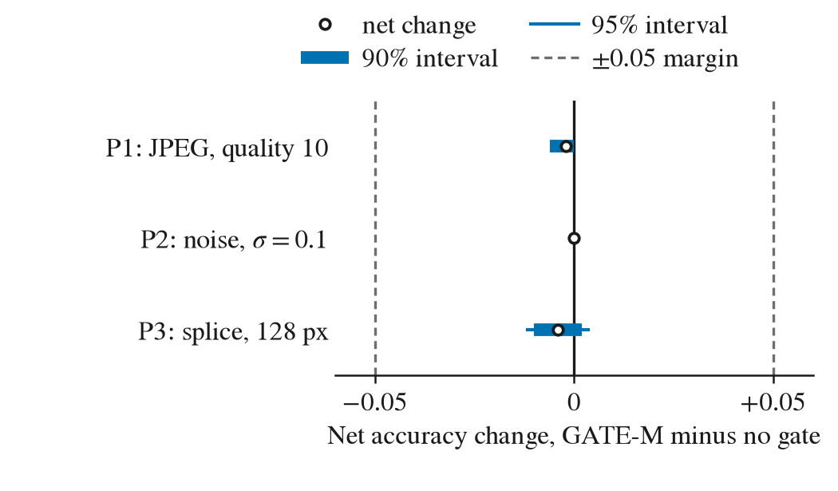
Fig. 4. Family P: net accuracy change of GATE-M minus no gate (open circle), $n=500$ items per corruption (P1 JPEG quality 10, P2 Gaussian noise with standard deviation 0.1, P3 splice of 128 px). Thick bar: 90%, thin bar: 95% paired percentile bootstrap interval (10 000 resamples); solid line at 0; dashed lines: the $±0.05$ margin. An interval has zero width when no pair is discordant (counts in the family P table, supplement S-II).
2) Calibration and the clean control: On the 500 clean test pairs the realised flagged share was 0.0456 at $α=0.05$ (95% interval 0.0442 to 0.0470), and at no level was there evidence of a violation of Proposition 1 (Fig. 2(b),(c)); the calibration statistics, and the flagged share of the unchanged tokens of corrupted items, which the guarantee does not cover, are in supplement S-II. In the clean control GATE-M gave 0.882 against 0.880 without a gate (net $0.002$, 95% interval $−0.004$ to $0.010$; $p=1.00$): no change was detected.
3) Positive control (PS, pipeline check): On the 500 test items GATE-M gave 0.870 against 0.870 without a gate under the patch corruption (net 0.000, 95% interval $−0.008$ to 0.008; $p=1.00$, Holm-adjusted 1.00) and 0.876 against 0.870 under swap (net 0.006, $−0.008$ to 0.020; $p=0.581$, Holm-adjusted 1.00). Neither hypothesis of the positive control was rejected (full table in supplement S-II), so the control was not met, which by the plan reads “pipeline defect suspected, audit triggered”. The plan’s audit (an automated audit run in the authors’ own pipeline, not an independent review) ran the unit tests of the run’s code (584 passed, 5 skipped, none failed) and recomputed every PS quantity from the stored arrays of all 500 items; it found no defect. Because it cannot see an error upstream of the stored arrays, it is not read as a check of the whole pipeline.
4) Token detection: On the detection items (about 200; exact counts in Fig. 5) the gate’s masked-likelihood score $q_{j}=−u_{j}$ separates code-level random replacements but is near chance on JPEG and Gaussian noise (Fig. 5(a)). On noise it is below the one-pass TbV score of the non-finetuned backbone; the marginal intervals do not overlap, which is descriptive, and no paired test was run; on JPEG the two overlap. With the best cheap rival (the pixel variance of a token’s patch, sign reversed) frozen and re-scored on the test items, $q$ minus the rival was $−0.198$ ($−0.211$ to $−0.186$) under JPEG and $−0.258$ ($−0.267$ to $−0.250$) under noise (Holm-adjusted $p=0.0004$). On the detection items, where the rival and its sign were selected, $q$ also lies below it (same-item selection; Fig. 5(b)). The preregistered falsifier for the score was therefore met, and this paper makes no claim that the score detects corrupted codes more accurately than cheap methods. The labels mark codes that the tokeniser changed, which a texture score can anticipate without any reference to the evidence; the rival’s higher AUROC is read as a sign of this label circularity, not as evidence about any corruption effect.
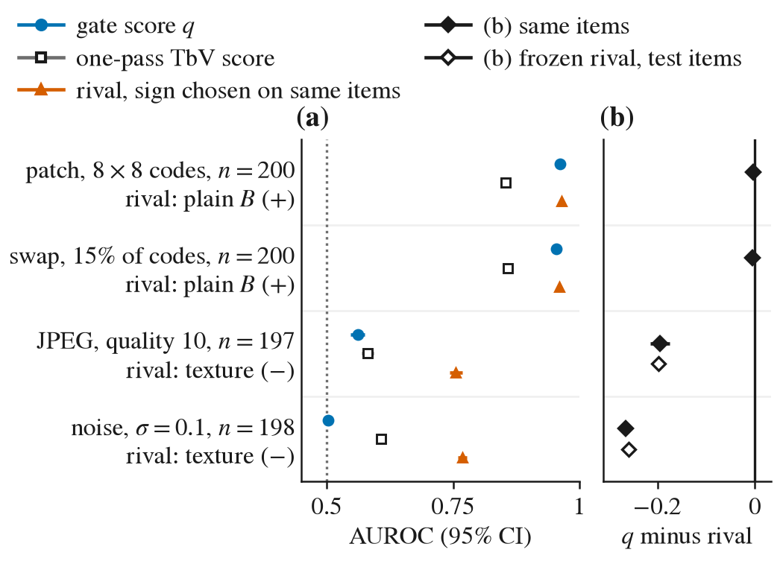
Fig. 5. Study 1, detection of changed image tokens (descriptive of the gate’s score; not part of family P). (a) Mean per-item AUROC against changed-code labels with the 95% percentile-bootstrap interval over items (10 000 resamples), $n$ per row as printed: the gate’s score $q_{j}=−u_{j}$, the one-pass TbV score of the non-finetuned model, and the best cheap rival, chosen with its sign on these same items among both orientations of every cheap score (same-item selection, so optimistic; name and sign in the row label). (b) Paired difference $q$ minus rival with its 95% interval, on the detection items where the rival was selected (filled) and with the rival frozen and re-scored on the test items (open; JPEG and noise; 492 and 497 items; Holm-adjusted $p=0.0004$ for both, the resolution floor of 10 000 resamples). Values in supplement S-II.
5) Mechanism and the remaining secondary families: No hypothesis of the mechanism test was tested, and the second-model family was not run, because both are conditional on a primary rejection with $b>c$. The equal-size gates, the evidence-ratio and pixel-denoising families, the descriptive families (including E-pred), and the denoiser’s coherence check are in supplement S-II and enter no statement about P.
6) Re-infilling the flagged tokens: On 300 items per cell, as planned, re-infilling the flagged set against re-infilling an equal-size random set (kept draw, exact McNemar, Holm over two) gave a net change of $0.010$ ($0.000$ to $0.023$; $p_{Holm}=0.50$) under the patch corruption and $−0.003$ ($−0.017$ to $0.007$; $p_{Holm}=1.00$) under splice. Neither cell was rejected; there is no evidence that the flagged set is better placed than a random one under this sampler, and nothing is stated about the backbone’s own re-infilling.
7) Family B: the two directions on foil captions: Family B, the preregistered two-way fusion test, compares a score-level combination of the text and image directions (Fisher discriminant weights fitted on separate fit pairs and frozen) with the better single direction. Its pairs come from FOIL-COCO [61]: clean images whose negative caption differs from the true caption in one word, so the family is not a corruption test. On the 298 test pairs the combination reached 0.876 against 0.879 for the better direction, the text direction (net $−0.003$, 95% interval $−0.010$ to $0.000$; $p=1.00$), so no gain of the combination over the better single score was detected (fit pairs and minimum detectable gain in supplement S-II).
8) Family H (added after the primary result): In a separately labelled family added after the primary result was known (family H: SugarCrepe hard negatives [12] on 50 COCO images not used elsewhere; Holm over the same three corruptions), the pre-written pilot rule found no corruption with decision headroom on 50 pilot images, so the family’s test was not run. Its rules and code were committed before any hard-negative item was scored (disclosure, caveats, and decision record in supplement S-III), and because its test was not run, nothing is stated about the gate on hard negatives.
9) Exploratory analyses: An exploratory comparison pre-specified in an addendum to the analysis plan, with intervals only and run once after the primary analysis was committed, contrasts the hard gate with five combiners of the same $Δ_{j}$: three that need no detector, a discount of the flagged tokens, and a graded weight on every token; the median and 20% trimmed-mean combiners are reported with their exact intervals in supplement S-II. The data do not show a difference between the hard gate and a trimmed mean that removes as many tokens as the gate flagged (exact 95% bounds on the difference of 0.023, 0.014, and 0.017). By the pre-stated rule, this counts against the added value of the detector on those cells (every cell, comparator, and limit in supplement S-II). In an exploratory suite of eight further cells (four corruption types of the imagecorruptions package [54] at two severities, 100 test items each; intervals only), no cell’s 95% interval of GATE-M minus none excluded zero (supplement S-II).
10) Cost: The main-test pass, which computes every arm of Study 1 at once, used a median of 84 network rows (one row is one input sequence in a forward-pass batch) and 11.2 s per item on one 12 GB laptop GPU, with a peak memory of 8.2 GB (supplement S-II).

V. Study 2: Learned Reliability-Aware Fusion of Token Evidence
Study 2 answers Q2 (Section I); the tested weighting of the evidence $Δ_{j}$ is called learned reliability-aware fusion (LRF), a name that describes its design, not a measured property.

A. Provenance of the Tested Method
Study 2 was added after Study 1 had been analysed (primary result negative), when the target venue changed. The method it tests was designed post hoc on Study 1’s 500 test items. Before the design, Study 1’s primary and secondary results, its positive-control audit, its exploratory comparators, and an exploratory learned-weighting analysis had all been seen. In that analysis four learned-weighting families (a logistic generalised additive model, gradient-boosted trees, a multilayer perceptron, and a grid model) were compared, and the logistic generalised additive model was selected by inner cross-validation. Two other method designs and two other project routes were considered and not pursued. A first freeze was found to read the true caption’s length through the layout of its inputs; the caption slot was therefore fixed, and the method was re-scored and re-frozen at that slot length, a choice declared before any re-frozen result existed. Before the re-freeze the analysts had also seen the result table of Study 1’s re-infilling family, the result of its family B, and the code of the decision rule of its family H; the re-freeze protocol itself had been fixed earlier and was not changed. The configuration was frozen (SHA-256 db7fdb4e…, commit 24d36a8a) before any Study 2 image was selected. Study 2 was preregistered (a dated addendum to the analysis plan, commit 941a260b) with a rule that no further confirmatory study would be added. All LRF numbers on Study 1’s items are post hoc and exploratory and appear only in supplement S-IV. Study 2 tests a different method on different images and does not bear on Study 1’s conclusion.
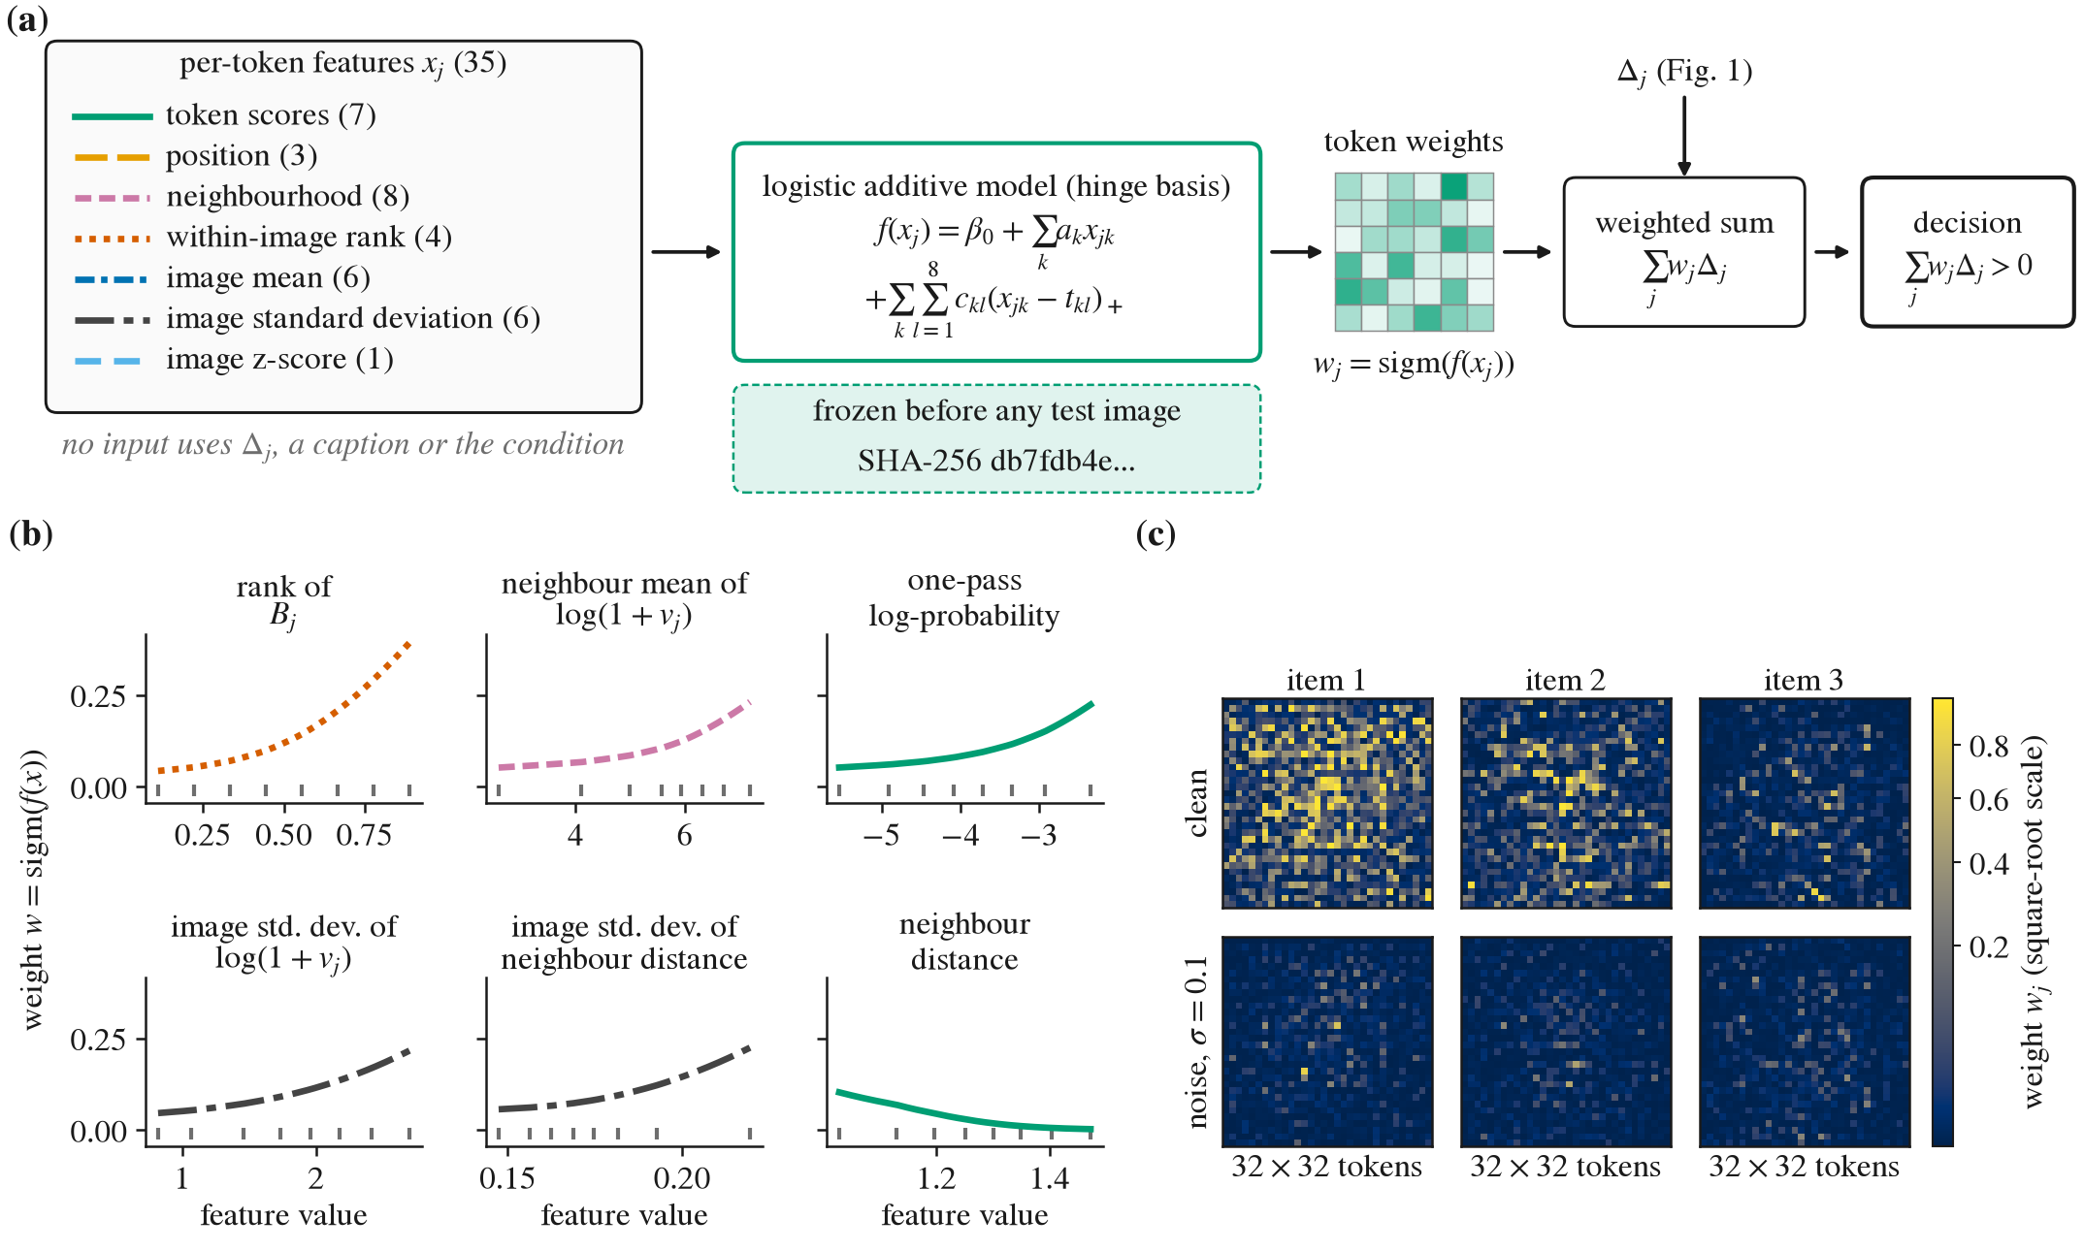
Fig. 6. Study 2: learned reliability-aware fusion (LRF) and its frozen weight model. (a) Schematic (no data; fixed weight grid). Each image token has 35 features $x_{j}$ in seven groups (counts as printed; formulas in supplement S-IV); no feature uses $Δ_{j}$, a caption, or the identity of the condition. A logistic additive model with a hinge basis (13) gives the weight $w_{j}$, and the true caption is chosen if j​wjΔj>0 (14). (b) Partial dependence of $w$ on the six of 35 features with the largest learned effect range, every other standardised feature at its mean 0 (knots: grey ticks; line style: feature group of (a)). (c) Token-weight maps on the $32×32$ grid for the first three items of the fold file (chosen by position, not outcome), clean (top) and under Gaussian noise with standard deviation 0.1 (bottom), on one square-root colour scale. Descriptive; not evidence that the weights track corruption.

B. The Frozen Weighting
Reliability-weighted fusion gives each source of evidence a weight that depends on its reliability [34]–[36], [38], [41], and attention-based multiple-instance pooling learns instance weights from instance features under a bag-level loss [45]. LRF applies this construction to the per-token evidence of a unified masked diffusion model: an additive model maps features of each image token to a non-negative weight, and the decision is the sign of the weighted evidence.
Features: Each token has 35 features in the seven groups of Fig. 6(a) (formulas in supplement S-IV). One group holds seven token scores (five computed by the model with the caption masked, a patch-texture score, and a codebook-neighbour distance), one holds the token’s grid position, and the other five summarise the scores over a neighbourhood or the image. No feature uses $Δ_{j}$, the caption-visible log-probabilities, the captions, the corruption labels, or the identity of the condition. Features are standardised with the means and standard deviations of the design tokens.
Weight model and decision: For token $j$ with standardised features $x_{j1},…,x_{j,35}$, the weight is a logistic generalised additive model [62] with a hinge basis,
$w_{j}=sigm\left(β_{0}+\sum_{k=1}^{35}{a_{k}}x_{jk}+\sum_{k=1}^{35}{\sum_{l=1}^{Q}{c_{kl}}} (x_{jk}−t_{kl})_{+}\right),$ (13)
where $sigm$ is the logistic function and the knots $t_{kl}$ are the $l/(Q+1)$ quantiles of feature $k$ over the design tokens. The decision and the normalised margin are
TABLE II
Study 2 Preregistered Families on the Fresh Fold: Accuracy Without and With LRF, Discordant Counts, $p$-Values, and Decisions
Hypothesis | $n$​ | Acc. none | Acc. LRF | $b$​ | $c$​ | Net (95% interval) | $p$ one-sided | $p$ Holm | $p$ two-sided | Preregistered decision
L1: noise, $σ=0.1$ | 450 | 0.733 | 0.802 | 58 | 27 | 0.069 $[0.029, 0.109]$ | 0.0005 | – | 0.001 | confirmed (one-sided)
L3: JPEG, quality 10 | 450 | 0.849 | 0.864 | 27 | 20 | 0.016 $[−0.013, 0.044]$ | 0.191 | 0.382 | 0.382 | not rejected
L4: splice, 128 px | 450 | 0.896 | 0.927 | 24 | 10 | 0.031 $[0.007, 0.058]$ | 0.012 | 0.049 | 0.024 | rejected (Holm)
L-NI: clean images | 450 | 0.887 | 0.918 | 27 | 13 | 0.031 $[0.009, 0.053]$$​^{†}$ | – | – | – | non-inferior (lower bound 0.009 above $−0.03$)
L-LEN: noise, length-matched negatives | 449 | 0.708 | 0.784 | 67 | 33 | 0.076 $[0.033, 0.120]$ | 0.0004 | – | 0.0009 | rejected (one-sided)
LG: shot noise | 300 | 0.673 | 0.767 | 43 | 15 | 0.093 $[0.047, 0.143]$ | 0.0002 | 0.0005 | 0.0003 | rejected (Holm, one-sided)
LG: impulse noise | 300 | 0.700 | 0.750 | 35 | 20 | 0.050 $[0.000, 0.100]$ | 0.029 | 0.029 | 0.058 | rejected (Holm, one-sided)
LG: speckle noise | 300 | 0.697 | 0.757 | 32 | 14 | 0.060 $[0.017, 0.103]$ | 0.006 | 0.011 | 0.011 | rejected (Holm, one-sided)
$b$: items LRF answers correctly and the unweighted rule incorrectly; $c$: the reverse; net $=(b−c)/n$. Intervals: 95% paired percentile bootstrap (10 000 resamples), except $​^{†}$ (L-NI): 90%, margin $−0.03$ fixed after an exploratory clean interval had been seen; L-NI’s test is the lower 90% bound against the margin, so no $p$ is printed. $p$: exact McNemar; $p$ Holm: L3 and L4 after L1 (two-sided), LG over its three cells (one-sided). Bold: null rejected at the preregistered level.
YLRF=1j=1mwjΔj>0, M=j​wjΔjj​wj, (14)
with a tie counted as wrong.
Objective and tuning: The parameters minimise, over the item-conditions of the design set,
$\frac{1}{N}\sum_{i=1}^{N}{log}\left(1+e^{−M_{i}/T}\right)+λ\left(∥a∥^{2}+∥c∥^{2}\right),$ (15)
a softplus loss on the margin $M_{i}$ of (14), which is positive when the true caption is chosen. The temperature is $T=0.170$; optimisation is AdamW without weight decay on mini-batches of 32 item-conditions. The configuration selected by successive halving on three inner folds of the 500 design items (search in supplement S-IV; $Q=8$ knots, $λ=0.0027$, learning rate 0.0169) was refitted on all 500 items for 40 epochs with a fixed seed. The training data were the 500 design images, each scored clean, after JPEG compression at quality 10, with Gaussian noise of standard deviation 0.1, and with a 128-pixel splice; these are also the four tested conditions.
Fixed caption slot and hashes: The caption-masked scores are computed with the caption slot filled by 13 padding tokens, so they do not depend on the length of either caption; $Δ_{j}$ keeps each caption at its own length (invariance checks in supplement S-IV). The model file and every input of the scorer are pinned by SHA-256 and checked before each item (supplement S-I). Fig. 6 draws the model and shows the learned shapes and three example weight maps.

C. Preregistered Protocol
Fresh fold and sample size: The fold was built after the object commit: 533 COCO val2017 images in a seeded order, drawn from the 2 449 eligible images that remain after the exclusions of Section III-D (2 526 image ids, some outside the captioned set) and the removal of images without instance annotations. Each image has one seeded true caption of 5 to 32 tokens, a wrong caption drawn by the preregistered derangement rule (a random caption of another fold image sharing no annotated COCO category with it), and a second, length-matched wrong caption drawn under the same category rule. The fold, its eight-check leak test (with an injected leak as positive control), and the code passed automated audits run in the authors’ own pipeline (not independent reviews) before the first item. A preregistered power rule, committed before the first item, fixed the test size as a prefix of the ordered list, so it could not select items: $n_{L}=450$ (its inputs are in supplement S-IV).
Arms, families, and tests: The arms are none (weight one on all 1 024 tokens) and LRF, under clean images and the three corruptions of Section III-C. Family L has three hypotheses, tested in a fixed sequence followed by Holm (familywise level 0.05). The primary L1 tests LRF against none under noise by the exact one-sided McNemar test at 0.05 and is “confirmed” if and only if $p≤0.05$ and $b>c$. Only if L1 is confirmed are L3 (JPEG) and L4 (splice) tested, by exact two-sided McNemar tests with Holm over two. A gain claim in the title, abstract, or highlights required L1 one-sided $p≤0.025$. L-NI (one hypothesis, regardless of L1) tests non-inferiority on clean images with margin $−0.03$, read from the lower bound of the 90% paired bootstrap interval; the margin was fixed after an exploratory clean interval had been seen. L-LEN (one hypothesis) repeats L1 with the length-matched wrong captions; items whose length-matched caption still differs in length are excluded and counted. Family LG (Holm over three, one-sided 0.05) tests LRF against none on other noise types (shot, impulse, speckle; imagecorruptions severity 3) [54] on the first 300 fold items. Shot and speckle noise are close relatives of Gaussian noise, impulse noise is the structurally different cell, and severity 3 is not matched to $σ=0.1$. According to the operations log, no output was read before its run was complete.

D. Results
Table II gives every preregistered test and Fig. 7 the family-L intervals; each family is at its own level, with no adjustment across families (Section III-E). The remaining quantities that the plan reports with every test ($n_{d}$, 90% intervals, the Clopper–Pearson interval of $b/n_{d}$ and the mid-$p$ values) are in supplement S-IV. On a fresh preregistered fold, the frozen LRF raised image-direction verification accuracy under Gaussian noise ($σ=0.1$) from 0.733 without reliability weighting to 0.802 (net 0.069, 95% interval 0.029 to 0.109; exact one-sided McNemar $p=0.0005$; preregistered one-sided $α=0.05$), including with length-matched negatives (0.708 to 0.784, net 0.076, 0.033 to 0.120; one-sided $p=0.0004$; $n=449$, one item excluded for a length mismatch). L1 is therefore confirmed. This result holds in one pretrained unified masked diffusion model (UniDisc, 1.4B parameters), on 450 COCO val2017 images not used to design or fit the method, with Gaussian noise at one severity. On clean images LRF lost no more than three percentage points (0.03 in accuracy; 90% interval of the net change 0.009 to 0.053); the margin was fixed after an exploratory clean interval had been seen. The clean-image estimate, descriptive, was positive (0.887 without weighting, 0.918 with; net 0.031); superiority on clean images was not a preregistered hypothesis. Supplement S-IV plots the discordant items of L1 and of the clean cell by margin (descriptive).
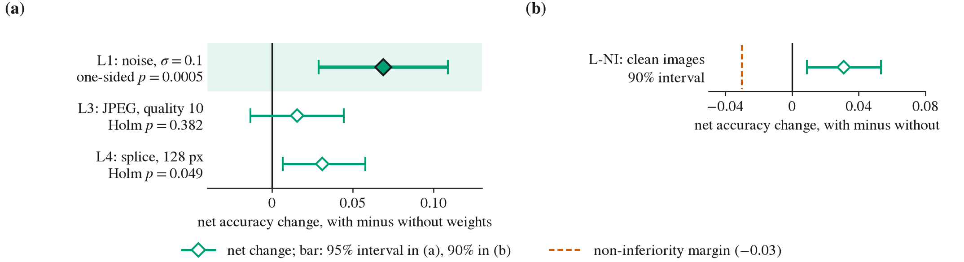
Fig. 7. Family L and L-NI on the fresh fold: net accuracy change of the frozen LRF, with minus without reliability weights, $n=450$. (a) Diamond: net change; bar: 95% paired percentile bootstrap interval. L1 (Gaussian noise, standard deviation 0.1; primary, shaded): exact one-sided McNemar $p$; L3 (JPEG quality 10) and L4 (128-px splice): Holm-adjusted two-sided $p$. (b) L-NI (clean images; own family): net change, 90% interval, and the margin $−0.03$ (dashed), fixed after an exploratory clean interval had been seen.
Under JPEG quality 10 no difference was detected (net 0.016, 95% interval $−0.013$ to $0.044$; Holm-adjusted $p=0.382$). Under the 128-pixel splice LRF raised accuracy from 0.896 to 0.927 (net 0.031, 0.007 to 0.058); the Holm-adjusted $p$ is 0.049, 0.001 below the 0.05 level (unadjusted two-sided $p=0.024$). No tested condition showed a reduction: the lowest 95% bound was $−0.013$, under JPEG.
None of the three other noise types (shot, impulse, speckle; imagecorruptions severity 3) was a training condition of the frozen weighting (training conditions: clean, JPEG quality 10, Gaussian noise 0.1, 128-pixel splice). Shot and speckle noise are close relatives of Gaussian noise, impulse noise is the structurally different cell, and severity 3 is not matched to $σ=0.1$; no claim is made about corruption types not tested. On these types ($n=300$ each), each LG hypothesis was rejected with $b>c$. Under shot noise accuracy rose from 0.673 to 0.767 (net 0.093, 0.047 to 0.143; one-sided $p=0.0002$, Holm-adjusted $p=0.0005$, two-sided $p=0.0003$), and under speckle noise from 0.697 to 0.757 (net 0.060, 0.017 to 0.103; one-sided $p=0.006$, Holm-adjusted $p=0.011$, two-sided $p=0.011$). Under impulse noise it rose from 0.700 to 0.750 (net 0.050), and the 95% interval has lower bound 0.0 (0.000 to 0.100). The one-sided and Holm-adjusted $p$-values are both 0.029, and the two-sided $p$ is 0.058, so this cell would not pass a two-sided 0.05 test, and no two-sided claim is made for it. The three cells are reported separately and are not pooled.

E. Reference Encoders
For reference, CLIP ViT-L/14 [63] and SigLIP so400m [64], different models trained on different data, reached accuracies of 0.996 to 1.000 on the same items in every condition (Table III), with the same decision rule on images regenerated with the runner’s corruption functions and seeds (supplement S-VI). Pixel parity was shown: the UniDisc tokeniser’s re-encoding of the regenerated images agreed with the stored codes on at least 98.6% of tokens (five items per condition set; threshold 98%). Nearly every cell is at or next to its ceiling, so no reading beyond the stated accuracies is drawn, and no test is made.
TABLE III
Reference Accuracy of CLIP ViT-L/14 and SigLIP so400m per Condition
Condition | $n$​ | CLIP acc. | CLIP drop (95% interval) | SigLIP acc. | SigLIP drop (95% interval)
Clean images | 450 | 0.998 | – | 0.998 | –
Gaussian noise, $σ=0.1$ | 450 | 1.000 | $−0.002$ $[−0.007, 0.000]$ | 0.998 | 0.000 $[0.000, 0.000]$
JPEG, quality 10 | 450 | 0.998 | 0.000 $[0.000, 0.000]$ | 1.000 | $−0.002$ $[−0.007, 0.000]$
Splice, 128 px | 450 | 0.996 | 0.002 $[0.000, 0.007]$ | 1.000 | $−0.002$ $[−0.007, 0.000]$
Clean images, same 300 items | 300 | 0.997 | – | 0.997 | –
Shot noise, severity 3 | 300 | 1.000 | $−0.003$ $[−0.010, 0.000]$ | 0.997 | 0.000 $[0.000, 0.000]$
Impulse noise, severity 3 | 300 | 0.997 | 0.000 $[0.000, 0.000]$ | 0.997 | 0.000 $[0.000, 0.000]$
Speckle noise, severity 3 | 300 | 1.000 | $−0.003$ $[−0.010, 0.000]$ | 0.997 | 0.000 $[0.000, 0.000]$
Cost per item | – | not measured (no timing in any committed baseline run)
Pixel parity, 5 items, the four conditions of the top block: minimum token agreement 0.989 (threshold 0.98)
Pixel parity, 5 items, clean and three severity-3 conditions: minimum token agreement 0.986 (threshold 0.98)
For reference only: different models trained on different data; no test and no comparison are made. Same first 450 fold items (300 for the severity-3 cells) and regenerated pixels; revisions and scores in supplement S-VI. Drop: clean minus corrupted accuracy of the same model on the same items, paired percentile bootstrap 95% interval. The row “Clean images, same 300 items” was computed at writing from the stored predictions (descriptive). Cost per item was not measured. Pixel parity: runs/​P2-​LRF-​BASELINES-​PARITY-​L1 and -​LG; these supersede the field pixel_​parity: not run of the main run’s file, which records only that the main run was made without the parity option.

F. Cost of Study 2
The fresh-fold pass, which computes the unweighted rule for four conditions and stores the inputs of LRF, used 67 network rows and a median of 8.0 s per item on one 12 GB laptop GPU, with a peak memory of 8.2 GB; the stage of the other noise types used 42 rows and 5.0 s per item (supplement S-IV). LRF adds no network row; its weights and decision are computed from the stored arrays on the CPU and were not timed.

G. Exploratory Ablation
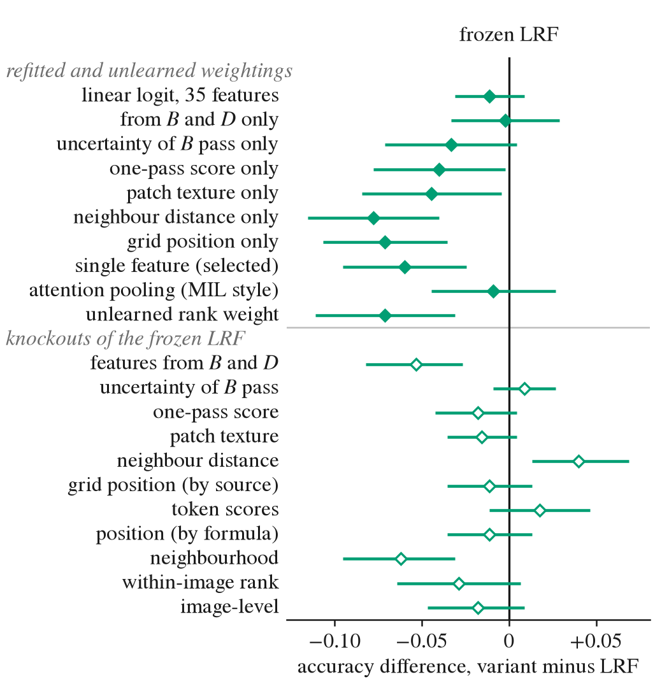
Fig. 8. Study 2, exploratory ablation (added after the primary, family H, and Study 2 results; intervals only, no test): paired accuracy difference, variant minus the frozen LRF, on the L1 noise cell ($n=450$), with the 95% paired percentile-bootstrap interval (10 000 resamples). A positive value favours the variant. Upper block: weightings refitted with LRF’s protocol on the 500 design items only, and one unlearned rank weight. Lower block: knockouts, the frozen LRF with one feature group set to its design-item mean (see the text for how a knockout interval is read). Intervals are marginal, dependent, and unadjusted (supplement S-VII, with the other cells).
Exploratory; added after the primary, family H, and Study 2 results; no ablation was preregistered, and every variant is in supplement S-VII. Single-source refits and other weightings were fitted with LRF’s protocol on the 500 design items only; knockouts set one feature group of the frozen LRF to its design-item mean (differences are variant minus LRF; positive favours the variant). Fig. 8 shows every variant on the noise cell. The following intervals contained zero: those of a linear logit on the same 35 features, of the features computed from $B$ and $D$ alone, of the features from the uncertainty of the $B$ pass alone, and of attention-weighted pooling in the style of gated-attention multiple-instance learning (MIL) [45]. They lay below zero for the other single-source weightings, the unlearned rank weight, and a single-feature weight (the distance from the grid centre, chosen from 35 candidate features by the inner-fold objective on the design items, a selection budget 35 times that of the frozen LRF; the selection used no fresh item). Among knockouts, the intervals for the features from $B$ and $D$ and for the neighbourhood features lay below zero and the interval for the codebook-neighbour-distance features above it; every other group’s interval contained zero. Setting a group to its mean gives inputs that the model did not see together in fitting; an interval away from zero shows that the frozen model’s decisions depend on those inputs, not that the group alone detects anything. Across the three refit seeds, the range of fresh-fold accuracy was at most 0.030 in every variant and cell; seed 0 was fixed before any fresh item and is not the best of three. The 336 intervals are dependent and unadjusted, and the other cells are in supplement S-VII.

VI. Discussion

A. Study 1
The preregistered test excludes an improvement or a loss of more than five percentage points in image-direction verification accuracy from gating under JPEG quality 10, Gaussian noise with $σ=0.1$, and a 128-pixel splice, for this model and these severities; it does not show that gating has no effect.
The exploratory comparison of the hard gate with five combiners of the same evidence is reported in Section IV-C and supplement S-II; it describes the combiners and is not an account of the primary result.
In a separately labelled family added after the primary result was known (family H: SugarCrepe hard negatives [12] on 50 COCO images not used elsewhere; Holm over the same three corruptions), the pre-written pilot rule found no corruption with decision headroom on 50 pilot images, so the family’s test was not run, and nothing is stated about the gate on hard negatives (Section IV-C8; supplement S-III).

B. Study 2
L1 shows that one frozen weighting, hash-pinned before any test image was chosen, raised image-direction verification accuracy under Gaussian noise with $σ=0.1$ on 450 COCO images that played no part in its design or fit, passing an exact paired test at the preregistered level and holding with length-matched negative captions. It does not show that the weighting works on a corruption it was not trained on, that its weights follow the reliability of a token, or that the effect carries to another model, dataset, or severity. Five inexpensive alternative readings remain open, each with its evidence in Section VI-C: (1) a reweighting that helps whatever the condition; (2) a supervised fit to the training corruption; (3) a single noise-sensitive feature, such as the codebook-neighbour distance or the one-pass observed-position score, which Fig. 6 cannot separate and on which the ablation of Section V-G bears only as an exploratory result; (4) a limited reach to other noise types, since the impulse-noise interval starts at 0.0; and (5) an unstable splice decision, whose Holm-adjusted $p$ of 0.049 lies 0.001 below the level. A second backbone or a corruption held out of training would settle these questions; neither was run.

C. Limitations
Study 1. One model and one severity per corruption were tested.
Study 2. One model, one dataset, and one severity per corruption were tested. LRF was trained on the tested corruption (Gaussian noise with $σ=0.1$ was a training condition), so L1 tests new images, not a new corruption. No preregistered test separates corruption-specific weighting from a generic gain, since the clean-image and splice estimates were also positive; the title’s “under Gaussian noise” names the tested condition, not a specificity. The Holm-adjusted $p$ of L4 is 0.049, and the two-sided $p$ of the impulse-noise cell is 0.058. The clean-image margin of L-NI was fixed after an exploratory clean interval had been seen. Whether COCO images were in the pretraining data of UniDisc, its tokeniser, CLIP, or SigLIP is unknown. Each image has one corruption realisation and one mask seed, so the intervals cover item sampling only. A fresh tokenisation of the same pixels in another process need not reproduce the stored codes: it agreed on 98.8% and 98.9% of image tokens in the two stopped self-checks (supplement S-I, Study 2 deviation 1), and on at least 98.6% in the pixel-parity runs. The reference encoders almost solve this matching task (Section V-E); this paper makes no claim of a verifier that ranks with them. No ablation was preregistered; Section V-G is exploratory. In that ablation, simpler weightings fitted on the design items (a linear logit, the features from $B$ and $D$ alone, the features from the uncertainty of the $B$ pass alone, and attention-weighted pooling) were not distinguishable from the frozen LRF within their intervals under Gaussian noise.
Both studies. All results are for category-disjoint negatives (a random caption of an image sharing no annotated COCO category with the test image). The preregistration is self-hosted (Section III-E), and the audits were run automatically in the authors’ own pipeline (not independent reviews).

D. Deviations From the Plans
Study 1: (1) The exploratory comparators of the hard gate, their parameters, and the fallback seed were fixed in an addendum committed before the main run’s headroom decision; the reading rules for few discordant items (the addendum’s revisions r2 and r3) were added after the headroom decision file was committed and read, before any main-test value or exploratory comparator output existed; the intervals carry no $p$-value and no multiplicity adjustment. (2) Outcome-label wording was fixed before the primary result, with a dated record of the null wording and of the reading adopted where card and plan differed on a rejection against the gate. (3) The time-input statement rests on a code reading at a pinned commit and a key check; its table moved to the supplement. (4) Family B ran before the re-infilling family under the plan’s fixed time inequality (a scheduling rule; supplement S-I). (5) Family H has its own disclosure and amendment items; one decision row was committed after its pilot driver started and before any pilot row existed. (6) The effective-$n$ record of the re-infilling figure carries a reason text written at analysis time. (7) The fold builder did not collect the image ids of negatives and mismatches separately (no analysis uses them), and its check left some run files outside the excluded classes unopened. (8) The exact Clopper–Pearson bounds of the family P table (supplement S-II) were added at writing (runs/​P2-​PAPER-​BOUNDS, descriptive). (9) The environment lock files of the detection and main-test stages are empty (as in Study 2 item 3). Study 2: (1) The L1 stage stopped twice at its tokenisation self-check before any item; a dated amendment moved the code pin, and a second changed one test only. (2) The scorer’s pin file was written while L1 ran, with every value copied from records committed before L1. (3) The environment lock files of the design, re-score, L1, and other-noise stages are empty; the environment was recorded after the runs, and the corruption package’s commit was verified from it. (4) Item arrays are untracked with committed SHA-256 manifests; hashes appear in CRLF and LF forms of the same content. (5) The pixel-parity files were moved unchanged from a wrong output directory with no prior hash (audit-time hashes recorded); they supersede the main reference-encoder file’s field “pixel_parity: not run”. (6) The reference-encoder download was 5.2 GB, against about 2 to 4 GB quoted to the first author. (7) What had been seen before the re-freeze is stated in Section V-A. (8) “No output was read before its run was complete” rests on the operations log. (9) The exploratory ablation was added at writing. Supplement S-I gives each item in full with its record.

VII. Conclusion
Study 1 measured a gate that withholds the image tokens flagged by UniDisc’s own masked likelihood, with the flag threshold set by conformal risk control on clean pairs. The preregistered test excludes an improvement or a loss of more than five percentage points in image-direction verification accuracy from gating under JPEG quality 10, Gaussian noise with $σ=0.1$, and a 128-pixel splice, for this model and these severities; it does not show that gating has no effect. The result is for one pretrained model of 1.4B parameters with category-disjoint negatives (a random caption of an image sharing no annotated COCO category with the test image).
Study 2 tested one frozen learned reliability-aware fusion of token evidence on a fresh preregistered fold. Under Gaussian noise with $σ=0.1$ it raised image-direction verification accuracy from 0.733 without reliability weighting to 0.802 (net 0.069, 95% interval 0.029 to 0.109; exact one-sided McNemar $p=0.0005$), including with length-matched negatives, and on clean images it lost no more than three percentage points (0.03 in accuracy; 90% interval of the net change 0.009 to 0.053); the margin was fixed after an exploratory clean interval had been seen. This holds for one model, on 450 COCO images not used to design or fit the method, at one severity; the weighting was trained on the tested corruption, and no preregistered test shows that its gain is specific to that corruption.

Acknowledgment
The authors thank Vellore Institute of Technology, Vellore, for providing support to carry out this research work.

Reproducibility and Data Availability
The code, the preregistration documents (cards, analysis plans, and their addenda), the hash pins, the recorded predictions, and the analysis outputs are kept in one version-controlled repository with its commit history (repository [AUTHOR: exact repository URL]); the repository is available to the reviewers on request through the editor and will be released at camera-ready, and the commit identifiers printed in this paper and in supplement S-I refer to it. A release of the repository is archived on Zenodo ([AUTHOR: Zenodo DOI, as https://doi.org/10.5281/zenodo.NNNNNNN]). The per-item arrays are not tracked; their SHA-256 manifests are committed. The software environment was recorded after the runs. The images and captions are the public COCO val2017 split [57], and the model is the released UniDisc checkpoint [4] at the snapshot pinned in supplement S-I.

Declaration of Generative AI Use
The authors used Claude (Anthropic) to improve the language and grammar of the manuscript. The authors reviewed and edited all content and take full responsibility for it.

References
- J. Austin, D. D. Johnson, J. Ho, D. Tarlow, and R. van den Berg, “Structured denoising diffusion models in discrete state-spaces,” in Advances in Neural Information Processing Systems 34 (NeurIPS 2021), 2021, pp. 17 981–17 993. [Online]. Available: https:/​​/​​proceedings.​​neurips.​​cc/​​paper/​​2021/​​hash/​​958c530554f78bcd8e97125b70e6973d-​​Abstract.​​html
- S. S. Sahoo, M. Arriola, Y. Schiff, A. Gokaslan, E. Marroquin, J. T. Chiu, A. Rush, and V. Kuleshov, “Simple and effective masked diffusion language models,” in Advances in Neural Information Processing Systems 37 (NeurIPS 2024), 2024, pp. 130 136–130 184, doi: 10.​52202/​​079017-​​4135.
- J. Ou, S. Nie, K. Xue, F. Zhu, J. Sun, Z. Li, and C. Li, “Your absorbing discrete diffusion secretly models the conditional distributions of clean data,” in International Conference on Learning Representations (ICLR 2025), 2025, pp. 64 972–65 009. [Online]. Available: https:/​​/​​proceedings.​​iclr.​​cc/​​paper_​​files/​​paper/​​2025/​​hash/​​a365e37c18fb91af547a2f0012a89e98-​​Abstract-​​Conference.​​html
- A. Swerdlow, M. Prabhudesai, S. Gandhi, D. Pathak, and K. Fragkiadaki, “Unified multimodal discrete diffusion,” arXiv preprint arXiv:2503.20853, 2025. [Online]. Available: https:/​​/​​arxiv.​​org/​​abs/​​2503.​​20853
- L. Yang, Y. Tian, B. Li, X. Zhang, K. Shen, Y. Tong, and M. Wang, “MMaDA: Multimodal large diffusion language models,” in Advances in Neural Information Processing Systems 38 (NeurIPS 2025), 2025, pp. 154 021–154 061, doi: 10.​52202/​​085713-​​4636.
- L. Li, Z. Long, Y. Shen, H. Gao, H. Cao, X. Sun, C. Shan, R. He, and C. Fu, “Omni-diffusion: Unified multimodal understanding and generation with masked discrete diffusion,” in Proceedings of the 43rd International Conference on Machine Learning, ser. Proceedings of Machine Learning Research, vol. 306, 2026, pp. 68 853–68 867. [Online]. Available: https:/​​/​​proceedings.​​mlr.​​press/​​v306/​​li26dv.​​html
- A. C. Li, M. Prabhudesai, S. Duggal, E. Brown, and D. Pathak, “Your diffusion model is secretly a zero-shot classifier,” in 2023 IEEE/​CVF International Conference on Computer Vision (ICCV), 2023, pp. 2206–2217, doi: 10.​1109/​​ICCV51070.​2023.​00210.
- K. Clark and P. Jaini, “Text-to-image diffusion models are zero-shot classifiers,” in Advances in Neural Information Processing Systems 36 (NeurIPS 2023), 2023, pp. 58 921–58 937, doi: 10.​52202/​​075280-​​2571.
- B. Krojer, E. Poole-Dayan, V. Voleti, C. Pal, and S. Reddy, “Are diffusion models vision-and-language reasoners?” in Advances in Neural Information Processing Systems 36 (NeurIPS 2023), 2023, pp. 8385–8405, doi: 10.​52202/​​075280-​​0367.
- D. Hendrycks and T. Dietterich, “Benchmarking neural network robustness to common corruptions and perturbations,” in International Conference on Learning Representations (ICLR 2019), 2019. [Online]. Available: https:/​​/​​openreview.​​net/​​forum?​​id=​​HJz6tiCqYm
- X. Zhang, Z. Li, Z. Zou, X. Gao, Y. Xiong, D. Jin, J. Li, and H. Liu, “Informative data selection with uncertainty for multimodal object detection,” IEEE Transactions on Neural Networks and Learning Systems, vol. 35, no. 10, pp. 13 561–13 573, 2024, doi: 10.​1109/​​TNNLS.​2023.​3270159.
- C.-Y. Hsieh, J. Zhang, Z. Ma, A. Kembhavi, and R. Krishna, “SugarCrepe: Fixing hackable benchmarks for vision-language compositionality,” in Advances in Neural Information Processing Systems, vol. 36, 2023, doi: 10.​52202/​​075280-​​1355.
- B. B. Moser, A. S. Shanbhag, F. Raue, S. Frolov, S. Palacio, and A. Dengel, “Diffusion models, image super-resolution, and everything: A survey,” IEEE Transactions on Neural Networks and Learning Systems, vol. 36, no. 7, pp. 11 793–11 813, 2025, doi: 10.​1109/​​TNNLS.​2024.​3476671.
- Y. Jeong, A. Uselis, S. J. Oh, and A. Rohrbach, “Diffusion classifiers understand compositionality, but conditions apply,” in Advances in Neural Information Processing Systems 38 (NeurIPS 2025), 2025, pp. 137 728–137 777, doi: 10.​52202/​​085713-​​4141.
- Z. Lin, D. Pathak, B. Li, J. Li, X. Xia, G. Neubig, P. Zhang, and D. Ramanan, “Evaluating text-to-visual generation with image-to-text generation,” in Computer Vision – ECCV 2024, ser. Lecture Notes in Computer Science, 2024, pp. 366–384, doi: 10.​1007/​​978-​​3-​​031-​​72673-​​6_​​20.
- J. Salazar, D. Liang, T. Q. Nguyen, and K. Kirchhoff, “Masked language model scoring,” in Proceedings of the 58th Annual Meeting of the Association for Computational Linguistics, 2020, pp. 2699–2712, doi: 10.​18653/​​v1/​​2020.​acl-​​main.​240.
- P. Li, “uChecker: Masked pretrained language models as unsupervised Chinese spelling checkers,” in Proceedings of the 29th International Conference on Computational Linguistics, 2022, pp. 2812–2822. [Online]. Available: https:/​​/​​aclanthology.​​org/​​2022.​​coling-​​1.​​248/​​
- A. Lou, C. Meng, and S. Ermon, “Discrete diffusion modeling by estimating the ratios of the data distribution,” in Proceedings of the 41st International Conference on Machine Learning, ser. Proceedings of Machine Learning Research, vol. 235, 2024, pp. 32 819–32 848. [Online]. Available: https:/​​/​​proceedings.​​mlr.​​press/​​v235/​​lou24a.​​html
- S. Nie, F. Zhu, Z. You, X. Zhang, J. Ou, J. Hu, J. Zhou, Y. Lin, J.-R. Wen, and C. Li, “Large language diffusion models,” in Advances in Neural Information Processing Systems 38 (NeurIPS 2025), 2025, pp. 56 354–56 392, doi: 10.​52202/​​085713-​​1689.
- H. Chang, H. Zhang, L. Jiang, C. Liu, and W. T. Freeman, “MaskGIT: Masked generative image transformer,” in 2022 IEEE/​CVF Conference on Computer Vision and Pattern Recognition (CVPR), 2022, pp. 11 305–11 315, doi: 10.​1109/​​CVPR52688.​2022.​01103.
- Q. Shi, J. Bai, Z. Zhao, W. Chai, K. Yu, J. Wu, S. Song, Y. Tong, X. Li, X. Li, and S. Yan, “Beyond text-to-image: Liberating generation with a unified discrete diffusion model,” in International Conference on Learning Representations (ICLR 2026), 2026, pp. 71 124–71 149. [Online]. Available: https:/​​/​​proceedings.​​iclr.​​cc/​​paper_​​files/​​paper/​​2026/​​hash/​​73eebcdbc4e122eea5be2ca3823ffc26-​​Abstract-​​Conference.​​html
- S. Li, K. Kallidromitis, H. Bansal, A. Gokul, Y. Kato, K. Kozuka, J. Kuen, Z. Lin, K.-W. Chang, and A. Grover, “LaViDa: A large diffusion language model for multimodal understanding,” in Advances in Neural Information Processing Systems 38 (NeurIPS 2025), 2025, doi: 10.​52202/​​085713-​​3511.
- Y. Xin, Q. Qin, S. Luo, K. Zhu, J. Yan, Y. Tai, J. Lei, Y. Cao, K. Wang, Y. Wang, J. Bai, Q. Yu, D. Jiang, Y. Pu, H. Chen, L. Zhuo, J. He, G. Luo, T. Li, M. Hu, J. Ye, S. Ye, B. Zhang, C. Xu, W. Wang, H. Li, G. Zhai, T. Xue, B. Fu, X. Liu, Y. Qiao, and Y. Liu, “Lumina-DiMOO: An omni diffusion large language model for multi-modal generation and understanding,” arXiv preprint arXiv:2510.06308, 2025. [Online]. Available: https:/​​/​​arxiv.​​org/​​abs/​​2510.​​06308
- X. Yang, B. Song, Y. Dong, W. Sun, T. Sun, S. Zheng, and Z. Hou, “MALFM-Captioner: A multipath alignment learning for image captioning with feature mask,” IEEE Transactions on Neural Networks and Learning Systems, pp. 1–13, 2026, early access, doi: 10.​1109/​​TNNLS.​2026.​3690650.
- G. Wang, Y. Schiff, S. S. Sahoo, and V. Kuleshov, “Remasking discrete diffusion models with inference-time scaling,” in Advances in Neural Information Processing Systems 38 (NeurIPS 2025), 2025, pp. 163 488–163 545, doi: 10.​52202/​​085713-​​4927.
- K. Zhai, S. Mollah, Z. Wang, and M. Shah, “CORE: Context-robust remasking for diffusion language models,” arXiv preprint arXiv:2602.04096, 2026. [Online]. Available: https:/​​/​​arxiv.​​org/​​abs/​​2602.​​04096
- J. Kim, S. Kim, T. Lee, D. Z. Pan, H. Kim, S. Kakade, and S. Chen, “Fine-tuning masked diffusion for provable self-correction,” arXiv preprint arXiv:2510.01384, 2025. [Online]. Available: https:/​​/​​arxiv.​​org/​​abs/​​2510.​​01384
- Y. Schiff, O. Belhasin, R. Uziel, G. Wang, M. Arriola, G. Turok, R. Zilberstein, M. Elad, and V. Kuleshov, “Learn from your mistakes: Self-correcting masked diffusion models,” arXiv preprint arXiv:2602.11590, 2026. [Online]. Available: https:/​​/​​arxiv.​​org/​​abs/​​2602.​​11590
- J. Lezama, H. Chang, L. Jiang, and I. Essa, “Improved masked image generation with Token-Critic,” in Computer Vision – ECCV 2022, ser. Lecture Notes in Computer Science, 2022, pp. 70–86, doi: 10.​1007/​​978-​​3-​​031-​​20050-​​2_​​5.
- Y. Ouyang, P. Hu, Z. Wan, Z. Wang, L. Xie, D. Bespalov, Y. N. Wu, G. Cheng, H. Zha, and Q. Sun, “Training-free self-correction for multimodal masked diffusion models,” arXiv preprint arXiv:2602.02927, 2026. [Online]. Available: https:/​​/​​arxiv.​​org/​​abs/​​2602.​​02927
- M.-Q. Le, A. Comas, A. Lattas, S. Moschoglou, P. Vélez, A. Raj, A. Germuth, T. Beeler, D. Samaras, and D. Qiu, “Concurrent image understanding and generation: Self-correcting coupled Markov jump processes,” arXiv preprint arXiv:2607.13188, 2026. [Online]. Available: https:/​​/​​arxiv.​​org/​​abs/​​2607.​​13188
- G. Jhingran, “Trust but verify: Designing region-inhomogeneous forward dynamics for discrete diffusion,” arXiv preprint arXiv:2610.22380, 2026. [Online]. Available: https:/​​/​​arxiv.​​org/​​abs/​​2610.​​22380
- Y. Fang, Z. Yang, Z. Chen, Z. Zhao, and J. Zhou, “Enhancing vision-language model reliability with uncertainty-guided dropout decoding,” in Advances in Neural Information Processing Systems 38 (NeurIPS 2025), 2025, pp. 165 747–165 772, doi: 10.​52202/​​085713-​​4991.
- Z. Chair and P. K. Varshney, “Optimal data fusion in multiple sensor detection systems,” IEEE Transactions on Aerospace and Electronic Systems, vol. AES-22, no. 1, pp. 98–101, 1986, doi: 10.​1109/​​TAES.​1986.​310699.
- J. Kittler, M. Hatef, R. P. W. Duin, and J. Matas, “On combining classifiers,” IEEE Transactions on Pattern Analysis and Machine Intelligence, vol. 20, no. 3, pp. 226–239, 1998, doi: 10.​1109/​​34.​667881.
- Q. Zhang, H. Wu, C. Zhang, Q. Hu, H. Fu, J. T. Zhou, and X. Peng, “Provable dynamic fusion for low-quality multimodal data,” in Proceedings of the 40th International Conference on Machine Learning, ser. Proceedings of Machine Learning Research, vol. 202, 2023, pp. 41 753–41 769. [Online]. Available: https:/​​/​​proceedings.​​mlr.​​press/​​v202/​​zhang23ar.​​html
- Q. Zhang, Y. Wei, Z. Han, H. Fu, X. Peng, Q. Hu, C. Deng, C. Xu, J. Wen, D. Hu, and C. Zhang, “Multimodal fusion on low-quality data: A comprehensive survey,” Information Fusion, vol. 135, p. 104437, 2026, doi: 10.​1016/​​j.​inffus.​2026.​104437.
- Z. Han, C. Zhang, H. Fu, and J. T. Zhou, “Trusted multi-view classification with dynamic evidential fusion,” IEEE Transactions on Pattern Analysis and Machine Intelligence, vol. 45, no. 2, pp. 2551–2566, 2023, doi: 10.​1109/​​TPAMI.​2022.​3171983.
- Z. Shao, W. Dou, and Y. Pan, “Dual-level deep evidential fusion: Integrating multimodal information for enhanced reliable decision-making in deep learning,” Information Fusion, vol. 103, p. 102113, 2024, doi: 10.​1016/​​j.​inffus.​2023.​102113.
- L. Huang, S. Ruan, P. Decazes, and T. Denœux, “Deep evidential fusion with uncertainty quantification and reliability learning for multimodal medical image segmentation,” Information Fusion, vol. 113, p. 102648, 2025, doi: 10.​1016/​​j.​inffus.​2024.​102648.
- A. Li, D. Miao, T. Gao, S. Mei, F. Gu, C. Chen, A. Wang, H. Fan, and X. Liu, “TCPFMC: Trustworthy cyclic progressive fusion for multimodal classification,” IEEE Transactions on Neural Networks and Learning Systems, vol. 37, no. 9, pp. 4246–4260, 2026, doi: 10.​1109/​​TNNLS.​2026.​3661974.
- Q. Chen, S. Li, Y. Liu, S. Pan, G. I. Webb, and S. Zhang, “Uncertainty-aware graph neural networks: A multihop evidence fusion approach,” IEEE Transactions on Neural Networks and Learning Systems, vol. 36, no. 10, pp. 18 463–18 477, 2025, doi: 10.​1109/​​TNNLS.​2025.​3581083.
- X. Jiang, X. Xu, L. Zhu, Z. Sun, A. Cichocki, and H. T. Shen, “Resisting noise in pseudo labels: Audible video event parsing with evidential learning,” IEEE Transactions on Neural Networks and Learning Systems, vol. 36, no. 6, pp. 10 874–10 888, 2025, doi: 10.​1109/​​TNNLS.​2024.​3505674.
- T. Qiu and Q. Li, “A framework for counterfactual explanation of predictive uncertainty in multimodal models,” IEEE Transactions on Neural Networks and Learning Systems, vol. 36, no. 7, pp. 12 507–12 520, 2025, doi: 10.​1109/​​TNNLS.​2024.​3476080.
- M. Ilse, J. Tomczak, and M. Welling, “Attention-based deep multiple instance learning,” in Proceedings of the 35th International Conference on Machine Learning, ser. Proceedings of Machine Learning Research, vol. 80, 2018, pp. 2127–2136. [Online]. Available: https:/​​/​​proceedings.​​mlr.​​press/​​v80/​​ilse18a.​​html
- X. Xiao, B. Wu, J. Wang, C. Li, X. Zhou, and H. Guo, “Seeing the image: Prioritizing visual correlation by contrastive alignment,” in Advances in Neural Information Processing Systems 37 (NeurIPS 2024), 2024, pp. 30 925–30 950, doi: 10.​52202/​​079017-​​0973.
- S. Petryk, S. Whitehead, J. E. Gonzalez, T. Darrell, A. Rohrbach, and M. Rohrbach, “Simple token-level confidence improves caption correctness,” in Proc. IEEE/​CVF Winter Conf. Appl. Comput. Vis. (WACV), 2024, pp. 5730–5740, doi: 10.​1109/​​WACV57701.​2024.​00564.
- V. Vovk, A. Gammerman, and G. Shafer, Algorithmic Learning in a Random World. New York: Springer, 2005, doi: 10.​1007/​​b106715.
- A. N. Angelopoulos and S. Bates, “Conformal prediction: A gentle introduction,” Foundations and Trends in Machine Learning, vol. 16, no. 4, pp. 494–591, 2023, doi: 10.​1561/​​2200000101.
- S. Bates, E. Candès, L. Lei, Y. Romano, and M. Sesia, “Testing for outliers with conformal p-values,” The Annals of Statistics, vol. 51, no. 1, pp. 149–178, 2023, doi: 10.​1214/​​22-​​AOS2244.
- A. N. Angelopoulos, S. Bates, A. Fisch, L. Lei, and T. Schuster, “Conformal risk control,” in International Conference on Learning Representations (ICLR 2024), 2024, pp. 55 198–55 218. [Online]. Available: https:/​​/​​proceedings.​​iclr.​​cc/​​paper_​​files/​​paper/​​2024/​​hash/​​f3549ef9b5ff520a7e41ff3cc306ab2b-​​Abstract-​​Conference.​​html
- D. Wang, P. Wang, Z. Ji, X. Yang, and H. Li, “Conformal loss-controlling prediction,” IEEE Transactions on Neural Networks and Learning Systems, vol. 36, no. 2, pp. 2973–2983, 2025, doi: 10.​1109/​​TNNLS.​2024.​3356512.
- G. Gomes, B. Martins, and C. Zerva, “A conformal risk control framework for granular word assessment and uncertainty calibration of CLIPScore quality estimates,” in Findings of the Association for Computational Linguistics: ACL 2025, 2025, pp. 12 348–12 365, doi: 10.​18653/​​v1/​​2025.​findings-​​acl.​638.
- C. Michaelis, B. Mitzkus, R. Geirhos, E. Rusak, O. Bringmann, A. S. Ecker, M. Bethge, and W. Brendel, “Benchmarking robustness in object detection: Autonomous driving when winter is coming,” arXiv preprint arXiv:1907.07484, 2019. [Online]. Available: https:/​​/​​arxiv.​​org/​​abs/​​1907.​​07484
- B. A. Nosek, C. R. Ebersole, A. C. DeHaven, and D. T. Mellor, “The preregistration revolution,” Proceedings of the National Academy of Sciences, vol. 115, no. 11, pp. 2600–2606, 2018, doi: 10.​1073/​​pnas.​1708274114.
- P. Sun, Y. Jiang, S. Chen, S. Zhang, B. Peng, P. Luo, and Z. Yuan, “Autoregressive model beats diffusion: Llama for scalable image generation,” arXiv preprint arXiv:2406.06525, 2024. [Online]. Available: https:/​​/​​arxiv.​​org/​​abs/​​2406.​​06525
- T.-Y. Lin, M. Maire, S. Belongie, J. Hays, P. Perona, D. Ramanan, P. Dollár, and C. L. Zitnick, “Microsoft COCO: Common objects in context,” in Computer Vision – ECCV 2014, ser. Lecture Notes in Computer Science, 2014, pp. 740–755, doi: 10.​1007/​​978-​​3-​​319-​​10602-​​1_​​48.
- Q. McNemar, “Note on the sampling error of the difference between correlated proportions or percentages,” Psychometrika, vol. 12, no. 2, pp. 153–157, 1947, doi: 10.​1007/​​BF02295996.
- S. Holm, “A simple sequentially rejective multiple test procedure,” Scandinavian Journal of Statistics, vol. 6, no. 2, pp. 65–70, 1979. [Online]. Available: https:/​​/​​www.​​jstor.​​org/​​stable/​​4615733
- D. B. Rubin, “Inference and missing data,” Biometrika, vol. 63, no. 3, pp. 581–592, 1976, doi: 10.​1093/​​biomet/​​63.​3.​581.
- R. Shekhar, S. Pezzelle, Y. Klimovich, A. Herbelot, M. Nabi, E. Sangineto, and R. Bernardi, “FOIL it! Find one mismatch between image and language caption,” in Proceedings of the 55th Annual Meeting of the Association for Computational Linguistics (Volume 1: Long Papers), 2017, pp. 255–265, doi: 10.​18653/​​v1/​​P17-​​1024.
- T. J. Hastie and R. J. Tibshirani, Generalized Additive Models. Chapman and Hall, 1990, reissued by Routledge, 2017, doi: 10.​1201/​​9780203753781.
- A. Radford, J. W. Kim, C. Hallacy, A. Ramesh, G. Goh, S. Agarwal, G. Sastry, A. Askell, P. Mishkin, J. Clark, G. Krueger, and I. Sutskever, “Learning transferable visual models from natural language supervision,” in Proceedings of the 38th International Conference on Machine Learning, ser. Proceedings of Machine Learning Research, vol. 139, 2021, pp. 8748–8763. [Online]. Available: https:/​​/​​proceedings.​​mlr.​​press/​​v139/​​radford21a.​​html
- X. Zhai, B. Mustafa, A. Kolesnikov, and L. Beyer, “Sigmoid loss for language image pre-training,” in 2023 IEEE/​CVF International Conference on Computer Vision (ICCV), 2023, pp. 11 941–11 952, doi: 10.​1109/​​ICCV51070.​2023.​01100.

