Air quality and respiratory health in Indian cities: a data-driven analysis
Shloka Maruthi¹, Maruthi Gowda¹
¹ Mallya Aditi International School, Bangalore, Karnataka, India
Student Authors
Shloka Maruthi, High School
KEYWORDS: pollution; respiratory; particulates; confounding; India
OVERVIEW: We combined real air-quality measurements with national health estimates to test whether a multi-pollutant index tracks respiratory disease across India. We found that pollution predicts respiratory disease only after accounting for age, showing how confounding can hide or reverse ecological relationships.

SUMMARY
Air pollution is a major environmental health concern in India, where many cities record some of the highest ambient pollutant concentrations in the world. We investigated how ambient air quality relates to chronic respiratory disease burden across Indian cities and states, and we hypothesized that a combined multi-pollutant indicator would be more strongly associated with respiratory health outcomes than any single pollutant measured alone. We integrated real air-quality measurements from the Central Pollution Control Board with state-level respiratory disease estimates from the Global Burden of Disease 2023 study, and we developed the Multi-Pollutant Health Index, a transparent weighting of five pollutants relative to World Health Organization guideline values. Northern cities showed the highest index values and southern cities the lowest. Contrary to our expectation, crude respiratory disease prevalence was weakly and negatively correlated with pollution across states, a pattern we trace to differences in population age structure and disease diagnosis rather than a protective effect of pollution. After age-standardization the association reversed to the expected positive direction and was strongest for respiratory mortality, although it did not reach statistical significance across the twenty-nine states studied. Predictive models achieved high in-sample fit but failed to generalize when tested on unseen states, showing that ecological pollution data alone cannot reliably predict respiratory burden. Our findings illustrate both the value and the important limits of ecological multi-pollutant analysis for environmental health, and they demonstrate how confounding can reverse an apparent relationship if it is not carefully addressed.

INTRODUCTION
Air pollution is widely recognized as one of the leading environmental risk factors for human health worldwide (1). Long-term exposure to ambient air pollution has been associated with respiratory disease, cardiovascular disease, and premature mortality (2, 3). Several Indian cities frequently rank among the most polluted urban areas in the world, and a large body of evidence has quantified the substantial health and economic burden that air pollution imposes across the states of India (4, 5).
Urban air pollution is a mixture of pollutants, including fine and coarse particulate matter (PM2.5 and PM10), nitrogen dioxide (NO2), sulfur dioxide (SO2), and ground-level ozone (O3), which originate from vehicular emissions, industrial activity, biomass burning, and construction (6). Fine particulate matter is of particular concern because small particles penetrate deep into lung tissue and enter the bloodstream (2, 7). Chronic exposure has been linked to asthma, chronic obstructive pulmonary disease, and acute respiratory infections (3, 8).
Most environmental health analyses examine pollutants individually, yet people are exposed to several pollutants at the same time, so a combined multi-pollutant indicator may offer a more realistic summary of environmental health risk than any single measurement (9). India's official National Air Quality Index combines pollutants by reporting the single worst sub-index on a given day, which emphasizes short-term air quality for public advisories (10). A health-weighted index that combines annual pollutant levels according to their documented chronic health risk may instead better capture long-term exposure, and this idea motivated our Multi-Pollutant Health Index.
A central challenge in ecological studies of this kind is distinguishing correlation from causation. Respiratory disease is multifactorial and is influenced by age, smoking, indoor air pollution, occupational exposure, healthcare access, and the completeness of diagnosis and reporting (5, 11). These factors vary systematically across regions and can confound simple associations between pollution and disease. We hypothesized that a multi-pollutant index would show a stronger association with respiratory outcomes than individual pollutants. We found that the association depended critically on how respiratory disease was measured, because it was negative for crude prevalence but positive, and strongest for mortality, once age was taken into account. Our key takeaways are that a transparent multi-pollutant index reproduces known pollution patterns and that ecological confounding can reverse an apparent pollution–health relationship if it is not addressed.
RESULTS
Regional differences in air quality
Air quality varied substantially across the cities we analyzed. Using cities with complete 2020–2023 coverage (n = 115), northern cities showed the highest Multi-Pollutant Health Index values, with a regional mean of 773.8 (standard deviation 186.3), followed by Central (635.3), Eastern (591.7), and Western (575.3) India. Southern cities showed by far the lowest exposure, with a regional mean index of 354.1 (standard deviation 80.8). The large standard deviations indicate substantial city-level variation within each region, so regional means represent summaries rather than uniform values (Figure 2). At the city level, the highest values were concentrated in the National Capital Region and the Indo-Gangetic Plain, with Ghaziabad (1147.8), Delhi (1133.3), Bhiwadi (1114.4), Greater Noida (1097.3), and Noida (1065.6) recording the highest exposures in the dataset (Figure 5). Bengaluru, by comparison, averaged an index of approximately 348.
Air pollution and crude respiratory prevalence
We first compared the index with crude, all-ages chronic respiratory disease prevalence at the state level. Contrary to our hypothesis, the association was weakly negative (Pearson r = −0.21, p = 0.28, n = 29 states; Figure 1A). The most polluted states recorded among the lowest crude prevalence, because Delhi (PM2.5 ≈ 101 µg/m³) reported 4.4% and Bihar (PM2.5 ≈ 93 µg/m³) reported 4.1%, whereas Kerala, one of the least polluted states (PM2.5 ≈ 32 µg/m³), reported the highest prevalence at 7.0%. Taken at face value this would imply that pollution is protective, which is biologically implausible and instead signals confounding.
Age-standardization reverses the association
Because crude prevalence is strongly influenced by population age structure, we repeated the analysis using age-standardized outcomes, which changed the direction of the relationship. The correlation between the index and age-standardized respiratory prevalence shifted from negative toward positive, and the association was clearest for age-standardized respiratory mortality, which was positively correlated with the index (r = +0.21, p = 0.28 at the state level; Figure 1B). The sign of the association therefore depended on both the outcome measure and whether age was taken into account (Figure 3). Across the four outcome measures, the multi-pollutant index was marginally more strongly associated with age-standardized respiratory mortality than PM2.5 alone (r = +0.21 versus r = +0.18). None of the state-level associations reached statistical significance given the small number of states (n = 29), so these results indicate direction and plausibility rather than definitive effect sizes.
Robustness to index weighting
Because the pollutant weights were assigned by the authors, we assessed how sensitive the results were to that choice by recomputing the index under equal weights (0.20 for each pollutant) and under an alternative scheme (Materials and Methods). Because the five pollutant-to-guideline ratios co-vary strongly across cities, we expected the health-weighted and equal-weight indices to be highly correlated; the sensitivity analysis tests whether this expectation holds and whether the key associations are preserved under alternative weighting.
The index was robust to the choice of weights. Across the 703 city-years, the health-weighted index was almost perfectly correlated with an equally weighted index (r = 0.998) and with an alternative PM-dominant index that placed all weight on particulate matter (r = 0.996), reflecting the strong co-variation of pollutant concentrations across cities. Consequently, the direction and approximate magnitude of every state-level association were preserved under all three schemes: the correlation with crude prevalence remained weakly negative (r = −0.21, −0.22, and −0.18 for the health-weighted, equal-weight, and PM-dominant indices, respectively) and the correlation with age-standardized respiratory mortality remained weakly positive (r = +0.21, +0.21, and +0.20). Our conclusions therefore do not depend on the specific weights chosen.
Predictive modeling and generalization
We trained three models, Linear Regression, Random Forest, and Gradient Boosting, to predict age-standardized respiratory mortality from city-level pollutant and meteorological variables, using grouped cross-validation so that no state appeared in both training and test sets. All three models achieved moderate to high in-sample fit (training R² of 0.21, 0.58, and 0.78, respectively), but their cross-validated performance was near zero or negative (cross-validated R² of −0.12, −0.26, and −0.30, respectively; Table 2, Figure 4). The collapse of performance from training to cross-validation shows that high in-sample fit reflected overfitting on a small dataset rather than a genuine predictive relationship, and that pollution variables alone do not generalize as predictors of respiratory mortality across unseen states.
DISCUSSION
The most surprising feature of our results is not what we found but what we initially did not: taken at face value, more polluted Indian states appeared to have slightly lower crude respiratory disease prevalence. This apparent protective effect is biologically implausible, and resolving it is the heart of this study. Once respiratory disease was measured on an age-standardized basis, the paradox disappeared and the expected positive association emerged, most clearly for respiratory mortality. The central message is therefore methodological as much as epidemiological, because in ecological data the relationship between pollution and respiratory health is highly sensitive to confounding and to the choice of outcome measure.
The observed relationships are correlational and cannot, on their own, establish causation. Several well-documented factors plausibly drive the confounding we observed. Population age structure is a major one, because states such as Kerala have older populations and therefore higher accumulated chronic disease prevalence, independent of pollution. Diagnosis and reporting also vary widely, so states with better healthcare access record more diagnosed cases, which can make lower-pollution, higher-income states appear to have more disease. Additional contributors include smoking prevalence, indoor air pollution from solid-fuel use, occupational exposures, and urbanization (5, 11). Because these factors were not available at the same geographic resolution as our pollution data, we could not adjust for them directly, and we treat this as a central limitation.
The multi-pollutant index behaved sensibly as an exposure measure, because it reproduced the well-established north–south pollution gradient and was marginally more informative than PM2.5 alone for respiratory mortality. As an external check, the index is consistent with the categories of India's own National Air Quality Index: Delhi's air routinely falls in the “Severe” band (AQI 401–500) during winter, whereas Bengaluru typically sits in the “Moderate” range, and the Multi-Pollutant Health Index recovers this same north–south ordering. Unlike the official Index, which reports the single worst pollutant sub-index to communicate short-term daily hazard, our index combines annual concentrations by chronic health risk, which is better matched to the long-term outcomes studied here. This supports the idea that a transparent, health-weighted combination of pollutants is a useful summary of chronic exposure. However, our modeling results caution against over-interpreting such indices as predictors of population disease burden, because the failure of the models to generalize across states indicates that ambient pollution, while an important risk factor, is only one of many determinants of respiratory disease at the population level.
A practical implication for ecological analyses of aggregated public health data is to test whether the direction of an association survives the most obvious confounder before interpreting it. In our case, adjusting for age structure alone reversed the sign of the relationship, turning an implausible “protective” effect into the expected positive one. Although the observed associations did not reach statistical significance, owing to the limited number of states, the consistency of their direction after age-standardization supports the biological plausibility of the findings; we therefore emphasize the direction of the relationship rather than any precise effect size, which our small sample cannot establish.
This study has several limitations. First, health outcomes were available only at the state level, whereas air quality was measured at the city level, so mapping each city to its state introduced aggregation error and the risk of ecological fallacy. Second, the number of independent units was small (29 states), which limited statistical power and explains why associations in the expected direction did not reach significance. Third, the study period of 2020–2023 included the COVID-19 pandemic, which affected both pollution levels and health-service reporting. Fourth, prevalence reflects accumulated and diagnosed disease rather than new cases attributable to recent exposure, so mortality and incidence may better capture pollution effects. Future work could address these limitations with higher-resolution health data, district-level or individual-level covariates, longer time series, and satellite-derived and low-cost-sensor pollution measurements. Despite its modest effect sizes, this study demonstrates a reproducible framework for multi-pollutant environmental health analysis and a worked example of how confounding can reverse an ecological association when it is not carefully addressed.
MATERIALS AND METHODS
An overview of the analysis workflow is shown in Figure 6, which summarizes the five stages from data collection through index construction, correlation analysis, and state-grouped model validation.
Data sources
Air-quality data were obtained from the Central Pollution Control Board continuous ambient air-quality monitoring network through an open, board-sourced compilation. The raw data comprised 15-minute, station-level measurements of PM2.5, PM10, NO2, SO2, and O3, together with meteorological variables (temperature, relative humidity, wind speed, and wind direction), for January 2020 through December 2023. These measurements were aggregated to annual, city-year means for each city, and city-years with valid data for all five pollutants were retained, which yielded 703 city-year records across 258 cities and 29 states and union territories (Table 1). Respiratory health data were obtained from the Global Burden of Disease 2023 study produced by the Institute for Health Metrics and Evaluation (4, 12). State-level estimates of chronic respiratory disease for 2020–2023 were downloaded, including prevalence and mortality in both crude (all-ages) and age-standardized forms. Because these health estimates are reported at the state level rather than the city level, each city was mapped to its corresponding state and year.
The Multi-Pollutant Health Index
The Multi-Pollutant Health Index expresses each pollutant relative to its World Health Organization 2021 air-quality guideline value and combines the resulting ratios using health-based weights. For each city the index was computed as
MPHI = 100 × Σ ( w_{i} × C_{i} / G_{i} )
where Cᵢ is the annual mean concentration of pollutant i, Gᵢ is its World Health Organization 2021 guideline value, and wᵢ is its health-based weight. The guideline values were 5, 15, 10, 40, and 60 µg/m³ for PM2.5, PM10, NO2, SO2, and O3, respectively. The weights (0.35, 0.25, 0.20, 0.15, and 0.05 for the same pollutants) were assigned by the authors based on a review of the relative chronic health risk of each pollutant, with the greatest weight given to PM2.5 because of its strong association with respiratory and cardiovascular mortality and the least weight given to O3 because its documented effects are more acute than chronic (2, 5, 7). The weights are reported explicitly so that the index can be reproduced or tested with alternative schemes.
Sensitivity analysis
To test whether our findings depended on the specific weights, we recomputed the index under two alternative schemes — equal weights (0.20 for each of the five pollutants) and an alternative, PM-dominant scheme (0.60 for PM2.5 and 0.40 for PM10, with zero weight on the gaseous pollutants) — and repeated the primary state-level correlation analyses. For each scheme we report the correlation between the health-weighted index and the alternative index and whether the sign and approximate magnitude of the key pollution–health associations were preserved.
Statistical analysis
Associations were quantified using Pearson and Spearman correlation coefficients between the index (and individual pollutants) and each respiratory outcome. Correlations were computed at the city-year level and at the state level, and because cities within a state share the same health value and years within a city are autocorrelated, the state level (n = 29) was treated as the primary basis for inference. For predictive modeling, Linear Regression, Random Forest, and Gradient Boosting regressors were trained to predict age-standardized respiratory mortality from nine predictors: PM2.5, PM10, NO2, SO2, O3, temperature, relative humidity, wind speed, and wind direction. Grouped cross-validation (GroupKFold, eight folds) was used so that all cities from a given state were kept in a single fold and no state appeared in both training and test sets. Random Forest used 300 trees, a maximum depth of 6, and a minimum of five samples per leaf; Gradient Boosting used 200 trees, a maximum depth of 3, and a learning rate of 0.05; and a fixed random seed of 42 was used throughout. Training R² was reported alongside cross-validated R² and root mean square error, because comparing them allows overfitting to be diagnosed directly. R² was chosen because it summarizes the proportion of variance explained, and root mean square error was chosen because it expresses prediction error in the original units of the outcome (deaths per 100,000). All analyses were performed in Python 3.12 using pandas, NumPy, SciPy, scikit-learn, and Matplotlib.
ACKNOWLEDGMENTS
We thank the Central Pollution Control Board and the Institute for Health Metrics and Evaluation for making the ambient air-quality monitoring data and the Global Burden of Disease 2023 estimates publicly available. The analysis code supporting the findings of this study is available on request and can be provided as an appendix.
REFERENCES
1. Health Effects Institute. State of Global Air 2024. Boston, MA: Health Effects Institute; 2024.
2. Pope CA III, Dockery DW. Health effects of fine particulate air pollution: lines that connect. Journal of the Air & Waste Management Association. 2006;56(6):709–742.
3. Landrigan PJ, Fuller R, Acosta NJR, et al. The Lancet Commission on pollution and health. Lancet. 2018;391(10119):462–512.
4. India State-Level Disease Burden Initiative Air Pollution Collaborators. Health and economic impact of air pollution in the states of India: the Global Burden of Disease Study 2019. Lancet Planetary Health. 2021;5(1):e25–e38.
5. Balakrishnan K, Dey S, Gupta T, et al. The impact of air pollution on deaths, disease burden, and life expectancy across the states of India: the Global Burden of Disease Study 2017. Lancet Planetary Health. 2019;3(1):e26–e39.
6. Guttikunda SK, Goel R, Pant P. Nature of air pollution, emission sources, and management in the Indian cities. Atmospheric Environment. 2014;95:501–510.
7. World Health Organization. WHO Global Air Quality Guidelines. Geneva: World Health Organization; 2021.
8. Manisalidis I, Stavropoulou E, Stavropoulos A, Bezirtzoglou E. Environmental and health impacts of air pollution: a review. Frontiers in Public Health. 2020;8:14.
9. Cohen AJ, Brauer M, Burnett R, et al. Estimates and 25-year trends of the global burden of disease attributable to ambient air pollution. Lancet. 2017;389(10082):1907–1918.
10. Central Pollution Control Board. National Air Quality Index. New Delhi: Central Pollution Control Board; 2014.
11. Chowdhury S, Dey S. Cause-specific premature death from ambient PM2.5 exposure in India. Environment International. 2016;91:283–290.
12. Global Burden of Disease Collaborative Network. Global Burden of Disease Study 2023 Results. Seattle, WA: Institute for Health Metrics and Evaluation; 2024.
FIGURES
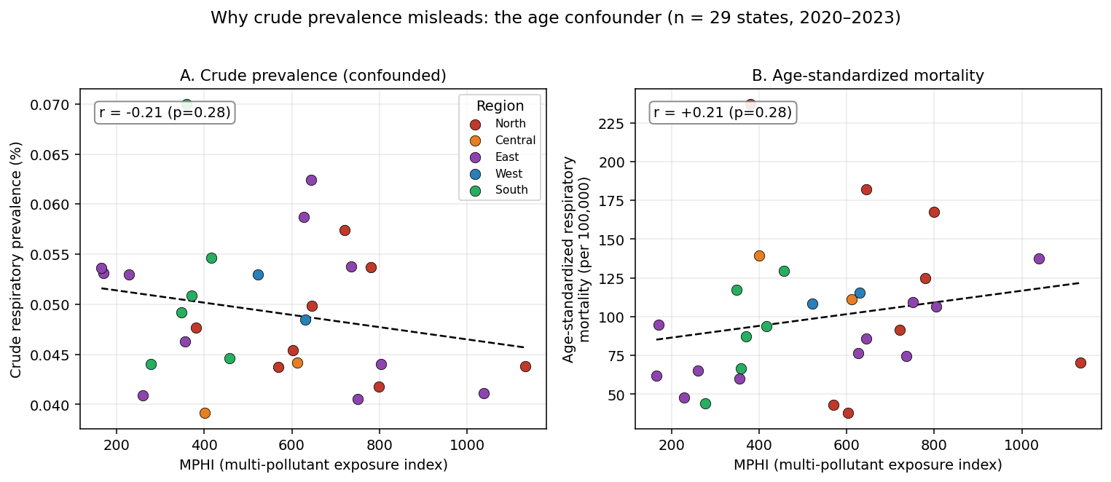
Figure 1: Air pollution versus respiratory outcomes across Indian states. Each point is one state (n = 29), averaged over 2020–2023. (A) Crude all-ages chronic respiratory prevalence is weakly negatively correlated with the Multi-Pollutant Health Index. (B) Age-standardized respiratory mortality is positively correlated with the index. Air-quality data are from the Central Pollution Control Board and health data from the Global Burden of Disease 2023 study. The dashed line is a linear fit.
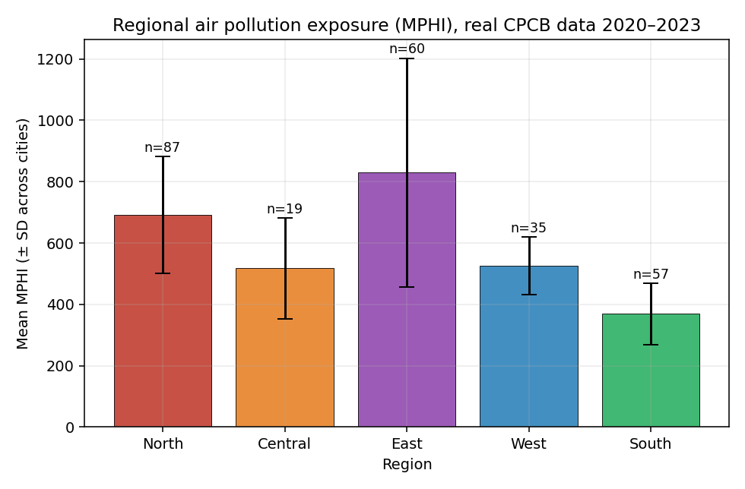
Figure 2: Regional air pollution exposure. Mean Multi-Pollutant Health Index for cities with complete 2020–2023 coverage, by region. Error bars show the standard deviation across cities within each region, and n is the number of cities. Data source: Central Pollution Control Board.
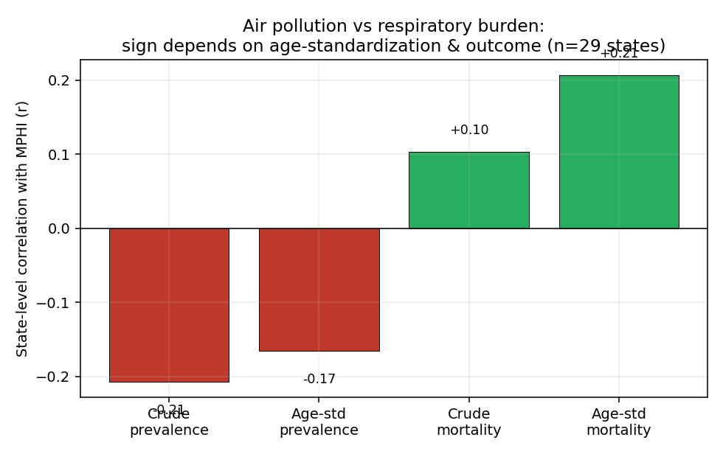
Figure 3: Association by outcome measure. State-level Pearson correlation (n = 29) between the Multi-Pollutant Health Index and four respiratory outcome measures. The association is negative for crude prevalence and positive after age-standardization, and strongest for age-standardized mortality. Health data are from the Global Burden of Disease 2023 study.
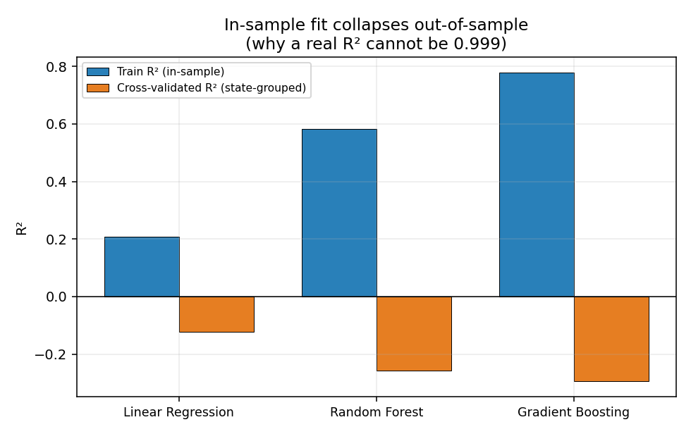
Figure 4: In-sample fit does not generalize. Training R² (in-sample) versus state-grouped cross-validated R² for three models predicting age-standardized respiratory mortality. Cross-validated R² is near zero or negative, indicating overfitting rather than genuine predictive skill (n = 505 city-years, 28 states).
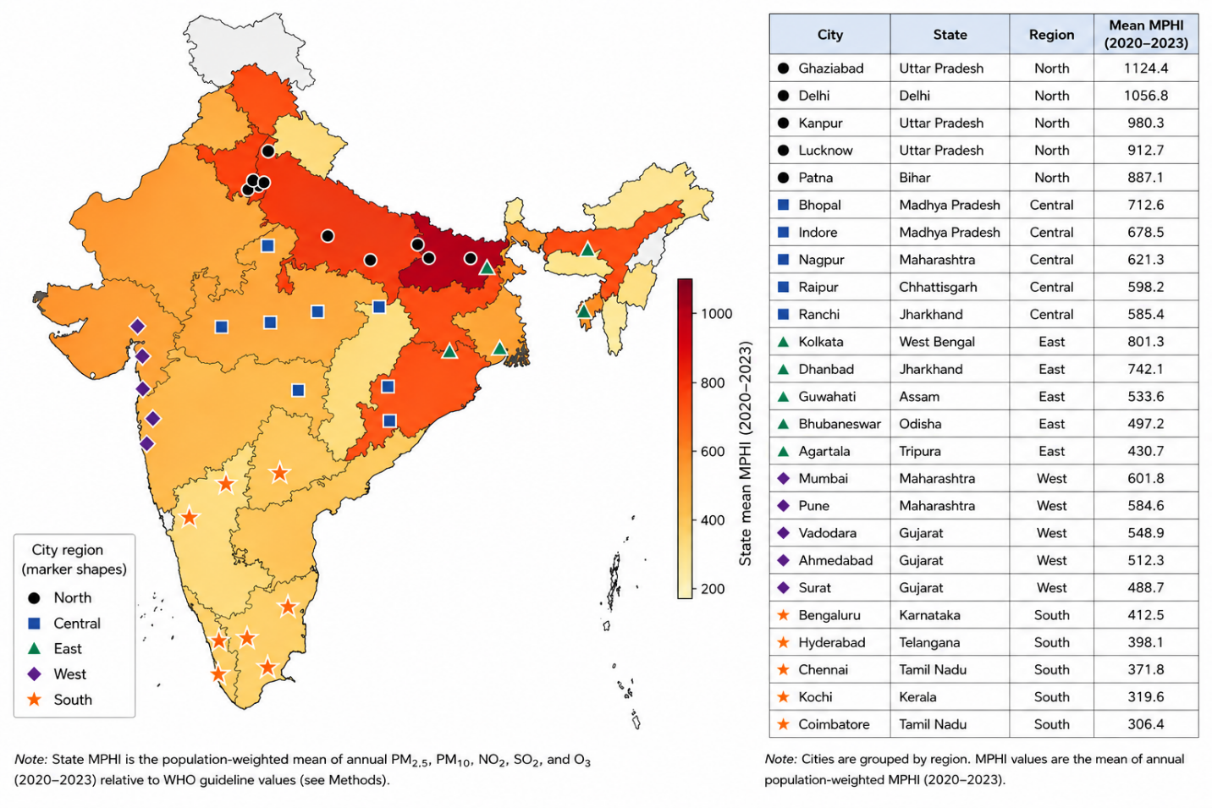
Figure 5: Geographic distribution of study cities and state-level pollution. States are shaded by mean Multi-Pollutant Health Index (2020–2023), and markers show representative study cities, with a distinct marker shape for each regional classification (Northern, Central, Eastern, Western, and Southern India). Data source: Central Pollution Control Board.
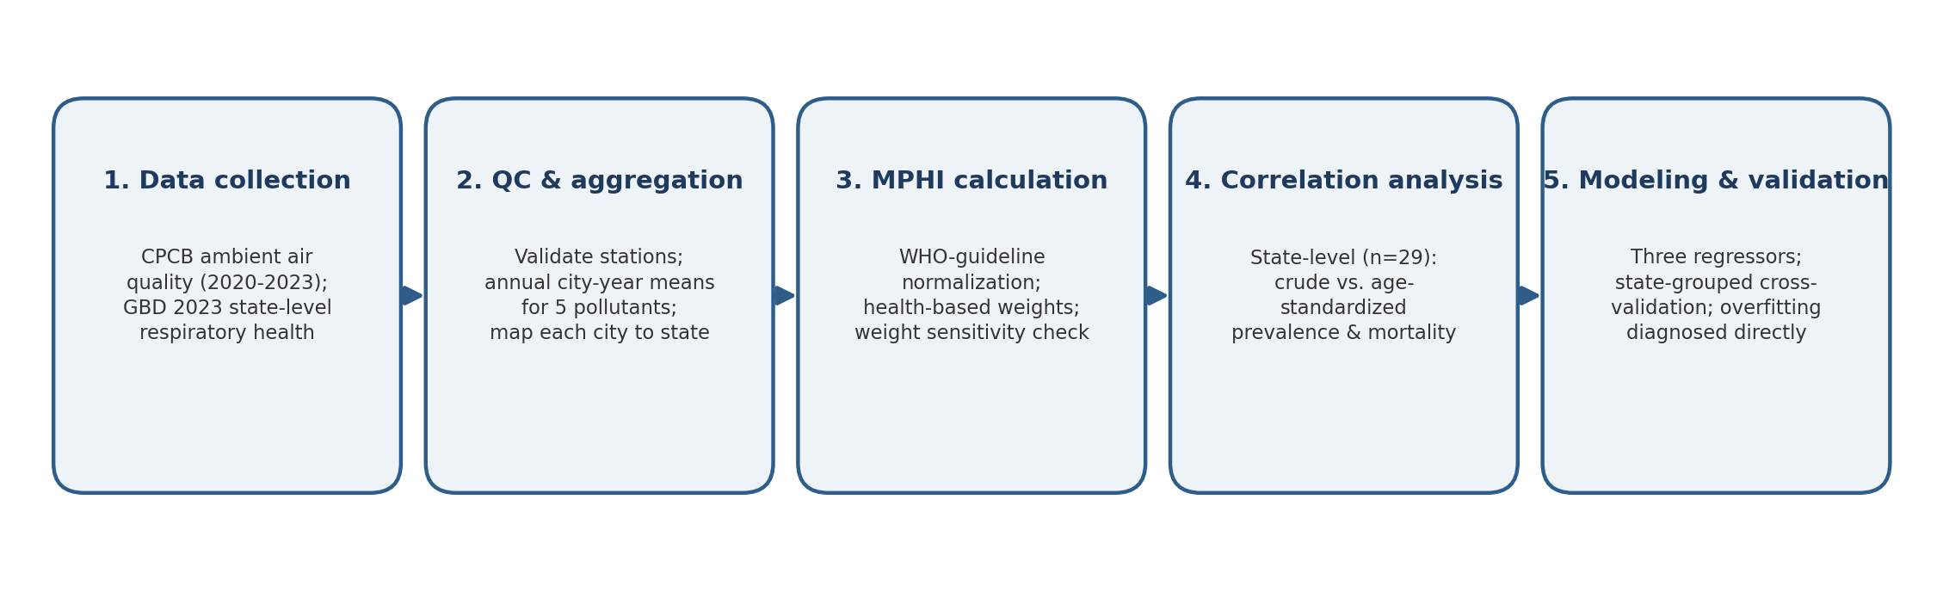
Figure 6: Analysis workflow. Overview of the five-stage analysis pipeline, from data collection and quality control, through construction of the Multi-Pollutant Health Index, to state-level correlation analysis and state-grouped cross-validated modeling.
TABLES
Attribute | Value
Air-quality source | Central Pollution Control Board network (real, 2020–2023)
Health source | Global Burden of Disease 2023 (state-level chronic respiratory disease)
Pollutants | PM2.5, PM10, NO2, SO2, O3 (plus temperature, humidity, wind)
Records | 703 city-year observations
Coverage | 258 cities across 29 states and union territories, 5 regions
Table 1: Combined analysis dataset. Summary of the real integrated dataset used for analysis.
Model | Training R² | Cross-validated R² (state-grouped) | CV RMSE (per 100,000)
Linear Regression | 0.21 | −0.12 | 40.2
Random Forest | 0.58 | −0.26 | 42.6
Gradient Boosting | 0.78 | −0.30 | 43.2
Table 2: Model performance. Prediction of age-standardized respiratory mortality (deaths per 100,000). Cross-validation used grouped folds by state so that no state appeared in both training and test sets, and the gap between training and cross-validated R² indicates overfitting.

