COVID-19

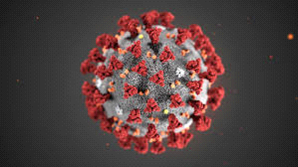

Since, the plolty output is not displayed by github. So, I am uploading all the output that will be displayed when you run the code

**Visualization:**

* Daily COVID-19 Cases Tracker shown through Bar Graph

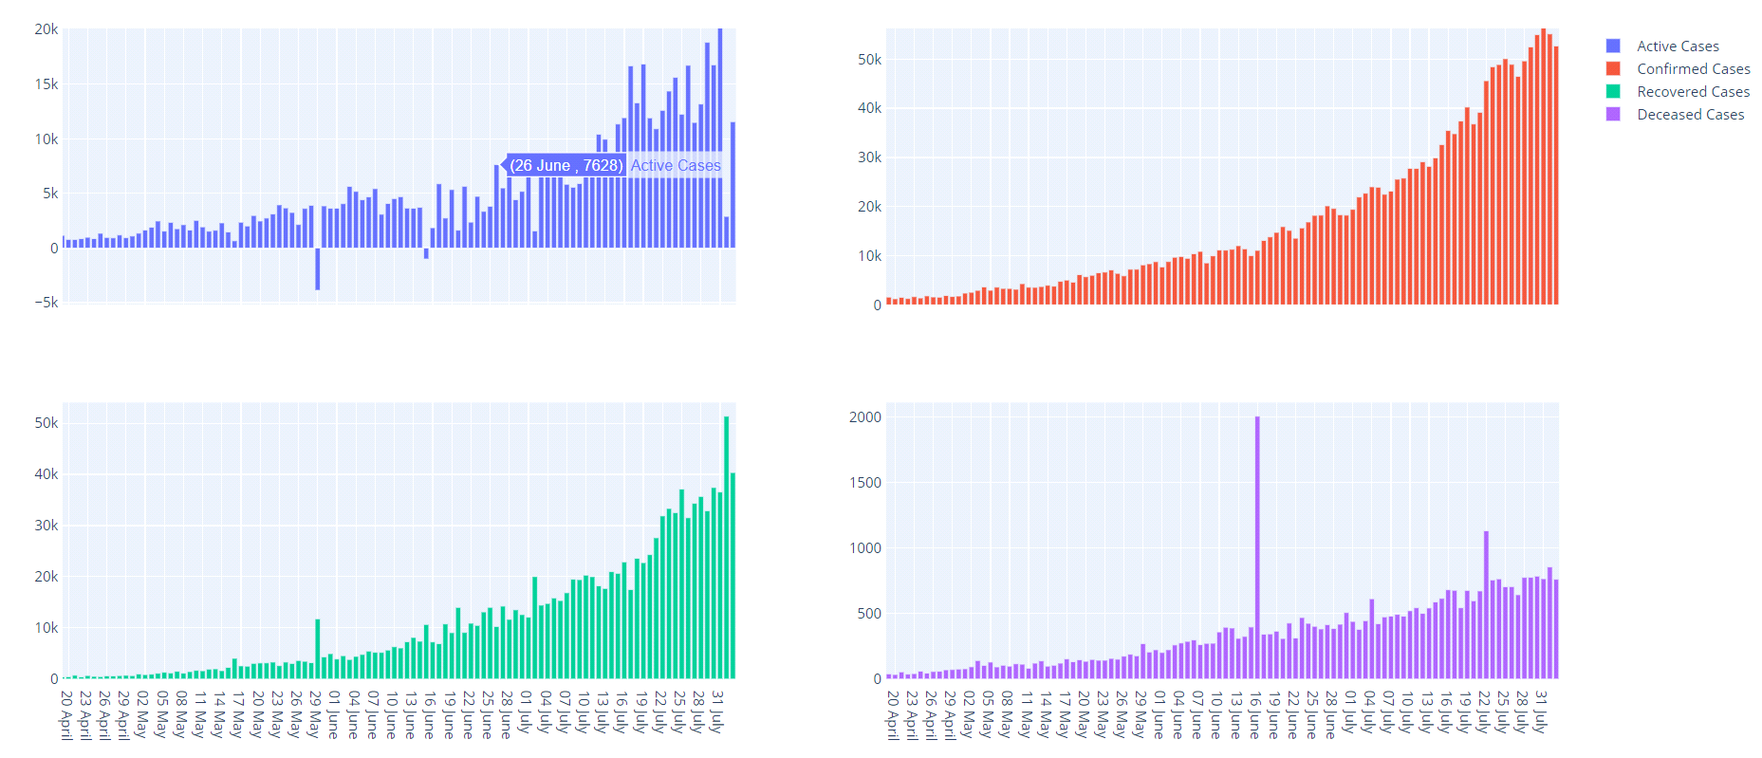

* Daily COVID-19 Cases Tracker shown through Line Graph

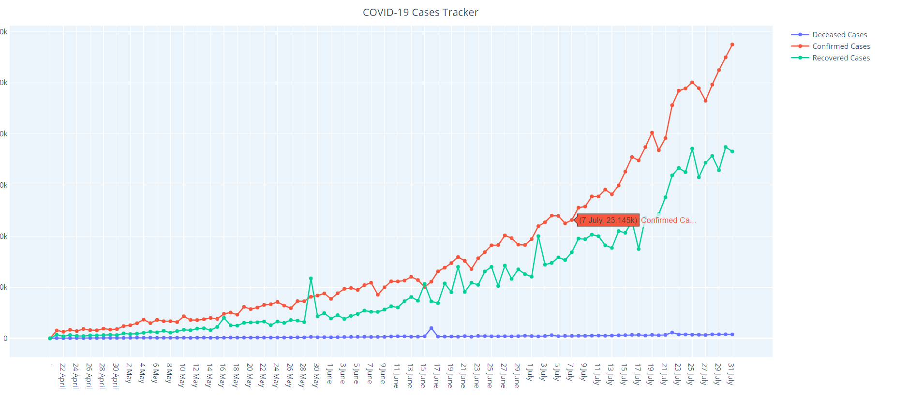

* State Wise COVID-19 Cases shown through Bar Graph

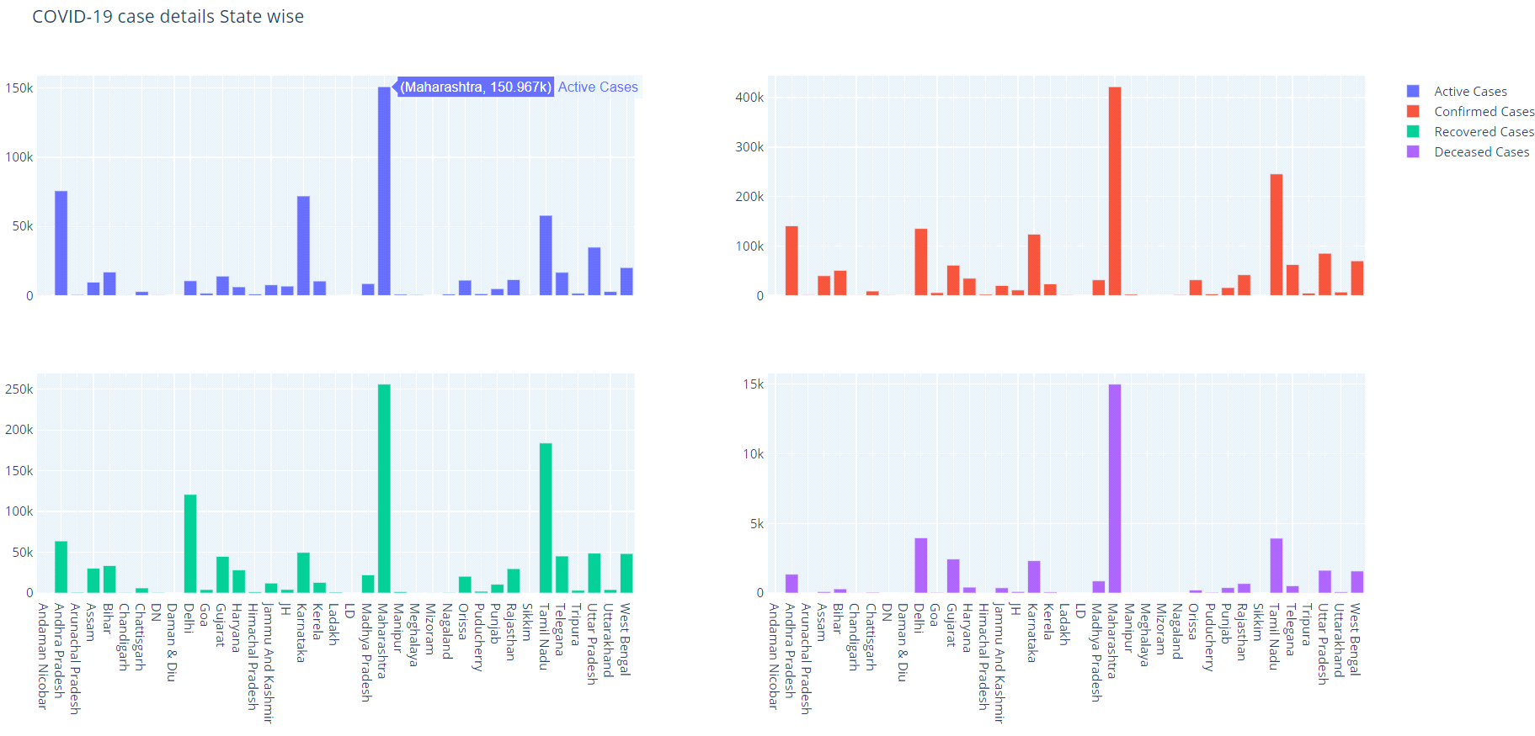

* Percentage of COVID-19 Cases in India through Donut Chart

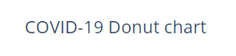

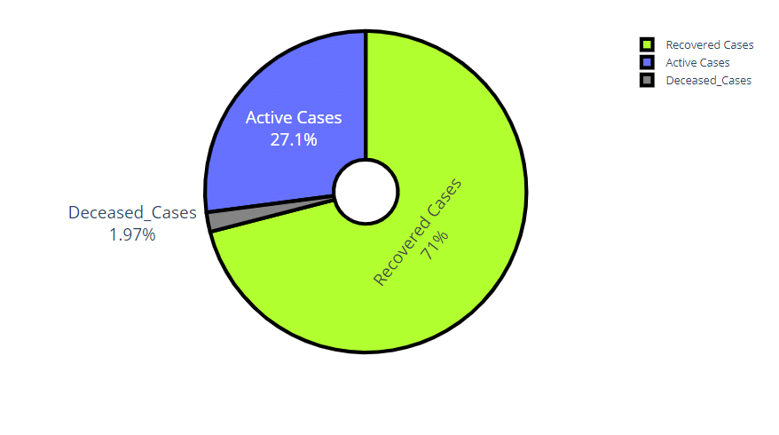

* Of the total Confirmed Cases in India,
* 27.1% -- ACTIVE CASES
* 71% -- RECOVERED CASES
* 1.97% -- DECEASED CASES
* Worldwide COVID-19 cases in Each Country



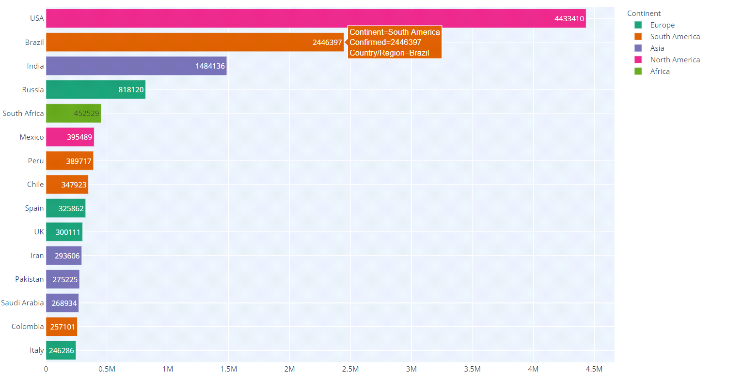



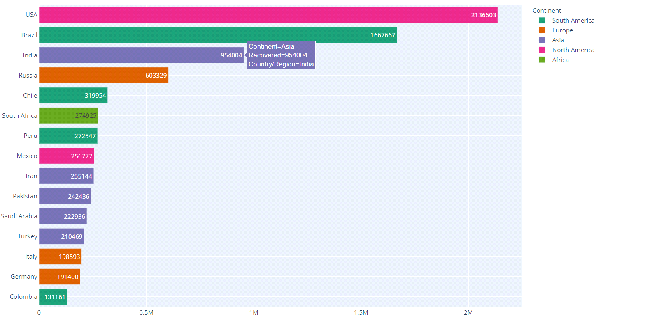



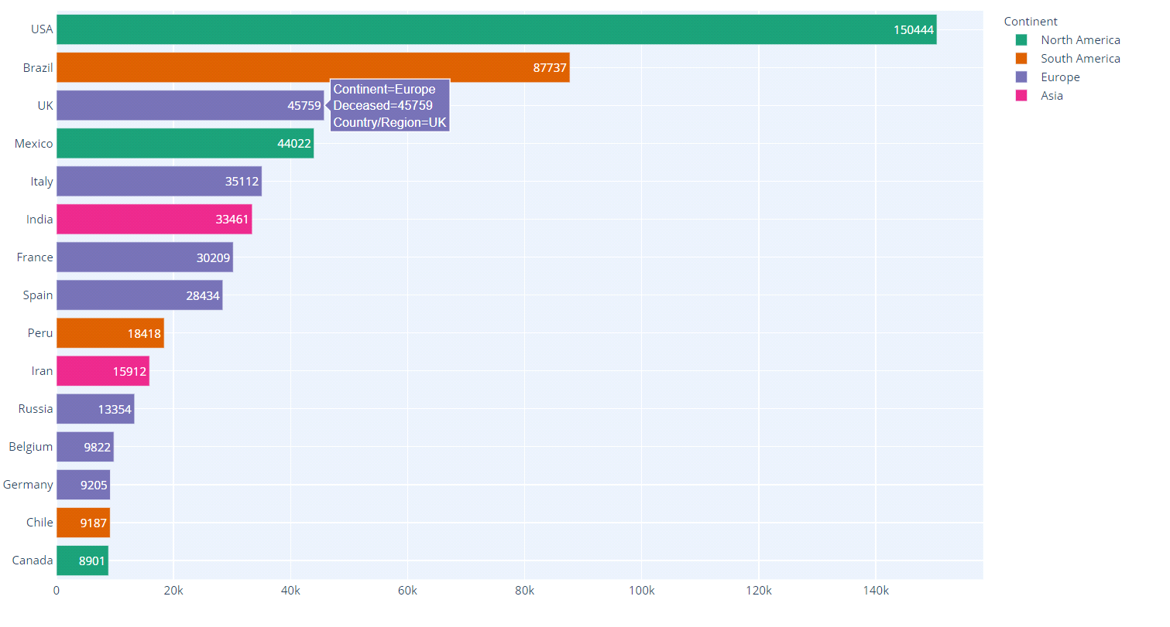

**Datasets:**

The data for the project is obtained from different csv files which are linked directly to the project. As a result, the Data gets Updated when the csv file is updated in the website.

Links to download the csv files:

* [**https://api.covid19india.org/csv/latest/case_time_series.csv**](https://api.covid19india.org/csv/latest/case_time_series.csv)
* [**https://api.covid19india.org/csv/latest/state_wise.csv**](https://api.covid19india.org/csv/latest/state_wise.csv)
* [**https://api.covid19india.org/csv/latest/state_wise_daily.csv**](https://api.covid19india.org/csv/latest/state_wise_daily.csv)
* [**https://raw.githubusercontent.com/imdevskp/covid_19_jhu_data_web_scrap_and_cleaning/master/worldometer_data.csv**](https://raw.githubusercontent.com/imdevskp/covid_19_jhu_data_web_scrap_and_cleaning/master/worldometer_data.csv)