KUBERNETES COST MONITORING AND RESOURCE OPTIMISATION
Right-sizing workloads with OpenCost, Prometheus and Grafana on Minikube
Detailed Project Report
Submitted by
Shloka Pol - [Roll No.]
B.Tech Computer Engineering, Final Year
K.J. Somaiya School of Engineering, Mumbai
DevOps Theory IA: Case Study Assignment
October 2026
Repository: github.com/shlokapol2005/k8s-cost-optimization

Abstract
Kubernetes schedules workloads, and cloud providers bill for nodes, according to what each container requests rather than what it uses. Requests are often set generously "to be safe", so a cluster can reserve many times the CPU and memory its workloads consume. Standard tooling shows usage well, but it does not show what the reservation costs or which workload is responsible for it.
This project explores OpenCost, an open-source Kubernetes cost allocation tool, as the alternative tool for the monitoring stage of the DevOps lifecycle. It is deployed with Prometheus and Grafana on a local Minikube cluster using Helm. Three deliberately over-provisioned workloads (api-service, background-worker and report-service) are deployed in a cost-demo namespace and exercised with a repeatable 120-second load test. Usage is read with kubectl top, cost is read from OpenCost under a custom pricing model based on approximate AWS us-east-1 t3.medium rates, and a custom Grafana dashboard with twelve panels shows requests, usage, cost and efficiency. Optimised requests are derived with the rule request = peak observed usage x 1.3 and applied as a rolling update. All manifests, scripts and results are version-controlled in GitHub, and a GitHub Actions workflow validates them on every push.
Measured results show total CPU requests falling from 3500m to 120m (96.6%) and memory requests from 3.5 Gi to 72 Mi (98%), with all pods remaining in the Running state. OpenCost's estimated namespace cost fell from $0.1195 to $0.0006 per hour. These cost figures are estimates produced by a configured pricing model on a local cluster, not a cloud bill. The report documents the setup, the experiment, a comparison of OpenCost with conventional tools on four aspects, the challenges met, and the limitations of the measurements, including a difference between the baseline and optimised worker workloads that affects how far the verification phase can be trusted.
Keywords: Kubernetes, OpenCost, FinOps, resource right-sizing, Prometheus, Grafana, Helm, Minikube, GitHub Actions, DevOps monitoring.

Table of contents
1. Introduction 7
1.1 Background 7
1.2 Problem statement 7
1.3 Objectives 7
1.4 Scope 8
2. Background and related concepts 9
2.1 Resource requests and limits 9
2.2 Over-provisioning and cost 9
2.3 FinOps and cost allocation 9
2.4 OpenCost 9
2.5 Prometheus and Grafana 9
3. Tool selection and DevOps lifecycle 11
3.1 Selected tool 11
3.2 Coverage of the DevOps lifecycle 11
3.3 Conventional tools used for comparison 12
4. Technology stack 13
4.1 Components 13
4.2 Environment 14
5. System architecture 15
5.1 Overall architecture 15
5.2 Load chain 15
5.3 Cost data flow 16
5.4 Repository structure 16
6. Implementation 18
6.1 Installing the tools 18
6.2 Starting the cluster 18
6.3 Deploying the baseline workloads 18
6.4 Installing Prometheus and Grafana 19
6.5 Installing OpenCost 20
6.6 Grafana dashboard 21
6.7 Load test and data collection 23
7. Experiment methodology 24
7.1 Hypothesis 24
7.2 Procedure 24
7.3 Choosing the optimised values 24
7.4 Applying the change 25
8. Version control and CI pipeline 26
8.1 Version control 26
8.2 CI workflow 26
8.3 Observations 27
9. Results and analysis 28
9.1 Resource requests 28
9.2 Utilisation and waste in the baseline 30
9.3 Estimated cost 31
9.4 Efficiency and projected savings 32
9.5 Limitations of the measurements 32
10. Comparative analysis 34
10.1 Ease of use and setup 34
10.2 Scalability and performance 34
10.3 Integration into the DevOps pipeline 35
10.4 Advantages and limitations of OpenCost 35
11. Challenges and lessons learned 36
11.1 Challenges encountered 36
11.2 Lessons learned 36
12. Conclusion and future work 37
12.1 Conclusion 37
12.2 Future work 37
References 38

List of figures
Figure 1: Position of OpenCost in the DevOps lifecycle
Figure 2: Technology stack by layer
Figure 3: High-level system architecture
Figure 4: Load chain between the test workloads
Figure 5: Cost data flow from cluster metrics to reports
Figure 6: Pods running in the cost-demo, monitoring and opencost namespaces
Figure 7: OpenCost allocation view before optimisation (baseline)
Figure 8: Grafana CPU panels before optimisation (baseline)
Figure 9: Grafana memory panels before optimisation (baseline)
Figure 10: Experiment workflow
Figure 11: CI job dependency graph
Figure 12: GitHub Actions run for the repository
Figure 13: CPU requests per pod, before and after
Figure 14: Memory requests per pod, before and after
Figure 15: Grafana CPU panels after optimisation
Figure 16: Grafana memory panels after optimisation
Figure 17: Baseline CPU requested versus CPU used per pod
Figure 18: OpenCost estimated namespace cost, before and after
Figure 19: OpenCost allocation view after optimisation

List of tables
Table 1: DevOps lifecycle coverage in this project
Table 2: Technology components and roles
Table 3: Environment configuration
Table 4: Baseline workload definitions
Table 5: Prometheus and Grafana configuration (monitoring/prometheus/values.yaml)
Table 6: OpenCost custom pricing model (opencost/values.yaml)
Table 7: Grafana dashboard panels
Table 8: Load test levels
Table 9: Derivation of optimised requests
Table 10: GitHub Actions jobs
Table 11: Resource requests per pod, before and after
Table 12: Total reservation before and after
Table 13: Baseline CPU utilisation (results/baseline.csv)
Table 14: OpenCost estimated cost of the cost-demo namespace
Table 15: Cross-check of OpenCost figures against request-based pricing
Table 16: Annualised saving estimate for the cost-demo namespace (illustrative)
Table 17: Ease of use and setup
Table 18: Scalability and performance
Table 19: Integration into the DevOps pipeline
Table 20: Advantages and limitations of OpenCost
Table 21: Challenges and how they were handled

1. Introduction

1.1 Background
Container orchestration made it easy to run many services on shared infrastructure. It also made it easy to forget what that infrastructure costs. In Kubernetes every container may declare a CPU and memory request, which the scheduler reserves on a node, and a limit, which caps what the container may use. Teams usually copy these numbers from a template or choose large values to avoid out-of-memory kills and throttling. Nobody is prompted to revisit them once the service is running.
The result is a cost that does not appear in ordinary monitoring. A dashboard may show a pod using 1 millicore of CPU, and the pod may still hold 2000 millicores of a node for as long as it runs. FinOps practice and tools such as OpenCost exist to close this gap by turning cluster metrics into cost per namespace, workload and pod.

1.2 Problem statement
Resource requests in Kubernetes are commonly set far above real usage, and the waste is hard to see with the tools most DevOps courses cover. This project addresses three gaps:
- Usage monitoring shows consumption but not the cost of what is reserved.
- There is no routine, data-driven way to choose request values, so they are guessed.
- Changes to resource configuration are rarely compared before and after under the same conditions.

1.3 Objectives
- Select and demonstrate one alternative tool from the monitoring stage of the DevOps lifecycle, here OpenCost, beyond the tools used in the standard lab experiments.
- Build a reproducible environment on Minikube with Prometheus, Grafana and OpenCost, installed through Helm and configured from files kept in Git.
- Deploy intentionally over-provisioned workloads and measure their real usage under a repeatable load test.
- Right-size the requests from the measurements, apply them as a rolling update and compare resource reservation, estimated cost and efficiency before and after.
- Compare OpenCost with conventional tools on ease of use and setup, scalability and performance, integration into the pipeline, and advantages and limitations.
- Document the setup, configuration, challenges and lessons learned, with working code in a GitHub repository.

1.4 Scope
The experiment runs on a single-node Minikube cluster on a laptop. The workloads are small nginx and busybox containers chosen so that load, usage and cost can be observed quickly, not realistic business services. Because there is no cloud provider, OpenCost values are estimates based on a configured price list and must not be read as a bill. Security scanning of the cluster and manifests is outside the scope of the work and is listed under future work.

2. Background and related concepts

2.1 Resource requests and limits
A Kubernetes container can declare a request and a limit for CPU and memory. The scheduler uses the request to decide where a pod fits: a node is considered full when the sum of the requests of its pods reaches its allocatable capacity, whatever the pods actually consume [1]. The limit is enforced at run time. CPU above the limit is throttled, and memory above the limit causes the container to be killed. CPU is measured in millicores (1000m is one core) and memory in bytes, usually Mi or Gi.

2.2 Over-provisioning and cost
Because the scheduler reserves the request, an over-sized request blocks capacity from other pods, forces additional nodes to be added, and raises the bill without improving performance. In a cloud environment the customer pays for nodes, and nodes are added when requests no longer fit. The waste of a workload can be expressed as 1 - (usage / request). A pod that uses 1m of a 2000m request wastes 99.95% of its reservation.

2.3 FinOps and cost allocation
FinOps is the practice of making cloud spend visible and accountable to the teams that cause it [2]. For Kubernetes this requires allocation: splitting the cost of shared nodes between namespaces, workloads and pods. The usual method prices the CPU and memory that each pod holds, using the larger of its request and its usage, and sums the result over the period of interest.

2.4 OpenCost
OpenCost is a vendor-neutral, open-source project for measuring and allocating Kubernetes infrastructure and container costs [3]. It reads container and node metrics from Prometheus, combines them with a price list, and exposes the result through an allocation API, a web interface and Prometheus metrics prefixed opencost_. When no cloud provider is available, a custom pricing configuration supplies the prices. This project uses that mode with approximate AWS us-east-1 t3.medium on-demand rates.

2.5 Prometheus and Grafana
Prometheus is a time-series database that scrapes metrics from targets at a fixed interval and answers queries written in PromQL [4]. Grafana draws dashboards from those queries [5]. The kube-prometheus-stack Helm chart installs both, together with kube-state-metrics, which exposes the requests and limits declared in Kubernetes objects, and node-exporter, which exposes node-level metrics [6]. Together they supply the usage and request data that OpenCost converts into cost.

3. Tool selection and DevOps lifecycle

3.1 Selected tool
The assignment asks for an alternative tool from one stage of the DevOps lifecycle. The stage chosen is Monitoring, and the tool is OpenCost. The mainstream tools for this stage are metrics and dashboard tools such as kubectl top, Prometheus and Grafana. They answer "how much is being used?" but not "what does the reservation cost, and who owns it?". OpenCost adds that second question. Prometheus, Grafana and Minikube are used in the project as supporting infrastructure, so that OpenCost can be shown inside a working pipeline and compared with them.

3.2 Coverage of the DevOps lifecycle
The assignment also asks for the tool to be shown inside a working pipeline. Figure 1 shows where each stage of the lifecycle is handled, and Table 1 lists what was implemented and what was not.
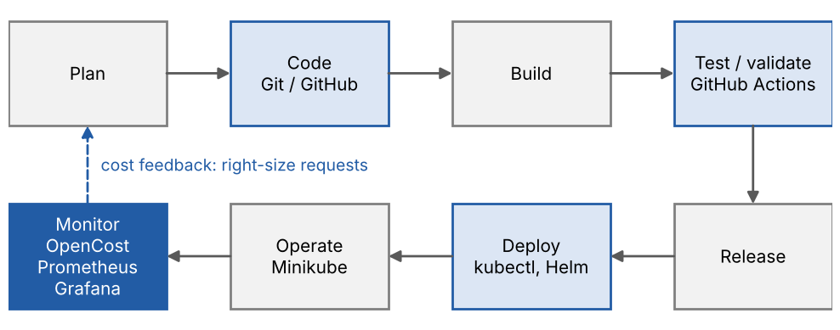
Figure 1: Position of OpenCost in the DevOps lifecycle
Table 1: DevOps lifecycle coverage in this project
Lifecycle stage | What was implemented | Tools
Version control | Manifests, scripts, dashboard, Helm values and results kept in one repository | Git, GitHub
Continuous integration | Workflow on push and pull request: manifest dry-run, YAML lint, shell lint, dashboard JSON check | GitHub Actions
Deployment and provisioning | Local cluster started with fixed resources; workloads applied from YAML; monitoring and cost stack installed from Helm charts with values files | Minikube, kubectl, Helm
Configuration and infrastructure as code | Declarative manifests, ConfigMaps, Helm values and a one-shot setup.sh script | YAML, Helm, Bash
Monitoring (focus) | Usage, requests, estimated cost and efficiency collected and visualised | OpenCost, Prometheus, Grafana, metrics-server
Security (DevSecOps) | Not implemented. Grafana credentials in the Helm values are for demonstration only. See Section 12.2 | -
Collaboration | README, SETUP_GUIDE and results documented in the repository | GitHub

3.3 Conventional tools used for comparison
OpenCost is compared with four conventional alternatives in Chapter 10: Prometheus with Grafana on their own, kubectl top with metrics-server, Kubecost, and the billing tools of a cloud provider. The first two were used in the experiment. Kubecost and cloud billing were not deployed, so the comparison with them rests on their public documentation and is labelled as such.

4. Technology stack
The stack is grouped into five layers (Figure 2): infrastructure, workloads, observability, cost allocation and automation.
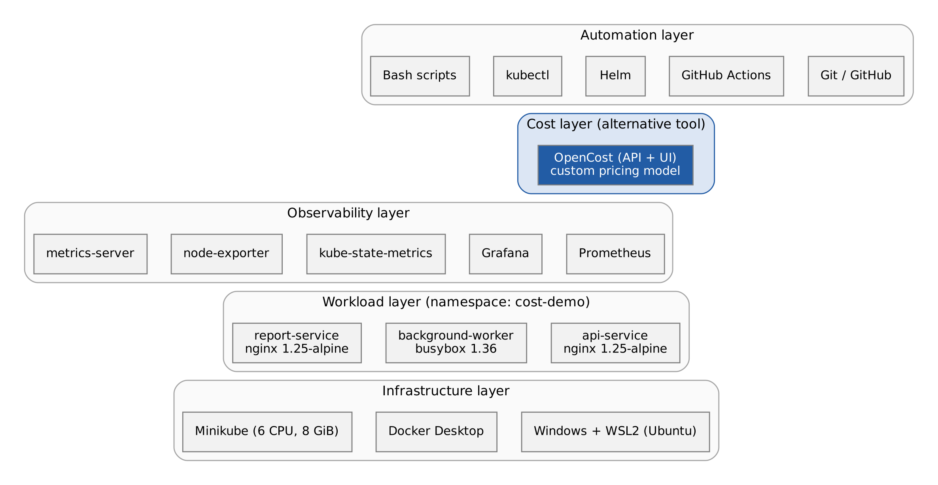
Figure 2: Technology stack by layer

4.1 Components
Table 2: Technology components and roles
Component | Role in the project
Windows, WSL2 (Ubuntu) | Linux environment in which all command-line tools run
Docker Desktop | Container runtime and the driver used by Minikube
Minikube | Single-node local Kubernetes cluster (6 CPUs, 8 GiB)
kubectl | Deploys manifests and reads status and usage (kubectl top)
Helm | Installs kube-prometheus-stack and OpenCost from charts and values files
metrics-server | Minikube add-on that supplies live pod usage to kubectl top
Prometheus | Stores cluster metrics scraped every 30 seconds, 7-day retention
Grafana | Dashboards for usage, requests, cost and efficiency
kube-state-metrics, node-exporter | Expose Kubernetes object data (requests, limits) and node metrics
OpenCost | Cost allocation engine with API (port 9003) and UI (port 9090)
nginx 1.25-alpine, busybox 1.36 | Container images of the three test workloads
Bash scripts | setup.sh, load-test.sh, collect-baseline.sh, collect-after.sh
GitHub, GitHub Actions | Version control and continuous integration

4.2 Environment
Table 3: Environment configuration
Item | Value
Host | Windows laptop with WSL2 and Ubuntu 22.04 (recommended in the setup guide)
Minikube start command | minikube start --cpus=6 --memory=8192 --driver=docker
Kubernetes version | 1.28 series (the CI job validates manifests with kubectl v1.28.0)
Add-ons | metrics-server (required); ingress (enabled by setup.sh, optional)
Helm releases | kube-prom-stack (namespace monitoring); opencost (namespace opencost)
Workload namespace | cost-demo
Sizing rationale | Baseline reservations (about 3.5 CPU, 3.5 Gi) plus the monitoring stack (about 2 CPU, 2 Gi) need at least 6 CPUs and 8 GiB

5. System architecture

5.1 Overall architecture
Figure 3 shows the system. Three namespaces share the Minikube cluster: cost-demo holds the test workloads, monitoring holds Prometheus, Grafana and the exporters, and opencost holds the cost engine. GitHub Actions validates the repository on each push but does not deploy to the cluster; deployment and experiments are run locally.
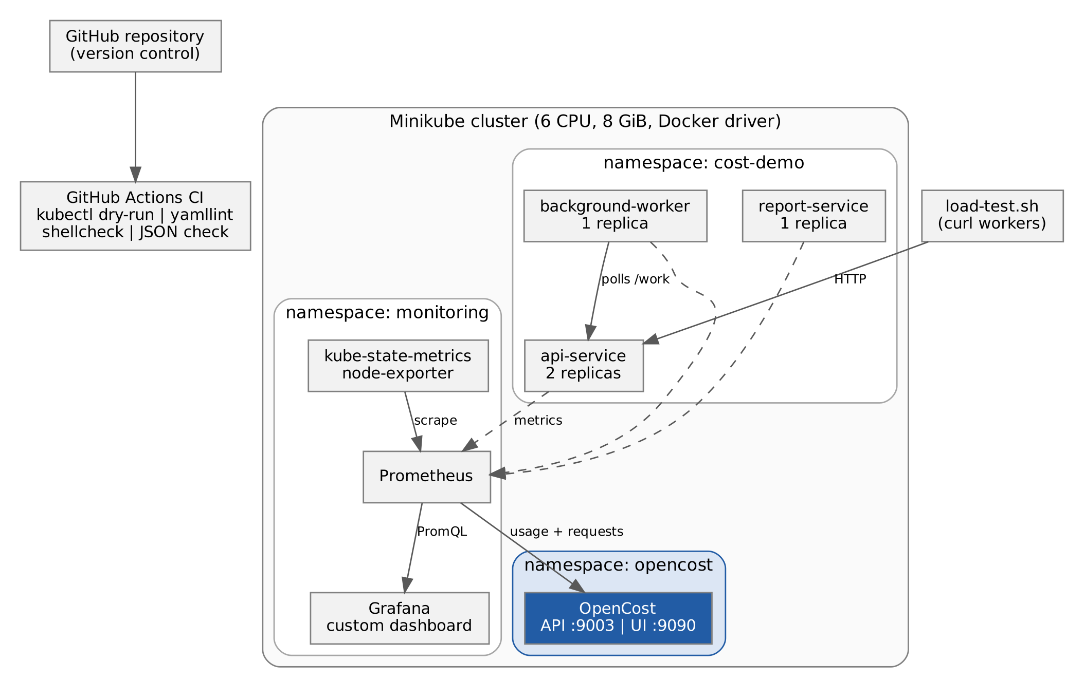
Figure 3: High-level system architecture

5.2 Load chain
The load test sends HTTP requests to api-service and report-service through port-forwards. The background-worker polls the /work endpoint of api-service every half second and runs an arithmetic loop for each response. External traffic therefore drives api-service directly and worker CPU indirectly, which gives each workload a measurable, different usage level (Figure 4).
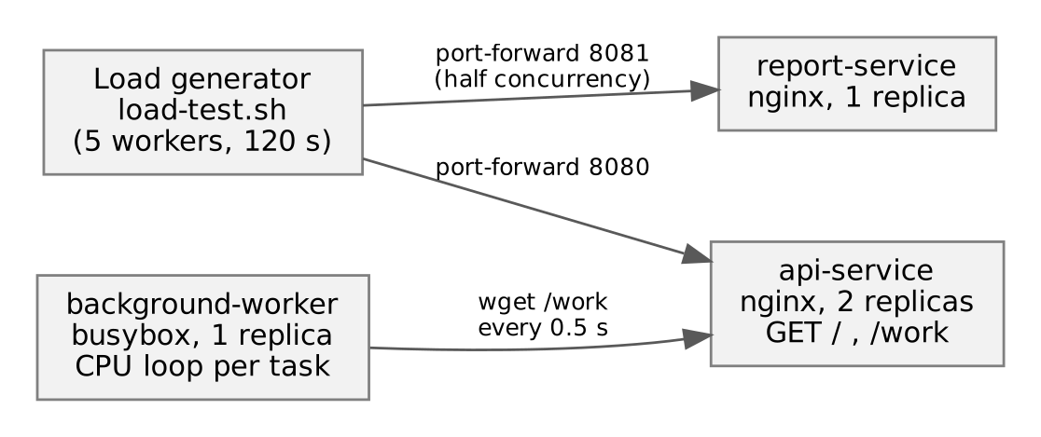
Figure 4: Load chain between the test workloads

5.3 Cost data flow
Figure 5 follows a measurement from the node to the report. Container usage comes from the kubelet, requests and limits come from kube-state-metrics, and Prometheus stores both. OpenCost queries Prometheus, applies the custom prices and exports its own opencost_ metrics, which Grafana plots next to the raw usage.
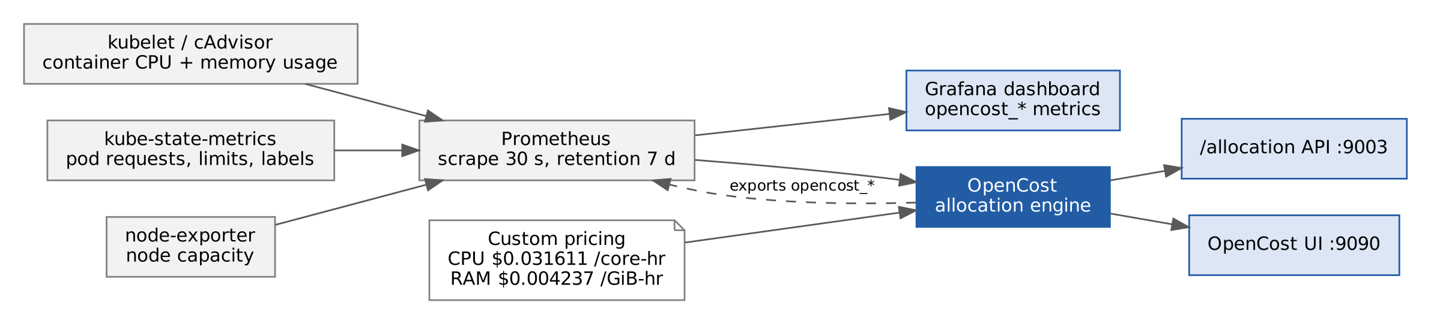
Figure 5: Cost data flow from cluster metrics to reports

5.4 Repository structure
The repository separates Kubernetes manifests, monitoring configuration, cost configuration, scripts and results:
k8s-cost-optimization/
.github/workflows/ci.yaml CI: manifests, YAML, shell, dashboard JSON
k8s/
namespace.yaml cost-demo namespace
api-deployment.yaml api-service (nginx, /work endpoint)
worker-deployment.yaml background-worker (polls api, CPU loop)
report-deployment.yaml report-service (2000m CPU request)
services.yaml ClusterIP services
optimized-deployments.yaml right-sized requests and limits
monitoring/
prometheus/values.yaml kube-prometheus-stack Helm values
grafana/dashboard.json custom dashboard (12 panels)
grafana/dashboard-configmap.yaml
opencost/
values.yaml Helm values and custom pricing
opencost-manifests.yaml direct kubectl install, no Helm
load-testing/load-test.sh curl-based load generator
scripts/ setup, collect-baseline, collect-after
results/ baseline.csv, optimized.csv, comparison.txt
screenshots/ Grafana and OpenCost captures
README.md, SETUP_GUIDE.md

6. Implementation
This chapter records the steps in the order they were carried out. The same steps are automated, with confirmation pauses, in scripts/setup.sh and written out in SETUP_GUIDE.md.

6.1 Installing the tools
All tools are installed inside WSL2 Ubuntu. Docker Desktop on Windows must have WSL integration enabled so that Minikube can use it.
curl -LO "https://dl.k8s.io/release/$(curl -sL https://dl.k8s.io/release/stable.txt)/bin/linux/amd64/kubectl"
chmod +x kubectl && sudo mv kubectl /usr/local/bin/
curl -LO https://storage.googleapis.com/minikube/releases/latest/minikube-linux-amd64
sudo install minikube-linux-amd64 /usr/local/bin/minikube
curl https://raw.githubusercontent.com/helm/helm/main/scripts/get-helm-3 | bash
docker info | head -5 # confirms Docker is reachable from WSL2

6.2 Starting the cluster
minikube start --cpus=6 --memory=8192 --driver=docker
minikube addons enable metrics-server
kubectl get nodes

metrics-server is required because kubectl top, and therefore the measurement scripts, read from it. It needs about two minutes after start before it returns values.

6.3 Deploying the baseline workloads
Three workloads are deployed to the cost-demo namespace with requests that are intentionally far above what they need (Table 4). Each nginx workload serves a fixed JSON response from a ConfigMap on port 8080 and has liveness and readiness probes. Services of type ClusterIP map port 80 to 8080.
Table 4: Baseline workload definitions
Workload | Image | Replicas | CPU request / limit | Memory request / limit | Behaviour
api-service | nginx:1.25-alpine | 2 | 500m / 1000m | 512Mi / 1Gi | Serves /, /health and /work
background-worker | busybox:1.36 | 1 | 1000m / 2000m | 1Gi / 2Gi | Polls /work every 0.5 s, runs a 10000-iteration loop per task
report-service | nginx:1.25-alpine | 1 | 2000m / 4000m | 2Gi / 4Gi | Serves a fixed JSON response; the most over-provisioned

kubectl apply -f k8s/namespace.yaml
kubectl apply -f k8s/api-deployment.yaml
kubectl apply -f k8s/worker-deployment.yaml
kubectl apply -f k8s/report-deployment.yaml
kubectl apply -f k8s/services.yaml
kubectl rollout status deployment/api-service -n cost-demo --timeout=120s
kubectl get pods -n cost-demo

[Insert screenshot here: screenshots/baseline-pods.png]
Output of kubectl get pods -n cost-demo, -n monitoring and -n opencost
Figure 6: Pods running in the cost-demo, monitoring and opencost namespaces

6.4 Installing Prometheus and Grafana
kube-prometheus-stack is installed with a values file that sets the scrape interval, retention, storage and Grafana options (Table 5). Setting the three *SelectorNilUsesHelmValues options to false lets Prometheus scrape monitors created by other charts, which is how the OpenCost metrics are picked up.
helm repo add prometheus-community https://prometheus-community.github.io/helm-charts
helm repo update
kubectl create namespace monitoring
helm upgrade --install kube-prom-stack prometheus-community/kube-prometheus-stack \
--namespace monitoring --values monitoring/prometheus/values.yaml \
--wait --timeout 10m

Table 5: Prometheus and Grafana configuration (monitoring/prometheus/values.yaml)
Setting | Value | Purpose
scrapeInterval / evaluationInterval | 30s / 30s | Frequency of metric collection and rule evaluation
retention | 7d | How long Prometheus keeps data
storage | 5Gi ReadWriteOnce volume | Persistent storage for the time series
*SelectorNilUsesHelmValues | false | Scrape service, pod and rule monitors from all charts
Grafana service | NodePort 32000, 1Gi persistence | Dashboard access and storage
Grafana dashboards | Provider folder "Cost Optimization" | Where the custom dashboard is loaded
Grafana anonymous access | Enabled, Viewer role | Read-only viewing during the demonstration
Alertmanager | Disabled | Not needed for the experiment
node-exporter, kube-state-metrics | Enabled | Node and Kubernetes object metrics

Grafana is reached by port-forward, which works regardless of how Minikube networking is set up:
kubectl port-forward svc/kube-prom-stack-grafana 3000:80 -n monitoring

6.5 Installing OpenCost
OpenCost must be told the exact name of the Prometheus service it should query. The name is found first and then written into opencost/values.yaml.
kubectl get svc -n monitoring | grep -i prometheus
# value used in this project:
# opencost.prometheus.internal.serviceName: kube-prom-stack-kube-prome-prometheus
helm repo add opencost https://opencost.github.io/opencost-helm-chart
helm upgrade --install opencost opencost/opencost \
--namespace opencost --create-namespace \
--values opencost/values.yaml --wait --timeout 5m
kubectl port-forward svc/opencost -n opencost 9090:9090 9003:9003

Since Minikube is not a cloud provider, OpenCost has no price list of its own. A custom pricing block (Table 6) supplies approximate AWS us-east-1 t3.medium on-demand rates. The cluster identifier is minikube-cost-demo. The repository also contains opencost-manifests.yaml, which installs OpenCost directly with kubectl (a service account, cluster role, deployment with API and UI containers, and a service) for use without Helm.
Table 6: OpenCost custom pricing model (opencost/values.yaml)
Resource | Price | Unit
CPU | 0.031611 | USD per CPU-hour
Memory (RAM) | 0.004237 | USD per GiB-hour
Storage | 0.000138 | USD per GiB-hour
Spot CPU / spot RAM | 0.006655 / 0.000892 | USD per unit-hour (configured, not used by the workloads)
GPU | 0.0 | No GPU in the cluster

[Insert screenshot here: screenshots/baseline-opencost-allocation.png]
OpenCost UI at http://localhost:9090 showing the cost-demo namespace
Figure 7: OpenCost allocation view before optimisation (baseline)

6.6 Grafana dashboard
A custom dashboard, "K8s Cost & Resource Optimization", is provided as dashboard.json and as a ConfigMap. It has four rows and twelve panels (Table 7). It is imported through Dashboards, Import, Upload JSON file, after selecting the Prometheus data source.
Table 7: Grafana dashboard panels
Row | Panel | Main PromQL series
Resource overview | CPU usage per pod (millicores) | rate(container_cpu_usage_seconds_total) x 1000 by pod
 | Memory usage per pod | container_memory_working_set_bytes by pod
Requests vs usage | CPU: requested vs used | kube_pod_container_resource_requests (cpu) and CPU usage by container
 | Memory: requested vs used | kube_pod_container_resource_requests (memory) and working set by container
Estimated cost | Estimated cost per pod (USD/hr) | opencost_pod_total_cost by pod
 | CPU vs memory cost breakdown | opencost_namespace_cpu_allocation_cost and opencost_namespace_memory_allocation_cost
 | Total namespace estimated cost | sum(opencost_pod_total_cost)
Efficiency | CPU efficiency gauge | CPU usage / CPU requests by container
 | Memory efficiency gauge | Working set / memory requests by container

[Insert screenshot here: screenshots/baseline-grafana-cpu.png]
CPU usage per pod and CPU requested vs used
Figure 8: Grafana CPU panels before optimisation (baseline)
[Insert screenshot here: screenshots/baseline-grafana-memory.png]
Memory usage per pod and memory requested vs used
Figure 9: Grafana memory panels before optimisation (baseline)

6.7 Load test and data collection
load-testing/load-test.sh starts port-forwards to api-service (port 8080) and report-service (port 8081), then launches curl workers for 120 seconds. api-service receives the configured number of workers and report-service receives half that number plus one. The medium level was used for both phases of the experiment.
Table 8: Load test levels
Level | Workers on api-service | Workers on report-service | Pause between requests
low | 2 | 2 | 1.0 s
medium (used) | 5 | 3 | 0.5 s
high | 15 | 8 | 0.1 s

collect-baseline.sh prints the pod status, the declared requests and limits (kubectl get deployments with custom columns) and live usage (kubectl top pods), and appends one row per workload to results/baseline.csv. collect-after.sh does the same for results/optimized.csv and writes results/comparison.txt. Each CSV row records timestamp, workload, CPU and memory request and limit, CPU used in millicores, memory used in Mi, and the phase.
bash load-testing/load-test.sh medium
bash scripts/collect-baseline.sh # BEFORE
kubectl apply -f k8s/optimized-deployments.yaml
bash load-testing/load-test.sh medium
bash scripts/collect-after.sh # AFTER

7. Experiment methodology

7.1 Hypothesis
The workloads in the cluster have resource requests far larger than their real usage. Reducing the requests to a value derived from measured usage will lower the estimated cost and the reserved capacity without taking any pod out of service.

7.2 Procedure
The experiment follows five steps (Figure 10): deploy the baseline, measure usage under load, derive new requests, apply them and measure again, then compare the two result files.
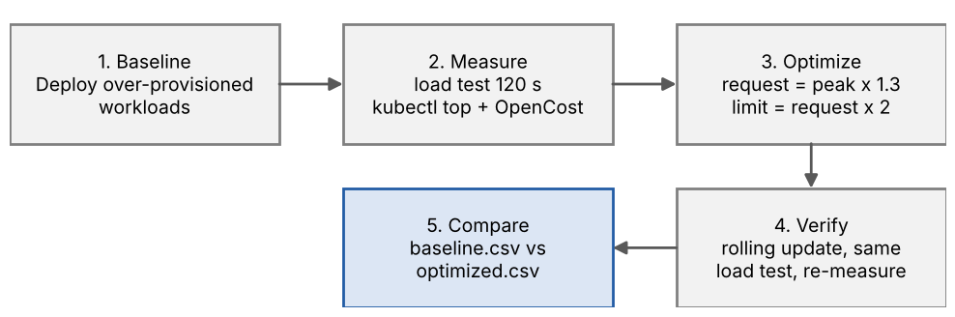
Figure 10: Experiment workflow
The same load level (medium, 120 seconds), the same namespace and the same three workloads were used in both phases so that differences can be attributed to the change in requests. The baseline CSV is stamped 2026-09-21 08:47 UTC and the optimised CSV 2026-09-21 11:33 UTC.

7.3 Choosing the optimised values
Requests were set to the peak observed usage multiplied by 1.3, which leaves 30% headroom, and limits were set to twice the request. Where the rule gave a value too small to be practical, a small fixed minimum was used. Usage was read from kubectl top while the load test ran (Table 9).
Table 9: Derivation of optimised requests
Workload | Observed CPU | Rule result | CPU request / limit | Observed memory | Rule result | Memory request / limit
api-service | 1m | 1.3m | 5m / 10m (minimum) | 12Mi | 15.6Mi | 20Mi / 40Mi
background-worker | 82m | 106.6m | 110m / 220m | ~0Mi | ~0Mi | 32Mi / 64Mi (minimum)
report-service | 1m | 1.3m | 5m / 10m (minimum) | 12Mi | 15.6Mi | 20Mi / 40Mi

7.4 Applying the change
k8s/optimized-deployments.yaml contains the same three Deployments with the new values and the label phase: optimized. kubectl apply triggers a rolling update, in which new pods are started and old pods are removed once the new ones are ready. The excerpt below shows the api-service resources:
resources:
requests:
cpu: "5m" # measured: 1m x 1.3 = 2m; 5m used as safe minimum
memory: "20Mi" # measured: 12Mi x 1.3 = 16Mi; 20Mi used
limits:
cpu: "10m"
memory: "40Mi"

8. Version control and CI pipeline

8.1 Version control
Every file needed to reproduce the experiment is committed to the GitHub repository github.com/shlokapol2005/k8s-cost-optimization: manifests, Helm values, the dashboard, scripts, measured results and documentation. The workflow runs on pushes to main and develop and on pull requests to main, so a change to a manifest or script is checked before it is merged.

8.2 CI workflow
The workflow (Figure 11, Table 10) has four jobs. The three validation jobs run in parallel, and a summary job runs after all three have finished. Deployment and the cost experiment are not part of CI because they need the local Minikube cluster.
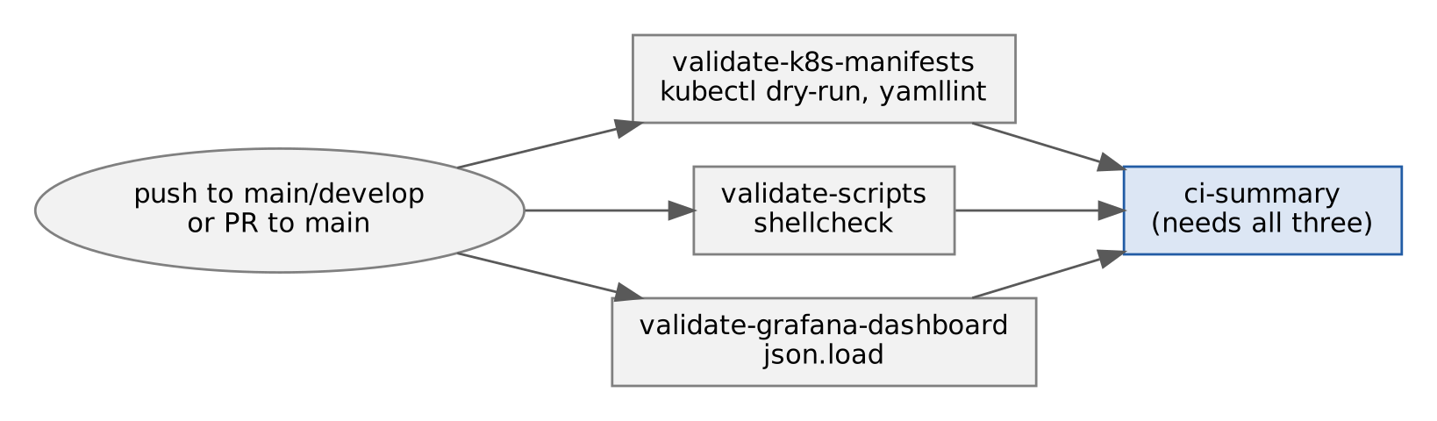
Figure 11: CI job dependency graph
Table 10: GitHub Actions jobs
Job | Check | Tool
validate-k8s-manifests | Dry-run of every file in k8s/ and YAML lint of k8s/, monitoring/ and opencost/ | kubectl v1.28.0 (azure/setup-kubectl), yamllint
validate-scripts | Lint of shell scripts in scripts/ and load-testing/ at warning severity | shellcheck
validate-grafana-dashboard | Parses dashboard.json and prints its title and panel count | Python json module
ci-summary | Prints the result once the three jobs above have completed | bash

[Insert screenshot here: screenshots/github-actions-ci.png]
Actions tab showing the four CI jobs passing
Figure 12: GitHub Actions run for the repository

8.3 Observations
The kubectl dry-run, yamllint and shellcheck steps end with "|| true", so they report problems in the log but never fail the job. Only the dashboard JSON check can fail the build. The workflow therefore provides visibility, not a hard gate. Turning these steps into blocking checks is listed under future work.

9. Results and analysis

9.1 Resource requests
Table 11 gives the requests per pod before and after the change, and Figure 13 and Figure 14 plot them on a logarithmic scale because the values differ by two orders of magnitude.
Table 11: Resource requests per pod, before and after
Workload | Replicas | CPU before | CPU after | Memory before | Memory after
api-service | 2 | 500m | 5m | 512Mi | 20Mi
background-worker | 1 | 1000m | 110m | 1Gi | 32Mi
report-service | 1 | 2000m | 5m | 2Gi | 20Mi

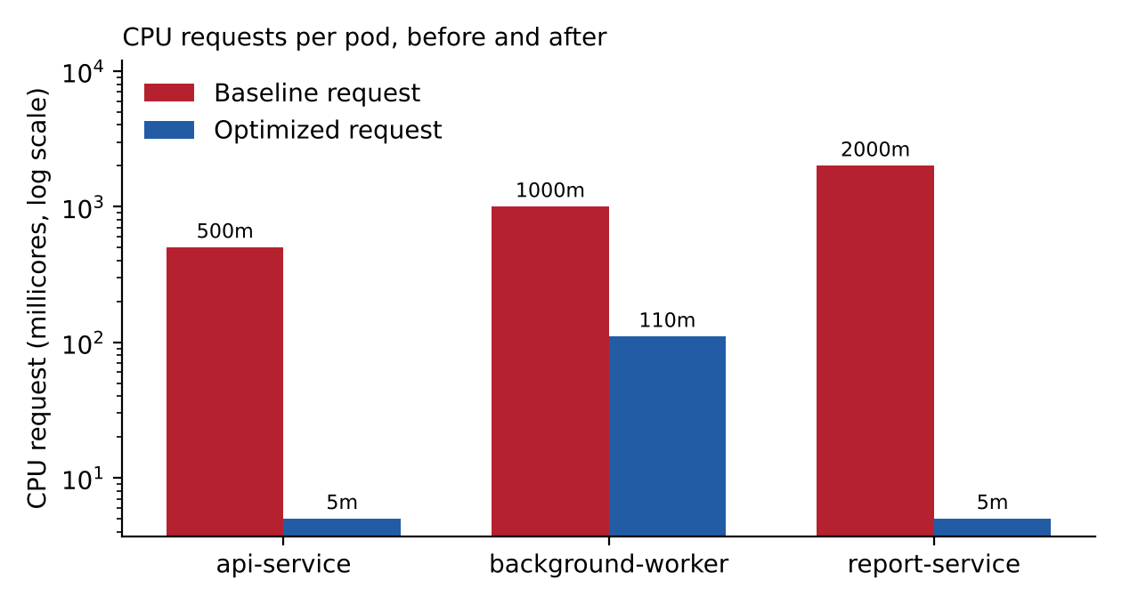
Figure 13: CPU requests per pod, before and after
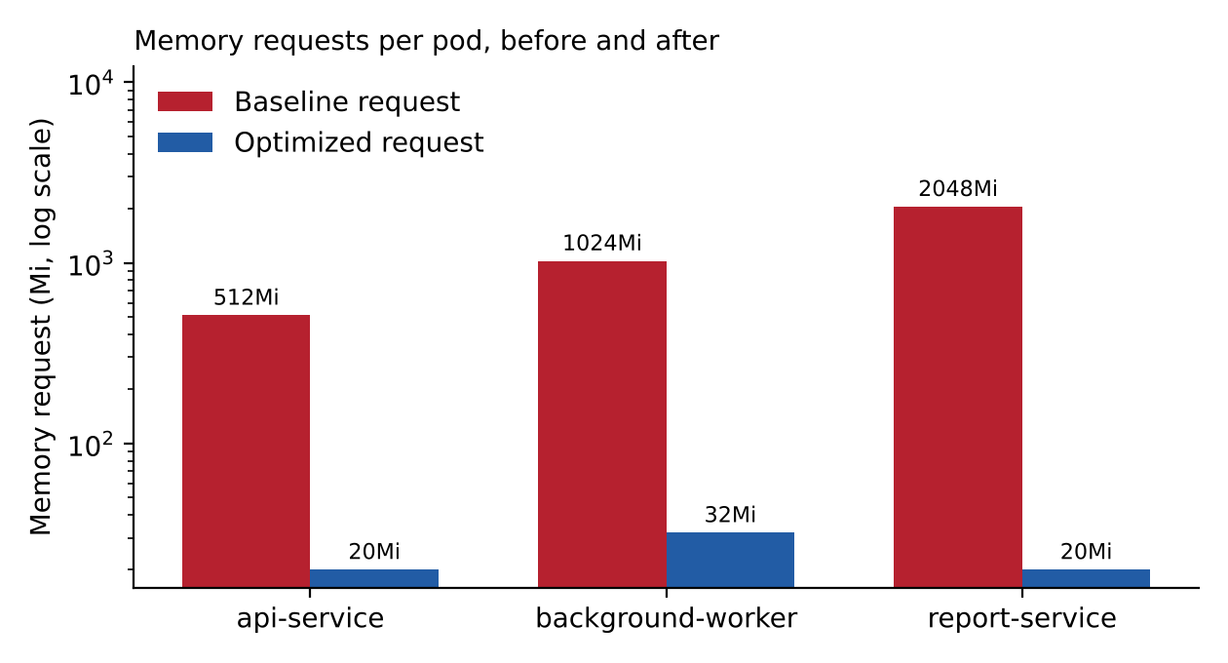
Figure 14: Memory requests per pod, before and after
Table 12 gives the totals. The repository results (README and comparison.txt) count each Deployment once, which gives 3500m to 120m of CPU and 3.5 Gi to 72 Mi of memory. Because api-service runs two replicas, the reservation actually held by the cluster is larger, and both views are shown.
Table 12: Total reservation before and after
Counting method | CPU before | CPU after | CPU reduction | Memory before | Memory after | Memory reduction
One pod per Deployment (as in repository results) | 3500m | 120m | 96.6% | 3.5Gi | 72Mi | 98.0%
All pods (api-service x 2) | 4000m | 125m | 96.9% | 4096Mi | 92Mi | 97.8%

[Insert screenshot here: screenshots/optimized-grafana-cpu.png]
CPU usage per pod and CPU requested vs used after the rolling update
Figure 15: Grafana CPU panels after optimisation
[Insert screenshot here: screenshots/optimized-grafana-memory.png]
Memory usage per pod and memory requested vs used after the rolling update
Figure 16: Grafana memory panels after optimisation

9.2 Utilisation and waste in the baseline
Under the medium load test the baseline workloads used a small fraction of what they had reserved (Table 13, Figure 17). In total 84m of CPU was in use against 3500m reserved, which is 2.4% utilisation and 97.6% waste.
Table 13: Baseline CPU utilisation (results/baseline.csv)
Workload | CPU requested | CPU used | Utilisation | Waste
api-service | 500m | 1m | 0.2% | 99.8%
background-worker | 1000m | 82m | 8.2% | 91.8%
report-service | 2000m | 1m | 0.05% | 99.95%
Total | 3500m | 84m | 2.4% | 97.6%

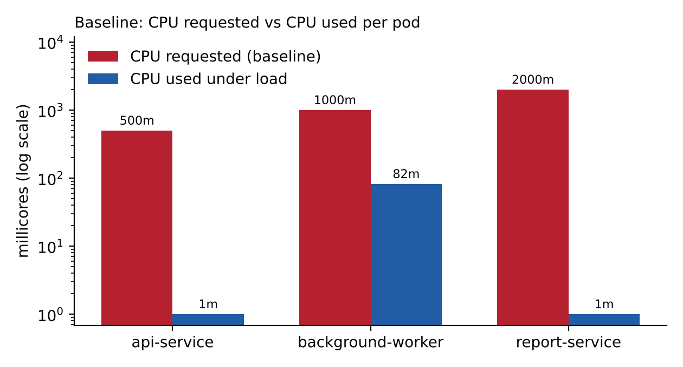
Figure 17: Baseline CPU requested versus CPU used per pod

9.3 Estimated cost
OpenCost reported the cost of the cost-demo namespace before and after the change (Table 14, Figure 18). The figures use the custom pricing model of Table 6.
Table 14: OpenCost estimated cost of the cost-demo namespace
Cost component | Before (USD/hr) | After (USD/hr) | Reduction
CPU | 0.105370 | 0.000530 | 99.5%
Memory | 0.014120 | 0.000050 | 99.6%
Total | 0.119490 | 0.000580 | 99.5%

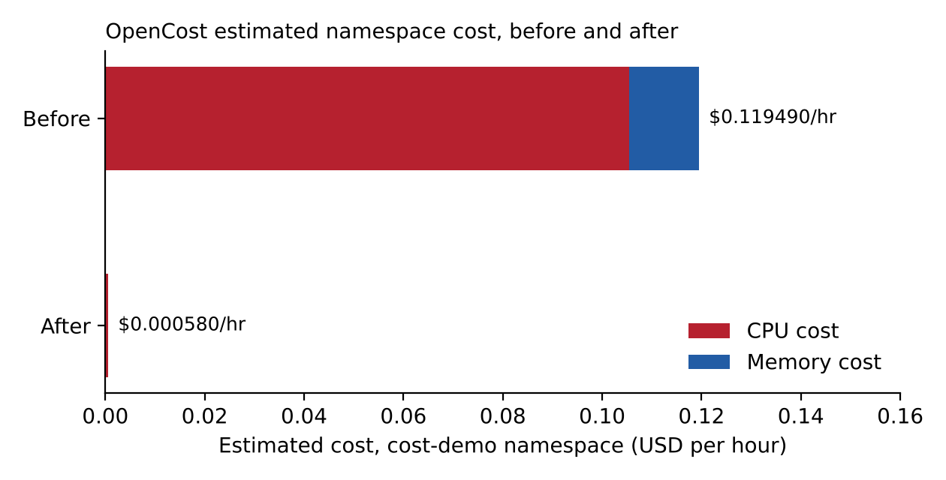
Figure 18: OpenCost estimated namespace cost, before and after
[Insert screenshot here: screenshots/optimized-opencost-allocation.png]
OpenCost UI showing the reduced cost of the cost-demo namespace
Figure 19: OpenCost allocation view after optimisation
The cost reduction (99.5%) is larger than the reduction in requests (96.6% to 96.9%). A cross-check explains part of the difference. Pricing the requests directly with the same price list gives the expected hourly cost in Table 15. The measured "before" value is about 83% of the expected one and the measured "after" value is about 13% of it. OpenCost averages over the time window of the query, so a window that is short or overlaps the rolling update will under-report a steady state. The request-based figures in Section 9.1 are therefore the more reliable headline result, and the cost figures should be read as indicative.
Table 15: Cross-check of OpenCost figures against request-based pricing
Quantity | Before | After | Reduction
Expected cost from requests, all pods (USD/hr) | 0.143392 | 0.004332 | 97.0%
Measured by OpenCost (USD/hr) | 0.119490 | 0.000580 | 99.5%
Measured as a share of expected | 83% | 13% | -

9.4 Efficiency and projected savings
The cluster efficiency reported by OpenCost rose from 3.5% to 8.7%, an improvement of 5.2 percentage points. It remains low in absolute terms because the load generated by the test is small and the workloads do almost nothing. Extending the hourly saving of $0.118910 gives the illustrative figures in Table 16. They apply to this namespace only and assume the cost figures in Table 14; they should be scaled for real node counts and treated with the caution described in Section 9.3.
Table 16: Annualised saving estimate for the cost-demo namespace (illustrative)
Period | Calculation | Saving (USD)
Per hour | 0.119490 - 0.000580 | 0.1189
Per day | 0.118910 x 24 | 2.85
Per month | 0.118910 x 730 | 86.80
Per year | 0.118910 x 8760 | 1041.65

All pods remained in the Running state during and after the rolling update, and no outage was observed. Availability was not measured separately, for example with a continuous probe during the update.

9.5 Limitations of the measurements
- Different worker workload. The baseline background-worker polls api-service every 0.5 s and runs a 10000-iteration loop for each response. The worker in optimized-deployments.yaml runs a 100-iteration loop and sleeps for 5 s, and does not poll the API. Its measured CPU therefore fell from 82m to 1m for a reason other than right-sizing, and the 110m request has not been verified against the original baseline load. Re-running the verification phase with the baseline worker script would fix this.
- Single sample. Each phase has one kubectl top reading per workload, taken at one instant, and the "peak" in the 1.3 rule is that reading, not the maximum over a time window. A longer observation with Prometheus (for example the 95th percentile of rate(container_cpu_usage_seconds_total)) would be a stronger basis.
- Synthetic load. The workloads are static nginx responses and a shell loop. Real services have start-up spikes and variable traffic.
- Tight limits. A limit of 10m CPU on nginx leaves little room and could cause CPU throttling under heavier traffic. The load test used here was light enough that this did not show.
- Estimated prices. Costs come from a configured price list on a local cluster and are not a bill.
- Cost window. The OpenCost figures depend on the query window, as shown in Section 9.3.

10. Comparative analysis
OpenCost is compared with four alternatives. Prometheus with Grafana, and kubectl top with metrics-server, were used in this project. Kubecost and cloud provider billing were not deployed, so statements about them come from their public documentation [3], [7] and not from the experiment.

10.1 Ease of use and setup
Table 17: Ease of use and setup
Tool | Setup | Learning curve | Experience in this project
OpenCost | Helm chart plus values; needs an existing Prometheus and its exact service name; custom pricing for non-cloud clusters | Low once running: UI and ready-made metrics | Worked after the Prometheus service name was corrected; showed $0 for the first 5 to 10 minutes
Prometheus + Grafana only | One Helm chart (kube-prometheus-stack) | Medium: PromQL and dashboard design needed | Twelve dashboard panels had to be written by hand; no price data
kubectl top + metrics-server | One Minikube add-on | Very low | Instant numbers but no history and no cost
Kubecost (documented) | Helm chart; commercial tiers | Low to medium | Not tested here
Cloud billing (documented) | No install, needs a cloud account | Low | Not usable on Minikube; reports at account or service level unless pod-level allocation is enabled

10.2 Scalability and performance
Table 18: Scalability and performance
Tool | Scalability | Performance notes
OpenCost | Depends on the Prometheus it reads from: metric volume and retention set the limits. Not tested beyond one node | Queries are computed from stored metrics; the footprint of OpenCost itself was not benchmarked
Prometheus + Grafana only | Well-established; large installations usually add long-term storage and federation | Scrape interval here 30 s, retention 7 days
kubectl top | Point-in-time reading per call; no history | Fast; suited to scripts, not trends
Kubecost (documented) | Built on the OpenCost core with additional enterprise features | Not tested here
Cloud billing (documented) | Scales to whole accounts | Data typically arrives with a delay, so it is not suited to immediate before and after checks

10.3 Integration into the DevOps pipeline
Table 19: Integration into the DevOps pipeline
Tool | Integration points
OpenCost | JSON allocation API (for example /allocation?window=1h&aggregate=namespace), opencost_ metrics in Prometheus and Grafana, Helm values kept in Git. A cost check could be added to CI by querying the API
Prometheus + Grafana only | Dashboards as JSON in Git; PromQL queries scriptable; no cost data without another source
kubectl top | Easily scripted: collect-baseline.sh and collect-after.sh write its output to CSV
Kubecost (documented) | API and UI; additional features depend on the licence tier
Cloud billing (documented) | Billing exports and APIs; separate from the cluster pipeline

10.4 Advantages and limitations of OpenCost
Table 20: Advantages and limitations of OpenCost
Advantages | Limitations
Open source and vendor-neutral, so it runs on any cluster, including a laptop | Needs a working Prometheus; mistakes in the service name or scrape setup give empty or zero data
Allocates cost to namespace, workload and pod, which the other tools used here cannot do | Reports cost; it does not change anything. Choosing and applying new requests was a manual step in this project
Custom pricing makes it usable without a cloud provider | Local figures are estimates and depend on the price list and the query window
Exposes an API, a UI and Prometheus metrics, so it fits scripts and dashboards | Results needed a cross-check (Section 9.3) before they could be trusted
Installs from one Helm chart with a short values file | No security or access controls were configured in this project

11. Challenges and lessons learned

11.1 Challenges encountered
Table 21: Challenges and how they were handled
Challenge | Handling
OpenCost could not reach Prometheus | The service name differs between installs. It is looked up with kubectl get svc -n monitoring and written into opencost/values.yaml before installing
OpenCost showed $0 | Normal at first; it needs 5 to 10 minutes of Prometheus data. The experiment waited before recording cost
UI and API ports confused | The UI is served on 9090 and the API on 9003; both are forwarded in one command
Pods stuck in Pending | The baseline reservations plus the monitoring stack exceed a small Minikube. It was started with 6 CPUs and 8 GiB, and setup.sh warns when free memory is low
kubectl top returned nothing | metrics-server needs about two minutes after it is enabled
Helm install timeouts | The timeout was raised (10 minutes for the monitoring stack) and pod logs checked
Usage close to zero for two workloads | The 1.3 rule gives values too small to be practical, so small fixed minimums (5m, 20Mi, 32Mi) were used
Choosing values without guessing | The optimised file ships with placeholders and instructions; values were filled in only after the baseline was measured

11.2 Lessons learned
- Cost follows reservation, not usage. A pod that uses 1m of CPU but requests 2000m costs the same as one that uses 2000m.
- Monitoring that shows usage is not enough to find waste; the request has to be shown next to the usage and priced.
- A before and after comparison is only as good as its control. The baseline and optimised worker scripts should have been identical, and a diff of the two manifests before the second run would have caught this.
- Cross-check tool output against a simple calculation. Pricing the requests by hand showed that the OpenCost "after" figure was too low to be a steady-state value.
- Keep configuration in files. Every step could be repeated because the cluster, charts, values and dashboard were all stored in Git.
- A CI step that ends in "|| true" is a log message, not a check.

12. Conclusion and future work

12.1 Conclusion
The project showed how OpenCost, used alongside Prometheus and Grafana, makes the cost of Kubernetes over-provisioning visible and measurable. Three workloads that reserved 3500m of CPU and 3.5 Gi of memory while using 84m of CPU were right-sized with a documented rule. Reserved CPU fell by 96.6% and reserved memory by 98%, and all pods remained Running. OpenCost estimated the namespace cost at $0.1195 per hour before and $0.0006 per hour after, subject to the caveats in Section 9.3. Measured against conventional tools, OpenCost is the only one in the set tested that attributes cost to individual workloads, at the price of depending on Prometheus and a correct price configuration. The limitations in Section 9.5, above all the different worker script in the optimised manifest, mean that the verification phase should be repeated before the 110m worker request is relied on.

12.2 Future work
- Repeat the verification phase with an identical worker script, and measure availability with a probe during the rolling update.
- Base the optimised values on a percentile of Prometheus data over a longer period, not a single kubectl top sample.
- Make the CI checks blocking by removing "|| true", and add an OpenCost API query that fails the build when namespace cost exceeds a threshold.
- Add security automation: manifest scanning (for example kube-linter or Trivy config scanning), secret management for the Grafana password, and removal of anonymous Grafana access.
- Evaluate the Kubernetes Vertical Pod Autoscaler in recommendation mode against the manual 1.3 rule.
- Run on a managed cloud cluster so that OpenCost uses real provider prices, and compare with Kubecost.
- Benchmark OpenCost memory and CPU use as the number of pods grows.

References
[1] The Kubernetes Authors, "Resource Management for Pods and Containers," https://kubernetes.io/docs/concepts/configuration/manage-resources-containers/.
[2] FinOps Foundation, "What is FinOps?," https://www.finops.org/.
[3] OpenCost Authors (CNCF), "OpenCost documentation," https://www.opencost.io/docs/.
[4] Prometheus Authors, "Prometheus documentation," https://prometheus.io/docs/.
[5] Grafana Labs, "Grafana documentation," https://grafana.com/docs/.
[6] Prometheus Community, "kube-prometheus-stack Helm chart," https://github.com/prometheus-community/helm-charts/tree/main/charts/kube-prometheus-stack.
[7] Kubecost, "Kubecost documentation," https://docs.kubecost.com/.
[8] The Helm Authors, "Helm documentation," https://helm.sh/docs/.
[9] The Kubernetes Authors, "minikube documentation," https://minikube.sigs.k8s.io/docs/.
[10] Kubernetes SIGs, "metrics-server," https://github.com/kubernetes-sigs/metrics-server.
[11] GitHub, "GitHub Actions documentation," https://docs.github.com/actions.
[12] S. Pol, "k8s-cost-optimization" (project repository), https://github.com/shlokapol2005/k8s-cost-optimization.

