DepShield Changes and Validation Report
  - Response to clustering and baseline comparison feedback
Prepared for faculty review | 16 October 2026
This report records the changes made to the DepShield project after reviewing the research paper and the submitted repair document. The completed work provides reproducible evaluation tools, clearer failure handling, a recreated graph with corrected annotations, and guidance for revising the paper. The original empirical comparison has not been rerun because its raw feature matrix and pinned repository sample were not supplied.

The concern raised by the original graph
The plotted silhouette score is highest at k=3, approximately 0.607, and falls to approximately 0.458 at the selected k=4. The inertia curve has no decisive elbow at four. These diagnostics therefore do not establish k=4 as statistically optimal. The paper already acknowledges this trade-off; the outstanding requirement is a measured comparison showing whether the fourth group improves remediation decisions.

Status of the response
Item | Status after this update
Clustering evaluation | Implemented: k=2–8, repeated seeds, centroid tables and assignment comparison.
Baseline comparison | Implemented: capture and comparison tools for npm audit and optional Snyk. Original sample runs remain pending.
Graph presentation | Recreated with k=3 highlighted and k=4 identified as the operational choice. Values are approximate image readings.
Software verification | All 16 research and clustering tests passed. Local website and API responded successfully.
Application policy | Four operational groups remain in use pending evidence. No forced switch to k=3 was made.
Research manuscript | Replacement wording and discrepancies are documented in EVALUATION.md. The original paper PDF was not edited.

The distinction between an implemented evaluation procedure and a completed scientific experiment is maintained throughout this report.

Clustering evaluation and graph changes
The previous evaluator tested k=2–6, produced only a silhouette plot, and substituted random features when data was missing. The revised evaluator tests valid values from k=2–8 and stops when the required measurements are unavailable.
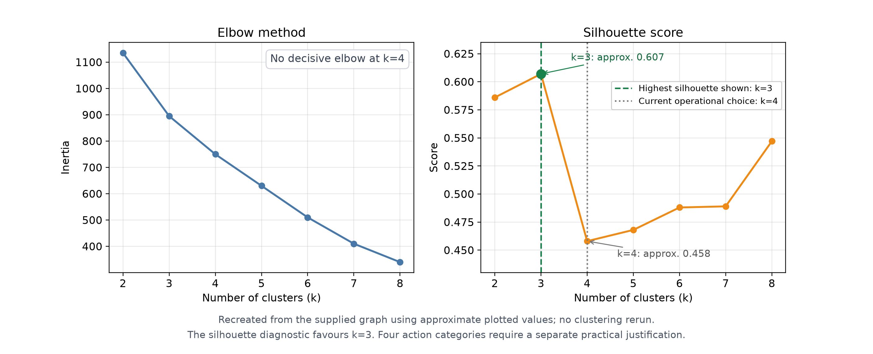
Figure 1 Recreated original diagnostics with corrected interpretation. Approximate plotted values were read from the supplied image; this is not a fresh K-means experiment.

What the revised evaluator records
- Input validation accepts raw scan JSON, exported factor fields and CSV. Missing, non-finite and out-of-range V/O/U/D/M values are rejected. Measured zeros remain valid.
- The saved normalized matrix is used unchanged. The default random seeds are 42, 7, 21, 84 and 123, with ten initializations per fit. The original preprocessing must still be recovered for historical reproduction.
- Outputs include mean inertia, mean silhouette and standard deviation across seeds, with the best mean-silhouette k marked on the plot. No particular k is forced to win.
- For both k=3 and k=4, the tool exports cluster sizes, factor centroids, package assignments and a membership cross-tab. Stability is recorded using adjusted Rand index against the first seed.
- Input hashes and software versions are preserved. Observed composite scores are kept separate from scores recomputed using the paper equation. Metrics use raw cluster assignments before action overrides.
The four application labels—Fix This Week, Replace, Monitor and Safe—remain an operational policy. Their usefulness must be assessed separately from statistical cluster separation. No particular merger between existing action groups is assumed.

Baseline comparison and reliable scan capture
The submitted repair document also identified the absence of matching npm audit and Snyk runs. New tools now support collecting and comparing those reports, but no original-sample baseline results have been manufactured or inferred from package counts.

Repository and input controls
A capture requires a clean local checkout at an explicitly supplied full 40-character commit SHA, with tracked package.json and package-lock.json files. The current capture supports lockfile formats 2 and 3. It records whether the repository is a training application or a production project, and checks the checkout and input hashes again after the run.
The capture preserves scan times, manifest and lockfile hashes, implementation hashes, software and tool versions, executed commands, and raw baseline outputs. Results go into a new directory outside the scanned checkout. It does not install repository dependencies or execute repository scripts.

What is compared
DepShield measure | Meaning
Composite High or Critical | Packages exceeding the current custom risk thresholds, including health and other adjustments.
Advisory High or Critical | Packages with at least one recorded High or Critical advisory.
Any advisory present | Packages with any recorded advisory; this intentionally has a broader threshold than the baseline.

Comparison uses unique package names because modern npm audit aggregates findings by name. The output reports shared packages, names found by only one tool, and Jaccard agreement. Developer dependencies are included; training and production samples remain identified separately. Snyk is optional and requires an authenticated CLI.

Failure handling and interpretation
- Strict research scans abort when core OSV or required npm metadata lookups fail. Incomplete package analysis cannot become a Safe placeholder in a research capture.
- An OSV parsing bug was fixed: an advisory without a CVSS vector now reaches the severity fallback instead of being lost through an uninitialized score.
- Valid npm audit or Snyk findings returned with exit code 1 are accepted. Failed or missing baseline runs are rejected, rather than counted as zero findings.
Agreement is not precision or recall. Advisory databases change, tools may share sources, and npm can propagate severity to parent packages. Claims about accuracy, false-positive reduction or time saved still require reference labels or a separate study. Manifest-only captures do not validate source-code reachability.

Additional findings from the research paper
Reviewing the full paper identified issues beyond the selected k. These were documented so that new measurements are not mistakenly described as reproductions of a different scoring model.

Composite score consistency
Equation 10 gives vulnerability, outdatedness, usage, depth and maintenance weights of 0.35, 0.15, 0.20, 0.15 and 0.15. Because this is a linear combination, applying these weights to cluster mean factors should reproduce mean risk apart from rounding. The printed values in Table 1 do not consistently do so.
Action label | Recomputed from printed factors | Printed composite R
Fix This Week | 0.2650 | 0.32
Replace | 0.1815 | 0.11
Monitor | 0.1000 | 0.09
Safe | 0.0780 | 0.07

Rounding to two decimal places can explain approximately 0.01 difference at most under these weights. The first two differences clearly exceed that allowance. These calculations audit the printed table; they are not replacement measurements of the underlying dataset.

Paper and implementation alignment
The current backend uses a CVSS-based score with penalties and adjustments. Usage and depth multipliers are disabled, and the O/U/D/M definitions differ from the paper. The revised capture labels its scoring model explicitly; the evaluator exports observed R alongside the paper-equation recomputation. The scoring model was not silently rewritten to make old results match.
The paper describes microservices, a queue, Redis caching, relational dependency edges, parser-based usage analysis and minimum-safe-version selection. This checkout instead has a synchronous Flask pipeline, regex import counts, simpler origin traces and latest-version recommendations. These differences are recorded for manuscript correction; the proposed infrastructure was not implemented during this repair.

Reporting changes prepared
EVALUATION.md contains replacement wording for cluster selection, results and discussion, limitations, the proposed protocol and conclusion. It also explains the required input data, commands, assumptions and generated outputs. It preserves uncertainty and does not claim that baseline or original-data clustering experiments have already been completed.

Register of project changes
Paths below are relative to the project folder. Added research scripts are separate from the user-facing dashboard. The table records the final scope of this update, including local startup fixes.
File or artifact | Change | Purpose
backend/scripts/evaluate_clustering.py | Replaced | Real-data validation, k=2–8 metrics, multiple seeds, k=3/k=4 tables, plot and provenance.
backend/scripts/evaluation_data.py | Added | Shared JSON/CSV readers, normalized-factor checks, input hashes and CSV export.
backend/scripts/generate_report_json.py | Replaced | Pinned local scan capture with optional npm audit and Snyk runs.
backend/scripts/compare_baselines.py | Added | Package-name agreement reports with separate risk and advisory measures.
backend/analyzer.py | Updated | Optional strict research failure handling and missing-CVSS score initialization.
backend/action_clustering.py | Noted | Clarifies the operational k=4 choice; the clustering policy remains unchanged.
backend/tests/test_evaluation.py | Added | Feature validation, clustering outputs, baseline parsing, provenance and scope tests.
backend/tests/test_research_scan.py | Added | Mocked network failures, missing vectors and strict-scan behavior.
EVALUATION.md and requirements-evaluation.txt | Added | Research instructions, paper corrections and plotting dependency declaration.
backend/app.py and backend/supabase_client.py | Updated | Optional local scan-only mode, unavailable monitoring responses and mode-aware health status.
src/components/GitHubLoginButton.jsx | Updated | Displays login-start errors and clears the loading state on failure.
README.md | Updated | Links the evaluation guide and documents local scan-only startup.
evaluation/figure_recreation | Added | Recreated chart in PNG and SVG, plus a CSV clearly marked as approximate image readings.

Local setup also installed the frontend and Python dependencies and placed the provided configuration file at the expected .env location. No credentials are included in this report. The original research PDF, the existing historical plot and the original clustering test file were retained.

Verification and remaining research work

Checks completed
All 16 automated tests passed after the evaluation and strict-scan changes. They cover existing action clustering, missing or invalid features, input-format compatibility, controlled clustering outputs, degenerate datasets, baseline distinctions, duplicate package aggregation, failed reports, mismatched scope, repository pin checks and strict API failure handling.
The tests use controlled fixtures and mocked network responses. Their scores and plots are software verification artifacts, not findings from the research sample. The recreated graph was visually checked for readability and correct annotations.
The local frontend and backend were started. The frontend returned HTTP 200, the API health response reported status ok, Git availability was confirmed, and scan-only mode was false after loading the supplied configuration. The browser displayed the application. This verifies startup, not a complete GitHub OAuth, monitoring or live vulnerability-scanning workflow.

What can be seen in the website
The dashboard retains its existing layout and four action groups. Most changes run through research scripts and saved evaluation outputs; no Research or Evaluation screen was added. Local scan-only mode is optional. With the supplied configuration, the preview was launched in full configured mode at http://127.0.0.1:5174/, with the API on port 5000.

Work still required before revising numerical results
- Recover the original per-package feature matrix, preprocessing and scoring implementation. The paper contains aggregate results, not the raw rows needed for reproduction.
- Recover the complete repository URLs, immutable commits and original manifests. Repository names and checkout labels in the paper are not sufficient identifiers.
- Run the k=3/k=4 comparison and inspect centroids, assignments and stability. Retain four clusters only with evidence of useful additional action distinctions.
- Run npm audit and, if available, Snyk on the same pinned sample. Preserve raw reports, dates and settings, and report the measured agreements and disagreements.
- Reconcile Table 1 with Equation 10 and align the manuscript with the actual implementation. Add developer labels or user-study evidence before claiming improved prioritization accuracy or time saved.

Statement suitable for the faculty review
The implementation now supports reproducible validation of the clustering choice and comparison with existing scanners. The recreated figure correctly identifies k=3 as the highest silhouette result in the supplied plot. Four action categories remain an operational choice. New original-sample results and claims of improved effectiveness remain pending until the required data and baseline runs are available.

Materials reviewed
DepShield Fixing the k=4 and Baseline-Comparison Gaps.docx; DepShield__1_.pdf, especially Sections 4 and 6–11 and Table 1; the supplied diagnostic graph; and the updated project files listed in this report.

