**CD Practical 2:**

**Write a C program to identify whether a given line is a comment or not.**

#include <stdio.h>

#include <stdlib.h>

#define FILENAME "program.txt"

int main() {

FILE *fp;

char ch[1000];

int i=2,single=0,multi=0;

fp=fopen(FILENAME,"r");

if(fp==NULL) {

printf("File \"%s\" does not exist!!!\n",FILENAME);

return -1;

}

printf("\n In our file: \n \n");

while (fgets(ch,1000, fp) != NULL)

{

if(ch[0]=='/' && ch[1]=='/')

{ single++;

for(i=2;i<=1000;i++)

{

if(ch[i]=='\n')

{

printf("%s - this is single line comment \n \n",ch);

break;

}

else continue;

}

}

if(ch[0]=='/' && ch[1]=='*')

{

for(i=2;i<=1000;i++)

{

if(ch[i]=='*'&&ch[i+1]=='/')

{

printf("%s - this is a multi-line comment \n \n",ch);

multi++;

break;

}

else continue;

}

}

}

int sum=single+multi;

fclose(fp);

printf("\n \n no of comments is: %d. There are %d single line and %d multi-line comments \n ",sum,single,multi);

return 0;

}

**File:**

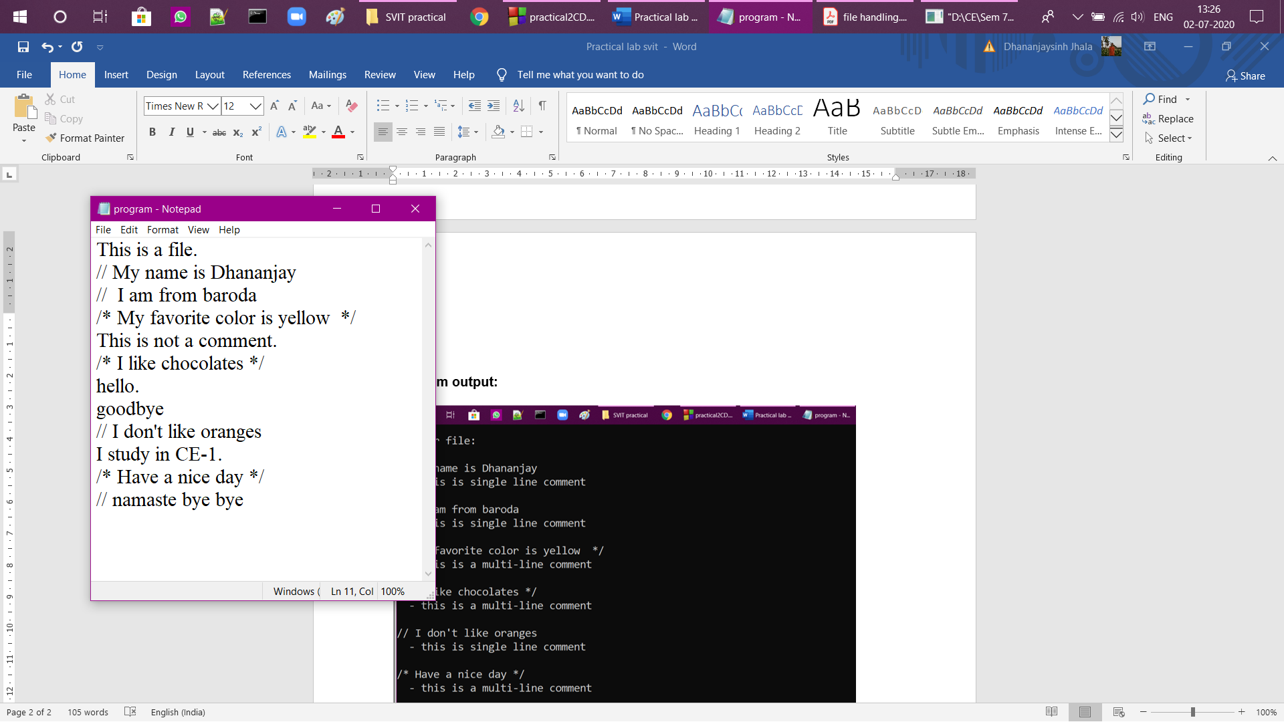

**Program output:**

