**CD Practical 3:**

**Write a C program to test whether a given identifier is valid or not.**

#include <stdio.h>

#include <stdlib.h>

#include <string.h>

#include <ctype.h>

#define FILENAME "identifierprog.txt"

int main()

{

FILE *fp;

char keyw[33][10]={"auto","double","int","struct","break","else","long","switch","case","enum","register","typedef","char","extern","return","union","const","float","short","unsigned","continue","for","signed","void","default","goto","sizeof","volatile","do","if","static","while"};

char line[128][20];

char ch[1000];

int i=0,tot=0;

fp=fopen(FILENAME,"r");

if(fp==NULL)

{printf("File \"%s\" does not exist!!!\n",FILENAME);return -1;}

printf("\n In our file: \n \n");

while(fgets(line[i],128,fp))

{

line[i][strlen(line[i]) - 1] = '\0';

i++;

}

tot = i;

for(int c=0;c<33;c++)

{

for(int d=0;d<tot;d++)

{

if(strcmp(keyw[c],line[d])==0)

printf("%s is not an idetifier \n\n",line[d]);

}

}

fclose(fp);

FILE *ffp;

ffp=fopen(FILENAME,"r");

while (fgets(ch,1000, ffp) != NULL)

{

if(!isalpha(ch[0]) && ch[0]!='_')

{

for(i=1;i<=1000;i++)

{

if(ch[i]=='\n')

{

printf("%s is not a valid identifier \n\n",ch);

break;

}

else continue;

}

}

}

fclose(ffp);

return 0;

}

**File:**

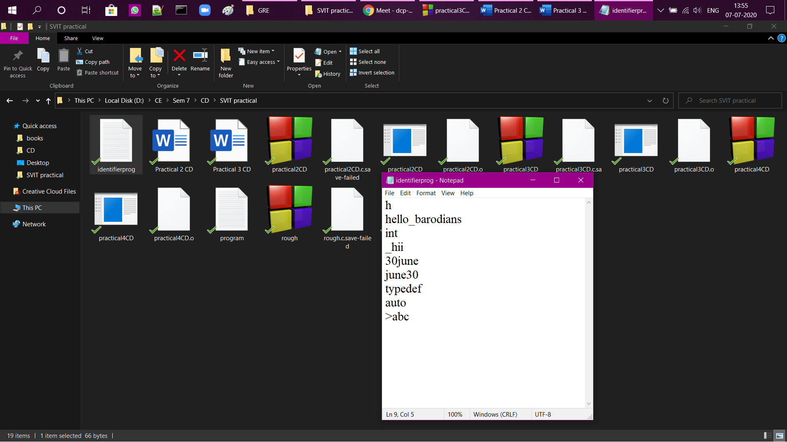

**Program output:**

