**CD Practical 6:**

**Implement following programs using Lex.**

**a. Create a Lexer to take input from text file and count no of characters, no. of lines & no. of words.**

%{

#include<stdio.h>

int l=0,w=0,c=0;

%}

%%

\n {l++; w++;}

[\t ' '] w++;c++;

[a-zA-z0-9] c++;

%%

int main(void)

{

yyin= fopen("myfile.txt","r");

yylex();

printf(" This File contains: ");

printf("\n%d lines", l);

printf("\n%d words",w);

printf("\n%d characters",c);

}

int yywrap()

{return(1);}

**Text file:**

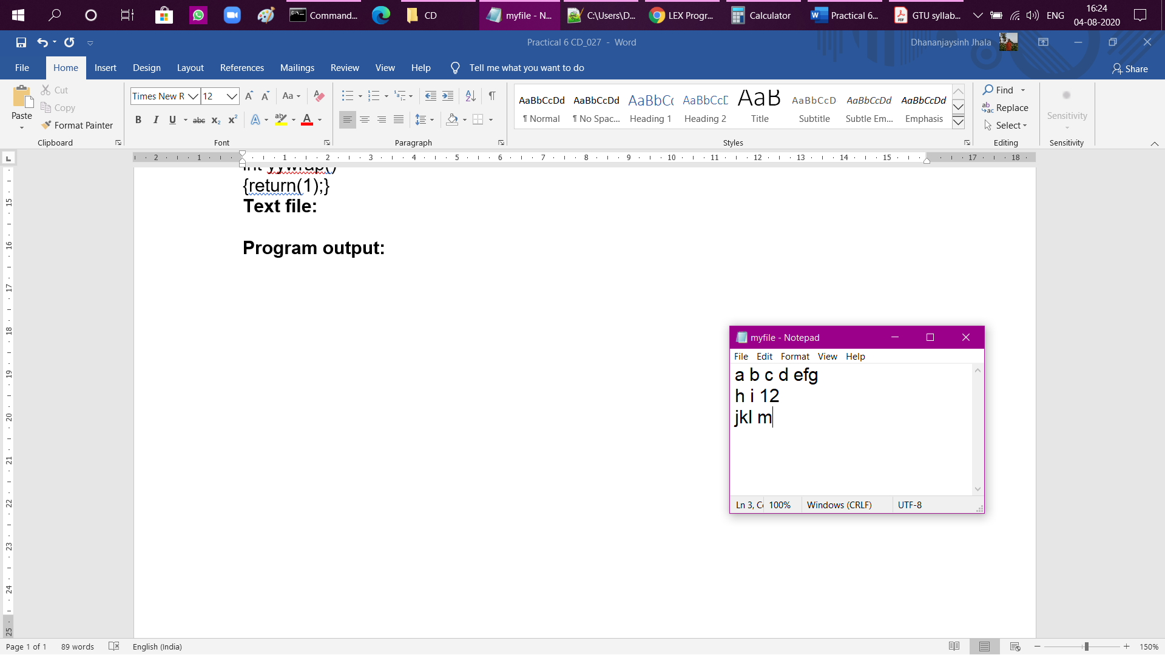

**Program output:**

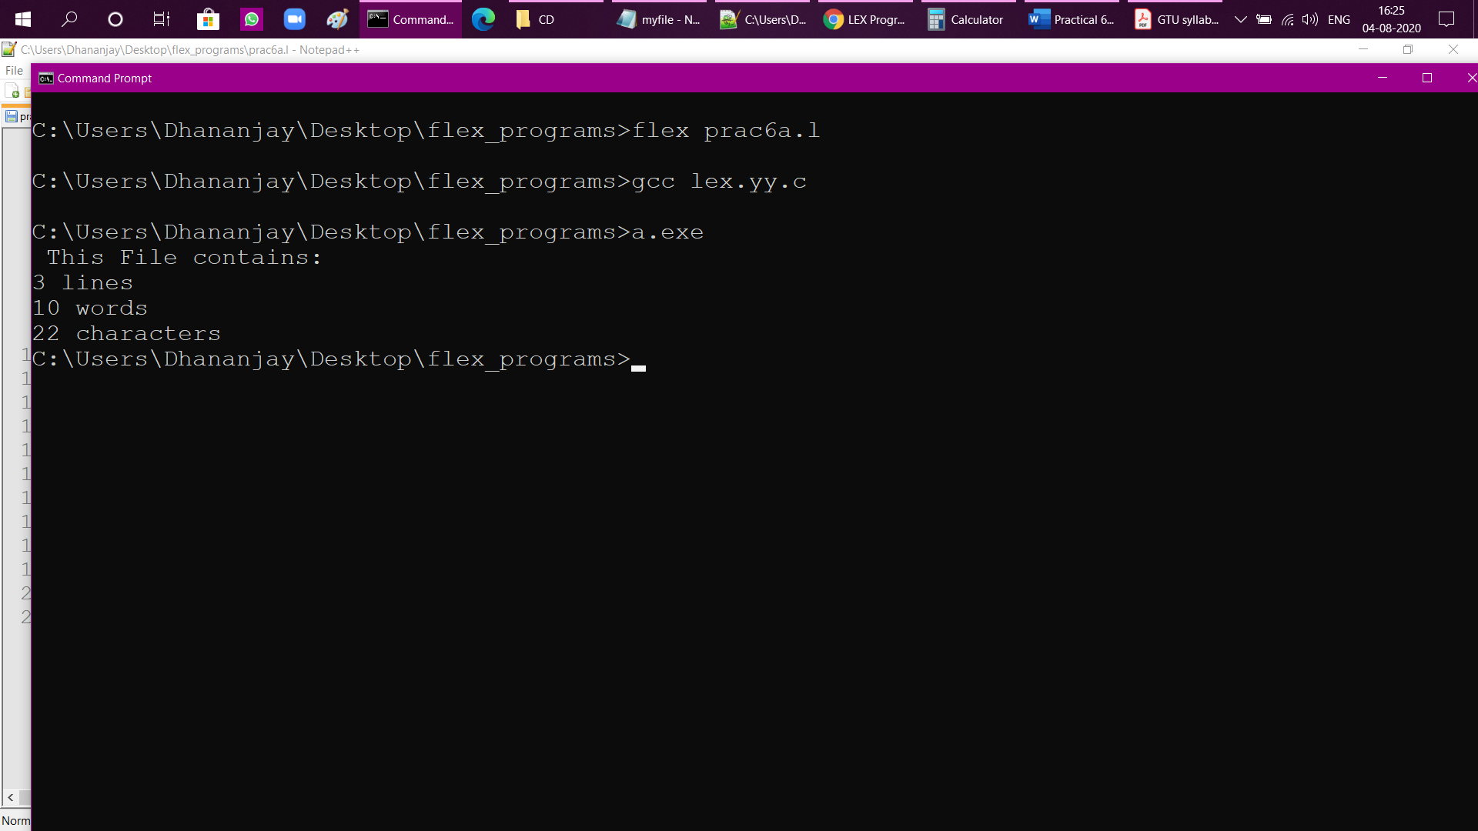

**b. Write a Lex program to count number of vowels and consonants in a given input string.**

%{

#include<stdio.h>

int v=0,c=0;

%}

%%

[aeiouAEIOU] v++;

[a-zA-Z] c++;

%%

int main(void)

{

yyin= fopen("myfile2.txt","r");

yylex();

printf(" This file has %d vowels and %d consonants",v,c);

}

int yywrap()

{ return(1);}

**Text file:**

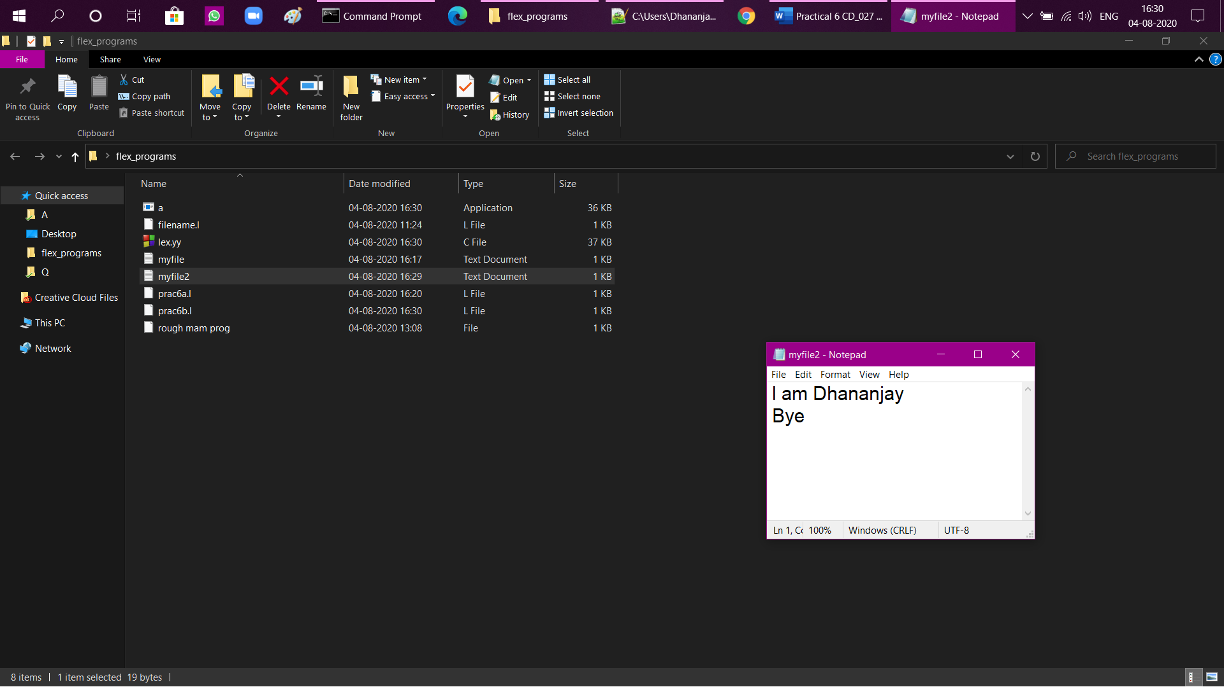

**Program output:**

