**CD Practical 7:**

**Implement following programs using Lex.**

**a. Write a Lex program to print out all numbers from the given file**

%{

#include<stdio.h>

%}

%%

[0-9]+ printf("\n %s is a number",yytext);

. ;

%%

int main()

{

yyin= fopen("numbers.txt","r");

yylex();

return 0;

}

int yywrap()

{ return(1);}

**Text file:**

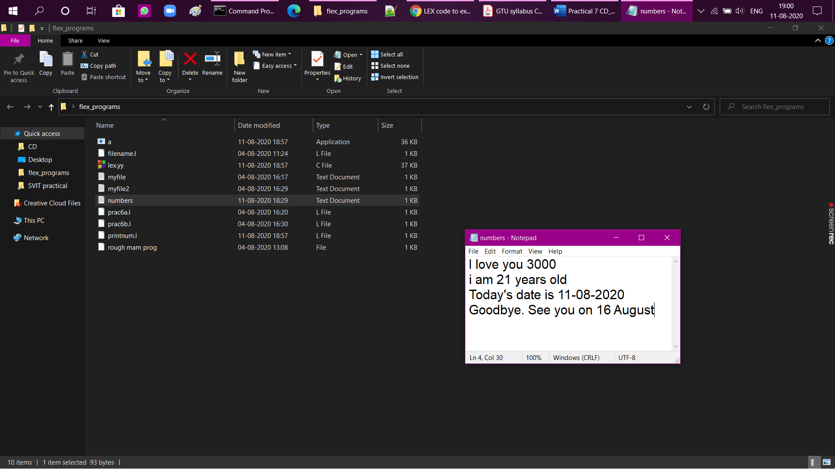

**Program output:**

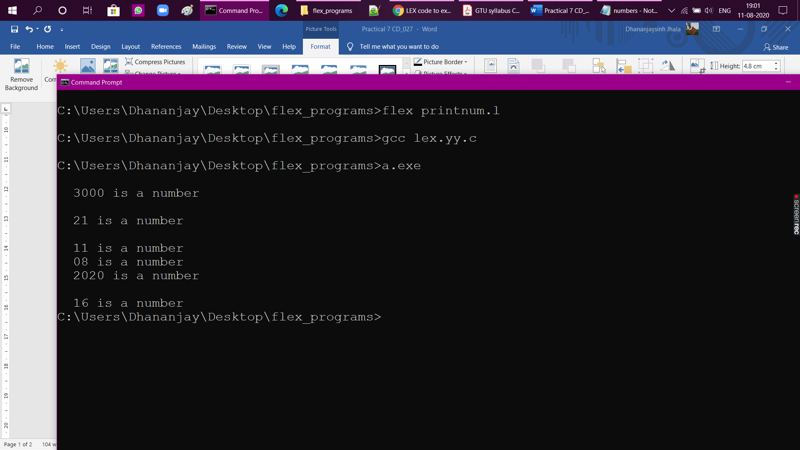

**b. Write a Lex program to printout all HTML tags in file.**

%{

#include<stdio.h>

%}

%%

"<"[^>]*> {printf("\n %s ", yytext); }

. ;

%%

int main(void)

{

yyin= fopen("htmltext.txt","r");

yylex();

}

int yywrap()

{ return(1);}

**Text file:**

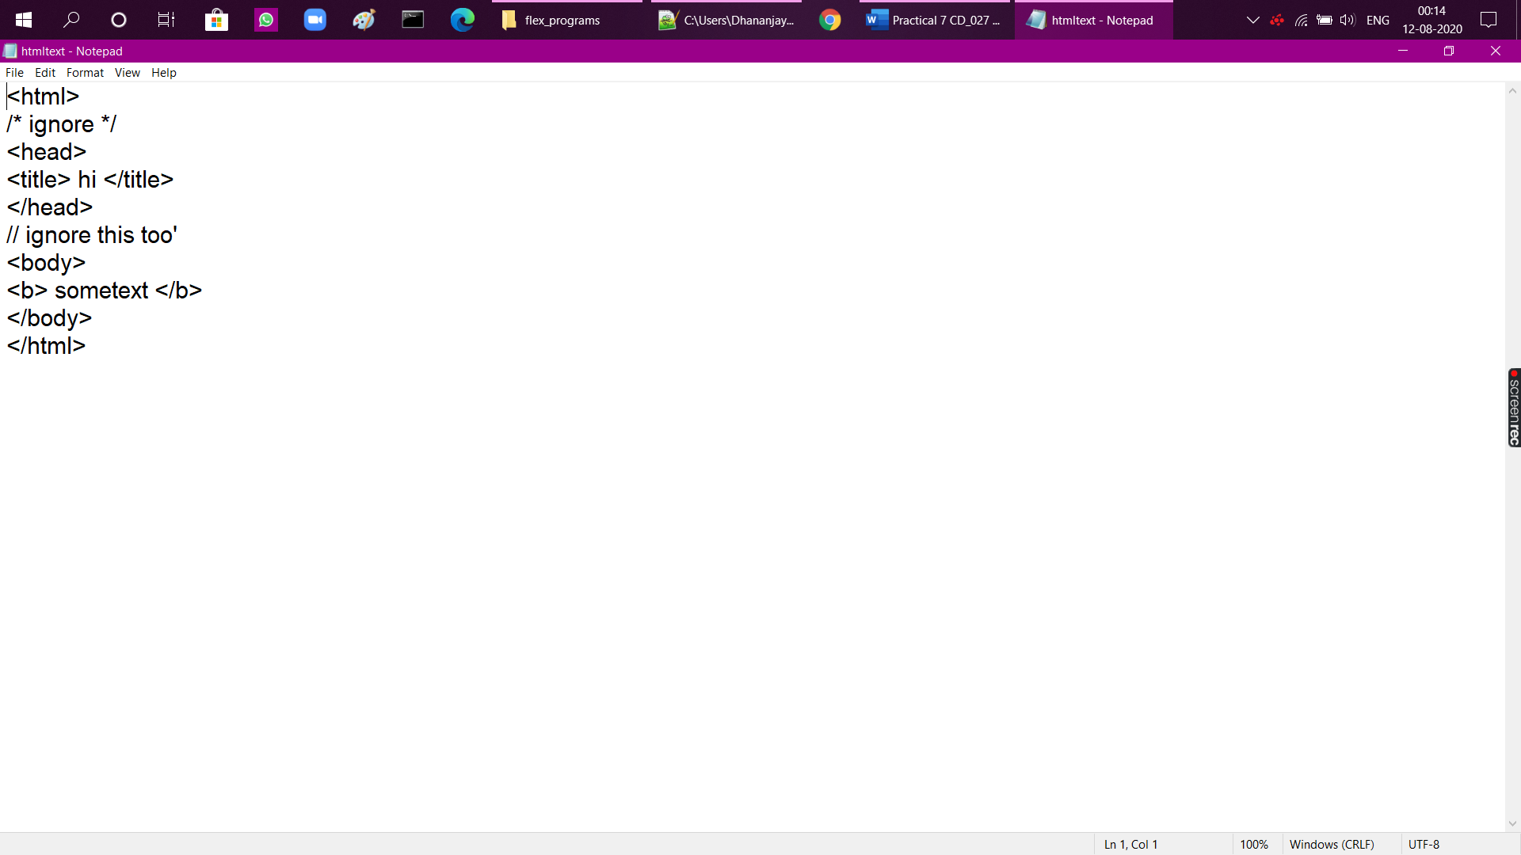

**Program output:**

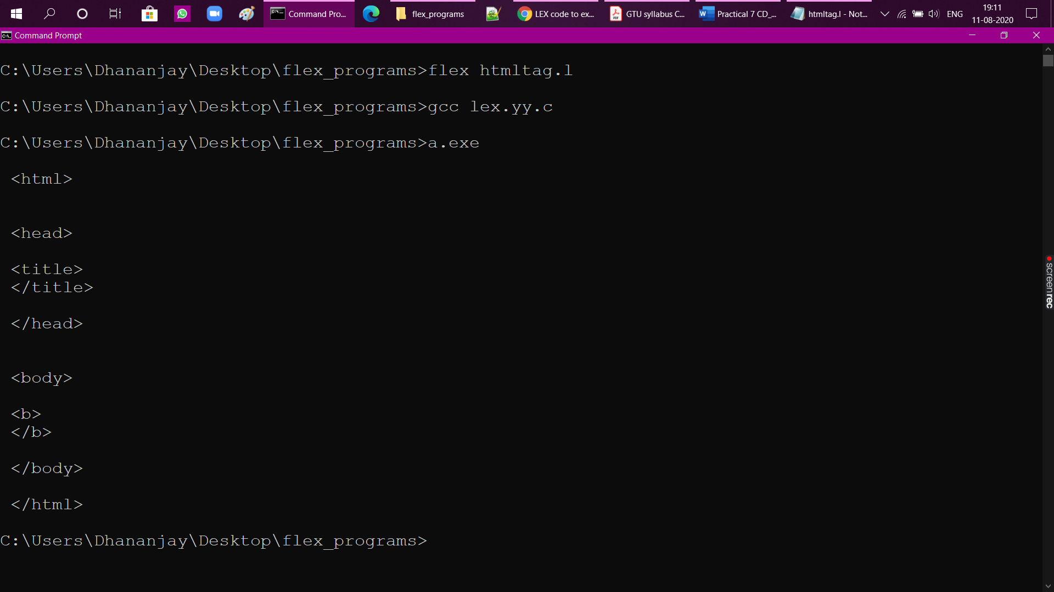

**c. Write a Lex program which adds line numbers to the given file and display the same onto the standard output.**

%{

int line_number = 1;

%}

%%

.*\n { printf("%10d %s", line_number++, yytext); }

%%

int yywrap(){}

int main(int argc, char*argv[])

{

extern FILE *yyin;

yyin = fopen("htmltext.txt","r");

yylex();

return 0;

}

**Text file:**



**Program output:**

