**Practical 10: Different Data Mining functionalities using XLMiner**

**Data Mining Usage in XLMiner**

Data Mining in XLMiner is comprised of four powerful functionalities that enable users to partition, classify, predict, and discover data associations.

* Partition: Used to partition data into training, validation, and/or test sets;
* Classify: Used to categorize a set of observations into pre-defined classes based on a set of variables. There are six different classification methods available for selection, including discriminant analysis, logistic regression, k-nearest neighbors, classification tree, naïve bayes, and neural network;
* Predict: Used to predict the response variable value based on a predictor variable. There are four different prediction methods available, including multiple linear regression, k-nearest neighbors, regression tree, and neural network;
* Associate: Used to recognize associations or correlations among variables in the dataset.

XLMiner supports all facets of the data mining process, including data partition, classification, prediction, and association. The second stage, classification, is used to categorize a set of observations into pre-defined classes based on a set of variables. XLMiner functionality features six different classification methodologies: discriminant analysis, logistics regression, k-nearest neighbors, classification tree, naïve Bayes, and neural network. Each method has its own unique features and the selection of one is typically determined by the nature of the variables involved.

**How to Access Classification Methods in Excel**

1. Launch Excel.
2. In the toolbar, click XLMINER PLATFORM.
3. In the ribbon's Data Mining section, click Classify.
4. In the drop-down menu, select a classification method.

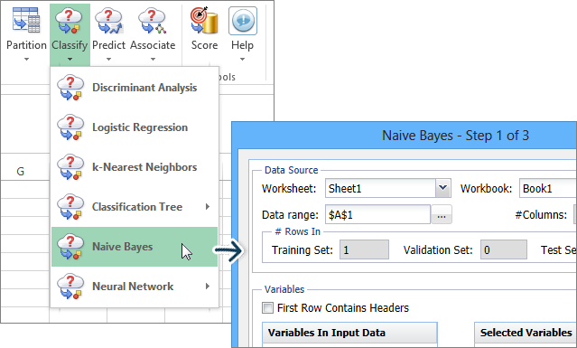

**Classification Methods**

* Discriminant Analysis Method
* Logistic Regression Method
* k-Nearest Neighbors Method
* Classification Tree Method
* Naïve Bayes Method
* Neural Network Method

The third stage, prediction, is used to predict the response variable value based on a predictor variable. XLMiner functionality features four different prediction methodologies: multiple linear regression, k-nearest neighbors, regression tree, and neural network. Each method has its own unique features and the selection of one is typically determined by the nature of the variables involved.

**How to Access Prediction Methods in Excel**

1. Launch Excel.
2. In the toolbar, click XLMINER PLATFORM.
3. In the ribbon's Data Mining section, click Predict.
4. In the drop-down menu, select a prediction method.

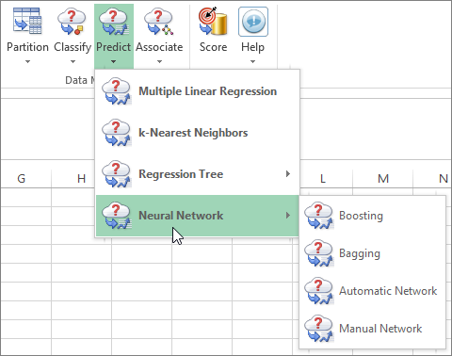

**Prediction Methods**

* Multiple Linear Regression
* k-Nearest Neighbors
* Regression Tree
* Neural Network