**Practical 4: Data Pre-processing in Weka**

1. Open and view data (weka→data→weathernumeric.arff)

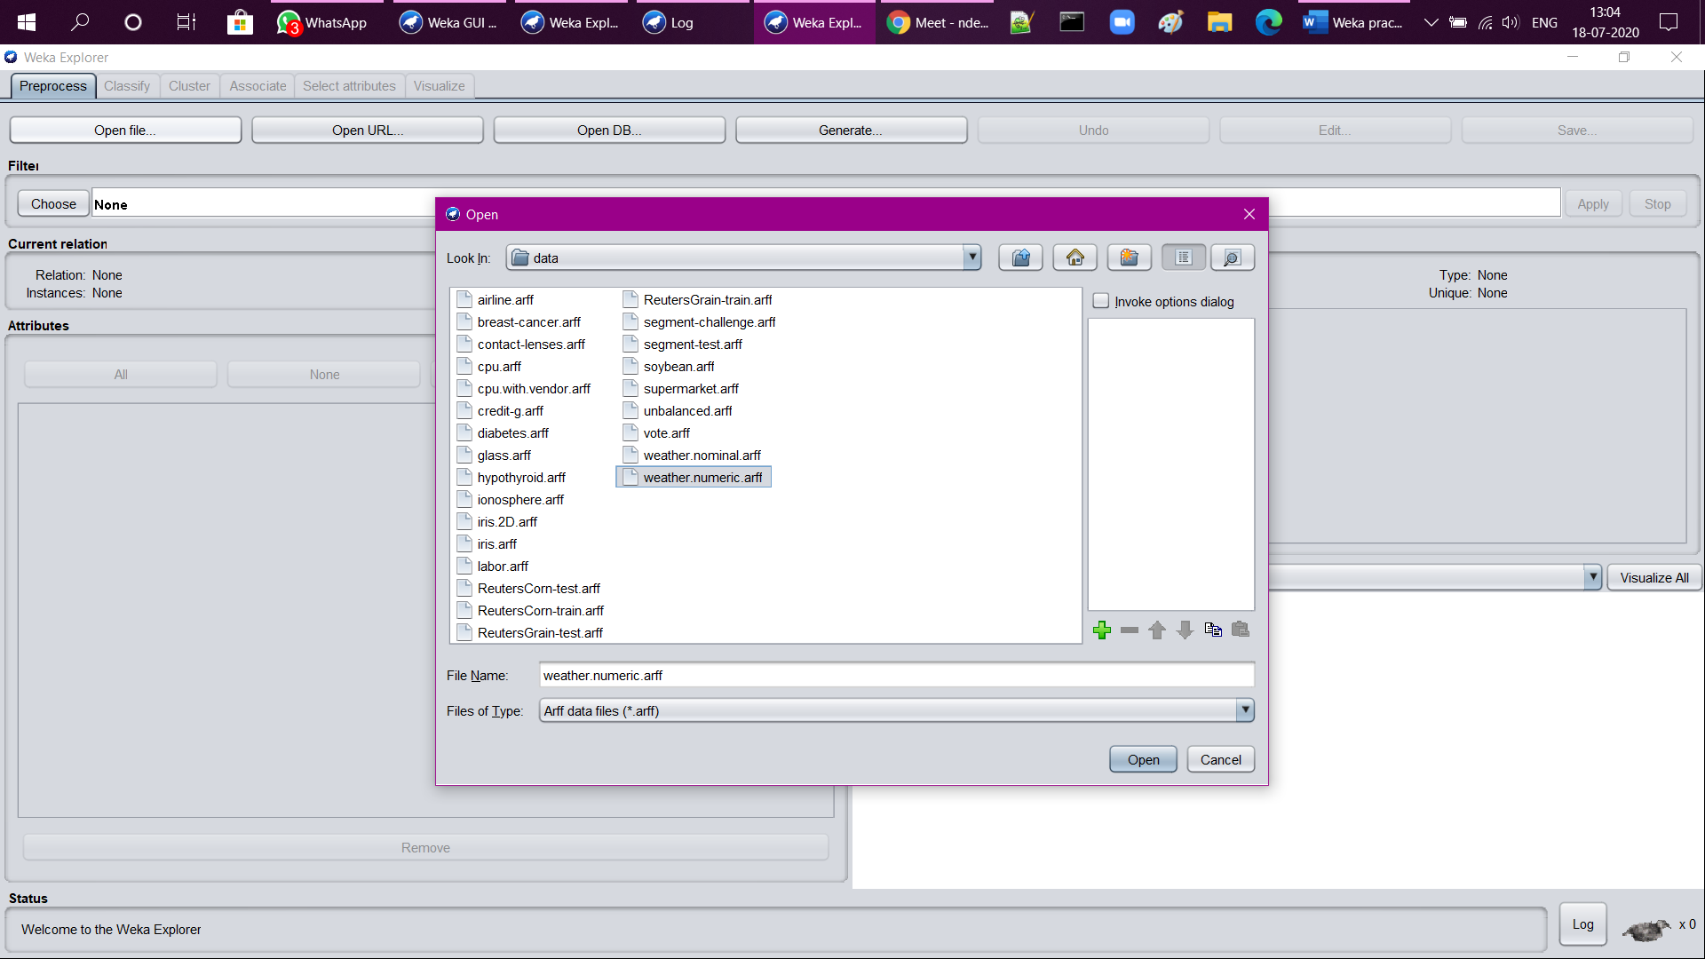

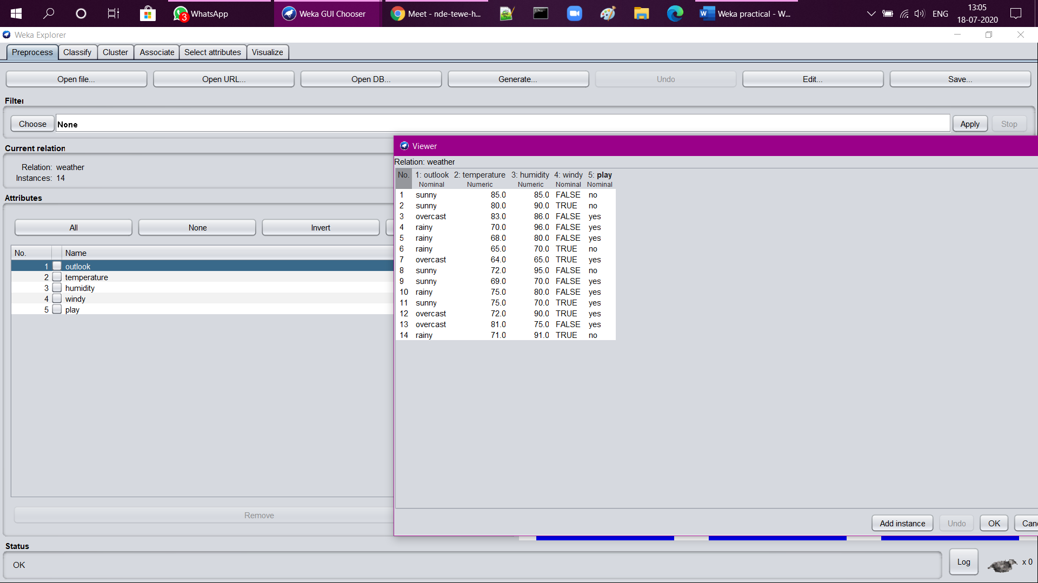

1. NumericToBinary (filters→unsupervised→attribute→NumericToBinary)

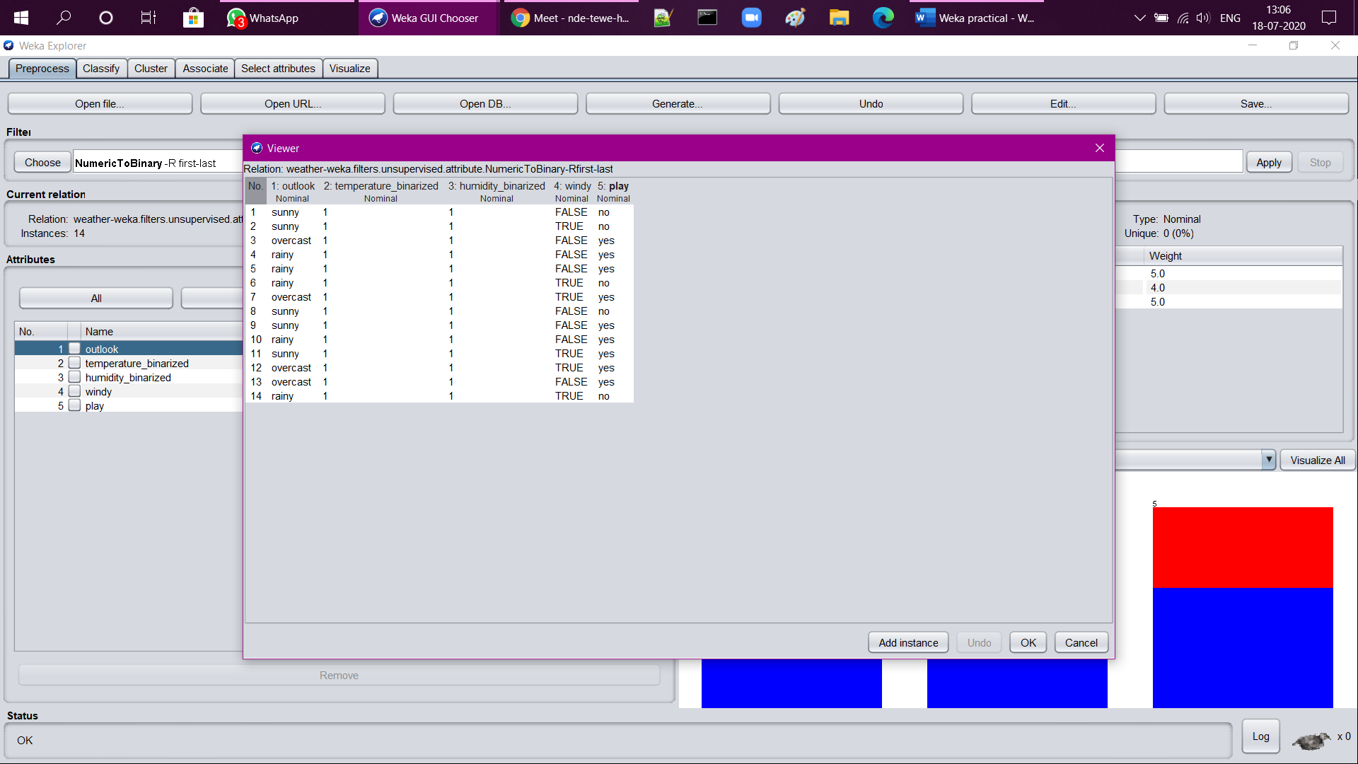

1. Obfuscate (filters→unsupervised→attribute→ Obfuscate)

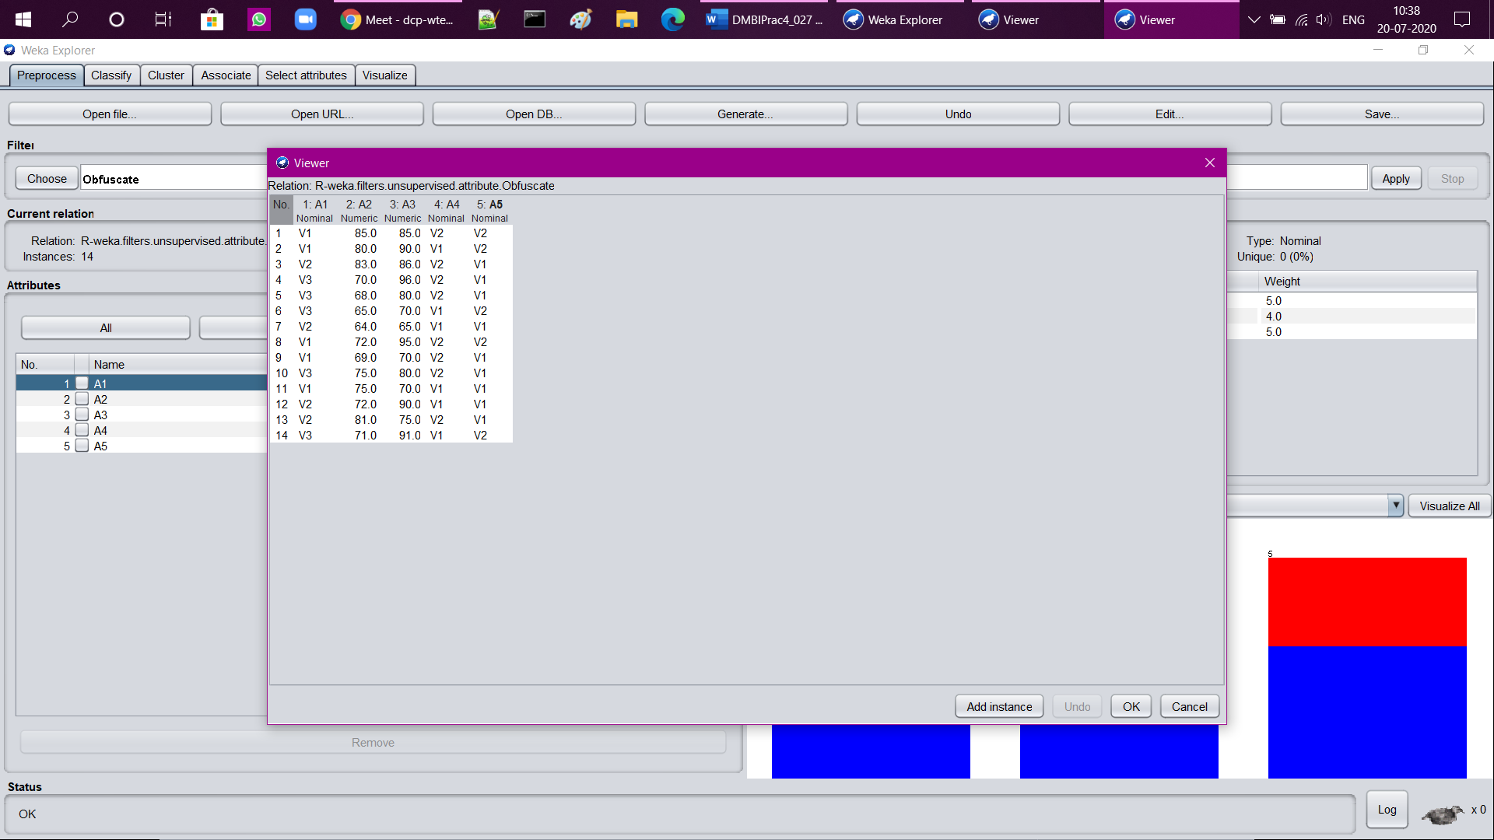

1. Normalize (filters→unsupervised→attribute→ Normalize)

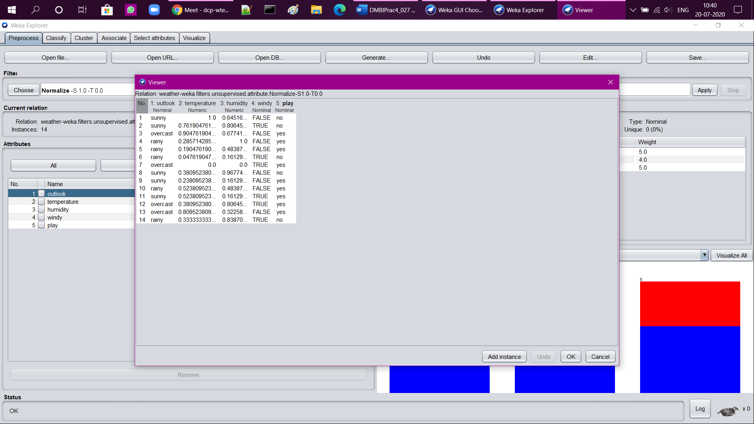

1. Remove

Before remove, 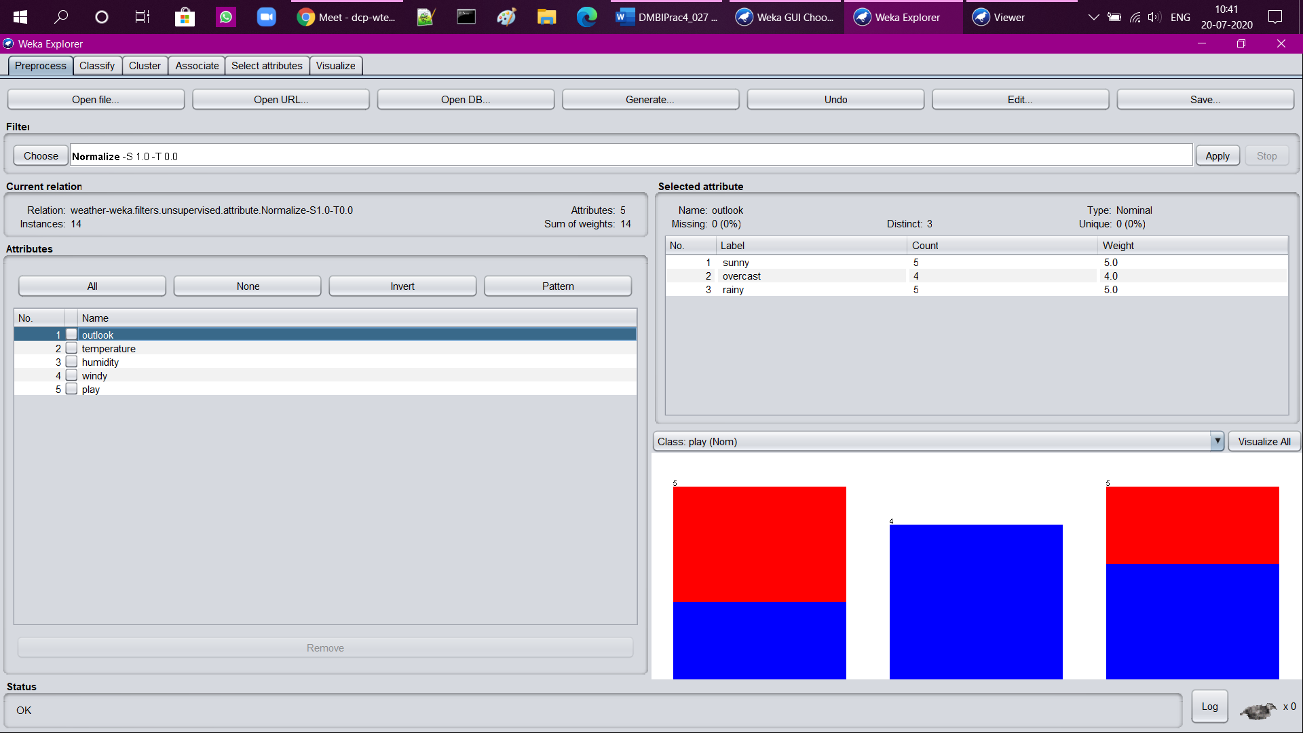

After applying remove with attribute first, (filters→unsupervised→attribute→ remove, and set attribute as “first”)

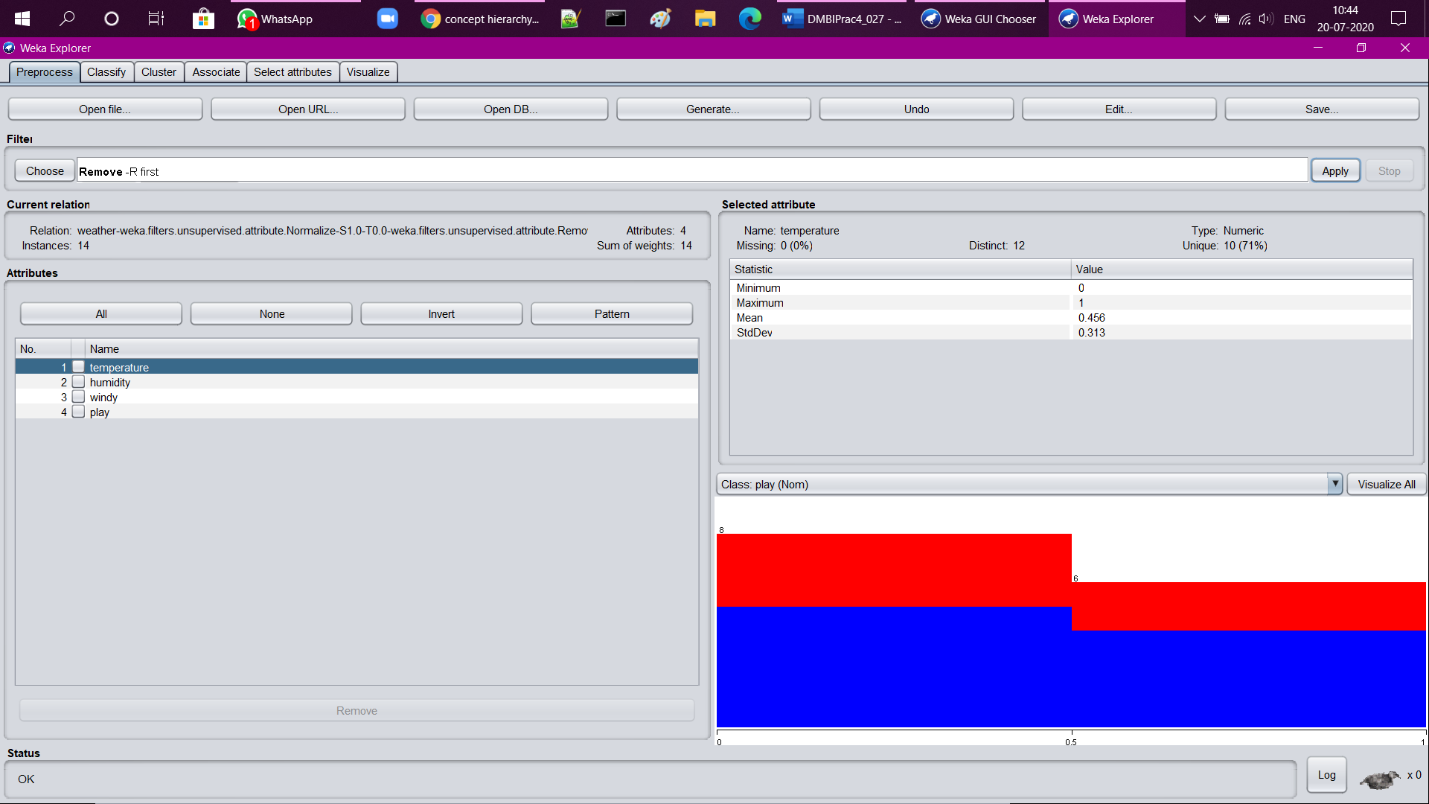



1. Standardize (filters→unsupervised→attribute→ Standardize)

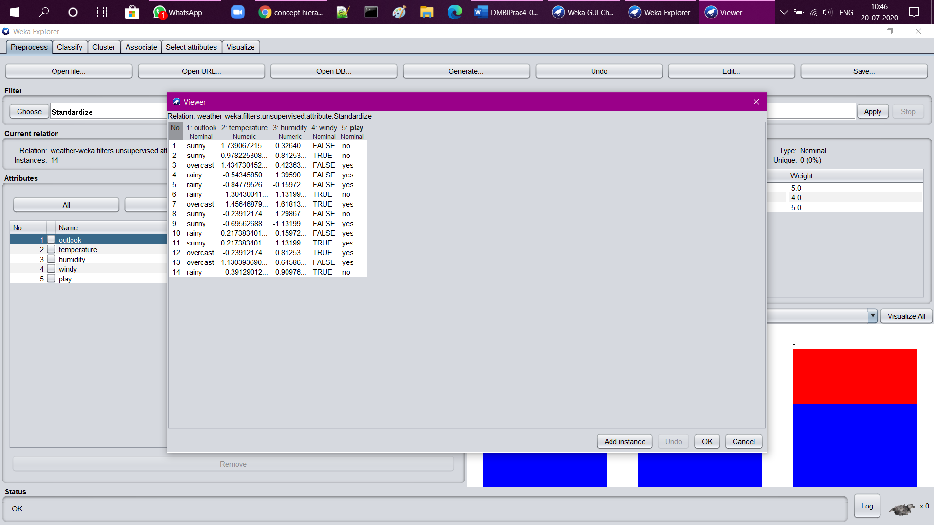

1. AddExpression (filters→unsupervised→attribute→ AddExpression)

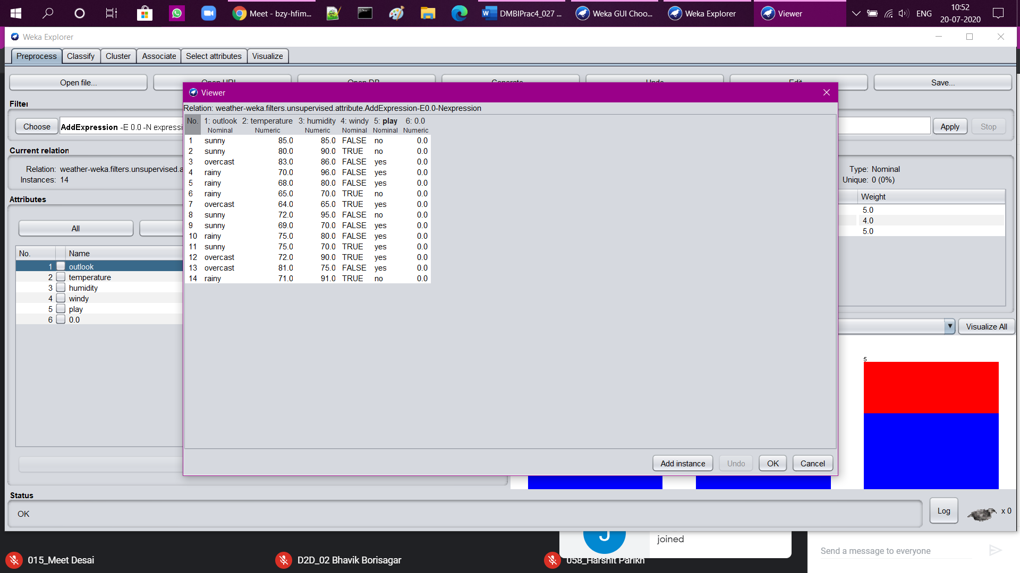

1. MathExpression

(filters→unsupervised→attribute→ MathExpression)

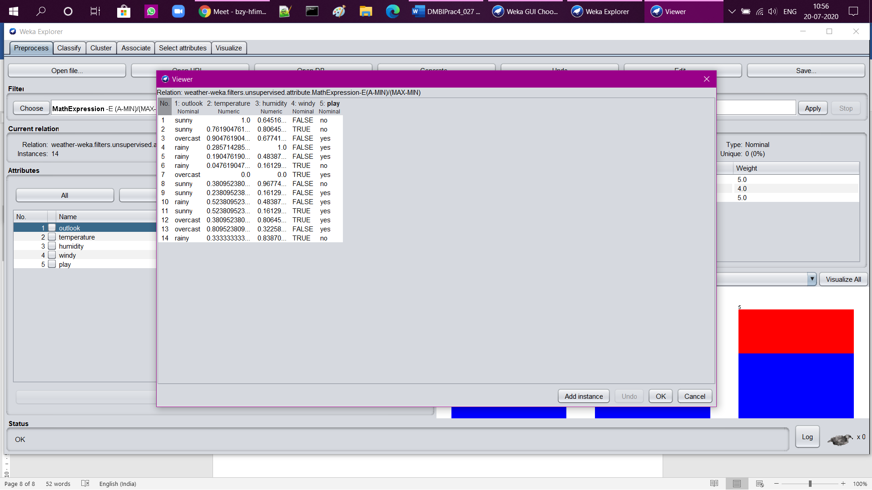

1. ReSample (filters→unsupervised→instance→ ReSample)

(set attribute randomSeed=”5”)

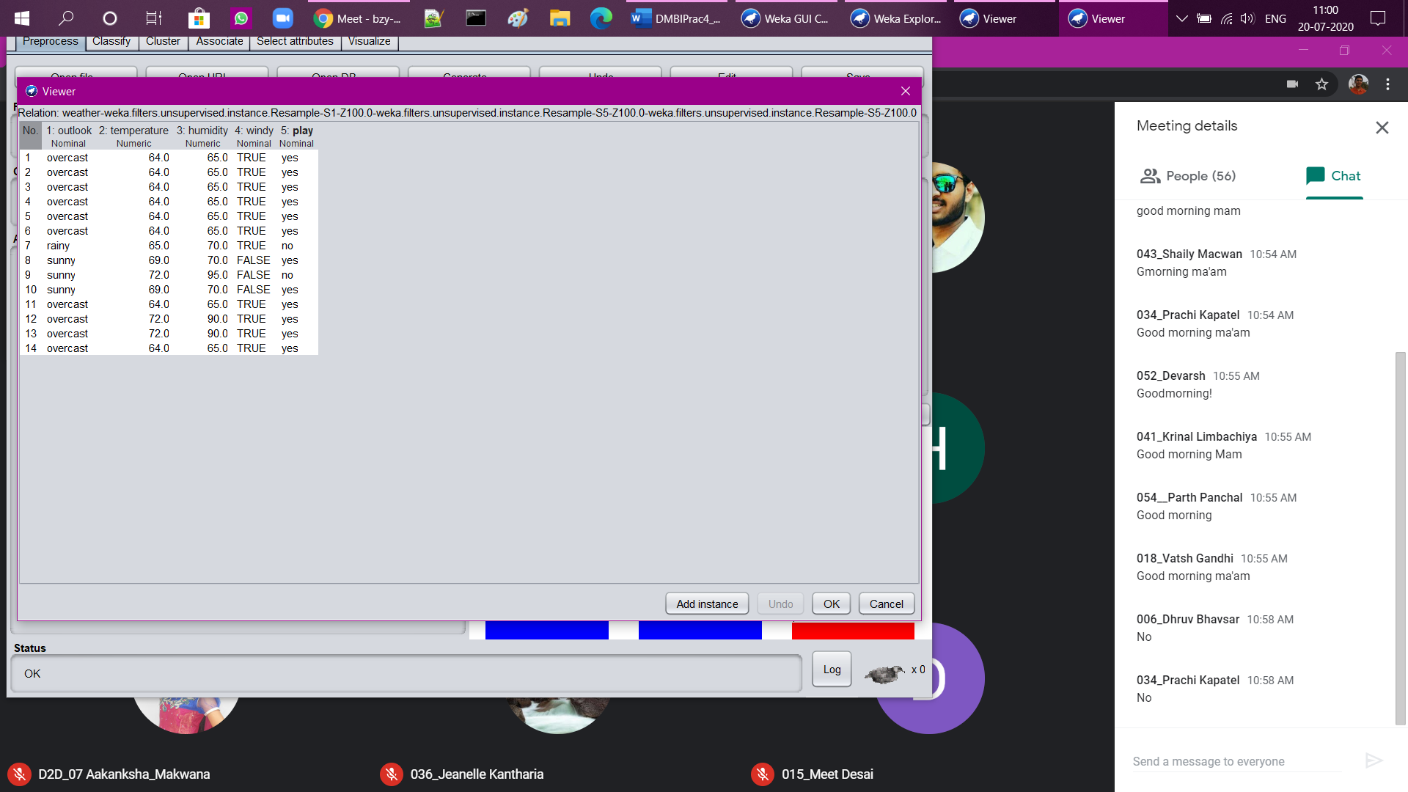

1. Add (filters→unsupervised→attribute→ Add)

(also when unnamed field is added, we have manually entered 3 values in our data)

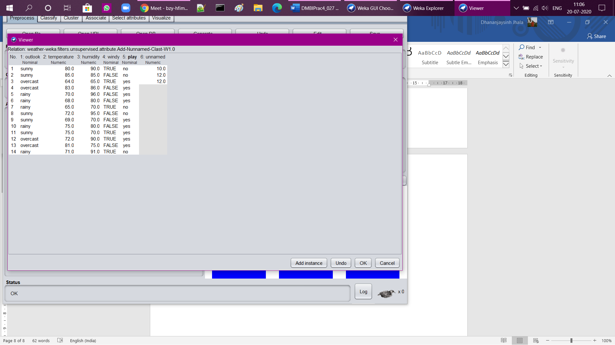

1. AddValues (filters→unsupervised→attribute→ AddValues)

(attributeIndex=”first”, labels=”hello” here)

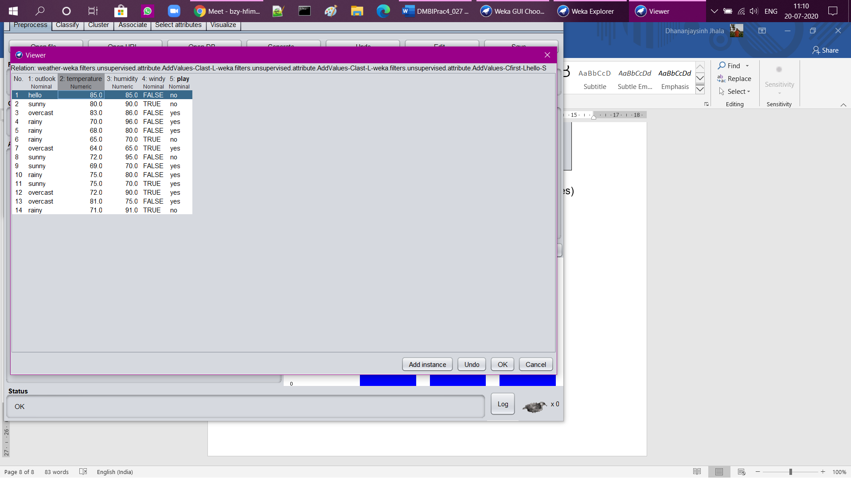

1. Discretize (filters→unsupervised→attribute→ Discretize)

