**Practical 5: Data Summarization using oracle 9i advanced grouping functions.**

1. Contents of table emp

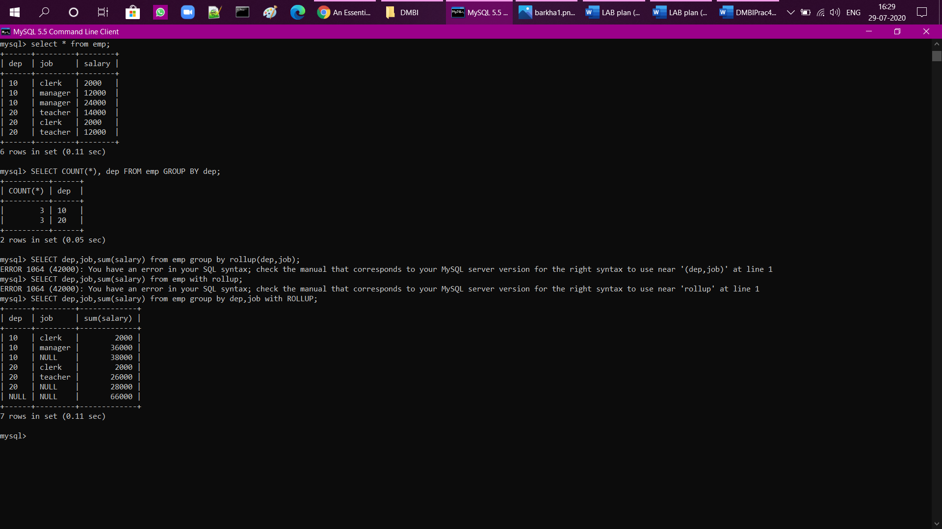

1. GROUP BY



1. ROLLUP

