**Practical 6: Study of SQL Server Analysis Services.**

* **Design and create cube by identifying measures and dimensions for star schema, snowflake schema**
* **Process and browse cube**

**Design and create cube by identifying measures and dimensions for design storage for cube using storage mode MOLAP, ROLAP and HOLAP.**

**Creating an Analysis Services Project**

* To create a data mining solution, you must first create a new Analysis Services project, and then add and configure a data source and a data source view for the project. The data source defines the connection string and authentication information with which to connect to the data source on which to base the mining model. The data source view provides an abstraction of the data source, which you can use to modify the structure of the data to make it more relevant to your project.

**Creating a Data Cube**

To build a new data cube using BIDS, you need to perform these steps:

* + Create a new Analysis Services project
  + Define a data source
  + Define a data source view
  + Invoke the Cube Wizard

**Invoking the Cube Wizard**

As you can probably guess at this point, you invoke the Cube Wizard by right clicking on the Cubes folder in Solution Explorer. The Cube Wizard interactively explores the structure of your data source view to identify the dimensions, levels, and measures in your cube.

To create the new cube, follow these steps:

1. Right-click on the Cubes folder in Solution Explorer and select New Cube.
2. Read the first page of the Cube Wizard and click Next.
3. Select the option to build the cube using a data source.
4. Check the Auto Build checkbox.
5. Select the option to create attributes and hierarchies.
6. Click Next.
7. Select the Finance data source view and click Next.
8. Wait for the Cube Wizard to analyze the data and then click Next.
9. The Wizard will get most of the analysis right, but you can fine-tune it a bit. Select DimTime in the Time Dimension combo box. Uncheck the Fact checkbox on the line for the dbo.DimTime table. This will allow you to analyze this dimension using standard time periods.
10. Click Next.
11. On the Select Time Periods page, use the combo boxes to match time property names to time columns as per Table 1

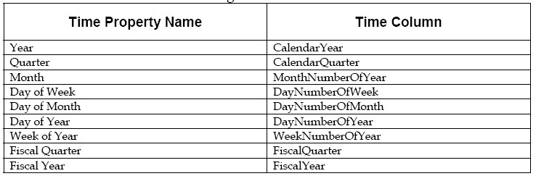

**Table 1: Time columns for Finance cube**

1. Click Next.
2. Accept the default measures and click Next.
3. Wait for the Cube Wizard to detect hierarchies and then click Next.
4. Accept the default dimension structure and click Next.
5. Name the new cube FinanceCube and click Finish.

**Deploying and Processing a Cube**

At this point, you’ve defined the structure of the new cube - but there’s still more work to be done. You still need to deploy this structure to an Analysis Services server and then process the cube to create the aggregates that make querying fast and easy.

To deploy the cube you just created, select Build ⇒ Deploy AdventureWorksCube1. This will deploy the cube to your local Analysis Server, and also process the cube, building the aggregates for you. BIDS will open the Deployment Progress window, as shown in Figure 5, to keep you informed during deployment and processing.

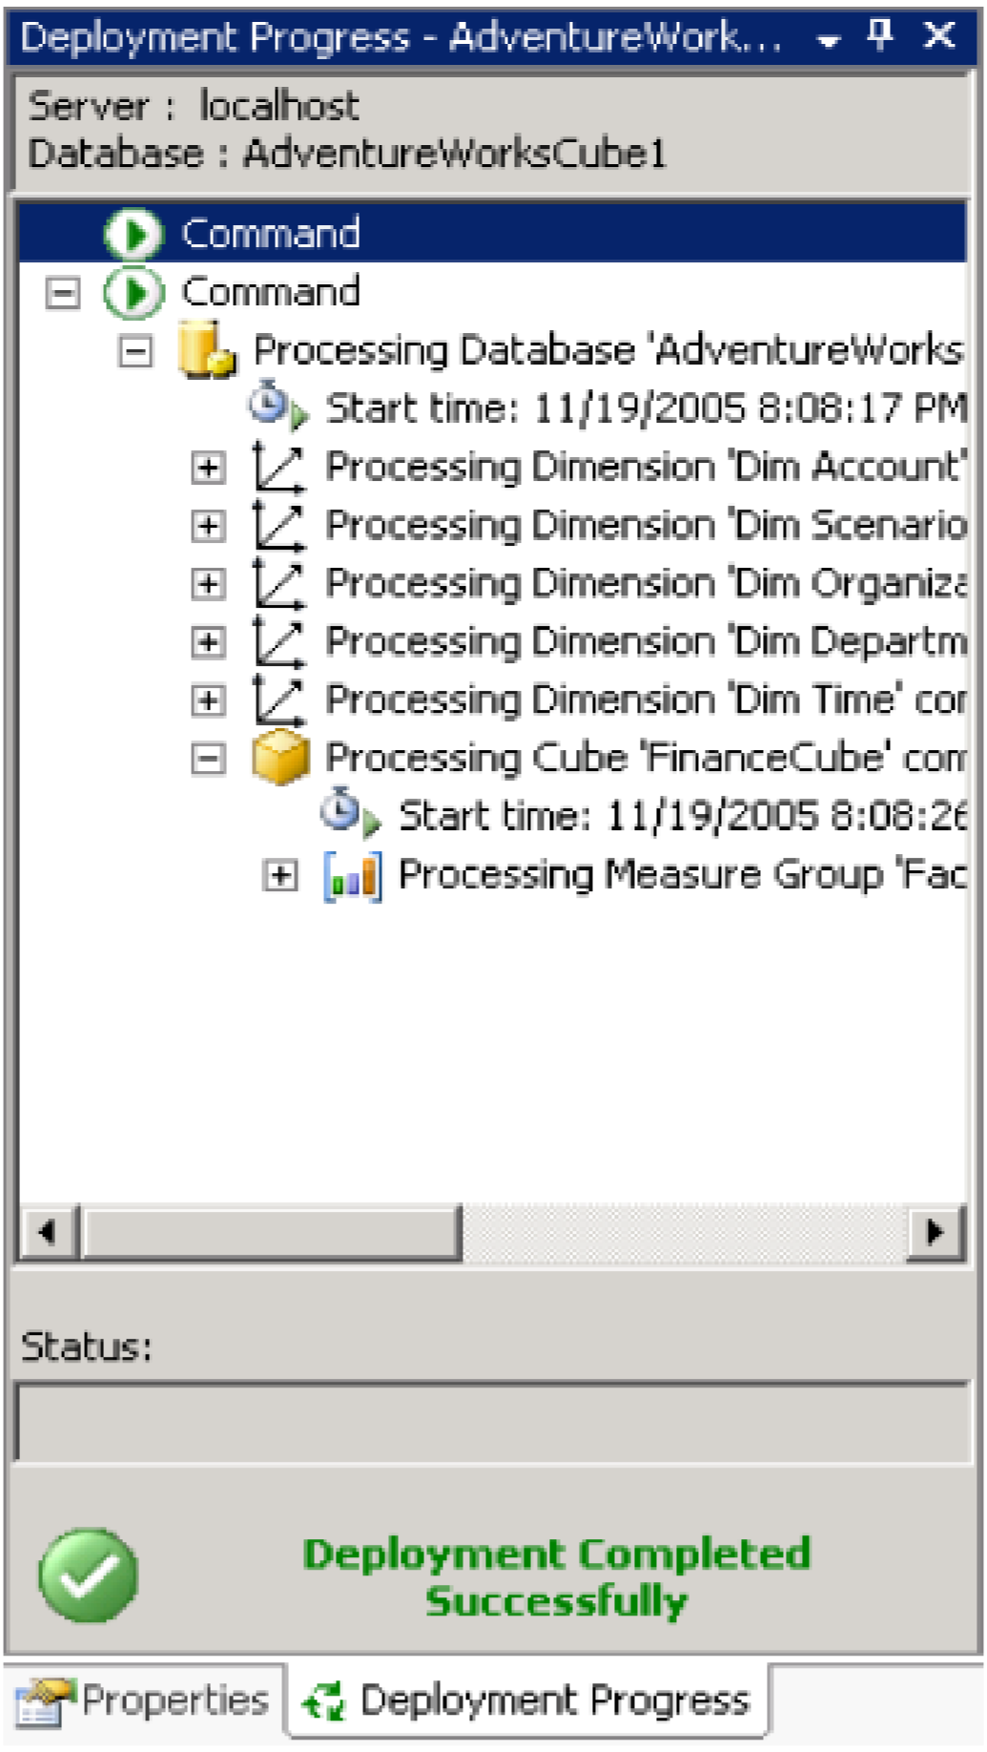

**Figure 5: Deploying a cube**

**Exploring a Data Cube**

At last you’re ready to see what all the work was for. BIDS includes a built-in Cube Browser that lets you interactively explore the data in any cube that has been deployed and processed. To open the Cube Browser, right-click on the cube in Solution Explorer and select Browse. Figure 6 shows the default state of the Cube Browser after it’s just been opened.

The Cube Browser is a drag-and-drop environment. If you’ve worked with pivot tables in Microsoft Excel, you should have no trouble using the Cube browser. The pane to the left includes all of the measures and dimensions in your cube, and the pane to the right gives you drop targets for these measures and dimensions. Among other operations, you can:

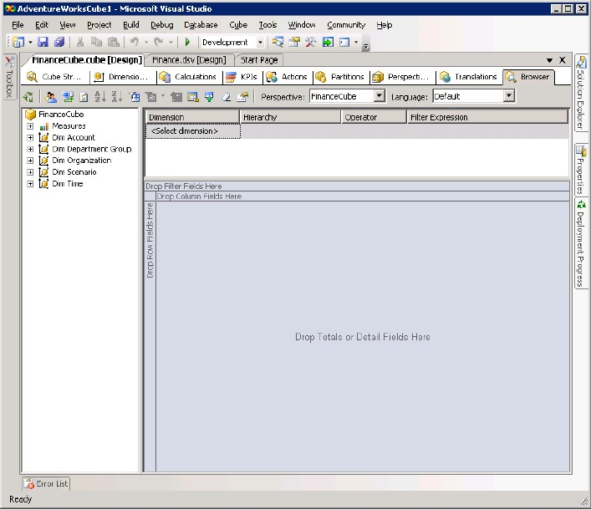

**Figure 6: The cube browser in BIDS**

* Drop a measure in the Totals/Detail area to see the aggregated data for that measure.
* Drop a dimension or level in the Row Fields area to summarize by that level or dimension on rows.
* Drop a dimension or level in the Column Fields area to summarize by that level or dimension on columns
* Drop a dimension or level in the Filter Fields area to enable filtering by members of that dimension or level.
* Use the controls at the top of the report area to select additional filtering expressions.

**To see the data in the cube you just created, follow these steps:**

1. Right-click on the cube in Solution Explorer and select Browse.
2. Expand the Measures node in the metadata panel (the area at the left of the user interface).
3. Expand the Fact Finance node.
4. Drag the Amount measure and drop it on the Totals/Detail area.
5. Expand the Dim Account node in the metadata panel.
6. Drag the Account Description property and drop it on the Row Fields area.
7. Expand the Dim Time node in the metadata panel.
8. Drag the Calendar Year-Calendar Quarter-Month Number of Year hierarchy and drop it on the Column Fields area.
9. Click the + sign next to year 2001 and then the + sign next to quarter 3.
10. Expand the Dim Scenario node in the metadata panel.
11. Drag the Scenario Name property and drop it on the Filter Fields area.
12. Click the dropdown arrow next to scenario name. Uncheck all of the checkboxes except for the one next to the Budget name.

Figure 7 shows the result. The Cube Browser displays month-by-month budgets by account for the third quarter of 2001. Although you could have written queries to extract this information from the original source data, it’s much easier to let Analysis Services do the heavy lifting for you.

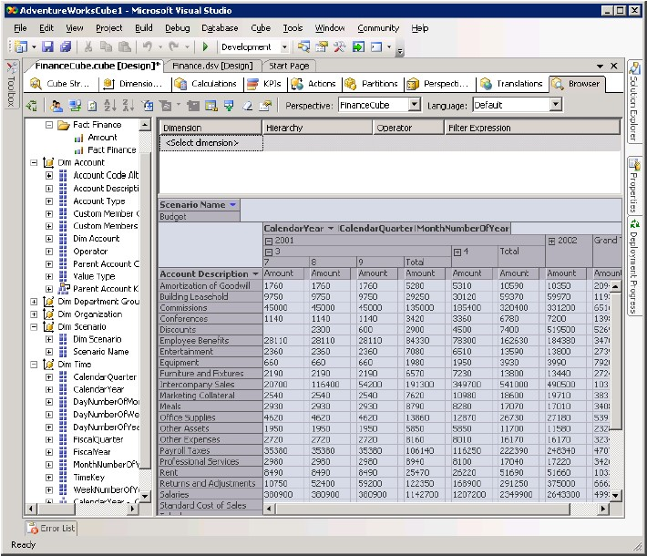

1. MOLAP (Multidimensional Online Analytical Processing)

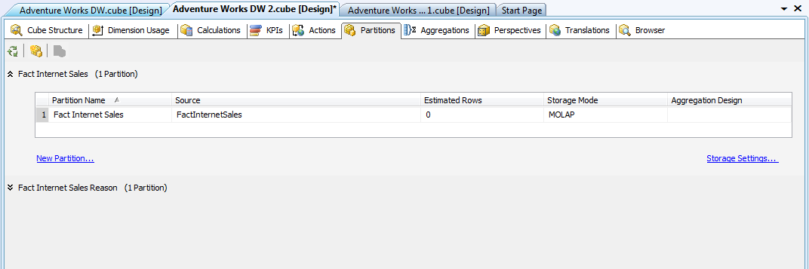

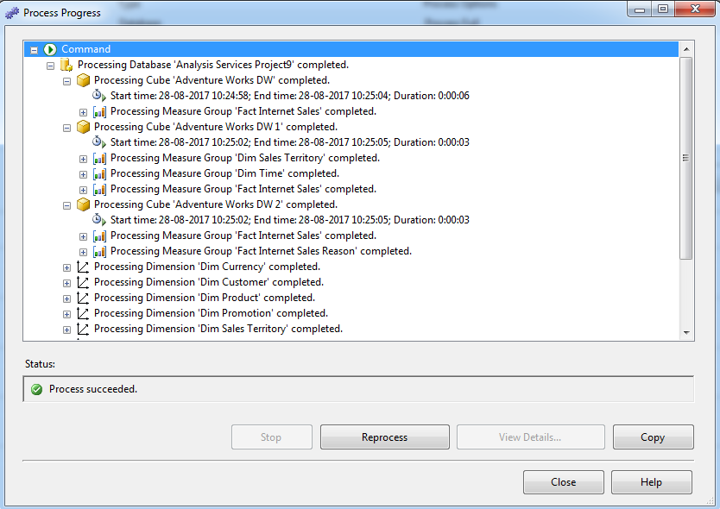

1. ROLAP (Relational Online Analytical Processing)

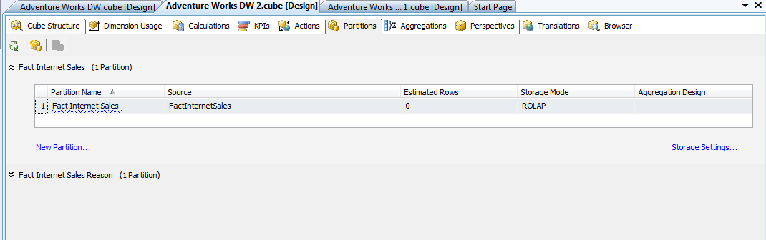

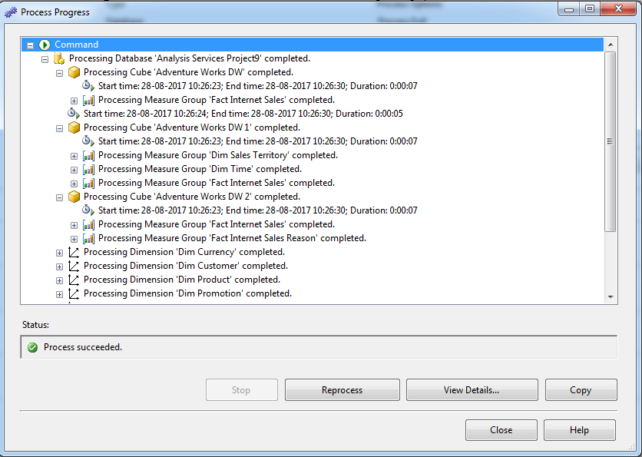

1. HOLAP (Hybrid Online Analytical Processing)

