Practical 9: Different data mining functionalities using Weka

Weka:
Data mining isn't solely the domain of big companies and expensive software. In fact, there's a piece of software that does almost all the same things as these expensive pieces of software the software is called WEKA.WEKA is the product of the University of Waikato (New Zealand) and was first implemented in its modern form in 1997. It uses the GNU General Public License (GPL). The software is written in the Java™ language and contains a GUI for interacting with data files and producing visual results (think tables and curves). It also has a general API, so you can embed WEKA, like any other library, in your own applications to such things as automated server-side data-mining tasks.
At this point, please go ahead and install WEKA. It's Java-based, so if you don't have a JRE installed on your computer, download the WEKA version that contains the JRE, as well.



Figure 1. WEKA startup screen

When you start WEKA, the GUI chooser pops up and lets you choose four ways to work with WEKA and your data. For all the examples in this article series, we will choose only the Explorer option. This option is more than sufficient for everything we need to do in these articles.

Figure 2. WEKA Explorer

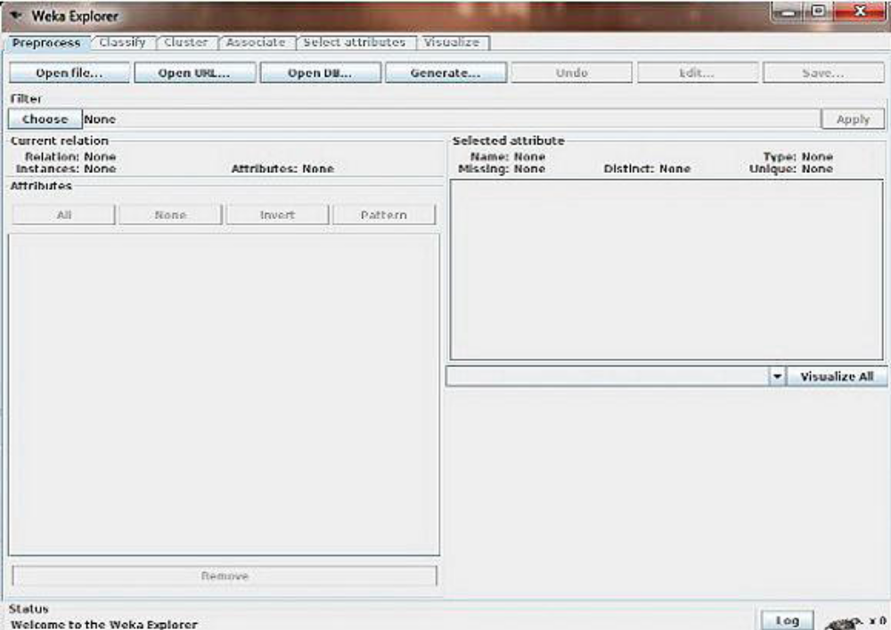

Step by step instructions

During installation, the ARFF files should have been associated with Weka. In this case, it is highly recommended to locate and double click on the file dud.arff, and to skip the following three points.
• In the starting interface of Weka, click on the button Explorer.
• In the Preprocess tab, click on the button Open File. In the file selection interface, select the file weather.arff.

Once the data is loaded, WEKA recognizes attributes that are shown in the ‘Attribute’ window.

Left panel of ‘Preprocess’ window shows the list of recognized attributes:
No. is a number that identifies the order of the attribute as they are in data file,
Selection tick boxes allow you to select the attributes for working relation,
Name is a name of an attribute as it was declared in the data file.
The ‘Current relation’ box above ‘Attribute’ box displays the base relation (table) name and the current working relation (which are initially the same) - “weather”, the number of instances – 14 and the number of attributes - 5. During the scan of the data, WEKA computes some basic statistics on each attribute. The following statistics are shown in ‘Selected attribute’ box on the right panel of ‘Preprocess’ window:
Name is the name of an attribute,
Type is most commonly Nominal or Numeric, and
Missing is the number (percentage) of instances in the data for which this attribute is unspecified,
Distinct is the number of different values that the data contains for this attribute, and
Unique is the number (percentage) of instances in the data having a value for this attribute that
no other instances have.

An attribute can be deleted from the ‘Attributes’ window. Highlight an attribute you would like to delete and hit Delete button on your keyboard.

By clicking on an attribute, you can see the basic statistics on that attribute. The frequency for each attribute value is shown for categorical attributes. Min, max, mean, standard deviation

(StdDev) is shown for continuous attributes.

Click on attribute Outlook in the ‘Attribute’ window.
Outlook is nominal. Therefore, you can see the following frequency statistics for this attribute in the ‘Selected attributes’ window:
Missing = 0 means that the attribute is specified for all instances (no missing values),
Distinct = 3 means that Outlook has three different values: sunny, overcast, rainy, and
Unique = 0 means that other instances do not have the same value as Outlook has.
Just below these values there is a table displaying count of instances of the attribute Outlook.
As you can see, there are three values: sunny with 5 instances, overcast with 4 instances, and rainy with 5 instances. These numbers match the numbers of instances in the base relation and table “weather.xls”.Lets take a look at the attribute Temperature.

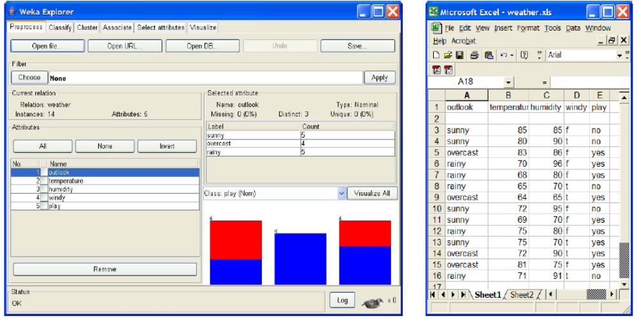

Setting Filters
Pre-processing tools in WEKA are called “filters”. WEKA contains filters for discretization, normalization, resampling, attribute selection, transformation and combination of attributes. Some techniques, such as association rule mining, can only be performed on categorical data. This requires performing discretization on numeric or continuous attributes.

For classification example you do not need to transform the data. For you practice, suppose you need to perform a test on categorical data. There are two attributes that need to be converted: ‘temperature’ and ‘humidity’. In other words, you will keep all of the values for these attributes in the data.

This means you can discretize by removing the keyword "numeric" as the type for the ‘temperature’ attribute and replace it with the set of “nominal” values. You can do this by applying a filter.

In ‘Filters’ window, click on the ‘Choose’ button.

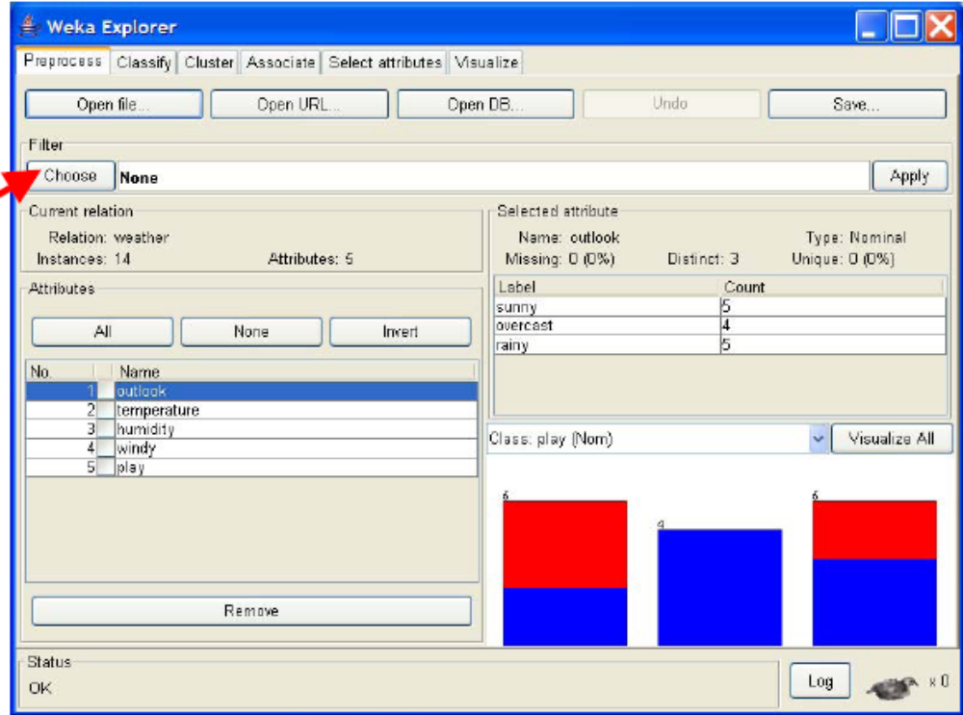

This will show pull-down menu with a list of available filters. Select Supervised ➔Attribute➔Discretize and click on ‘Apply’ button. The filter will convert Numeric values into Nominal. When filter is chosen, the fields in the window changes to reflect available options.

Building “Classifiers”
Once you have your data set loaded, all the tabs are available to you. Click on the ‘Classify’ tab.

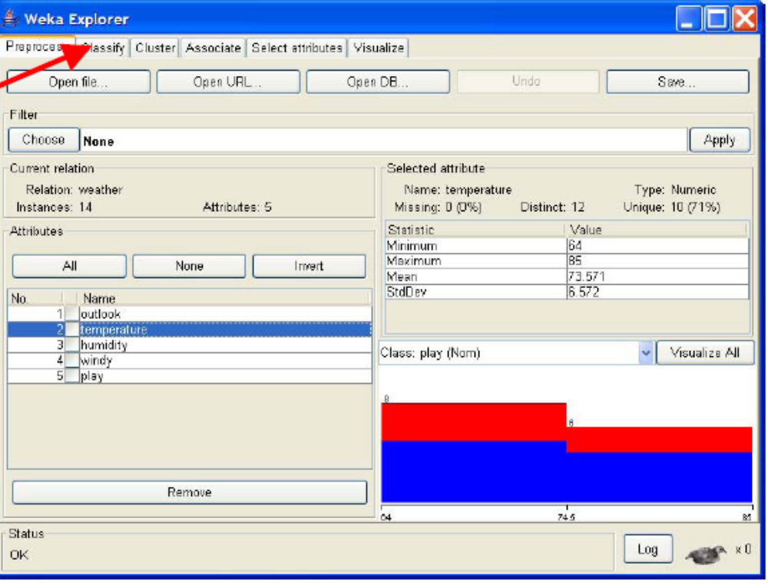

‘Classify’ window comes up on the screen.

Choosing a Classifier
Click on ‘Choose’ button in the ‘Classifier’ box just below the tabs and select C4.5 classifier WEKA ➔Classifiers ➔Trees ➔J48.

Setting Test Options
Before you run the classification algorithm, you need to set test options. Set test options in the ‘Test options’ box. The test options that available to you are :

1. Use training set. Evaluates the classifier on haw well it predicts the class of the instances it was trained on.
2. Supplied test set. Evaluates the classifier on how well it predicts the class of a set of instances loaded from a file. Clicking on the ‘Set…’ button brings up a dialog allowing you to choose the file to test on.
3. Cross-validation. Evaluates the classifier by cross-validation, using the number of folds that are entered in the ‘Folds’ text field.
4. Percentage split. Evaluates the classifier on how well it predicts a certain percentage of the data, which is held out for testing. The amount of data held out depends on the value entered in the ‘%’ field.
In this exercise you will evaluate classifier based on how well it predicts 66% of the tested data. Check ‘Percentage split’ radio-button and keep it as default 66%. Click on ‘More options…’ button.

Identify what is included into the output. In the ‘Classifier evaluation options’ make sure that the following options are checked:

1. Output model. The output is the classification model on the full training set, so that it can be viewed, visualized, etc.
2. Output per-class stats. The precision/recall and true/false statistics for each class output.
3. Output confusion matrix. The confusion matrix of the classifier’s predictions is included in the output.
4. Store predictions for visualization. The classifier’s predictions are remembered so that they can be visualized.
5. Set ‘Random seed for Xval / % Split’ to 1. This specifies the random seed used when randomizing the data before it is divided up for evaluation purposes.
When training set is complete, the ‘Classifier’ output area on the right panel of ‘Classify’ window is filled with text describing the results of training and testing. A new entry appears in the ‘Result list’ box on the left panel of ‘Classify’ window.

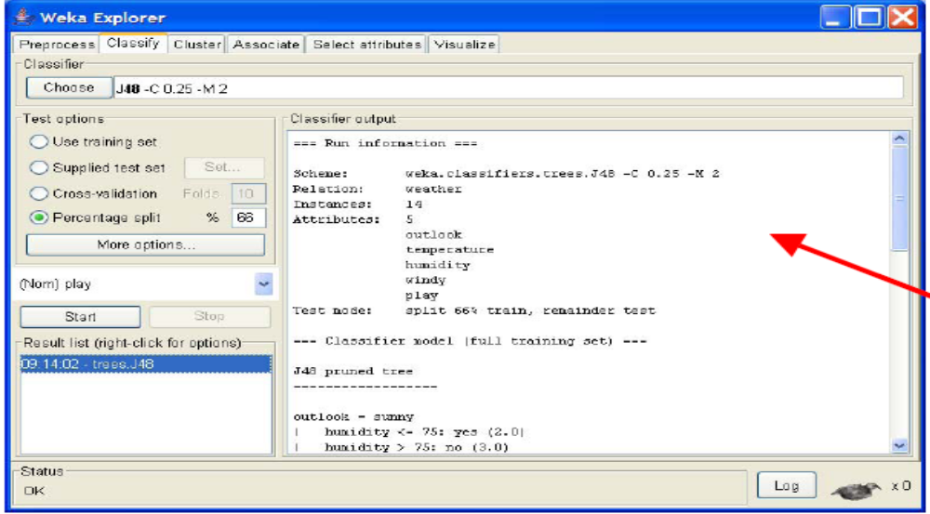

Analyzing Results :

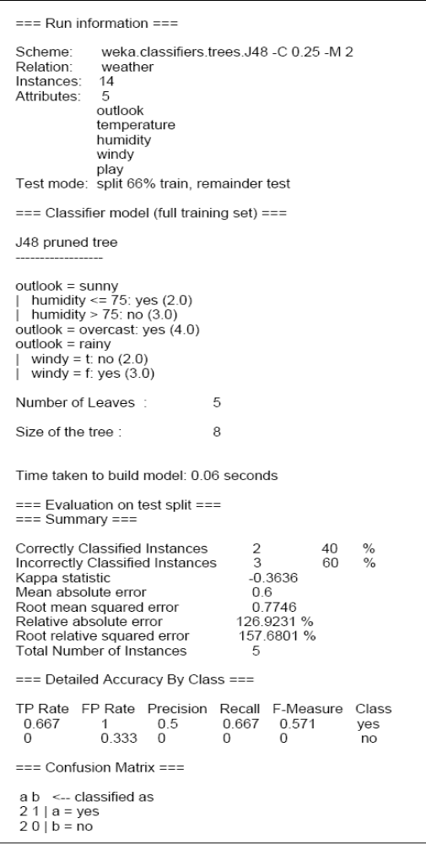

Visualization of Results

After training a classifier, the result list adds an entry.

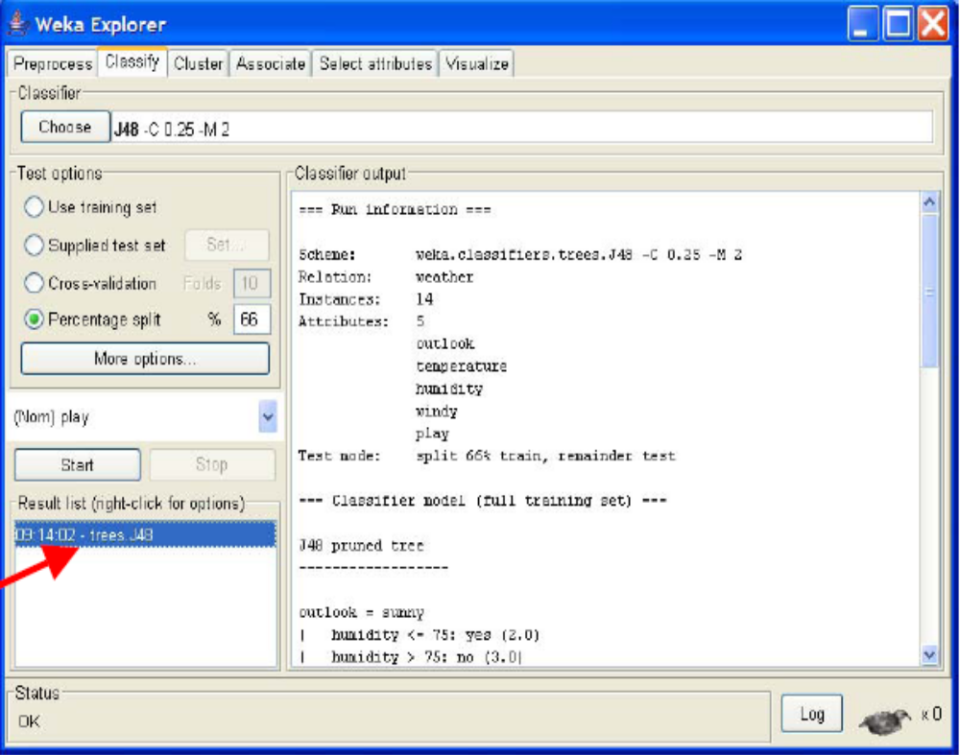

WEKA lets you to see a graphical representation of the classification tree. Right-click on the entry in ‘Result list’ for which you would like to visualize a tree. It invokes a menu containing the following items:

Select the item ‘Visualize tree’; a new window comes up to the screen displaying the tree.

