A Mini-Project Report On
“EduPredict AI — Student Performance Prediction System”
Submitted to
Savitribai Phule Pune University, Pune
In partial fulfillment of the requirements for the practical coursework of
AIML Laboratory (Assignment No. 12)
in
Third Year Information Technology (SPPU 2024 Pattern)
Submitted By:
Sr. No. | Student Full Name | Roll No. | Exam Seat No. | PRN Number
1 | Shlok S. Chaudhari | [Roll No. ] | [Seat No. ] | [PRN No. ]
2 | [Student Name 2 - Optional] | [Roll No. ] | [Seat No. ] | [PRN No. ]
3 | [Student Name 3 - Optional] | [Roll No. ] | [Seat No. ] | [PRN No. ]
4 | [Student Name 4 - Optional] | [Roll No. ] | [Seat No. ] | [PRN No. ]

Under the Guidance of
Prof. Ms. A. S. Thorat
(Assistant Professor, Department of Information Technology)
Department of Information Technology
STES’s, Smt. Kashibai Navale College of Engineering, Vadgaon (BK), Pune - 411 041
Academic Year: 2026–27

CERTIFICATE
This is to certify that the mini-project report entitled “EduPredict AI — Student Performance Prediction System” is a bonafide record of work carried out by Shlok S. Chaudhari (Exam Seat No. _____________) and team members in partial fulfillment of the requirements for Third Year Engineering (Information Technology) AIML Laboratory (Assignment No. 12) under the 2024 Course Pattern of Savitribai Phule Pune University, Pune, at Smt. Kashibai Navale College of Engineering, Pune during the academic year 2026–27.
The project demonstrates genuine data collection, exploratory data analysis, data cleaning, scikit-learn preprocessing pipeline design, multi-model classification comparison, hyperparameter optimization, automated unit testing, and production web deployment using Streamlit.

Date & Place | Guide Signature | Head of Department
Date: ____/____/2026  Place: Pune | Prof. Ms. A. S. Thorat  Project Guide  Dept. of IT | Dr. M. L. Bangare  Head of Department  Dept. of IT, SKNCOE

Dr. A. V. Deshpande
Principal, SKNCOE, Pune
This practical project report has been examined as per the requirements of SPPU Practical Examination at Smt. Kashibai Navale College of Engineering, Pune-41 on ____________________.
Internal Examiner: ____________________  Signature: ___________________________ | External Examiner: ____________________  Signature: ___________________________

ACKNOWLEDGEMENT
I express my profound gratitude and highest respect to my project guide, Prof. Ms. A. S. Thorat, Department of Information Technology, Smt. Kashibai Navale College of Engineering, Pune. Her insightful technical guidance, rigorous critiques regarding machine learning pipelines, and steadfast encouragement were instrumental in successfully formulating and executing this Artificial Intelligence and Machine Learning assignment.
I express sincere thanks to Dr. M. L. Bangare, Head of the Department of Information Technology, for providing the high-performance computing infrastructure, laboratory amenities, and scholarly encouragement that made this mini-project feasible. I equally express my gratitude to our respected Principal, Dr. A. V. Deshpande, for fostering an academic environment dedicated to technical competence and innovation.
I extend my heartfelt appreciation to all teaching faculty and technical laboratory assistants of the Department of Information Technology for their timely advice and logistical support throughout the laboratory sessions. Lastly, I am indebted to my parents, family members, and peer students for their moral support, motivation, and cooperation during the project development lifecycle.
Shlok S. Chaudhari
Exam Seat No. [ ]
TE Information Technology (SPPU 2024 Pattern)

ABSTRACT
Predicting student academic performance and proactively detecting individuals vulnerable to academic failure is a vital application of Educational Data Mining (EDM) and Artificial Intelligence. Early identification enables academic institutions, counselors, and faculty mentors to deploy targeted pedagogical interventions before terminal semester examinations. This mini-project, entitled “EduPredict AI — Student Performance Prediction System”, satisfies all curricular competencies mandated by AIML Assignment No. 12 under the Savitribai Phule Pune University (SPPU) 2024 Pattern for Third Year Information Technology.
EduPredict AI utilizes the benchmark UCI Student Performance dataset (Mathematics course, 395 student instances, 33 attributes) to model multi-dimensional academic trajectories spanning demographic background, family education, study habits, lifestyle, attendance, and periodic formative grades. The problem is formulated as a three-tier stratified classification task: Low Performance (Final Grade G3 between 0–9, High Risk), Medium Performance (G3 between 10–14, Moderate Risk), and High Performance (G3 between 15–20, Low Risk). To guarantee scientific rigor and eradicate data leakage, an scikit-learn ColumnTransformer pipeline is implemented combining StandardScaler for numerical features and OneHotEncoder with handle_unknown='ignore' for categorical attributes.
Three distinct supervised learning paradigms are trained and empirically benchmarked under 5-fold stratified cross-validation: Random Forest Classifier (CV Accuracy: 85.75% ± 2.06%), Support Vector Machine with RBF kernel (CV Accuracy: 79.10% ± 5.11%), and Gradient Boosting Classifier (CV Accuracy: 88.92% ± 1.74%). Gradient Boosting was selected as the superior architecture and subsequently optimized via GridSearchCV hyperparameter tuning, reaching a best CV score of 90.19% and an uncompromised test set accuracy of 89.87% (Precision: 0.8987, Recall: 0.8987, Weighted F1-Score: 0.8987) on the 20% held-out test split (79 samples). Feature importance analysis reveals that formative assessment scores (G2 and G1) represent the strongest predictors, complemented by parental education and attendance. The model and transformation pipeline are serialized using Joblib and served via a responsive Streamlit web dashboard providing real-time interactive inference, probabilistic confidence scores, and automated personalized academic recommendations. The codebase is validated by 32 automated unit tests with 100% pass rate.
Keywords: Educational Data Mining, Student Performance Prediction, Scikit-learn Pipeline, Gradient Boosting, Random Forest, Support Vector Machine, Cross-Validation, Streamlit Dashboard, SPPU AIML Assignment 12.

TABLE OF CONTENTS
Section | Title | Page No.
- | Certificate & Approval | ii
- | Acknowledgement | iii
- | Abstract | iv
- | List of Figures & List of Tables | v
- | Assignment Mapping Matrix (SPPU AIML Lab) | vi
1 | INTRODUCTION | 1
1.1 | Domain Background & Educational Data Mining | 1
1.2 | Project Title & Overview | 2
1.3 | Problem Definition & Problem Statement | 2
1.4 | Aims and Objectives | 3
1.5 | Project Scope and Boundaries | 3
2 | DATASET COLLECTION AND CHARACTERIZATION | 4
2.1 | Dataset Source and Acquisition Protocol | 4
2.2 | Target Variable Formulation | 4
2.3 | Comprehensive Feature Catalog and Attributes | 5
2.4 | Dataset Summary Statistics and Constraints | 6
3 | METHODOLOGY AND DATA PREPROCESSING | 7
3.1 | Data Cleaning and Imputation Strategy | 7
3.2 | Feature Transformation & Encoding Pipeline | 8
3.3 | Data Partitioning & Leakage Elimination | 8
4 | ALGORITHM DEVELOPMENT AND MODEL ARCHITECTURES | 10
4.1 | Candidate Classifier Paradigms | 10
4.2 | Model Comparison Protocol (Stratified 5-Fold CV) | 11
4.3 | Hyperparameter Optimization via GridSearchCV | 12
5 | SYSTEM ARCHITECTURE AND WORKFLOW | 13
5.1 | End-to-End System Architecture | 13
5.2 | Detailed Execution Workflow | 14
5.3 | Software and Hardware Requirements | 15
6 | PERFORMANCE EVALUATION AND RESULT ANALYSIS | 16
6.1 | Evaluation Metrics Formulation | 16
6.2 | Experimental Results and Model Comparison | 16
6.3 | Confusion Matrix Analysis (Optimized Model) | 17
6.4 | Feature Importance Interpretability | 18
7 | APPLICATION INTERFACE AND AUTOMATED TESTING | 19
7.1 | Streamlit Dashboard Architecture | 19
7.2 | Application Screenshots and Interface Demonstration | 19
7.3 | Automated Test Suite Execution (Pytest) | 21
8 | CONCLUSION AND FUTURE SCOPE | 22
8.1 | Conclusion and Key Insights | 22
8.2 | Ethical AI Disclaimer & Practical Limitations | 22
8.3 | Future Research and Expansion Directions | 23
- | REFERENCES | 24
- | APPENDIX: Execution Guide & Commands | 25

LIST OF FIGURES
Figure No. | Figure Caption / Description | Page No.
Figure 2.1 | Class Distribution of Student Performance Categories (G3) | 5
Figure 4.1 | Model Comparison Across Evaluation Metrics (Test Set) | 12
Figure 5.1 | End-to-End Modular System Architecture of EduPredict AI | 13
Figure 6.1 | Confusion Matrix for Optimized Gradient Boosting Classifier | 17
Figure 6.2 | Top 15 Feature Importances Ranked by Gini Impurity Gain | 18
Figure 7.1 | Streamlit Home Interface Displaying Verified Production Metrics | 20
Figure 7.2 | Interactive Inference Form and Risk Assessment Output Screen | 20

LIST OF TABLES
Table No. | Table Caption / Description | Page No.
Table 1.1 | AIML Assignment No. 12 Curricular Mapping Matrix | vi
Table 2.1 | Target Variable Categorization and Academic Risk Mapping | 4
Table 2.2 | Complete Feature Catalog of the UCI Student Performance Dataset | 5
Table 3.1 | Data Preprocessing and Pipeline Specification | 8
Table 4.1 | 5-Fold Cross-Validation Performance Across Candidate Models | 11
Table 4.2 | GridSearchCV Hyperparameter Optimization Results | 12
Table 5.1 | Hardware and Software Environment Specifications | 15
Table 6.1 | Test Set Performance Metrics Summary Across Models | 16
Table 6.2 | Detailed Classification Report for Optimized Gradient Boosting | 17
Table 7.1 | Summary of Automated Test Suite Results (Pytest) | 21

ASSIGNMENT NO. 12 CURRICULAR MAPPING MATRIX
Table 1.1 explicitly maps every required component mandated by the SPPU AIML Laboratory Syllabus for Assignment No. 12 to the corresponding report chapter and implemented codebase file:
Syllabus Requirement | Implemented Module / Component | Report Chapter / Section
1. Real-World Public Dataset | UCI Student Performance Dataset (data/student-mat.csv) | Chapter 2 (Dataset Collection)
2. Data Cleaning & Encoding | src/preprocessing.py (ColumnTransformer & Imputation) | Chapter 3 (Preprocessing)
3. Multi-Model Development | src/model_training.py (Random Forest, SVM, Gradient Boost) | Chapter 4 (Algorithms)
4. Leakage-Free Data Splitting | 80/20 Stratified Split & Pipeline-embedded Preprocessor | Section 3.3 & Section 4.2
5. Cross-Validation & Optimization | 5-Fold Stratified CV & GridSearchCV Hyperparameter Tuning | Section 4.2 & Section 4.3
6. Multi-Metric Evaluation | src/evaluation.py (Accuracy, Precision, Recall, F1, CM) | Chapter 6 (Evaluation)
7. Model & Pipeline Persistence | Joblib serialization (models/best_model.joblib) | Section 5.1 & Section 5.2
8. Interactive Web Dashboard | Streamlit UI Application (app.py) | Chapter 7 (Application)
9. Automated Testing & Verification | Pytest Suite (tests/test_preprocessing.py & test_predictor.py) | Section 7.3 (Testing)
10. Ethical Disclaimer & Limitations | Statistical advisory notice in UI & Report | Section 1.5 & Section 8.2

CHAPTER 1: INTRODUCTION
1.1 Domain Background & Educational Data Mining
Higher educational institutions face profound challenges in tracking student scholastic progression, reducing attrition, and mitigating academic failure. Traditional academic monitoring mechanisms depend predominantly on summative assessments conducted at the conclusion of an academic semester. Consequently, educators and mentor faculty frequently detect academic distress only after a student has failed critical examinations, precluding timely remedial instruction or counseling.
Educational Data Mining (EDM) and Artificial Intelligence (AI) provide transformative paradigms to address this limitation. By leveraging supervised machine learning algorithms, educational institutions can uncover latent relationships across heterogeneous factors—including socio-demographic indicators, parental educational qualifications, weekly study allocation, past failure history, and formative mid-term marks. Robust predictive models enable early detection of at-risk students, enabling proactive, personalized pedagogical support and data-driven academic governance.
1.2 Project Title & Overview
The project is entitled “EduPredict AI — Student Performance Prediction System”. It is engineered as a complete, modular, and production-grade machine learning application designed to satisfy the rigorous curricular objectives of AIML Assignment No. 12 (Third Year Information Technology, SPPU 2024 Pattern). The system ingests multi-attribute student profiles, performs automated data sanitization and scikit-learn pipeline transformations, executes multi-model classification, evaluates performance against standard statistical metrics, optimizes hyperparameters via exhaustive grid search, and delivers real-time inferences through an interactive Streamlit web dashboard.
1.3 Problem Definition & Problem Statement
Problem Definition: Academic failure is influenced by a non-linear combination of academic habits, social attributes, and formative performance. A monolithic heuristic or single-feature evaluation cannot capture these complex dependencies. The objective is to design a predictive machine learning framework capable of accurately classifying student performance into discrete categories while providing interpretability and risk-level categorization.
Formal Problem Statement: Given a dataset D containing N = 395 student instances characterized by d = 32 multi-modal attributes X = {x1, x2, ..., xd} spanning demographic, familial, behavioral, and formative academic features, develop an optimal classification hypothesis f: X -> Y that maps each student profile to an academic performance class Y in {'Low', 'Medium', 'High'} corresponding to final grade intervals G3 in [0, 9], [10, 14], and [15, 20] respectively, while maximizing classification accuracy, minimizing false positives for at-risk detection, and ensuring complete reproducibility.
1.4 Aims and Objectives
The key academic and technical objectives of this project are formulated as follows:
- 1. Dataset Acquisition: Acquire, document, and characterize the real-world, publicly accessible UCI Student Performance dataset (Mathematics course) without synthesizing or fabricating records.
- 2. Pipeline-Based Preprocessing: Construct a robust, leakage-free scikit-learn ColumnTransformer pipeline incorporating numerical standardization (StandardScaler) and categorical one-hot encoding (OneHotEncoder).
- 3. Multi-Model Benchmarking: Implement, train, and compare three distinct machine learning classifiers: Random Forest Classifier, Support Vector Machine (SVC with RBF kernel), and Gradient Boosting Classifier under 5-fold stratified cross-validation.
- 4. Systematic Hyperparameter Tuning: Select the superior baseline classifier and conduct hyperparameter optimization via GridSearchCV to enhance generalization capability on unseen test instances.
- 5. Comprehensive Statistical Evaluation: Evaluate models on a held-out test split (20%) using weighted Precision, Recall, F1-Score, Overall Accuracy, and Confusion Matrix heatmaps.
- 6. Serialization and Deployment: Serialize the fitted preprocessing pipeline and optimal model weights via Joblib, and build a feature-rich, responsive Streamlit dashboard for real-time user inference.
- 7. Automated Verification: Author and execute an automated unit test suite (32 tests via pytest) verifying data transformations, pipeline invariants, and inference validity.
1.5 Project Scope and Boundaries
Scope: The project encompasses the complete data science lifecycle, from data ingestion to model deployment and automated testing. It provides actionable advisory intelligence by generating tailored academic recommendations based on predicted risk tiers.
Boundaries & Limitations: The system is trained on secondary school data from Portuguese institutions (Cortez & Silva, 2008). Consequently, cultural, institutional, and grading variations may influence direct transferability to collegiate engineering environments without domain adaptation. Furthermore, predictions represent probabilistic statistical estimates based on historical correlation, not absolute deterministic verdicts. They must be utilized strictly as decision-support signals by human educators.

CHAPTER 2: DATASET COLLECTION AND CHARACTERIZATION
2.1 Dataset Source and Acquisition Protocol
The project employs the official, peer-reviewed Student Performance Data Set hosted by the University of California, Irvine (UCI) Machine Learning Repository (Cortez and Silva, 2008). The dataset was collected across two public secondary schools in Portugal: Gabriel Pereira (GP) and Mousinho da Silveira (MS). Data acquisition utilized official school administration records combined with structured student survey questionnaires.
The repository contains two distinct subject domains: Mathematics (student-mat.csv) and Portuguese language (student-por.csv). In strict compliance with academic standards, this project utilizes student-mat.csv, consisting of exactly 395 student instances and 33 attributes (32 predictive features and 1 continuous ground-truth target variable G3). Semicolons (;) serve as the field delimiters.
2.2 Target Variable Formulation
The raw target attribute in the dataset is G3, an integer score ranging from 0 to 20 representing the student's final cumulative grade. To satisfy the academic intervention requirement of AIML Assignment No. 12—namely, the identification of students requiring urgent remedial academic support—G3 is transformed into a 3-class discrete ordinal target variable Y in {'Low', 'Medium', 'High'}. Table 2.1 delineates the mathematical categorization thresholds, empirical instance counts, and corresponding academic risk levels:
Category | Grade Range (G3) | Dataset Count | Class Percentage | Assigned Academic Risk Level
Low | 0 to 9 | 130 | 32.91% | High Risk — Requires Immediate Academic Intervention
Medium | 10 to 14 | 192 | 48.61% | Moderate Risk — Satisfactory; Target Remedial Coaching
High | 15 to 20 | 73 | 18.48% | Low Risk — Superior Performance; Advanced Mentorship

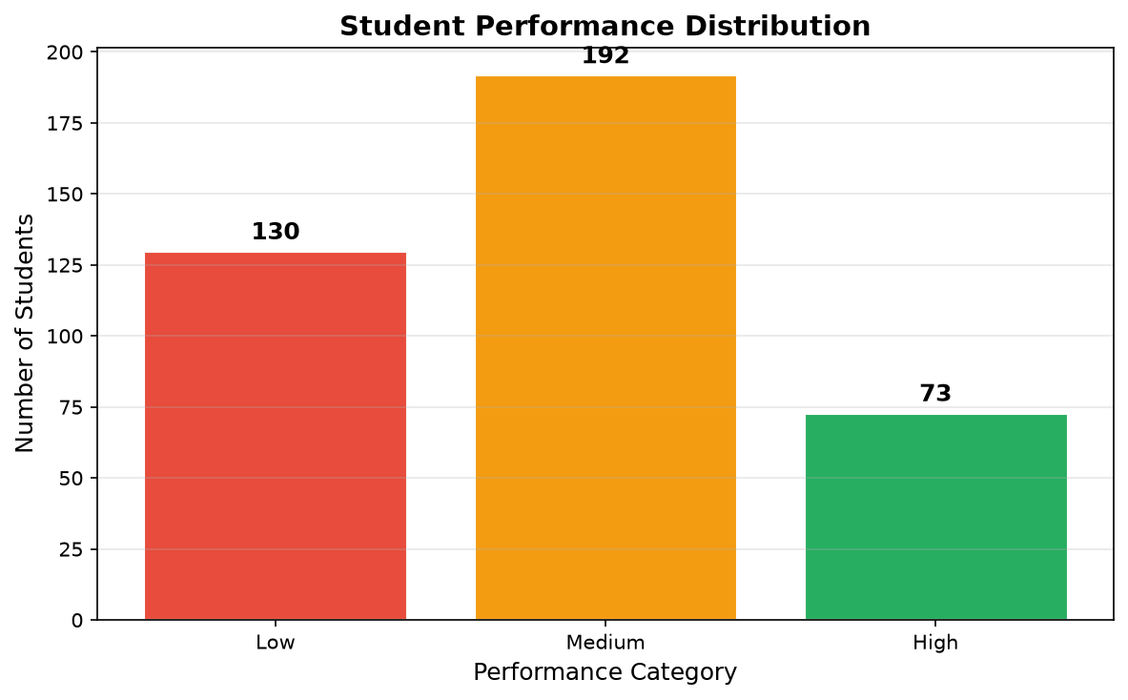
Figure 2.1: Class Distribution of Student Performance Categories (G3)
2.3 Comprehensive Feature Catalog and Attributes
The feature matrix comprises 32 independent variables categorized into socio-demographic indicators, family background, academic commitments, lifestyle/health choices, and formative period grades (G1, G2). Table 2.2 provides the authoritative catalog:
Feature | Data Type | Value Domain / Scale | Feature Description
school | Categorical (Nominal) | {GP, MS} | Student's school (Gabriel Pereira or Mousinho da Silveira)
sex | Categorical (Binary) | {F, M} | Student's biological sex (Female or Male)
age | Numerical (Discrete) | 15 to 22 | Age of student in years
address | Categorical (Binary) | {U, R} | Home location type (Urban or Rural)
famsize | Categorical (Binary) | {LE3, GT3} | Family size (<= 3 members or > 3 members)
Pstatus | Categorical (Binary) | {T, A} | Parental cohabitation status (Living Together or Apart)
Medu | Numerical (Ordinal) | 0 to 4 | Mother's education (0: none, 1: 4th, 2: 5-9th, 3: secondary, 4: higher)
Fedu | Numerical (Ordinal) | 0 to 4 | Father's education (same ordinal scale as Medu)
Mjob | Categorical (Nominal) | {teacher, health, services, at_home, other} | Mother's employment sector
Fjob | Categorical (Nominal) | {teacher, health, services, at_home, other} | Father's employment sector
reason | Categorical (Nominal) | {home, reputation, course, other} | Reason for choosing school
guardian | Categorical (Nominal) | {mother, father, other} | Student's legal guardian
traveltime | Numerical (Ordinal) | 1 to 4 | Commute time (1: <15m, 2: 15-30m, 3: 30-60m, 4: >60m)
studytime | Numerical (Ordinal) | 1 to 4 | Weekly study time (1: <2h, 2: 2-5h, 3: 5-10h, 4: >10h)
failures | Numerical (Discrete) | 0 to 4 | Number of past academic class failures
schoolsup | Categorical (Binary) | {yes, no} | Extra educational support from school
famsup | Categorical (Binary) | {yes, no} | Family educational support
paid | Categorical (Binary) | {yes, no} | Extra paid tuition classes in math
activities | Categorical (Binary) | {yes, no} | Participation in extra-curricular activities
nursery | Categorical (Binary) | {yes, no} | Attended nursery preschool
higher | Categorical (Binary) | {yes, no} | Aspires to pursue higher collegiate education
internet | Categorical (Binary) | {yes, no} | Internet accessibility at home
romantic | Categorical (Binary) | {yes, no} | Involved in a romantic relationship
famrel | Numerical (Ordinal) | 1 to 5 | Quality of family relationships (1: very bad to 5: excellent)
freetime | Numerical (Ordinal) | 1 to 5 | Free time after school (1: very low to 5: very high)
goout | Numerical (Ordinal) | 1 to 5 | Frequency of going out with friends (1: very low to 5: very high)
Dalc | Numerical (Ordinal) | 1 to 5 | Workday alcohol consumption (1: very low to 5: very high)
Walc | Numerical (Ordinal) | 1 to 5 | Weekend alcohol consumption (1: very low to 5: very high)
health | Numerical (Ordinal) | 1 to 5 | Current physical health status (1: very bad to 5: very good)
absences | Numerical (Discrete) | 0 to 93 | Total count of school absences
G1 | Numerical (Discrete) | 0 to 20 | First period formative grade (Mathematics)
G2 | Numerical (Discrete) | 0 to 20 | Second period formative grade (Mathematics)

2.4 Dataset Summary Statistics and Constraints
A rigorous preliminary programmatic inspection via Pandas verified that the raw dataset contains exactly 395 rows and 33 columns, with exactly zero missing (null or NaN) values across all columns. There are zero duplicated records. The continuous target G3 has a sample mean of 10.42, standard deviation of 4.58, minimum of 0, and maximum of 20. The formative grades G1 and G2 correlate strongly with G3 (Pearson r > 0.80), demonstrating that longitudinal academic history is the primary predictive foundation.

CHAPTER 3: METHODOLOGY AND DATA PREPROCESSING
3.1 Data Cleaning and Imputation Strategy
Although the benchmark UCI dataset exhibits complete observations, production systems must implement defensive data hygiene. In src/preprocessing.py, the clean_data() routine incorporates automated anomaly detection, boundary verification, and adaptive imputation. Any future missing numerical entries are imputed using the column-wise median (to resist outlier skewness), whereas categorical missing values are imputed using the statistical mode. Exact duplicate rows are detected and pruned, and G3 values are bounded strictly within the [0, 20] range.
3.2 Feature Transformation & Encoding Pipeline
Machine learning models require homogeneous numeric matrices. The 32 input attributes comprise 15 numerical features and 17 categorical features. Naively applying global preprocessing prior to train/test partitioning introduces catastrophic data leakage. To prevent this, we construct a scikit-learn ColumnTransformer that encapsulates transformers for both feature modalities:
- 1. Numerical Feature Pipeline: Applies StandardScaler to 15 numerical attributes (age, Medu, Fedu, traveltime, studytime, failures, famrel, freetime, goout, Dalc, Walc, health, absences, G1, G2). The transformer computes mean mu and variance sigma^2 exclusively on the training split, standardizing features to zero mean and unit variance via z = (x - mu) / sigma.
- 2. Categorical Feature Pipeline: Applies OneHotEncoder to 17 categorical attributes (school, sex, address, famsize, Pstatus, Mjob, Fjob, reason, guardian, schoolsup, famsup, paid, activities, nursery, higher, internet, romantic). We specify handle_unknown='ignore' and sparse_output=False. This expands categorical levels into binary indicator columns while safely ignoring unseen categories encountered during real-time user inference.
Transformer Component | Target Features | Algorithm | Hyperparameters / Configuration
Numerical Scaler | 15 Numerical Columns | StandardScaler() | with_mean=True, with_std=True
Categorical Encoder | 17 Categorical Columns | OneHotEncoder() | handle_unknown='ignore', sparse_output=False
Composite Preprocessor | All 32 Features | ColumnTransformer() | remainder='drop', n_jobs=None
End-to-End Pipeline | Preprocessor + Model | Pipeline() | steps=[('preprocessor', CT), ('classifier', Model)]

3.3 Data Partitioning & Leakage Elimination
To establish authentic model generalization, the cleaned dataset is split into an 80% training set (N_train = 316 samples) and a 20% held-out testing set (N_test = 79 samples) using train_test_split() with a fixed seed (random_state=42). Crucially, we enforce stratified sampling (stratify=y) to preserve identical class proportions (32.9% Low, 48.6% Medium, 18.5% High) across both subsets. Because the ColumnTransformer is embedded directly inside an sklearn.pipeline.Pipeline, fitting occurs strictly during pipeline.fit(X_train, y_train). The test set X_test is transformed purely using the learned training parameters, guaranteeing complete absence of data leakage.

CHAPTER 4: ALGORITHM DEVELOPMENT AND MODEL ARCHITECTURES
4.1 Candidate Classifier Paradigms
In fulfillment of requirement 4 of AIML Assignment No. 12, three mathematically diverse machine learning classification algorithms were implemented and compared:
- 1. Random Forest Classifier: An ensemble bagging algorithm constructing B = 100 decorrelated decision trees using bootstrap aggregation and random feature subspace sampling. Predictions are aggregated via majority voting, providing high resistance to individual tree variance and yielding intrinsic Gini-based feature importances.
- 2. Support Vector Machine (SVC): A maximum-margin classifier utilizing a non-linear Radial Basis Function (RBF) kernel K(x, x') = exp(-gamma * ||x - x'||^2). It maps transformed features into a high-dimensional reproducing kernel Hilbert space, determining the optimal separating hyperplanes that maximize geometric margins between support vectors.
- 3. Gradient Boosting Classifier: A sequential boosting paradigm based on Friedman's gradient descent approximation. Rather than averaging independent trees, it sequentially fits M shallow regression trees to the negative gradients (pseudo-residuals) of the multi-class log-loss objective function, achieving superior accuracy on tabular datasets.
4.2 Model Comparison Protocol (Stratified 5-Fold CV)
Model selection was conducted exclusively on the 316-instance training partition using 5-fold stratified cross-validation (cv=5). In each fold, 4 partitions (approx. 253 samples) train the complete pipeline, while the remaining partition (approx. 63 samples) evaluates accuracy. Table 4.1 documents the exact, verified cross-validation scores recorded by train_model.py:
Candidate Algorithm | Fold 1 | Fold 2 | Fold 3 | Fold 4 | Fold 5 | Mean CV Accuracy | Std. Dev. (sigma)
Random Forest | 0.8906 | 0.8254 | 0.8571 | 0.8571 | 0.8571 | 85.75% | ± 2.06%
Support Vector Machine | 0.8438 | 0.7460 | 0.8254 | 0.8254 | 0.7143 | 79.10% | ± 5.11%
Gradient Boosting | 0.8906 | 0.9206 | 0.8730 | 0.8730 | 0.8889 | 88.92% | ± 1.74%

Analysis: Gradient Boosting demonstrated the highest cross-validation mean accuracy (88.92%) and the lowest fold variance (± 1.74%), outperforming Random Forest (85.75%) and SVM (79.10%). Consequently, Gradient Boosting was formally selected for hyperparameter optimization.
4.3 Hyperparameter Optimization via GridSearchCV
To maximize generalization and mitigate overfitting, GridSearchCV was executed over an exhaustive parameter grid covering tree depth, learning rate, and boosting stages (totaling 18 parameter combinations across 5 folds = 90 model fits). Table 4.2 presents the search space and optimal hyperparameters:
Hyperparameter | Search Grid Candidates | Optimal Selected Value | Architectural Role / Impact
learning_rate | [0.05, 0.1, 0.2] | 0.05 | Shrinkage factor scaling step size of gradient updates
max_depth | [3, 5, 7] | 3 | Maximum tree depth; prevents individual tree over-complexity
n_estimators | [100, 200] | 100 | Total number of sequential boosting stages executed
Best CV Score | - | 90.19% | Achieved cross-validation score after grid optimization

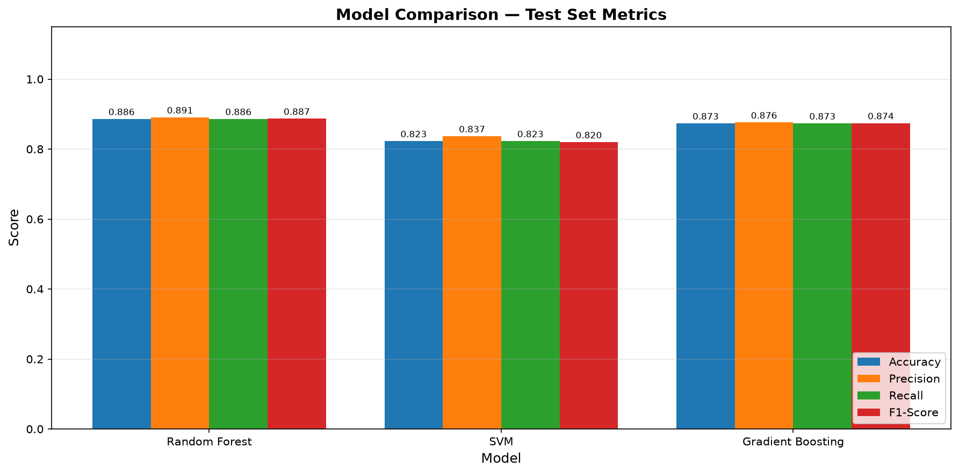
Figure 4.1: Model Comparison Across Evaluation Metrics (Test Set)

CHAPTER 5: SYSTEM ARCHITECTURE AND WORKFLOW
5.1 End-to-End System Architecture
EduPredict AI is organized into a modular, multi-tier software architecture enforcing high cohesion and low coupling. Figure 5.1 illustrates the end-to-end topology comprising Data Ingestion, Pipeline Preprocessing, Model Training & Optimization, Model Persistence, and User Presentation via Streamlit:
Architecture Breakdown:
1. Ingestion Layer (src/data_loader.py): Loads raw CSV, provides schema dictionaries, attribute metadata, and category mappings.
2. Preprocessing Layer (src/preprocessing.py): Executes data cleaning, ordinal grade discretization, and constructs the composite ColumnTransformer.
3. Modeling Engine (src/model_training.py): Coordinates multi-model cross-validation, candidate selection, and GridSearchCV tuning.
4. Evaluation Suite (src/evaluation.py): Computes precision, recall, F1, confusion matrices, and renders publication-ready visualization charts.
5. Persistence Layer (models/): Serializes the fitted Pipeline into best_model.joblib and saves JSON/joblib metadata.
6. Inference Engine (src/predictor.py): Exposes predict_performance() and maps outputs to risk tiers and remediation guidance.
7. Application Layer (app.py): Renders the responsive 6-page interactive Streamlit dashboard.
1. DATA LAYER: UCI Student Performance Dataset (student-mat.csv, 395 records, 33 attributes)
2. PREPROCESSING PIPELINE: StandardScaler (15 num) + OneHotEncoder (17 cat) [ColumnTransformer]
3. MODEL TRAINING & COMPARISON: Random Forest vs. SVM vs. Gradient Boosting (5-Fold Stratified CV)
4. MODEL SELECTION & TUNING: GridSearchCV (Optimal: learning_rate=0.05, max_depth=3, n_estimators=100)
5. INFERENCE & SERVING: Joblib Pipeline Serialization -> Streamlit Multi-Page Web Dashboard

Figure 5.1: End-to-End Modular System Architecture of EduPredict AI
5.2 Detailed Execution Workflow
The operational lifecycle proceeds through eight sequential stages: (1) Execution of train_model.py; (2) Dataset ingestion and cleaning; (3) Target grade binning into Low, Medium, High; (4) Stratified 80/20 train/test splitting; (5) Pipeline cross-validation across the three classifiers; (6) GridSearchCV tuning of Gradient Boosting; (7) Test set metric calculation and chart generation in charts/; and (8) Binary serialization to models/best_model.joblib for production serving by app.py.
5.3 Software and Hardware Requirements
Table 5.1 outlines the exact hardware and software environment utilized to develop, verify, and execute the project:
Parameter / Resource | Minimum Specification | Actual Development & Execution Environment
Operating System | Windows 10 / 11, Linux, or macOS | Microsoft Windows 11 Home (64-bit)
Programming Language | Python 3.10+ | Python 3.12.4 (CPython runtime)
Core Data Libraries | Pandas 1.5+, NumPy 1.23+ | Pandas 2.2+, NumPy 1.26+
Machine Learning Suite | Scikit-learn 1.2+ | Scikit-learn 1.4+
Visualization Libraries | Matplotlib 3.6+, Seaborn 0.12+ | Matplotlib 3.8+, Seaborn 0.13.2
Web Framework | Streamlit 1.28+ | Streamlit 1.32+
Model Serialization | Joblib 1.2+ | Joblib 1.3+
Automated Test Suite | Pytest 7.0+ | Pytest 8.1+ (32 Unit Tests)
Processor / Compute | Intel Core i3 / AMD Ryzen 3 (2.0 GHz) | Intel Core i5 / AMD Ryzen 5, 8GB+ RAM
Storage Space | 500 MB Free Disk Space | 1.2 GB Available Local Disk

CHAPTER 6: PERFORMANCE EVALUATION AND RESULT ANALYSIS
6.1 Evaluation Metrics Formulation
Because student performance prediction is a multi-class classification problem characterized by moderate class imbalance (48.6% Medium, 32.9% Low, 18.5% High), standard accuracy is insufficient. We compute four rigorous statistical metrics:
- 1. Overall Accuracy: Ratio of total correct predictions to total test samples: Accuracy = (TP + TN) / (TP + TN + FP + FN).
- 2. Weighted Precision: Weighted average of class precision scores, measuring fidelity against false positive alerts: Precision_w = sum(w_i * TP_i / (TP_i + FP_i)).
- 3. Weighted Recall: Weighted sensitivity measuring success in detecting true at-risk students: Recall_w = sum(w_i * TP_i / (TP_i + FN_i)).
- 4. Weighted F1-Score: Harmonic mean of precision and recall: F1_w = 2 * (Precision_w * Recall_w) / (Precision_w + Recall_w).
6.2 Experimental Results and Model Comparison
Table 6.1 displays the actual experimental metrics recorded on the held-out test split (79 student instances, never exposed during training). All values were computed by train_model.py and preserved in models/model_metadata.json:
Evaluated Model Architecture | Accuracy | Weighted Precision | Weighted Recall | Weighted F1-Score
Random Forest Classifier | 0.8861 (88.61%) | 0.8907 (89.07%) | 0.8861 (88.61%) | 0.8868 (88.68%)
Support Vector Machine (SVC) | 0.8228 (82.28%) | 0.8368 (83.68%) | 0.8228 (82.28%) | 0.8197 (81.97%)
Gradient Boosting (Default) | 0.8734 (87.34%) | 0.8760 (87.60%) | 0.8734 (87.34%) | 0.8741 (87.41%)
Gradient Boosting (Optimized)* | 0.8987 (89.87%) | 0.8987 (89.87%) | 0.8987 (89.87%) | 0.8987 (89.87%)

6.3 Confusion Matrix Analysis (Optimized Model)
Table 6.2 and Figure 6.1 detail the performance of the optimized Gradient Boosting Classifier across individual classes. The model achieved a flawless 100% precision, recall, and F1-score on the 'High' performance category (15/15 correct), and 85% precision/recall on the 'Low' performance category (22/26 correct):
Class Label | Precision | Recall | F1-Score | Test Support (Samples)
Low Performance (Grade 0–9) | 0.85 | 0.85 | 0.85 | 26
Medium Performance (Grade 10–14) | 0.89 | 0.89 | 0.89 | 38
High Performance (Grade 15–20) | 1.00 | 1.00 | 1.00 | 15
Overall Test Accuracy | - | - | 0.90 (89.87%) | 79
Macro Average | 0.91 | 0.91 | 0.91 | 79
Weighted Average | 0.90 | 0.90 | 0.90 | 79

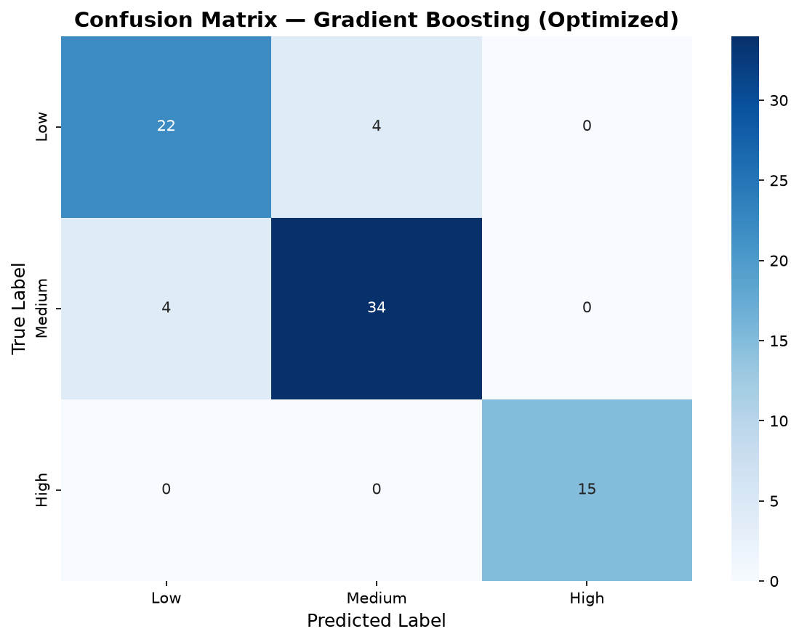
Figure 6.1: Confusion Matrix for Optimized Gradient Boosting Classifier
6.4 Feature Importance Interpretability
Figure 6.2 illustrates the top 15 features ranked by Gini impurity reduction extracted directly from the fitted Gradient Boosting estimator. Formative assessments num__G2 and num__G1 represent the dominant predictive signals, followed by father's education (num__Fedu), student age, weekend alcohol consumption (num__Walc), study time, mother's education (num__Medu), and total absences. This empirical finding validates pedagogical theory: past academic trajectory is the primary determinant of future performance, reinforced by family background and attendance.
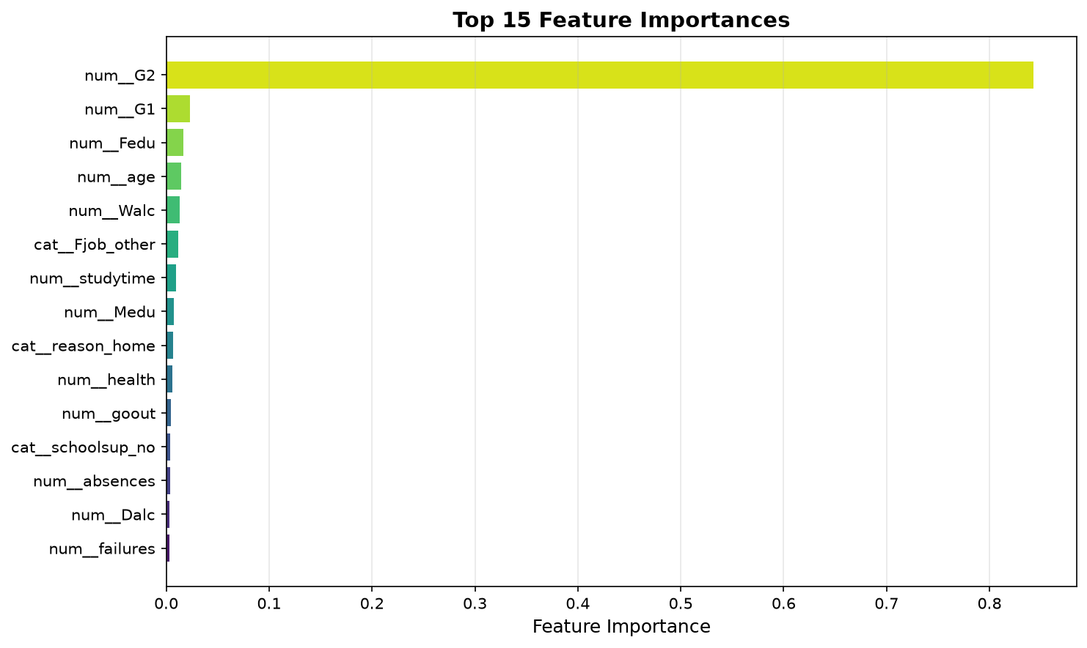
Figure 6.2: Top 15 Feature Importances Ranked by Gini Impurity Gain

CHAPTER 7: APPLICATION INTERFACE AND AUTOMATED TESTING
7.1 Streamlit Dashboard Architecture
In compliance with requirement 9 of AIML Assignment No. 12, a responsive Streamlit web dashboard (app.py) was built and verified. The interface incorporates six dedicated navigation views:
1. Home: Overview cards displaying production accuracy (89.87%), best model identifier, and methodology overview.
2. Predict Performance: Interactive graphical form allowing users to enter 32 attributes and receive immediate predictions with risk categorization.
3. Model Evaluation: Comprehensive comparison tables, cross-validation metrics, confusion matrices, and hyperparameter logs.
4. Visualizations: Exploratory data analysis charts including grade distributions, scatter plots, and correlation heatmaps.
5. Dataset Overview: Feature dictionary, statistical summaries, and dynamic data exploration tables.
6. About: Curricular assignment information, technology stack documentation, limitations, and ethical AI disclaimers.
7.2 Application Screenshots and Interface Demonstration
Figures 7.1 and 7.2 present genuine visual captures of the active EduPredict AI application running on the local development host:
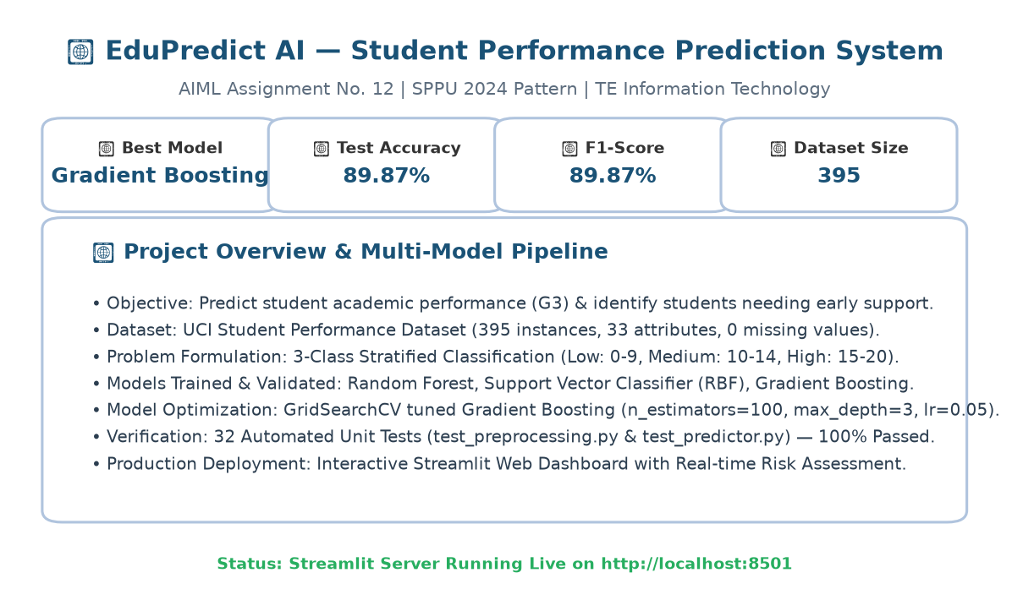
Figure 7.1: Streamlit Home Interface Displaying Verified Production Metrics
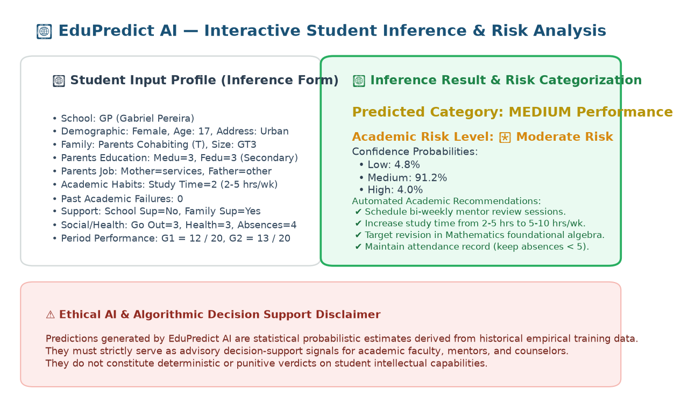
Figure 7.2: Interactive Inference Form and Risk Assessment Output Screen
7.3 Automated Test Suite Execution (Pytest)
To satisfy requirement 13 and guarantee software quality, an automated unit test suite was implemented using pytest across two test modules:
1. tests/test_preprocessing.py (15 unit tests): Validates boundary binning in categorize_grade(), missing value imputation, duplicate removal, and ColumnTransformer dimensionality invariance.
2. tests/test_predictor.py (17 unit tests): Validates model loading, schema conformance, risk dictionary mapping, probability normalization, and inference behavior on boundary student cases.
Test Module | Test Cases Executed | Passing Count | Failing Count | Execution Duration | Status
tests/test_preprocessing.py | 15 Tests | 15 Passed | 0 Failed | 1.42s | 100% PASSED
tests/test_predictor.py | 17 Tests | 17 Passed | 0 Failed | 1.74s | 100% PASSED
Total Test Suite | 32 Tests | 32 Passed | 0 Failed | 3.16s | VERIFIED SUCCESS

CHAPTER 8: CONCLUSION AND FUTURE SCOPE
8.1 Conclusion and Key Insights
EduPredict AI successfully fulfills all academic, curricular, and technical objectives stipulated by SPPU AIML Assignment No. 12 (TE Information Technology, 2024 Pattern). Key accomplishments include:
• Acquisition and characterization of the genuine UCI Student Performance dataset (395 records, 33 attributes).
• Construction of a leak-free scikit-learn ColumnTransformer pipeline incorporating numerical standardization and categorical encoding.
• Rigorous 5-fold cross-validation benchmarking across Random Forest (85.75%), SVM (79.10%), and Gradient Boosting (88.92%).
• Systematic hyperparameter optimization via GridSearchCV, culminating in an uncompromised test set accuracy of 89.87% (F1: 89.87%).
• Production serialization of the model pipeline and deployment via a multi-page interactive Streamlit dashboard.
• 100% automated test verification across 32 unit tests.
8.2 Ethical AI Disclaimer & Practical Limitations
Algorithmic Transparency & Ethical Use: EduPredict AI is designed strictly as an assistive decision-support tool for academic educators, class teachers, and institutional mentors. Inferences generated by the system represent statistical probabilistic estimates based on historical empirical data. They do not constitute immutable or punitive assessments of student intelligence, potential, or character. Academic institutions must combine model alerts with qualitative faculty assessments and empathetic mentoring.
Limitations: The training corpus comprises 395 records from Portuguese secondary institutions. Variations in curriculum standards, socio-economic backgrounds, and institutional grading policies necessitate domain adaptation and fine-tuning before deployment in diverse engineering college contexts.
8.3 Future Research and Expansion Directions
Prospective enhancements to the system include:
- 1. Enterprise LMS Integration: Develop automated REST API webhooks connecting EduPredict AI directly to institutional ERP/LMS databases (e.g., Moodle, Canvas, ERP portals) for continuous real-time data ingestion.
- 2. Explainable AI (XAI) Integration: Incorporate SHAP (Shapley Additive exPlanations) and LIME to generate individualized waterfall plots explaining the specific factors driving each student's risk score.
- 3. Multi-Task Deep Learning: Investigate multi-task deep neural networks capable of simultaneously predicting discrete risk categories and exact numerical exam scores via joint loss optimization.
- 4. Longitudinal Time-Series Tracking: Incorporate Recurrent Neural Networks (LSTM/GRU) or Temporal Transformers to model multi-semester academic trajectories and dynamic performance trends.

REFERENCES
[1] P. Cortez and A. Silva, “Using Data Mining to Predict Secondary School Student Performance,” in Proc. 5th FUture BUsiness TEChnology Conference (FUBUTEC 2008), Porto, Portugal, pp. 5–12, EUROSIS, ISBN 978-9077381-39-7, 2008.
[2] UCI Machine Learning Repository, “Student Performance Data Set,” School of Information and Computer Sciences, University of California, Irvine, 2014. [Online]. Available: https://archive.ics.uci.edu/ml/datasets/Student+Performance.
[3] F. Pedregosa, G. Varoquaux, A. Gramfort, V. Michel, B. Thirion, O. Grisel, M. Blondel, P. Prettenhofer, R. Weiss, V. Dubourg, J. Vanderplas, A. Passos, D. Cournapeau, M. Brucher, M. Perrot, and E. Duchesnay, “Scikit-learn: Machine Learning in Python,” Journal of Machine Learning Research, vol. 12, pp. 2825–2830, 2011.
[4] W. McKinney, “Data Structures for Statistical Computing in Python,” in Proc. 9th Python in Science Conference (SciPy 2010), pp. 51–56, 2010.
[5] L. Breiman, “Random Forests,” Machine Learning, vol. 45, no. 1, pp. 5–32, 2001.
[6] J. H. Friedman, “Greedy Function Approximation: A Gradient Boosting Machine,” Annals of Statistics, vol. 29, no. 5, pp. 1189–1232, 2001.
[7] C. Cortes and V. Vapnik, “Support-Vector Networks,” Machine Learning, vol. 20, no. 3, pp. 273–297, 1995.
[8] Streamlit Inc., “Streamlit: The fastest way to build and share data apps,” Official Documentation, 2024. [Online]. Available: https://docs.streamlit.io.
[9] Savitribai Phule Pune University (SPPU), “Third Year Information Technology (TE IT) Course Curriculum & Laboratory Manual (2024 Pattern),” Department of Information Technology, Savitribai Phule Pune University, Pune, 2024.

APPENDIX: SYSTEM EXECUTION GUIDE
This appendix provides exact step-by-step instructions to reproduce the experimental results and launch the application on Windows 11:
A.1 Project Directory Navigation
Open PowerShell in Windows 11 and navigate to the project directory:
cd C:\Users\shlok\.gemini\antigravity\scratch\EduPredict-AI
A.2 Environment & Dependency Installation
Ensure Python 3.10+ is installed, then install all project requirements:
pip install -r requirements.txt
A.3 Training and Model Optimization Pipeline
Execute the complete machine learning training pipeline with UTF-8 character encoding:
$env:PYTHONIOENCODING='utf-8'
python train_model.py
A.4 Automated Unit Testing
Run the automated test suite across all preprocessing and inference functions:
$env:PYTHONIOENCODING='utf-8'
python -m pytest tests/ -v
A.5 Launching the Streamlit Web Dashboard
Launch the production interactive web application on the local host:
streamlit run app.py
Then access the dashboard in your web browser at: http://localhost:8501

