Program 1: Write a program to demonstrate ListBox.
Public Class Form1
Private Sub Form1_Load(sender As Object, e As EventArgs) Handles MyBase.Load
lstItems.Items.Add("Item 1")
lstItems.Items.Add("Item 2")
lstItems.Items.Add("Item 3")
End Sub
Private Sub btnAdd_Click(sender As Object, e As EventArgs) Handles btnAdd.Click
If txtNewItem.Text = "" Then
MessageBox.Show("Please enter a new item.")
Else
lstItems.Items.Add(txtNewItem.Text)
txtNewItem.Text = ""
End If
End Sub
Private Sub btnRemove_Click(sender As Object, e As EventArgs) Handles btnRemove.Click
If lstItems.SelectedIndex = -1 Then
MessageBox.Show("Please select an item to remove.")
Else
lstItems.Items.RemoveAt(lstItems.SelectedIndex)
End If
End Sub
Private Sub btnClear_Click(sender As Object, e As EventArgs) Handles btnClear.Click
lstItems.Items.Clear()
End Sub
Private Sub btnShowSelected_Click(sender As Object, e As EventArgs) Handles btnShowSelected.Click
If lstItems.SelectedIndex = -1 Then
MessageBox.Show("Please select an item.")
Else
lblResult.Text = "Selected Item: " & lstItems.SelectedItem
End If
End Sub
Private Sub btnTotal_Click(sender As Object, e As EventArgs) Handles btnTotal.Click
lblTotal.Text = "Total: " & lstItems.Items.Count.ToString()
End Sub
End Class
Output:
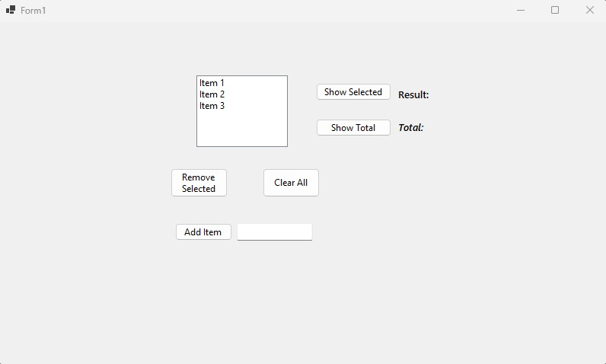
Fig 6.1 — Initial state with default items loaded
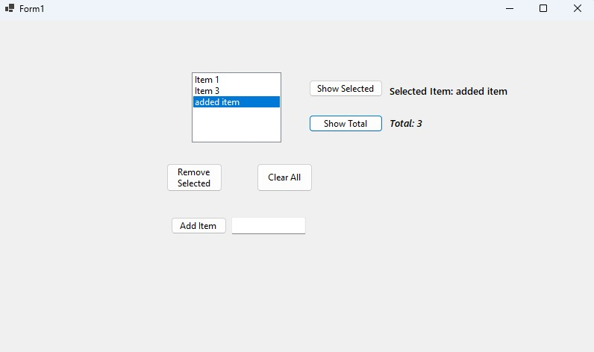
Fig 6.2 — Adding a new item and displaying selected item & total count
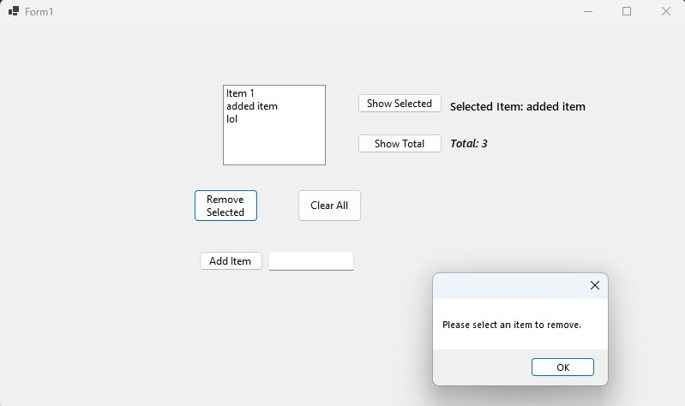
Fig 6.3 — Remove Selected validation when no item is selected
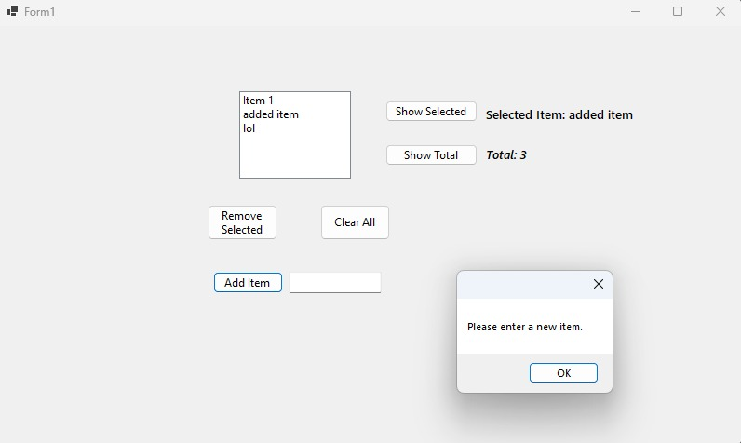
Fig 6.4 — Add Item validation when text field is empty
Program 2: Write a program to demonstrate ComboBox.
Public Class Form1
Private Sub Form1_Load(sender As Object, e As EventArgs) Handles MyBase.Load
cboItems.Items.Add("Item 1")
cboItems.Items.Add("Item 2")
cboItems.Items.Add("Item 3")
cboItems.Items.Add("Item 4")
End Sub
Private Sub btnShowChoice_Click(sender As Object, e As EventArgs) Handles btnShowChoice.Click
If cboItems.SelectedIndex = -1 Then
MessageBox.Show("Please select an item.")
Else
lblChosen.Text = "Chosen Item: " & cboItems.SelectedItem.ToString()
End If
End Sub
End Class
Output:
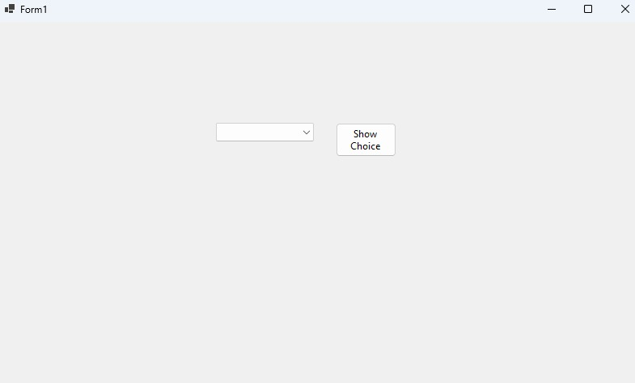
Fig 6.5 — ComboBox with default items loaded
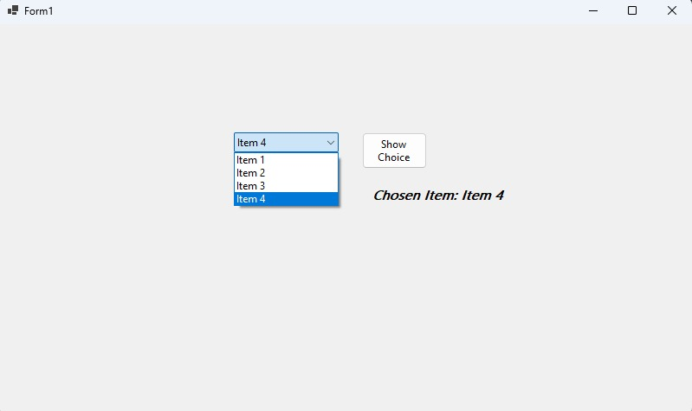
Fig 6.6 — Selecting Item 4 and displaying the chosen item
Program 3: Write a program to demonstrate CheckBox.
Imports System.Collections.Generic
Public Class Form1
Private Sub btnShowHobbies_Click(sender As Object, e As EventArgs) Handles btnShowHobbies.Click
Dim hobbies As New List(Of String)
If chkReading.Checked Then hobbies.Add("Reading")
If chkMusic.Checked Then hobbies.Add("Music")
If chkSports.Checked Then hobbies.Add("Sports")
If chkGaming.Checked Then hobbies.Add("Gaming")
If hobbies.Count = 0 Then
lblResult.Text = "No hobbies selected."
Else
lblResult.Text = $"Selected hobbies: {String.Join(", ", hobbies)}"
End If
End Sub
End Class
Output:
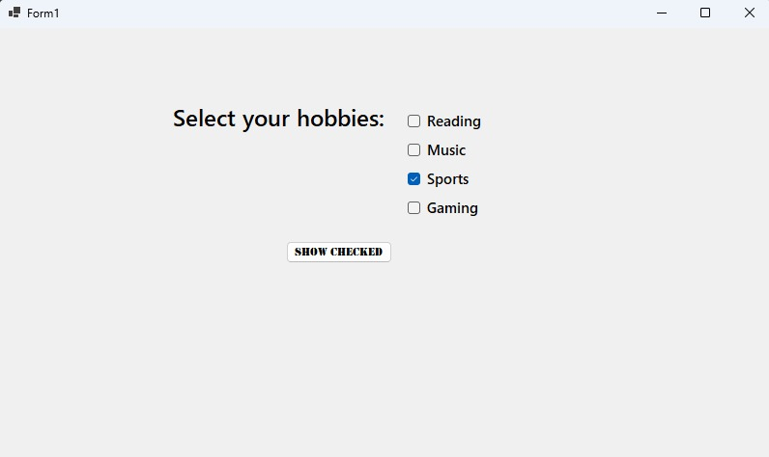
Fig 6.7 — CheckBox with "Sports" selected at default
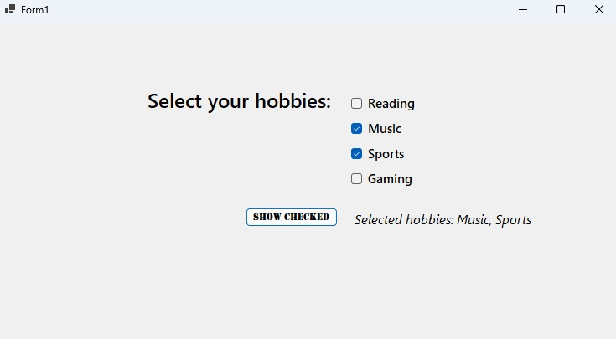
Fig 6.8 — Multiple selections: Music and Sports checked
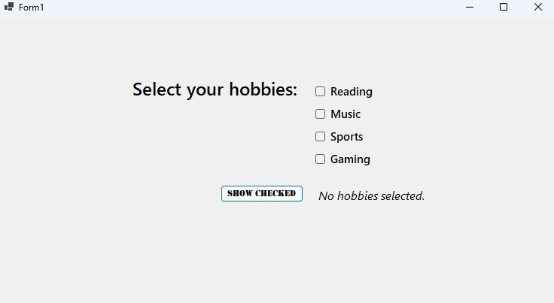
Fig 6.9 — No hobbies selected — validation message displayed

Program 4: Write a program to demonstrate RadioButton.
Public Class Form1
Dim result As String
Private Sub rdbEasy_CheckedChanged(sender As Object, e As EventArgs) Handles rdbEasy.CheckedChanged
If rdbEasy.Checked Then
result = "Easy"
lblSelected.Text = $"Selected: {result}"
End If
End Sub
Private Sub rdbMedium_CheckedChanged(sender As Object, e As EventArgs) Handles rdbMedium.CheckedChanged
If rdbMedium.Checked Then
result = "Medium"
lblSelected.Text = $"Selected: {result}"
End If
End Sub
Private Sub rdbHard_CheckedChanged(sender As Object, e As EventArgs) Handles rdbHard.CheckedChanged
If rdbHard.Checked Then
result = "Hard"
lblSelected.Text = $"Selected: {result}"
End If
End Sub
End Class
Output:
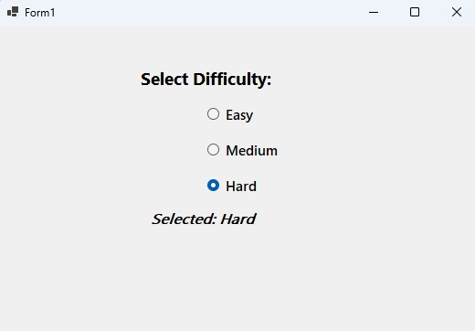
Fig 6.10 — RadioButton with "Hard" difficulty selected

