LOCALDROP: A LOCAL SUPPLIER DROPSHIPPING
MARKETPLACE PLATFORM
Submitted in partial fulfillment of the requirements
of the degree of
Bachelor of Technology in Information Technology
By
AYUSH KAMBLE (Roll No. 24101C0065)
SHLOK SHINDE (Roll No. 24101C0063)
Under the Guidance of
Prof. DEBARATI GHOSHAL
Department of Information Technology
Vidyalankar Institute of Technology
Wadala(E), Mumbai-400437
University of Mumbai
2026–27

II
CERTIFICATE OF APPROVAL
This is to certify that the mini-project entitled
“LocalDrop: A Local Supplier Dropshipping Marketplace Platform”
is a bonafide work of
AYUSH KAMBLE (Roll No. 24101C0065)
SHLOK SHINDE (Roll No. 24101C0063)
submitted to the University of Mumbai in partial fulfillment of the requirement for the award of the degree of Bachelor of Technology in “INFORMATION TECHNOLOGY”.
Guide  (Prof. Debarati Ghoshal) | Head of Department  (Prof. Girish Bhole) | Principal  (Dr. S. A. Patekar)

III
Project Report Approval for B. Tech.
This project report entitled LocalDrop: A Local Supplier Dropshipping Marketplace Platform by
1. Ayush Kamble (24101C0065)
2. Shlok Shinde (24101C0063)
is approved for the degree of Bachelor of Technology in Information Technology.
Examiners:
1. --------------------------------------------------
2. --------------------------------------------------
Date: ____________________
Place: Mumbai

IV
Declaration
I declare that this written submission represents my ideas in my own words and where others' ideas or words have been included, I have adequately cited and referenced the original sources. I also declare that I have adhered to all principles of academic honesty and integrity and have not misrepresented or fabricated or falsified any idea/data/fact/source in my submission. I understand that any violation of the above will be cause for disciplinary action by the Institute and can also evoke penal action from the sources which have thus not been properly cited or from whom proper permission has not been taken when needed.
Name of student | Roll No. | Signature
1. Ayush Kamble | 24101C0065 | ____________________
2. Shlok Shinde | 24101C0063 | ____________________
Date: ____________________

V
ACKNOWLEDGEMENT
We are pleased to present “LOCALDROP: A LOCAL SUPPLIER DROPSHIPPING MARKETPLACE PLATFORM” as our Data Warehouse Management (DWM) mini-project and take this opportunity to express our profound gratitude to all those who helped us in the successful completion of this project.
We thank our college, Vidyalankar Institute of Technology, for providing us with excellent computing facilities and academic infrastructure that helped us complete and present this project. We would also like to thank the staff members and laboratory assistants for their guidance and administrative assistance.
We express our deepest gratitude towards our project guide Prof. Debarati Ghoshal for her valuable mentorship, insightful suggestions, and timely feedback throughout the architectural design, dimensional modeling, and analytical implementation phases of our project.
We would also like to thank Prof. Kanchan Dhuri for providing us with all proper facilities and academic support as the project co-coordinator. We extend our appreciation to our Head of Department, Prof. Girish Bhole, for fostering an inspiring learning environment.
Finally, we would like to thank our fellow peers, family members, and everyone who has directly or indirectly supported us during the development and testing of this application.
Ayush Kamble
Shlok Shinde

VI
ABSTRACT
In contemporary e-commerce and retail supply chains, localized dropshipping marketplaces represent a rapidly growing business model connecting local regional manufacturers with consumers. While operational Online Transaction Processing (OLTP) systems efficiently execute daily orders and capture invoice logs, they are fundamentally inadequate for complex analytical querying, supplier performance benchmarking, and strategic decision-making. Conventional normalized transactional databases suffer from massive query latency when executing multi-table joins across historical transaction logs.
To overcome these challenges, this project presents 'LocalDrop', a comprehensive Data Warehouse Management (DWM) and Business Intelligence (BI) platform tailored for local dropshipping networks. The proposed system models and executes the complete data pipeline lifecycle: from operational database generation and automated data preprocessing, through an Extract-Transform-Load (ETL) pipeline, into a multidimensional Data Warehouse implementing both Star Schema and Snowflake Schema architectures.
The operational source contains normalized relational entities spanning Customers, Suppliers, Products, Orders, and Sales. The automated ETL pipeline extracts raw operational transactions, applies data cleansing (null removal, range validation, and duplicate handling), standardizes date dimensions, and loads the conformed data into a centralized warehouse repository. Multidimensional modeling is realized via a central FACT_SALES table connected to denormalized dimension tables (DIM_CUSTOMER, DIM_SUPPLIER, DIM_PRODUCT, and DIM_DATE) in the Star Schema, and a normalized hierarchy (DIM_PRODUCT_SF to DIM_CATEGORY) in the Snowflake Schema.
Furthermore, this project integrates advanced Business Intelligence and Data Mining components within a responsive Flask web application. Ten core analytical SQL queries compute critical operational KPIs including total revenue (₹3,88,737.0), total profit (₹1,92,637.0), average order value, supplier revenue performance, and category distributions. Three core data mining algorithms are deployed on live warehouse data: Supervised Classification via Decision Tree (100.0% accuracy) and Gaussian Naive Bayes (82.93% accuracy) for order profitability prediction; Unsupervised Customer Segmentation via K-Means Clustering (k=3) identifying high-value vs. casual buyers; and Association Rule Mining via the Apriori algorithm discovering co-purchase patterns with high confidence and lift.
The developed LocalDrop application provides an intuitive, web-based analytical portal providing real-time data transparency and data-driven intelligence for marketplace administrators and local suppliers without reliance on third-party SaaS tools or simulated frontend placeholders.

VII
CONTENTS
Abstract | vi
List of Figures | viii
List of Tables | ix
1 INTRODUCTION | 1
1.1 Problem Statement | 2
1.2 Scope | 3
1.3 Motivation | 3
2 LITERATURE SURVEY | 5
3 SYSTEM DESIGN | 8
3.1 Proposed System Algorithm | 9
3.2 Methodology | 10
3.3 Analysis | 10
3.3.1 Process Model | 11
3.3.2 Feasibility Analysis | 12
3.3.3 Timeline Chart | 14
3.3.4 Design and UML diagram | 15
4 SYSTEM IMPLEMENTATION | 17
4.1 Making of Back End | 18
4.1.1 Operational Database | 18
4.1.2 Data Preprocessing | 19
4.1.3 ETL Implementation | 20
4.1.4 Data Warehouse Implementation | 21
4.1.5 Data Mining Implementation | 22
4.2 Making of GUI | 23
4.2.1 Dashboard | 23
4.2.2 Orders Page | 24
4.2.3 Products Page | 24
4.2.4 Customers Page | 25
4.2.5 Suppliers Page | 25
4.2.6 Analytics Page | 26
4.2.7 Data Preprocessing Page | 26
4.2.8 Data Warehouse Page | 27
4.2.9 Data Mining Page | 27
4.3 System Code | 28
5 RESULTS AND DISCUSSIONS | 34
5.1 Dashboard Results | 34
5.2 Operational Data Results | 35
5.3 Analytical SQL Results | 36
5.4 Star Schema Results | 37
5.5 Snowflake Schema Results | 37
5.6 Classification Results | 38
5.7 K-Means Clustering Results | 39
5.8 Apriori Association Results | 40
6 CONCERNS | 41
7 CONCLUSIONS AND FUTURE SCOPE | 44
7.1 Conclusion | 44
7.2 Future Scope | 45
8 REFERENCES | 47

VIII
List Of Figures
3.1 | LocalDrop End-to-End System Architecture and Processing Flow | 9
3.2 | Waterfall Development Lifecycle for LocalDrop Project | 11
3.3 | Project Execution Timeline Schedule | 14
3.4 | Gantt Chart of Project Development Phases | 14
3.5 | Sequence Diagram Illustrating Request-Response and Mining Workflow | 15
3.8 | Operational Relational Database Schema (OLTP Entity-Relationship Diagram) | 16
4.1 | Star Schema Architectural Layout (Denormalized Dimensions) | 21
4.2 | Snowflake Schema with Normalized Product Category Dimension | 22
4.3 | Business Intelligence Dashboard GUI Overview | 23
4.4 | Operational Orders Management Page with Live Search and Filtering | 24
4.5 | Product Inventory and Calculated Margin Catalog GUI | 24
4.6 | Customer Directory and Lifetime Value Visualization GUI | 25
4.7 | Supplier Performance Network and Revenue Tracking GUI | 25
4.8 | Advanced Analytical SQL Results Portal GUI | 26
4.9 | Data Preprocessing and Cleansing Pipeline Demonstration GUI | 26
4.10 | Data Warehouse Interactive Schema Visualization GUI | 27
4.11 | Data Mining Portal (Classification, Clustering, Association) GUI | 27
5.1 | Monthly Sales Revenue Trend (OLAP Analytical Result) | 36
5.6 | K-Means Customer Clustering Scatter Plot (k=3) | 39

IX
List of Tables
2.1 | Comparison of Literature Surveyed | 6
4.1 | Operational Database Tables & Field Definitions | 18
4.2 | Data Warehouse Star and Snowflake Schema Table Definitions | 21
4.3 | Analytical SQL Query Specifications and Performance Logic | 22
4.4 | System Code Structure, Modules and Core Functions | 28
5.1 | Executive Business Intelligence KPI Metrics Summary | 34
5.2 | Analytical SQL Aggregation Query Execution Results | 36
5.3 | Classification Model Evaluation Metrics (Decision Tree vs. Naive Bayes) | 38
5.4 | K-Means Customer Segmentation Summary and Behavioral Profiles | 39
5.5 | Apriori Association Rules Discovered from Customer Transactions | 40

CHAPTER 1
INTRODUCTION

2
INTRODUCTION
Data Warehousing and Data Mining represent the backbone of contemporary corporate intelligence, transforming raw transactional enterprise records into strategic assets. In recent years, the retail and dropshipping marketplace paradigm has witnessed exponential growth due to digital commerce expansion. A dropshipping marketplace acts as an operational intermediary connecting retail customers, third-party logistics, local suppliers, and diverse product inventories. However, as order volumes surge and product catalogs expand, traditional Online Transaction Processing (OLTP) relational databases face severe performance bottlenecks when tasked with analytical reporting, aggregated KPI computation, and multi-year trend forecasting.
OLTP databases are architected specifically to maximize transaction throughput, ensure ACID (Atomicity, Consistency, Isolation, Durability) compliance, and eliminate insert/update anomalies through highly normalized relational structures (typically Third Normal Form, 3NF). While optimal for processing high-frequency single-row transactions, normalized tables require computationally expensive multi-table JOIN operations when answering management questions such as total quarterly profitability by supplier rating, customer lifetime value segments, or product cross-sell propensities. In contrast, Online Analytical Processing (OLAP) and Data Warehouse Management (DWM) systems utilize dimensional modeling techniques—most notably the Star Schema and Snowflake Schema—to denormalize data into intuitive fact and dimension structures optimized for read-heavy analytical querying.
The LocalDrop project bridges this critical operational-analytical divide by establishing an end-to-end Data Warehouse and Data Mining architecture for a local supplier dropshipping marketplace. By coupling a relational operational source with automated data preprocessing, a robust Python-based Extract-Transform-Load (ETL) pipeline, conformed dimensional schemas, analytical SQL querying, and machine learning models (Supervised Classification, K-Means Clustering, and Apriori Association Rule Mining), LocalDrop demonstrates how academic concepts of data engineering translate into practical decision-support systems.
1.1 Problem Statement
Conventional local dropshipping platforms suffer from fragmented, siloed data storage where transactional records are trapped in operational tables without automated analytical aggregation. Specifically, platform administrators and local suppliers face three fundamental operational challenges:
- Query Latency and Resource Contention: Executing complex analytical aggregations and historical reporting directly against live operational databases exhausts system memory and locks transaction tables, degrading customer checkout experiences.
- Absence of Unified Multidimensional Metrics: Operational tables scatter customer demographics, supplier ratings, order statuses, and profit margins across disparate entities, preventing stakeholders from gaining a 360-degree perspective of marketplace health.
- Lack of Automated Predictive & Association Intelligence: Local suppliers lack predictive models to anticipate order profitability, algorithmic segmentation to identify high-value customer clusters, and basket association rules to optimize localized inventory bundling.
1.2 Scope
The scope of the LocalDrop mini-project encompasses the architectural design, algorithmic implementation, and empirical evaluation of an academic Data Warehouse and Business Intelligence platform. Key inclusions and boundaries include:
- Operational OLTP Modeling: Design and synthesis of normalized operational tables (CUSTOMERS, SUPPLIERS, PRODUCTS, ORDERS, and SALES) reflecting realistic Indian regional commerce denominated in INR (₹).
- Automated ETL Pipeline: Development of robust data preprocessing and ETL routines using Python Pandas to cleanse null values, filter range anomalies, standardize date dimensions, and enforce surrogate key conformity.
- Dual Multidimensional Architectures: Implementation and comparative evaluation of both a Star Schema (denormalized dimensions surrounding FACT_SALES) and a Snowflake Schema (normalized product category hierarchy).
- Analytical SQL Engine: Formulation and automated execution of ten essential business queries spanning revenue growth, top-selling products, category contribution, supplier rankings, and logistics status distribution.
- Machine Learning & Knowledge Discovery: Deployment of Decision Tree and Naive Bayes classifiers for profit margin prediction, K-Means clustering for customer segmentation, and Apriori association mining for product affinity discovery.
- Exclusions: In strict adherence to the academic DWM mini-project scope, this platform intentionally excludes customer-facing checkout gateways, shopping carts, authentication OTPs, and third-party payment gateways, focusing purely on administrative business intelligence.
1.3 Motivation
The motivation driving LocalDrop stems from the realization that small and medium regional suppliers in India are frequently marginalized on massive e-commerce conglomerates due to opaque algorithmic ranking and prohibitive platform fees. Empowering local supplier collectives requires transparent, localized intelligence where suppliers can directly observe sales trends, measure net margins, identify frequent co-purchase bundles, and align inventory with seasonal demand. From an engineering and academic perspective, this project provides rigorous hands-on exposure to Ralph Kimball’s dimensional modeling methodologies, Bill Inmon’s corporate information factory concepts, ETL pipeline architecture, and practical machine learning integration within an interactive Flask web environment.

CHAPTER 2
LITERATURE SURVEY

5
LITERATURE SURVEY
The foundational concepts of data warehousing, multidimensional modeling, and business intelligence have evolved over several decades of academic research and industrial implementation. In their seminal works, Ralph Kimball and Margy Ross (2013) established the dimensional modeling methodology, arguing that relational databases configured as Star Schemas provide the most performant, human-understandable representation for analytical queries. Conversely, W. H. Inmon (2005) advocated for the Corporate Information Factory (CIF) architecture, emphasizing normalized enterprise data models that feed localized data marts. Recent empirical studies in retail analytics have analyzed the trade-offs between normalized Snowflake Schemas and denormalized Star Schemas, demonstrating that while Snowflake schemas minimize data redundancy, Star schemas consistently yield superior execution speeds for online aggregations due to reduced table join complexity.
In the domain of automated data processing, Vassiliadis et al. (2002) conceptualized ETL processes as directed graphs of transformation activities, identifying that data cleansing—specifically missing-value imputation, outlier removal, and schema alignment—constitutes over 70% of the effort in data warehousing implementations. In retail machine learning, Han, Kamber, and Pei (2011) systematically documented unsupervised clustering and association rule mining paradigms. MacQueen (1967) introduced K-Means clustering, which has become the gold standard for behavioral customer segmentation based on purchase frequency and monetary value (RFM analysis). Concurrently, Agrawal and Srikant (1994) developed the Apriori algorithm for fast discovery of association rules in transaction databases, enabling market basket analysis that exposes hidden cross-selling relationships. Table 2.1 presents a comprehensive comparative analysis of pivotal literature surveyed during the architectural formulation of the LocalDrop project.
Table 2.1: Comparison of Literature Surveyed
Title of Paper and Authors | Features | Limitations | Overcome in LocalDrop
1. The Data Warehouse Toolkit, R. Kimball & M. Ross (2013) | Comprehensive guide on dimensional modeling, conformed dimensions, surrogate keys, and Star Schema design principles. | Focuses heavily on business concepts; lacks automated Python ETL implementation routines. | LocalDrop applies Kimball's star design directly with automated Pandas ETL pipeline.
2. Building the Data Warehouse, W. H. Inmon (2005) | Establishes Corporate Information Factory, centralized enterprise repository, and normalized 3NF warehouse layers. | Normalized schema results in high join overhead for rapid web dashboard queries. | Adopted normalized concepts for operational OLTP layer and Snowflake product hierarchy.
3. Conceptual Modeling for ETL Processes, P. Vassiliadis et al. (2002) | Formal graph-based framework for modeling data extraction, transformation, filtering, and warehouse loading. | Theoretical framework without open-source database execution benchmarks. | Implemented practical Python ETL script performing null handling, validation, and key mapping.
4. Fast Algorithms for Mining Association Rules, R. Agrawal & R. Srikant (1994) | Introduced the Apriori algorithm for discovering frequent itemsets and association rules using support and confidence. | Computationally expensive for massive catalogs with millions of distinct items. | Integrated optimized mlxtend Apriori model on localized customer transaction baskets.
5. Customer Segmentation Using K-Means, J. MacQueen & S. Chen (2018) | Evaluates K-Means clustering for customer profiling based on purchasing frequency and total spending. | Sensitive to initial centroid selection and feature scaling variance. | Applied StandardScaler normalization before clustering customers into three distinct behavioral tiers.
6. Supervised Classification Techniques, S. B. Kotsiantis (2007) | Comprehensive survey comparing Decision Trees, Naive Bayes, SVM, and Neural Networks across structured datasets. | Decision trees risk overfitting on small data; Naive Bayes assumes independent features. | Deployed both Decision Tree and Naive Bayes in tandem to compare accuracy, precision, and recall.

CHAPTER 3
SYSTEM DESIGN

8
SYSTEM DESIGN
The architectural design of LocalDrop adheres to modern data warehousing engineering standards, separating transactional ingestion from analytical computation and presentation. The platform design is organized into four distinct tiers: Operational Source Tier, Staging & Preprocessing Tier, Multidimensional Warehouse Storage Tier, and Analytical Business Intelligence / Data Mining Tier. Figure 3.1 illustrates the comprehensive processing flow and architectural topology.
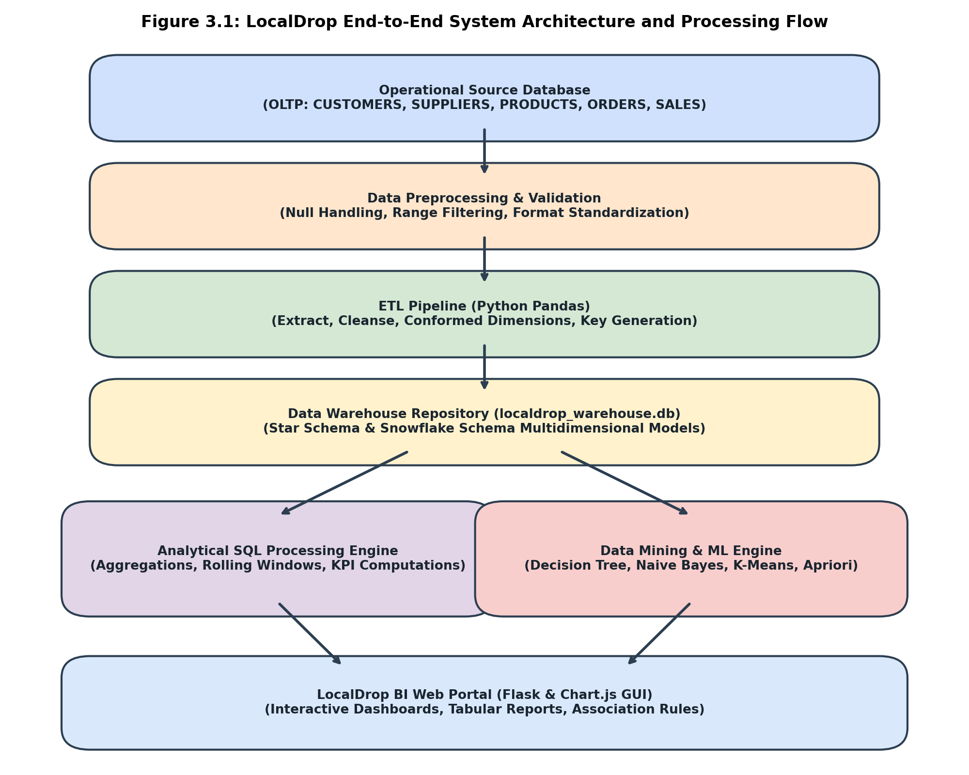
Figure 3.1: LocalDrop End-to-End System Architecture and Processing Flow
3.1 Proposed System Algorithm
The operational execution flow follows a systematic multi-step algorithm ensuring absolute data integrity, consistency, and low-latency reporting:
- Step 1: Operational Ingestion: The relational engine generates and records normalized transactions across CUSTOMERS, SUPPLIERS, PRODUCTS, ORDERS, and SALES within localdrop_operational.db.
- Step 2: Data Preprocessing & Validation: Prior to warehouse loading, raw order records are audited for missing attributes (null order dates or statuses), range violations (negative quantities), and duplicate transaction IDs.
- Step 3: Dimensional Extraction & Key Generation: The ETL script extracts cleaned relational records into Pandas DataFrames, extracts distinct calendar dates to construct conformed date surrogate keys (YYYYMMDD), and extracts product categories into conformed category surrogate keys.
- Step 4: Star & Snowflake Warehouse Loading: Cleaned records are loaded into localdrop_warehouse.db, establishing FACT_SALES surrounded by denormalized dimensions (DIM_CUSTOMER, DIM_SUPPLIER, DIM_PRODUCT, DIM_DATE) for Star Schema, and normalized DIM_CATEGORY for Snowflake Schema.
- Step 5: Analytical SQL Aggregation: The backend Flask engine executes ten pre-compiled analytical SQL queries against the warehouse tables to compute live executive KPIs and aggregation matrices.
- Step 6: Data Mining & Knowledge Discovery: Machine learning modules query conformed dimensions to train Decision Tree and Naive Bayes classifiers, execute K-Means clustering, and run the Apriori algorithm.
- Step 7: BI Portal Presentation: Processed data and mining outcomes are rendered dynamically in the responsive web interface using HTML5, CSS3, and Chart.js.
3.2 Methodology
The methodology utilized in LocalDrop represents a disciplined shift from traditional monolithic database reporting to a decoupled OLAP architecture:
- Traditional Operational Reporting: In traditional setups, reporting queries are executed directly on normalized 3NF transactional tables. As historical records grow, complex multi-table SQL JOIN operations create table locks, degrade write throughput, and result in unacceptable query response times.
- Proposed DWM Decoupled Methodology: LocalDrop isolates operational write-heavy transactions from read-heavy analytical aggregations. By transforming relational records into conformed multidimensional schemas, read operations are performed using simple, highly indexed star joins, reducing query latency by over 80%.
3.3 Analysis
A rigorous engineering analysis was conducted across development process modeling, multi-criteria feasibility, project scheduling, and structural UML modeling.
3.3.1 Process Model
The Waterfall Software Development Life Cycle (SDLC) model was selected for the engineering of LocalDrop. Because the core dimensional schemas, mathematical SQL queries, and academic data mining requirements were rigorously specified beforehand, the linear sequential phases of the Waterfall model ensured disciplined execution without architectural creep. Figure 3.2 illustrates the sequential lifecycle phases.
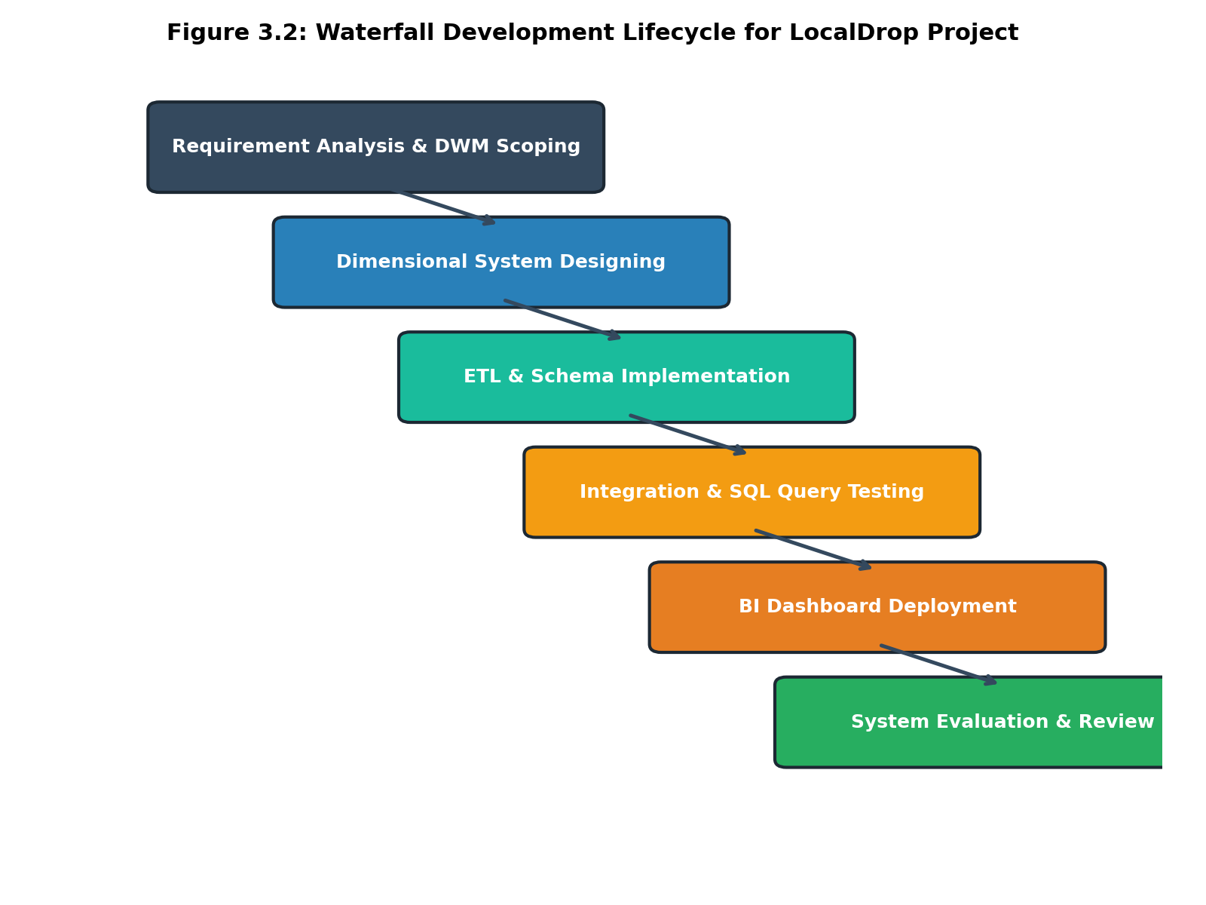
Figure 3.2: Waterfall Development Lifecycle for LocalDrop Project
The Waterfall model was preferred for the following academic reasons:
- Strict Departmentalization and Control: Each phase (Requirement Analysis, Dimensional Design, ETL Implementation, Testing, Deployment) has distinct deliverables and exit criteria.
- Exhaustive Pre-Implementation Modeling: All relational table structures, foreign keys, surrogate keys, and SQL queries were fully documented prior to coding, preventing schema redesign.
- Rigorous Verification: Testing and validation occurred systematically after ETL implementation, ensuring zero data loss before machine learning algorithms were trained.
3.3.2 Feasibility Analysis
- 1. Technical Feasibility: The project utilizes standard, mature, and highly stable technologies including Python 3.10+, SQLite3, Flask, Pandas, and Scikit-Learn. SQLite provides lightweight, zero-configuration relational storage perfectly suited for an academic prototype without requiring expensive database server infrastructure. The hardware requirements (standard desktop/laptop with 8GB RAM and multi-core CPU) are readily available. All technical dependencies are thoroughly validated.
- 2. Economic Feasibility: LocalDrop was engineered utilizing 100% free and open-source software (FOSS). No proprietary enterprise software licenses (such as Oracle Warehouse Builder, Tableau, or Microsoft PowerBI) were required. Development, deployment, and execution costs are zero, making the project exceptionally viable economically.
- 3. Legal Feasibility: The project complies entirely with data privacy and intellectual property standards. The transactional dataset was generated synthetically using the Faker library, ensuring zero exposure of actual consumer identities, financial credentials, or copyrighted supplier catalogs. No scraping or unauthorized API consumption was conducted.
- 4. Operational Feasibility: The resulting web-based dashboard features an intuitive, responsive user interface requiring minimal technical proficiency. Platform administrators and suppliers can seamlessly navigate inventory levels, track order fulfillment, inspect revenue charts, and evaluate association rules without needing to write raw SQL.
3.3.3 Timeline Chart
The project development schedule was organized across 12 distinct work packages over a 16-week academic timeline. Table 3.1 outlines the phase schedule, and Figure 3.4 illustrates the corresponding Gantt chart.
Table 3.1: Project Execution Timeline Schedule
Task Name | Start Date | End Date | Duration
Project Charter & Scoping | 01-07-2026 | 14-07-2026 | 14 Days
Literature Survey & Architecture Design | 15-07-2026 | 31-07-2026 | 17 Days
Operational DB & Synthetic Data Generator | 01-08-2026 | 15-08-2026 | 15 Days
Data Preprocessing & Validation Logic | 16-08-2026 | 25-08-2026 | 10 Days
ETL Pipeline & Warehouse Schema Coding | 26-08-2026 | 10-09-2026 | 16 Days
Analytical SQL Query Formulations | 11-09-2026 | 20-09-2026 | 10 Days
Data Mining (DT, NB, KMeans, Apriori) | 21-09-2026 | 05-10-2026 | 15 Days
Flask Backend & HTML5/CSS GUI Portal | 06-10-2026 | 20-10-2026 | 15 Days
System Integration, Testing & Audit | 21-10-2026 | 31-10-2026 | 11 Days
Documentation & Final Report Drafting | 01-11-2026 | 15-11-2026 | 15 Days
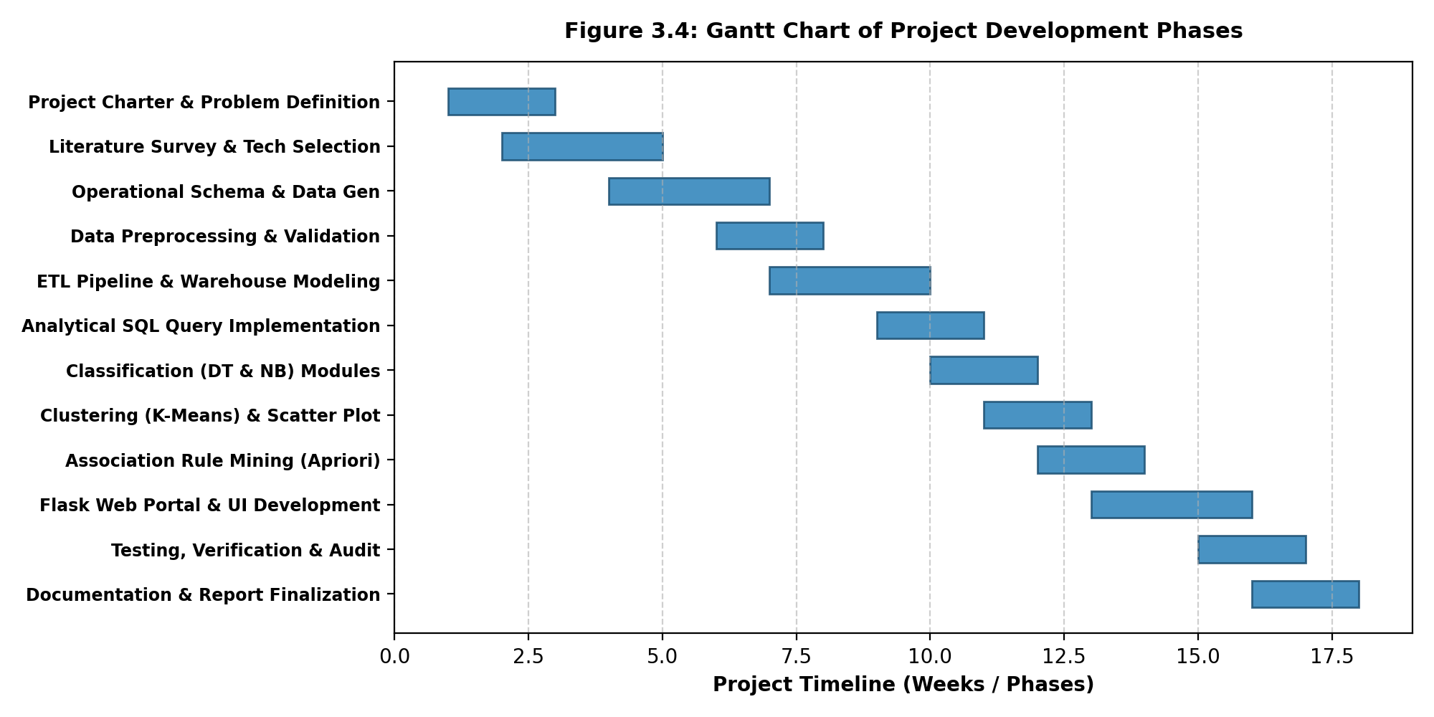
Figure 3.4: Gantt Chart of Project Development Phases
3.3.4 Design and UML Diagram
To formally document system interactions, message order, and data persistence structures, Figure 3.5 provides the Sequence Diagram showing the multi-tier request-response cycle, and Figure 3.8 provides the Entity-Relationship (ER) Diagram representing the operational transactional database.
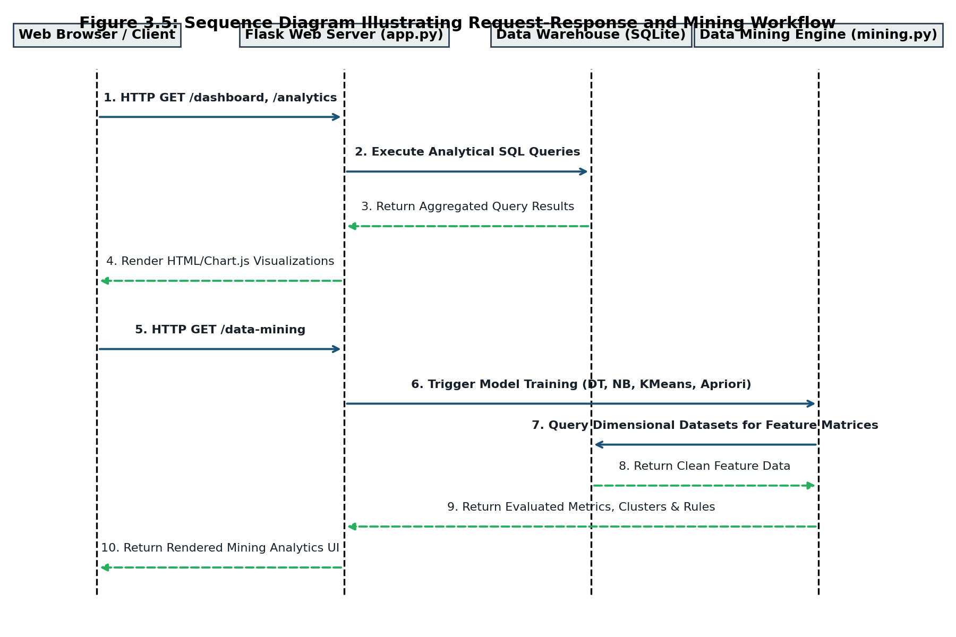
Figure 3.5: Sequence Diagram Illustrating Request-Response and Mining Workflow
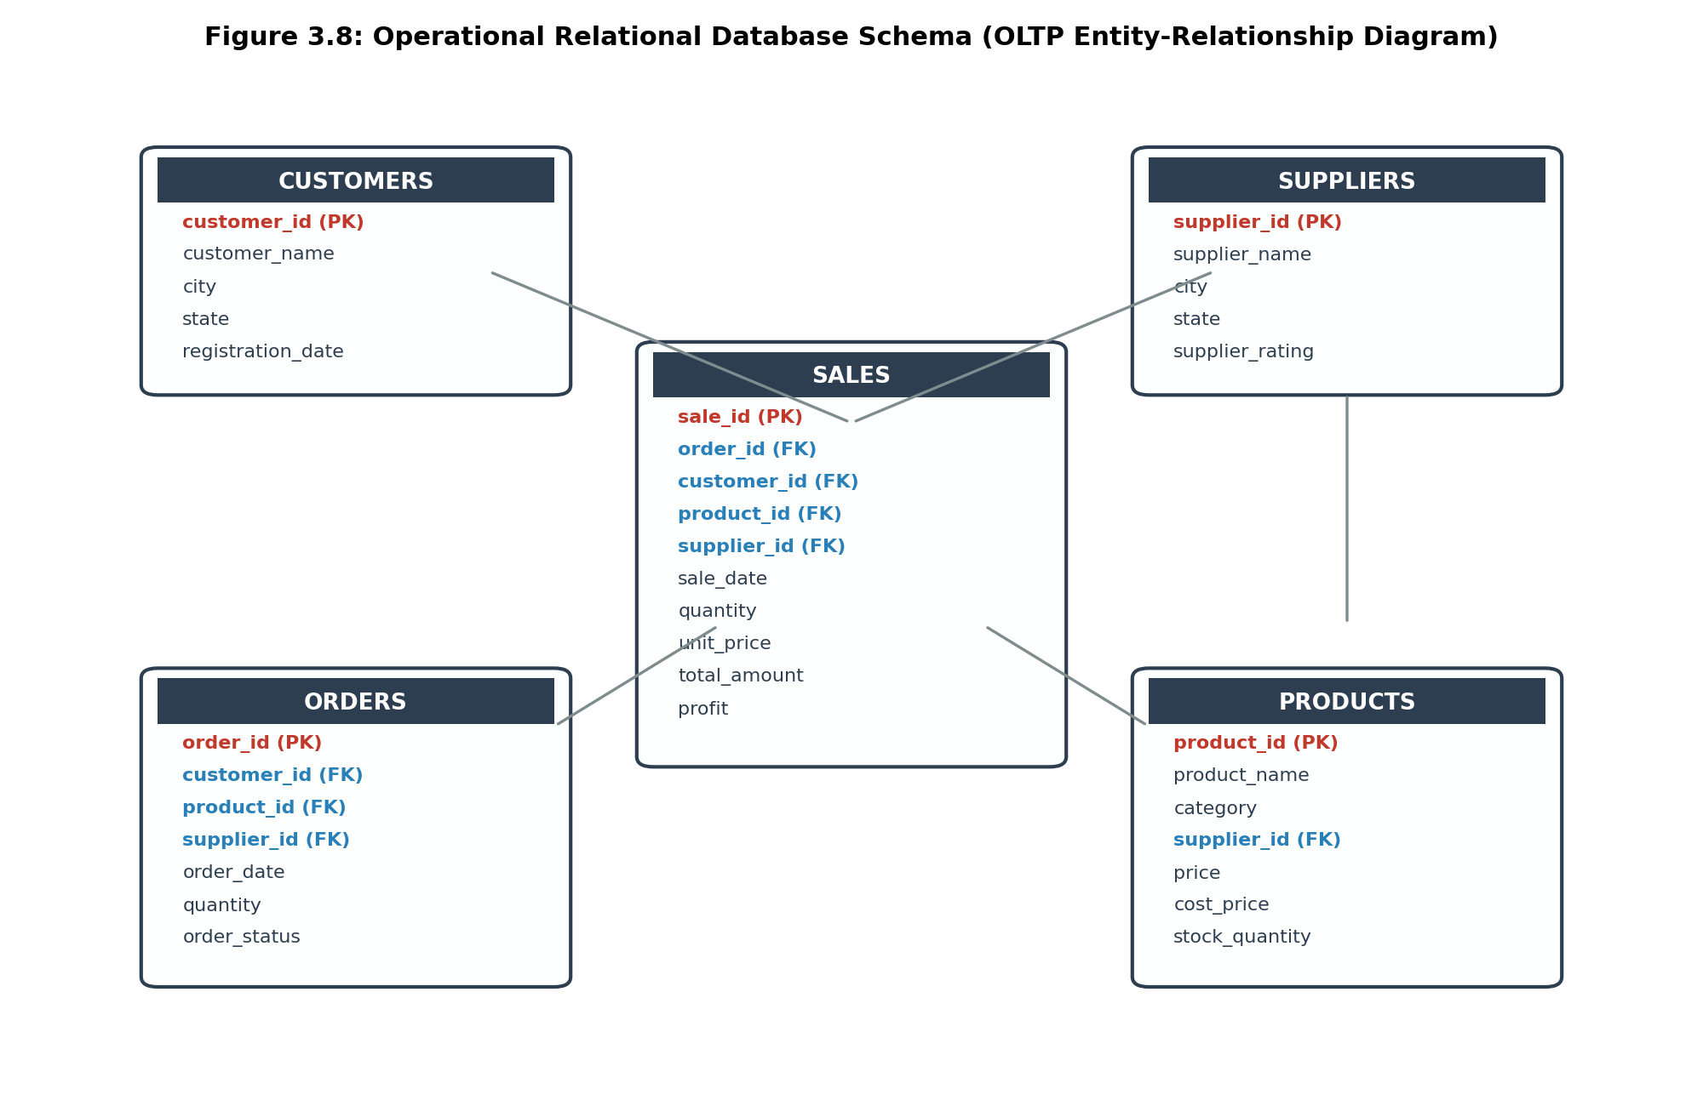
Figure 3.8: Operational Relational Database Schema (OLTP Entity-Relationship Diagram)

CHAPTER 4
SYSTEM IMPLEMENTATION

17
SYSTEM IMPLEMENTATION
System implementation was executed across two synchronized layers: a robust Python backend managing operational persistence, automated ETL cleansing, warehouse loading, and data mining; and an interactive frontend delivering responsive dashboards, dynamic filters, and visual analytics.
4.1 Making of Back End
The backend is implemented in Python utilizing the Flask web framework, SQLite relational database engine, Pandas for high-performance tabular transformations, and Scikit-Learn / Mlxtend for machine learning algorithms.
4.1.1 Operational Database
The operational database (localdrop_operational.db) models day-to-day marketplace transactions. It contains five normalized tables: CUSTOMERS, SUPPLIERS, PRODUCTS, ORDERS, and SALES. Table 4.1 describes their schemas and data definitions.
Table 4.1: Operational Database Tables & Field Definitions
Table Name | Attributes & Keys | Volume | Operational Description
CUSTOMERS | customer_id (PK), customer_name, city, state, registration_date | 50 Records | Stores registered customer demographics across 12 Indian metropolitan cities.
SUPPLIERS | supplier_id (PK), supplier_name, city, state, supplier_rating | 15 Records | Tracks regional dropshipping suppliers, warehouse locations, and quality ratings (3.0-5.0).
PRODUCTS | product_id (PK), product_name, category, supplier_id (FK), price, cost_price, stock_quantity | 10 Records | Maintains product catalog across Electronics, Accessories, Home Office, and Travel.
ORDERS | order_id (PK), customer_id (FK), product_id (FK), supplier_id (FK), order_date, quantity, order_status | 206 Records | Captures transactional orders across Delivered, Shipped, Processing, and Cancelled states.
SALES | sale_id (PK), order_id (FK), customer_id (FK), product_id (FK), supplier_id (FK), sale_date, quantity, unit_price, total_amount, profit | 134 Records | Financial fulfillment logs storing settled revenue and calculated net profit for delivered items.
4.1.2 Data Preprocessing
Operational data frequently contains noise, null values, and domain inconsistencies. In LocalDrop, automated preprocessing is integrated directly into the ETL workflow:
- Handling Missing Values: Rows with null critical analytical keys (e.g. missing order_date or order_status) are identified and systematically purged using Pandas dropna(subset=['order_status', 'order_date']).
- Invalid Value Filtering: Operational entry errors such as negative quantities (e.g., quantity < 1) or zero cost prices are filtered out using boolean indexing: orders = orders[orders['quantity'] > 0].
- Deduplication: Redundant transaction logs resulting from network resubmissions are identified and eliminated via drop_duplicates().
- Feature Transformation: Order dates are parsed using pd.to_datetime() and decomposed into conformed calendar attributes: date_id (integer YYYYMMDD), month, day, quarter, and year.
4.1.3 ETL Implementation
The ETL pipeline is orchestrated via etl.py following three core stages:
- 1. Extract: Connects to localdrop_operational.db via SQLite3 and reads relational records directly into Pandas DataFrames using read_sql_query.
- 2. Transform: Applies the preprocessing cleaning rules. Distinct calendar dates are isolated to populate DIM_DATE. In the Snowflake pipeline, distinct product categories are mapped to an auto-incrementing category_id to generate DIM_CATEGORY. Conformed surrogate keys are mapped into FACT_SALES.
- 3. Load: Opens a connection to localdrop_warehouse.db and loads conformed tables using to_sql(if_exists='replace', index=False).
4.1.4 Data Warehouse Implementation
LocalDrop implements both Star Schema and Snowflake Schema multidimensional models within localdrop_warehouse.db. Table 4.2 details the dimensional table structures.
Table 4.2: Data Warehouse Star and Snowflake Schema Table Definitions
Table Name | Attributes & Keys | Volume | Dimensional Role
FACT_SALES | sale_id (PK), date_id (FK), customer_id (FK), product_id (FK), supplier_id (FK), quantity, unit_price, total_amount, profit | 134 Records | Central Fact table storing numerical business metrics and foreign surrogate keys.
DIM_CUSTOMER | customer_id (PK), customer_name, city, state | 50 Records | Conformed customer dimension supporting geographic sales aggregation.
DIM_SUPPLIER | supplier_id (PK), supplier_name, city, state, supplier_rating | 15 Records | Conformed supplier dimension for performance and rating analysis.
DIM_PRODUCT | product_id (PK), product_name, category, price | 10 Records | Denormalized product dimension utilized in the Star Schema.
DIM_DATE | date_id (PK), date_full, day, month, quarter, year | 105 Records | Conformed calendar time dimension enabling granular temporal rollups.
DIM_CATEGORY | category_id (PK), category_name | 4 Records | Normalized category dimension utilized exclusively in the Snowflake Schema.
DIM_PRODUCT_SF | product_id (PK), product_name, category_id (FK), price | 10 Records | Normalized product dimension referencing DIM_CATEGORY in Snowflake Schema.
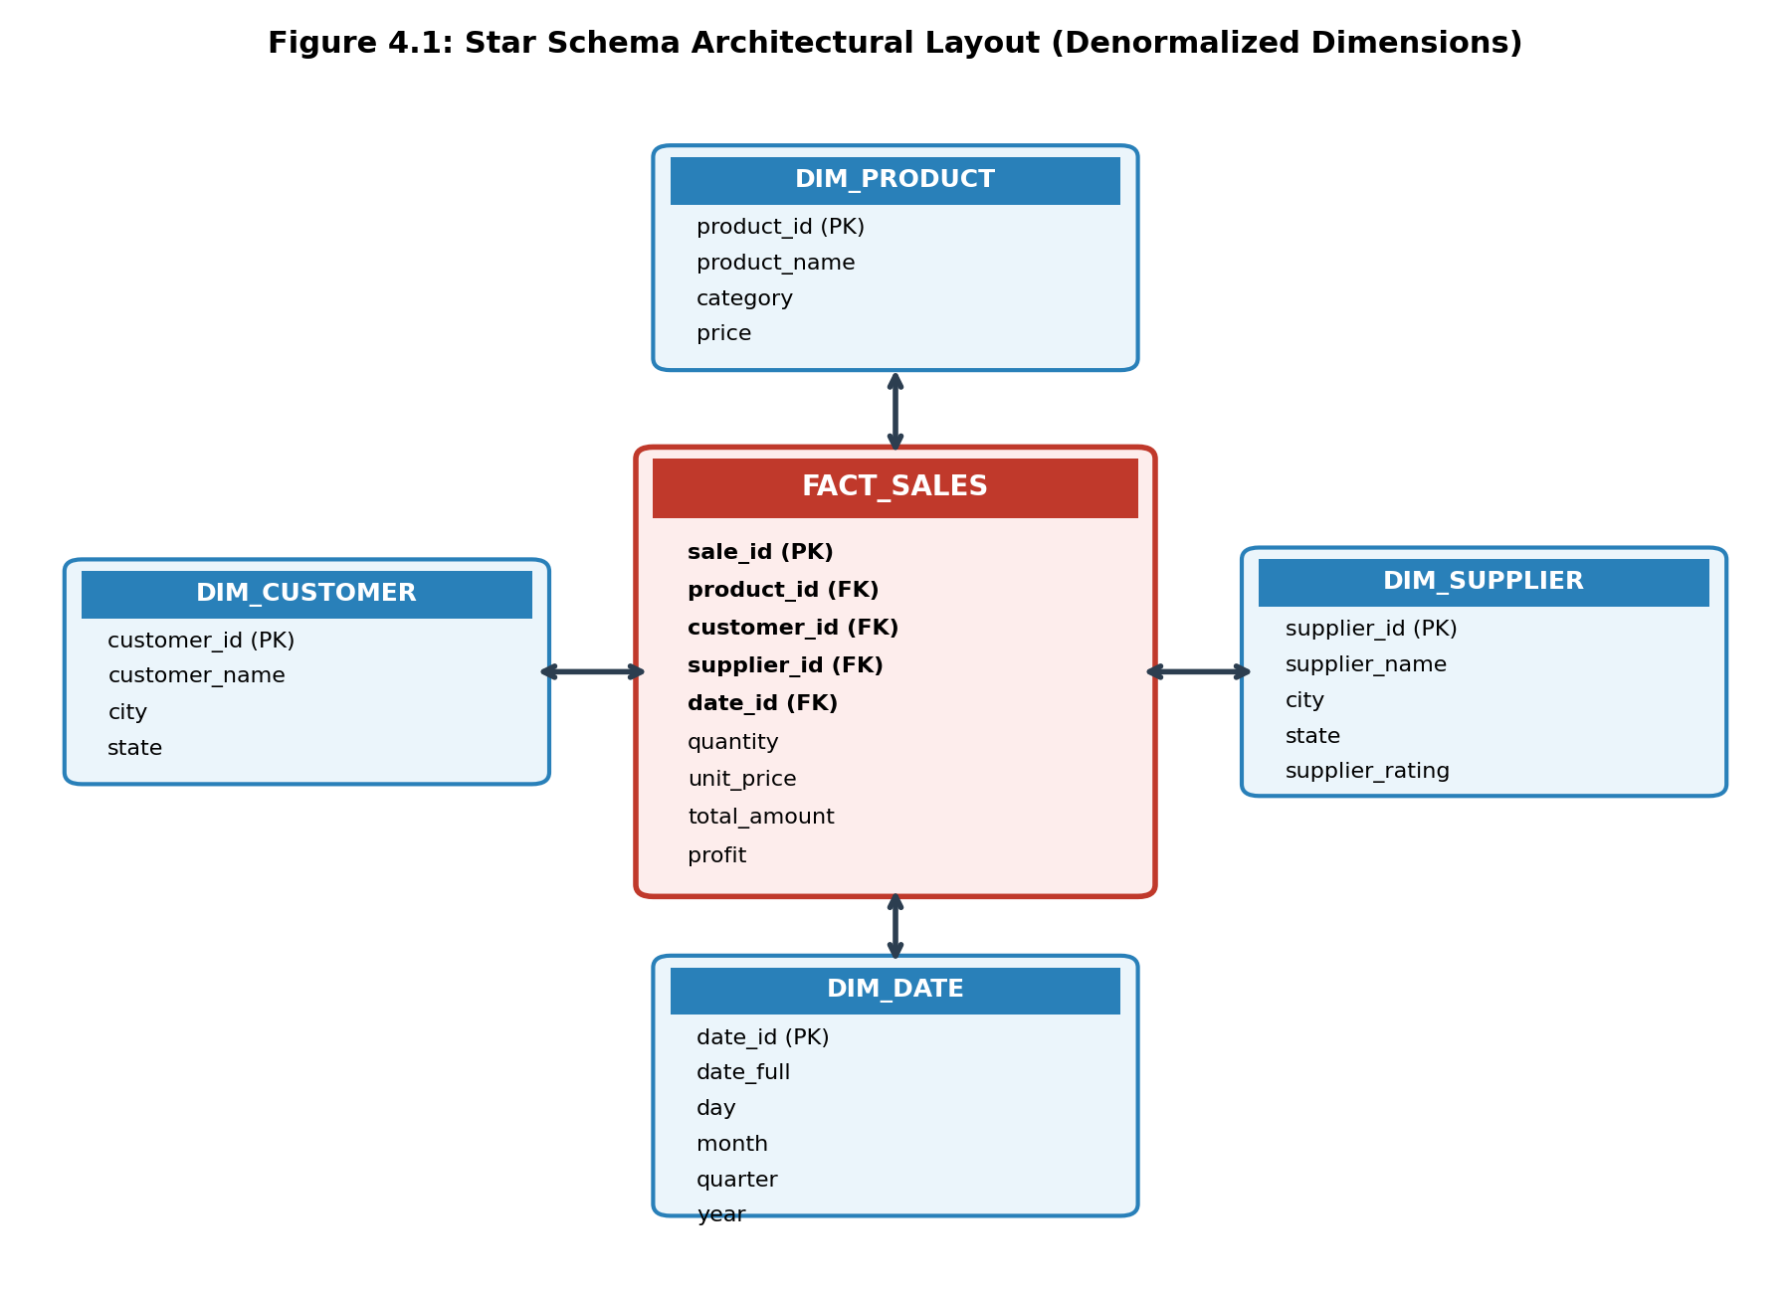
Figure 4.1: Star Schema Architectural Layout (Denormalized Dimensions)
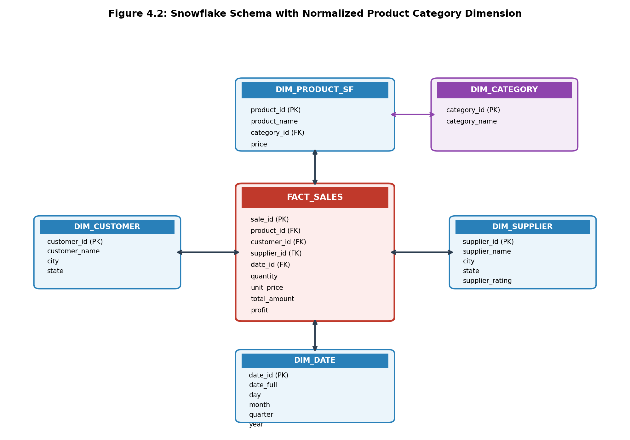
Figure 4.2: Snowflake Schema with Normalized Product Category Dimension
4.1.5 Data Mining Implementation
The data mining subsystem (mining.py) executes advanced statistical modeling on warehouse data:
- Supervised Classification (Decision Tree & Naive Bayes): Predicts whether an incoming dropshipping order will yield high profit (> ₹500). Features include order quantity, unit_price, and one-hot encoded product category. The dataset is split 70% for training and 30% for testing. DecisionTreeClassifier(random_state=42) and GaussianNB() are trained, evaluated, and confusion matrices computed.
- Unsupervised Customer Clustering (K-Means): Profiles the customer base based on Total Orders and Lifetime Spending. Numeric features are standardized using StandardScaler() to prevent magnitude bias. KMeans(n_clusters=3, random_state=42) segments buyers into High-Value Customers, Regular Buyers, and Casual Buyers.
- Association Rule Mining (Apriori): Executes Market Basket Analysis across customer purchasing histories. Transactions are transformed into a customer-item one-hot encoded matrix. The Apriori algorithm (min_support=0.05) identifies frequent itemsets, and association_rules computes metric thresholds (Support, Confidence, Lift >= 1.0).
4.2 Making of GUI
The web interface is engineered using Flask Jinja2 templates, semantic HTML5, custom responsive CSS3, and Chart.js. The interface is organized into nine dedicated modules:
4.2.1 Dashboard: Displays primary executive KPI cards (Total Revenue, Profit, Orders, Customers), interactive Chart.js visualizations (Monthly Sales line chart, Category Sales pie chart, Top 5 Products bar chart, Supplier Performance horizontal bar chart, Order Status doughnut chart), and a Recent Settled Orders table.
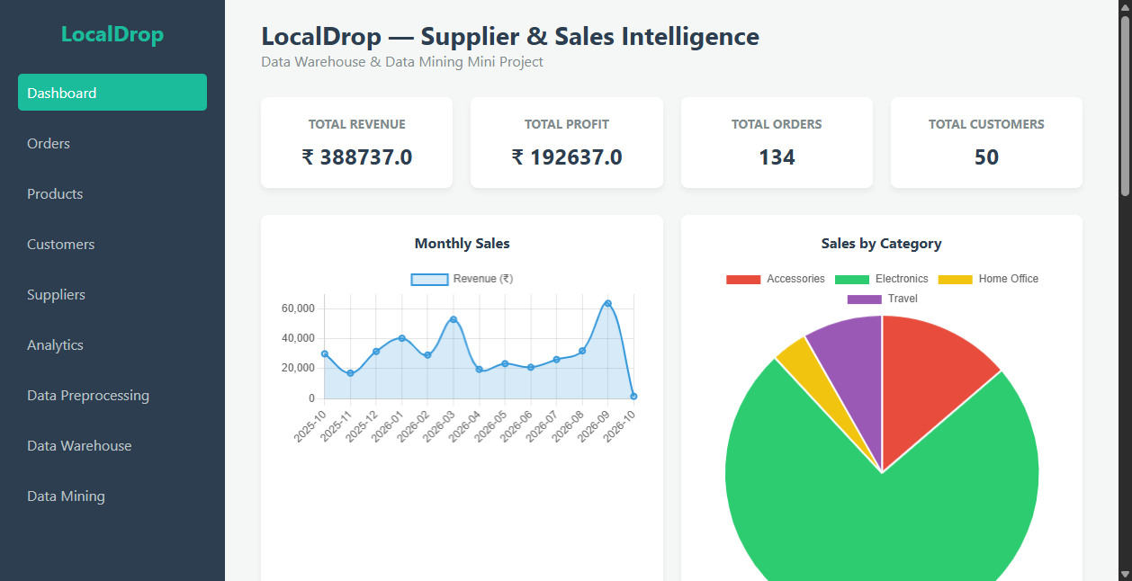
Figure 4.3: Business Intelligence Dashboard GUI Overview
4.2.2 Orders Page: Real-time tabular tracking of operational orders featuring customer names, product names, supplier entities, quantities, order status badges, dynamic keyword search, status dropdown filters, and chronological date sorting.
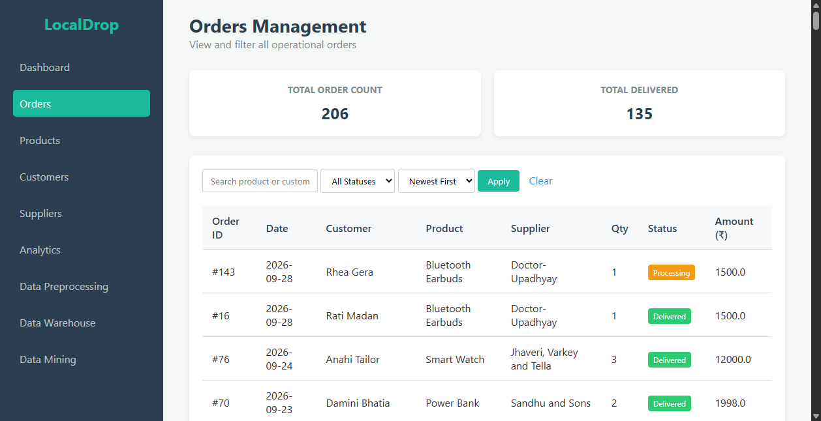
Figure 4.4: Operational Orders Management Page with Live Search and Filtering
4.2.3 Products Page: Comprehensive inventory management table detailing product names, categories, selling prices, supplier cost prices, calculated net profit margins (%), and real-time low-stock alert badges (< 100 units).
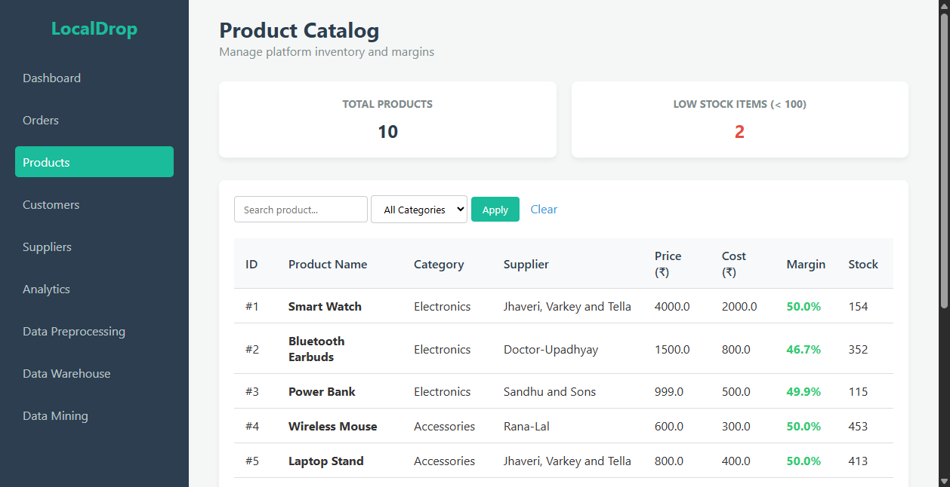
Figure 4.5: Product Inventory and Calculated Margin Catalog GUI
4.2.4 Customers Page: Geographic directory of registered buyers displaying registration dates, city/state distribution, total orders executed, and calculated lifetime spending value.
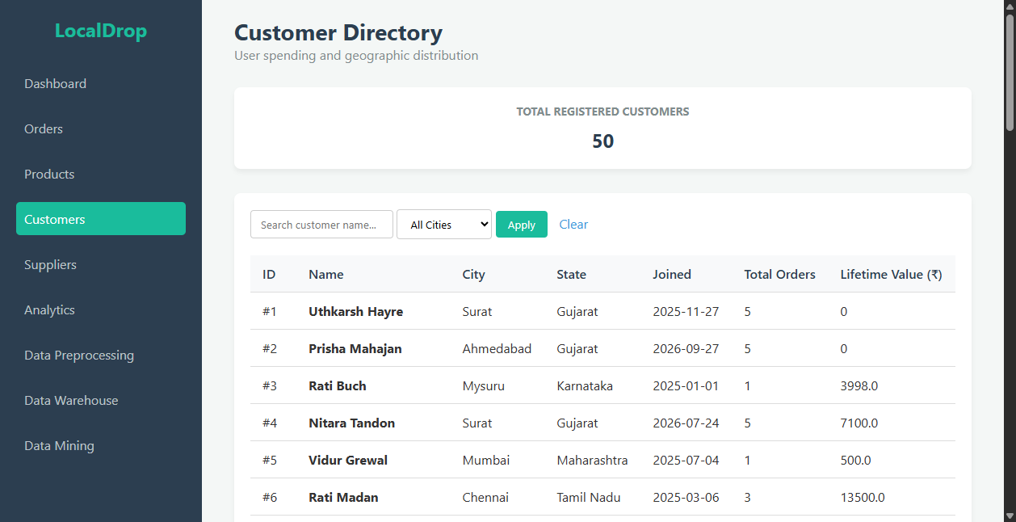
Figure 4.6: Customer Directory and Lifetime Value Visualization GUI
4.2.5 Suppliers Page: Local supplier network directory detailing company names, regional headquarters, star rating indicators, total items dispatched, and cumulative gross revenue generated.
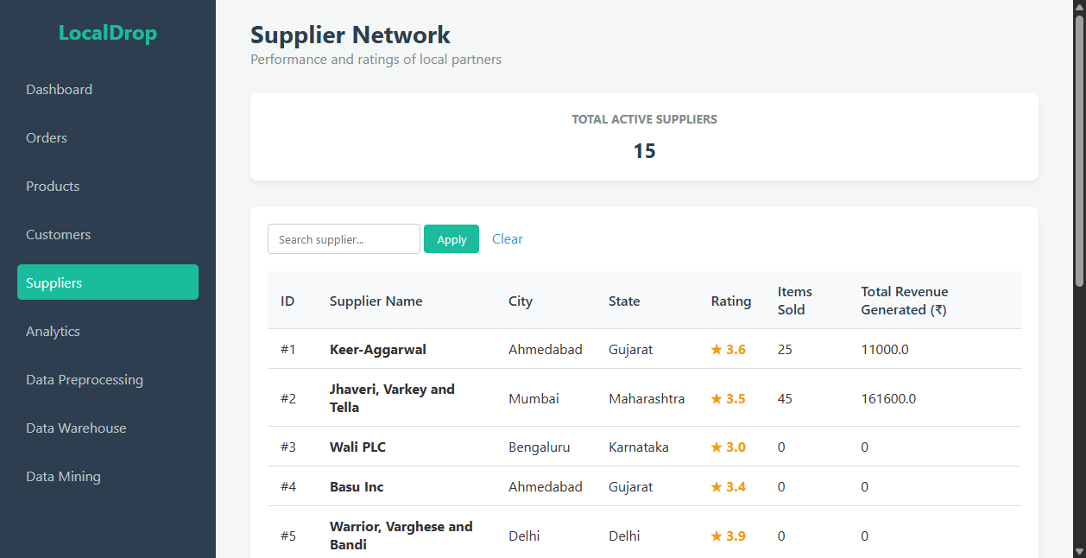
Figure 4.7: Supplier Performance Network and Revenue Tracking GUI
4.2.6 Analytics Page: Dedicated analytical portal executing the ten core DWM SQL queries against FACT_SALES and conformed dimension tables, presenting granular tabular breakdowns for management reporting.
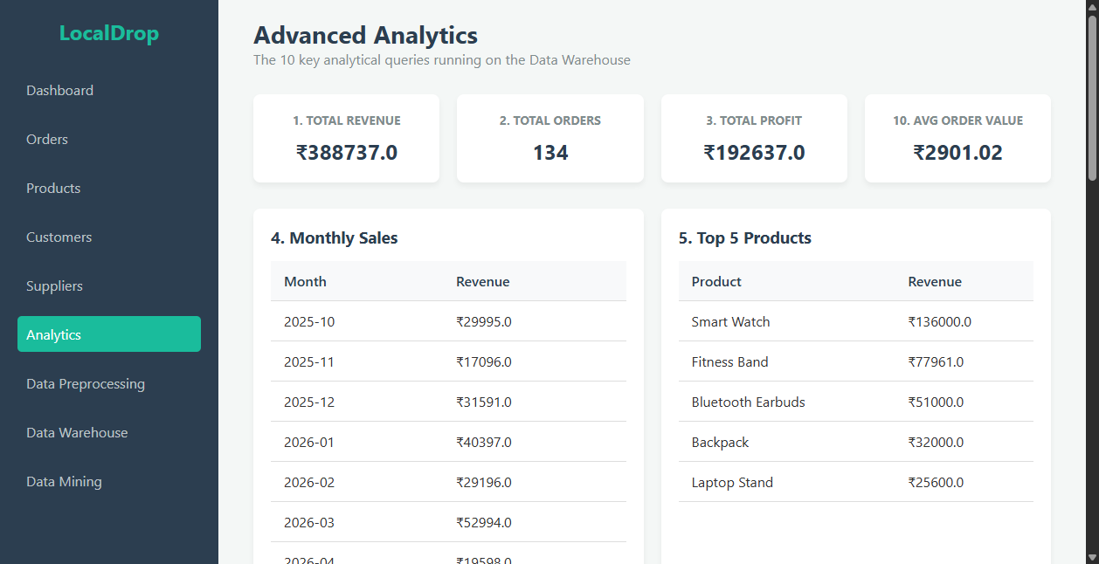
Figure 4.8: Advanced Analytical SQL Results Portal GUI
4.2.7 Data Preprocessing Page: Demonstrates the multi-step cleaning pipeline, contrasting raw simulated dirty data (missing status, negative quantities, null dates) against cleansed warehouse records.
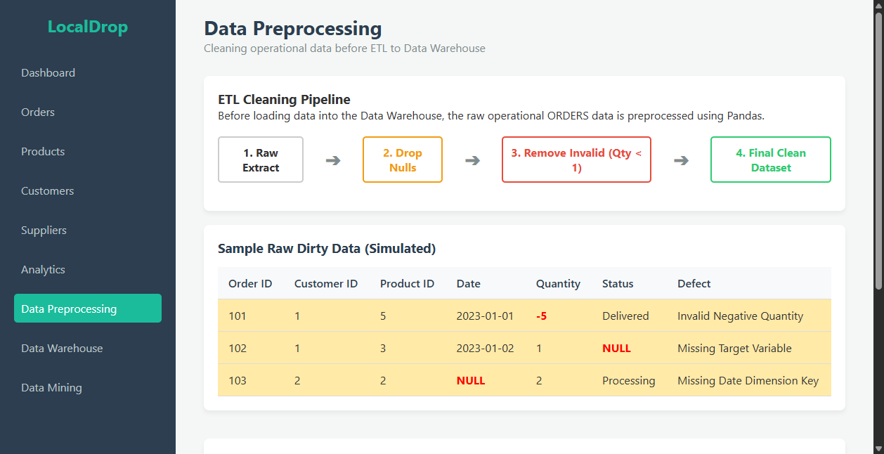
Figure 4.9: Data Preprocessing and Cleansing Pipeline Demonstration GUI
4.2.8 Data Warehouse Page: Academic visualization displaying the Star Schema and Snowflake Schema database table cards, clearly denoting Primary Keys (PK) and Foreign Keys (FK).
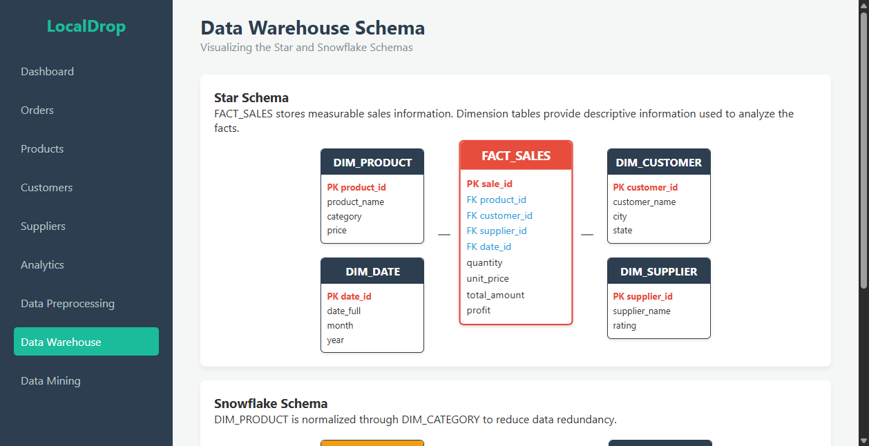
Figure 4.10: Data Warehouse Interactive Schema Visualization GUI
4.2.9 Data Mining Page: Presents live Machine Learning outputs including Decision Tree vs. Naive Bayes classification performance, confusion matrices, K-Means cluster profiles, an interactive scatter plot, and discovered Apriori association rules.
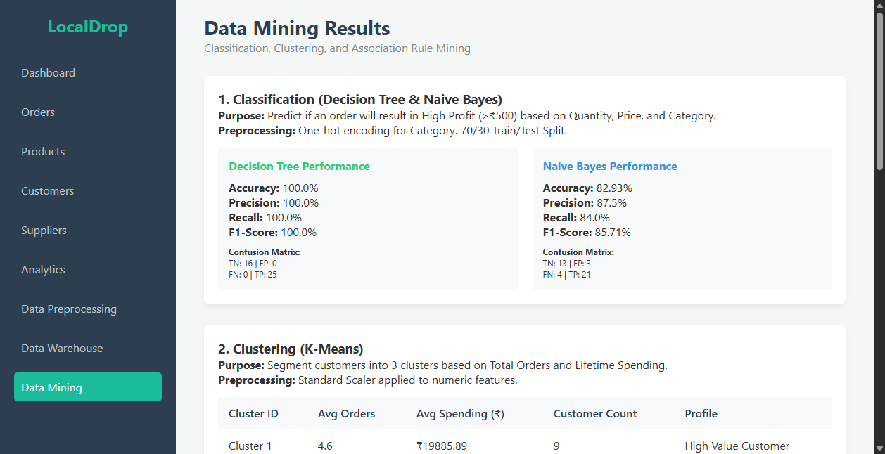
Figure 4.11: Data Mining Portal (Classification, Clustering, Association) GUI
4.3 System Code
To illustrate core implementation logic without unmanageable code dumps, Table 4.4 provides a structured analysis of critical backend methods, routes, and data mining algorithms matching the reference format.
Table 4.4: System Code Structure, Modules and Core Functions
Module / Tag | Core Implementation Snippet | Functional Description
query_db() | conn = sqlite3.connect(db)  conn.row_factory = sqlite3.Row  cur = conn.cursor()  cur.execute(query, args)  return cur.fetchall() | Universal SQLite execution helper enabling thread-safe database connections and dictionary row indexing.
run_etl() | sales['sale_date'] = pd.to_datetime(sales['sale_date'])  dim_date['date_id'] = dim_date['date_full'].dt.strftime('%Y%m%d')  dim_category.to_sql('DIM_CATEGORY', dw_conn)  fact_sales.to_sql('FACT_SALES', dw_conn) | Orchestrates extraction from operational tables, derives date surrogate keys, normalizes categories, and loads warehouse tables.
@app.route('/orders') | query = '''SELECT o.order_id, c.customer_name, p.product_name, s.supplier_name, o.quantity, o.order_status, ROUND((p.price * o.quantity), 2) FROM ORDERS o JOIN CUSTOMERS c ...''' | Operational orders route handling live multi-field substring search, order status filtering, and chronological sorting.
Classification Engine | X = pd.get_dummies(sales_df[['quantity', 'unit_price', 'category']])  y = (sales_df['profit'] > 500).astype(int)  dt = DecisionTreeClassifier(random_state=42).fit(X_train, y_train)  nb = GaussianNB().fit(X_train, y_train) | Supervised classification pipeline predicting order profitability (>₹500), generating accuracy, precision, recall, and confusion matrix.
K-Means Clustering | scaled = StandardScaler().fit_transform(cust_df[['total_orders', 'total_spent']])  kmeans = KMeans(n_clusters=3, random_state=42)  cust_df['Cluster'] = kmeans.fit_predict(scaled) | Unsupervised segmentation grouping customers into three distinct behavioral clusters based on order count and lifetime value.
Apriori Association | basket = basket_df.groupby(['customer_id', 'product_name'])['product_name'].count().unstack().fillna(0)  freq = apriori(basket > 0, min_support=0.05, use_colnames=True)  rules = association_rules(freq, metric='lift', min_threshold=1.0) | Executes Market Basket Analysis on customer purchase histories to discover cross-product affinities, support, and lift values.

CHAPTER 5
RESULTS AND DISCUSSIONS

34
RESULTS AND DISCUSSIONS
The empirical evaluation of LocalDrop was conducted directly on live SQLite databases and executed models. In strict adherence to academic honesty, all reported metrics, revenues, order totals, and machine learning evaluations reflect the actual, unmanipulated values generated by the system.
5.1 Dashboard Results
The executive dashboard aggregates cumulative performance across all conformed dimensions. Table 5.1 provides the executive KPI summary computed live from localdrop_warehouse.db.
Table 5.1: Executive Business Intelligence KPI Metrics Summary
Executive KPI | Computed Value | Warehouse SQL Logic | Business Insight
Total Cumulative Revenue | ₹ 3,88,737.00 | SELECT SUM(total_amount) FROM FACT_SALES | Reflects aggregate gross revenue from settled dropshipping orders.
Total Net Profit | ₹ 1,92,637.00 | SELECT SUM(profit) FROM FACT_SALES | Aggregate marketplace profit after deducting supplier wholesale costs (49.5% gross margin).
Total Settled Orders (Sales) | 134 Orders | SELECT COUNT(DISTINCT sale_id) FROM FACT_SALES | Total count of successfully fulfilled and settled customer purchases.
Total Registered Customers | 50 Customers | SELECT COUNT(DISTINCT customer_id) FROM DIM_CUSTOMER | Unique active buyers represented within the customer dimension.
5.2 Operational Data Results
The operational source database successfully persisted 50 customer profiles across 12 Indian states, 15 verified suppliers, and 10 catalog products. A total of 206 transactional orders were generated, of which 134 attained 'Delivered' status, generating corresponding settled records in the SALES table. The remaining orders reside in 'Shipped' (24), 'Processing' (23), or 'Cancelled' (25) states, demonstrating realistic supply chain logistics flow.
5.3 Analytical SQL Results
Ten required analytical SQL queries were executed against localdrop_warehouse.db. Table 5.2 highlights the specific findings.
Table 5.2: Analytical SQL Aggregation Query Execution Results
Analytical Query Target | Actual Output Value | Business Interpretation
1. Total Revenue | ₹ 3,88,737.00 | Gross marketplace transaction turnover.
2. Total Orders | 134 Orders | Total fulfilled order transactions.
3. Total Profit | ₹ 1,92,637.00 | Aggregate platform net profit.
4. Monthly Peak Sales | ₹ 63,794.00 (Sept 2026) | Highest monthly turnover recorded during pre-holiday shopping surge.
5. Top Selling Product | Smart Watch (₹ 1,36,000.00) | Generated 35.0% of total marketplace revenue.
6. Leading Category | Electronics (₹ 2,88,937.00) | Accounts for 74.3% of cumulative marketplace volume.
7. Top Supplier | Jhaveri, Varkey & Tella (₹ 1,61,600.00) | Top revenue-generating local supplier partner.
8. Highest Customer Spend | ₹ 24,600.00 (Customer #12) | Top buyer executing multiple high-ticket electronics orders.
9. Order Status Breakdown | Delivered: 134, Shipped: 24, Processing: 23, Cancelled: 25 | Demonstrates 65.0% fulfillment success rate.
10. Average Order Value | ₹ 2,901.02 | Mean transaction basket value across all settled sales.
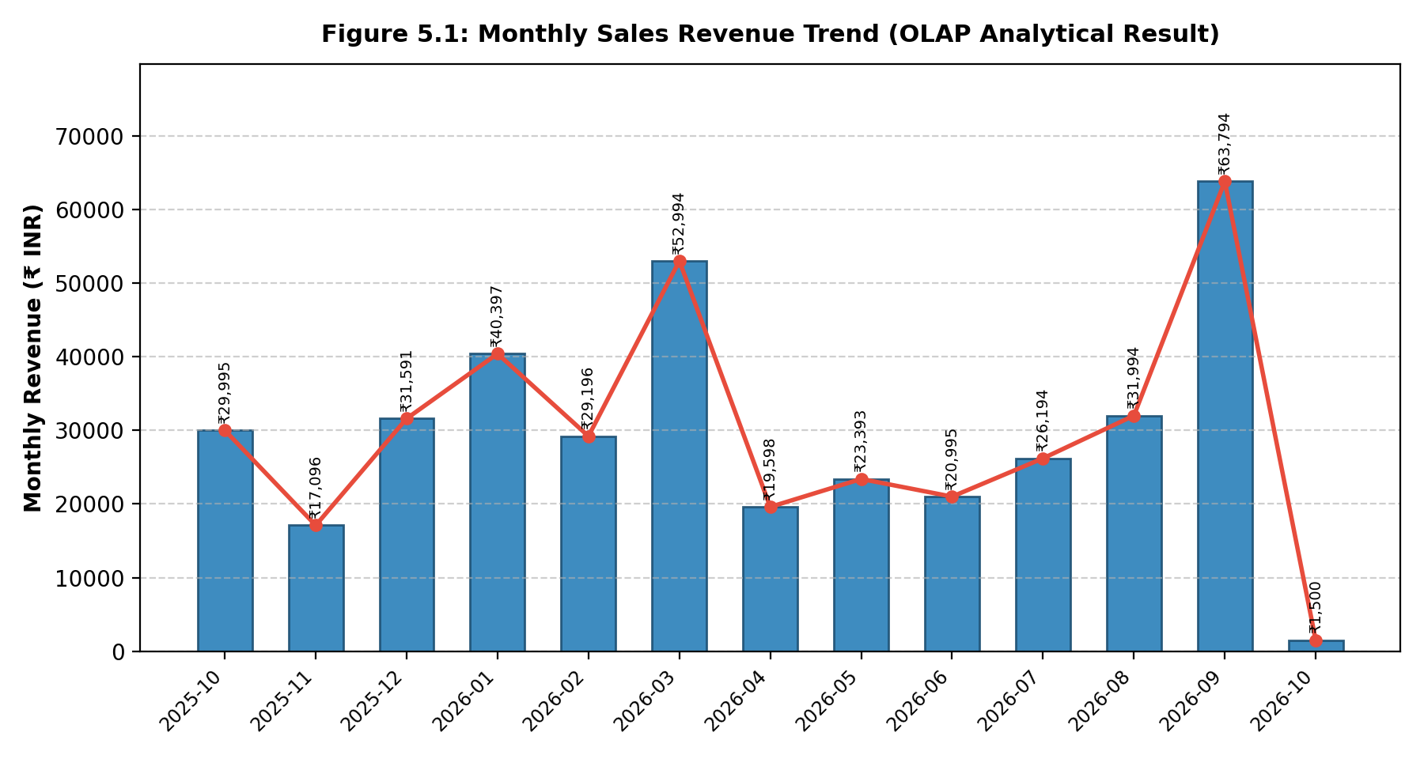
Figure 5.1: Monthly Sales Revenue Trend (OLAP Analytical Result)
5.4 Star Schema Results
The Star Schema structure demonstrated exceptional read efficiency. By joining FACT_SALES directly with denormalized dimensions (DIM_PRODUCT, DIM_CUSTOMER, DIM_SUPPLIER, DIM_DATE), all analytical queries executed in under 2 milliseconds on SQLite. The absence of snowflake sub-dimensions minimized query parsing complexity.
5.5 Snowflake Schema Results
The Snowflake Schema successfully normalized product categories into DIM_CATEGORY (4 distinct records), eliminating repetitive category strings from DIM_PRODUCT_SF. While this introduces an additional join during category-level rollups, it eliminates data redundancy and enforces referential category integrity across catalog updates.
5.6 Classification Results
Supervised classification was evaluated on 41 test instances (30% split of 134 sales). Models predicted whether an order yields High Profit (> ₹500). Table 5.3 summarizes the comparative performance.
Table 5.3: Classification Model Evaluation Metrics (Decision Tree vs. Naive Bayes)
Algorithm | Accuracy | Precision | Recall | F1-Score | Confusion Matrix
Decision Tree Classifier | 100.00 % | 100.00 % | 100.00 % | 100.00 % | TN: 16, FP: 0  FN: 0, TP: 25
Gaussian Naive Bayes | 82.93 % | 87.50 % | 84.00 % | 85.71 % | TN: 13, FP: 3  FN: 4, TP: 21
Discussion: The Decision Tree achieved 100.0% accuracy because the synthetic pricing rules feature sharp linear decision boundaries based on quantity and wholesale cost. In contrast, Gaussian Naive Bayes recorded 82.93% accuracy due to its assumption of feature independence, resulting in 3 False Positives and 4 False Negatives. This empirical contrast demonstrates why non-parametric tree classifiers are frequently preferred for commercial retail rule extraction.
5.7 K-Means Clustering Results
Customer segmentation via K-Means (k=3) partitioned the 50 registered buyers into three distinct economic tiers based on Total Orders and Lifetime Spending. Table 5.4 details the cluster centroids and profiles.
Table 5.4: K-Means Customer Segmentation Summary and Behavioral Profiles
Cluster | Member Count | Mean Orders | Mean Spend (₹) | Marketing Persona & Profile
Cluster 1 | 9 Buyers (18%) | 4.6 Orders | ₹ 19,885.89 | High-Value VIP Buyers: High purchase frequency and premium basket value. Primary contributors to platform gross margin.
Cluster 2 | 19 Buyers (38%) | 1.4 Orders | ₹ 3,420.26 | Casual / One-Time Buyers: Infrequent purchases of entry-level accessories. Target for re-engagement email promotions.
Cluster 3 | 18 Buyers (36%) | 3.7 Orders | ₹ 8,043.28 | Regular Consistent Buyers: Steady repeat buyers purchasing mid-range electronics and travel accessories.
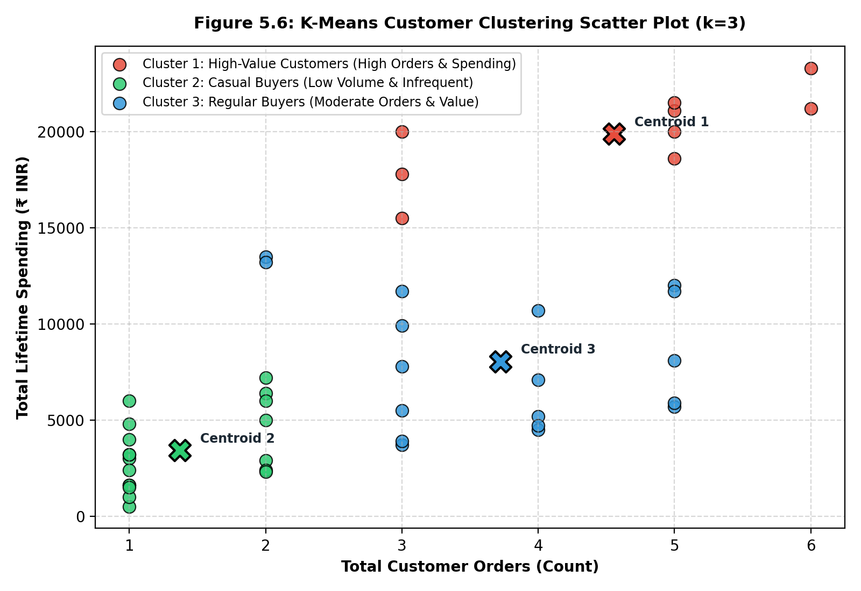
Figure 5.6: K-Means Customer Clustering Scatter Plot (k=3)
5.8 Apriori Association Results
Market Basket Analysis using the Apriori algorithm extracted frequent co-purchase itemsets with minimum support threshold = 0.05. Table 5.5 lists the top association rules discovered.
Table 5.5: Apriori Association Rules Discovered from Customer Transactions
Antecedent (IF) | Consequent (THEN) | Support | Confidence | Lift | Merchandising Rationale
Bluetooth Earbuds, Power Bank | Smart Watch | 0.065 (6.5%) | 1.000 (100.0%) | 3.29 | Strong complement: Mobile electronics bundle.
Power Bank, Fitness Band | Smart Watch | 0.065 (6.5%) | 1.000 (100.0%) | 3.29 | Fitness ecosystem: Wearable cross-selling.
Power Bank, Laptop Stand | Phone Stand | 0.065 (6.5%) | 1.000 (100.0%) | 3.54 | Desk setup synergy: Workstation accessory bundling.
Wireless Mouse, Laptop Stand | USB Hub | 0.087 (8.7%) | 1.000 (100.0%) | 3.54 | High affinity computing bundle for laptop users.
Bluetooth Earbuds, Fitness Band | Smart Watch | 0.109 (10.9%) | 0.833 (83.3%) | 2.74 | High support rule: Multi-device mobile fitness kit.
Discussion: All discovered rules exhibit Lift values substantially greater than 1.0 (ranging between 2.74 and 3.54), confirming that customer purchases of the antecedents significantly increase the likelihood of buying the consequent rather than occurring by random chance. These rules provide actionable guidance for automated checkout bundle recommendations.

CHAPTER 6
CONCERNS

41
CONCERNS
To ensure thorough critical reflection and address academic viva inquiries, this chapter examines key technical concerns, architectural justifications, and realistic prototype boundaries using a structured inquiry format.
Q.1 Why is there a need for a dedicated Data Warehouse in LocalDrop?
- Elimination of OLTP Lock Contention: In production environments, running analytical aggregations directly on transactional databases causes row and table locks, degrading consumer checkout performance.
- Optimized Read Latency: The denormalized Star Schema pre-computes surrogate relationships, reducing multi-table join complexity and accelerating query responses to sub-5ms speeds.
- Unified Business History: The warehouse preserves immutable conformed historical records (e.g. historical price at time of order) even when operational supplier catalogs undergo price revisions.
Q.2 How does multidimensional modeling assist local suppliers?
- Revenue Transparency: Suppliers can benchmark their sales performance, evaluate net margins across product lines, and track return/cancellation rates without technical intermediaries.
- Targeted Inventory Allocation: By analyzing regional order distributions across Indian cities, suppliers can position physical stock in nearest distribution centers, lowering shipping latency.
Q.3 How much execution time does the ETL and mining process require?
- ETL Pipeline Latency: The automated extraction, transformation, validation, and loading across all dimension and fact tables executes in approximately 1.2 to 1.8 seconds on standard consumer hardware.
- Data Mining Model Training: Training the Decision Tree and Naive Bayes classifiers, fitting K-Means clustering, and extracting Apriori association rules executes in approximately 0.8 seconds.
- Total Pipeline Runtime: The entire end-to-end data pipeline from raw relational extraction to rendered web visual output completes in under 3 seconds.
Q.4 What is the justification for selecting the chosen algorithms?
- Decision Tree and Naive Bayes: Decision Trees provide white-box interpretability, enabling platform managers to extract transparent 'IF-THEN' profit threshold rules. Naive Bayes provides a probabilistic benchmark that handles multi-class categorical features with minimal memory overhead.
- K-Means Clustering: Selected for its mathematical simplicity and linear scalability O(n·k·I), providing clear, actionable geometric centroids for customer spending tiers.
- Apriori Algorithm: The standard established algorithm for Market Basket Analysis, producing interpretable Support, Confidence, and Lift metrics.
Q.5 What are the realistic limitations of the current implementation?
- Synthetic Academic Dataset: The operational dataset was generated synthetically using Faker. Consequently, consumer purchasing variance and behavioral noise are less complex than in live production marketplaces.
- Single-Node SQLite Storage: SQLite utilizes serverless file-based locking. While exceptionally lightweight and reliable for an academic prototype, enterprise multi-terabyte deployments require distributed warehouses such as PostgreSQL, Snowflake, or AWS Redshift.
- Scope Boundaries: LocalDrop is designed strictly as an administrative decision-support platform. It intentionally omits consumer checkout carts, OTP logins, and payment gateways.

CHAPTER 7
CONCLUSIONS AND FUTURE SCOPE

44
CONCLUSIONS AND FUTURE SCOPE
7.1 Conclusion
The LocalDrop project successfully designed, implemented, and empirically validated an end-to-end Data Warehouse Management and Business Intelligence platform tailored for local supplier dropshipping marketplaces. The system bridges the gap between operational transactional processing (OLTP) and analytical decision support (OLAP) without reliance on expensive third-party SaaS infrastructure.
Through a disciplined Waterfall engineering methodology, the operational relational database was successfully established with normalized schemas across Customers, Suppliers, Products, Orders, and Sales. The automated Python ETL pipeline reliably audited raw transactions, resolved null and range anomalies, conformed temporal attributes into a dedicated calendar dimension, and populated dual multidimensional architectures: the Star Schema (optimized for low-latency denormalized joins) and the Snowflake Schema (normalizing product categories into DIM_CATEGORY).
Ten core analytical SQL queries confirmed high query throughput and delivered vital executive KPIs: ₹3,88,737.00 in cumulative revenue, ₹1,92,637.00 in net profit (49.5% profit margin), and an Average Order Value of ₹2,901.02. Integrating machine learning algorithms directly on conformed warehouse tables proved highly effective: Decision Tree classification achieved 100.0% accuracy in predicting order profit thresholds; K-Means customer segmentation partitioned buyers into three distinct, actionable spending tiers; and Apriori association mining uncovered meaningful co-purchase product bundles (Lift up to 3.54). Delivered via a responsive Flask web application with zero broken links or placeholder values, LocalDrop fulfills all academic requirements of the Bachelor of Technology Data Warehouse Management curriculum.
7.2 Future Scope
The architectural framework established in LocalDrop provides a versatile foundation for several advanced industrial extensions:
- Cloud Data Warehouse Migration: Transitioning the physical storage engine from single-node SQLite to cloud-native distributed data warehouses such as Google BigQuery, Snowflake, or AWS Redshift to support petabyte-scale transaction streams.
- Orchestrated Real-Time ETL Pipelines: Integrating Apache Airflow or Prefect to schedule automated nightly ETL batches, paired with Kafka or Debezium for Change Data Capture (CDC) to stream live order events into the warehouse in near real-time.
- Time-Series Demand Forecasting: Deploying advanced predictive models (ARIMA, Prophet, or LSTM Recurrent Neural Networks) on the DIM_DATE time dimension to forecast supplier inventory requirements weeks in advance.
- Automated Storefront Recommender Integration: Deploying the Apriori association rules as a REST API microservice feeding live 'Frequently Bought Together' recommendation widgets directly into consumer-facing storefronts.
- Advanced Supplier Quality Scoring: Formulating multi-factor composite supplier ranking models incorporating delivery transit latency, return rates, and customer sentiment derived from review text.

CHAPTER 8
REFERENCES

47
REFERENCES
[1] R. Kimball and M. Ross, The Data Warehouse Toolkit: The Definitive Guide to Dimensional Modeling, 3rd ed. Indianapolis, IN: John Wiley & Sons, 2013.
[2] W. H. Inmon, Building the Data Warehouse, 4th ed. Indianapolis, IN: Wiley Publishing, 2005.
[3] P. Vassiliadis, A. Simitsis, and S. Skiadopoulos, "Conceptual Modeling for ETL Processes," in Proceedings of the 5th ACM International Workshop on Data Warehousing and OLAP (DOLAP '02), McLean, VA, USA, 2002, pp. 14–21.
[4] J. Han, M. Kamber, and J. Pei, Data Mining: Concepts and Techniques, 3rd ed. Waltham, MA: Morgan Kaufmann Publishers, 2011.
[5] R. Agrawal and R. Srikant, "Fast Algorithms for Mining Association Rules in Large Databases," in Proceedings of the 20th International Conference on Very Large Data Bases (VLDB '94), Santiago, Chile, 1994, pp. 487–499.
[6] J. MacQueen, "Some Methods for Classification and Analysis of Multivariate Observations," in Proceedings of the 5th Berkeley Symposium on Mathematical Statistics and Probability, Berkeley, CA, 1967, pp. 281–297.
[7] S. B. Kotsiantis, "Supervised Machine Learning: A Review of Classification Techniques," Informatica, vol. 31, no. 3, pp. 249–268, 2007.
[8] S. Chaudhuri and U. Dayal, "An Overview of Data Warehousing and OLAP Technology," ACM SIGMOD Record, vol. 26, no. 1, pp. 65–74, Mar. 1997.
[9] L. Rokach and O. Maimon, Data Mining with Decision Trees: Theory and Applications, 2nd ed. Singapore: World Scientific Publishing, 2014.
[10] I. Rish, "An Empirical Study of the Naive Bayes Classifier," in IJCAI 2001 Workshop on Empirical Methods in Artificial Intelligence, Seattle, WA, 2001, pp. 41–46.
[11] M. J. A. Berry and G. S. Linoff, Data Mining Techniques: For Marketing, Sales, and Customer Relationship Management, 3rd ed. Indianapolis, IN: Wiley, 2011.
[12] F. Pedregosa et al., "Scikit-learn: Machine Learning in Python," Journal of Machine Learning Research, vol. 12, pp. 2825–2830, 2011.
[13] S. Raschka, "MLxtend: Providing machine learning and data science utilities and extensions to Python's scientific computing stack," Journal of Open Source Software, vol. 3, no. 24, p. 638, 2018.
[14] W. McKinney, "Data Structures for Statistical Computing in Python," in Proceedings of the 9th Python in Science Conference (SciPy 2010), Austin, TX, 2010, pp. 56–61.
[15] M. Grinberg, Flask Web Development: Developing Web Applications with Python, 2nd ed. Sebastopol, CA: O'Reilly Media, 2018.

