Feature Selection Experiment Report:
1. Experiment Overview: This report analyzes the experimental outputs produced by main.ipynb, whose purpose is to study how different feature-selection algorithms and retained-feature ratios affect performance on datasets of varying difficulty levels (hard, medium, and easy). The notebook benchmarks two embedded feature-selection approaches, STG and LSPIN, against a full-feature ExtraTrees baseline across six high-dimensional classification datasets. The protocol uses 5-fold stratified cross-validation and evaluates retained-feature ratios from 100% to 5%.
The experiment was conducted on 6 tabular datasets, which were strategically divided into two groups based on their sample sizes and inherent characteristics:
- Extreme Low Sample Size (LSS) Datasets: Breast (hard), colon (medium), leukemia (easy), and SMK-CAN-187 (medium).
- Medium-Large Datasets: madelon (hard) and RELATHE (easy).
2. Methodology & Technical Implementation
- 5-Fold Stratified Cross-Validation (CV).
- Feature-retention ratios: 1.0, 0.9, 0.8, 0.7, 0.6, 0.5, 0.4, 0.3, 0.2, 0.1, 0.05
- Methods compared:
  - Baseline ExtraTrees on full features
  - STG-selected features + ExtraTrees
  - LSPIN-selected features + ExtraTrees
    - Because LSPIN generates local, sample-specific gates, we aggregated these values by calculating the mean across the sample axis to derive a global feature importance ranking.
- Reported metrics: AUC and accuracy (train and test)

To optimize computation time without compromising validity, the evaluation model (ExtraTreesClassifier) was fixed to a single robust configuration for all datasets: n_estimators=200 and max_depth=4.
Hyperparameters were specifically tailored to the dataset sizes:
- For LSS Datasets: Models utilized Full Batch training, up to 1,000 epochs, and the SGD optimizer. LSPIN was configured with a narrow gating network of (100, 10) to mitigate the lack of data.
- For Medium-Large Datasets: Epochs up to 500-1000 (e.g., for STG on RELATHE and madelon) with smaller batch sizes (40 and 200), while LSPIN utilized a wider gating network of (500,). All models used tanh activation functions.
3. Graphs
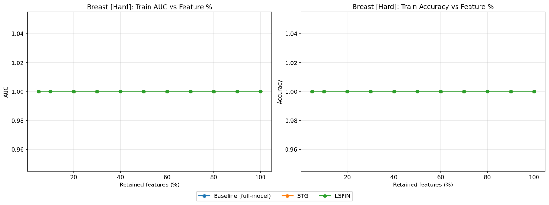
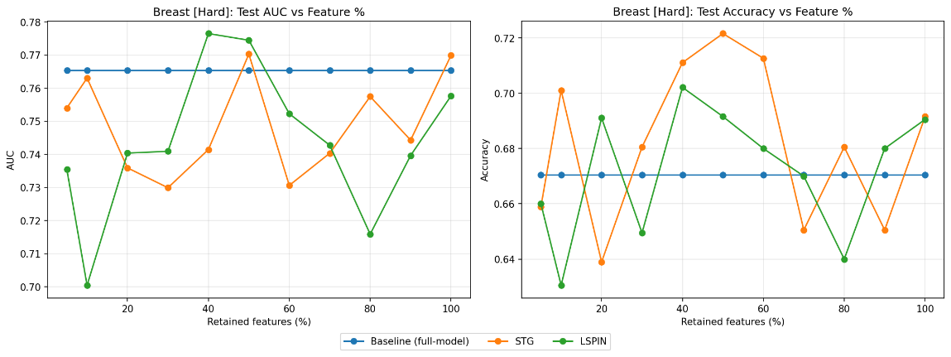

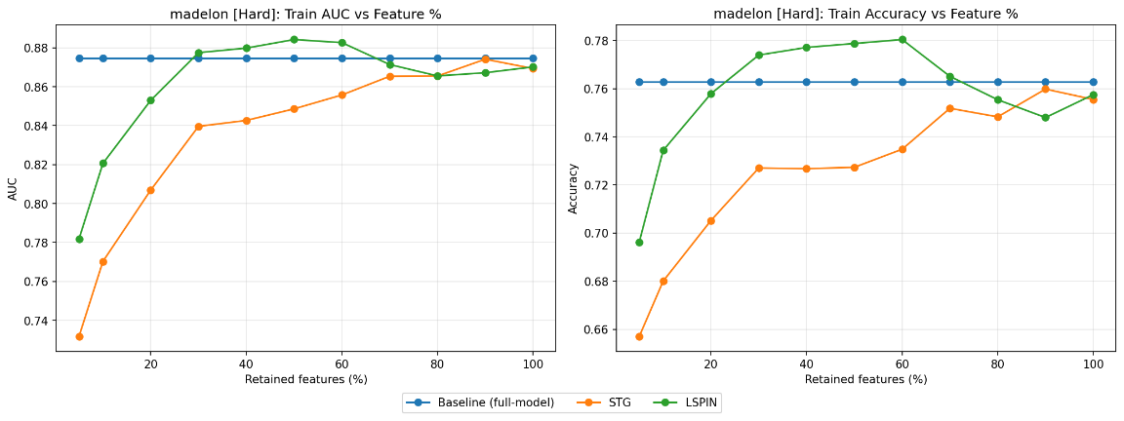
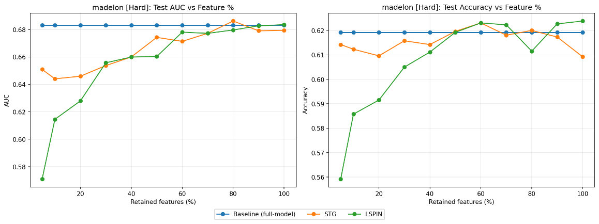

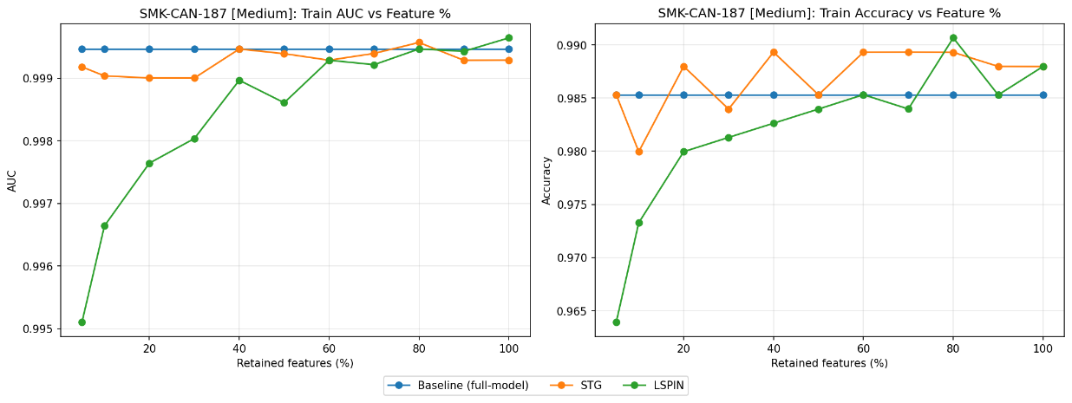
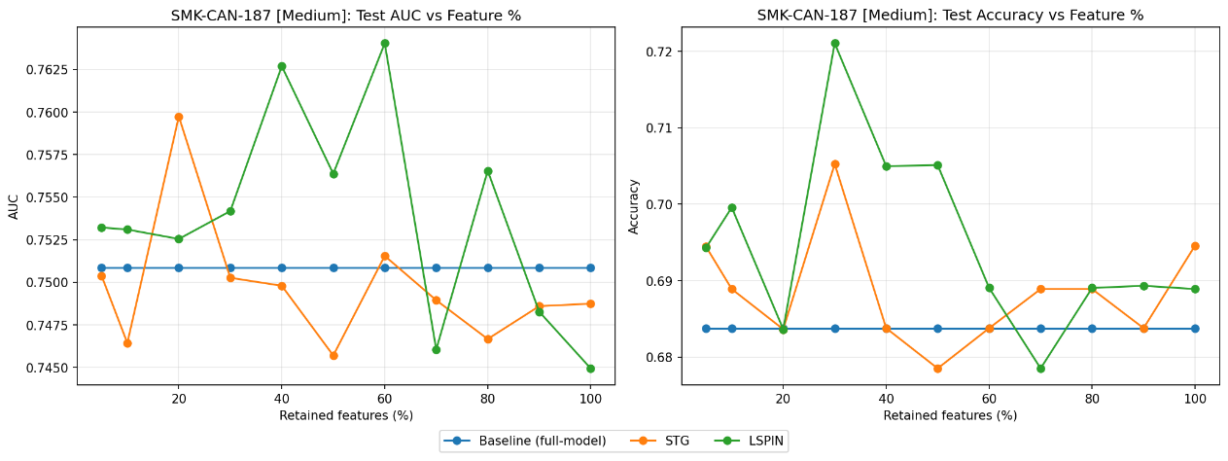

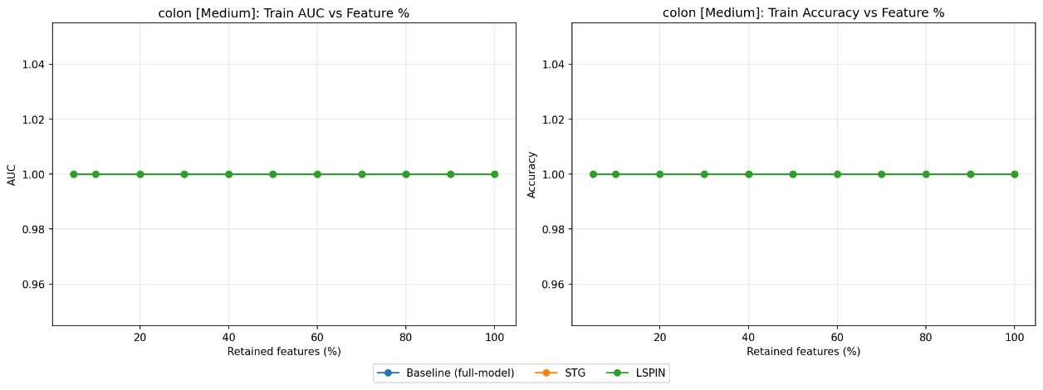
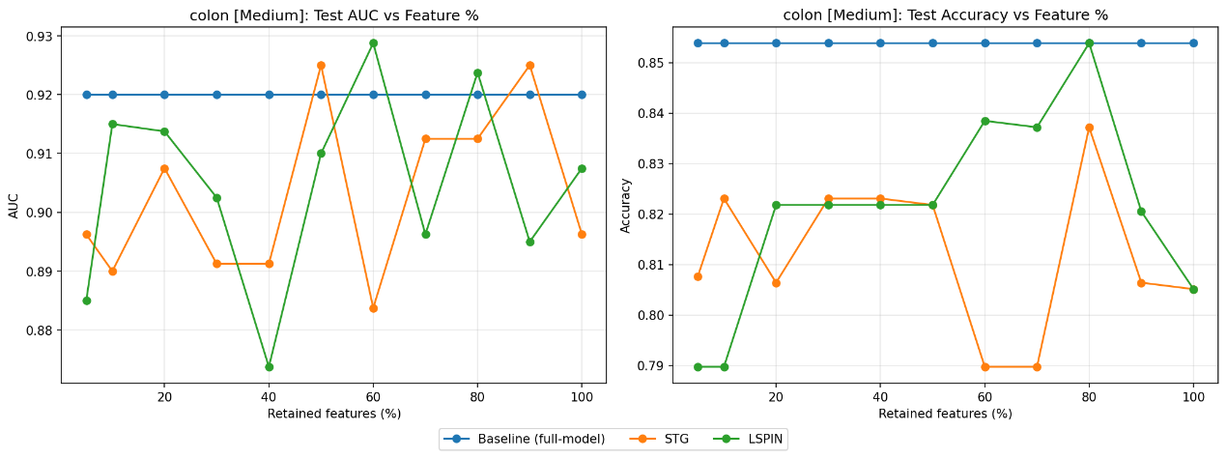

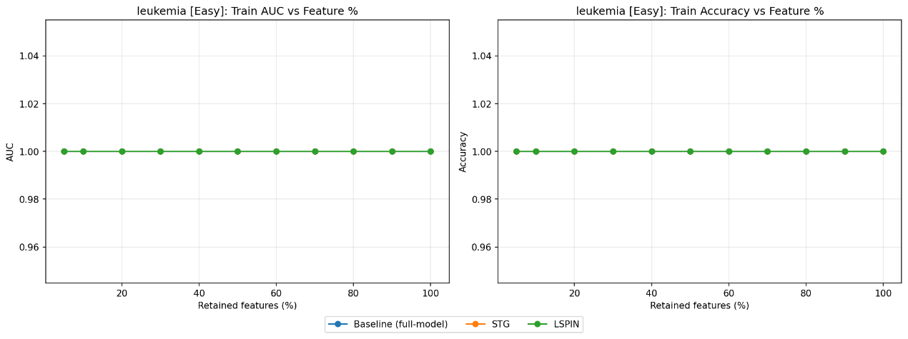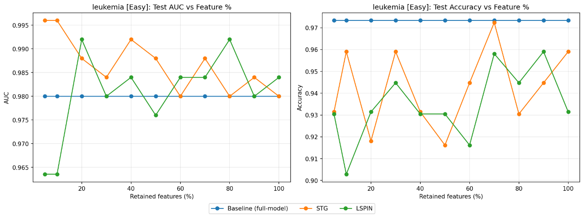

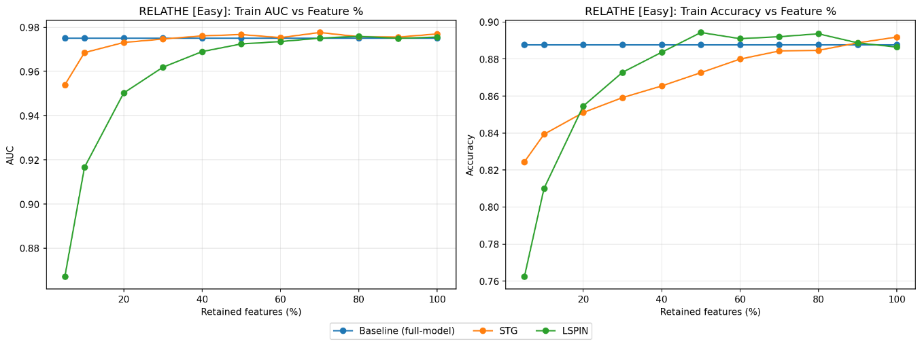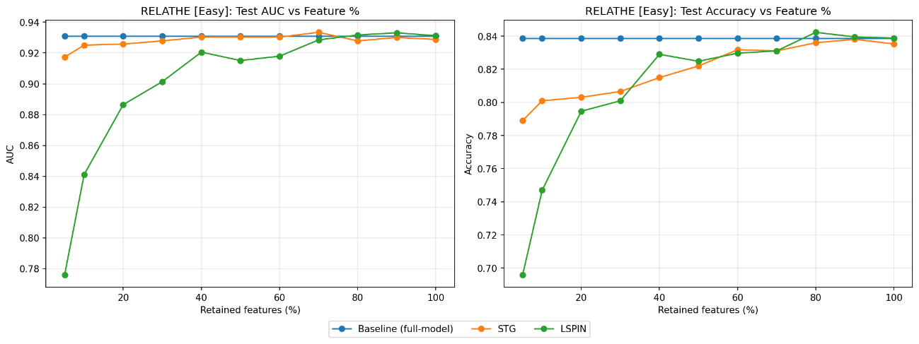
4. Results Analysis Based on the generated performance curves, several key observations emerged:
- Model Convergence: The training loss curves confirm that both STG and LSPIN demonstrated clear, stable loss reduction across all evaluated datasets. Notably, STG consistently exhibited a steeper and faster convergence compared to LSPIN.
- Overfitting on Extreme LSS Datasets: For the datasets with severe sample scarcity (Breast, colon, SMK-CAN-187, and leukemia), both STG and LSPIN achieved a perfect training AUC and Accuracy of 1.0 across all feature retention levels. However, their performance on the test sets was highly volatile, characterized by sharp fluctuations and inconsistencies.
- Dataset Difficulty and Feature Reduction:
  - On datasets classified as "Easy" (such as RELATHE and leukemia), the feature selection algorithms successfully matched or even slightly outperformed the full-model baseline, even when drastically reducing the number of retained features.
  - Conversely, on datasets classified as "Hard" (such as Breast and madelon), the feature selection models struggled to consistently surpass the baseline. For madelon, heavily reducing the feature percentage resulted in a sharp decline in test AUC and Accuracy, with the models only nearing baseline performance when retaining 80-100% of the original features. SMK-CAN-187 (Medium difficulty) showed highly erratic test results, though LSPIN occasionally produced massive performance spikes at specific retention levels (e.g., 40% and 60%).

Training loss curves:
